EduGenie: Google Gemini Powered Learning Assistant
Project Documentation

A FastAPI and Gemini based AI-powered educational assistant

Submitted by: ______________________________
Mentor: ______________________________
Date: ______________________________

1. Project Description
EduGenie is an AI-powered educational assistant designed to help learners understand academic topics through a simple web interface. The implemented system uses a FastAPI backend and an HTML/CSS/JavaScript frontend, with Google Gemini providing generative AI capabilities.
- Ask academic questions and receive clear answers.
- Explain difficult concepts using learner-friendly language.
- Generate a three-question multiple-choice quiz from educational text.
- Summarize long educational passages for quick revision.
- Generate a structured learning path based on topic, learner level, and goal.

2. Objectives
- Provide students with an accessible AI-based learning companion.
- Reduce the difficulty of understanding complex academic concepts.
- Provide quick question-answering and revision support.
- Generate practice quizzes automatically from study material.
- Create structured learning recommendations from beginner to advanced stages.
- Provide a modular backend that can be extended with additional educational features.

3. Use-Case Scenarios

Scenario 1: Academic Question Answering
A student asks, “What is Artificial Intelligence?” EduGenie sends the question to the Q&A module, which generates a concise, student-friendly answer using Gemini.

Scenario 2: Understanding a Difficult Topic
A learner enters “Machine Learning” and selects a beginner level. The Explanation module generates a simple definition, explanation, analogy, example, and key points.

Scenario 3: Self-Assessment
A learner pastes study material into the Quiz feature. EduGenie generates exactly three MCQs, each with four options, a correct answer, and an explanation.

Scenario 4: Quick Revision
A student pastes a long educational passage into the Summary feature. EduGenie produces a concise summary followed by important key points.

Scenario 5: Personalized Learning
A learner enters a topic, current level, and learning goal. The Learning Path module creates a structured roadmap with topics, concepts, practice activities, approximate time, and resource types.

4. System Architecture
User
|
v
HTML / CSS / JavaScript Frontend
|
v
FastAPI Backend
|
+--> /qa ----------------------> Q&A Module --------+
+--> /explain -----------------> Explanation -------+
+--> /quiz --------------------> Quiz Module --------+--> Google Gemini API
+--> /summarize ---------------> Summary Module -----+
+--> /learn/recommendations ---> Learning Path ------+
|
v
JSON Response
|
v
Frontend Result Display
The frontend collects learner input and sends HTTP POST requests to the FastAPI backend. Each endpoint invokes its corresponding Python module. The modules construct task-specific prompts and use the Gemini API to generate the response. The backend returns structured JSON to the frontend.

5. Technologies Used
Technology | Purpose | Implementation
Python | Application development | Backend modules and API logic
FastAPI | Web/API framework | REST endpoints and application server
Uvicorn | ASGI server | Runs the FastAPI application
HTML/CSS/JavaScript | Frontend | User interface and API interaction
Jinja2 | Templating | Serves the HTML frontend
Google Gemini API | Generative AI | Q&A, explanation, quiz, summary and learning paths
Pydantic | Data validation | Request and response models
pytest | Testing | Automated module and API tests
python-dotenv | Configuration | Loads environment variables from .env

6. Prerequisites
- Python 3.10 or newer.
- A Google Gemini API key.
- Internet connection for Gemini API requests.
- VS Code or another code editor.
- Command Prompt or terminal.

7. Installation and Setup
python --version
python -m venv .venv
.venv\Scripts\activate
python -m pip install --upgrade pip
pip install -r requirements.txt
Create a .env file in the project root and store the Gemini API key securely:
GEMINI_API_KEY=YOUR_ACTUAL_GEMINI_API_KEY
GEMINI_MODEL=gemini-3.5-flash-lite
The API key should not be committed to source control or shared publicly.

8. Project Folder Architecture
EduGenie/
├── main.py
├── config.py
├── gemini_client.py
├── models.py
├── qna.py
├── explanation_module.py
├── quiz_module.py
├── summary_module.py
├── learning_path.py
├── requirements.txt
├── .env
├── .gitignore
├── templates/
│ └── index.html
├── static/
│ └── style.css
└── tests/
├── __init__.py
├── test_api.py
└── test_modules.py
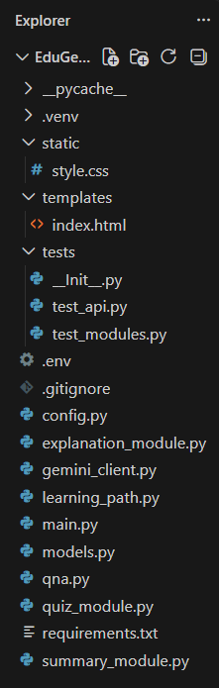

9. Project Workflow

MILESTONE 1: Architecture and Gemini Integration
The project was organized as a modular FastAPI application. Gemini access was isolated in gemini_client.py so that all AI modules use a common client and configuration.

Activity 1.1: Configuration
config.py loads the Gemini API key, model name, and input limits from environment variables. gemini_client.py creates the Gemini client and provides a reusable generate_text function.

MILESTONE 2: Core Functionalities Development

Activity 2.1: Q&A Module
The Q&A module receives an academic question and creates a prompt instructing Gemini to answer directly, use simple language, explain important terms, and provide examples when helpful.
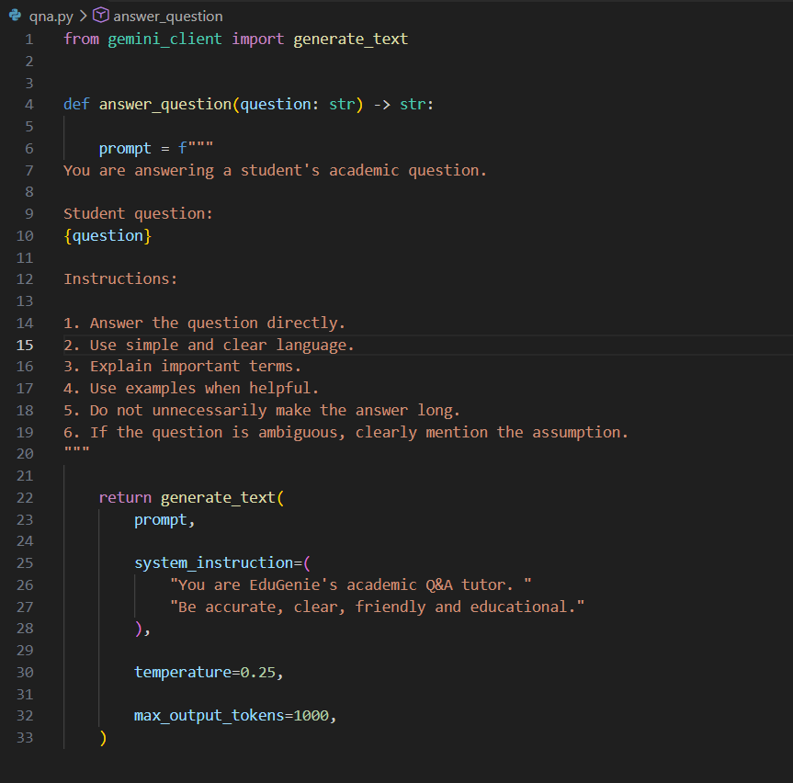

Activity 2.2: Explanation Module
The Explanation module asks Gemini to explain a topic according to the learner level. The response is organized around a simple definition, easy explanation, analogy, example, and key points.
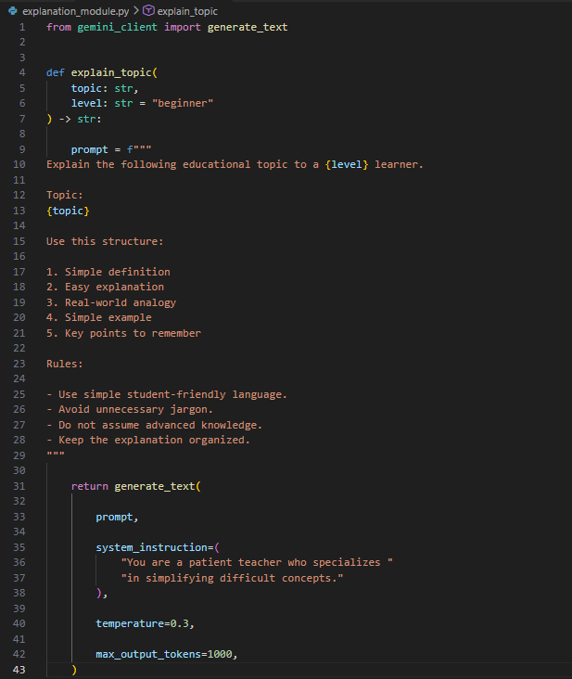

Activity 2.3: Quiz Module
The Quiz module generates exactly three MCQs with four options each. Gemini is requested to return structured JSON. The implementation removes Markdown code fences when necessary, parses the JSON, and validates the number of questions, options, required fields, and correct answers.
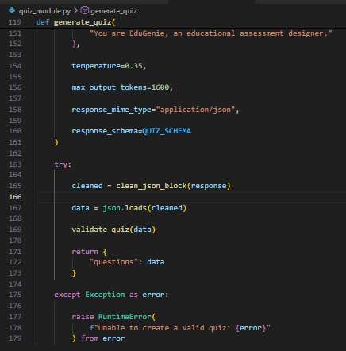

Activity 2.4: Summary Module
The Summary module converts educational passages into concise revision material while retaining important facts and relationships. It requests a short summary followed by key points.
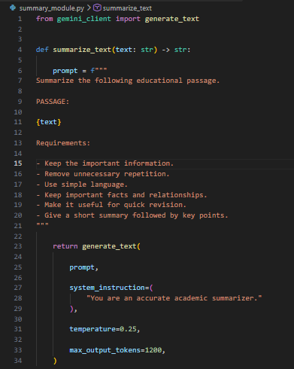

Activity 2.5: Learning Path Module
The Learning Path module accepts a topic, learner level, and goal. Gemini generates a roadmap containing learning stages, concepts, practice activities, approximate time, resource types, a weekly routine, practice suggestions, and a progression checklist.
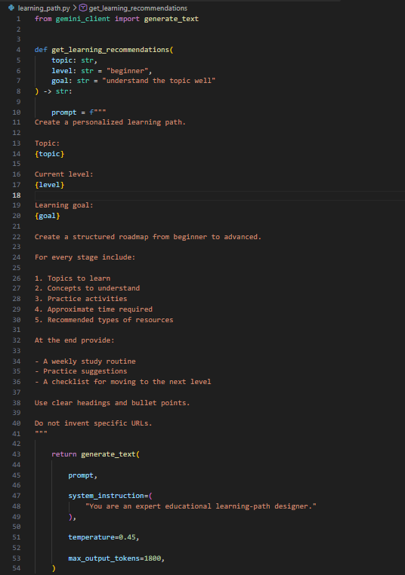

MILESTONE 3: Backend API with FastAPI
The backend exposes REST endpoints for each major EduGenie capability.
Method / Endpoint | Purpose | Response
GET / | Serves the EduGenie frontend | HTML page
GET /health | Checks service availability | Health status
POST /qa | Answers an academic question | answer
POST /explain | Explains a topic | explanation
POST /quiz | Generates a quiz | questions
POST /summarize | Summarizes text | summary
POST /learn/recommendations | Creates a learning path | learning_path

MILESTONE 4: Frontend Development
The frontend provides a simple educational interface using HTML, CSS and JavaScript. It collects user input, calls the appropriate backend endpoint, and displays the generated result.
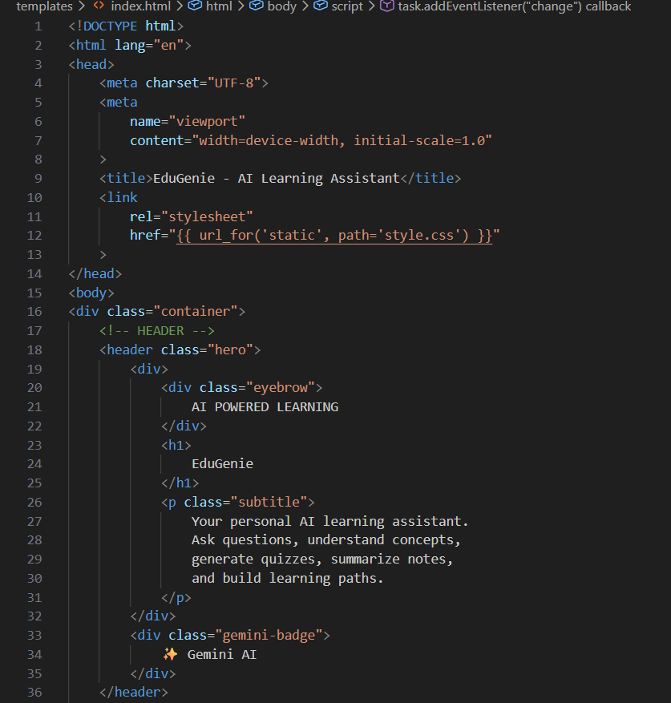

MILESTONE 5: Testing and Local Deployment
The application is run locally with Uvicorn. Automated tests are provided for both individual modules and API endpoints.
uvicorn main:app --reload
The application is accessed locally through http://127.0.0.1:8000 and the interactive API documentation is available through the FastAPI /docs route.
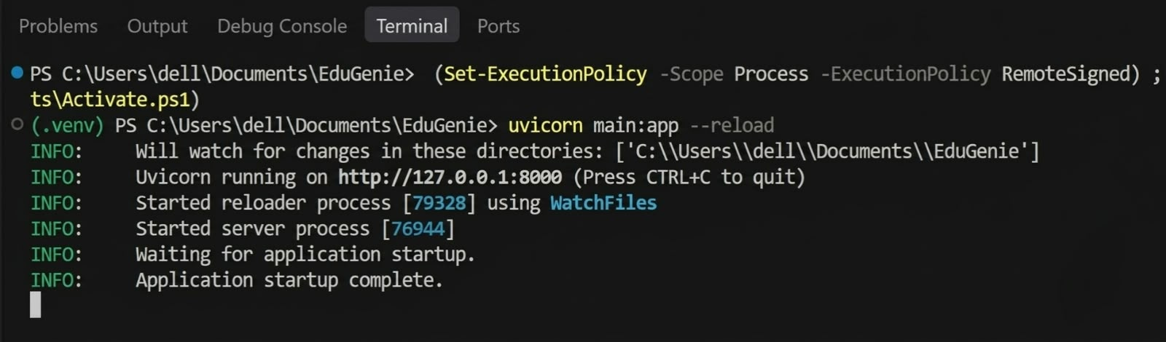

10. Detailed Module Logic

10.1 Q&A Module
Student question
↓
Q&A prompt
↓
Gemini
↓
Student-friendly answer
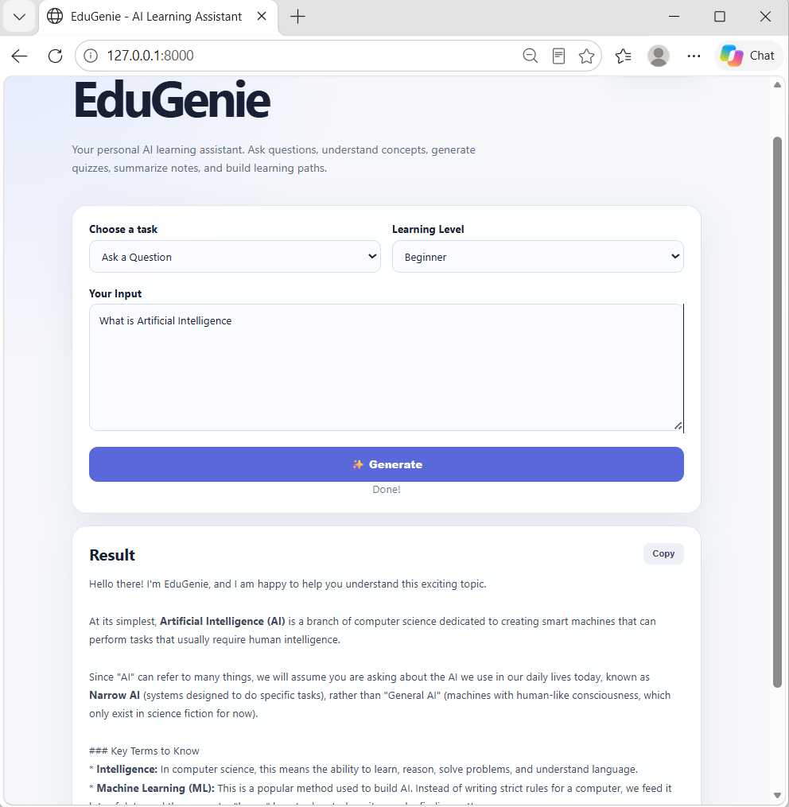

10.2 Explanation Module
Topic + learner level
↓
Structured teaching prompt
↓
Gemini
↓
Definition + explanation + analogy + example + key points
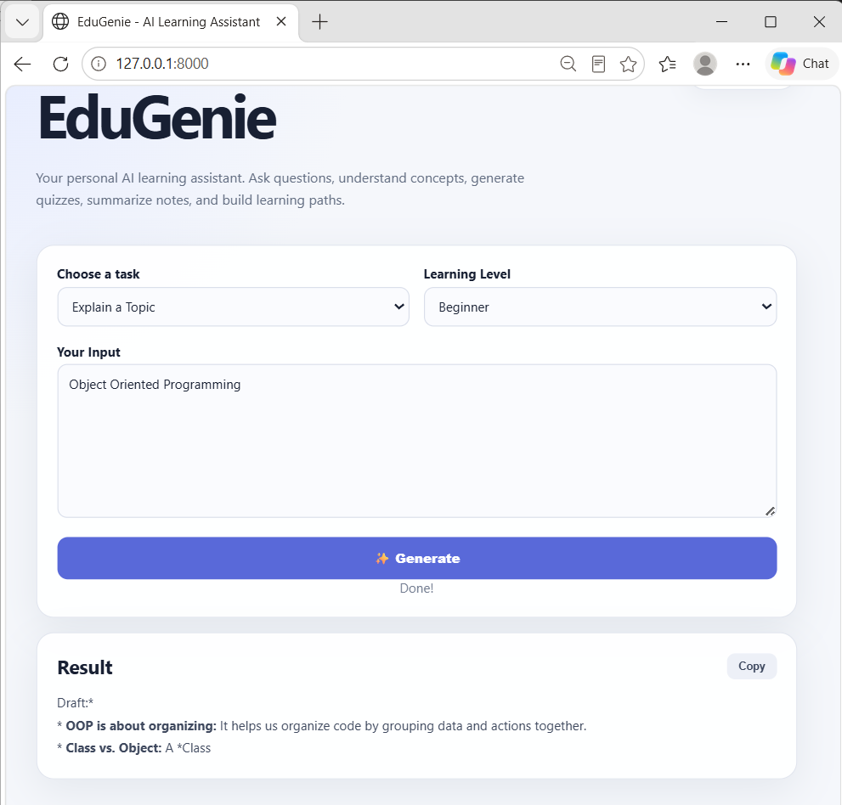

10.3 Quiz Module
Educational passage
↓
Gemini structured JSON request
↓
JSON cleaning
↓
JSON parsing
↓
Quiz validation
↓
3 questions × 4 options

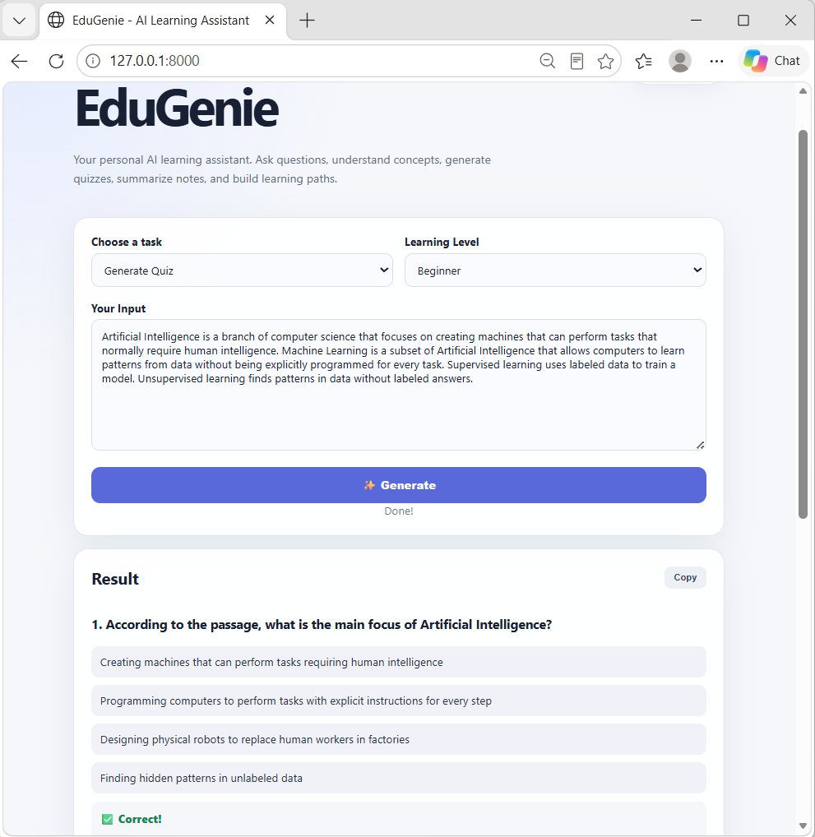

10.4 Summary Module
Long educational passage
↓
Summary prompt
↓
Gemini
↓
Short summary + key points
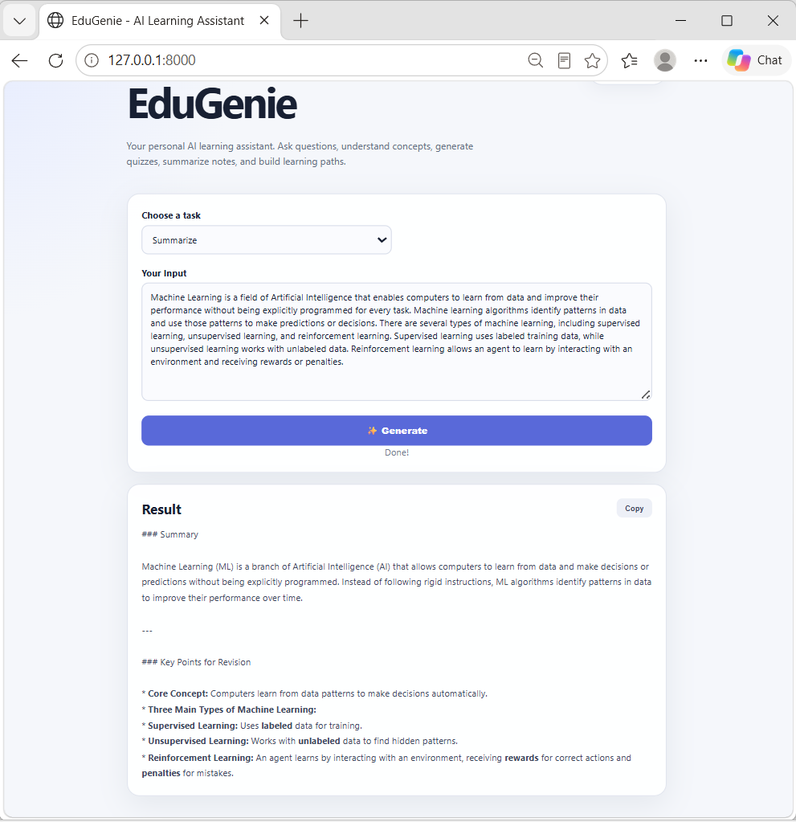

10.5 Learning Path Module
Topic + level + goal
↓
Learning-path prompt
↓
Gemini
↓
Structured roadmap + practice + routine + checklist

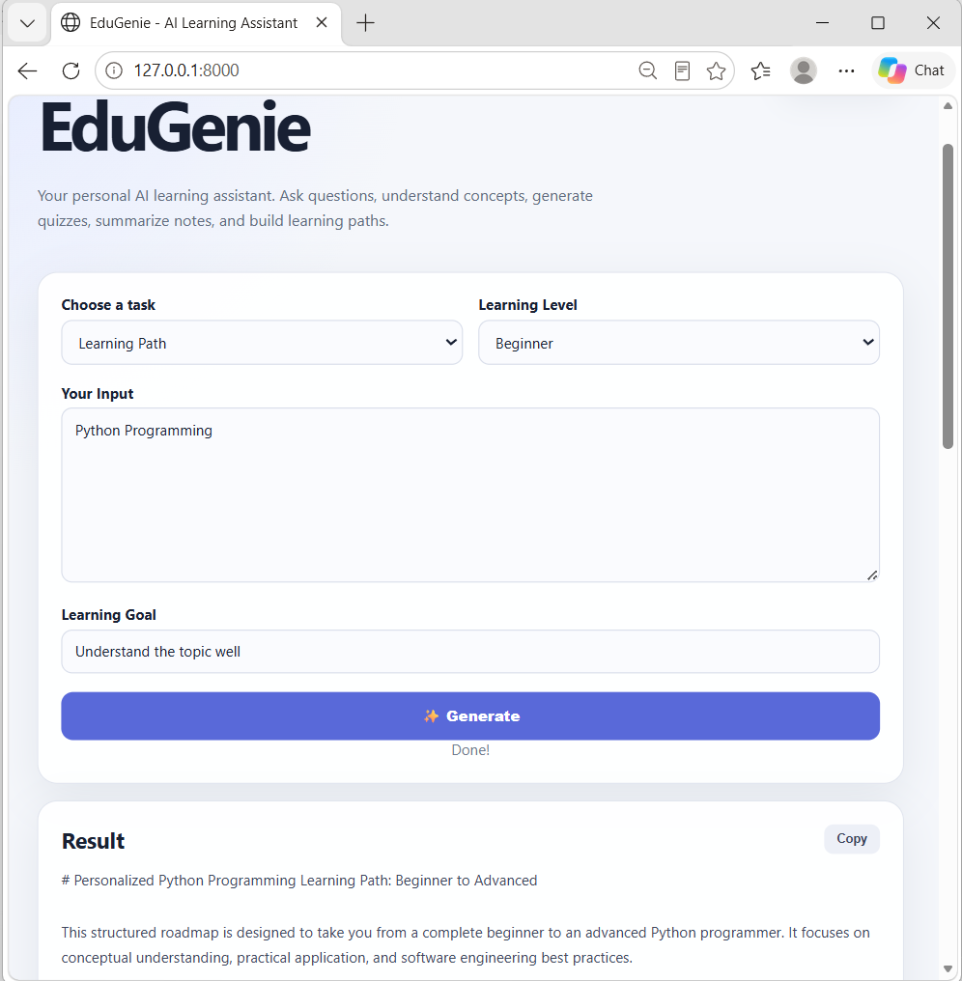

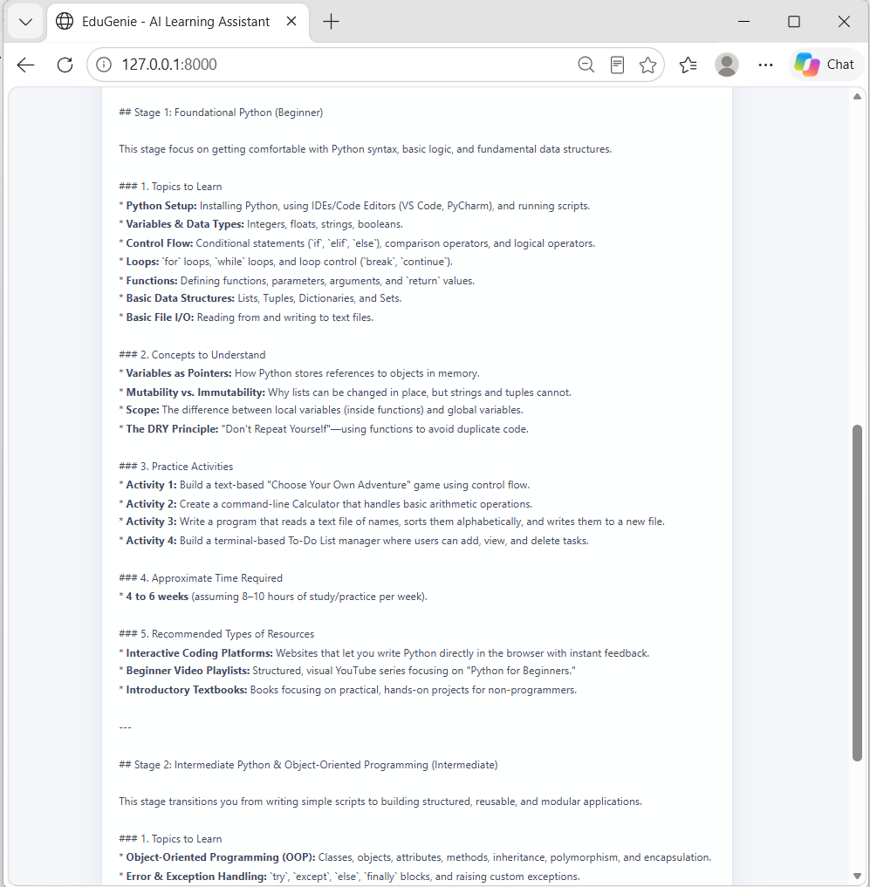

11. Data Models and Validation
Pydantic models validate incoming API data. The project defines request models for Q&A, explanation, quiz, summary, and learning recommendations. The quiz response is also represented through validated models so the API returns a predictable structure.
- QARequest validates the student question.
- ExplainRequest validates topic and learner level.
- QuizRequest validates educational text and level.
- SummaryRequest validates text.
- LearningPathRequest validates topic, level, and goal.
- QuizQuestion validates question, four options, correct answer, and explanation.

12. Error Handling
The Gemini client checks whether an API key is configured and raises a clear configuration error when it is missing. Temporary Gemini server errors such as HTTP 503 are retried before a user-friendly failure is returned. Quiz generation also validates generated JSON so malformed or incomplete quiz data does not silently pass through the application.

13. Functional Testing
Feature | Test Input | Observed Status
Application startup | Open / | Passed
Q&A | What is Artificial Intelligence? | Passed
Explain | Machine Learning, beginner | Passed
Quiz | AI and Machine Learning passage | Passed
Summarization | Machine Learning passage | Passed
Learning Path | Python Programming, beginner | Ready for final verification
API tests | python -m pytest | Included in project
During development, the application was also checked through the Uvicorn logs. Successful requests returned HTTP 200 responses. A temporary Gemini HTTP 503 overload condition was encountered and handled through model configuration and retry/error handling.

14. Automated Testing
python -m pytest
The test suite covers the application endpoints and core module behavior. AI calls are mocked in tests so the tests can verify application logic without depending on a live Gemini response.

15. Results
- The EduGenie web interface loads successfully.
- The FastAPI backend exposes the planned educational endpoints.
- Gemini-powered Q&A successfully returns answers.
- The explanation feature produces learner-friendly explanations.
- The quiz feature produces three questions with four options each.
- The summarization feature produces concise revision content.
- The learning-path feature is implemented to create structured recommendations.
- The project contains automated tests for API and module behavior.

16. Challenges and Solutions

16.1 Temporary Gemini 503 Error
The Gemini API temporarily returned HTTP 503 with a high-demand message. The project was adjusted to use an available Gemini model configuration and to retry temporary server failures before returning a clear error.

16.2 FastAPI Template Response Compatibility
The frontend initially encountered a server-side template response error because of the Starlette template API signature. The home route was updated to use the current request/name/context form.

16.3 Structured Quiz Output
Generative models can return formatted JSON inside Markdown code blocks. The Quiz module therefore cleans code fences, parses the JSON, and validates its structure before returning the response.

17. Future Enhancements
- Voice-based question answering.
- Multilingual educational support.
- Mobile application.
- Student progress tracking and dashboards.
- Gamification through badges, streaks, and challenges.
- Adaptive learning paths based on learner performance.
- Teacher and parent dashboards.
- Integration with Learning Management Systems.
- Support for image and PDF based learning.
- Persistent learning history and personalized recommendations.

18. Project Deliverables
- FastAPI backend application.
- Gemini API integration.
- HTML/CSS/JavaScript frontend.
- Five educational AI modules.
- Validated request and response models.
- Automated module tests.
- Automated API tests.
- Environment-based configuration.
- Project requirements and setup instructions.

19. Conclusion
EduGenie has been developed as a modular AI-powered educational assistant that combines a simple web interface, a FastAPI backend, and Google Gemini generative AI. The system supports question answering, simplified concept explanation, automatic quiz generation, educational summarization, and structured learning recommendations.
The project demonstrates how generative AI can be integrated into an educational application through reusable Python modules and REST APIs. Its modular design makes the application easier to test, maintain, and extend. The project also demonstrates practical concepts including prompt engineering, structured AI output, input validation, API integration, frontend-backend communication, error handling, and automated testing.
Future versions can extend EduGenie with voice interaction, multilingual support, progress tracking, adaptive learning, mobile access, and richer document-based learning. The current implementation provides a working foundation for these enhancements.

