­

Dynatrace Basic Training Reference

Updated <Date>



# OVerview

This document details the dashboards and views that are covered in the Dynatrace Basic Training:

Table of Contents

* Application Health – Verification of Alerts 3
  + Accessing the Incidents Dashlet 3
  + Which Dashboard do I open?4
* Application Health – Monitoring Overview 5
  + Accessing the Monitoring Dashboard5
  + Transaction Flow Intro6
  + Key Performance Indicators7
  + Dashboard Links7
* Application Health – Application Overview 8
  + Accessing and Navigating the Application Overview8
  + Violations9
  + Key Performance Indicators10
* Application Health – AvgRT Dashboard 12
  + Accessing the AvgRT Dashboard 12
* Application Health – General Dashboard 13
  + Accessing the General Dashboard 13
  + Transaction Flow 13
* Host Health – Host Health Dashboard 15
  + Accessing the Host Health Dashboard 15
* Host Health – Process Health Dashboard 16
  + Accessing the Process Health Dashboard 16

# Application Health – Verification of Alerts

Incidents are when Dynatrace detects problems or threshold violations. The Event Management Team selects the KPI (Key Performance Indicators) to be alerted on in production. The following explains how to verify alerts that Dynatrace has sent to BPPM.

Accessing the Incidents Dashlet

Open the Cockpit from the left side of the Dynatrace Client

Open the appropriate Dynatrace Server

Right Click on the Incidents Dashlet and select “Open in a new Dashboard”

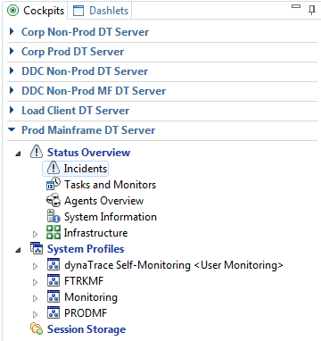

Select the appropriate system profile per your environment and the appropriate timeframe

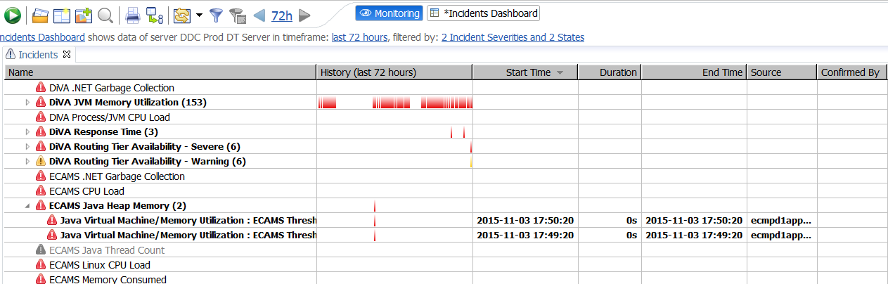

Which Dashboard do I open?

There are many dashboards and views to view trending on these incidents/alerts; however, here is an easy process to decide which dashboard to open.

Which application is it?

Is the metric a host/process metrics?

* Host and Process Metrics can be found in the Host Health Overview Dashboard for that application

Is the metric named one of the following? – Response Time Degraded, Response Time Degraded for Slow Requests, or Failure Rate Too High

* These metrics are all visible in the Application Overview Dashboard

All other metrics are available in an AvgRT, Overview, or Custom Dashboard per application.

# Application Health – Monitoring Overview

The Monitoring Overview Dashboard is the starting point to analyze the performance of applications in a specific System Profile.

Accessing the Monitoring Dashboard

Click the  button (with the eye) on the top right of the Dynatrace Client.

Once selected, a blue drop down  in the top left corner of the Dynatrace Client will appear. From here you can select which *system profile* you would like to view.

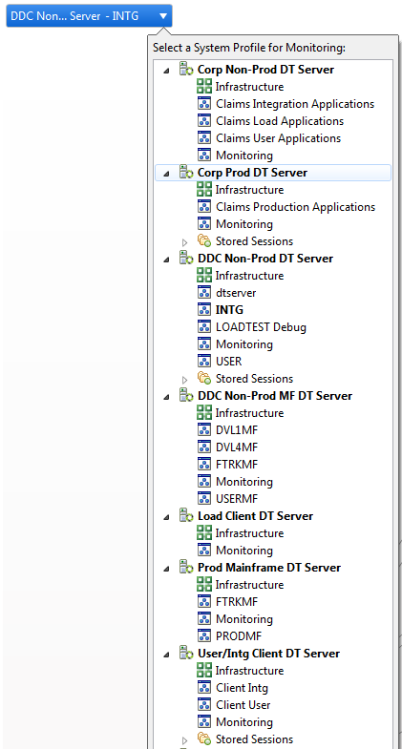

The selected System Profile’s name will appear on the blue drop down.

The *system profiles* are logical splits of the environments and applications on a Dynatrace server.

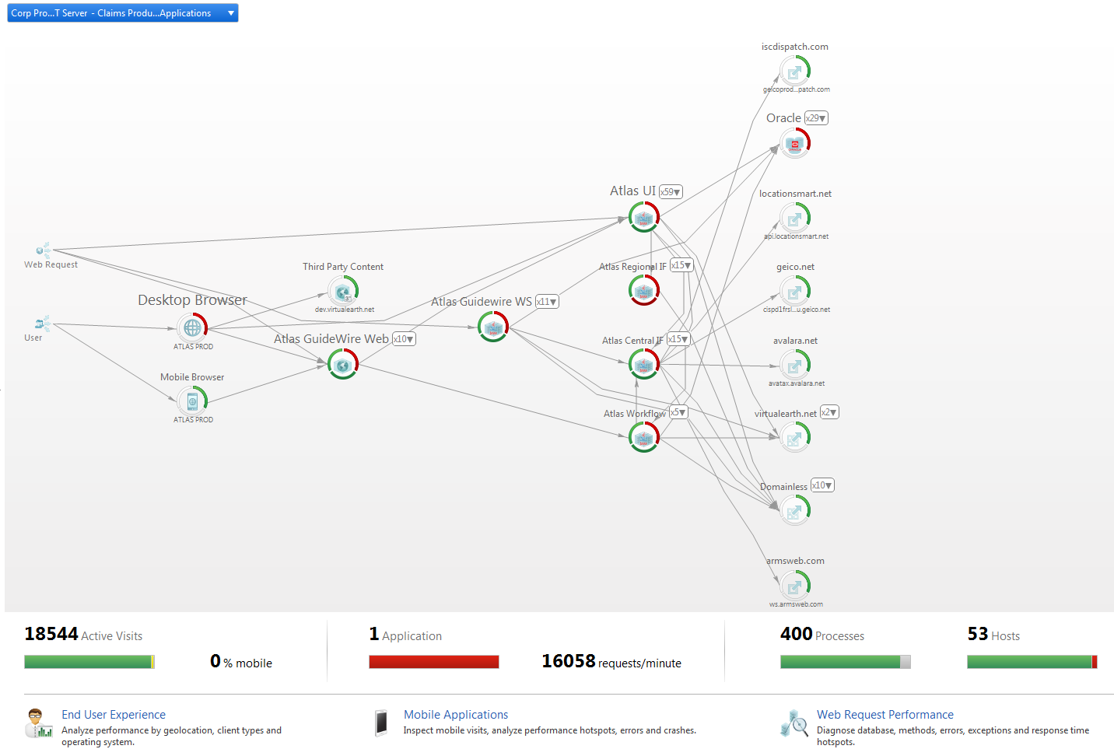

Monitoring Overview Dashboard

Transaction Flow Intro

The Monitoring Overview embeds a Transaction Flow Dashlet (a piece of a dashboard) to show an overview of your environment featuring OMNI-channel (the main entry points grouped by channel (client types) and application), Agent Groups, databases, and external services.

Note: The Transaction Flow embedded in the Monitoring Overview Dashboard is optimized for quick data access and for app monitoring across an entire system profile. For viewing only your application, advanced analysis and to access all drill down options, use the Transaction Flow Dashlet in your application’s General Dashboard.

Key Performance Indicators

The KPI sections below the Transaction Flow link to separate views that provide more detail about each monitored aspect.

Visits

A visit is a group of actions created with the first user action and ends after the user is inactive for a specified period of time.

The Visit section shows the currently active visits for live sessions or finished visits for stored sessions and their User Experience Index (Satisfied, Tolerating or Frustrated). For a detailed explanation of these categories see User Experience Management.

Applications

The Application section shows the selected System Profile's applications and their health states (OK, Critical or Not Connected) and the total requests per minute of all applications.

Processes and Hosts

The Processes and Hosts section shows the selected environment's health state (OK, Critical or Not Connected).

Dashboard Links

End User Experience

Provides detailed information about end user performance, aggregated by geo-location, client type and operating system.

Mobile Applications

Provides detailed information about mobile visits, performance hotspots, errors, and crashes.

Web Request Performance

Provides detailed information about databases, methods, errors, exceptions, and response time hotspots.

# Application Health – Application Overview

The Application Overview Dashboard lists your system's applications, sorted by relevance. For each application, it displays the current status and the history within the selected timeframe.

Accessing the Application Overview

Click the  button (with the eye) on the top right of the Dynatrace Client.

Use the drop-down list  to switch to the system profile for your environment/application.

Click Application in the KPI section of the Monitoring Dashboard.



Application Filter

The application filter can be used to show only applications of interest. You can define filters according to the health state of the applications. As the figure below shows, you can select a tab labeled for each health state to display data for the applications that are in that state. You can also use the search box to filter for applications with names that contain the search string.



Application Name and Details

Click the application name or the Application Details button, as shown in the figure, to open the Application Details dashlet.

Opening the Application Details Dashlet

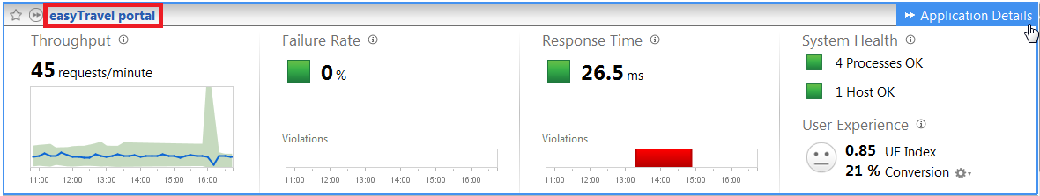

Application Favorite

You can mark applications as favorite by toggling the favorite star to the left of the application name. Your favorite applications are listed above the other applications. This feature is especially useful to keep an eye on important applications.

Favorite Icon

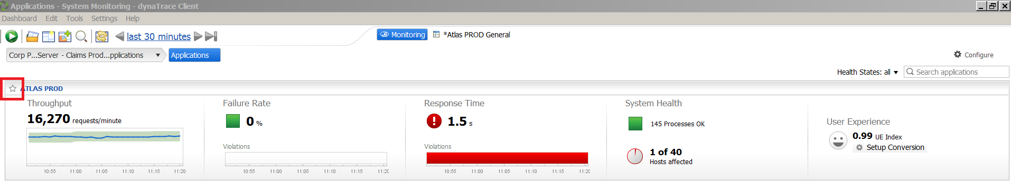

This feature is user-specific. Each user Dynatrace can define different favorite applications. Other users are not affected by your favorites.

Violation Indicators

A Violation Indicator shows where there are current baseline violations for the measurement for at least one Business Transaction of the application.

|  |  |
| --- | --- |
| https://community.dynatrace.com/community/download/attachments/196642825/Led_Red_36x36.png?version=1&modificationDate=1341390896353&api=v2 | There are violating Business Transactions. |
| https://community.dynatrace.com/community/download/attachments/196642825/Led_Green_36x36.png?version=1&modificationDate=1341390882930&api=v2 | Everything is OK. |

Violation Histories

The violation history shows all violations and their duration in the currently selected timeframe. Violations are marked red in the timeline.



Throughput

The chart shows the throughputcount (requests per minute) as line graph (blue) and the expected range (green), based on the data for the last week.

Throughput Chart

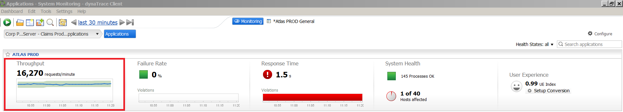

Failure Rate

The failure rate is the average percentage of failed requests. A violation is indicated if at least one Business Transaction currently produces more failures than expected, based on the data for the last week.

Failure Rate Chart

Failure Rate Chart

Response Time

The response time charted in the Application Overview is the median response time of current requests.

Response Time Chart

Response Time Chart

A violation is indicated if the median response time or the response time of the slowest 10% of requests is higher than expected for at least one Business Transaction.

For details on how the expected baselines of Throughput, Failure Rate and Response time are calculated, please visit:

<https://community.dynatrace.com/community/display/DOCDT62/Baseline+and+Smart+Alerting+Explained>

System Health

The System Health section shows the status of running processes for the application. Processes are affected if they are unhealthy or are running on unhealthy hosts.

System Health Indicators

System Health Indicators

The **Processes** and **Host** health indicator icons can display four states:

* Green – OK
* Red – Unhealthy
* Affected percentage
* Grey – N/A

Affected processes are either unhealthy on their own or are running on an unhealthy host.

Hover over an icon to display information about affected processes and hosts.

Click the link in the icon's hover popup for detailed information on the affected processes and hosts.

Transaction Details

By clicking on one of the Business Transactions (Web Requests and User Actions), trending and details of the transactional health are visible.

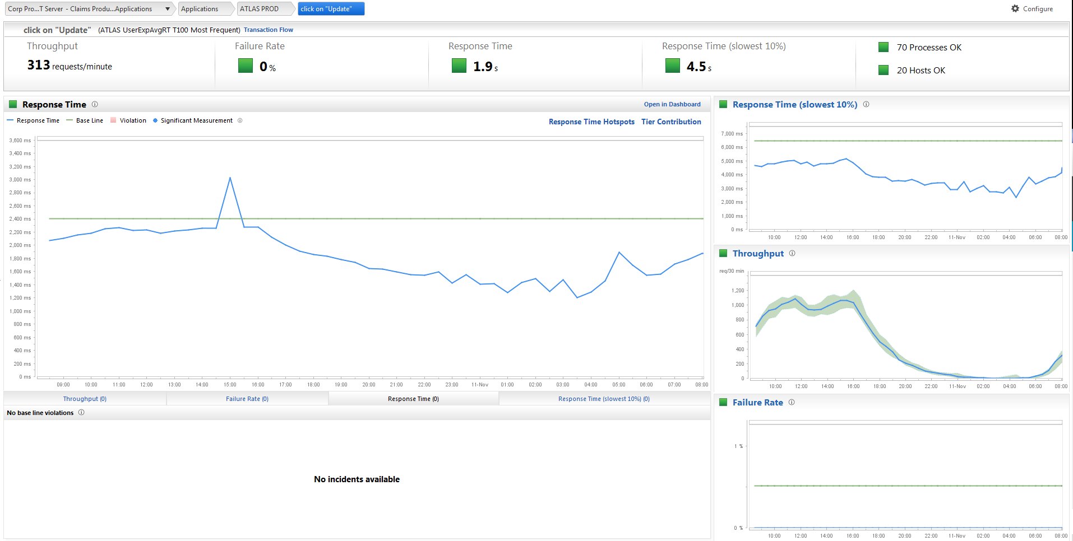

# Application Health – avg Rt Dashboard

The AvgRT (Average Response Time) dashboard provides a quick overview of application health. This dashboard highlights the overall average response time and number of transactions as well as the host health and process health.

Many applications have either a customized AvgRT dashboard or separate overview or custom dashboards.

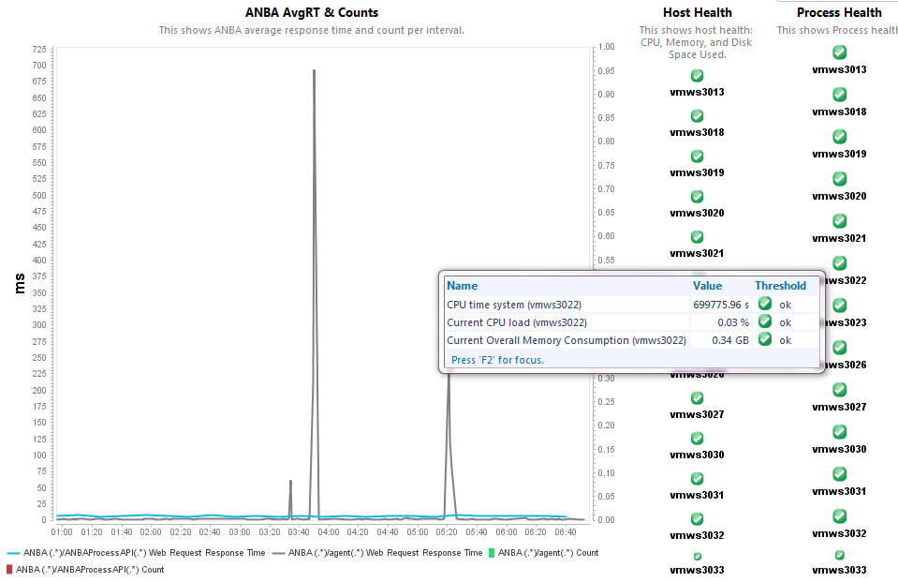

Tip: Hovering over charts in Dynatrace provides insight into the metrics charted, as seen above.

Accessing the AvgRT Dashboard:

Click Dashboard menu in the Dynatrace Client and select open.

Choose the appropriate Dynatrace server for your application/environment on the left side of

the pop up.

In the dashboards window, type the name of the application to quickly filter.

Locate and select the Application’s AvgRT dashboard and click open.

# Application Health – General Dashboard

The General Dashboard provides deep level transactional data for an application. Many of the dashlets will be learned in future training, however, the Transaction Flow that is found here is a good transactional health overview.

Note: The General Dashboard contains very granular data. Due to this, opening shorter periods of time is highly recommended to reduce loading times and Dynatrace limits the number of transactions analyzed at one time.

Accessing the General Dashboard:

Click Dashboard menu in the Dynatrace Client and select open.

Choose the appropriate Dynatrace server for your application/environment on the left side of

the pop up.

In the dashboards window, type the name of the application to quickly filter.

Locate and select the Application’s General dashboard and click open.

Transaction Flow

The Transaction Flow Dashlet highlights the transactional health of an application in an easy to view topology diagram. This diagram is organized my Agent Groups (logical portions or tiers of an application).

From a high level, we only see the health of each tier or Agent group.

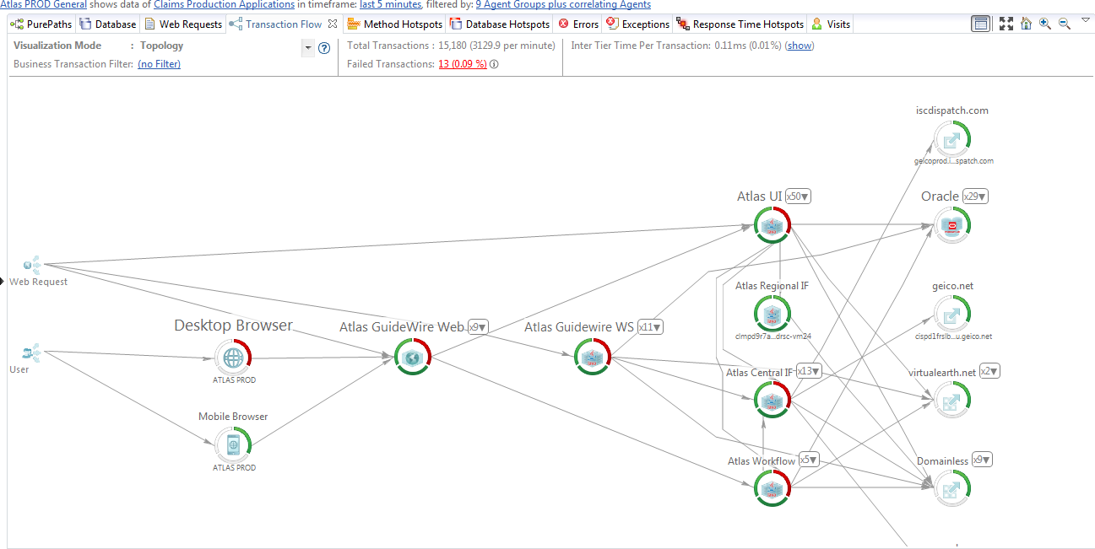

When zooming in, more details and metrics are available and clicking on the agent groups gives visibility to the individual agents (processes or JVMs).

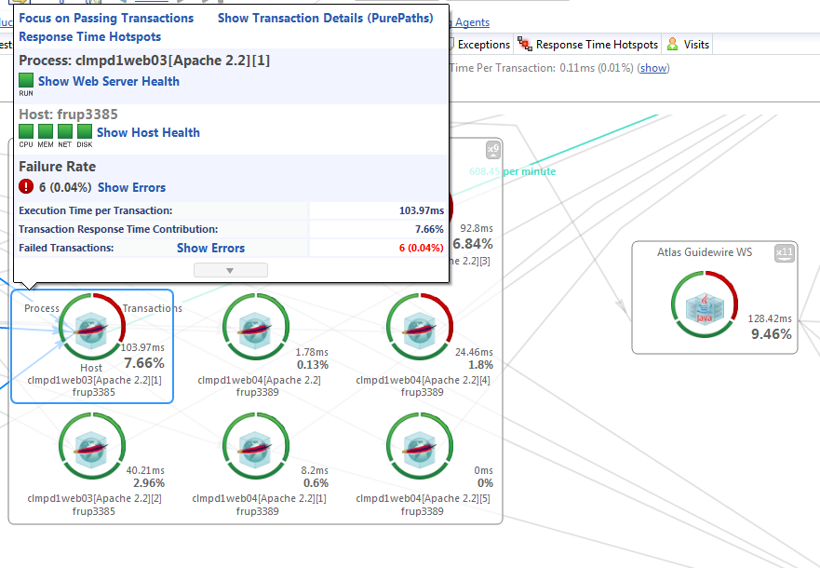

The circles around the agent (process or JVM), shows the health of the Processes, Host, or passing Transactions. The Process and host metrics are defaulted on the same criteria as the Host Health Overview.

The Transactional Health is measured on failure rate/errors on that portion of the application.

The percentage next to the hosts represents the response time contribution of that process for the entire application over the selected time frame.

More details and drill downs from the Transaction Flow will be covered in future training; however, you may see the following link for more information:

https://community.dynatrace.com/community/display/DOCDT62/Transaction+Flow

# Host Health – Host Health Dashboard

The Host Health Overview dashboard provides insight into the host metrics including: CPU, Memory, Network Utilization, Disk usage, and Process resource consumption.

Clicking on the host name on the left side of the screen opens the charts for the data for that host.

The status colors in Host Health dashboard are based on Dynatrace defaults and cannot be changed. To gain insight into what the violation is based on, hover over the green or red squares on the dashboard as seen below.

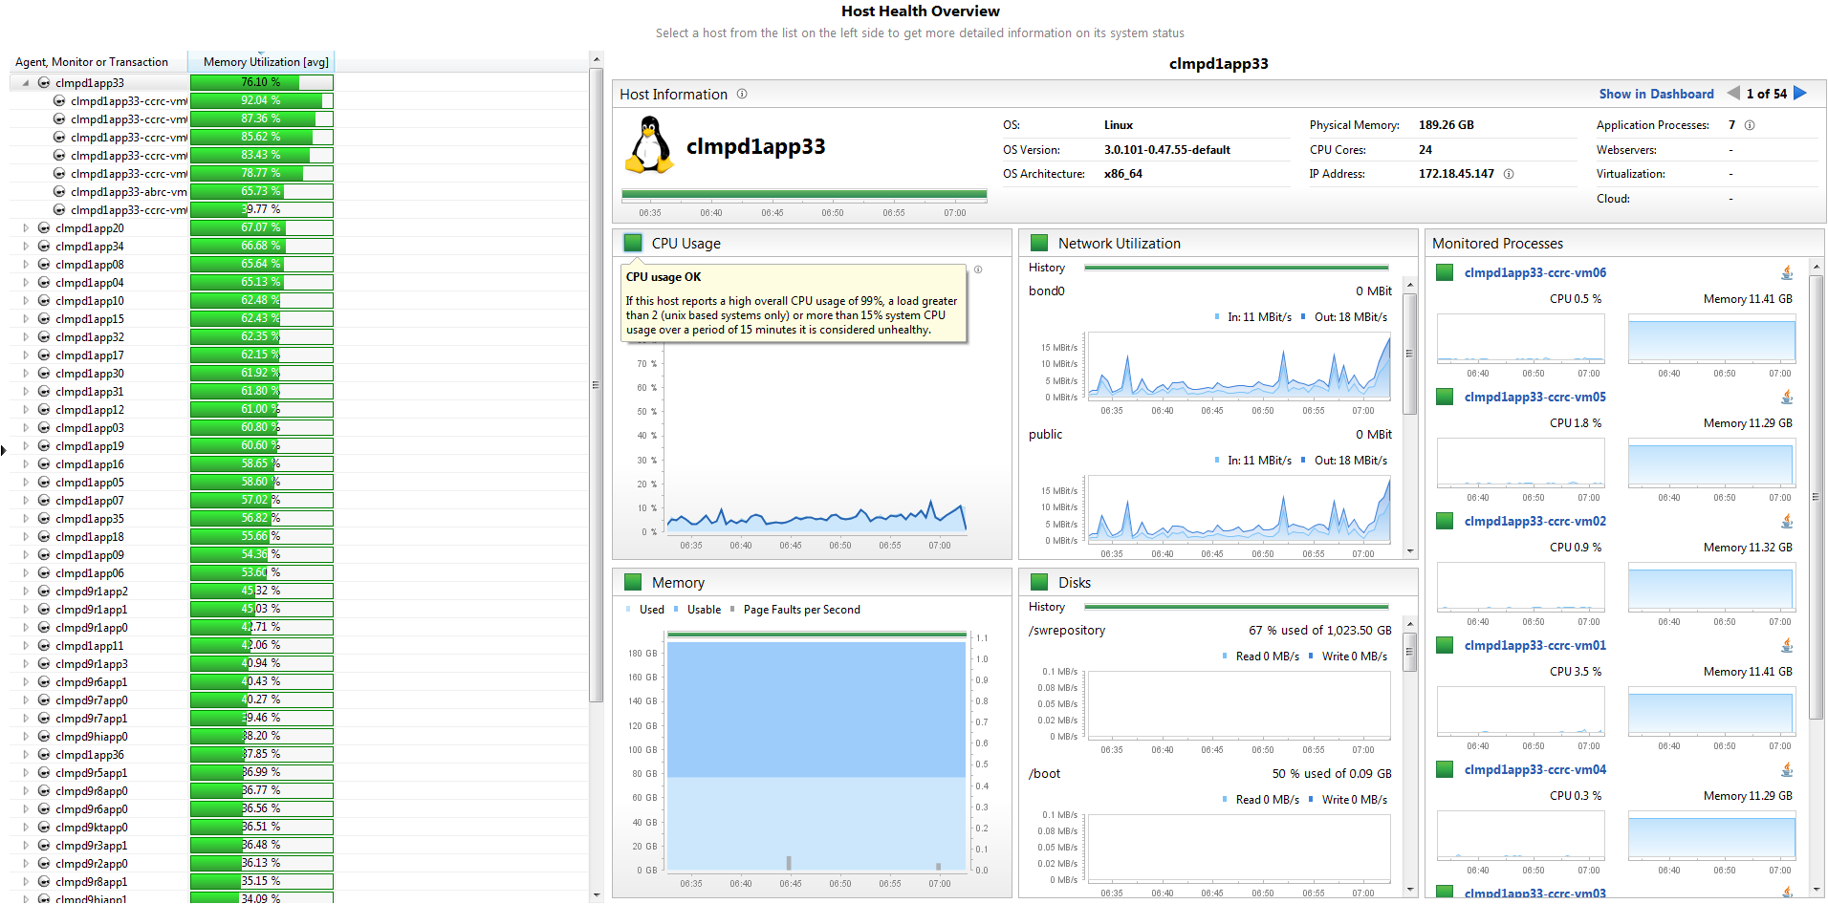

Accessing the Host Health Dashboard:

Click Dashboard menu in the Dynatrace Client and select open.

Choose the appropriate Dynatrace server for your application/environment on the left side of

the pop up.

In the dashboards window, type the name of the application to quickly filter.

Locate and select the Application’s Host Health dashboard and click open.

# Host Health – Process Dashboard

The process dashboards provide valuable insight into process health including memory utilization, garbage collection time, number of passing transactions, uptime, and thread count.

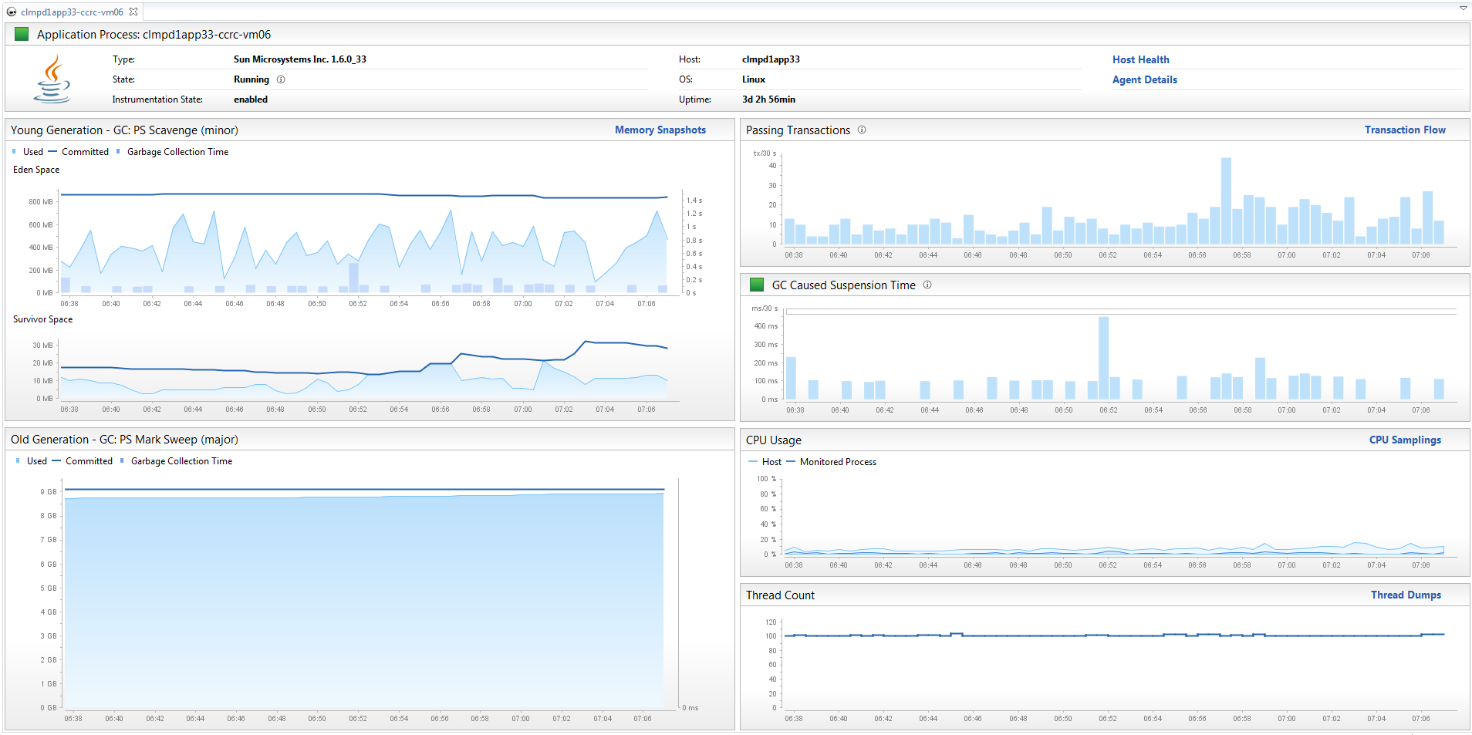

Opening Process Health Dashboard:

The Process Health dashboard is an ad-hoc dashboard and can be opened from a few locations.

Clicking on the process name on the right side of the Host Health Dashboard will open the corresponding Process Health.

Hovering over the process in the Transaction Flow will give the user an option to Show Application Process, which opens the corresponding Process Health.

