Kay Royo

GEOG 225

October 31, 2018

Birds Lab

Introduction

There are variety of endangered bird species that are native to the Hawaiian Islands such as the honeycreepers and akepa. The Hawaiian akepa is placed in the genus *Loxops* while the honeycreeper is closely related to the rosefinches in the genus *Carpodacus*. The honeycreepers and akepa both evolved into a diverse range of species and subspecies over time. There were a total of 71 taxa of endemic Hawaiian birds recorded and 23 of them are now extinct while 30 are considered as endangered by the US Fish and Wildlife Service. Both of the Hawaiian honeycreepers and akepa are considered endangered by the International Union for the Conservation of Nature (IUCN). The decreasing number of Hawaiian bird species is due to variety of factors such as habitat loss, presence of predators, exposure to diseases, and competition with other species. However, biologists determined that habitat loss and diseases are the main reasons behind the decline in endemic Hawaiian bird species such as the honeycreepers and akepa. There are numerous observations that support the presence of avian diseases such pox and malaria being the cause of the endangerment of the honeycreepers and akepa. One of the important observations shows that pox and malaria are present in wetlands between 3,000 feet and 5,000 feet elevation that overlap with the habitat of honeycreepers and akepa. The purpose of this lab is to show the location of the endangered habitat for the honeycreeper and akepa due to avian diseases on a map.

Geoprocessing Methods

1. Select Big Island using “Select” tool then create layer from selected feature
2. Clip Akepa layer to Big Island
3. Clip Creeper layer to Big Island
4. Clip wetlands layer to Big Island
5. Clip contours layer to Big Island
6. Create layer from 3000 ft. contour
7. Create layer from 5000 ft. contour
8. Use “Erase” tool to erase 5000 polygon from 3000 polygon and create target elevation layer
9. Buffer wetlands to 50 meter
10. Buffer Akepa to 150 meter
11. Buffer Creeper to 150 meter
12. Clip 3 buffered wetlands (mosquitos) to elevation polygon
13. Intersect dangerous mosquitos with the buffered Akepa
14. Intersect dangerous mosquitos with the buffered Creeper
15. Add hillshade background on maps

Methods Flowchart

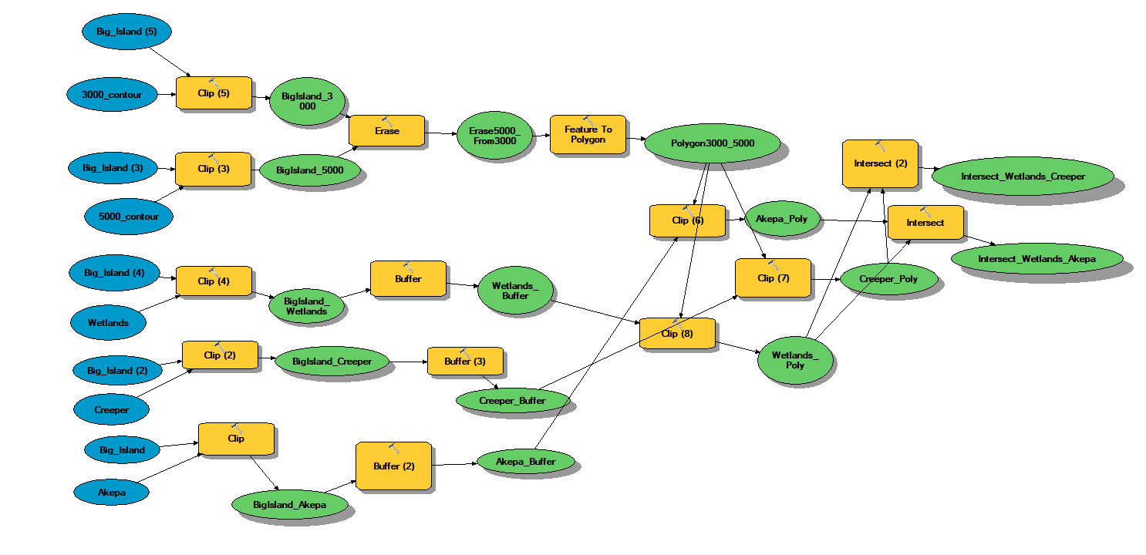

Final Map

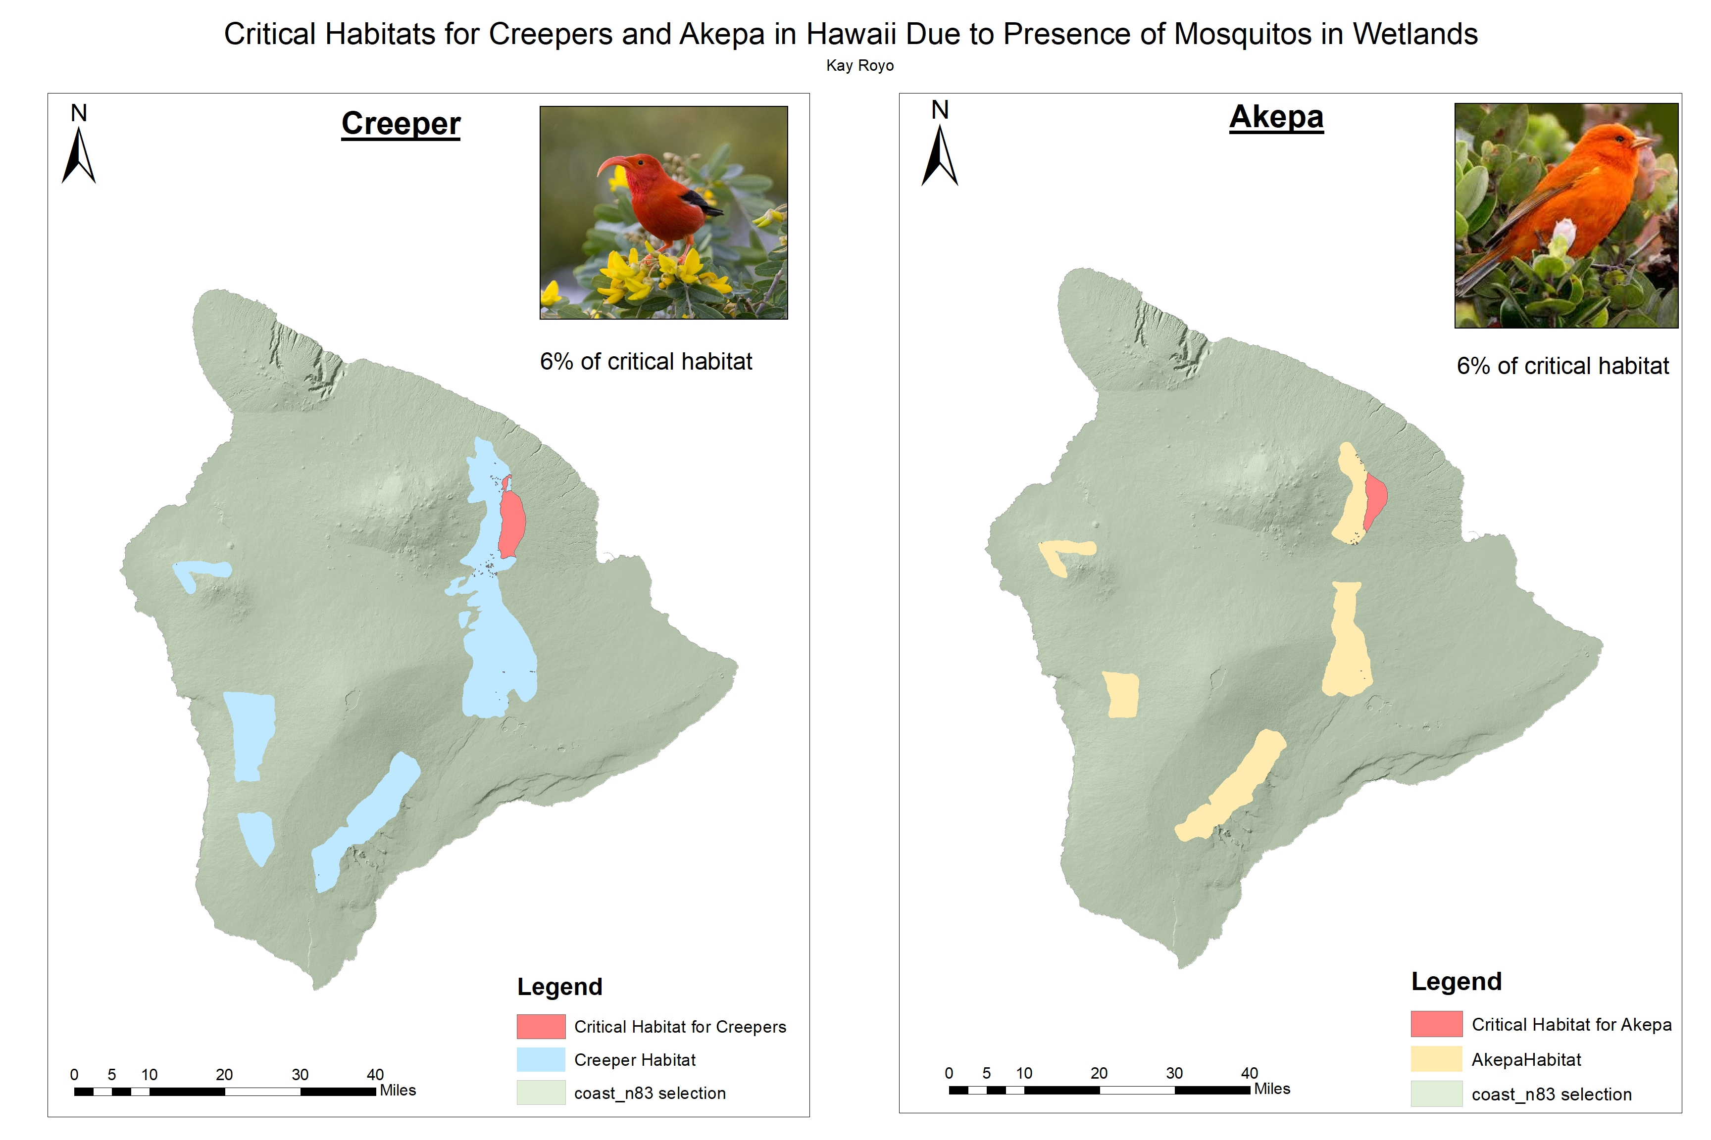

Conclusion

Based on the final map shown above, six percent of the overall distribution of the honeycreepers and akepa in Hawaii overlaps with the wetlands dominated by mosquitos that means these areas are the endangered habitats for both the akepa and honeycreepers. It is evident that the endangered habitats for the honeycreepers and akepa are highly related due to their occurrence in the northeastern part of the island.