My Cars Solutions

User Manual

Common functionalities:

# 1. Search

* After visiting [https://mycarsolutions.net](https://mycarsolutions.net/) click on the Search Bar
* The Search Bar allows you to search for vehicles and accessories across the entire collection and displays the searched items in a new page.

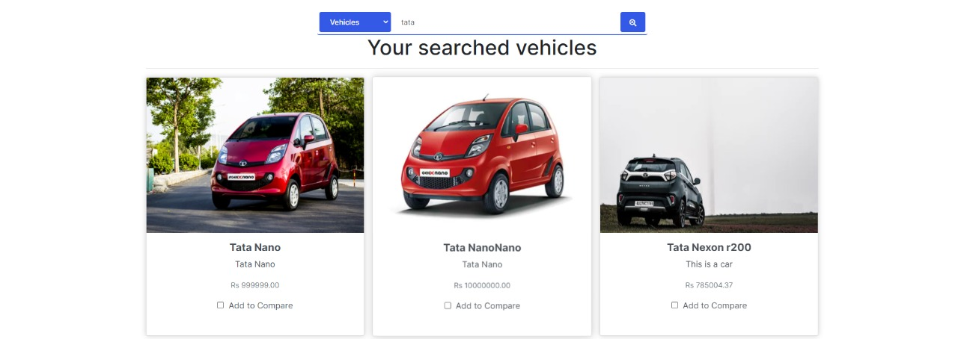

# 2. Advance Search

* After visiting [https://mycarsolutions.net](https://mycarsolutions.net/) click on the Advance Search Button.
* The Advance Search Bar allows you to search for vehicles and accessories by using various filters provided in the advanced search page and displays the searched items in a new page.

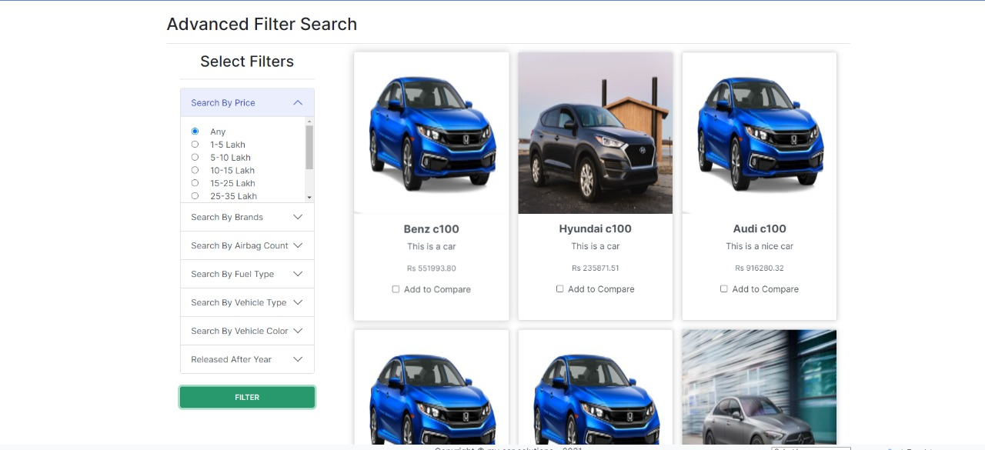

# 3. Vehicle Comparison

* The Vehicle comparison feature allows you to select multiple vehicles (maximum 4) and compare with respect to various features.
* This Comparison can be saved for further reference and can be downloaded too.

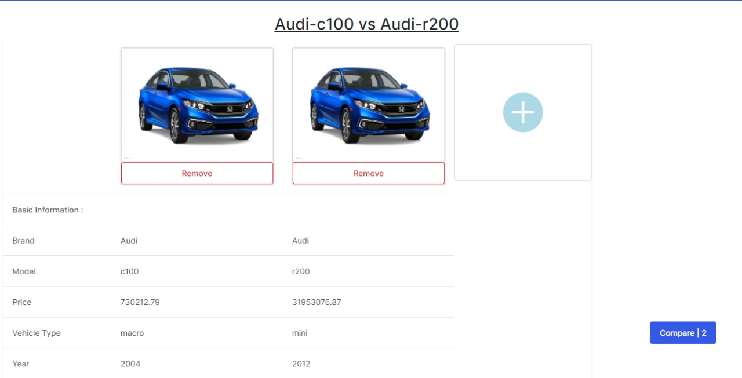

# 4. Vehicle Details

* After visiting [https://mycarsolutions.net](https://mycarsolutions.net/) , a particular vehicle can be selected from the carousel of vehicles.
* After selecting a particular vehicle, all it’s details are displayed in a new page..

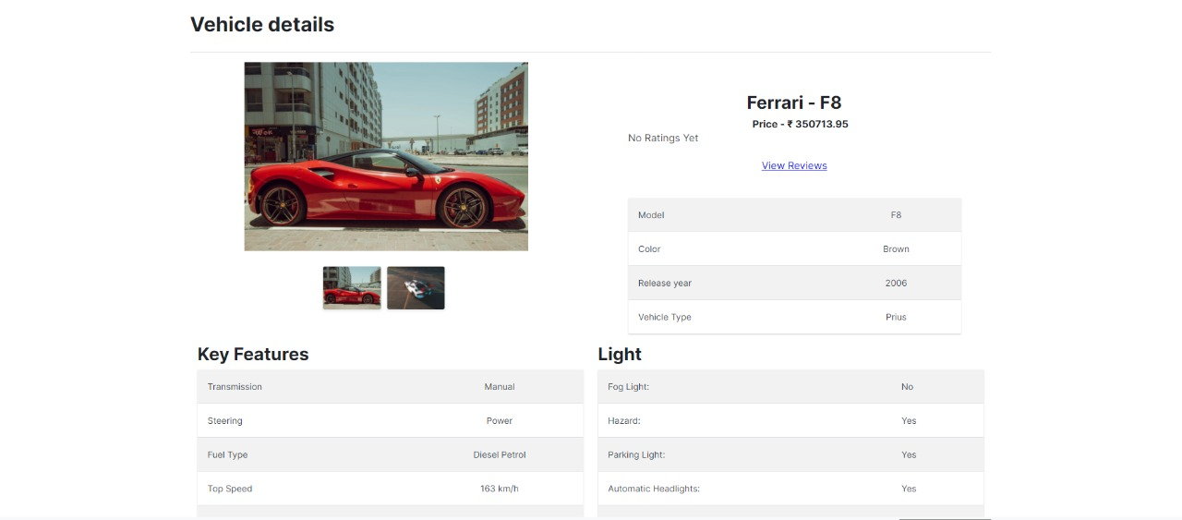

## 4.1 Rating

The Rating for the selected vehicle is displayed in Vehicle Details.

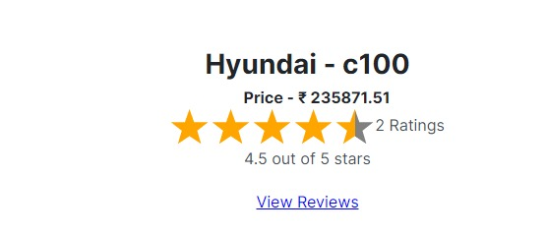

## 4.2 Review

The Reviews for the selected vehicle are displayed in Vehicle Details.

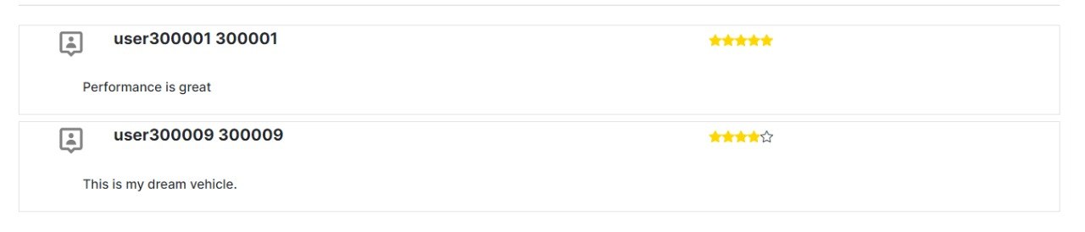

Customer Manual:

# 1.Registration

* After Visiting [https://mycarsolutions.net](https://mycarsolutions.net/) go to Registration page from navigation bar at top right corner by clicking on Register button.
* Now to Register as a Customer fill your details and select user type as a customer.

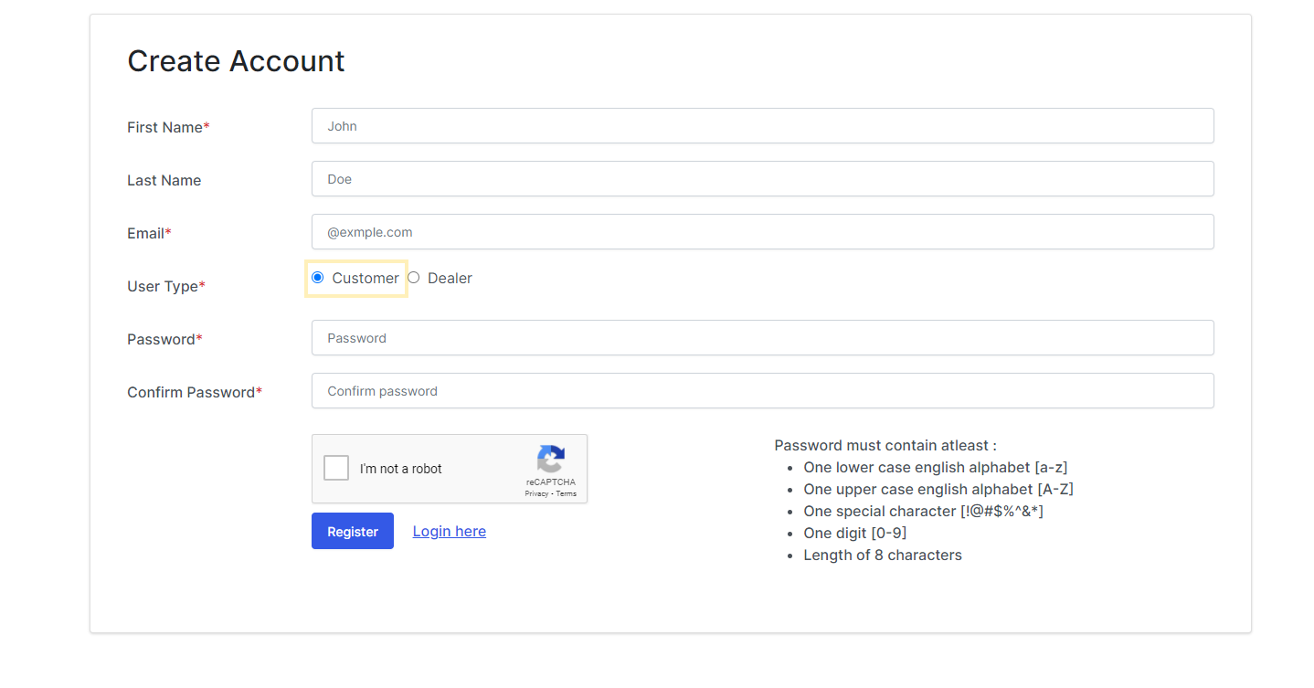

* An email will be sent to your registered email , Check both inbox and spam and click on the link, you will be redirected login page after you are verified.

# 2.Login

* You can go to login page by clicking on Login button that will be present on the right corner of the navigation bar.
* Enter you credentials and login , you will be redirected to customer’s dashboard.

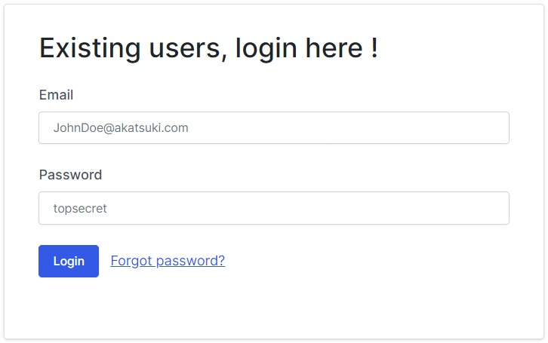

# 3.Dashboard

* Your dashboard will look like this image below , that will have all your functionalities on the left margin.

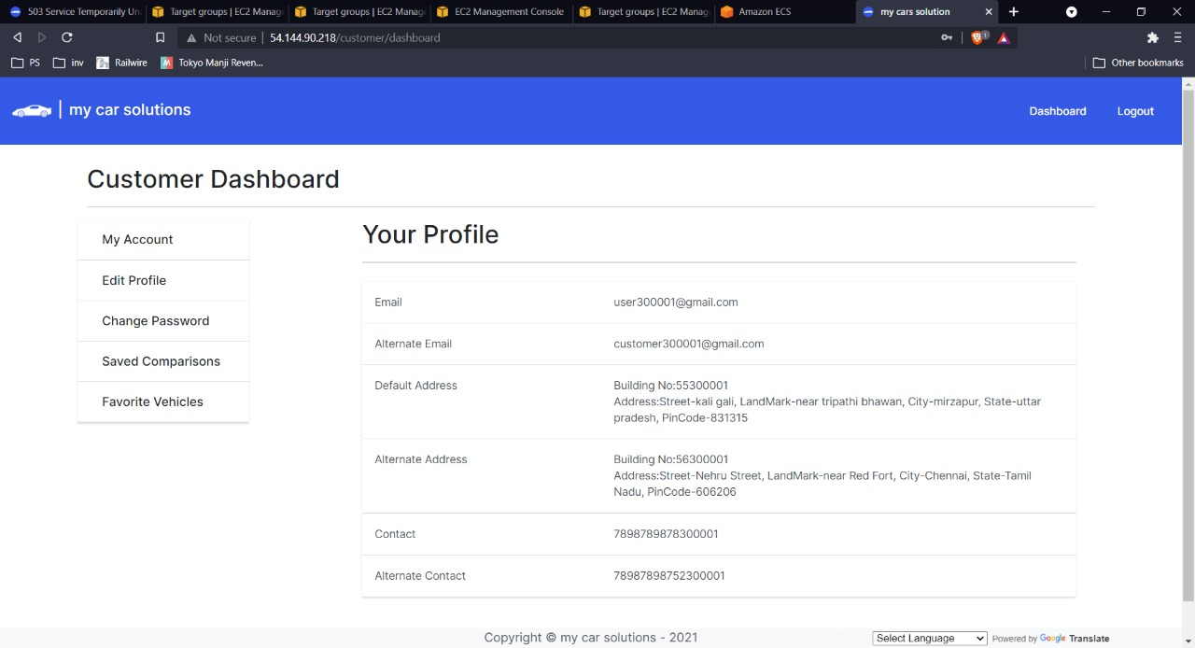

## 3.1 My Account

* In My account , you will see your profile details.



## 3.2 Edit Profile:

* Click on the Edit Profile link on left side of your dashboard.
* In Edit Profile page, you will see text box for each profile detail e.g., address ,alternate address,etc where you can edit these text box to update you details.

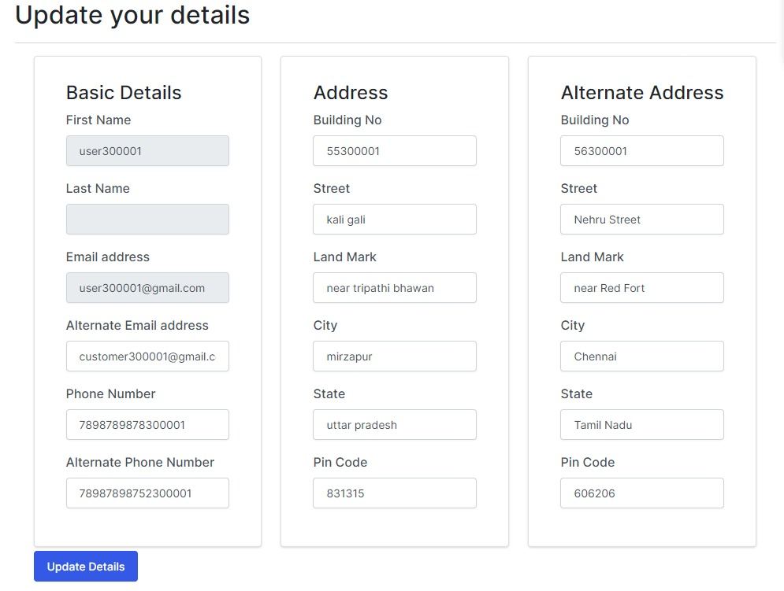

* After clicking on update Details button that will update your Profile Details.

## 3.3 Change Password

* You can change your password using change password option on the dashboard.
* Your password must contain at least one digit and one uppercase and one lowercase letter and one special character, and at least 8 or more characters.

## 3.4 Saved Comparison

* Click on the Saved Comparison link on left side of your dashboard.
* Here you will see a list of all comparisons that you saved.
* Each list item consist its id, name of comparison, date of creation, number of vehicles,Delete Button and a Download button.
* After clicking Download button, a CSV file will be downloaded in your device which contains the vehicle comparisons.

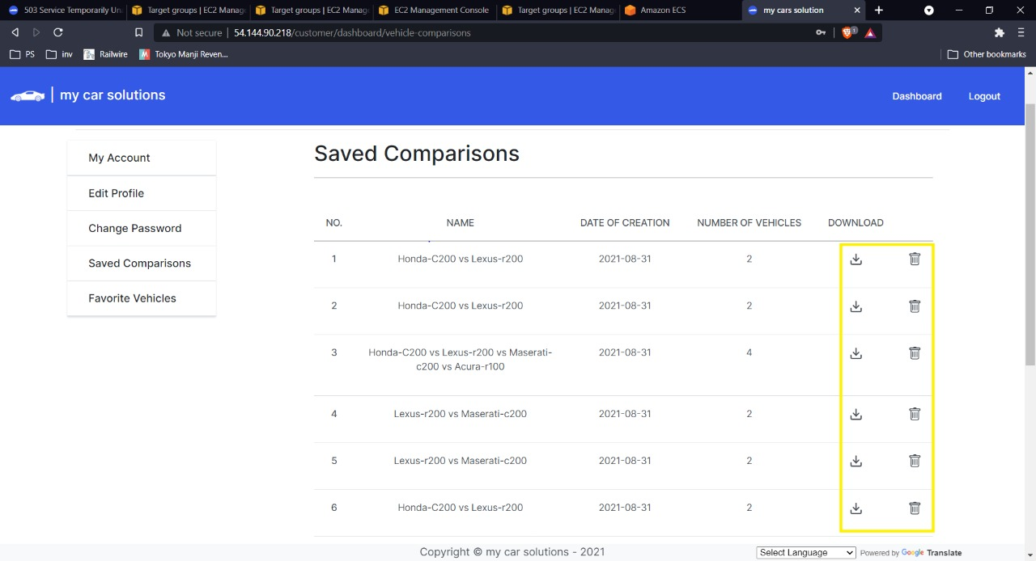

* After clicking on Delete button, that comparison will going to be deleted from your saved comparison list.

## 3.5 Favorite Vehicles

* Click on the Favorite Vehicles link on left side of your dashboard.
* Here, all vehicles which you added as favorite is going to be shown in card format.
* You can click on these cards to redirect to the Vehicle detail page for that vehicle.

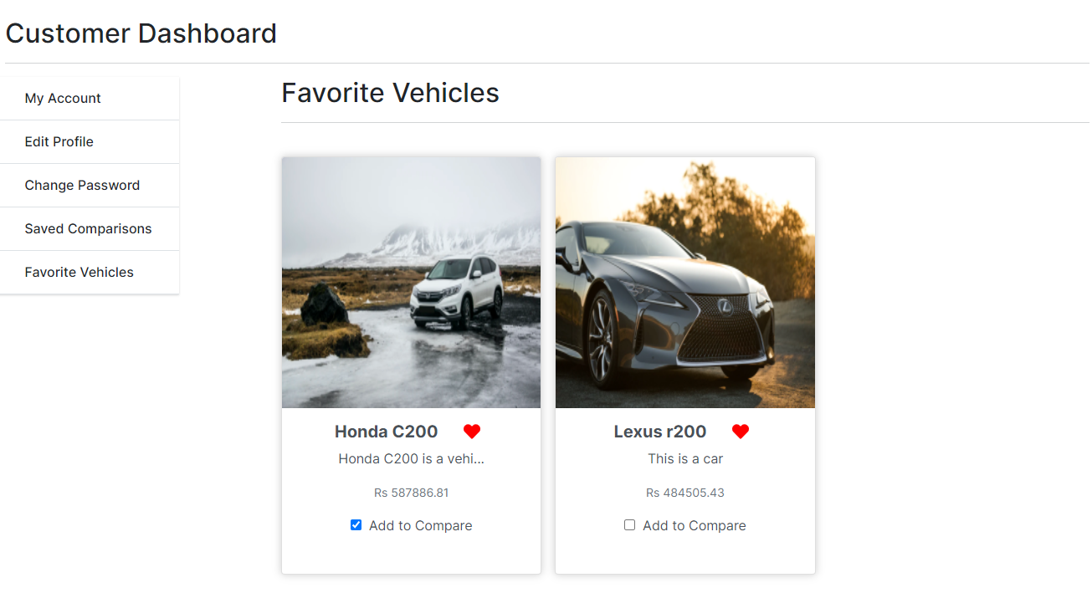

# 4.Home Page.

## 4.1 Adding Favorite vehicles

* You will see a heart icon on every vehicle card.
* If you click on this icon, it will be added into your favorite vehicles list.
* You can see them in My Favorite page in Dashboard.

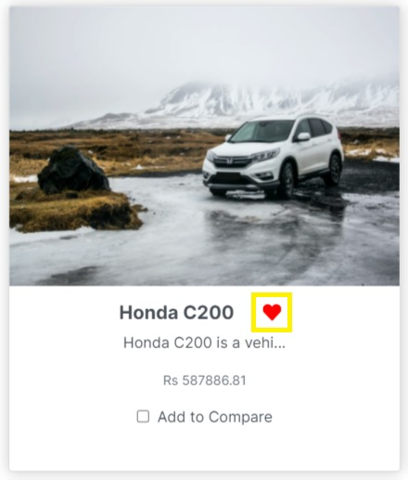

## 4.2 Adding For Vehicles Comparison

* You will see a add to compare check box on every vehicle card.
* If you click on this check box, it will be added into your comparison page.
* At most you can add 4 vehicles to comparison matrix.
* You will see a compare button in right bottom corner with a counter of no of vehicles you added .if you click this button you will be redirected to comparison page.

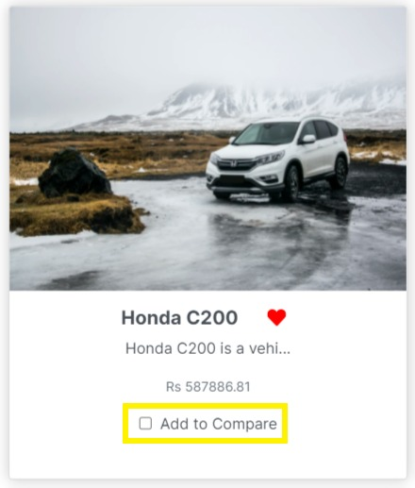

# 5. Vehicles Detail Page.

## 5.1 Rating.

* You will see a Rating title in right bottom corner with 5 star and a submit button.
* Here you can click on any star to give rating on the scale of 5(1 is lowest and 5 is highest).
* After clicking on star, click on submit button to save this rating
* if you come again to this page later, your rating will going to shown in these stars.

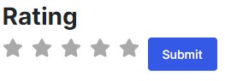

## 5.2 Review.

* You will see a Review title in left bottom corner with a large text box and a submit review button.
* Here you can write your review about that vehicle.
* After giving review, click on submit review button to save this review
* if you come again to this page later, your review will going to shown in the text box.

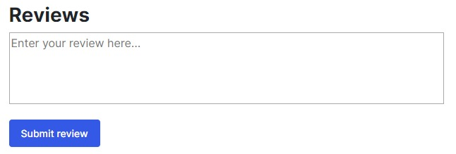

# 5. Vehicle Comparison Page:

## 5.1 Save Comparison Button:

* If you click on this Button, your current comparison will be saved with the name same as the title of you current comparison.
* You can see these comparison later in My Comparison page in your Dashboard.

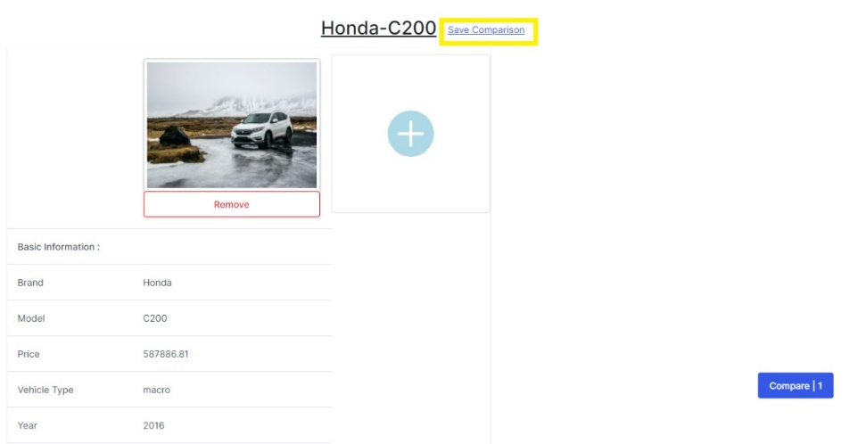

Dealer Manual:

# 1.Registration

* After Visiting [https://mycarsolutions.net](https://mycarsolutions.net/) go to Registration page from navigation bar at top right corner by clicking on Register button.
* Now to Register as a dealer fill your details and select user type as a dealer.

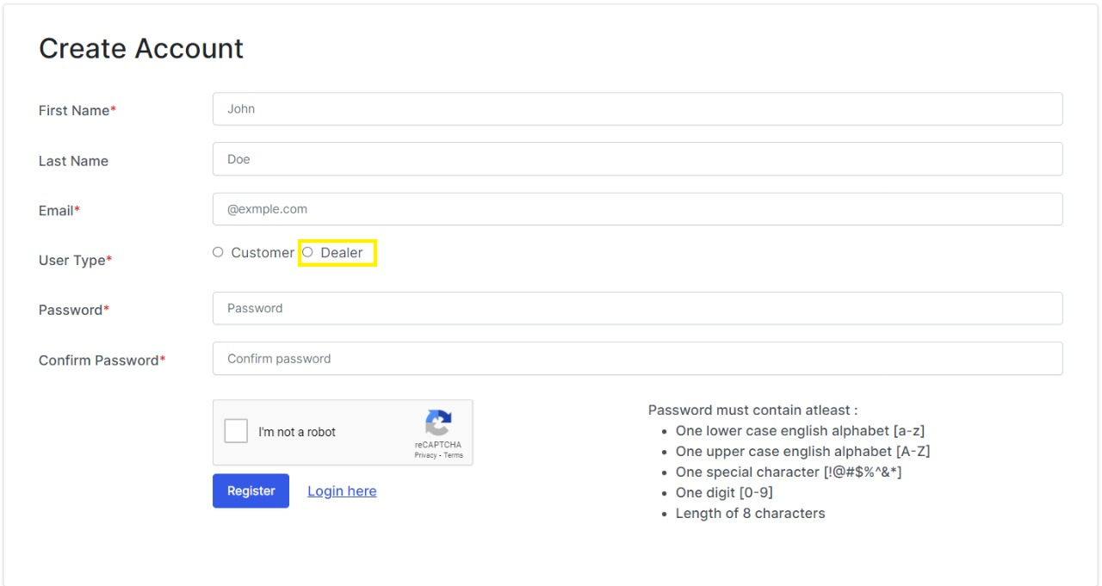

* An email will be sent to your registered email , Check both inbox and spam and click on the link, you will be redirected login page after you are verified.

# 2.Login

* You can go to login page by clicking on Login button that will be present on the right corner of the navigation bar.
* Enter you credentials and login , you will be redirected to dealer’s dashboard.



# 3.Dashboard

* Your dashboard will look like this image below , that will have all your functionalities on the left margin.

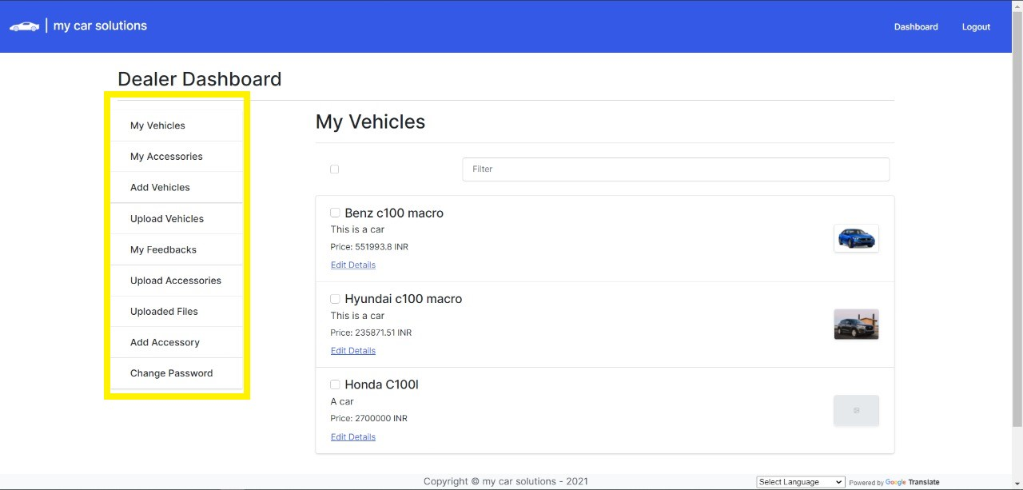

## 3.1 My Vehicles

In My vehicles , you will see all the vehicles that are uploaded by you.

### 3.1.1 Edit Vehicle Details:

* Each vehicle will have the option edit and the edit link will looks like the image given below.

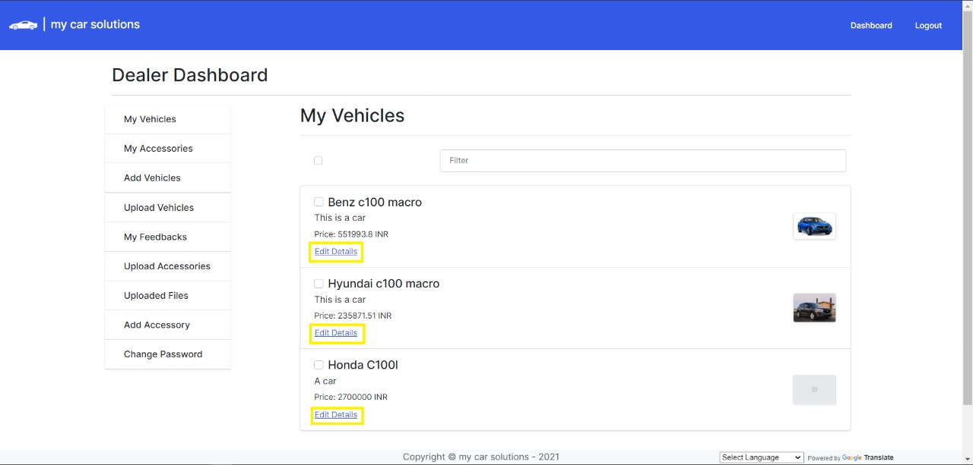

* After clicking on edit details link , you will be redirected to an edit details page , there you will have the option to edit all the attributes of your vehicle

### 3.1.2 Delete Vehicles/Download

* You can select the specific vehicles that you want to delete or download according to your needs.
* The download will give the vehicle’s information in CSV format.

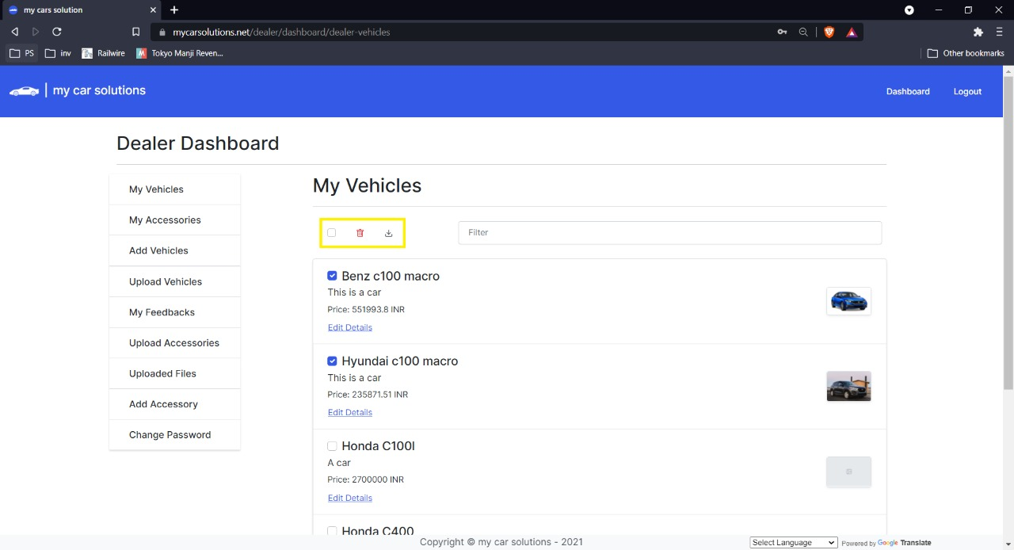

## 3.2 My Accessories

In My Accessories , you will see all the accessories that are uploaded by you.

### 3.2.1 Edit Accessories/Delete Accessories

* Each accessories will have option edit/delete accessories and it will looks like the image given below.

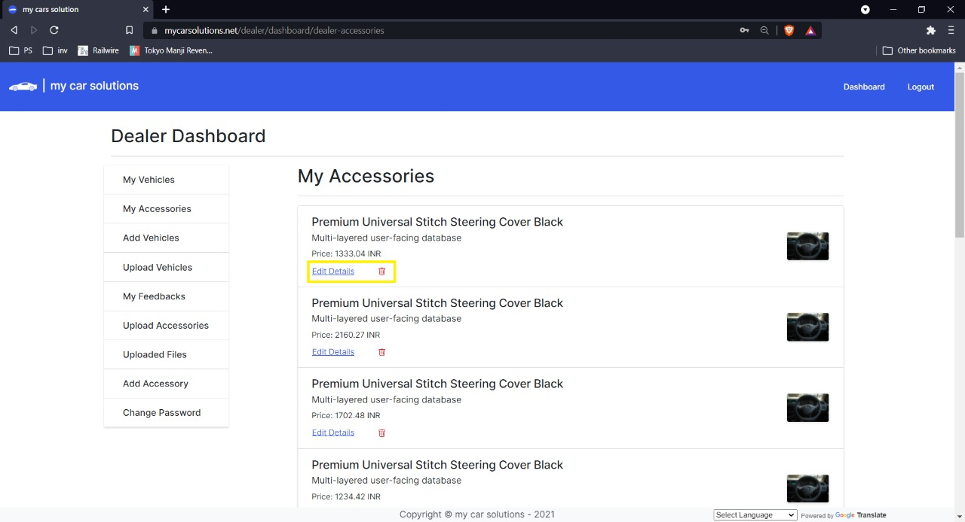

* After Clicking on Edit you will be redirected to an edit accessory page that will have the option to edit all the attributes of your accessory.

## 3.3 Add Vehicle

* After Clicking on Add Vehicle button that is present on the left margin of your dashboard , You will be redirected to Add New Vehicle Page that will look like the image below.

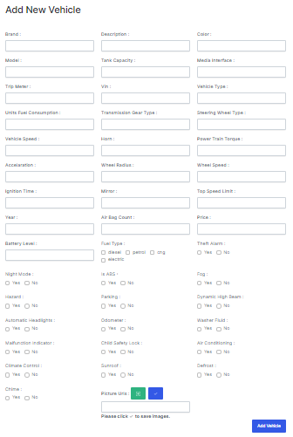

* You need to enter the details of your vehicle according to the image above.

## 3.4 Upload Vehicles(CSV Format)

* After clicking on the upload vehicles button on the dashboard you will be redirected to upload vehicles page that will look like the image below.

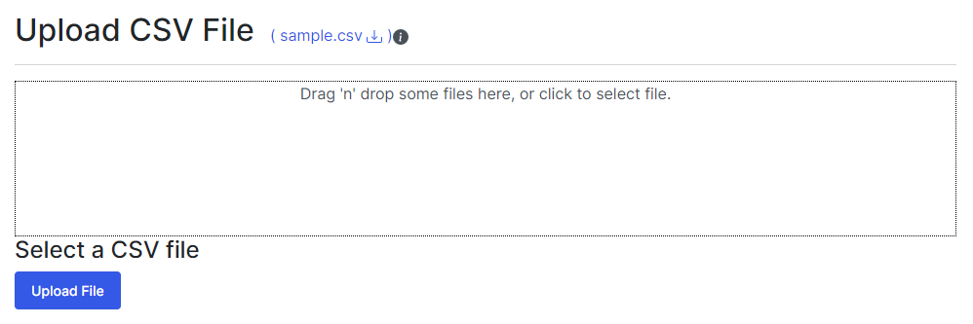

* You need to click within the box or click on upload button and then you can select your csv file that has your vehicle details.
* In CSV file your vehicle detail should follow these predefined format.

(tankCapacity,mediaInterface,theftAlarm,pictureUrls,tripMeter,airBagCount,description,price,color,vin,brand,model,year,vehicleType,fuelType,unitsFuelConsumption,transmissionGearType,steeringWheelType,vehicleSpeed,horn,powerTrainTorque,accelaration,nightMode,isABS,wheelRadius,wheelSpeed,light("fog, "hazard", "parking, "dynamicHighBeam", "automaticHeadlights":),ignitionTime,odometer,washerFluid,malfunctionIndicator,batteryLevel,airConditioning,languageConfiguration,mirror,childSafetyLock,topSpeedLimit,climate( "climateControl","sunroof","defros),chime)

* You can download sample.csv for reference.
* Note for uploading vehicles.

* If the vehicleid is already present , it will update the data. If not , it will store the data.  
* All this data should be in a predefined attributes.  
* For arrays , the format will be "[abc , ...]".  
* For objects , the format will be "abc , ...".  
* 'vin' should be unique for all the documents.`

## 3.5 My Feedbacks

* In My Feedbacks , you can see the review that are given by the customers for the vehicles that you uploaded.

## 3.6 Upload Accessories(JSON Format)

* After clicking on Upload Accessories button on the right margin of the dashboard , you will be redirected to upload accessories page that will look like the image below.

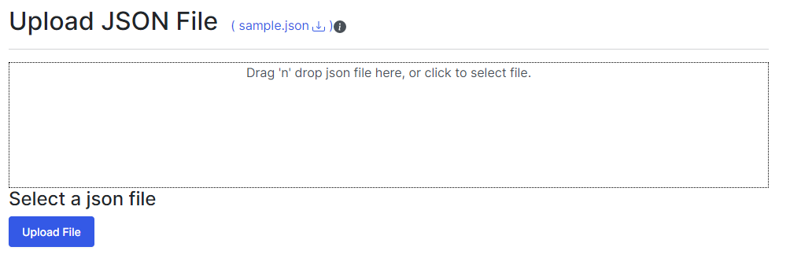

* You need to click within the box or click on upload button and then you can select your json file that has your accessory details.
* Your Accessory details in JSON file should follow the predefined format that you can see in the sample.json file.
* Note for Uploading JSON file

* If the Vehicle Accessory Id is already present , it will update the data. If not , it will store the data.  
* You can add multiple Vehicle Accessories within a single Json file  
* Refer to sample.json for getting a idea on json format

## 3.7 Uploaded Files

* In uploaded files page , you can see the files that you uploaded in the past , It has the details of your file like number of vehicles in the file , success ratio , date and time.

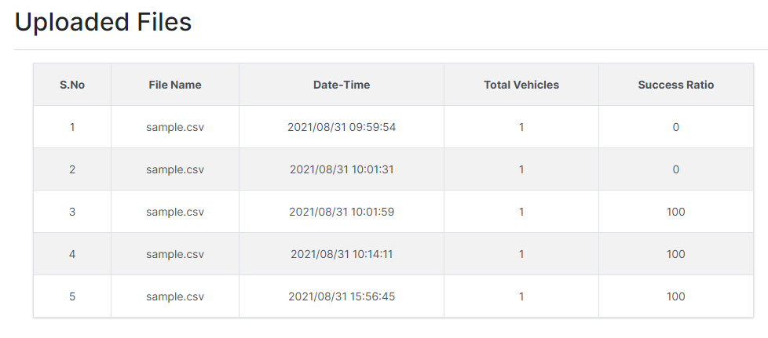

## 3.8 Add Accessory

* After Clicking on the Add Accessory button , You will be redirected to add accessory page that will look like the image below.

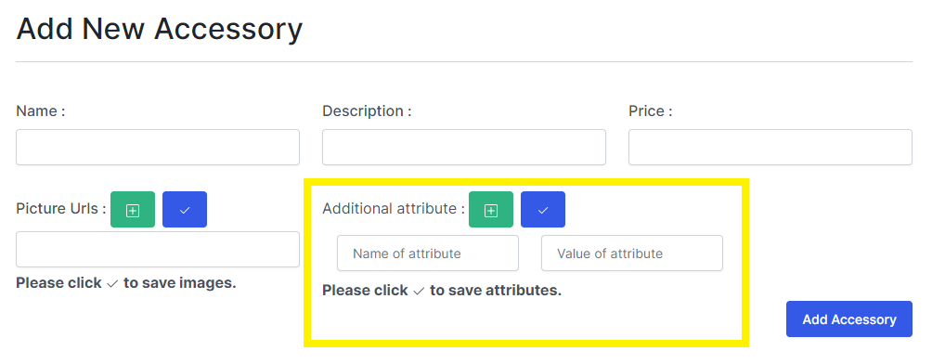

* You can Add your custom attribute for your Accessory using Additional Attribute.

## 3.9 Change Password

* You can change your password using change password option on the dashboard.
* Your password must contain at least one digit and one uppercase and one lowercase letter and one special character, and at least 8 or more characters.