Superly

Instructions

1 Introductory

1.1 Starting the System

- Run the project jar

- Open the web browser and enter to the URL line- localhost:8080

- Press enter
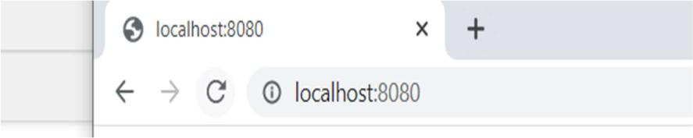

1.2 Menus

At (almost) each point when using the software you will be greeted by a menu.

Example – the Login Menu:
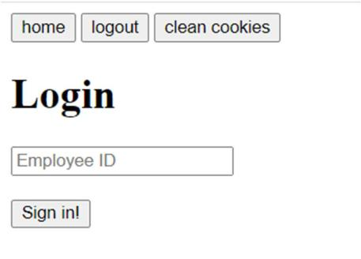

In order to choose an option out of the menu,

simply click the button associated with the wanted option, or if input is require, please enter the input to the correspond text box and then press the associated button.

For example,

To see your options as an employee you need to log in, that will be preformed as followed:
- Enter your ID in the textbox

- Press the button sign in

Note: you can login as an admin if you enter in the ID box “admin”
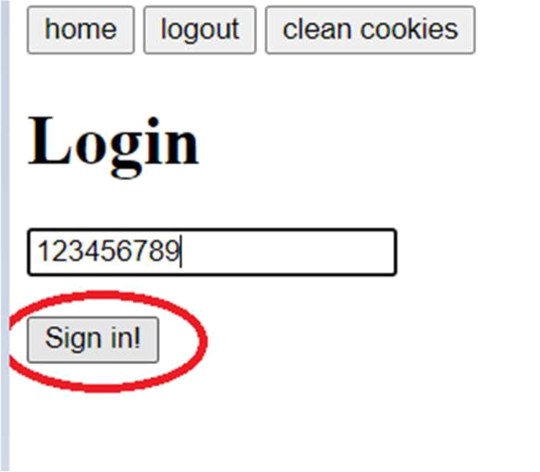

1.3 HomePage

When you want to get back to your home page you should click the “home” button (int the top of each menu), the menu which was your home page will be open

So when exiting the Employee Management Menu the Main Menu will be booted.

Note: if you are not login your homepage will be the Login page
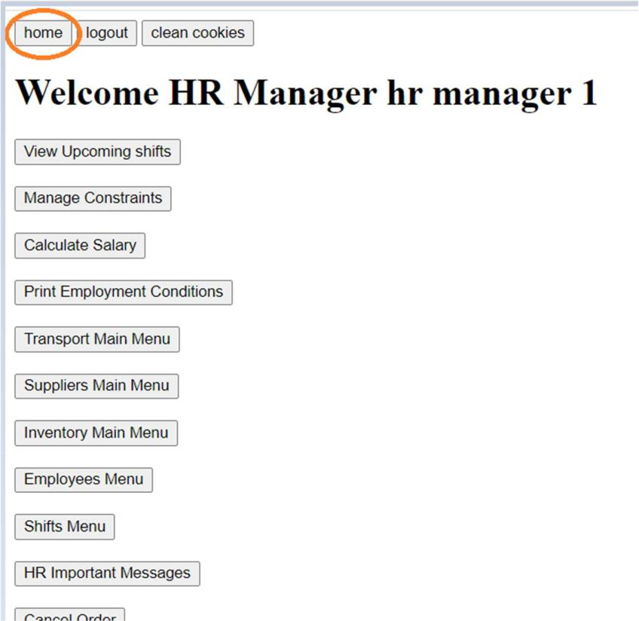
2 Menus

2.1 Login

Main function:

Log in- allow you to log in, after logged in a page will open with the functionality needed for this employee

Page:
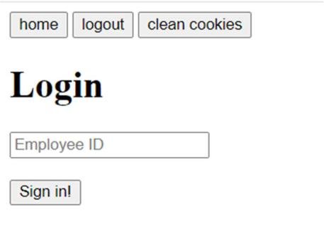

Accessed through:

entering
2.2 Admin Page

Main function:

- Access to all functionality allow in the system

- note: the admin cannot see info about himself that’s because he is not a employee.in the system

page:
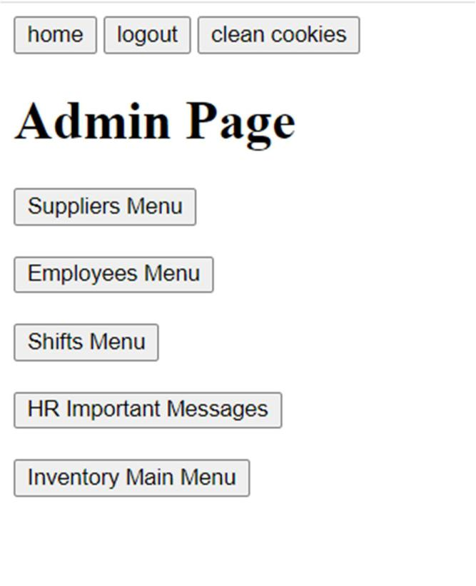

2.3 Carrier Page

Main function:

- View and update Details

- Supplier management

- Inventory management

page:
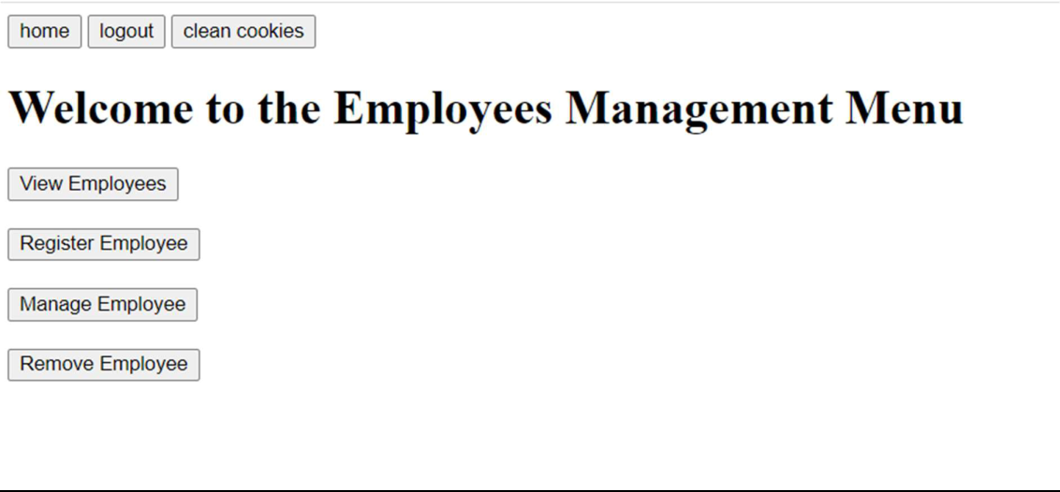

2.4 Cashier Page

Main function:

- View and update Details

- Transport Management

- Suppliers Management

- Inventory Management
page:
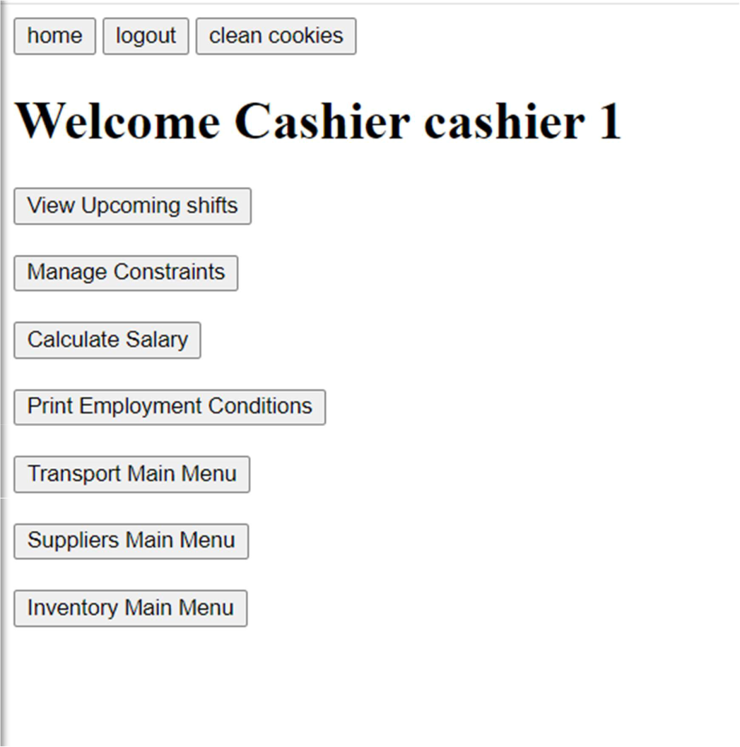

2.5 HR Manager Page

Main function:

- View and update Details

- Shift management

- Employee management

- Cancel Orders

- View massages
page:
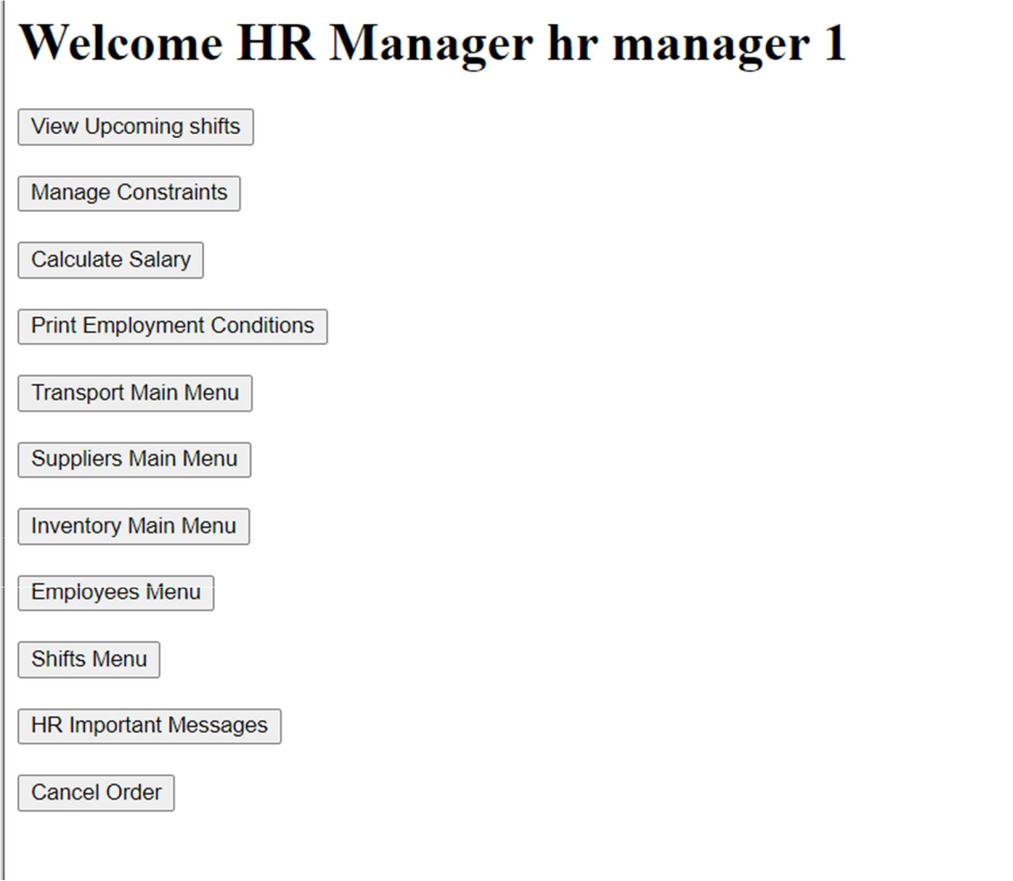

2.6 Logistic Manager Page

Main function:

- View and update Details

- Transport Management

- Suppliers Management

- Inventory Management
page:
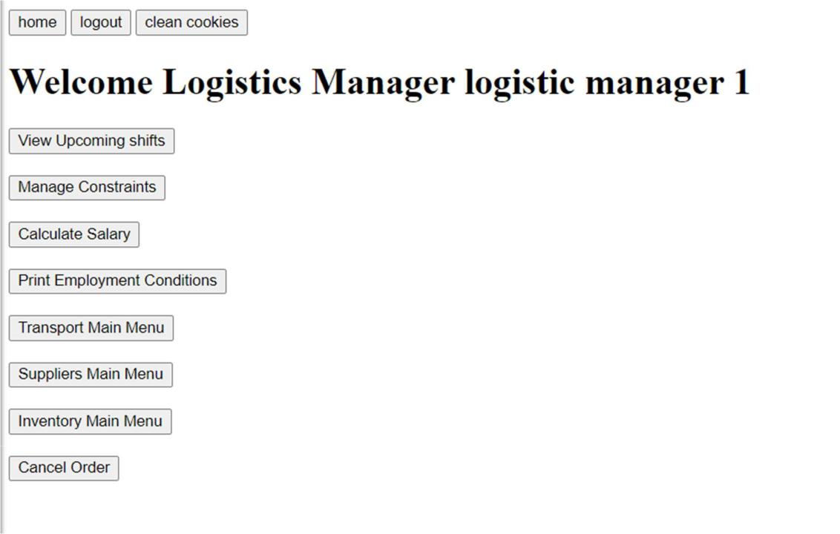

2.7 Sorter Page

Main function:

- View and update Details

- Transport Management

- Suppliers Management

- Inventory Management
page:
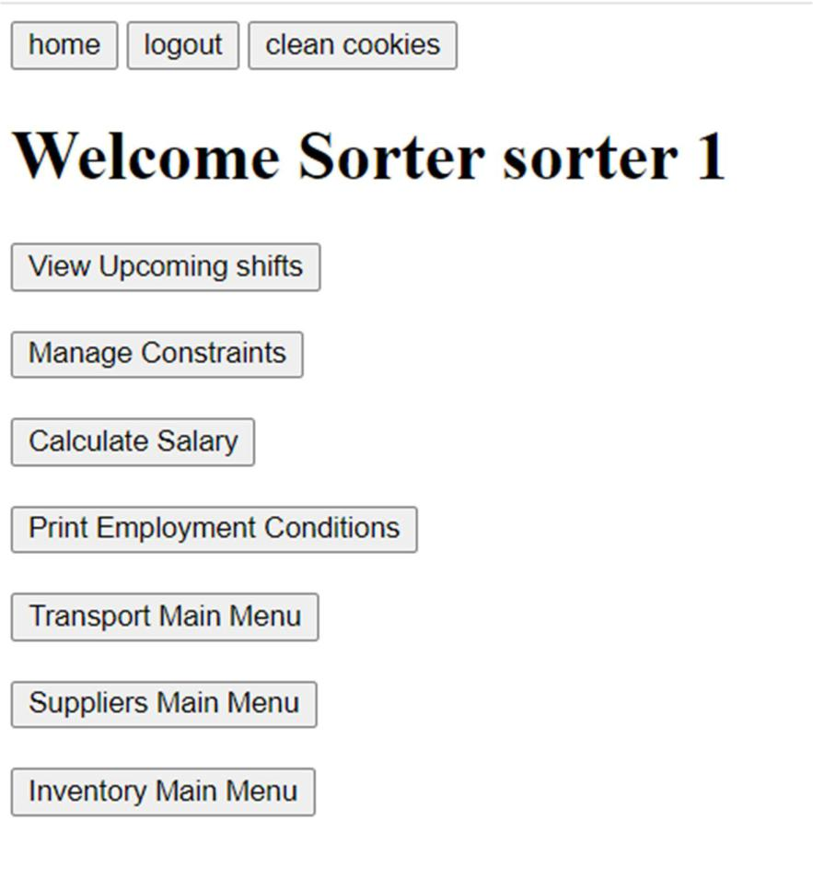

2.8 Storekeeper Page

Main function:

- View and update Details

- Transport Management

- Suppliers Management

- Inventory Management

page:
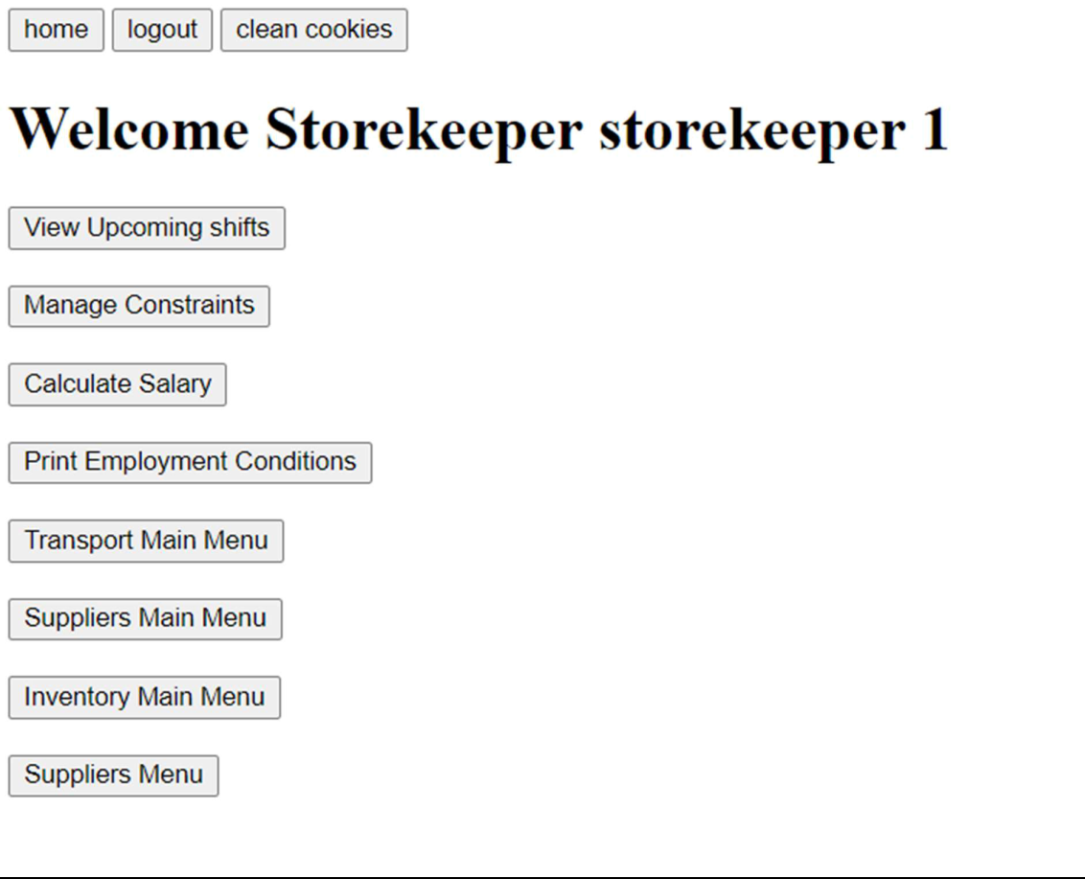

2.9 Transport Manager Page

Main function:

- View and update Details

- Transport Management

- Suppliers Management

- Inventory Management

page:
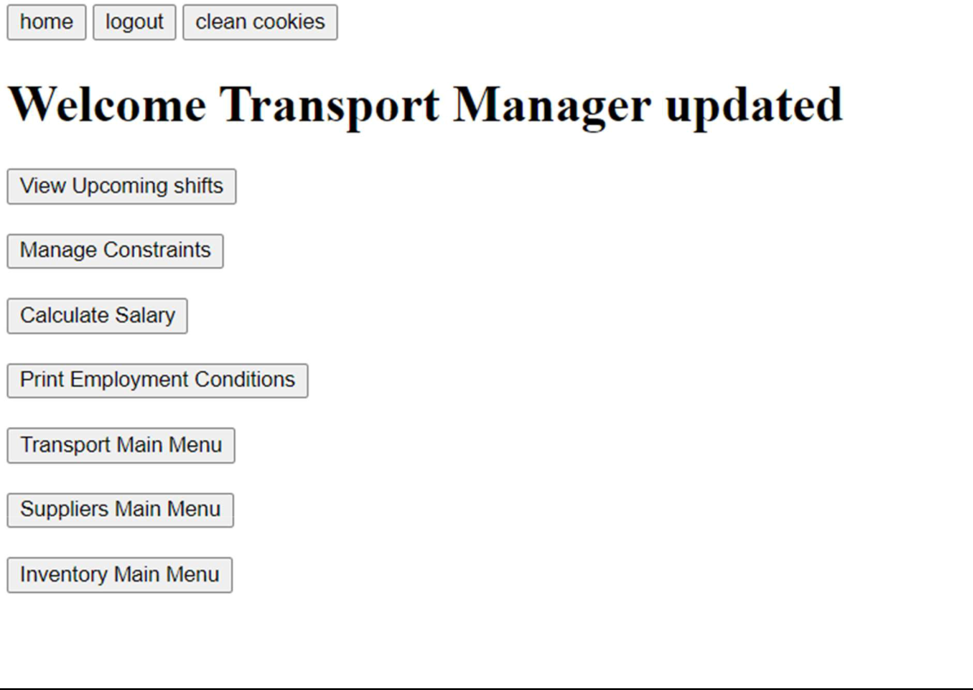
2.10 Suppliers Menu

Main function:

- Manage Suppliers

- View/ remove orders

page:
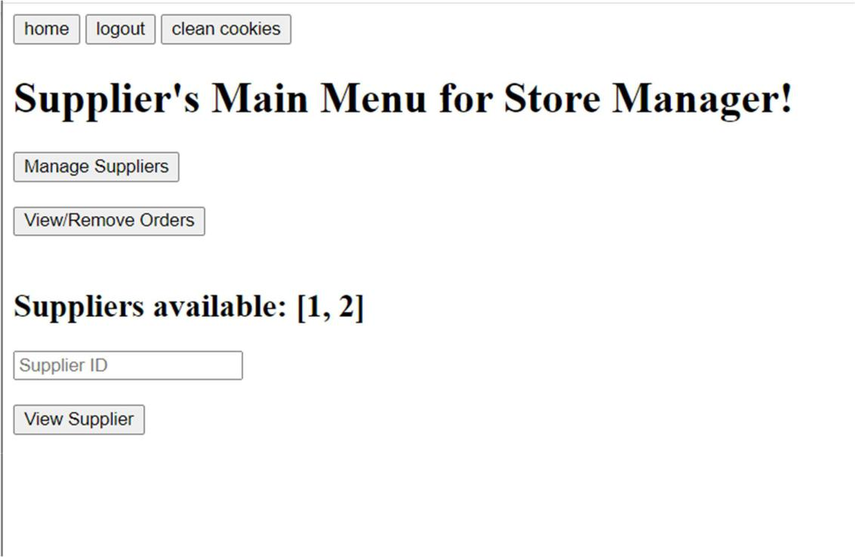
2.11 Shift Menu

Main function:

- Shifts Management

- Shifts Review

page:
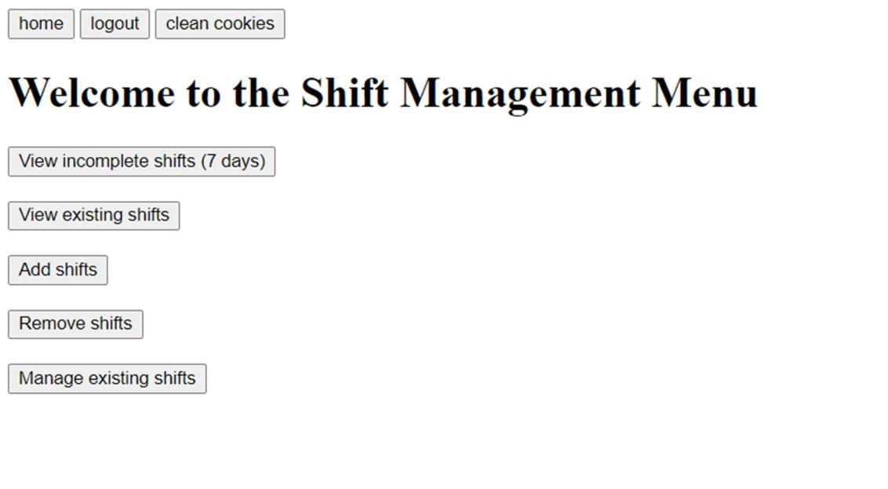

2.12 Employees Menu

Main function:

- View employees

- Employees un/registration

- Employee management

page:
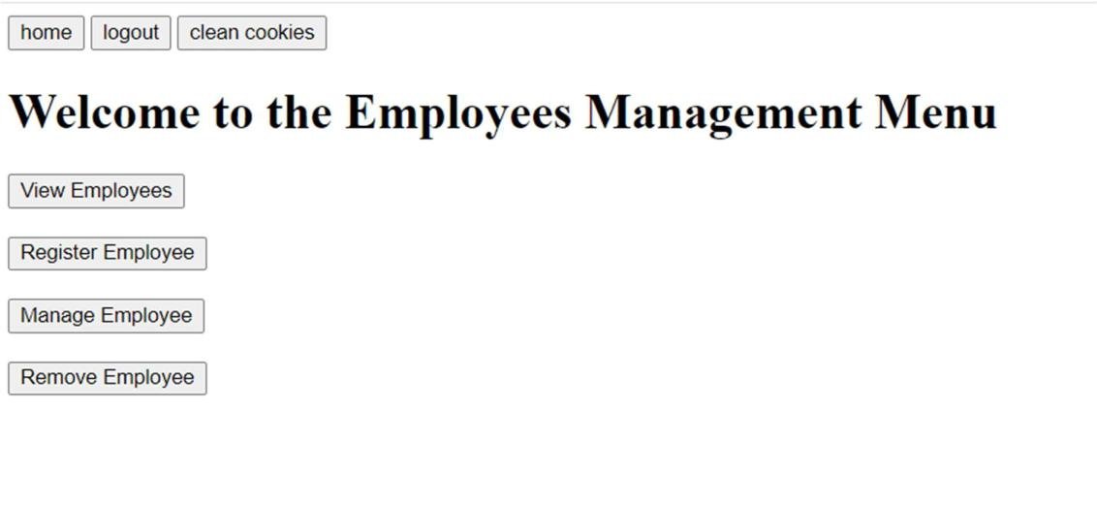

2.13 HR important messages Menu

Main function:

- Show massages to the HR

page:
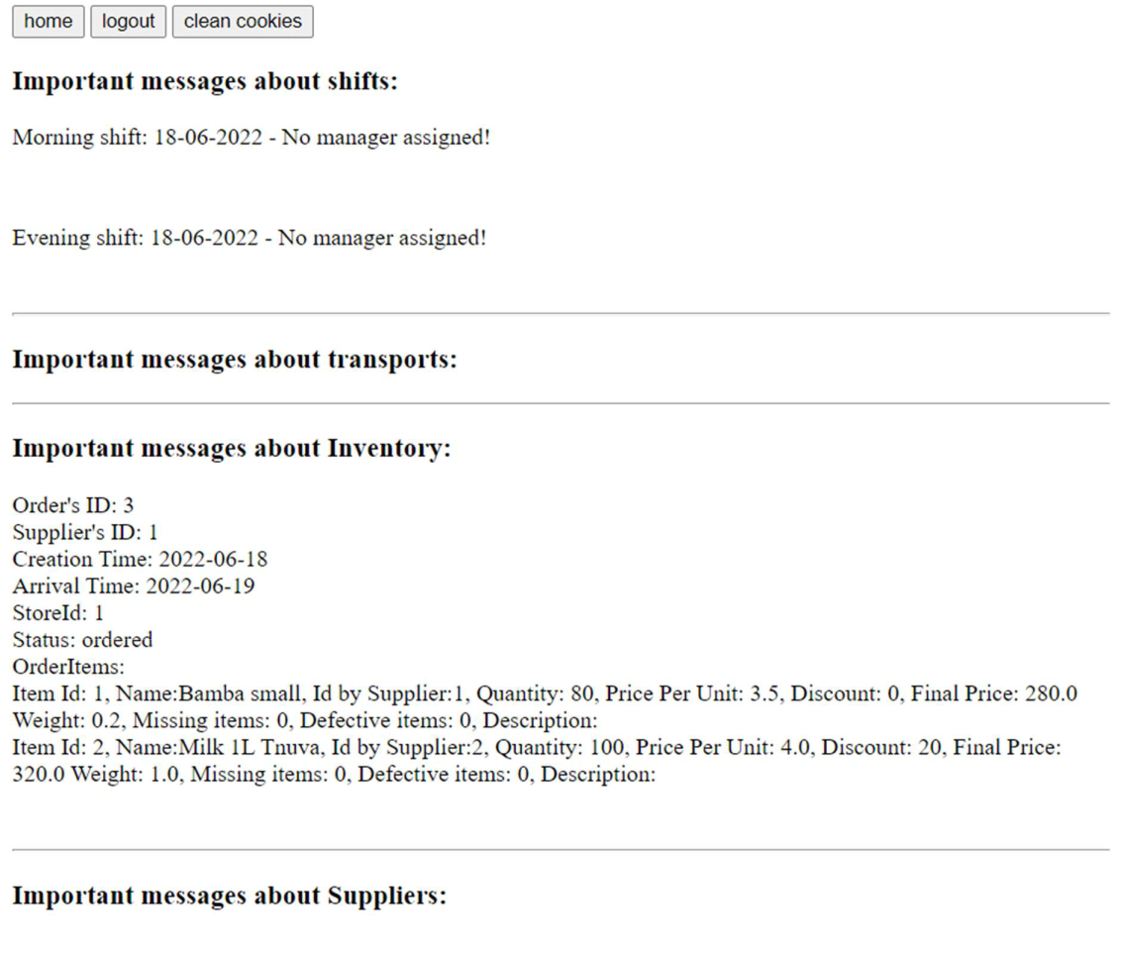
2.14 HR important messages Menu

Main function:

- Show massages to the HR

page:
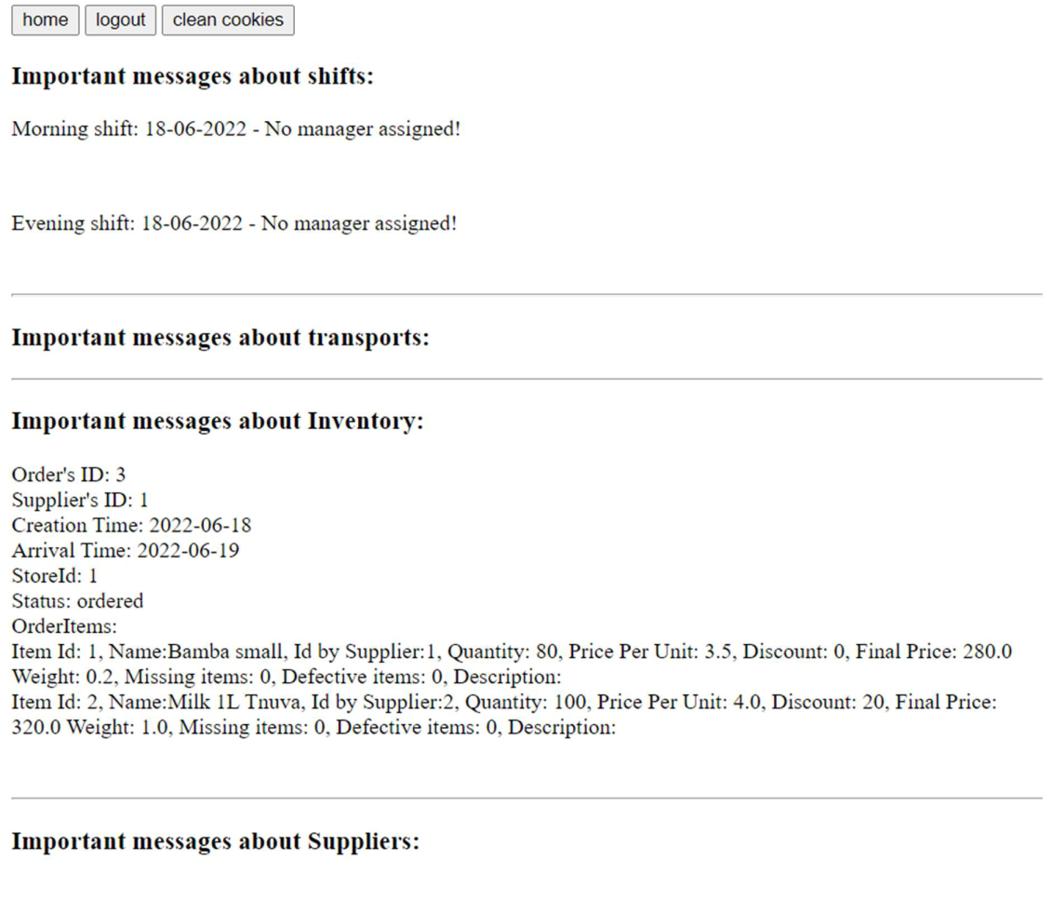
2.15 Inventory Menu

Main function:

- Manage Products

- Manage Categories

- Manage Sales

- View Reports

- Manage Inventory

page:
