Documentation:
Outline:
This workout app allows users to both register and login to their account and post their workouts for every user to see. Once they have completed their workout, they can post what they have done so that other users can see and use their workout. It makes you describe your workout, how many sets you have done, how many reps, and the duration of the workout. Once you have filled out all the information you can post it so that other users can see and use your workout in the gym to help them. This is done because a lot of the time in the gym, I struggle to find new workouts to do so using this, I can use other people’s workouts.

Architecture:
Presentation Tier –
Web browser – HTML/CSS/JavaScript/EJS Templates

HTTP/HTTPS
Application Tier –

Data Tier –

MySQL Database Server:
- users (authentication data)
- workouts (workout templates)
- exercises (exercises that have been done)
- sessions (session logs)
- session_exercises (duration, reps, sets of the exercises
Route Handlers:
- /routes/users.js (login/register)
- /routes/workouts.js (view/add workouts)
- /routes/sessions.js (view/log sessions)
- /routes/main.js (home/about pages)

Middleware Layer
- requireLogin (authentication)
- Session middleware
- Body parser

This workout app follows the 3-tier web architecture. The application tier uses node.js with express.js for the HTTP requests. This is all secured by using bcryptjs for password hashing. In the data tier, there is a MySQL database that stores users, workouts, exercises, sessions and session_exercises. The users table allows users to log in and register. The workout table is used to store a workout in the system. The exercises table allows users to give more information to the workout. Sessions table inputs the details of the session the user did (date and duration). Sessions_exercises allows to input reps and sets.

Data model:
Workouts –
Id (Primary key)
User ID (Foreign key)
Title
Description
Difficulty
Created at
Users –
Id (Primary key)
Username
Hashed password

Exercises –
Id (Primary key)
Workout ID (Foreign key)
Name
Sets
Reps
Order Index

Sessions –
Id (Primary key)
User ID (Foreign key)
Workout ID (Foreign key)
Session date
Duration
Notes
Created at

Session Exercises –
Id (Primary key)
Session ID (Foreign key)
Exercise ID (Foreign key)
Sets
Reps

The data model starts with creating a user and an auto generated hashed password. The users can log their workouts by entering the title of the workout, the description and the difficulty. This then gets added to the exercises database where the user can add the name of the workout, the number of sets and reps they have done. In the sessions database, you can add to the workout that you have done by adding the date, duration and notes of the workout. The session_exercises database allows the user to put in the number or sets and reps that each workout requires.

User Functionality:
The user start by either registering or logging in to their account with a username and password. I have set up an account using the username: gold and password: smiths. The passwords are hashed using bcryprtjs so that it protects the users passwords. Once the user is registered, they can use the apps features. The code for registering can be seen below:
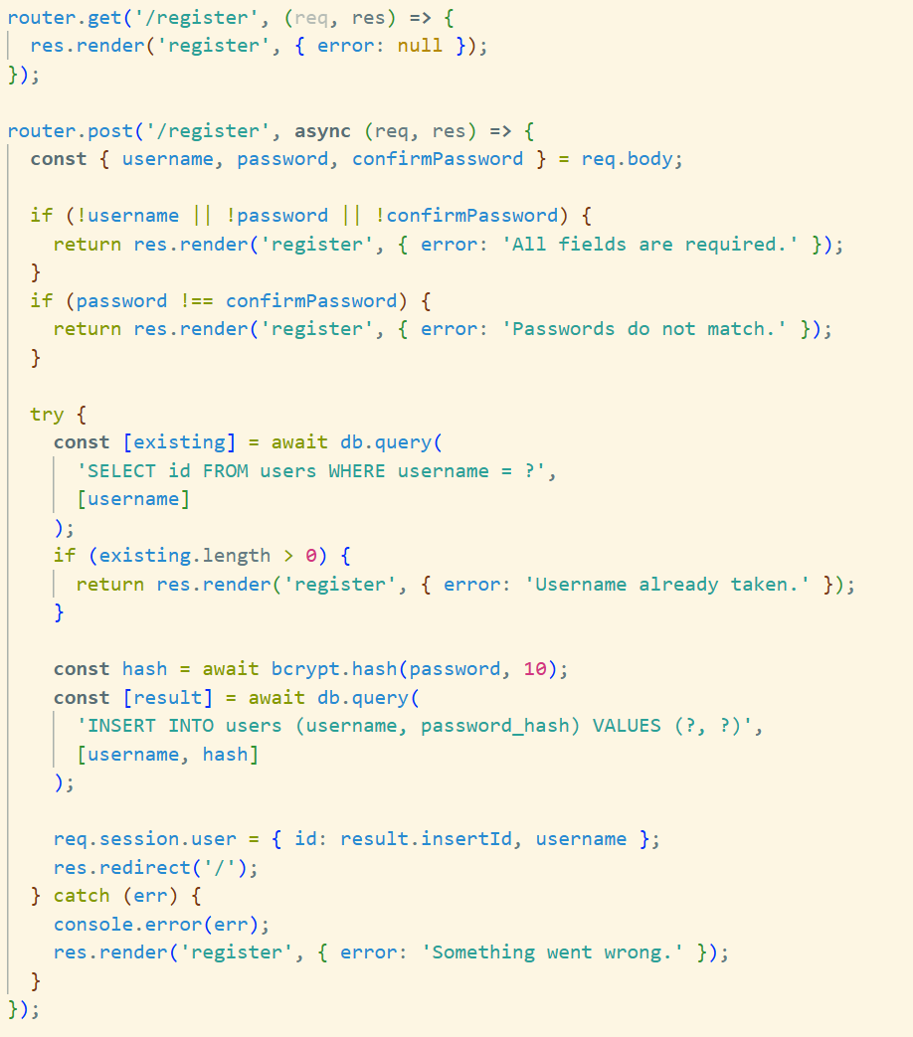
Once the user has either logged in to an account or registered, they can then add their own workouts for other users to see. After this, they will be able to add their own workouts. With this, they will be able to add the title of their workout, e.g. full body workout, the description of their workout, e.g. a comprehensive full body workout, and the difficulty of the workout (either easy, medium or hard). This has been made so if other users would like a hard workout that works the full body, they can use the workout that the user has added for them to try themselves. The code for creating a new workout can be seen below:
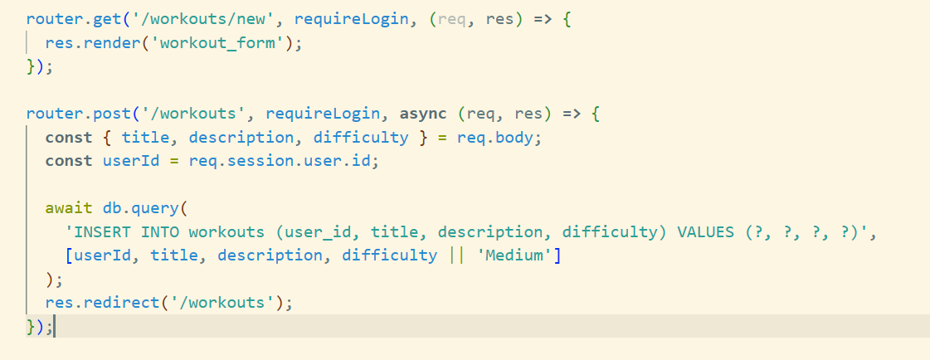
After adding the workout, the logged in user can then add the exercises to their workouts. The exercise form captures the exercise name (e.g., "Bench Press"), target sets (e.g., 3)and the target reps (e.g., 10). This creates a workout prescription that serves as the template for future training sessions. The code for this can be seen below:
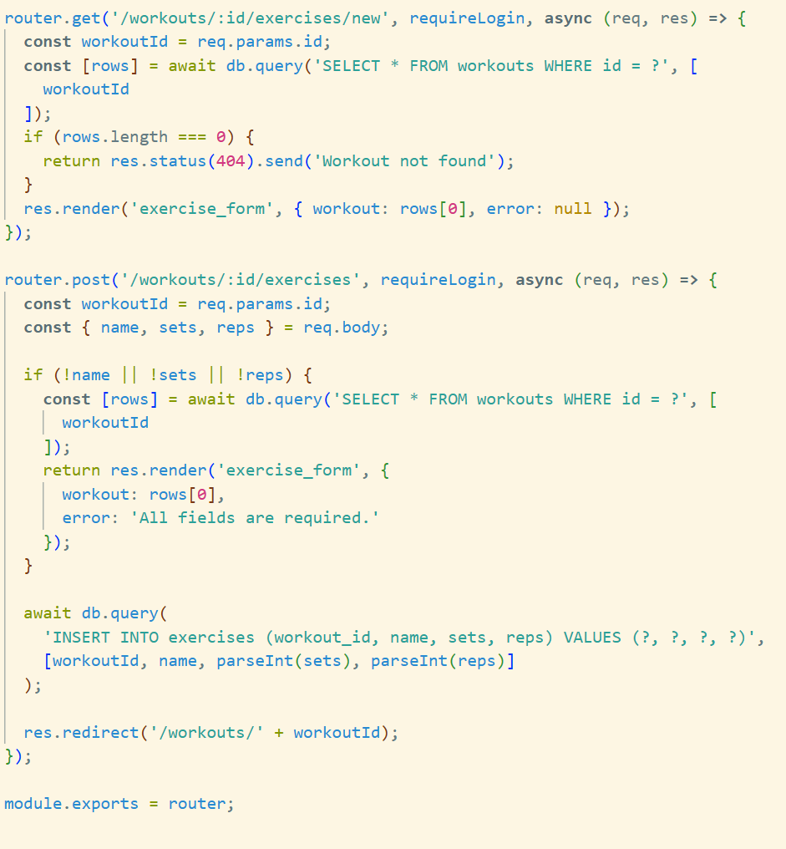
When a user completes a workout, they can log a session by selecting what workout they did, put the date that they did it in, add the duration of the workout, and they can add notes to help others who want to do the same workouts. This creates a session record that captures the workout context. The system then allows users to record actual performance for each exercise in the workout. The code for this can be seen below:
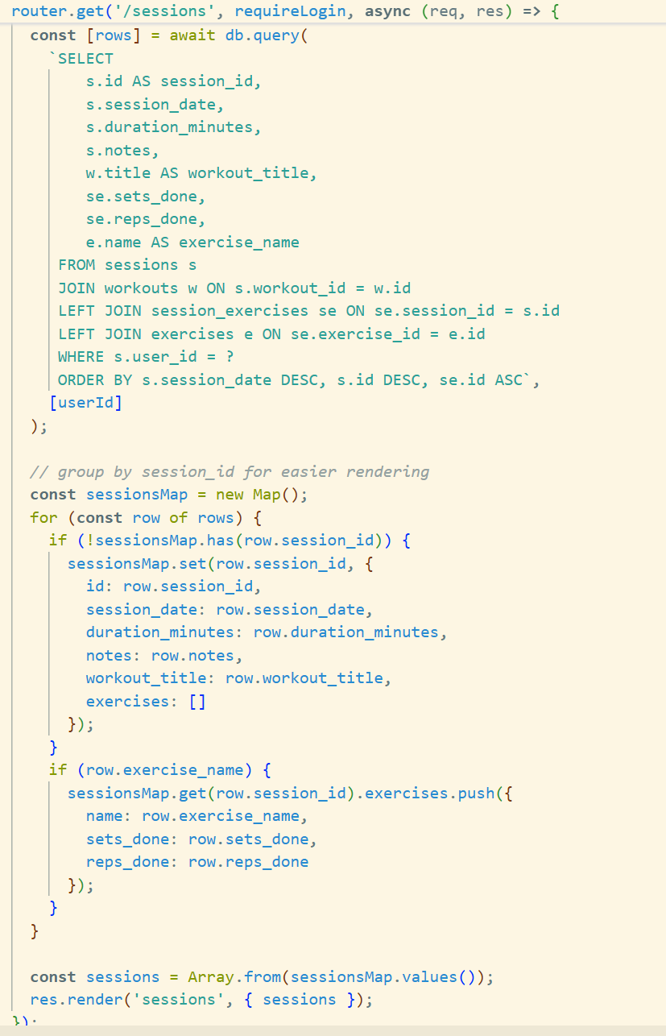
For every exercise in a session, users record their actual performance of the workout. They add the sets completed and the amount of reps that they have done. I have created a table for this called sessions_exercises table, so users can compare their planned targets and what they have actually done. Once the user has used the app for a long duration of time, they will have a comprehensive training history. This code can be seen below:
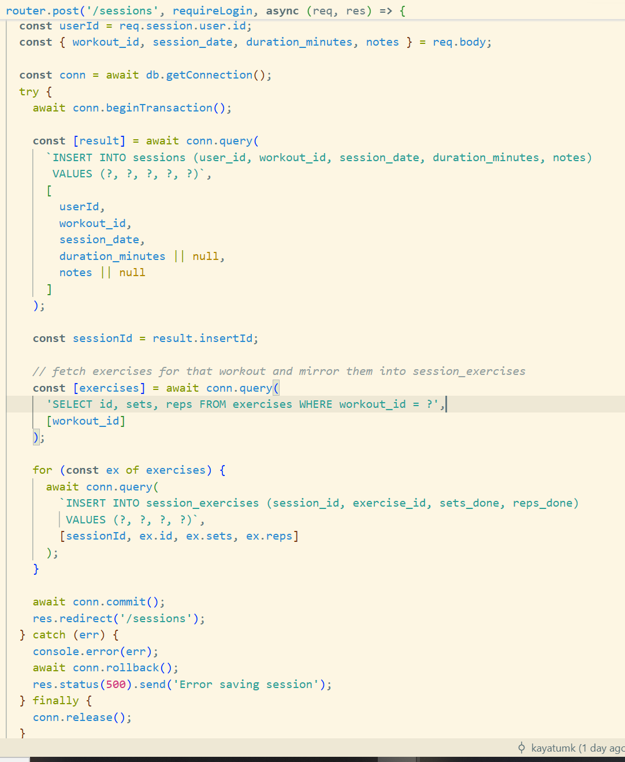

Advanced Techniques:
One of the advanced techniques that I have implemented in this code is adding a layout.ejs file which displays all of the additional files that the user can see when using the application. The code for this file is shown below:
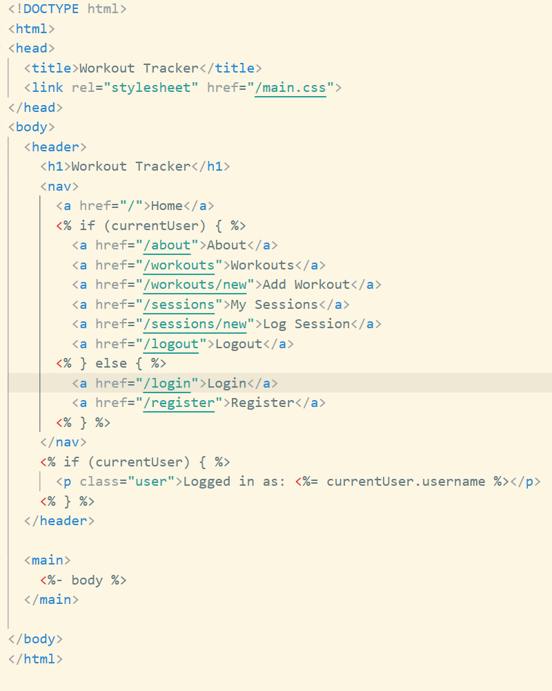
As I have used this ejs file, I have used <%- include('layout', { body: `….. ` }) %> for all of the other ejs files.
Rather than creating new database connections for each query, I implemented connection pooling using mysql2's promise-based pool functionality. This significantly improves application performance by reusing existing connections and managing concurrent database requests efficiently.
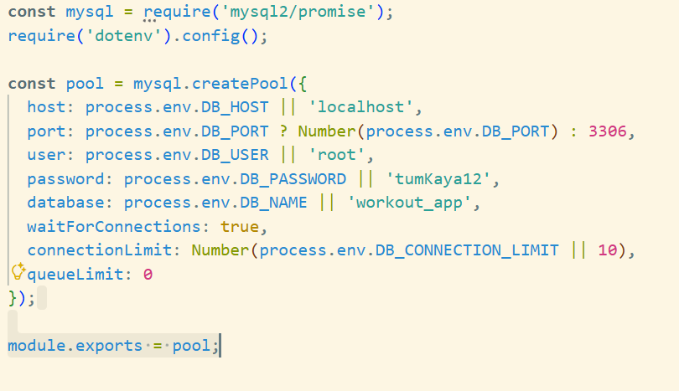
I implemented a sophisticated SQL query that joins multiple tables and aggregates data efficiently on the database side rather than in application code. This reduces memory usage and improves response times.
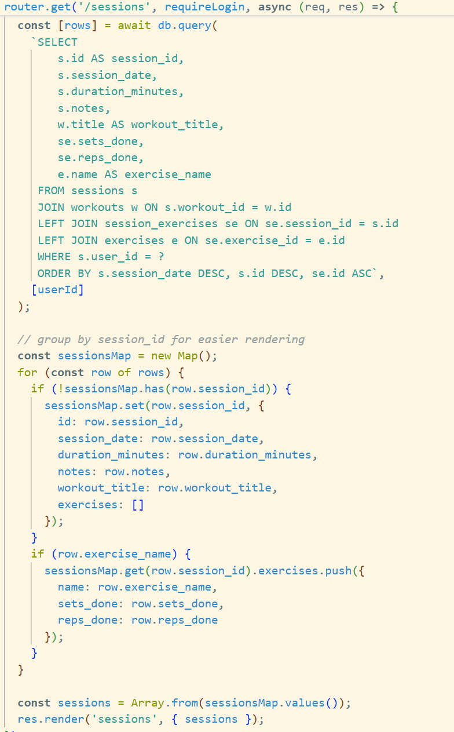
I consistently use modern async/await syntax instead of callback hell or promise chains, making asynchronous database operations more readable and maintainable.
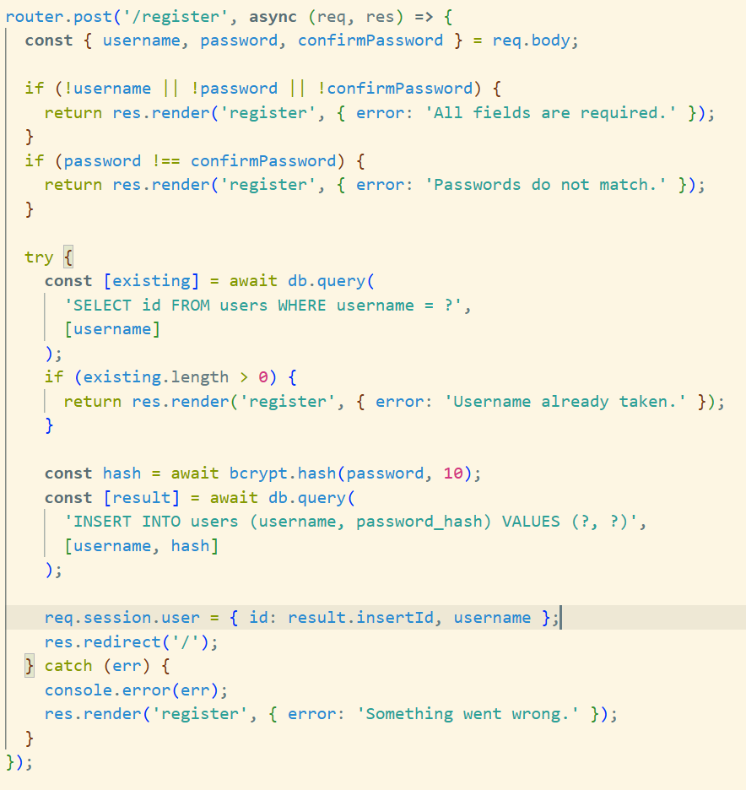
The try-catch blocks provide clear error handling, and the sequential nature of async/await makes the code logic easy to follow compared to nested callbacks.

AI declaration:
In this project, I have used AI to help me understand the errors were being shown and helping me fix these errors. I have a tutor to help me with coding as it has been something I have struggled with in the past, so the code was done by me, but my tutor helped in making the layout of the programming better.

