# 336 partner project

# Created on October 25 2017

# Table of Contents

1.0. Home Page

2.0. Game Info

3.0. Shopping Cart

# 1.0. Home Page

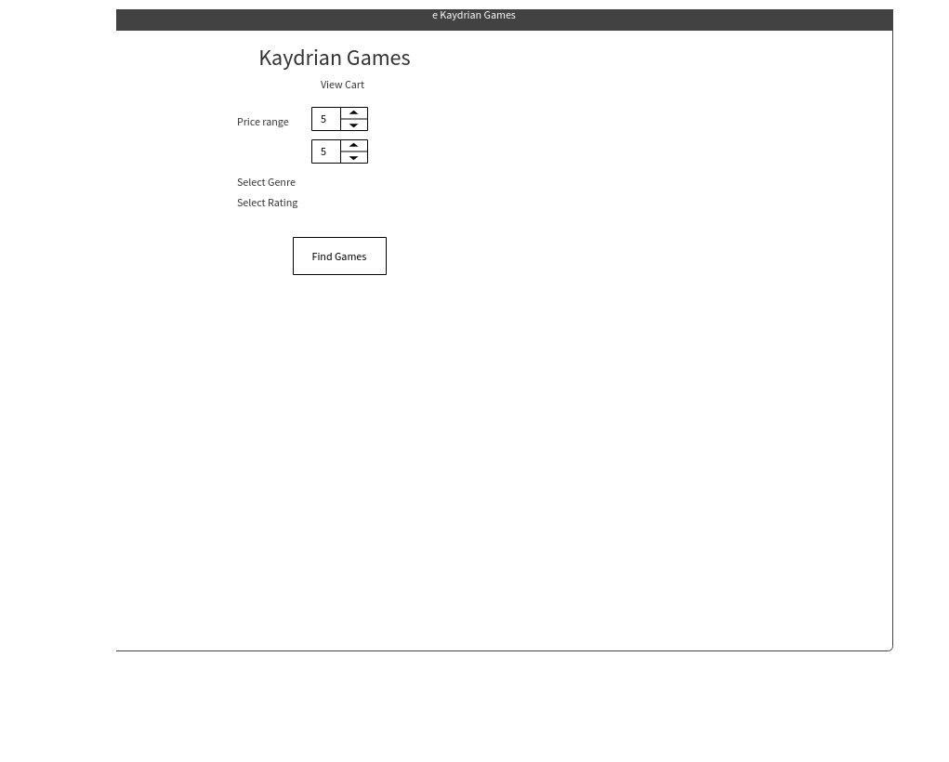

# 2.0. Game Info

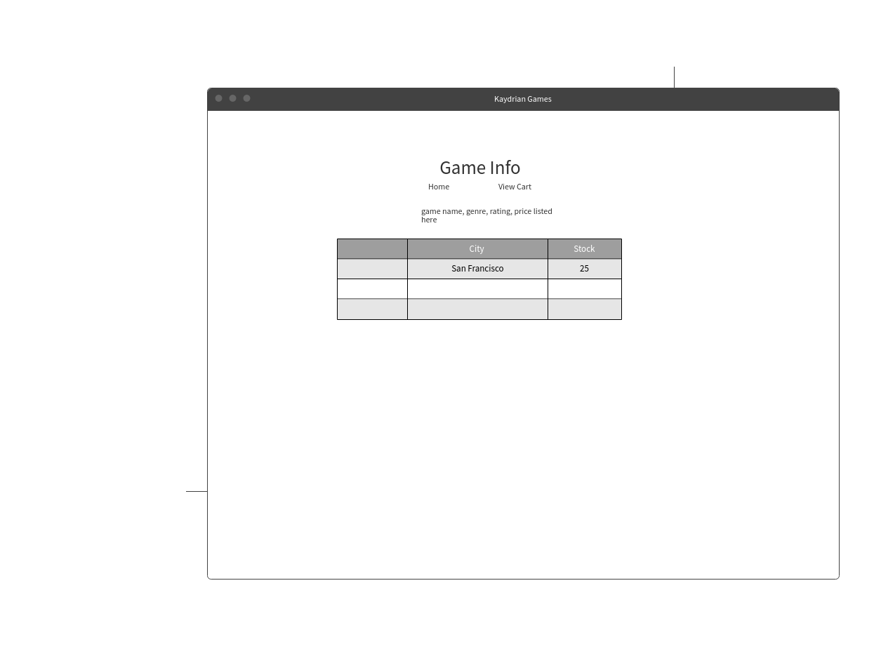

# 3.0. Shopping Cart0 Imagen

User Story:

As a customer, I will be able to search for a video game by price, genre, and rating. Once this is done, I will be able to choose a game and see where it’s available and how many are available. I can then add it to the shopping cart and see how much I owe.

