Activity 16
- Screenshot of web page showing the full Catalog.
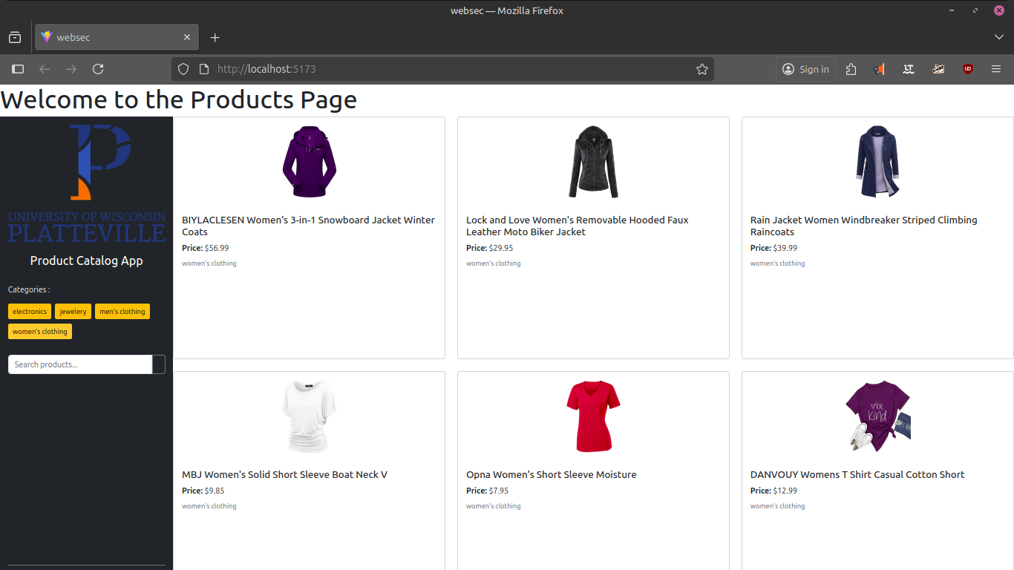
- Screenshot of web page showing a filter using a Button.
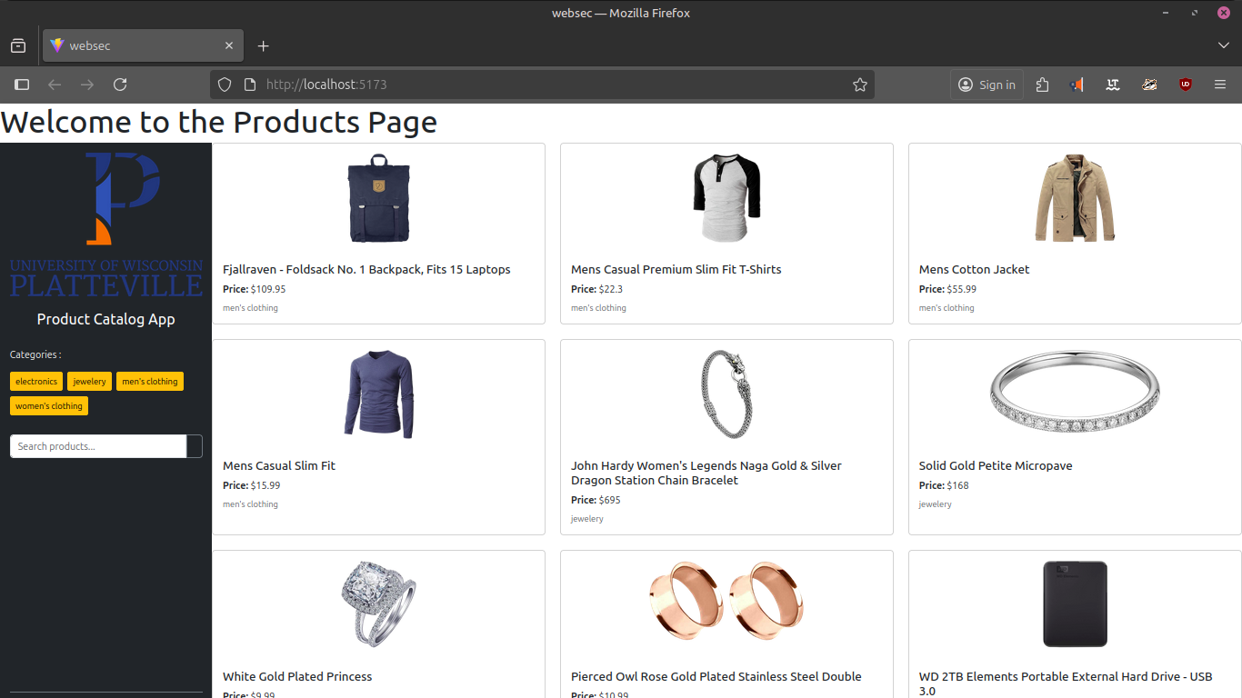
- Screenshot of web page showing a filter using Search.
