Studio Sync: Web-Based Landing Page Customization and Generation System for Photographers
A project Capstone Presented to
Northeastern Cebu Colleges, Inc.
In Fulfillment of the Requirement of
BACHELOR OF SCIENCE IN INFORMATION TECHNOLOGY
THE RESEARCHERS:
Evangelista, Kent Clarence Evangelista C.
Petallar, Rovic Lester
Tungal, Marvin
Pradilla, Josiephos
Procurato, Edsel

CHAPTER 1
PROJECT CONTEXT
Globally, the necessity for a professional digital presence has become a critical baseline for creative professionals seeking to showcase their portfolios and secure clientele; however, significant technical and financial barriers actively impede this process. Building a professional online portfolio from scratch requires a level of web development proficiency that many artists lack, while hiring external developers often demands budgets that freelance creatives cannot sustain (Davis & Chen, 2024). Furthermore, existing global website builders, though marketed as user-friendly, frequently involve steep learning curves and produce generic layouts that fail to adequately highlight a photographer’s unique aesthetic (Williams, 2023).
Compounding this operational dilemma is the widespread vulnerability caused by over-reliance on third-party social media platforms like Instagram and Facebook. Many photographers use social media as their sole portfolio repository; however, platform algorithm changes frequently suppress organic reach, aggressively compress high-resolution RAW photographs, and penalize posts containing outbound booking links. Furthermore, managing client inquiries through unstructured direct messaging (DM) threads leads to communication breakdowns, missed opportunities, accidental double bookings, and an unprofessional booking experience for clients.
In the Philippines, these technical and financial obstacles disproportionately affect freelance photographers and small creative enterprises operating within a highly competitive local gig economy. Recent studies on Philippine micro, small, and medium enterprises (MSMEs) and freelancers indicate that digital adoption remains constrained by a pervasive lack of technical expertise, digital anxiety, and limited budgets for IT infrastructure (Cordova, Santos, & Reyes, 2025). Consequently, many local creative professionals resort to informal digital platforms, ultimately compromising their marketability and their ability to secure premium contracts due to the perceived complexity and expense of professional website development (Peña & Yao, 2023).
The lack of information technology adoption in Philippine creative enterprises has considerably affected the efficiency of portfolio presentation and client booking. Though many local visual artists have slowly embraced digital tools, the absence of an end-to-end integrated system remains an issue in minimizing client acquisition friction, showcasing uncompressed galleries, and providing seamless reservation processes. Highlighting the necessity of an automated and integrated generation system can assist in enhancing overall business efficiency and client satisfaction in the creative sector.
This systemic industry challenge directly mirrors the personal observation of numerous talented local photographers struggling to attract and retain clients simply because they rely exclusively on social media platforms for their digital presence. These creatives possess remarkable artistic capability, high-end camera equipment, and editing mastery, but find the prospect of building a professional website too technical, prohibitively expensive, or overwhelmingly intimidating. In local creative communities in Cebu, when prospective corporate clients or overseas couples inquire about official portfolios and booking availability, photographers are forced to send casual Facebook links or PDF rate sheets via chat. As a result, their reliance on unstructured social feeds limits their professional credibility and acts as a severe bottleneck to their business growth.
Therefore, the researchers suggest a Web-Based Landing Page Customization and Generation System for Photographers that will assist visual artists in efficiently and effectively creating, customizing, and managing their online presence. It will be a computerized platform that utilizes Artificial Intelligence to automate the design and coding processes based on simple user inputs. It will also feature integrated high-resolution media management, automated edge deployment, and an online client booking module so that visitors can view services, check real-time availability, and reserve photography sessions directly. By combining these features into one easy-to-use interface, the system proposed here hopes to eliminate web development barriers, minimize booking errors, avoid scheduling conflicts, and increase overall client satisfaction and business growth.
Purpose and Description
The purpose of this research is applying an automated, AI-driven landing page customization and generation system to improve creative business operations, enhance brand professionalism, and increase revenue by efficiently handling portfolio generation, high-resolution media delivery, and client reservations. Studies have shown that automating web design and layout synthesis enhances operational efficiency and minimizes technical barriers for non-technical users (Miller & Zhao, 2024). International solutions leveraging generative AI and intelligent design algorithms allow users to bypass traditional coding and manual layout configuration, rapidly producing professional, responsive digital portfolios (Thompson, 2023).
Additionally, research on cloud-based automated systems highlights how real-time integration with external platforms, such as cloud object storage and edge deployment networks, can increase site speed and client conversion rates significantly. Global platforms like Wix ADI and Framer AI leverage machine learning models to automatically generate responsive layouts, select color palettes, and create tailored website structures based on minimal user input, catering to creators worldwide (Wix, 2023; Framer, 2023). These findings underscore the importance of implementing an AI-powered system to ensure seamless operations, maximize client bookings, and enhance the overall creative brand experience.
In the Philippine context, there is an urgent and growing need for accessible, AI-driven business tools tailored to the operational realities of independent contractors and freelancers. As government and private sector initiatives push for the digital transformation of local MSMEs, implementing cost-effective, automated platforms is crucial for enabling Filipino creatives to scale their services without being hindered by infrastructure costs (Garcia, 2024). Tailoring AI generation specifically for visual artists provides an immediate, localized remedy to the digital anxiety and financial constraints currently stunting the Philippine freelance creative sector (Villanueva & Ocampo, 2023).
In hindsight, the application of an AI-driven landing page generation and customization system is a life-changing solution for improving working efficiency, enhancing brand credibility, and increasing revenue in the freelance creative industry. Both international and local studies have demonstrated that automating design, asset management, and booking processes reduces errors, streamlines client onboarding, and enhances resource allocation. For local freelance photographers, adopting StudioSync is not just an upgrade but a strategic need to remain competitive in today’s digital era. Looking ahead, further research and development should focus on integrating artificial intelligence, automated edge deployment, and real-time client booking to continually elevate the freelance photography business experience.
Objectives of the Study
The primary objective of this study is to design, develop, and evaluate Studio Sync: Web-Based Landing Page Customization and Generation System for Photographers to improve effectiveness, brand credibility, and overall client experience. Specifically, this study aims to:
Provide an intuitive user interface that allows photographers to seamlessly input their personal preferences, branding choices, typography, and stylistic parameters.
Integrate an AI-driven generation agent capable of translating user inputs into responsive, customized web layouts and semantic source code.
Develop a robust workspace and asset management module for users to securely upload, categorize, and stream high-resolution image galleries into generated pages using Cloudflare R2 object storage.
Implement an automated deployment pipeline integrated with the Vercel API to automatically deploy generated pages and instantly provision live, shareable URLs.
Incorporate an integrated client booking and reservation module that allows visitors to view photography services, check schedule availability, book sessions, and receive automated confirmation emails.
Design and develop a client service customization request module that provides structured ticketing, file attachments, and threaded communication between photographers and clients.
Create a comprehensive analytics and reporting module that provides photographers and system administrators with real-time statistics regarding page traffic, visitor engagement, and platform performance.
Design and develop a centralized administrative backend system that streamlines operational workflows, client interactions, project monitoring, and content management.
Evaluate the system’s usability, generation accuracy, and overall performance through testing with freelance and professional photographers.
By achieving these objectives, the study seeks to modernize the digital transition process for local visual artists, ultimately improving brand professionalism, administrative efficiency, and overall freelance business growth.
Scope and Limitations
The Studio Sync: Web-Based Landing Page Customization and Generation System for Photographers aims to streamline portfolio creation, client booking, and asset management through a computerized platform. The system includes the following pages and functionalities:
Log-in Page – This page provides authentication and security for users. Both the administrator and photographers can access the system with role-based permissions, supported by standard credentials and modern biometric Passkeys.
Registration Page – This allows the registration of new system users. Photographers can register their accounts to establish their personal workspaces.
Client Dashboard – Serves as the main workspace hub for photographers, displaying active projects, generation statuses, visitor traffic overviews, and recent booking notifications.
Design Preference Form – Located within the client workspace, this allows photographers to easily input highly specific design choices, such as photography niche, typography, color palettes, layout styles, and required content sections through simple selections.
AI Generation Engine – The core multi-step, fully automated pipeline powered by the Gemini API via the Laravel AI SDK. It autonomously generates an optimized prompt, writes the raw HTML and Tailwind CSS code, and performs an AI QA Review to identify and fix design flaws before finalization.
Page Management Module – Allows users to manually edit, update, or refine their generated webpage post-creation directly within the system interface, enabling precise customization without requiring manual coding.
Automated Deployment Module – Integrates directly with the Vercel API. Once the HTML code is finalized, the system automatically deploys it and instantly provisions a live, shareable URL for the photographer to view and distribute.
Media and File Uploads – Integrates Cloudflare R2 object storage to handle the seamless uploading, hosting, and global streaming of high-resolution portfolios and system assets without egress fees.
Booking and Reservation Page – Allows visitors to view photography service packages, check real-time availability on an interactive calendar, and submit booking reservations.
Automated Notification Mailer – Dispatches automated email booking confirmations to guests and instant reservation notifications to the photographer's dashboard.
Client Customization Request Page – An interactive ticketing hub where clients can submit backend or styling customization requests, attach reference files, and track request statuses.
Contact and Inquiry Page – Captures messages submitted by landing page visitors, routes them directly to the photographer's dashboard, and supports direct email replies.
Statistics and Analytics – A multi-tiered analytics module designed to track visitor traffic, page views, and booking conversions for photographers, while providing administrators with system-wide usage data.
Admin Dashboard – Provides the administrator with a comprehensive overview to actively monitor all generated projects, track platform activity, and oversee user operations.
Limitations
The system has some limitations that users should be aware of. First, because the system generates code autonomously, it initially relies on dynamic image placeholders (e.g., Cloudflare R2) for portfolio galleries. Photographers are required to manually replace these placeholder URLs with their actual hosted photographs in the final production environment. Second, the AI generation engine is explicitly constrained to producing a comprehensive, single-page HTML and Tailwind CSS document; it does not output a complex multi-page Content Management System (like WordPress) or a full frontend framework application (like React or Vue). Furthermore, while the Vercel API provides an immediate live staging link (e.g., a .vercel.app subdomain), the system does not act as a domain registrar and lacks features for purchasing or routing custom root domains (e.g., www.photographername.com). When it comes to payment options, the automated gateway is exclusively tied to PayPal, meaning domestic Philippine digital wallets like GCash or Maya require manual coordination. Additionally, generation speed is dependent on upstream Gemini API response times and network latency. Even with these limitations, the system was still designed to help improve the web generation and client management process for freelance photographers. It aims to make portfolio deployment faster and simpler while keeping operations secure, organized, and focused on what is really important. Maybe in the future, adding more features could make the system even better.
CHAPTER 2
REVIEW RELATED LITERATURE
The integration of Artificial Intelligence (AI) into web design and development has revolutionized how individuals and businesses create digital experiences. AI-powered website generators and workspace management tools are digital platforms that streamline the process of designing, coding, and launching websites by translating user prompts and preferences into fully functional code. These systems are crucial for reducing development time, lowering barriers to entry for non-technical users, and maximizing creative productivity. On a global scale, these platforms are typically integrated into larger Software as a Service (SaaS) ecosystems used by international digital agencies and enterprises.
For instance, global platforms like Wix ADI (Artificial Design Intelligence) and Framer AI leverage advanced machine learning models to automatically generate responsive layouts, select color palettes, and create tailored website structures based on minimal user input (Wix, 2023; Framer, 2023). Similarly, tools like Hostinger's AI Website Builder provide integrated solutions that combine hosting with rapid, AI-driven site generation, catering to small businesses and individual creators worldwide. More recently, developer-oriented platforms such as v0 by Vercel and Relume have demonstrated the power of generating modular UI components and full-page wireframes using large language models trained on modern utility-first CSS frameworks like Tailwind CSS, enabling rapid prototyping and deployment.
In local settings, the adoption of AI-driven development tools is rapidly growing, especially among startups, digital marketing agencies, and freelance developers in the Philippines. These localized implementations often focus on budget-friendly and scalable solutions that address specific operational needs. For example, local digital agencies are increasingly adopting open-source frameworks like Laravel to build in-house project management and site generation tools. These platforms help streamline client onboarding, manage creative assets, and generate prototype landing pages quickly, allowing local teams to remain competitive in a fast-paced digital economy. These localized systems, while sometimes less complex than global enterprise platforms, are highly tailored to the specific workflows and cultural contexts of their users.
The advent of AI-powered website generation systems has significantly improved the tech and creative industries by automating repetitive coding tasks, improving accuracy in layout design, and enhancing the overall user experience for creators. Locally, for small-to-medium digital studios and freelance developers, the adoption of AI-assisted platforms like StudioSync helps automate routine tasks such as scaffolding new projects, organizing workspaces, and generating initial HTML structures. This reduces human error and significantly improves developer productivity. For example, integrating AI into the workflow allows developers to focus on custom logic and refinement rather than writing boilerplate code, thereby managing peak project loads more effectively.
On an international scale, large tech companies leverage advanced generative AI platforms integrated with complex workspace and asset management tools. These systems facilitate collaborative operations by synchronizing data and assets across distributed teams. According to recent tech industry reports, an increasing percentage of web development agencies use cloud-based AI tools to prototype and generate UI components in real-time. Furthermore, platforms like Webflow and Vercel are continuously integrating AI capabilities that analyze user behavior and prompt history to deliver more tailored and optimized code outputs, reinforcing developer loyalty and boosting competitive advantage.
Real-world applications of AI web generators also extend to seamless project management and cloud integration, especially in response to the growing demand for rapid digital transformation. Systems are widely adopted globally to offer features such as instant preview generation, intuitive preference selection, and automated deployment pipelines. The evolution reflects a broader reliance on AI to bridge the gap between design and development in both developing and developed markets.
The implementation of AI-powered website generation platforms like StudioSync in the Philippines must operate in compliance with several key legal frameworks. These laws ensure the proper handling of user information, protect intellectual property, and mandate operational standards that uphold data security. Developers and agencies adopting such AI technologies must be aware of their legal responsibilities to avoid penalties and maintain user trust.
One of the most significant laws affecting web platforms is the Data Privacy Act of 2012 (Republic Act No. 10173). Since project management and booking systems store sensitive personal data such as user emails, passwords, customer phone numbers, and reservation details, platform operators are required to ensure that data is collected with consent, stored securely, and only accessed for legitimate purposes. Under this law, establishments must implement appropriate data privacy and cybersecurity protocols to protect user profiles and workspaces, including encryption, two-factor authentication, and secure access management.
In addition, the Intellectual Property Code of the Philippines (Republic Act No. 8293) provides a legal basis for copyright and ownership of digital content, which is particularly relevant for photographers and AI-generated websites. Under Section 172.1(k) of RA 8293, photographic works are recognized as original intellectual creations protected from the moment of their creation. The system must guarantee that photographers retain full ownership over their uploaded media and provide clear terms of service regarding the commercial ownership of the AI-generated HTML content, prompts, and code to avoid copyright infringement issues.
Furthermore, the Electronic Commerce Act of 2000 (Republic Act No. 8792) establishes the legal validity, effect, and enforceability of electronic data messages, digital commercial transactions, and online contracts. In StudioSync, automated booking confirmations, transaction records, and electronic notifications serve as legally recognized electronic agreements between photographers and their clients. The system ensures that electronic transaction logs and payment receipts are recorded accurately.
Finally, digital platforms must comply with the Consumer Act of the Philippines (Republic Act No. 7394) and local business regulations. This statute mandates fair trade practices, transparency in pricing, and the protection of customer rights. The system must clearly show accurate service package rates, session inclusions, durations, and booking policies to avoid deceptive practices. Inaccurate information or booking discrepancies can lead to consumer complaints, making transparent system design vital.
These legal frameworks show that while AI provides efficiency and modern capabilities for web development, it must be implemented responsibly and in compliance with Philippine law. Proper system audits, secure authentication (such as Passkeys and Two-Factor Authentication), and strict data access controls are highly encouraged to align digital operations with national regulations and protect both business interests and user rights.
In summary, the adoption and implementation of AI-powered project and workspace management systems have become essential in improving development efficiency, accelerating prototyping, and enhancing user experiences in both local and international contexts. From freelance developers and small agencies in the Philippines to global tech platforms, AI generation technologies help automate complex coding and design tasks while reducing manual effort. As these systems evolve to include advanced language models and real-time asset management, compliance with legal frameworks—such as the Data Privacy Act of 2012, the Intellectual Property Code, the Electronic Commerce Act, and the Consumer Act—becomes increasingly critical. These laws ensure the ethical collection of data, the protection of generated content, and the promotion of consumer rights. The review of literature and legal foundations presented underscores the importance of balancing technological advancement with regulatory compliance, providing a strong basis for the system design and implementation strategies that will be explored in the subsequent chapters.
Technical Background
The StudioSync platform is a web-based system developed to help improve the process of generating AI-powered websites, managing creative projects, and organizing workspaces. It is built using a modern full-stack web architecture, utilizing the Laravel framework for the back-end and React with Inertia.js for the front-end. It uses a relational database to store and manage data such as user accounts, workspaces, project configurations, AI-generated prompts, and HTML content. The purpose of the system is to automate the manual process of scaffolding web pages and managing project assets, which is commonly prone to delays and repetitive effort.
With the system, users can securely log in or register using standard authentication or modern Passkeys. Once authenticated, users can access a dashboard that displays their customized Workspaces and Projects. There are dedicated screens for creating new workspaces, setting project preferences, and prompting the AI to generate a tailored website. The system utilizes background jobs to process the AI generation asynchronously, ensuring a smooth user experience. Overall, the system is designed to make web project management and AI-driven prototyping seamless and highly organized for creators and developers.
Laravel Framework (PHP) – A high-level, robust PHP web framework used to design and develop the back-end logic, API endpoints, and database interactions of StudioSync.
React – A popular JavaScript library for building user interfaces, used to create the dynamic, interactive front-end components of the system.
Inertia.js – A routing tool that bridges Laravel and React, allowing the system to function as a modern Single Page Application (SPA) without the complexity of building a separate API.
Relational Database (e.g., SQLite / MySQL) – The structured storage system where all important records (e.g., users, workspaces, projects, assets, bookings, deployments) are saved and retrieved.
Vercel API – Used to programmatically deploy the AI-generated websites, allowing users to instantly publish and view their generated projects on live edge-network URLs.
Cloudflare R2 – A highly scalable, S3-compatible object storage service utilized by the system to efficiently store and retrieve project media, generated assets, and user uploads without egress fees.
Git & GitHub – Utilized for robust version control, enabling secure tracking of changes in the main application's codebase and facilitating the seamless transfer of generated project code to user repositories.
Laravel Cloud – A tailored, high-performance hosting platform used for deploying the main StudioSync application, ensuring scalable and streamlined infrastructure management for the core system.
Tailwind CSS – A utility-first CSS framework used for rapidly styling the system's user interface and generated landing pages, ensuring a responsive and modern design.
Laravel AI SDK – The AI integration package used to communicate with Large Language Models (LLMs) to process user preferences, generate prompts, and output the final HTML content for the generated projects.
Background Jobs & Queues – A mechanism in Laravel used to handle time-consuming tasks, such as generating websites via AI (GenerateWebsiteJob), in the background without freezing the user interface.
User Authentication (Fortify & Passkeys) – The secure process of verifying user identities, implemented using Laravel Fortify for standard login/registration and enhanced with Passkeys and Two-Factor Authentication (2FA) for modern security.
CRUD Operations – Refers to the basic functions in the system: Create, Read, Update, and Delete, applied to core data models like Workspaces, Projects, Services, and Bookings.
MVC Architecture – The software design pattern (Model-View-Controller) adopted by Laravel to separate the application logic, database models, and user interface representation.
Primary Key & Foreign Key – Database concepts used to uniquely identify records (e.g., id) and establish relationships between tables (e.g., a project belonging to a workspace_id and user_id).
Vite – A modern, fast build tool and development server used to compile, optimize, and bundle the React components and Tailwind CSS assets.
Radix UI – Unstyled, accessible UI components used in the React front-end to build complex interactive elements like dropdowns, dialogs, and tooltips reliably.
CHAPTER 3
METHODOLOGY
The Agile methodology is employed in the development process by the advocates. Agile is a flexible and iterative software development method that supports constant improvement and collaboration. The identified challenge involves managing the complexity of building an operational and user-friendly landing page customization and generation platform while ensuring timely progress and effective teamwork. The objective is to create a system that allows photographers to seamlessly generate portfolios, manage high-resolution assets, and handle client bookings while adapting to changes and challenges throughout development. The proponents aim to design and develop a system that not only meets its functional requirements but also enhances the team’s ability to work collaboratively and respond to problems as they arise. The scope of the development includes planning and prioritizing tasks, organizing development into time-boxed iterations or sprints, conducting regular reviews, and continuously testing and improving the system. The Agile methodology follows a cyclical process that includes key phases such as sprint planning, task execution, daily stand-ups, sprint review, and retrospective. This method addresses common development challenges such as unclear requirements, shifting priorities, and inefficient workflows by promoting frequent communication, adaptability, and regular delivery of working features.
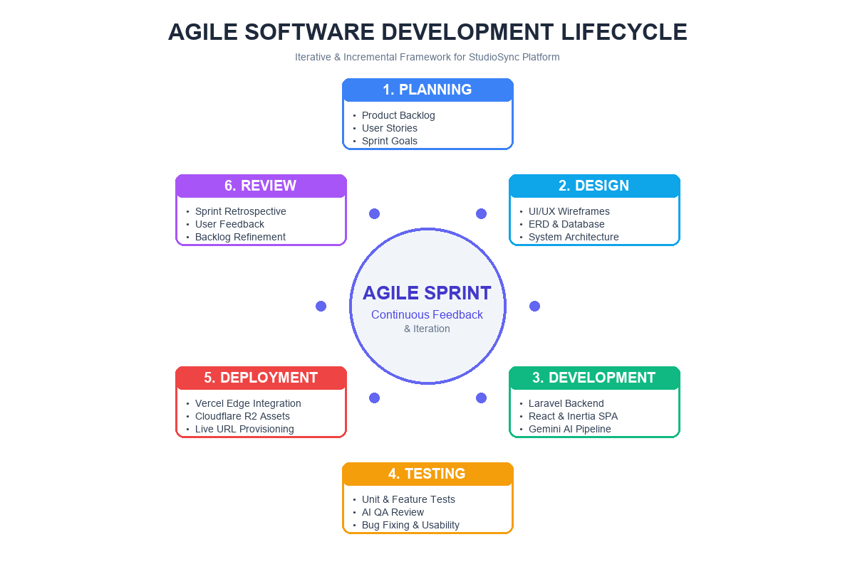
Planning: The researchers began with an idea gathering to plan and decide on the type of system to develop. During this phase, several ideas were proposed and discussed among the team. After a thoughtful evaluation and group voting process, the team agreed to commit on building a Web-Based Landing Page Customization and Generation System for Photographers, recognizing its relevance and potential impact on local visual artists. To better understand the specific needs and requirements, the researchers conducted interviews with freelance photographers and studio managers in Cebu, who provided essential data and insights regarding their current portfolio management and booking processes. This information served as the foundation for defining the system's objectives and core functionalities, ensuring that the solution would directly address real-world challenges faced by creative professionals.
Design: The design phase focuses on conceptualizing and structuring the StudioSync system based on the requirements gathered during the initial stages. This includes designing the system’s flow, organizing content, and ensuring that the interface is intuitive for non-technical photographers. The researchers used the Entity-Relationship Diagram (ERD) to represent the data flow between key components such as user accounts, workspaces, projects, assets, bookings, deployments, and customization requests. A clear structure was planned for navigating between project lists, design preference forms, live customizer screens, and booking management records. The design also encompassed prompt engineering architectures to interface effectively with the Gemini API, ensuring consistent generation of semantic HTML and Tailwind CSS code.
Development: The development of the StudioSync platform was carried out using Laravel as the main backend framework and React with Inertia.js for frontend data management and reactive user interfaces. The process began with setting up the development environment and creating core modules such as login and registration, which included input validation, Two-Factor Authentication, and modern Passkeys authentication logic. Once authentication was functional, the dashboard was developed to display dynamic project statistics and workspace switching. The design preference form was created with interactive fields for photography niche, color palettes, typography, and sections. Upon submission, the generation pipeline dispatched background jobs to process prompts via the Laravel AI SDK and Gemini API, synthesizing clean HTML and Tailwind CSS markup. An automated AI QA review pass was implemented to check and refine layout integrity. Cloudflare R2 object storage was integrated to handle high-resolution image uploads and asset folders. The automated deployment module was built using the Vercel REST API to deploy generated pages and instantly provision live URLs. Direct booking and client customization request modules followed, complete with automated transactional confirmation mailers and threaded commenting. All functionalities were developed with iterative testing and debugging to ensure a stable and functional final product.
Testing Phase: During the testing phase, we place a strong emphasis on frequently testing the login and authentication process by adding new users and verifying standard login, Passkeys, and 2FA functionality. This ensures that the authentication system is secure and operates as expected, allowing users to access the system without issues. In parallel, we consistently test the AI generation engine and booking system by submitting diverse design preferences, testing prompt responses, adding reservations, updating booking statuses, and checking for bugs or errors that might occur. This includes verifying Cloudflare R2 image uploads, ensuring proper status updates when a website is deployed to Vercel, and addressing any potential conflicts or system errors that may arise. We also test edge cases like invalid prompt inputs, oversized image files, or overlapping booking slots. By continuously testing both the generation and booking features throughout the development process, we can identify and resolve issues early, ensuring the system works smoothly and efficiently before it's deployed. This ongoing testing is essential for maintaining system reliability and improving user experience.
Deployment and Maintenance: Once the development and testing phases are complete, the system is ready for deployment. In this stage, we prepare the primary application for deployment on cloud infrastructure (Laravel Cloud), configuring environment variables, database connections, SSL certificates, and queue workers to handle background generation jobs. For generated landing pages, the deployment pipeline connects programmatically to the Vercel edge network, allowing each finalized project to be deployed instantly to a secure, public edge URL. Cloudflare R2 buckets are configured with appropriate CORS headers and CDN caching for fast global photo streaming. Application logs and queue health are monitored continuously to verify that everything is functioning as expected and maintain reliable system performance.
Review: The Review phase marks the final step in the development lifecycle of the StudioSync system. After deployment and maintenance are set in motion, the team gathers feedback from all stakeholders, including users, photographers, and project advisers, to assess the overall performance and functionality of the system. This phase focuses on evaluating whether the system meets the initial project requirements and user needs. During the review, the team conducts thorough evaluations to identify areas for improvement, potential enhancements, and any unforeseen issues that may have emerged after deployment. Feedback is collected from actual users through testing or direct input, and the system’s usability is assessed to ensure that it aligns with the expectations of freelance visual artists. The review also includes an assessment of the maintenance efforts to ensure that the system remains efficient, reliable, and secure. Based on the insights gained from this phase, the team may plan for future updates, new features, or refinements to the system. The review also serves as an opportunity to reflect on the development process itself, identify what went well, and document lessons learned for future projects. The goal of the review is to ensure that the system continues to provide value to users, and if necessary, prepare the groundwork for the next iteration of the system.
Requirements Analysis
The staff or photographer must first verify their identity by logging into the system using the login form or biometric Passkey. If the user does not have an account, they will need to register through the registration page for identification and access purposes. Once logged in, the user can navigate to the dashboard, which displays key project data such as active workspaces, total projects, visitor analytics, and current bookings.
The system provides an intuitive sidebar navigation that allows the user to easily access different pages within the system. One of these pages is the Workspace and Projects list, where all created portfolio projects are shown. Clicking to create a new project opens the Design Preference Form, where photographers input their branding choices, typography, color palettes, and required sections.
Upon form submission, the system initiates the AI Generation Engine in the background, which creates the master prompt, generates responsive HTML and Tailwind CSS code, and executes an AI QA review to verify visual balance. Users are then directed to the live Page Customizer, where they can preview the generated landing page, edit copy inline, and map their Cloudflare R2 photos into gallery containers.
Following this, users can proceed to the Deployment Manager to publish the site to Vercel with a single click, instantly receiving a live, shareable URL. The system also includes a Booking Management page where photographers configure their service packages, prices, and available calendar slots, allowing prospective clients to book appointments directly. When an appointment is booked, an automated confirmation email is dispatched, and the reservation is recorded on the photographer's schedule.
Additional features include a Client Service Request page for handling bespoke design revisions with threaded comments, a Media Asset page for organizing high-resolution photos in Cloudflare R2 folders, a profile page where users can update security settings and 2FA, and a logout option to ensure secure user sessions. The StudioSync platform is designed to streamline portfolio creation, automate web generation, and simplify client management through a user-friendly interface connected to a relational database.
Context Diagram
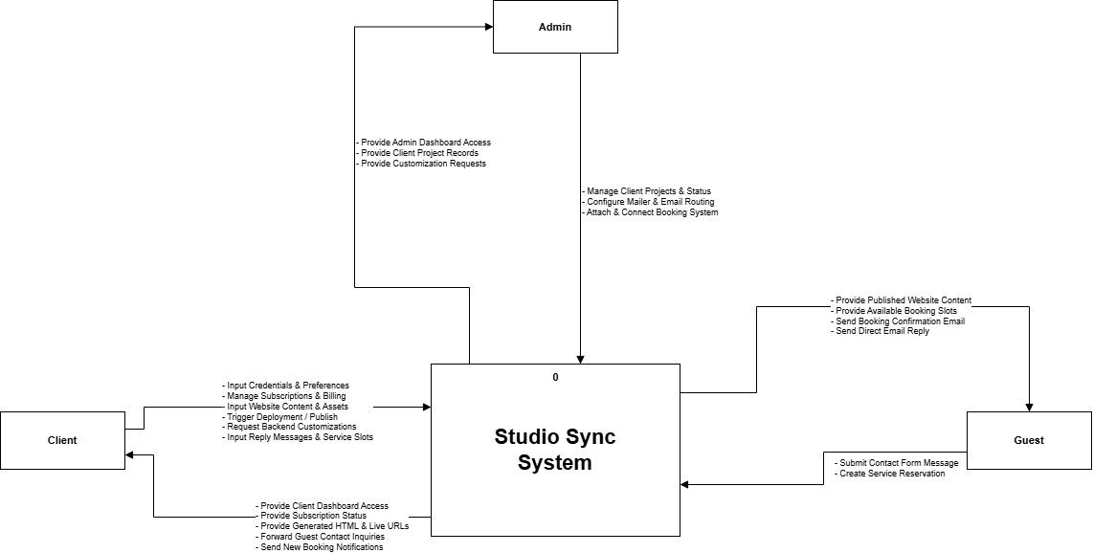
The context diagram in the file shows the Studio Sync System itself at the center, represented as a single process. Surrounding this central process are external entities Admin, Client, and Guest. These entities interact with the system by performing actions. The Admin manages client projects, configures mailer and email routing, and connects the booking system, while receiving admin dashboard access, client project records, and customization requests. The Client inputs website content and assets, manages subscriptions and billing, triggers deployments, and sets up service slots, while receiving generated HTML, live URLs, forwarded guest inquiries, and new booking notifications. Finally, the Guest submits contact form messages and creates service reservations while receiving published website content, available booking slots, booking confirmation emails, and direct email replies.
Data Flow Diagram
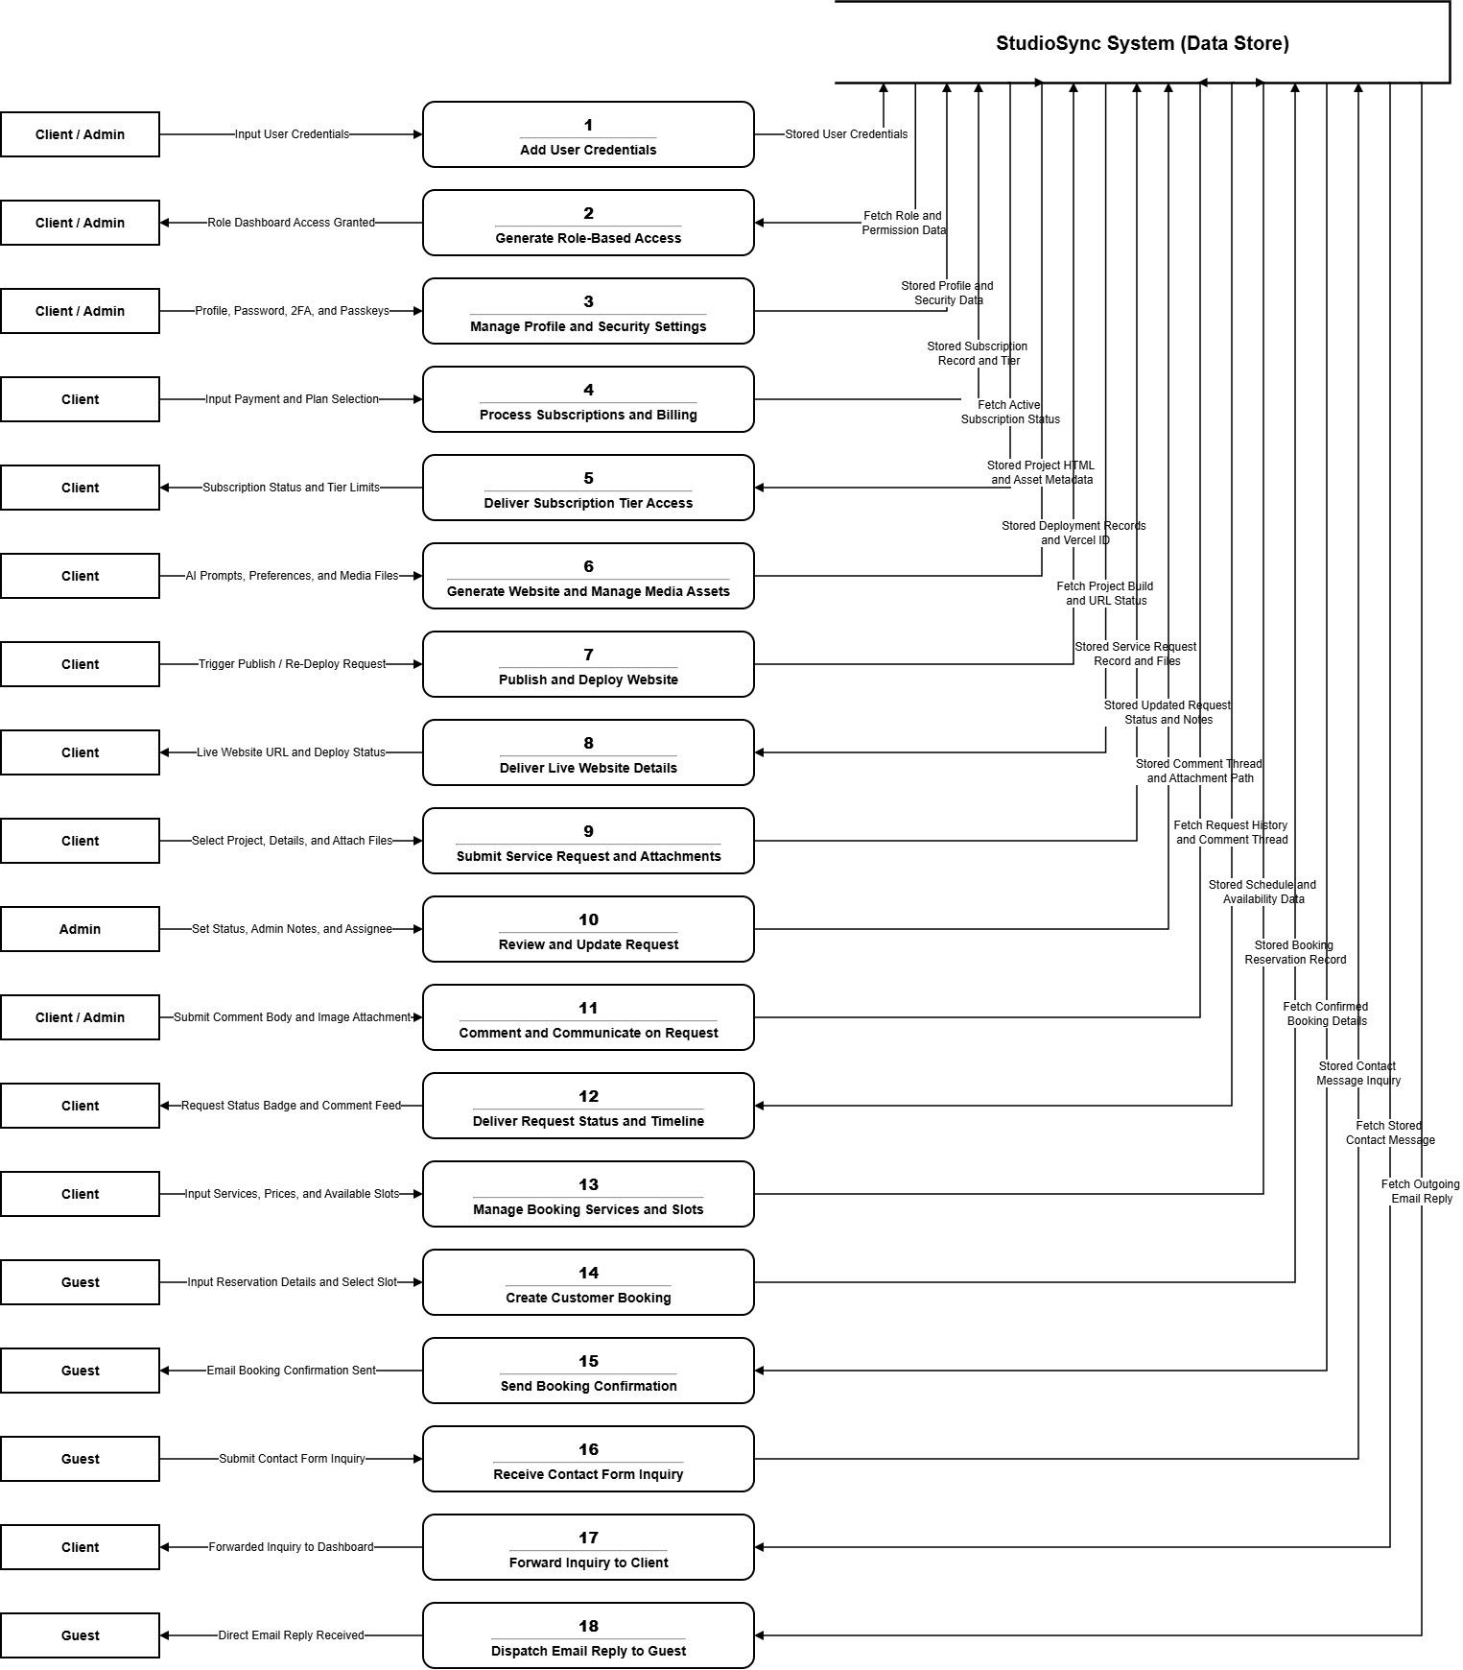
The data flow diagram illustrates how information moves through admins, clients, guests, and the databases interacting with the system to input, manage, or access data. The admins and clients provide user credentials to generate role-based dashboard access. Then clients input payment selections, AI prompts, project assets, and service schedules to generate and publish their websites. Guests input contact form inquiries and reservation details, which the system uses to send direct email replies and booking confirmations. Backend customizations, mailer routing, and booking system setups can be managed and configured by the admins, while clients can also submit feature requests, trigger deployments, and reply directly to guest inquiries. This data flows into the portal's central processes, which include storing generated HTML, deployment statuses, and booking schedules in the Studio Sync System database. Finally, the system can fetch user roles, available plans, project files, and available booking slots to coordinate platform operations.
Entity Relationship Diagram
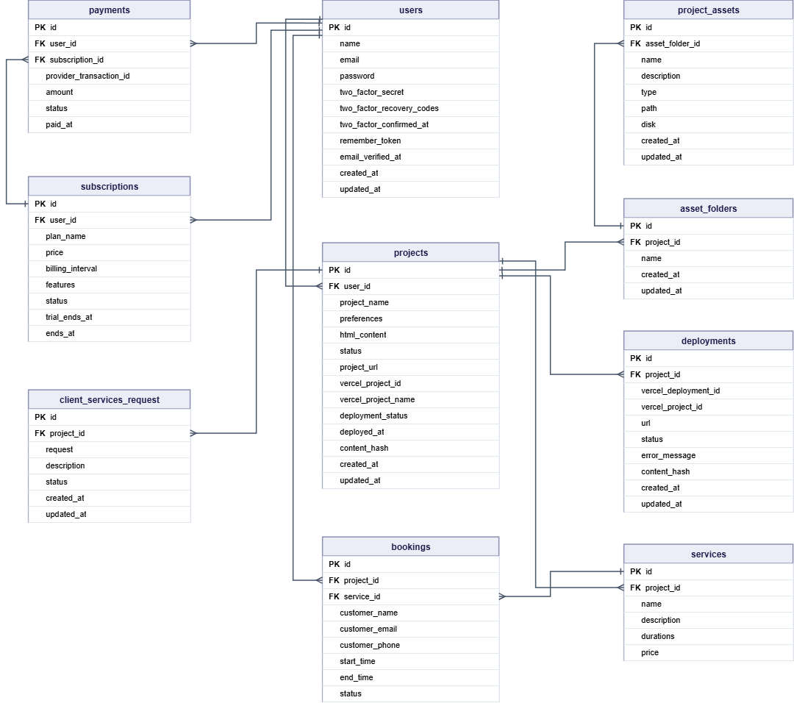
The Entity-Relationship Diagram (ERD) provides a structured visual representation of the database schema and relationships between key entities. The entities include users, payments, subscriptions, plans, workspaces, projects, client_services_request, bookings, services, deployments, asset_folders, project_assets, contact_messages, and contact_replies. Each entity is defined by specific attributes. A one-to-many relationship exists between users and workspaces, meaning each user can create or manage multiple workspaces, but each workspace is linked to one user. A one-to-many relationship exists between workspaces and projects, meaning each workspace can encompass multiple projects, but each project is assigned to only one workspace. A one-to-many relationship exists between projects and several other entities—including bookings, services, deployments, asset_folders, client_services_request, and contact_messages—meaning a single project can manage multiple instances of these elements. A one-to-many relationship exists between services and bookings, allowing a single service to be tied to multiple bookings over time. Additionally, one-to-many relationships link users to both subscriptions and payments, plans to subscriptions, and subscriptions to payments to map out the billing lifecycle. Further one-to-many relationships connect asset_folders to project_assets, and contact_messages to contact_replies. The ERD effectively maps out the data structure of this project and workspace management system, ensuring clarity in database design and facilitating efficient data management and retrieval.
CHAPTER 4
Design of the System
Log in
This screen provides authentication and security for users. Registered photographers and administrators input their username/email and password or activate hardware-backed biometric Passkeys (WebAuthn) for secure, passwordless authentication into their dashboard.
Registration
This screen allows new photographers to register and create their personal StudioSync accounts. The form captures username, email, and secure password credentials with client-side and server-side validation to ensure data integrity.
Dashboard
Serves as the primary operational hub upon login. It displays summary metric cards including total projects, active deployments, unique visitor traffic, and pending client bookings, alongside quick-action buttons to launch new generation requests.
Workspace and Project List
Displays a complete categorized list of the photographer's workspaces and projects. Users can view project statuses (Draft, Generating, Generated, Deployed), switch between distinct photography brands, or create new project workspaces.
Design Preference Form
Allows photographers to configure aesthetic parameters before AI generation. Users select their photography niche (Wedding, Portrait, Editorial, Commercial), primary and secondary color palettes, typography styles, and required sections (Hero, About, Gallery, Services, Testimonials, Contact).
AI Generation and Preview Page
Presents real-time status indicators while the background queue processes the Gemini AI generation pipeline. Once synthesized, the page renders an interactive live preview of the generated HTML and Tailwind CSS landing page.
Page Customizer and Editor
Provides an in-browser visual editing workspace where photographers can click to edit text copy inline, adjust typography scales, customize styling classes, and inspect raw HTML5 markup without manual coding.
Deployment Manager
Manages the automated cloud deployment to the Vercel edge network. With a single click, the system bundles project assets, executes edge publishing, and displays the live, SSL-secured .vercel.app URL with sharing shortcuts.
Media Asset Library
A visual file manager connected to Cloudflare R2 object storage. Photographers can create custom asset folders, upload high-resolution photographs, view image previews, and copy public CDN URLs to populate their galleries.
Booking and Reservation Page
An embedded public scheduling interface on the photographer's landing page where prospective clients can browse package inclusions, select open calendar dates and times, and submit booking requests with instant email confirmations.
Client Service Request Page
A collaborative ticketing portal allowing clients to submit custom design requests and feature additions, attach reference imagery, track status updates, and participate in threaded discussions with the photographer.
Analytics and Reports Page
Presents detailed visual charts and statistical metrics regarding landing page performance, tracking total page views, visitor engagement, device breakdowns (mobile vs desktop), and booking conversion rates over time.
Conclusion and Recommendation
In conclusion, the Studio Sync: Web-Based Landing Page Customization and Generation System for Photographers project has successfully fulfilled its goals. The project aimed to replace the old, manual, expensive, and technically intimidating process of web portfolio development with an automated, AI-driven platform tailored specifically for visual artists. Its main goal was to eliminate technical barriers, reduce reliance on volatile social media algorithms, improve business efficiency, and enhance client booking satisfaction. These objectives have been achieved through the implementation of StudioSync.
Firstly, the StudioSync system has greatly reduced the workload and technical barrier for photographers. Building a professional, responsive portfolio that once required extensive coding knowledge or expensive web development contracts can now be accomplished in minutes through simple preference selections and automated AI generation. This has eliminated repetitive manual coding and allowed photographers to focus on their creative art and client relationships rather than struggling with web development frameworks.
Secondly, the project has simplified how portfolios, high-resolution media, and client bookings are managed. Photographers can now upload, organize, and stream their full-resolution galleries via Cloudflare R2 without quality degradation or bandwidth fees, and deploy their landing pages instantly to the Vercel edge network with live URLs. Furthermore, the embedded booking calendar provides accurate, real-time availability tracking, making client inquiry and appointment scheduling seamless and less prone to mistakes.
Thirdly, the system has streamlined the client communication and customization process. Prospective clients can easily browse services, reserve dates, and receive automated email confirmations, while existing clients can submit specific revision requests and converse directly through a threaded ticketing module. This speeds up client onboarding and ensures clear, professional collaboration.
Lastly, the system has solved many problems local freelance photographers faced with informal social media operations. While it initially utilizes dynamic placeholders and focuses on single-page landing architectures, it provides a reliable, secure, and modern way for photographers to establish a credible digital brand and automate bookings. This project is a great step toward modernizing digital operations for creative professionals in the Philippines, and it can be improved further in the future by adding more features.
Overall, the StudioSync platform has helped photographers become more organized, visible, and commercially efficient. It improves freelance productivity and provides a better experience for clients by making portfolio generation and booking management intuitive, fast, and reliable.
Recommendations
To further improve the StudioSync platform and make operations even more efficient and user-friendly, the following recommendations are proposed for future enhancements:
Develop Local Philippine Payment Gateway Integration: Enable clients to pay booking deposits directly through local Philippine digital wallets such as GCash, Maya, and QR Ph, increasing convenience for local customers and expanding the photographer’s reach to a wider audience.
Automate Custom Domain DNS Routing: Allow photographers to connect and manage their own custom root domains (e.g., www.photographername.com) directly from the dashboard using automated Cloudflare or Vercel DNS APIs without manual DNS editing.
Expand to Multi-Page Website Generation: Extend the AI generation engine to create multi-page portfolio websites, including dedicated client proofing galleries, commercial client archives, and photography blogs for improved SEO.
Integrate On-Platform AI Image Optimization: Introduce automatic image watermarking, WebP compression, and AI-assisted retouching directly within the Cloudflare R2 media upload workflow.
Develop a Mobile Companion Application: Build a native mobile app for iOS and Android to receive real-time push alerts for new bookings and client service requests on the go during active photo shoots.
By implementing these recommendations, the StudioSync system can become more comprehensive, versatile, and user-friendly. Adding local payment options will improve checkout convenience. Automated custom domain routing will strengthen brand identity. Expanding to multi-page generation and image optimization will provide a complete digital studio suite. Regular updates and enhancements will ensure the system stays current with creative industry needs, ultimately enhancing both photographer productivity and client satisfaction.
Bibliography
Cordova, J. M., Santos, A., & Reyes, P. (2025). Barriers to digital transformation and technological adoption among Philippine MSMEs. Philippine Journal of Business and Economics, 22(1), 34-51.
Davis, R., & Chen, L. (2024). Overcoming technical barriers in digital portfolio creation for freelance creatives. International Journal of Digital Design, 15(2), 112-128.
Garcia, E. T. (2024). Adapting AI-driven business tools for independent contractors in the Philippines. Manila Journal of Technology, 9(2), 115-130.
Miller, S., & Zhao, X. (2024). Artificial intelligence in web design: Automating portfolio generation for non-technical users. Journal of Automated Software Engineering, 19(1), 200-215.
Peña, L., & Yao, M. (2023). Navigating the digital platform economy: Challenges and digital anxiety among rural freelance workers in the Philippines. Asian Journal of Information Systems, 11(3), 88-105.
Thompson, E. (2023). The democratization of web development through AI-driven website builders. Computers in Human Behavior, 142, 107650.
Villanueva, C., & Ocampo, R. (2023). Accelerating digital adoption for Philippine freelancers through accessible technology. Southeast Asian Journal of Digital Transformation, 5(4), 77-92.
Williams, T. (2023). The cost of digital obscurity: Financial constraints in web development for independent artists. Journal of Creative Industries, 8(4), 45-60.
Congress of the Philippines. (1992). Republic Act No. 7394: The Consumer Act of the Philippines. Manila, Philippines.
Congress of the Philippines. (1997). Republic Act No. 8293: Intellectual Property Code of the Philippines. Manila, Philippines.
Congress of the Philippines. (2000). Republic Act No. 8792: Electronic Commerce Act of 2000. Manila, Philippines.
Congress of the Philippines. (2012). Republic Act No. 10173: Data Privacy Act of 2012. Manila, Philippines.
Framer. (2023). Framer AI: Generate sites with AI. Retrieved from https://www.framer.com
Hostinger. (2023). AI Website Builder and Cloud Management. Retrieved from https://www.hostinger.com
Wix. (2023). Wix ADI: Artificial Design Intelligence in automated web creation. Retrieved from https://www.wix.com

