Nagize impanuka ejo ubwo narindi mu muhanda nyuma nkaza guhura

Ni imodoka iri kwihuta cyane maze ikangonga maze ikangirika.

Nkaba mfite ama pic yimanuka arimo naya.

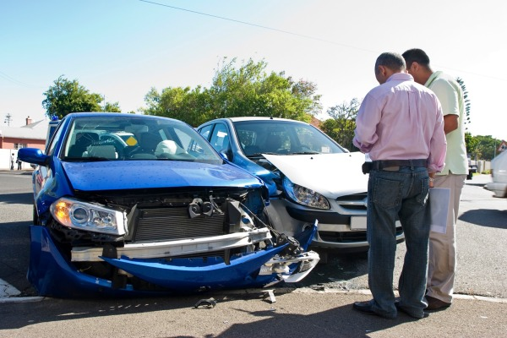

Nkaba shaka ukunu nabona ubwishyu bw’imodoka yanjye

Murakoze cyane mugire umunsi mwiza