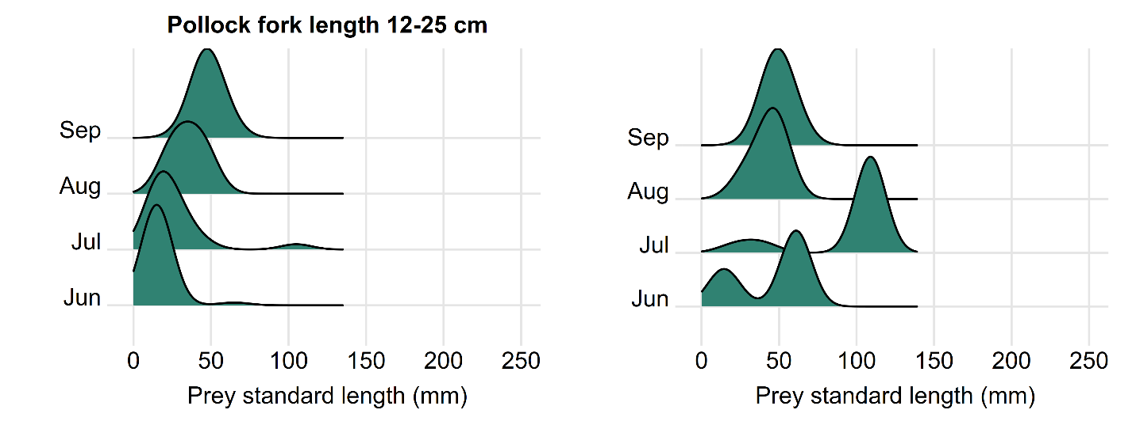

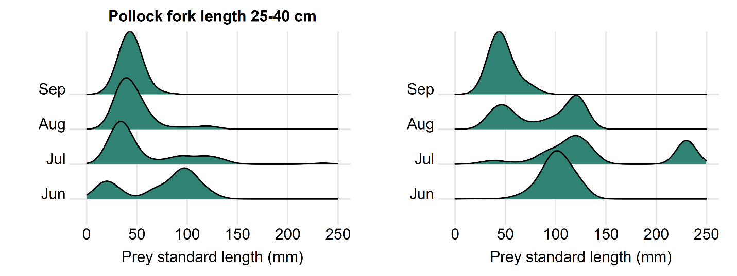

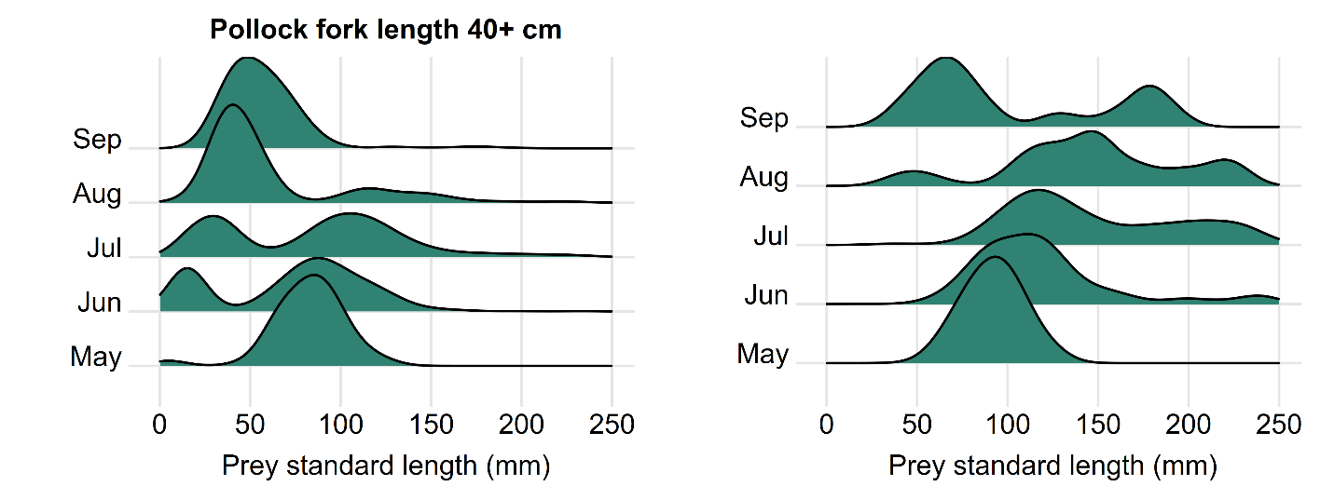

**Figure 6.** Numerical frequency (left figures) and % by weight based on length-weight regressions (right figures) of pollock prey standard lengths measured in pollock stomachs collected in the NOAA AFSC bottom-trawl and hydroacoustic surveys 1981-2019, for pollock predators of fork length 12-25cm (133 prey measurements from 66 predators, top); fork length 25-40cm (216 prey measurements from 78 predators, middle); and fork length 40+cm (4,606 prey measurements from 1,781 predators, bottom).

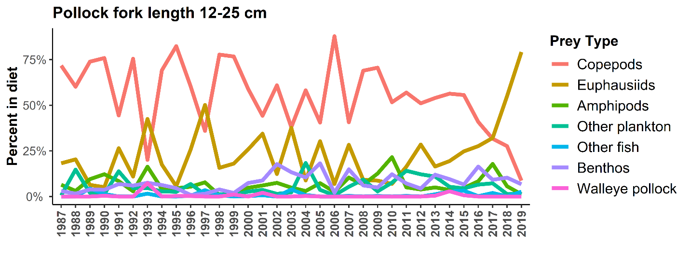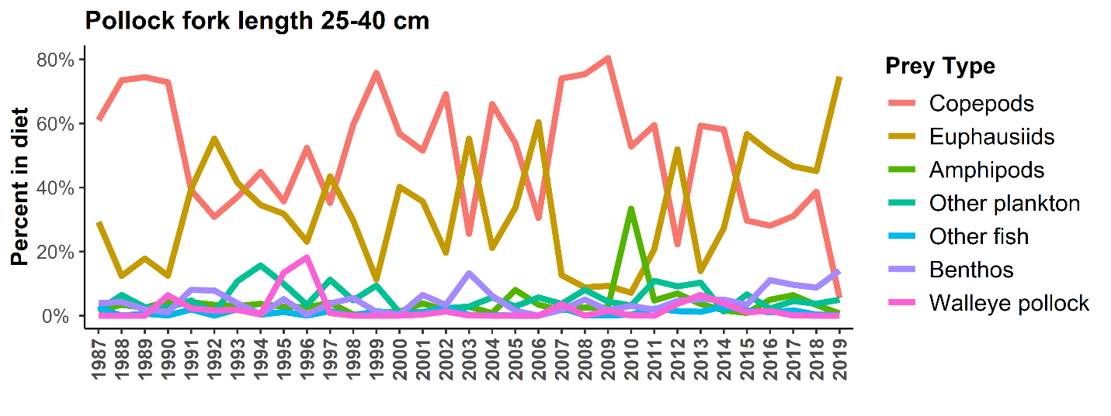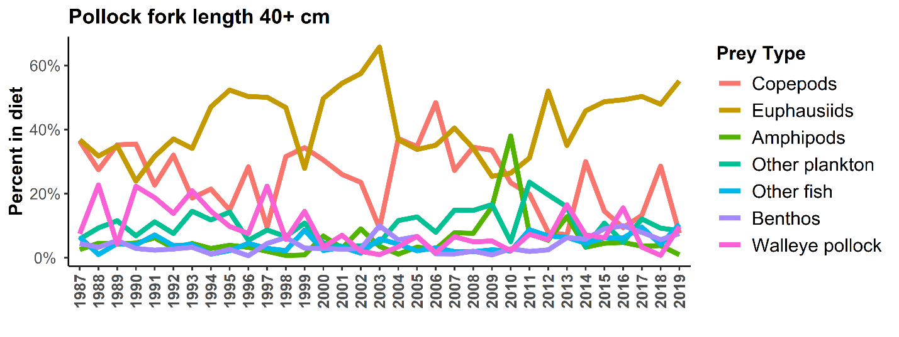

**Figure 7.** Percent by weight of prey from pollock of different fork lengths (12-25 cm, top; 25-40 cm, middle; 40+cm, bottom) summed across regions of the middle and outer shelves sampled by the annual AFSC bottom-trawl surveys from 1987-2019 (see Figure 3).