**DOCUMENTATION**

**Introduction**

This application is called Account Registration App. This application is used to record certain information of the students. Those were their complete name (first, middle and last), ID no. which will also serve as their password, their email address, and their phone no. these information will be a great use for future reference since those data wont be erased unless you purposely erase it from the app. There’s no limit of how many data you want to record using this application. You can modify the information that has been recorded here just ensure that you have “enter” it so that it will be changed.

**Technologies**

The technologies that has been used in developing this application system are Netbeans, MySQL Workbench, and Wamserver only.

**Screenshots**

This is the log in form of the application where the user will have to enter his/her username and his/her password. After filling all the information needed, the user will have to click the “Login” box for him/her to enter to the application. The “Cancel” box here will make the application to be downed.

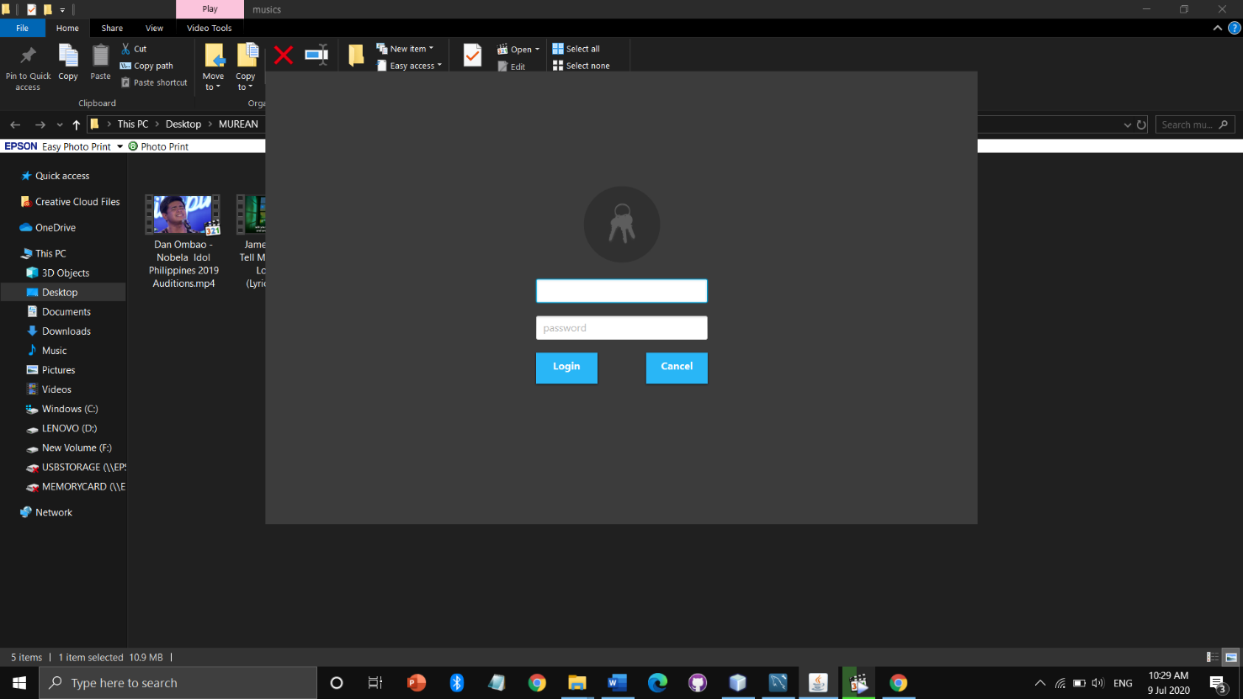

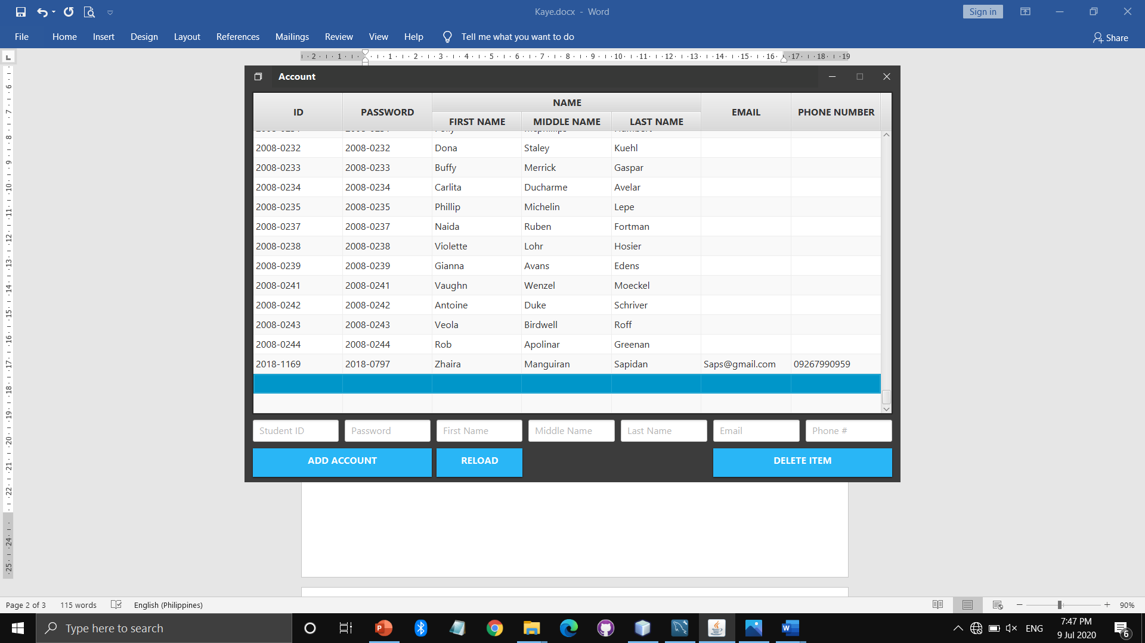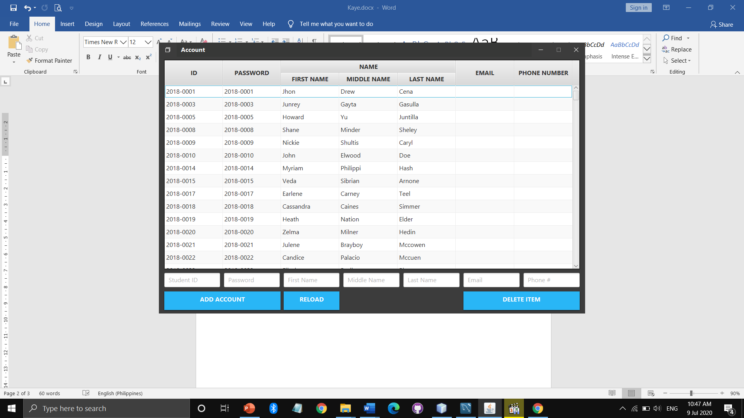

Delete whole column column

Refresh

Add another column

After clicking the Login box this will be the display that will be shown by the app. This part of the application contains tables where the user will fill it with the information needed from students namely ID no., password (ID no.), complete name of the student, email address and phone no.

**Team Members**



Name: Keiza Lorraine Lodovice

* Encoder
* Designer of the application



Name: Rona Jane Ramirez

* Video editor
* Designer of the application
* Documentation editor