Rence Quinio

Biga, Calapan City

Friday,June23,2023

Authorization Letter for Claiming the Prize of the Battle of the Bands

Dear Cashier,

I, Rence Quinio, hereby authorize Lucky Axl, to claim the prize on my behalf for winning the Battle of the Bands competition held on June 19,2023. Unfortunately, due to a family gathering scheduled for the same day, I am unable to personally attend the prize collection ceremony.

I trust Lucky Axl to act as my representative and perform all necessary actions to receive the prize in question.

Thank you for your understanding and assistance in this matter. I trust that Lucky Axl will handle this responsibility with utmost care and professionalism.

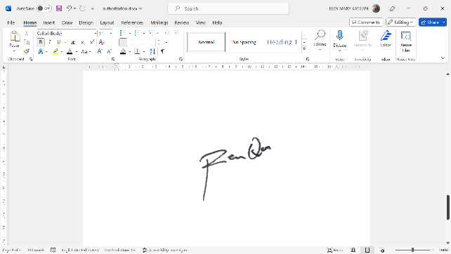Yours sincerely,

Rence Quinio

Jun Mark Moreno

Biga, Calapan City

Friday,June23,2023

Authorization Letter for Claiming the Prize of the Battle of the Bands

Dear Cashier,

I, Jun Mark Moreno, hereby authorize Lucky Axl, to claim the prize on my behalf for winning the Battle of the Bands competition held on June 19,2023. Unfortunately, due to a family gathering scheduled for the same day, I am unable to personally attend the prize collection ceremony.

I trust Lucky Axl to act as my representative and perform all necessary actions to receive the prize in question.

Thank you for your understanding and assistance in this matter. I trust that Lucky Axl will handle this responsibility with utmost care and professionalism.

Yours sincerely,

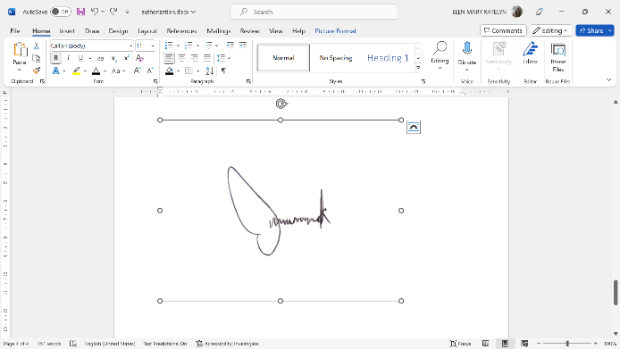

Jun Mark Moreno

