COVID-19 Data Integration, Analysis, and Visualization Platform
REPORT

1. Data Exploration and Enhancement
1.1 EDA
First of all I would like to see what tables are in this dataset.

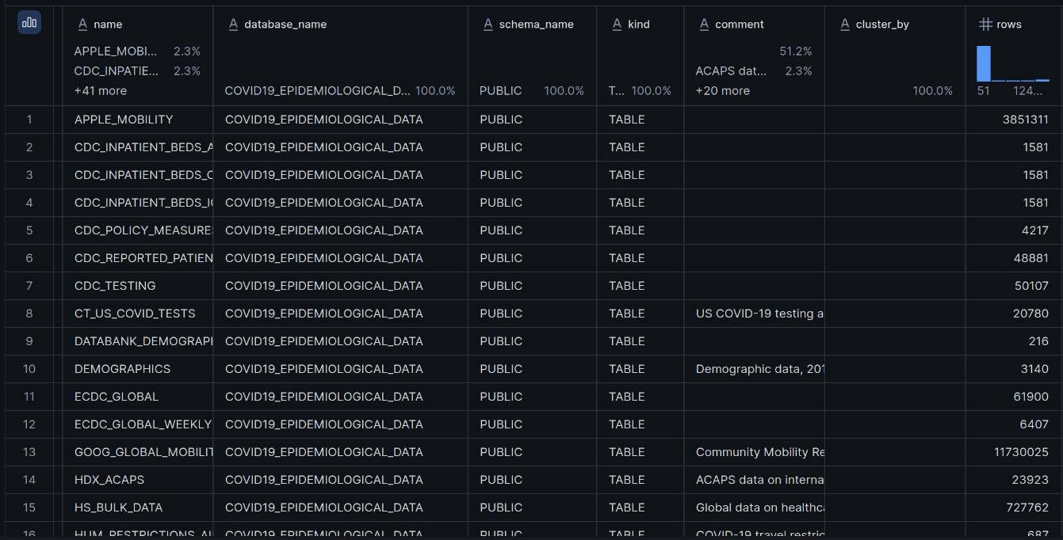
Picture 1.1.1 Tables that COVID-19 dataset comprises
In total the database comprises 43 tables. It is not reasonable to use every single one for this project simply due to limitations with available credits for manipulations with data, so I think that we need to look at the number of rows each table has and decide where we are likely to find great insights.
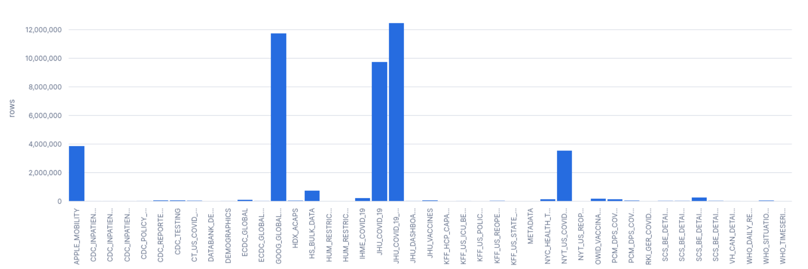
Picture 1.1.2. Number of rows in each table
The COVID-19 Epidemiological Data contains many datasets with significantly different sizes. During the exploration of tables I came to the conclusion that the largest tables include JH COVID-19 data, Google mobility data, and Apple mobility data. I decided to choose the JH dataset (JHU_COVID_19) as the primary epidemiological source and believe that I should stick to it without undertaking EDA on many tables because it will likely result in a messy, hard to maintain report and superficiality of the investigation. I think that it is better to concentrate on a single good table and discover its features and patterns in depth.
Now I would like to see exactly what types of columns they consist of and for that I would need to look into the description of each of them.
JHU_COVID_19:
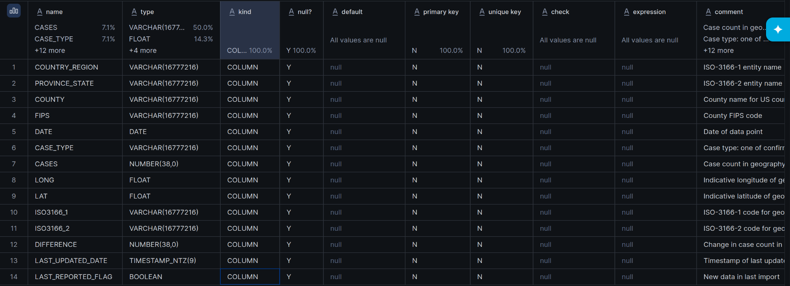
Picture 1.1.3. The description of JHU_COVID_19 table
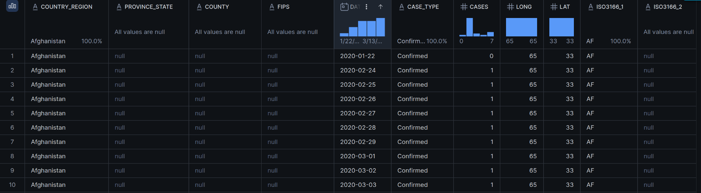 Picture 1.1.4.1. The first 10 rows in the JHU_COVID_19 table
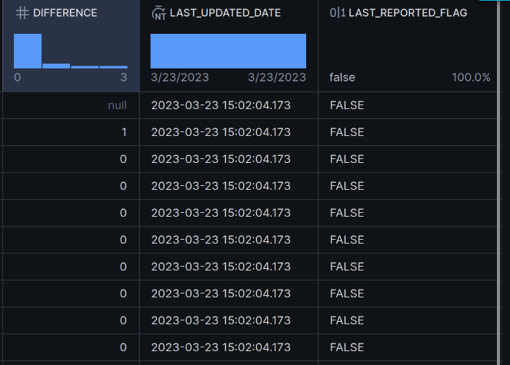
Picture 1.1.4.2. The first 10 rows in the JHU_COVID_19 table
I believe that the most important thing at this stage is to understand what kind of information a table tries to convey and if I understood correctly JHU_COVID_19 is a time-series table where granularity is that each row represents one case type for a specific geographic location on a specific date. So in simple words the granularity can be depicted as:
one row per date × geographic location × case type
First of all I would like to see what case types are available in this table:

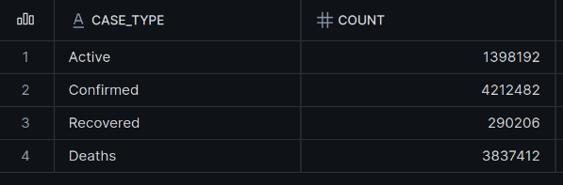
Picture 1.1.5.1. Descriptive statistics: Types of cases along with its number of rows
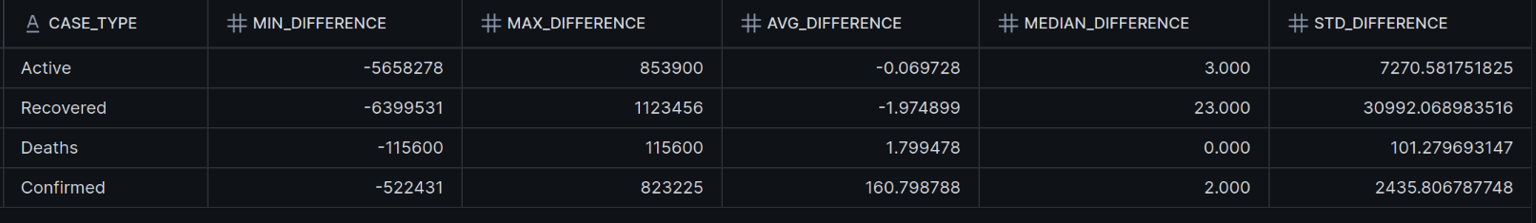
Picture 1.1.5.2. Descriptive statistics: Types of cases along with its distribution statistics
The descriptive statistics show large differences between case types and several extreme positive and negative values. The median values are much lower than the averages, which indicates that the data is highly skewed and affected by outliers. Recovered and active cases show especially high variability, indicating that some corrections and reporting changes were applied in the dataset.

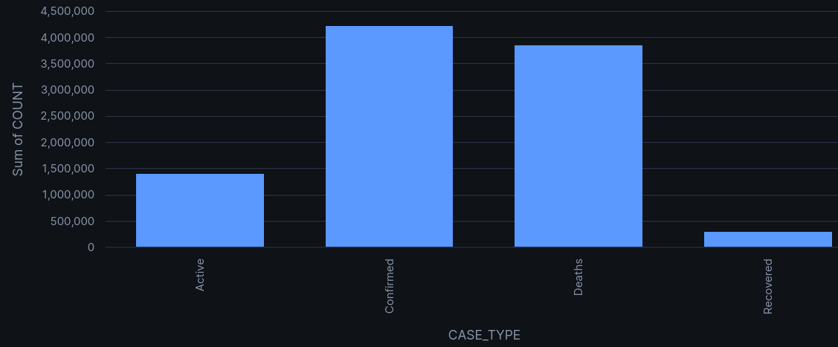
Picture 1.1.6 The distribution of case type labels in the table
And to be precise there are 3837412 of deaths records, 4212482 of confirmed records, 290206 of recovered and 1398192 of active records.
I would like to know the date range because I didn’t see it mentioned in the database and table descriptions. So based on the picture 1.7 I see that the date range is between 2020-01-22 and 2023-03-09:
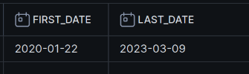
Picture 1.1.7 Date coverage of data in the JHU_COVID_19 table
Also I would like how many unique values in COUNTRY_REGIONS columns along with list of top 20 countries by the number of rows:
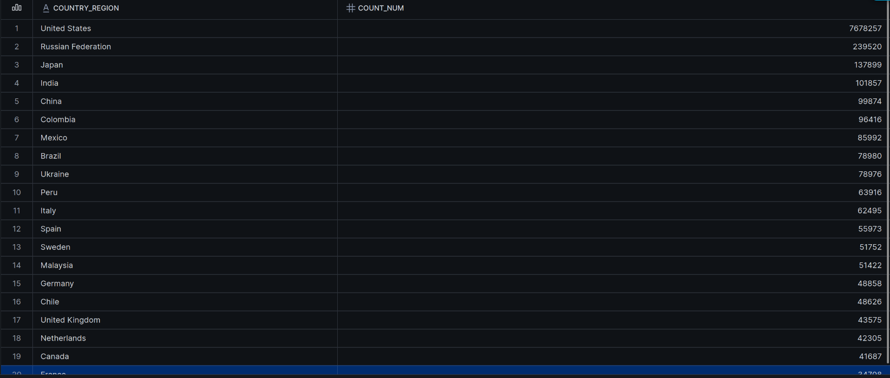
Picture 1.1.8 Top 20 countries by the number of rows
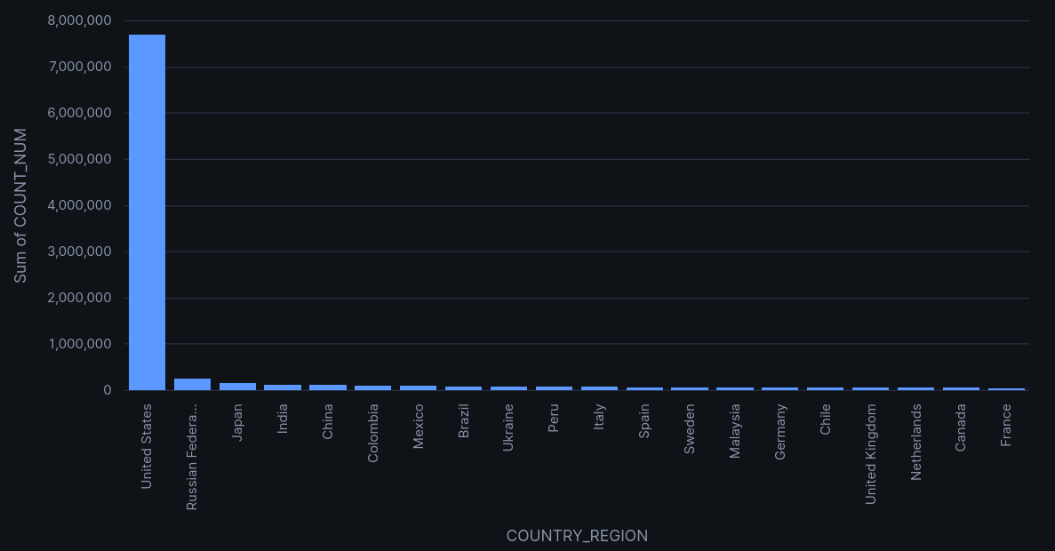
Picture 1.1.9 Bar chart with top 20 countries by the number of rows
Based on information provided by Picture 1.1.8 and Picture 1.1.9 I can conclude that this dataset has an overwhelming number of rows dedicated to the USA. However it doesn’t indicate that It had the most COVID-19 infected population. It is due to the specifics of location not ending on COUNTRY REGION alone (in the case of the USA it is a state), its states are also divided into counties, so the number of combinations is way higher than in other countries. I would say it is more geographically detailed, because county-level reporting creates vastly more rows.
I already know that there are such columns like COUNTRY _REGION, PROVINCE_STATE and COUNTY, however I don't know how many of each of them we have in this data.
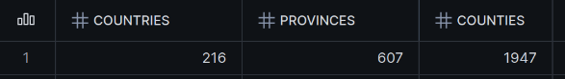
Picture 1.10 Number of geographical locations for each level

During the first observations on this table I noticed that there are some columns that have a lot of null values, so in pictures 1.1.9.1 and 1.1.9.2 you can see the exact number of them.

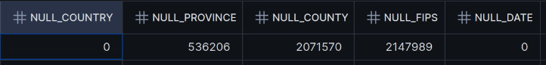
Picture 1.1.11.1 Number of null values in the JHU_COVID_19 table
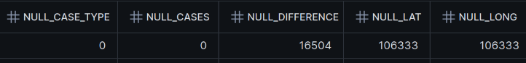
Picture 1.1.11.2 Number of null values in the JHU_COVID_19 table
It is reasonable to assume that some countries might not have separate names for provinces and counties. However, what is really important to notice here is that FIPS is actually mostly dedicated for USA since it has over 7 millions of rows of not null FIPS and it is quite understandable because FIPS that stands for Federal Information Processing Standards originates from the USA. For more details look at Picture 1.1.10.
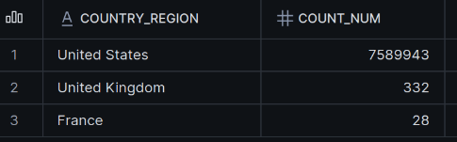
Picture 1.1.12 Countries with the number of rows where FIPS is not NULL

Lets proceed with Picture 1.1.11.2 and what actually caught my eye is NULL latitude and longitude of the location. So I wanted to check if there is some interesting pattern to it and actually there is. It is a deliberate action because they can not simply give any other number for the coordinate to something they are not sure of or can not disclose, since it will lead to completely another distinct location.
I would like to start with the USA, since we already know that it is the majority in this dataset, it has the most null values in null latitude and longitude. So on Picture 1.1.11 you can see that there are null values in these columns when they can not exactly give a specific county.
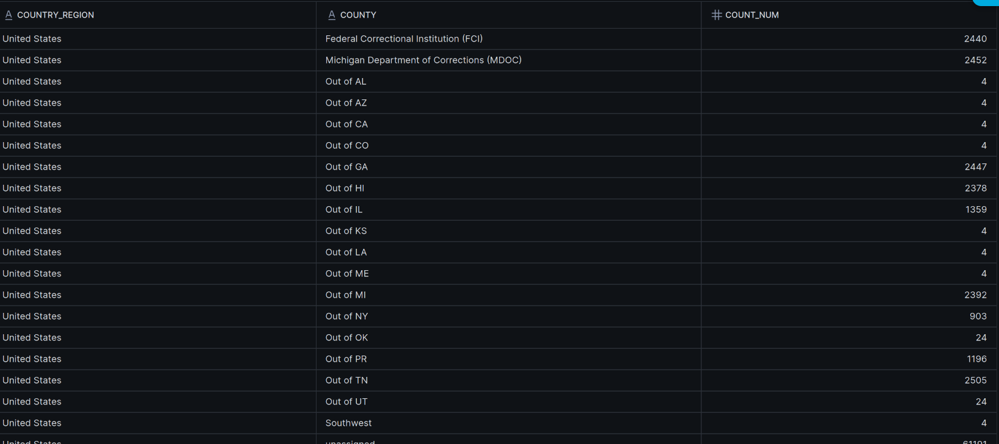
Picture 1.1.13 USA Locations where coordinates are NULL
Speaking of other countries that have the same problem, based on Picture 1.1.12, the situation is actually the same: they do not give exact coordinates when the region inside the country is shown as Unknown.
Also I noticed that this dataset is not perfectly clean in terms of strict geography. We can see Cruise Ship in COUNTRY_REGION column and some cruise ships names like Diamond/Grand Princess along with port quarantine in Japan and Repatriated travellers in Canada as PROVINCE_STATE. So it is most likely that this dataset can not give exact coordinates for cases like this.
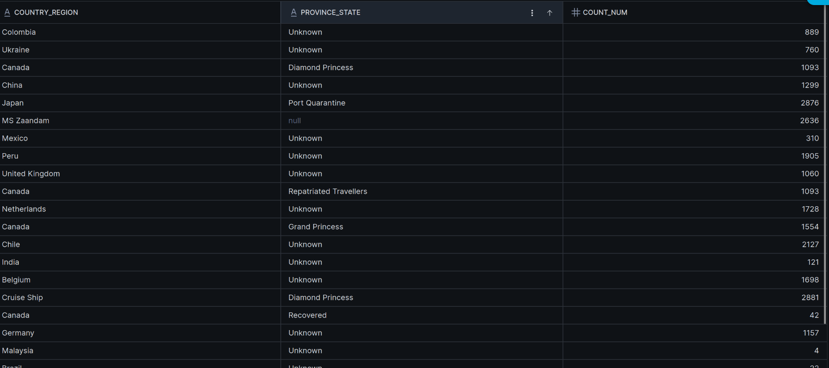
Picture 1.1.14 Locations where coordinates are NULL

Then I would like to check if there are some duplicated values in this table to see whether it is consistent:
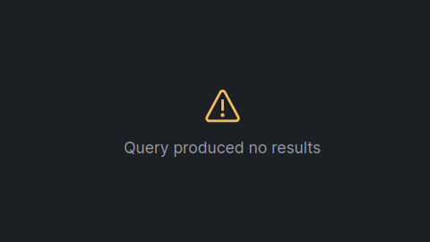
Picture 1.1.15 Checking whether there are duplicates
As you can see on the Picture 1.1.15, the query did not produce a result, meaning that there are no duplicated values.

Now I would like to find out how many people were infected by, died or recovered from COVID-19 in the top 15 countries ordered by these metrics. In order to achieve it I used column difference because it basically shows how case count actually changed throughout these 3 years and as a result of summarizing we get the total number for people that were either infected, died or recovered from this virus. During this investigation I found out that there are some countries where column DIFFERENCE was not calculated or populated so it resulted in null values for aggregation of column DIFFERENCE like on Picture 1.11.6. THe same situation can be observed in other types of cases
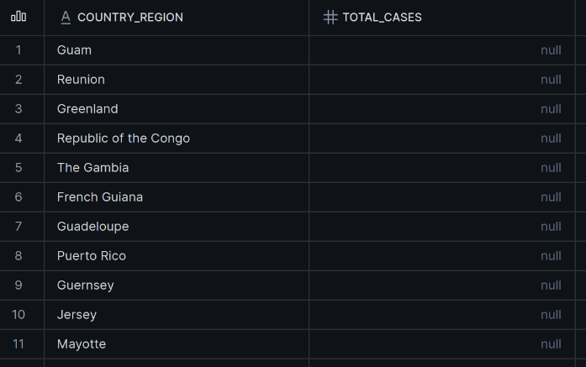
Picture 1.1.16 Countries where column difference was not populated
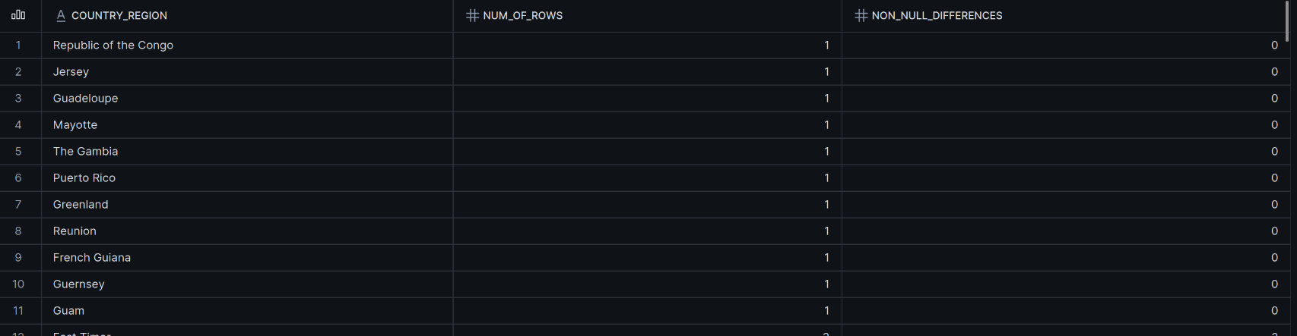
Picture 1.1.17 Number of populated differences for case type “Confirmed”
This picture above basically proves my point that the column DIFFERENCES is not populated for these countries and actually results in null for aggregation.
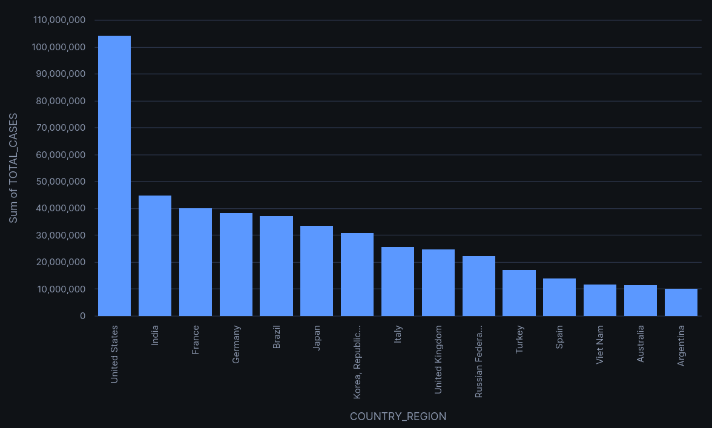
Picture 1.1.18 Top 15 countries by confirmed cases
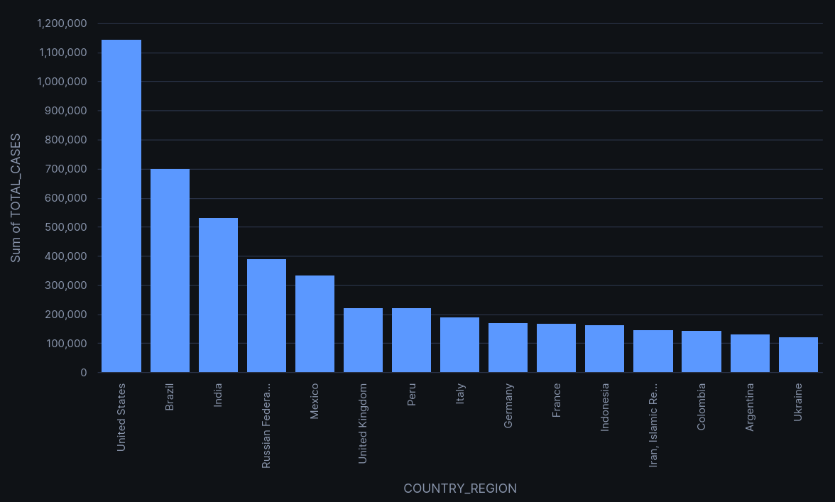
Picture 1.1.19. Top 15 countries by deaths
Later on, it turned out that recovered cases were not suitable for aggregation using SUM(DIFFERENCE) across the full time period. In some countries, the cumulative recovered count was later reset to zero when recovery reporting was discontinued. For example, on Picture 1.1.20 Argentina had 4,615,834 recovered cases on 2021-08-04, followed by 0 on 2021-08-05, producing a DIFFERENCE value of -4,615,834. As a result, summing DIFFERENCE over the whole period cancels previous positive recovery values out and may mislead by incorrectly producing a total close to zero. Therefore, trying to sum up only positive values can be beneficial. However the result is not satisfying, since it returned results that are basically have no relation to actual real-world statistics. See Picture 1.1.21 for more.
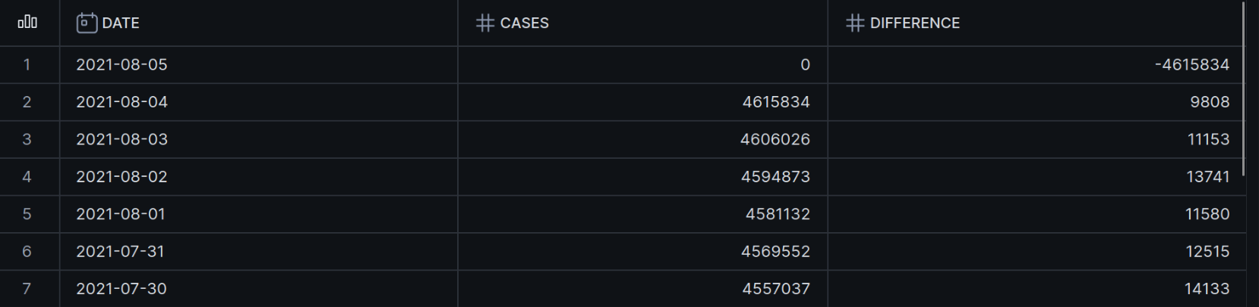
Picture 1.1.20 Example why summing won’t work for recoveries
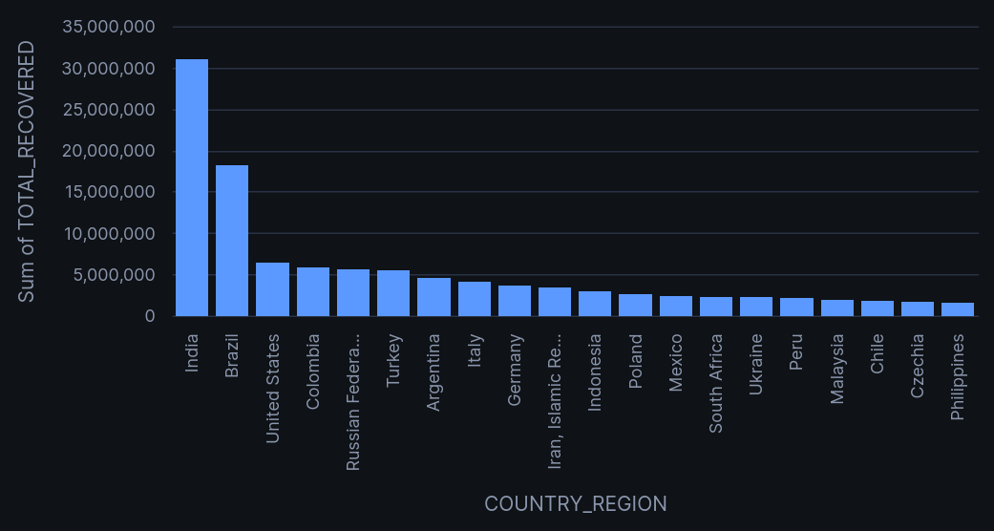
Picture 1.1.21 Bar chart with the number of recoveries for countries.
I would like to look at how total confirmed cases changed every month:
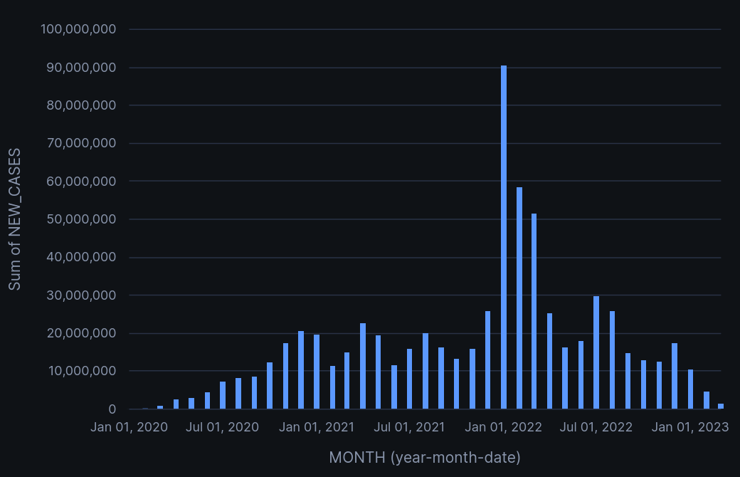
Picture 1.1.22 Total confirmed cases worldwide by month:

Since it is a time-series data it can be interesting to investigate rolling means for this table. For example finding out the confirmed cases mean for the past 7 days. It basically gives a better understanding of how its data changes than raw daily cases. Speaking of practical experience in data science I can tell that such kinds of metrics can actually provide a decent insight for prediction. This makes the overall infection trend easier to identify.
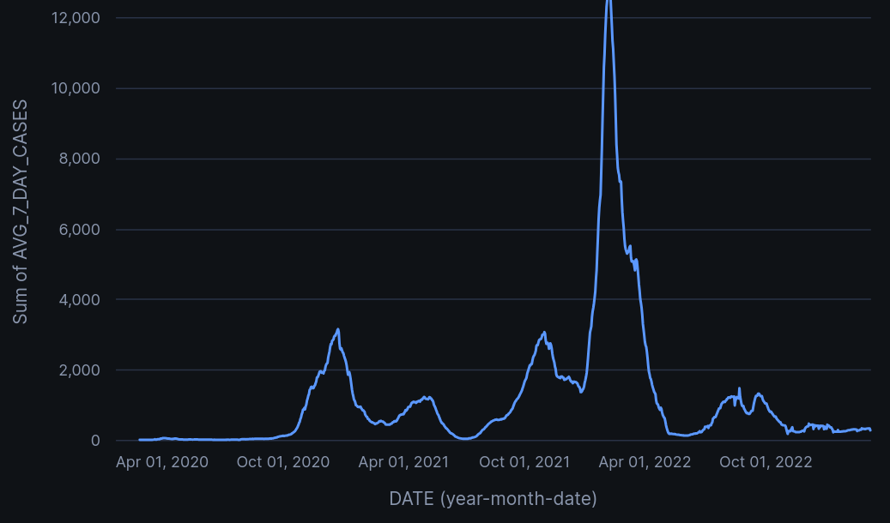
Picture 1.1.23 Daily new COVID-19 cases in Lithuania with a 7-day rolling average
What we can extract from the line chart above is that in March-April 2022 there was a surge in the number of infections. The COVID-19 table itself does not provide enough information to determine the cause of this rapid increase.
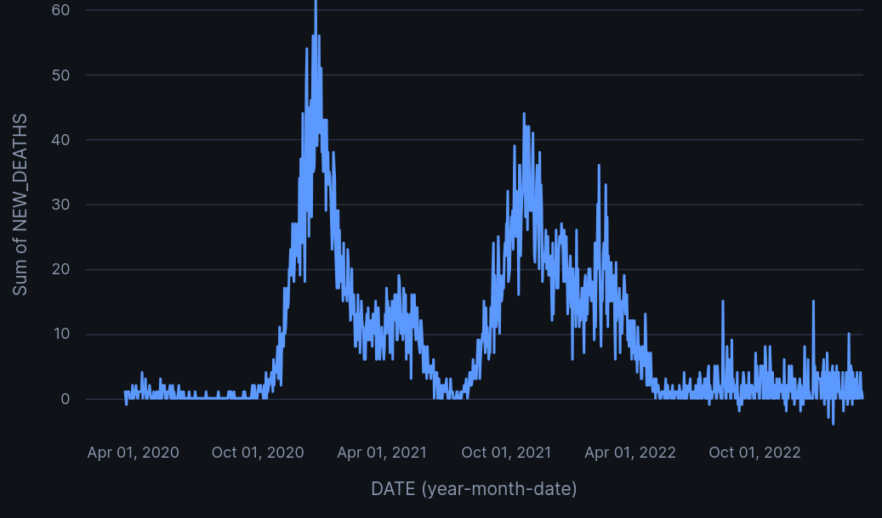
Picture 1.1.24 Daily mortality cases in Lithuania with a 7-day rolling average
The highest mortality was observed during the winter of 2020–2021, reaching approximately 55–60 deaths per day. A second significant increase occurred in late 2021, with around 40–45 deaths per day. From early 2022, mortality gradually declined, although occasional increases remained visible.

So, as a summary for the EDA section I would like to conclude: the JHU_COVID_19 table provides daily COVID-19 observations from January 2020 to March 2023 at varying geographic levels. Confirmed cases and deaths have the most complete reporting coverage, while recovered and active cases contain more significant reporting inconsistencies. Geographic and missing-value analysis also showed that data availability varies considerably between countries. Therefore, confirmed cases and deaths are the most reliable measures for further analysis.
1.2 Preparation and ingestion of an external dataset.
For the purpose of external dataset creation I decided to download three datasets: population, gpt per capita and population density. I am going to use them to enrich the COVID-19 dataset with additional context
The external datasets had different schemas and country namings, so PySpark was used to prepare them before ingesting them into Snowflake.
The population dataset initially stored years as separate columns, so the population dataset was transformed from wide format into long format using the Spark stack() function.
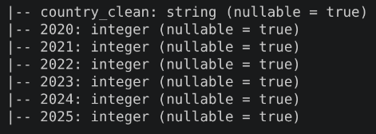
Picture 1.2.1 Schema for population dataset before transformation
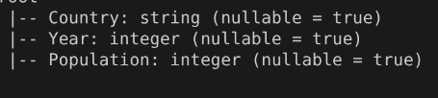
Picture 1.2.2 Schema for population after transformation
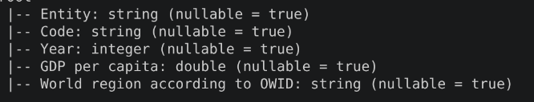
Picture 1.2.3 Schema for GDP per capita dataset
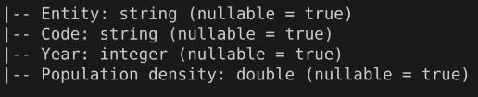
Picture 1.2.4 Schema for population density dataset
In all three datasets only the years from 2020 to 2023 were retained because this corresponds to the time coverage of the JHU_COVID_19 dataset.
Later on I identified an issue during the integration and it was about inconsistent country naming between the datasets. This resulted in null values after joining these datasets and this problem would have later on moved to the merge with JHU_COVID_19 in Snowflake. In order to resolve this issue I created country-name mapping in PySpark. All external datasets were normalized to the country namings used by the Snowflake dataset before the joins were performed.
So after running normalization the next step is to merge these tables using left join on columns country and year. Population served as the base dataset, while GDP per capita and population density were added as supplementary attributes.
Even after normalization there remained to be null values in GDP per capita dataset. I investigated the remaining missing GDP values separately. This time for most of these countries and territories the reason was not inconsistent namings but rather the fact that they did not contain corresponding values for the 2020–2023 period. Syria was a partial exception: GDP values were available for 2020, 2021 and 2022, but no value was available for 2023.
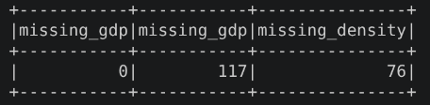
Picture 1.2.5 Number of missing values in tables before normalization
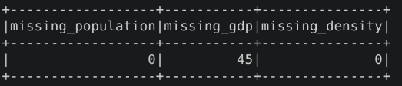
Picture 1.2.6 Number of missing values in tables after normalization

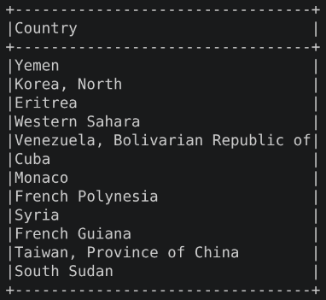
Picture 1.2.7 Countries that have null values
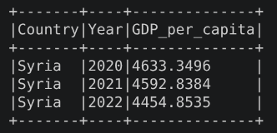
Picture 1.2.8 Statistics for 2023 is not available in Syria
On Picture 1.2.9 you can see that final schema for the external demographics datasets that is going to be ingested into Snowflake.
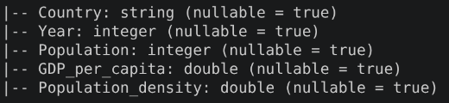
Picture 1.2.9 Schema for final demographics dataset
As the final part of this section, I ingested the resulting dataset into a Snowflake database called COIVD_ANALYTICS with the table name COUNTRY_DEMOGRAPHICS. On the picture 1.2.10 you can see the current structure of the database stored in the Snowflake. EXTRNAL_DATA schema is used for some external datasets that can be used to enrich JHU_COVID_19 data, whereas ANALYTICS schema will store views with country-level * year granularity for now, since demographics data has exactly this aggregation.
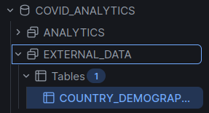
Picture 1.2.10 Structure of database COVID ANALYTICS

1.3 Integration of datasets
The original JHU_COVID_19 table has finer granularity, where each row represents a specific case type for a geographic location on a specific date. Therefore, the data could not be joined directly with the demographic table without first reducing it to a common granularity. Confirmed cases and deaths were aggregated by country and year.
The resulting view has 814 rows that is more that 772 (193 country * 4 years) and it is understandable, since I already mentioned that there are some inconsistencies in the names of regions like cruise ships, Olympic events and territories that are not represented in the external demographic datasets. Overall you can have a simple glance of how the view looks like on Picture 1.3.2.
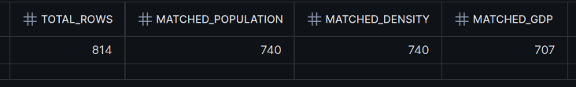
Picture 1.3.1 How many matched records in the data
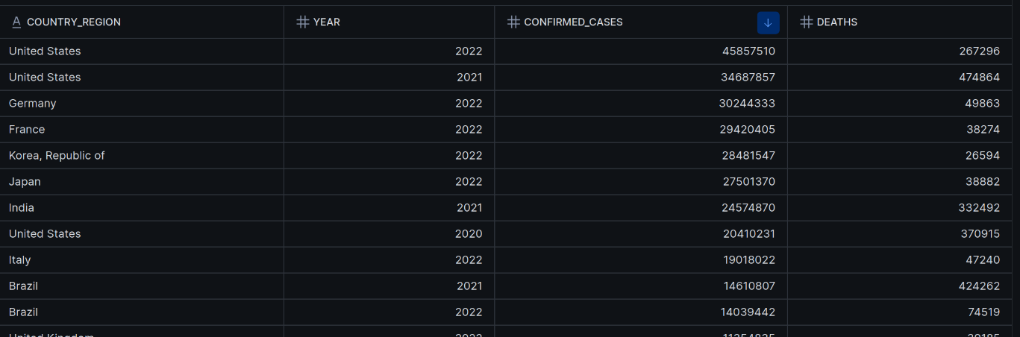
Picture 1.3.2 How data looks like after changing granularity
Since I got a view with fitting granularity, I can finally merge it with demographics data and engineer some columns to provide richer insight. As a result of this join several additional analytical features were engineered from the integrated dataset: CASES_PER_100K, DEATHS_PER_100K,CASE_FATALITY_RATE DENSITY_QUARTILE and GDP_QUARTILE. Here the bigger quartile is the higher density/gdp in the corresponding country. Refer to the Pictures 1.3.3 to see how this view looks like.

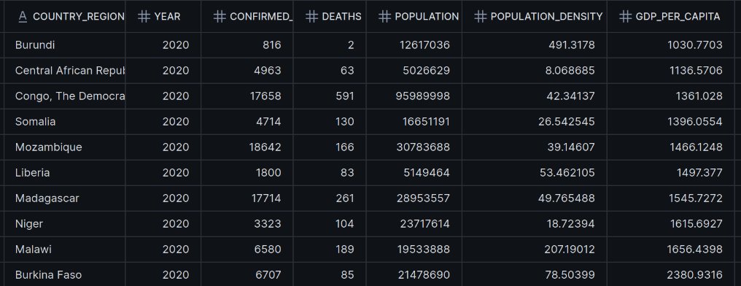
Picture 1.3.3.1 10 rows from COVID_DEMOGRAPHIC_ANALYSIS view
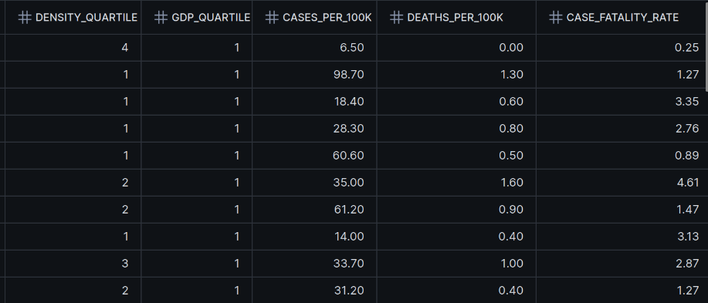
Picture 1.3.3.2 10 rows from COVID_DEMOGRAPHIC_ANALYSIS view
Quartiles would allow us to aggregate by year and quartile to see some possible trends and where the situation might be worse: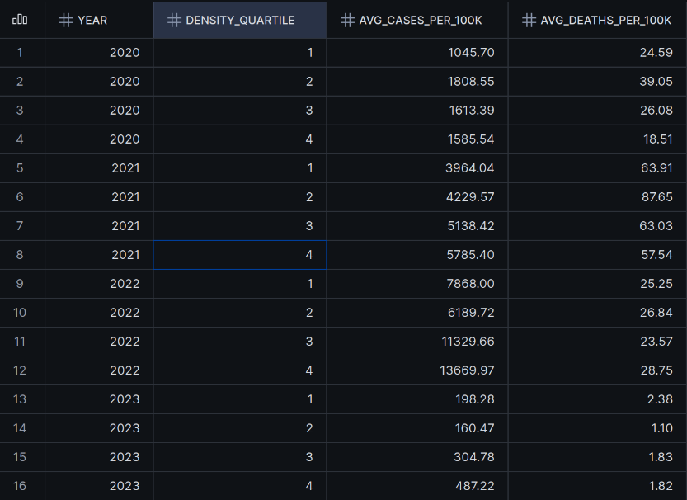
Picture 1.3.4 COVID_DEMOGRAPHIC_ANALYSIS grouped by YEAR and DENSITY_QUARTILE
The query used to get this table on Picture 1.3.4 groups countries into four population-density quartiles and calculates the average number of confirmed cases and deaths per 100,000 people for each group and year. It serves us as a measure to compare COVID-19 outcomes between countries with different levels of population density and investigate whether density may have something to do with infection or mortality rates. The same thing can be done with GDP_QUARTILE feature.

2. NoSQL
2.1 Designing schema in MongoDB database
As you already know from the name of this section, for the NoSQL database I chose MongoDB Atlas for storing supplementary data. Another reason why I chose it is that we covered it during bootcamp and it is a chance to practice working with it.
As I understood correctly MongoDB is going to be used for annotations created by users of my application. The data will mostly consist of id of this annotation, country this annotation is about, year that is described in comment, metric that author is referring to, and the author’s name itself.
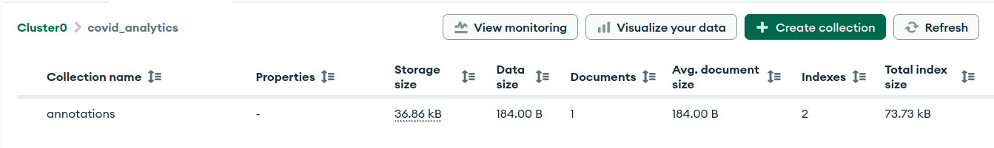
Picture 2.1 Table annotations from covid_analytics database along with its info
As you can see on the Picture 2.1, I created a database called covid_analytics in a MongoDB Atlas. This database contains an annotations collection where user annotations/comments on data points related to analytical results I got from the integration of JHU_COVID_19 and demographics dataset.
I know that since it is a NoSQL database, there is no fixed table schema and you can insert data with whatever fields you want. However, I applied a JSON Schema validator to the annotations collection to enforce some fields: country, year, metric and comment. There first three must be string and year is enforced to be an integer between 2023 and 2023.
I decided to do that because these fields are essential and convey exactly what annotations collection was created for: comment on a metric related to a specific country and year. Here is the schema for annotations collection:

Field | Type | Description | Required
_id | ObjectId | Unique id | Yes
country | String | Country associated with the annotation | Yes
year | Integer | Year associated with the annotation and analytical result | Yes
metric | String | What metric is referred to | Yes
comment | String | Annotation text | Yes
author | String | Author of the annotation | No
created_at | Datetime | Date of annotation creation | No
updated_at | Datetime | Date of the latest annotation update | No

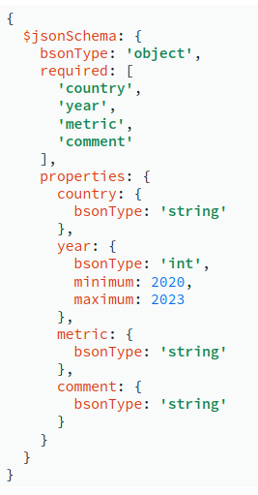
Picture 2.2 Validation enforced to collection annotations
On the picture below you can see an example of how the data might look like:
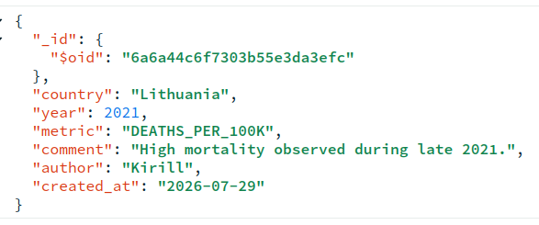
Picture 2.3 The example of the document inside of annotations collection

2.2 CRUD and Indexes

Another point that I wanted to mention is that I implemented CRUD operation for annotations collection:
- create_annotation() - creates a new annotation
- get_annotations() - retrieves annotations
- update_annotation() - updates already existing annotations
- delete_annotation() - removes an annotation
Python and PyMongo were used to establish connection with MongoDB.
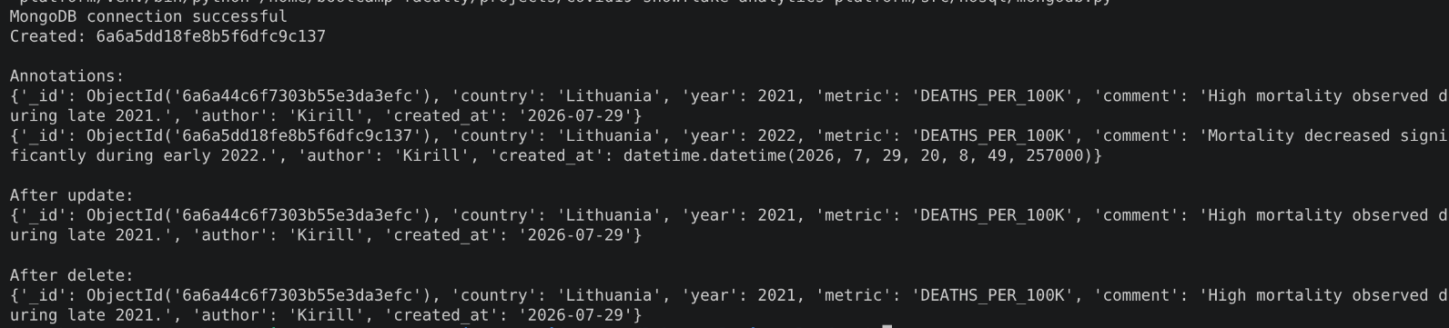
Picture 2.2.1 The output after each CRUD operations on a single annotation

In order to improve the lookup speed of queries I created a compound index based on country and year, since annotations will be mostly retrieved by using these fields. However there is a drawback to that, index is stored in a b-tree structure and apart from requiring additional storage it needs to recalculate the position of annotation inb-tree as soon as there is an update or deletion. This basically results in longer update and delete queries execution speed.

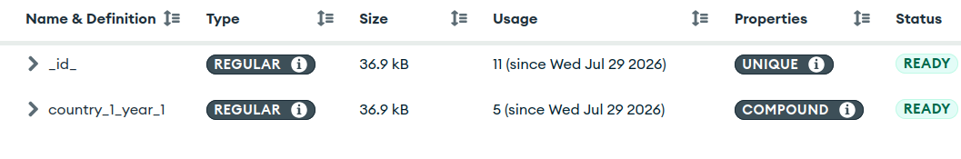
Picture 2.2.2 Indexes used in annotations collection

