1. 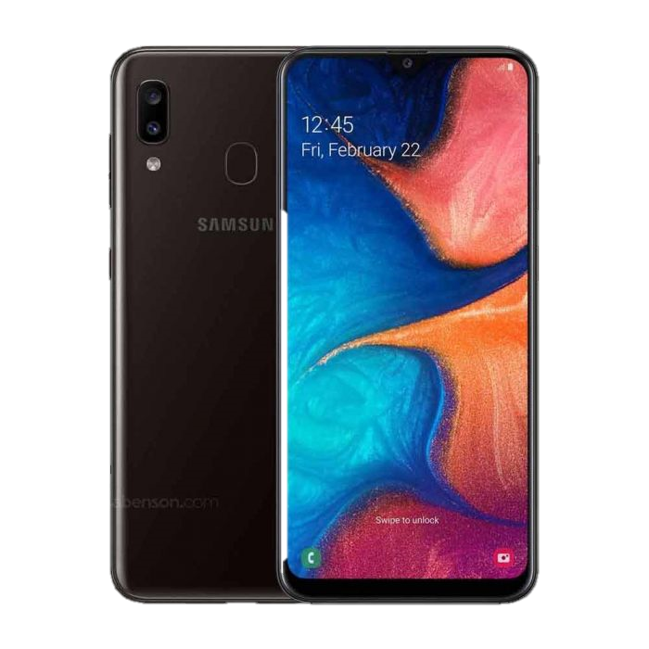I am currently using the Samsung Galaxy A20 moment and five things **I like** about it: [1] It is cheap. [2] The battery range from 4000mAh and 5000mAh. [3] The back cam is good considering the price itself. [4] Big display [5] It is light. On the other hand, **bad things** that it possesses as an opinion: [1] It crashes despite not having any application running in the background. [2] In contrast to the big screen, if you don’t use a phone case you might close an app or whatever you are looking at because it has a small gap for the border. [3] The mirror-like back is hard to clean. [4] It easily heats up despite using it for several minutes in games. [5] Low display resolution.
2. Since it is light, it is not hard to carry and it does not easily get dents. It fits perfectly on my hands. In terms of software, it’s kind of less likely what I expect because I thought it would start lagging on about 3 years of usage. But then this phone is with me for a year and months and it’s already lagging. Sometimes it won’t turn on and would hand for quite a while.
3. [1] A little bit bigger border on the screen would make it easier for people especially those who don’t usually use phone cases. [2] A better back of the phone would be easier to clean or will not easily get dirty. [3] It might be the processor or the battery that causes the phone to heat, therefore it's something that could improve. [4] A higher display resolution. [5] and lastly, the causes of a crash needs to be fixed.