Engbino, Kaye P.

**PERSUASIVE TECHNOLOGIES & BEHAVIORAL CHANGE PRODUCTS/DESIGNS**

**Title of Product/Design:** Cigarette Bin

**Pictures:**

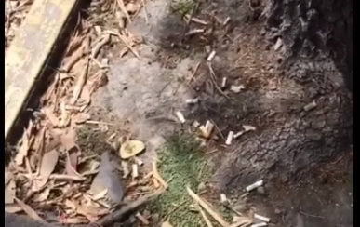

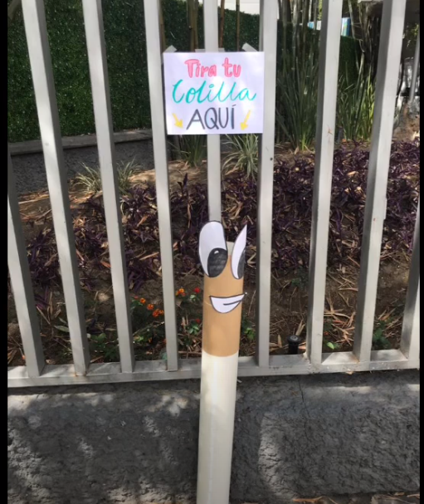

**Comprehensive Details of the Product/Design:**

It has been people’s habit to drop throw their sticks after usage. A group of students noticed it and decided to make a cigarette bin that has a sensor in it. Whenever someone throws a cigarette, it makes a funny sound. They put a label on the top to throw the cigarette in and as one student tried, he realized that it makes a funny sound. So he asked his friend to throw it in there to make sure he was not hearing things and realized it was real. Later, people then stopped throwing their sticks on the floor and used the bin instead.

**References:** Martinez. I.L (2020, March 11). *Cigarette Bin.* YouTube. https://www.youtube.com/watch?v=OQd6dvI_pzQ.

**Title of Product/Design:** Basketball Trash Can

**Pictures:**

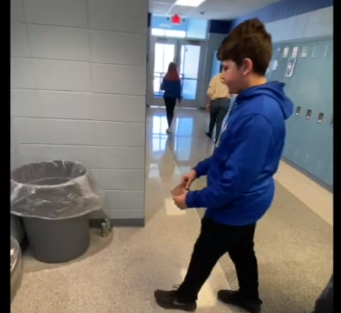 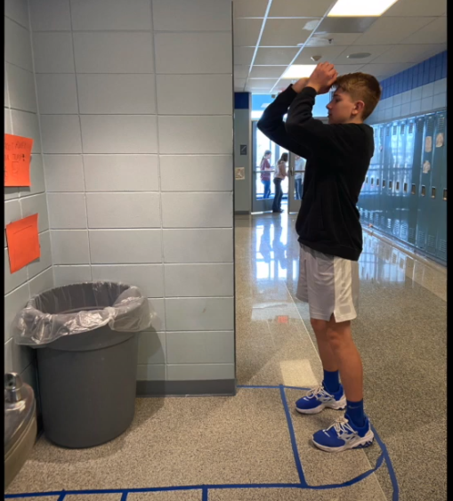

**Comprehensive Details of the Product/Design:**

Throwing trash is not a fun thing to do especially to kids. A group of students decided to make it fun not just for them but to also avoid kids to throw their garbage anywhere. The team decided to make a court-like drawing using tape near the trash bin and then the second figure above is what happened. Before that, kids just carry their trash with them but after the experiment. Kids now try to play with their trash like it’s a ball before throwing it into the bin.

**References:** Lyman. G. (2020, February 18). *Basketball Trash Can.* YouTube. https://www.youtube.com/watch?v=9MWOsKYbJdI.