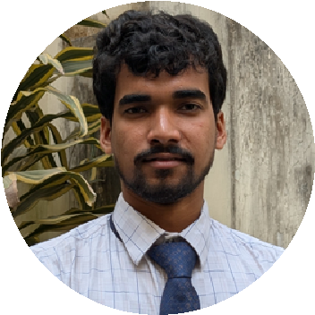
I am a detail-oriented and quick learner with a strong foundation in statistics and data science. I bring leadership experience, technical proficiency in web development, and excellent communication skills. Passionate about using data and digital tools to solve real-world problems and contribute to impactful projects.
Savar, Dhaka, Bangladesh
SYED KAYES MAHMUD
PROFILE SUMMARY

syedka
y
esmahmud
@g
mail.com

+8801737787307
htt
ps://www.linkedin.com/in/s
y
ed-ka
y
es-mahmud-b722b534
7
EDUCATION

Jahangirnagar University  Statistics and Data Science  B.Sc . session: 2023- now |  | Rajshahi Cant. Board School & College  Higher Secondary Certificate, 2021  Science, GPA 5.00 out of 5.00 | Doldoli High School  Secondary School Certificate, 2018 Science, GPA 5.00 out of 5.00.
WORK EXPERIENCES

Jahangirnagar university Science club| Head of HRM February 2025 - present
- By fostering collaboration and aligning people strategies with organizational goals, I help strengthen the organization’s visibility and engagement at all levels.

Jahangirnagar University Science club| Content Writer February 2023- January 2025
-From the start, I helped the organization grow writing content people enjoy. It now has a big number of followers, which shows the work connects well with the audience.”
JUSC Math Olympiad

and Science Fest- 2024 | Team Leader
Worked as Team Leader in the Math Olympiad and Science fest,

guiding team strategy and overseeing collaborative problem-solving efforts

VOLUNTEERING EXPERIENCES

JUSC Math Olympiad and Science Fest- 2023 | Volunteer
- Worked as an active member in this event under JUSC. The task was to assisting with team coordination, problem-solving sessions, and eventday logistics.

Digital Skills
Web Development (Html, CSS, JS, React,
Bootstrap, Vite and others)
Video making with Ai
ACCOMPLISHMENTS
SKILLS
Leadership
Fluent English
Communications and Persuasion skills
Team Collaboration
Critical Thinking
TOOLS
Microsoft Office Suite
Canva
google Workspace
sanitation program with BRAC in 2015

last update: 29.07.25

