CS 423

Lab 5

Kaylee Hurst

#00100217

khurst@my.athens.edu

First Person Camera:

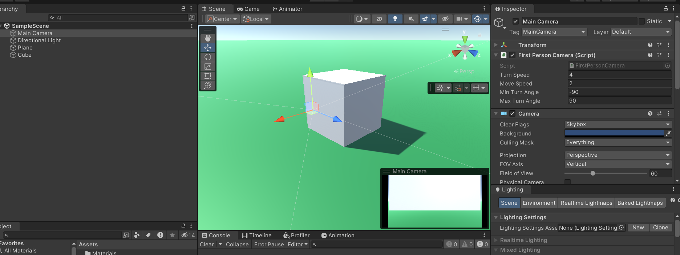

Third Person Camera:

