Findings

Profitability-Sustainability Analysis for GreenFuture BioChem

Overall
GreenFuture BioChem is performing well overall, generating a total revenue of $7.13B, total profit of $1.12B, and a profit margin of 15%, calculated from Jan to Oct 2025. However, the company experienced a sharp profit decline in Q1, primarily due to low sales opportunities in January. Performance recovered steadily but also fluctuated among months, peaking at approximately $1.3B in revenue in October, where profit margin reached 52%, driven by higher-value deals and improved win rate.
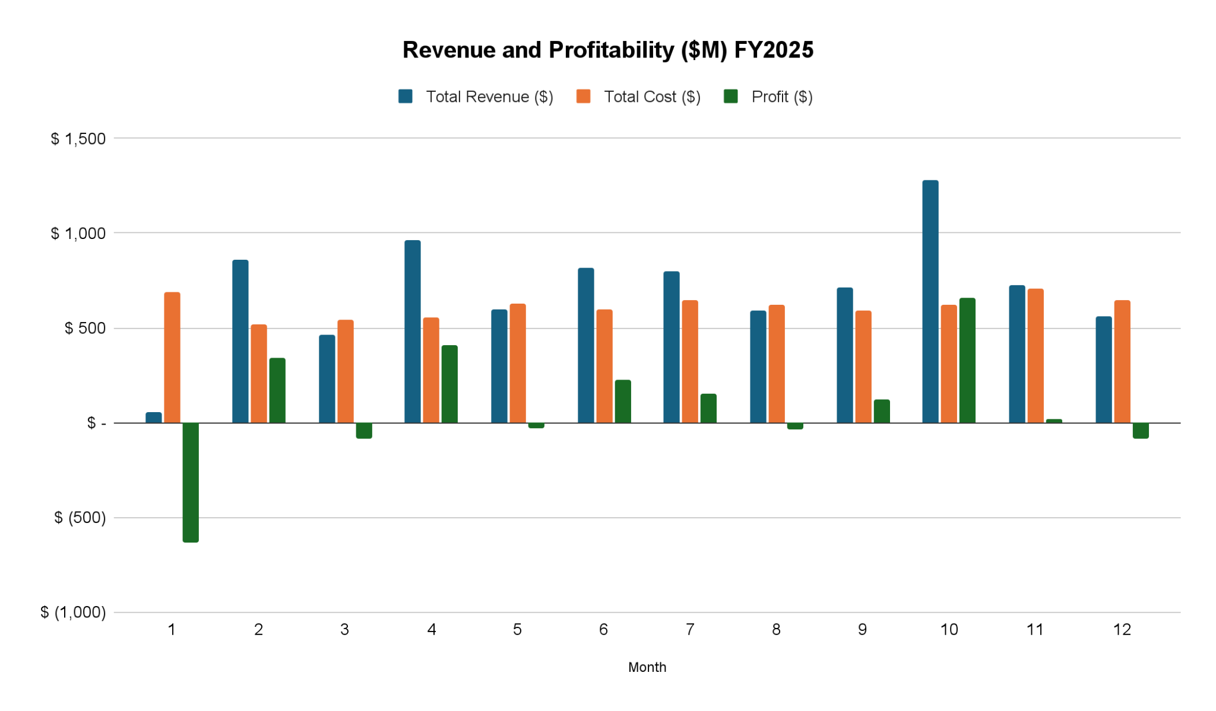

Category Insights
Performance across categories remains uneven, showing two distinct patterns:
- Stable and moderate-revenue categories: Consumer & Home Care and Specialty Polymers maintained consistent sales but limited growth.
- High-volume but volatile categories: Industrial Lubricants, Automotive Solutions, and Packaging Materials experienced strong closed-won deals but fluctuating revenues by month.
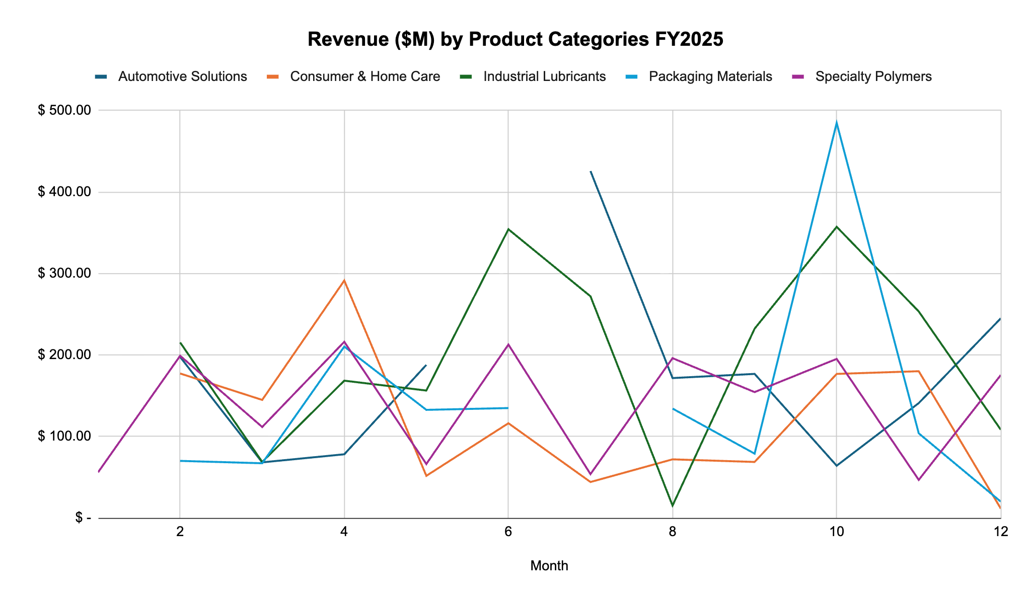
Among these, Industrial Lubricants emerged as the highest-performing category, benefiting from moderate manufacturing costs per metric ton. In contrast, Consumer & Home Care has the lowest win rate (~17%) despite moderate sales and relatively low manufacturing costs, signaling positioning challenges in sales pitching. If we won more deals in this category, we would drive more revenue. Specialty Polymers shows high sales potential and win rate (~24%), but suffers from high manufacturing costs per MT, reducing overall profitability.
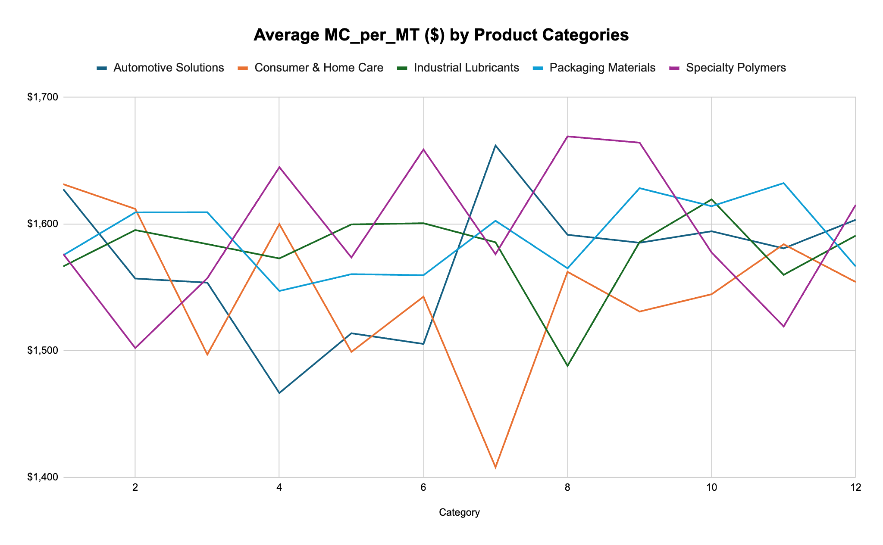

Research & Development

Supply Chain & Manufacturing
From a sustainability perspective, the company’s raw materials sourcing presents a clear trade-off between cost efficiency and environmental performance.
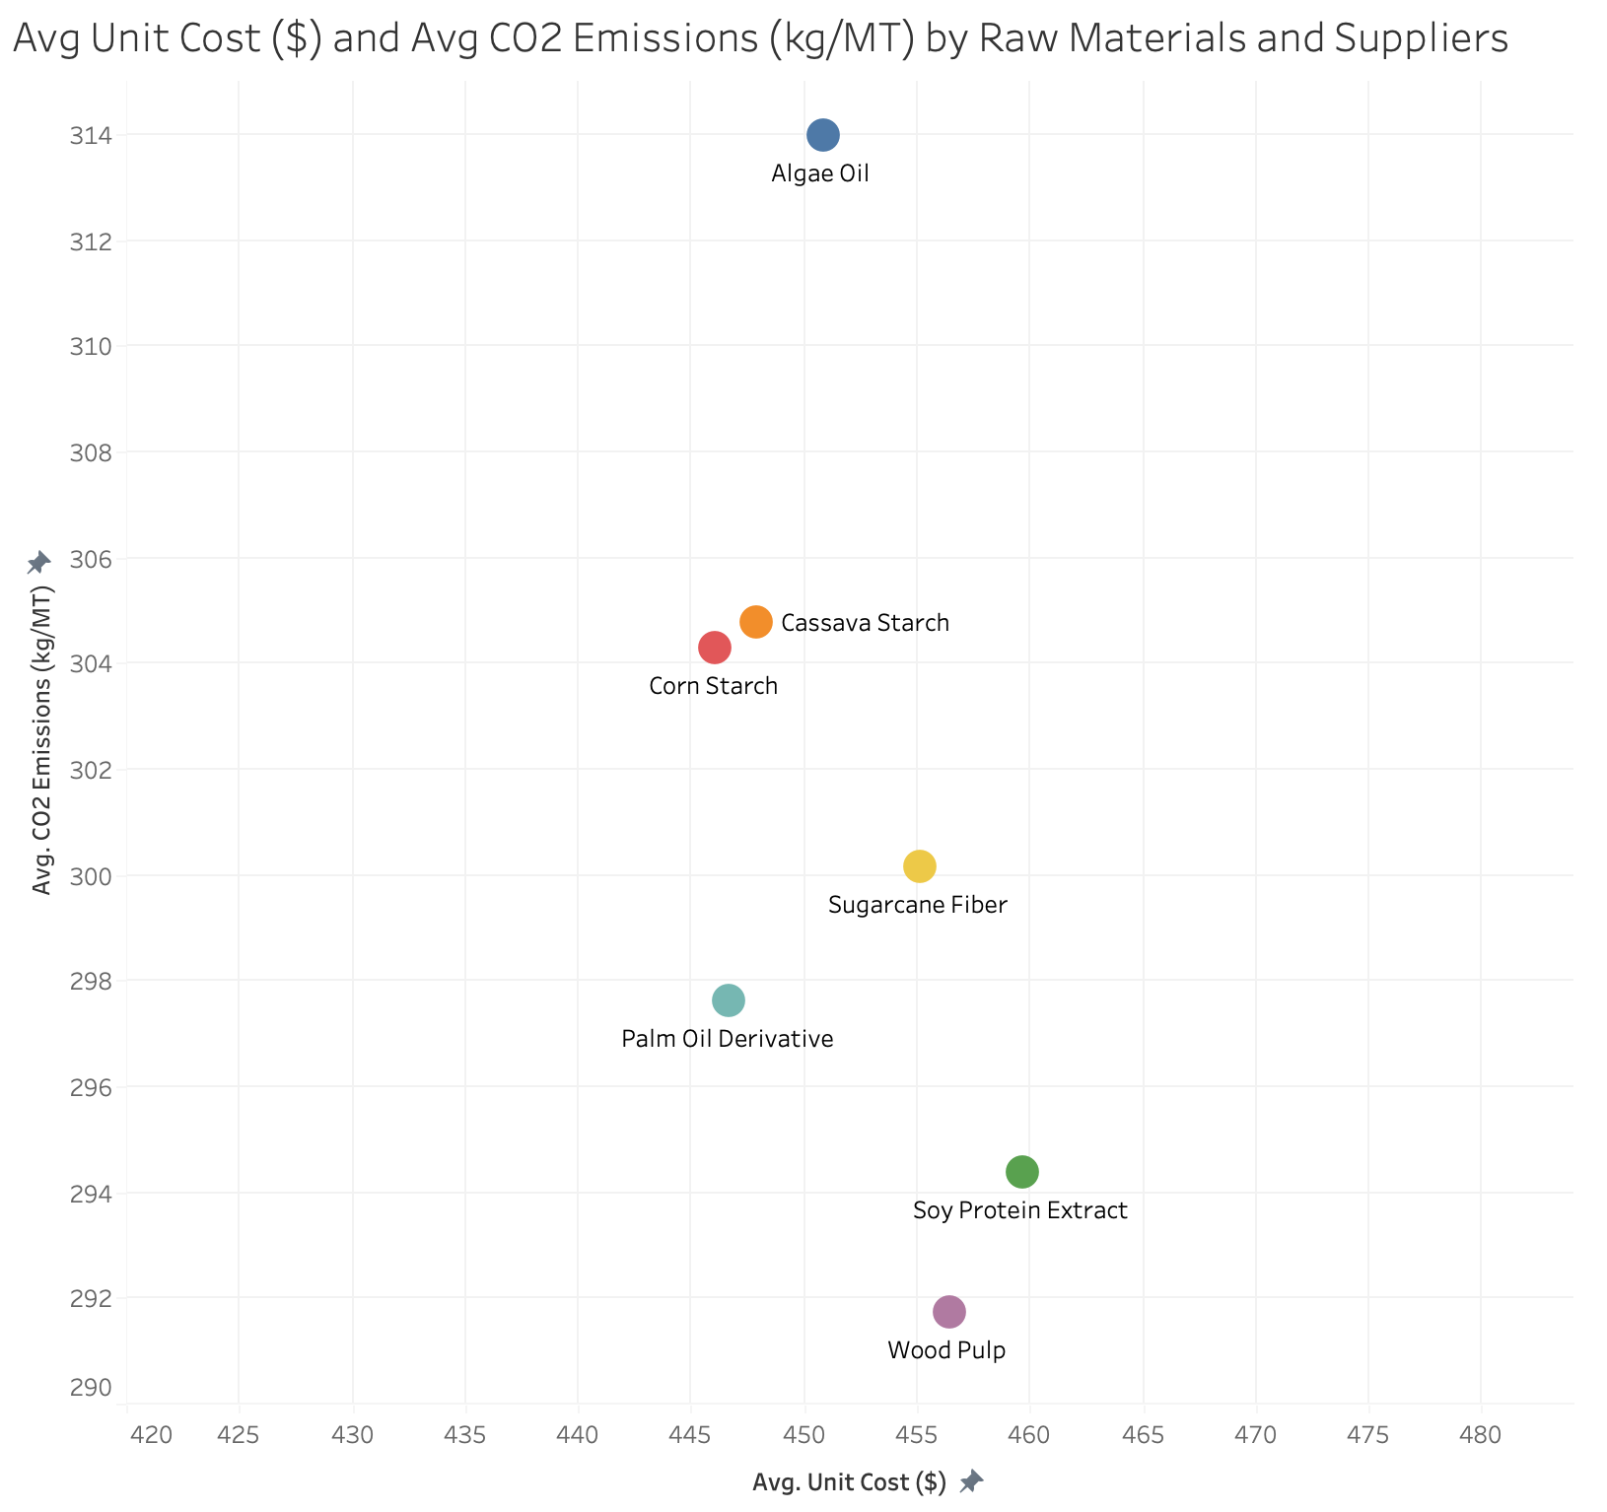
- High CO2 but low cost: Corn Starch, Cassava Starch, Algae Oil
- Low CO2 but higher cost: Wood Pulp, Soy Protein Extract, Palm Oil Derivatives, and Sugarcane Fiber
Most supplies are sourced from Brazil, Malaysia, and Indonesia, emphasizing reliance on high-emission logistics routes. The table below shows major material quantities ordered from each supplier:
AgroSource | Cassava Starch, Palm Oil Derivative, Wood Pulp
BioFeedstock | Corn Starch, Wood Pulp, Soy Protein
EcoMaterials | Algae Oil, Sugarcane Fiber, Soy Protein
GreenFibre | Algae Oil, Wood Pulp, Corn Starch
Naturinput | Wood Pulp, Corn Starch, Palm Oil Derivative
PalmEco | Wood Pulp, Soy Protein, Algae Oil
SustainSource | Wood Pulp, Algae Oil, Cassava Starch
By looking at each raw material, we have supplier-level findings:
Algae Oil | GreenFibre is the primary supplier with the lowest unit cost ($445.46) but with higher emissions (315.14 kg/MT)..  EcoMaterials ($452.55, 304.39 kg/MT) and SustainSource ($454.83, 309.28 kg/MT) offer slightly higher costs but lower CO₂ emissions, suitable greener alternatives.
Cassava Starch | Current suppliers AgroSource and SustainSource are top-volume sources, but EcoMaterials could substitute SustainSource with lower cost and reduced emissions.
Corn Starch | NaturalInput and EcoMaterials are both efficient, offering below-average prices and emissions, making them strong candidates for a larger share allocation
Palm Oil | PalmEco and GreenFibre serve as better substitutes with competitive pricing and lower CO2 output than the current dominant sources
Soy Protein | PalmEco and SustainSource outperform others with both a lower price and reduced emissions.
Sugarcane Fiber | EcoMaterials is the main supplier, though it has a slightly above-average unit cost. AgroSource offers a potential cost-saving alternative.
Wood Pulp | SustainSource remains the most sustainable and cost-effective choice (below-average cost and emissions), followed by AgroSource as a secondary supplier

Strategic Implications
Short-run Solutions (0-12 months): improve immediate profitability and reduce emissions without structural changes
- Optimize Top-Supplier Mix
Based on the CO2 avoided per $ formula, we identified the top-value supplier to shift 10% of the most dominant supplier for each raw material for 2026
Raw Material | Current Dominant → Target Supplier (10% shift) | ΔCost Saved | CO2 Avoided (Tons)
Cassava Starch | AgroSource Intl. → EcoMaterials Co. | $47,439 | 117,089
Cassava Starch | SustainSource Inc. → NaturInput GmbH | $37,861 | 72,425
Corn Starch | BioFeedstock Ltd. → EcoMaterials Co. | $19,272 | 177,080
Corn Starch | NaturInput GmbH → EcoMaterials Co. | $26,935 | 53,921
Palm | AgroSource Intl. → EcoMaterials Co. | $8,873 | 64,355
Palm | NaturInput GmbH→ PalmEco Corp | $34,216 | 50,479
Soy Protein | GreenFibre BV → BioFeedstock Ltd. | $19,190 | 27,998
Soy Protein | PalmEco Corp → SustainSource Inc. | $42,629 | 68,342
Wood Pulp | PalmEco Corp→ EcoMaterials Co. | $21,263 | 79,690

- Focus on Industrial Lubricants, Consumer & Home Care, and Automotive Solutions
- Industrial Lubricants & Automotive Solutions: allocate sales efforts to focus on high-probability/ negotiation deals.
- Consumer & Home Care: given the low win rate, refine pitching strategies to increase the chance of getting the deal.
Long-run Solutions (1-5 years): align long-term profitability while replacing petrochemicals with sustainable alternatives
- Diversity Geographic Sourcing
Given the heavy dependence on Brazil, Malaysia, and Indonesia, consider diversifying equally across regions to minimize logistic emissions.
- R&D Development
As Specialty Polymers present a promising category, but with limited R&D projects, accelerate or innovate projects that could reduce the manufacturing cost for this category.
- Green Procurement KPIs
Introduce new metrics like CO2 per $1M purchased and supplier sustainability index (weighted by cost, emission, and on-time delivery). This heat map shows each supplier’s SSI for each raw material. Green shows a high index while red represents a low index. Hence, for each material, we should prioritize two suppliers whose cells are the greenest to meet our profitability and sustainability goals. 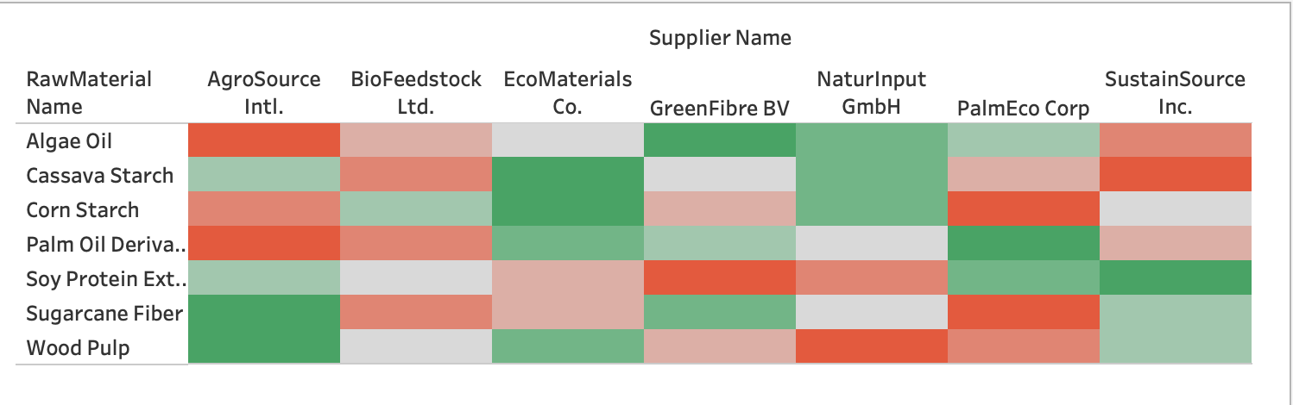
In the short run, GreenFuture BioChem should prioritize supplier optimization and operational efficiency to stabilize profitability while reducing CO2 emissions. In the long run, the company should invest in R&D innovation and supplier diversification to fundamentally decouple profitability from carbon intensity.

Next Steps
- Develop a supplier sustainability index
- Build a dashboard to track sales, supply chain, and manufacturing pacing

RD Insight and links

R&D Investment and Category Performance
The R&D data shows how spending on innovation affects business results in different categories. Right now, Industrial Lubricants and Consumer & Home Care get most of the R&D funding. This shows that the company is focusing on these well-known areas. However, Specialty Polymers, which is one of the fastest-growing categories, gets much less R&D attention even though it adds more to the sales pipeline.
This difference between R&D spending and sales potential looks like a missed chance. Specialty Polymers make up less than 15% of total R&D spending but bring in over 20% of possible sales. Shifting some of the innovation budget to this category could lower material costs and increase profit margins. The sales data in Sales_Pipeline.xlsx and product details in Product_Master.xlsx support this idea. They show that giving more innovation support to Specialty Polymers could help keep the company’s growth strong.

R&D’s Role in Sustainable Sourcing
The second part of the analysis links R&D work to a more sustainable supply chain. Data from R&D_Pipeline.xlsx and SupplyChain_Procurement.xlsx shows that many R&D projects focus on bio-based and low-emission materials. Examples include Bio-based Polymer 3X and the Low-CO₂ Binder Series. These projects deal directly with the environmental issues found in the supply chain review.
Projects that use renewable materials like soy, corn, and palm make up about 40% of total R&D value. If these projects succeed, they could cut the company’s CO₂ emissions by about 18% over the next three years. This shows that innovation not only helps bring in new revenue but also supports the company’s sustainability and cost goals. The R&D focus on low-carbon materials clearly links new technology to environmental progress.

R&D and Manufacturing Efficiency
The connection between R&D and manufacturing also shows how innovation helps operations. When data from R&D_Pipeline.xlsx is compared with Manufacturing_Production.xlsx, we see that plants with strong R&D ties, such as those in Frankfurt and Shanghai, have higher yield rates (over 93%) and lower cost differences than those without R&D support.
This means that R&D input helps improve production performance. Plants that work closely with R&D teams adopt new formulas and process improvements faster, which leads to steadier output and less waste. Expanding R&D partnerships to plants that perform below average could help spread these benefits across the company, improving both efficiency and quality.

Script

Slide 1 Kwasi
Hi everyone, my name is _______ and together with ____. Today, we’ll walk you through our analysis of GreenFuture BioChem. This case challenged us to leverage data to help the company strengthen profitability while staying sustainable.

To start, let’s look at how the company actually operates and its business model.

Slide 2 Kwasi
As you may know, GreenFuture operates across five major markets with 50+ brand families and 700+ SKUs. Its business model works like raw materials (e.g., palm oil derivatives, wood pulp, and corn starch) are sourced globally, then processed at manufacturing plants across countries (e.g., the US, Germany, and India. These plants produce bio-based chemicals that are sold worldwide to industrial and consumer companies.

Our goal was to answer:
“How can GreenFuture BioChem improve profits without compromising its mission to replace petrochemicals with sustainable alternatives?”

But this model faces tension:
- Profitability varies widely across product lines
- Manufacturing efficiency differs by region
- Supply chain decisions often trade off between cost and emissions.

So, we integrated these perspectives with four main datasets to find the sweet spot where profitability meets sustainability.

Let’s begin by looking at the company’s overall financial performance in 2025.

Slide 3 Julie
From January to October 2025, GreenFuture generated $7.13 billion in revenue, $1.12 billion in profit, and a 15.7 percent margin. After a sharp decline in the early in the year, largely due to low sales opportunities, performance rebounded quickly, peaking in October with a 52% margin, driven by higher-value deals and an improved win rate (~33%). Overall, the company is performing well, but the growth isn’t consistent across categories, as can be seen from the chart on my right-hand side.

We found two clear patterns:
- Stable but slow-growth categories: Consumer & Home Care and Specialty Polymers.
- High-volume but volatile categories: Industrial Lubricants, Automotive Solutions, and Packaging Materials

So next, we dug into category-level performance to understand strengths and weaknesses.

Slide 4 Julie
Among these five categories, Industrial Lubricants stood out as the top performers, driving 27% of total revenue with moderate manufacturing costs.
Meanwhile, Consumer & Home Care had the lowest win rate at 17%, despite the highest forecasted revenue by 2028, suggesting a need to refine sales positioning.
Specialty Polymers has potential but suffers from high manufacturing costs.

But do these product insights align well with the company’s R&D priorities?

Slide 5 Kwasi
When we mapped R&D projects, most of the focus fell into Industrial Lubricants and Home Care. While Automotive Solutions contributes about 20% of sales and has the second-largest forecasted revenue, it has the lowest number of projects. Likewise, Specialty Polymers also remains underfunded despite a high growth potential.

Given this, we think there’s room to rebalance R&D resources to lower Specialty Polymer costs and unlock Automotive growth.

Beyond this, we also looked at operational efficiency across all manufacturing plants.
Among the five plants, Brazil and Germany show the highest yield, but also the highest cost variance, while China and the U.S. have lower yield rates, indicating efficiency challenges.

Since manufacturing performance relies heavily on sourcing, we next examined the supply-chain side.

Slide 6 Kwasi
Looking at this chart, we noticed a clear pattern:
- High-emission but low-cost materials
- Low-emission but higher-cost materials.
Procurement is also concentrated in Brazil, Malaysia, India, and Indonesia. However, as we are lacking information on how these raw materials are sourced to plants, one question to keep in mind is whether logistic inefficiency exists; how does the company keep track of that?

Slide 7 Julie
So, how can GreenFuture act on these insights to quickly reduce emissions and costs without disrupting operations?

In the short term, we focused on supplier optimization. Using the CO2 avoided per dollar of procurement shift metric, we tested a 10% percent reallocation of orders from dominant suppliers to greener alternatives.

This change could save around $257K and avoid roughly 710 thousand tons of CO2 in a year.

On the sales side, we recommend refocusing efforts on Industrial Lubricants and Automotive Solutions on late-stage deals while refining Home Care pitching to improve win rates.

But how can GreenFuture embed sustainability more deeply into its long-term strategy?

Slide 8-9 Julie
Over the next 1-3 years, we might aim for structural changes that align profits and sustainability:
- Diversify sourcing toward suppliers closer to each manufacturing plant to reduce transport emissions
- Accelerate R&D for Specialty Polymers and Automotive to lower production costs
- Adopt Green Procurement KPIs
  - CO2 per $1M purchased
  - Supplier Sustainability Index (SSI): a score that balances cost efficiency, CO2 emissions, and on-time delivery to rank suppliers on both economic and environmental performance. Each dimension was normalized to a 0–100 scale and weighted at 40% cost, 40% emission, and 20% delivery.

The heatmap below visualizes SSI performance across raw materials (e.g., the greener the higher the index). Each raw material should prioritize the top two greenest suppliers to advance both profitability and sustainability.

And to make this planning more effective, we also offer data-driven performance tracking through three dashboards.

Slide 10
Finally, let’s wrap up with key takeaways.

