Name: KAYITESI Henriette
ID: 26953
PL/SQL Assignment
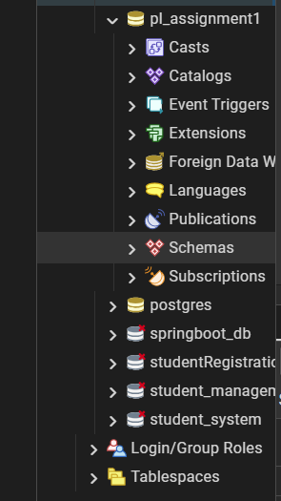
Readme
Business Context
- Company Type:
A mid-sized guesthouse offering short-term accommodation to local and international travelers.
- Industry:
Hospitality and tourism.
- Department:
Operations and management, focusing on room occupancy, bookings, and revenue performance.
Data Challenge
The guesthouse collects booking data but does not actively analyze it to understand room performance, guest behavior, or revenue trends. Management lacks visibility into which rooms generate the most income, how demand changes over time, and which guests contribute most to revenue. Without this insight, it is difficult to optimize pricing, improve occupancy rates, and plan operations efficiently.
Expected Outcome
The analysis aims to identify top-performing rooms, analyze guest spending patterns, and track monthly revenue trends. These insights will help management make informed decisions on pricing strategies, marketing focus, and operational planning to improve overall profitability.
STEP 2: SUCCESS CRITERIA
1. Identify the top 5 rooms by revenue per month using RANK().
2. Calculate running monthly revenue totals using SUM() OVER().
3. Analyze month-over-month revenue growth using LAG().
4. Segment guests into spending quartiles using NTILE(4).
5. Compute three-month moving average revenue using AVG() OVER().
STEP 3: DATABASE SCHEMA DESIGN
The 3 tables that I used are:
Guests
- guest_id (PK)
- full_name
- email
- city
Rooms
- room_id (PK)
- room_type
- price_per_night
Bookings
- booking_id (PK)
- guest_id (FK)
- room_id (FK)
- booking_date
- nights
- total_amount
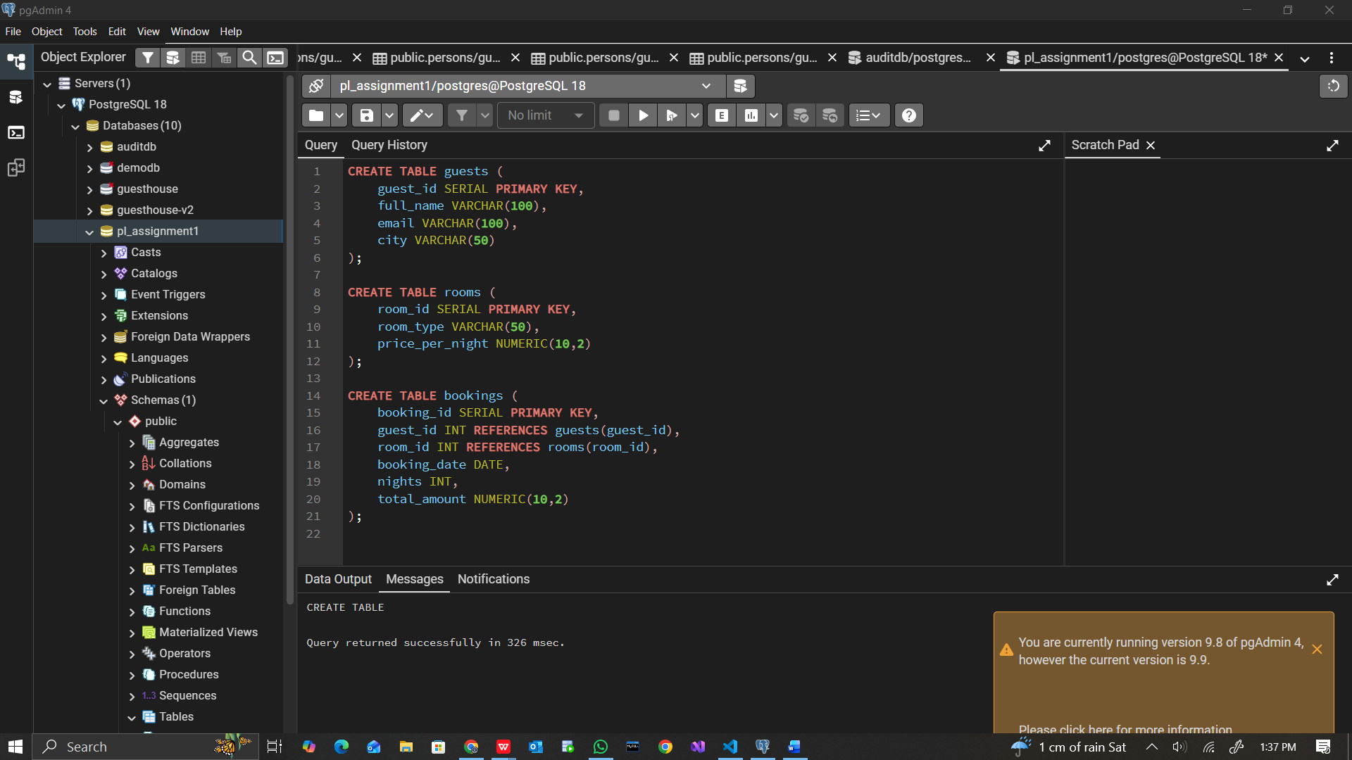
3.3 Insert Sample Data
You must insert enough data.
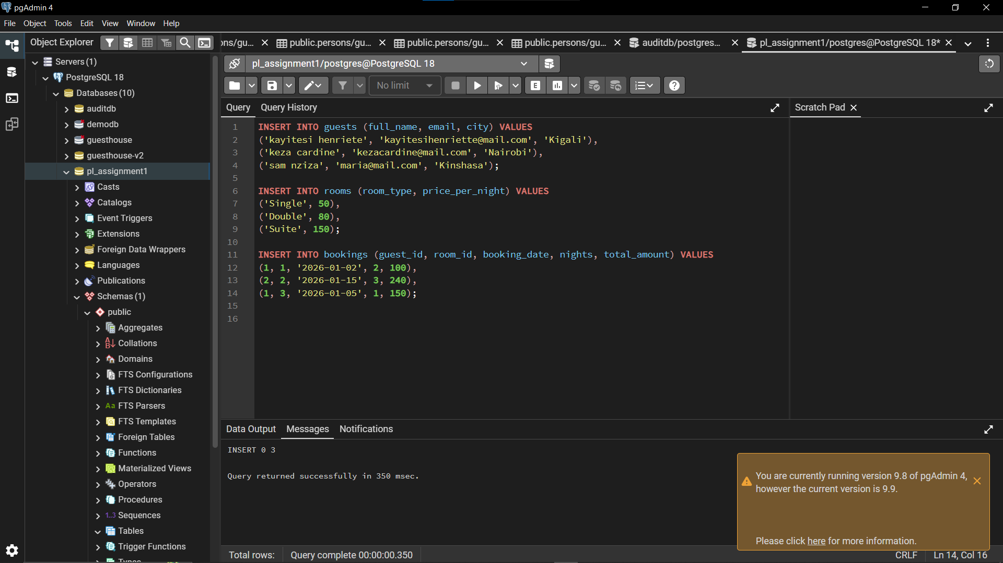
3.4 ER Diagram
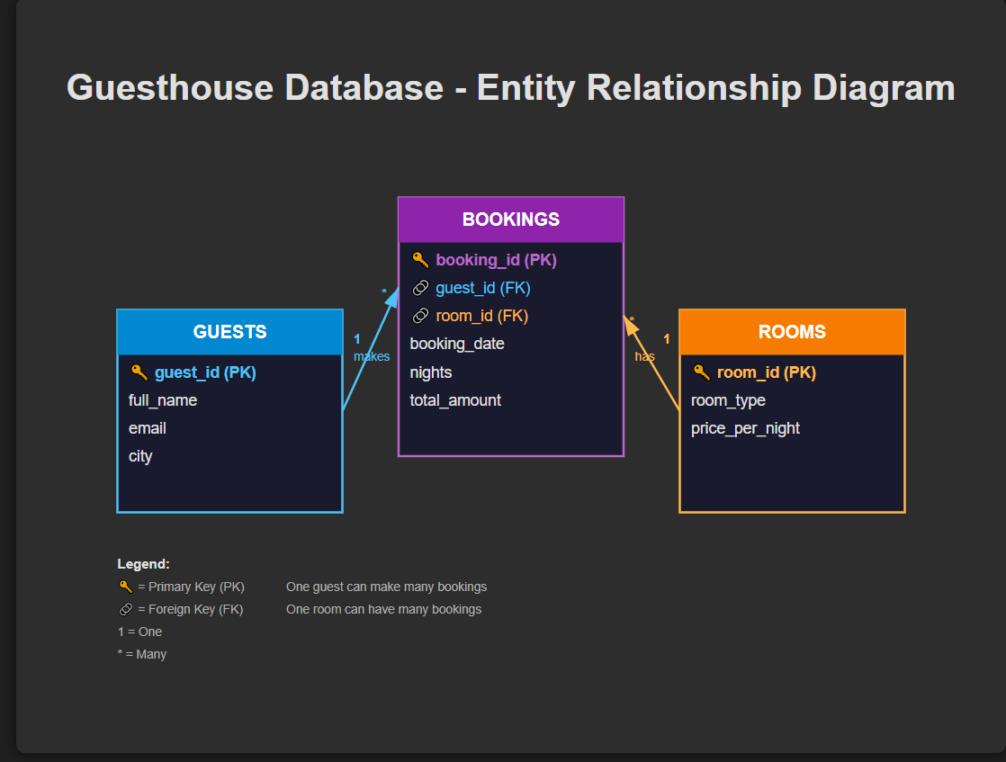
STEP 4: PART A — SQL JOINS
4.1 INNER JOIN
Purpose: valid bookings with guests and rooms
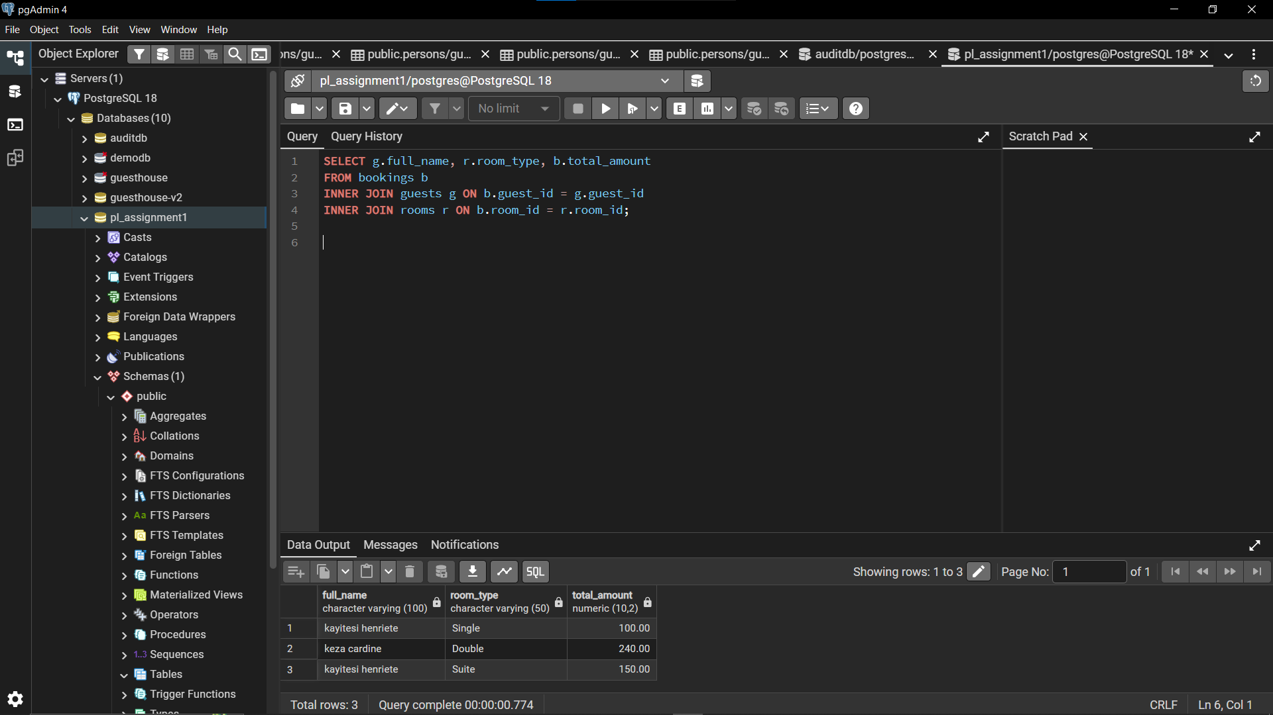
This query retrieves bookings that have valid guest and room records. It ensures that only confirmed and complete booking transactions are analyzed. This helps management focus on actual revenue-generating bookings.
4.2 LEFT JOIN
Guests who never booked
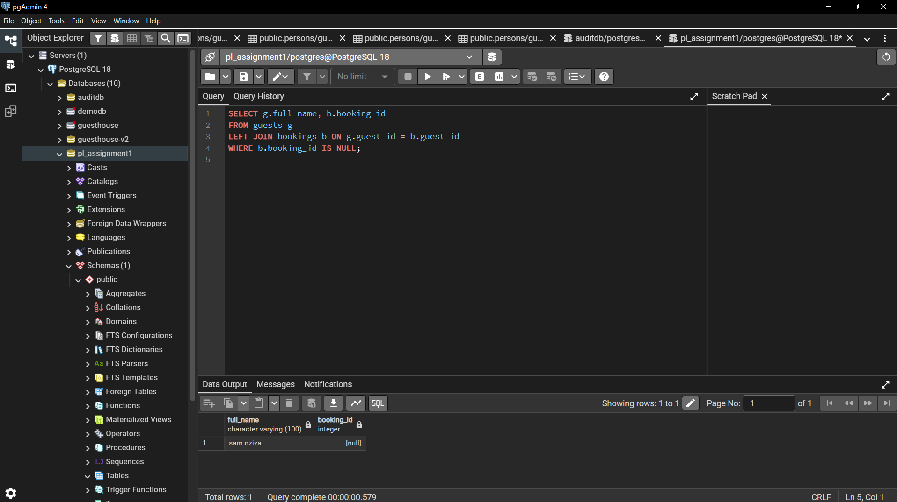
This query identifies guests who exist in the system but have never made a booking. By using a LEFT JOIN and filtering for null booking records, it highlights inactive or first-time guests. This information can help management design targeted marketing campaigns to encourage bookings from these guests.
4.3 RIGHT JOIN (or FULL JOIN)
Rooms never booked
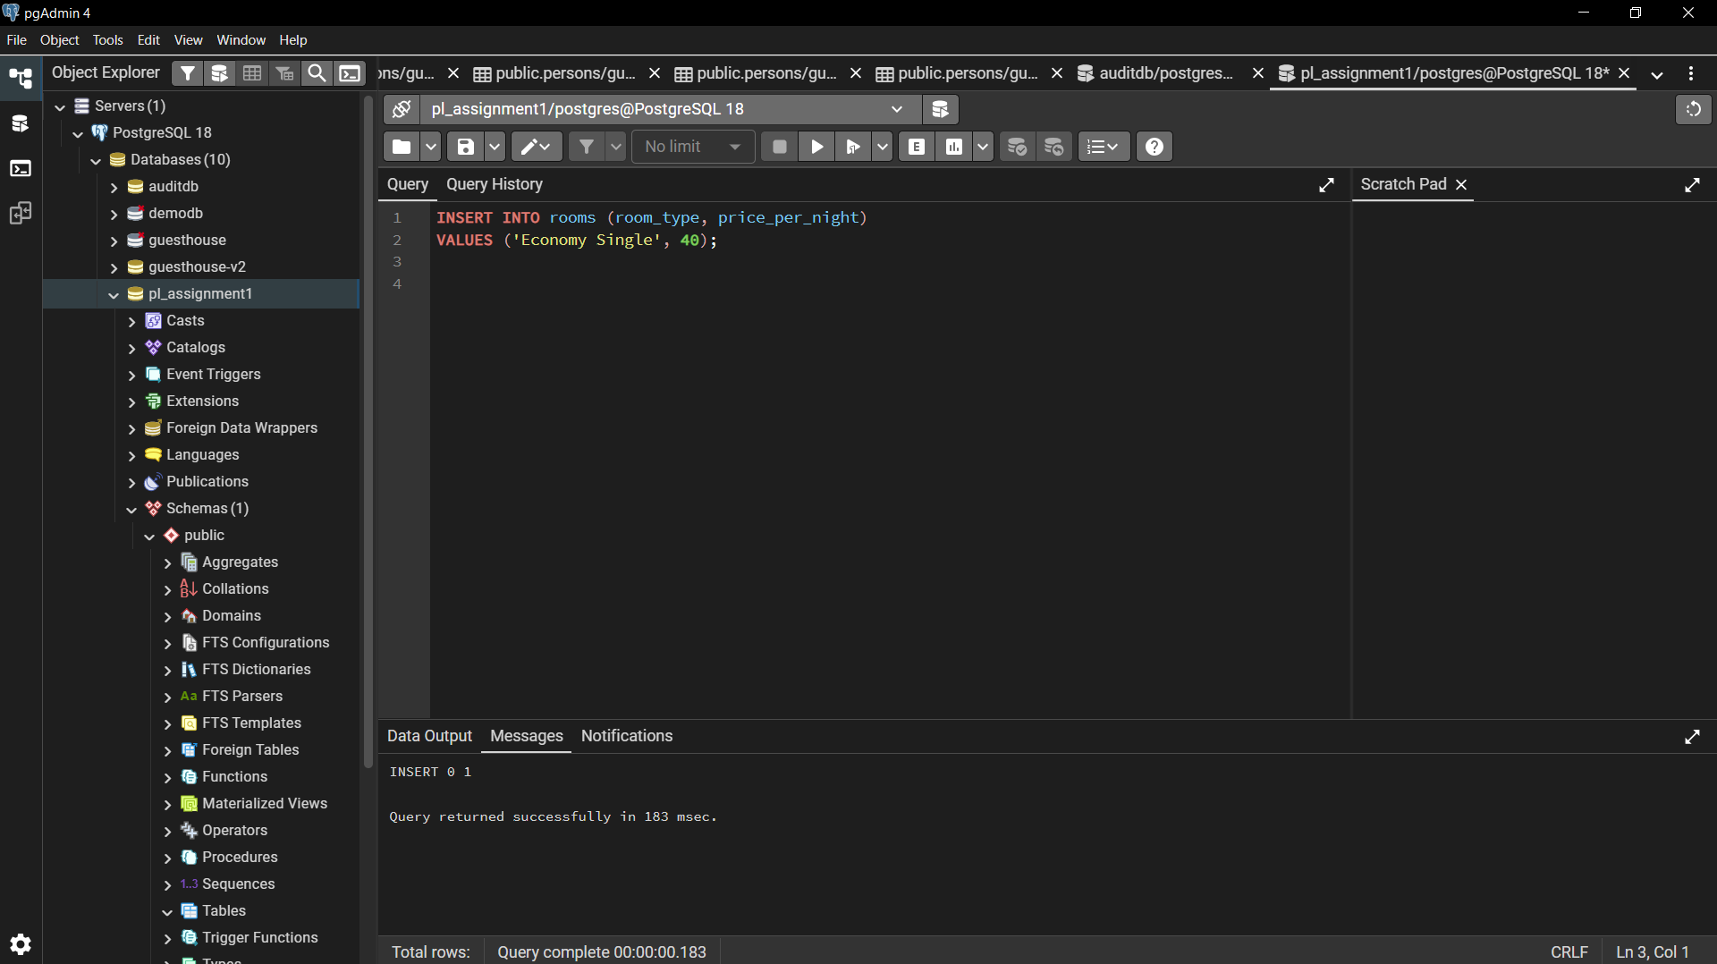
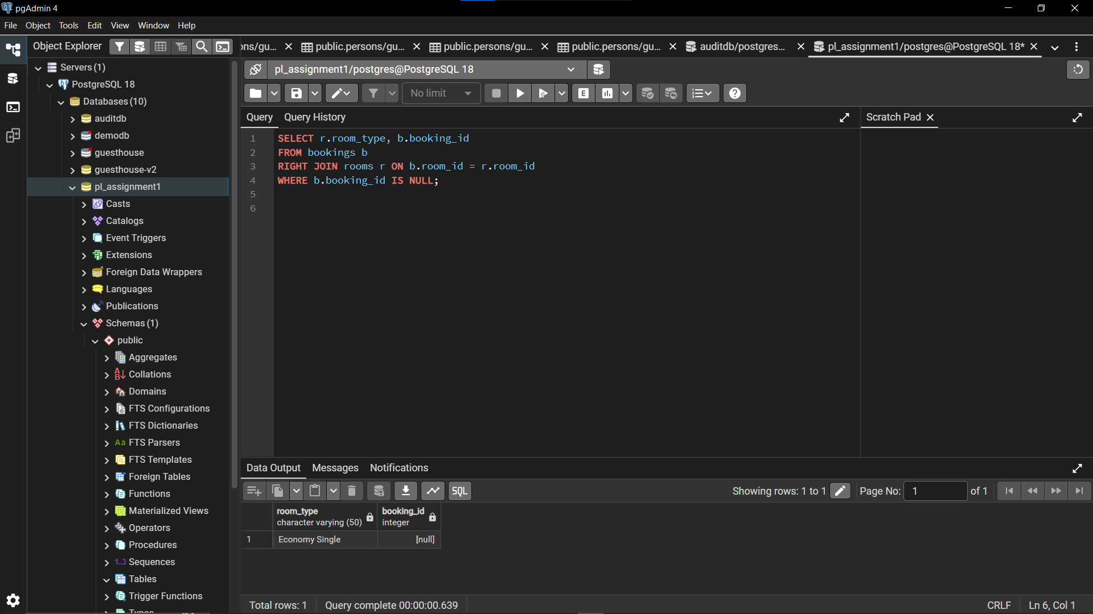
This query retrieves all rooms and checks whether they have associated bookings. Rooms that appear with a null booking ID indicate that they have never been booked. Identifying such rooms helps management detect underutilized assets and adjust pricing or promotion strategies accordingly.

4.4 FULL OUTER JOIN
All guests and rooms, matched or not
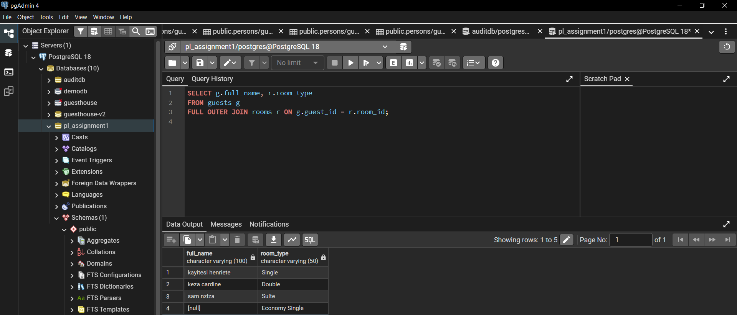
This query combines all records from both guests and rooms, including those that do not have matching relationships. It provides a comprehensive view of all entities in the system, highlighting unmatched guests and rooms. This allows management to assess data completeness and identify gaps in booking activity.
4.5 SELF JOIN
Bookings in the same month

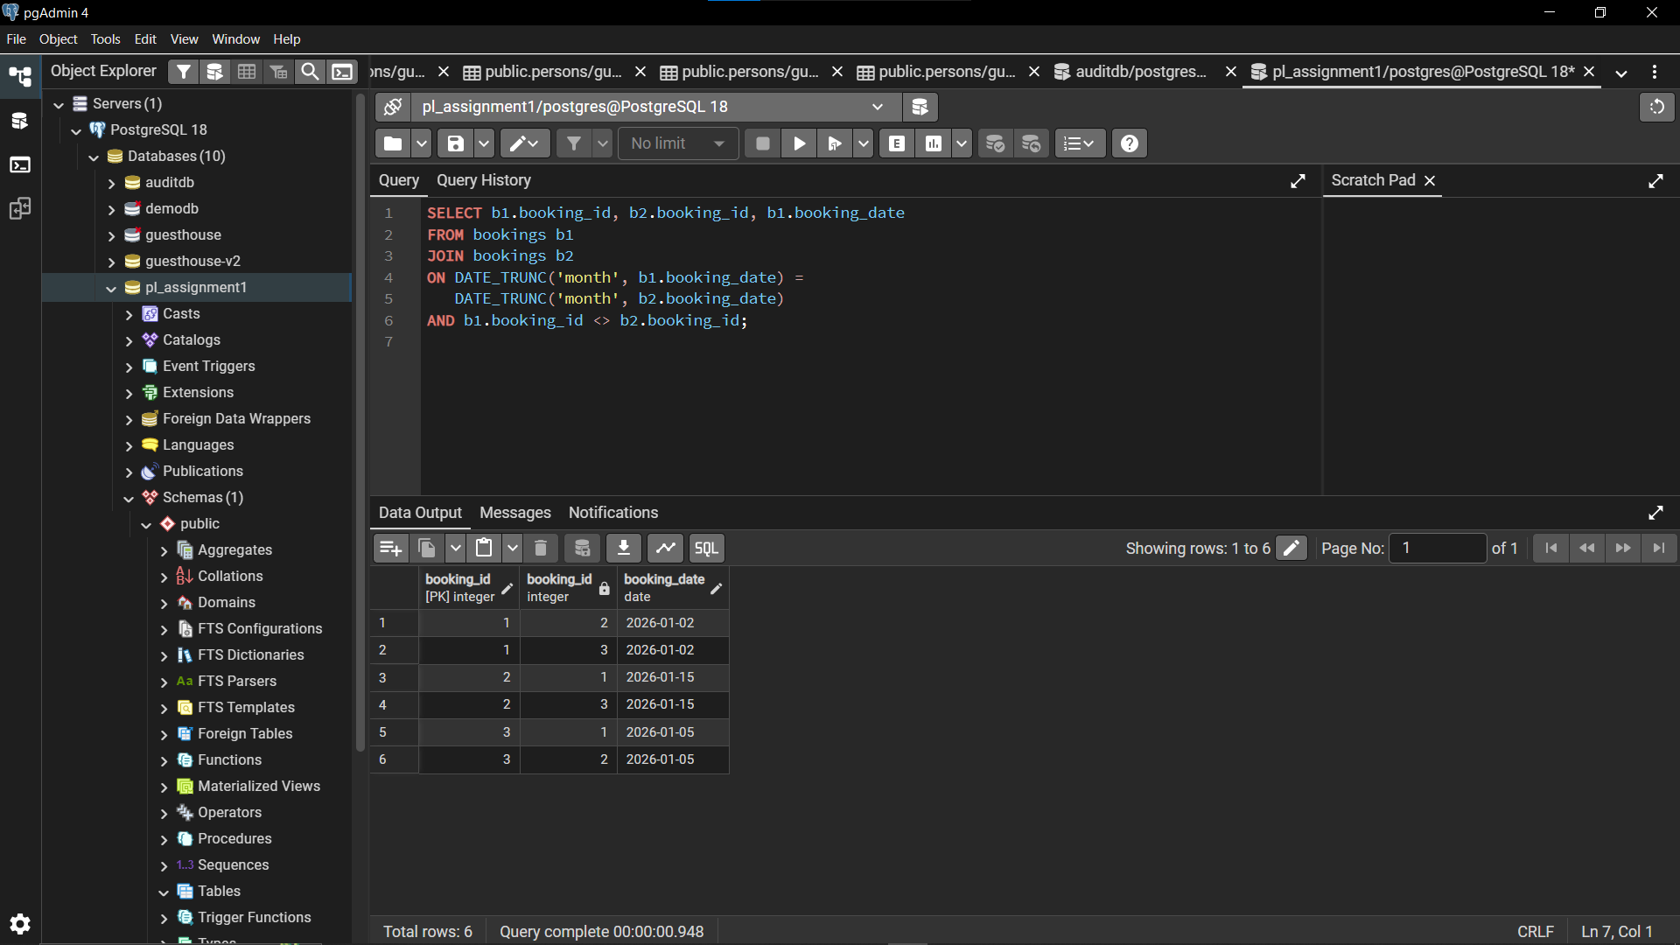

This query compares bookings within the same table to identify bookings that occurred during the same month. By joining the bookings table to itself, it enables analysis of booking density and patterns over specific periods. This helps management understand peak booking times and plan resources accordingly.
STEP 5: PART B — WINDOW FUNCTIONS
5.1 Ranking Functions
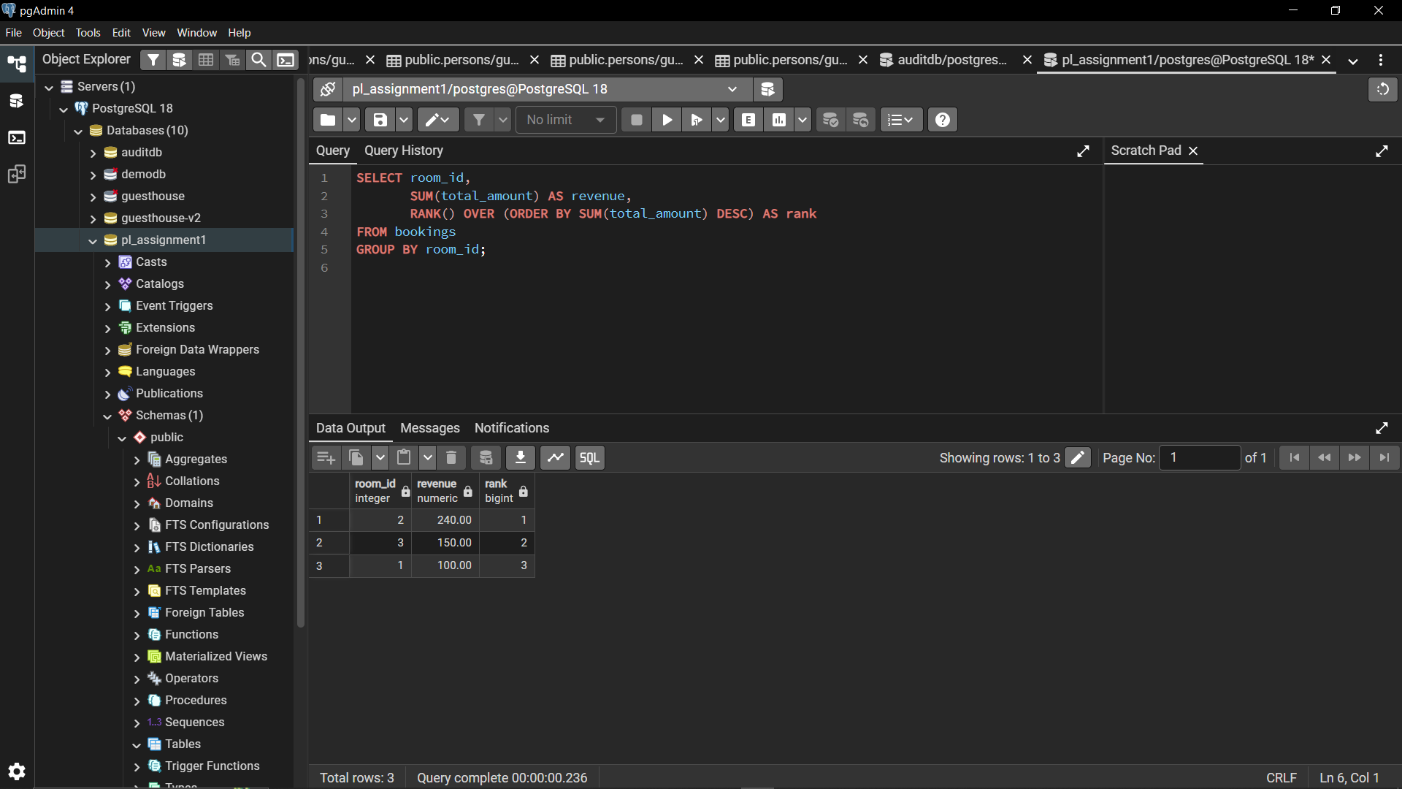
5.2 Aggregate Window Functions
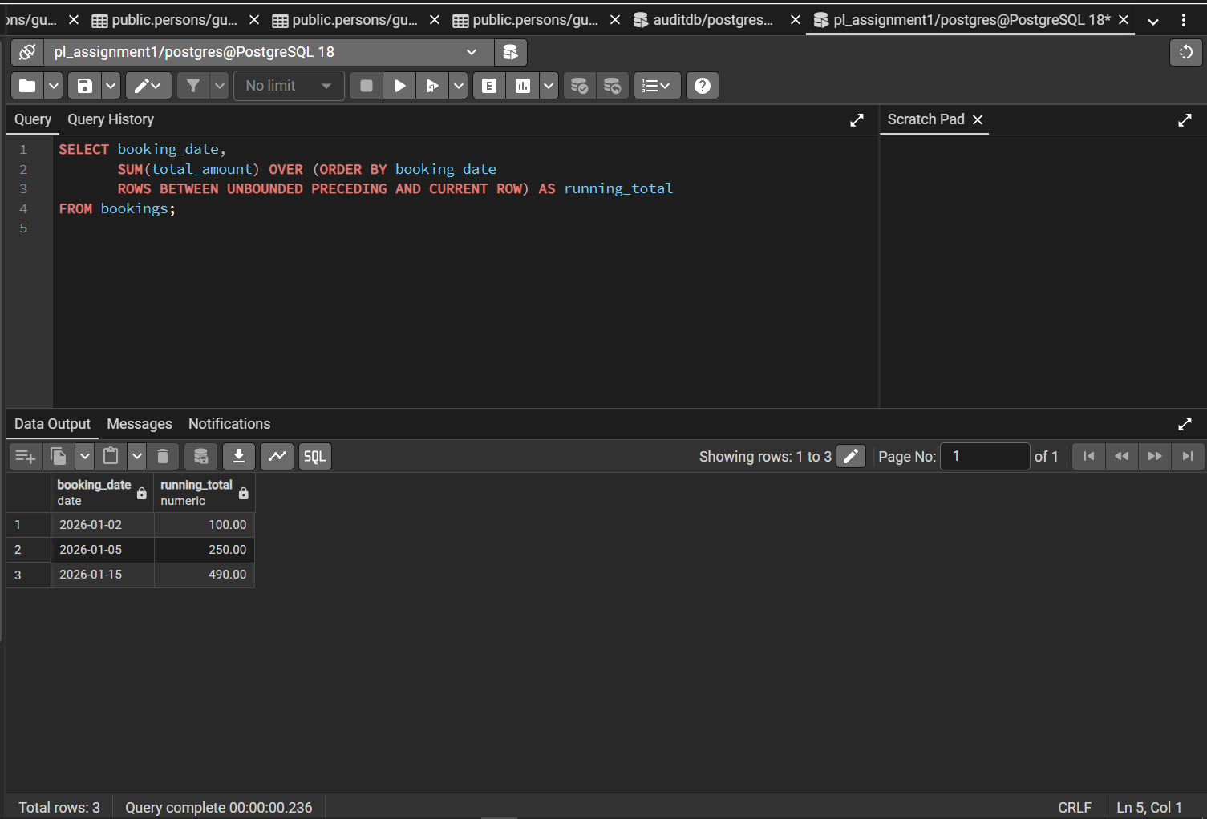

5.3 Navigation Functions (LAG)
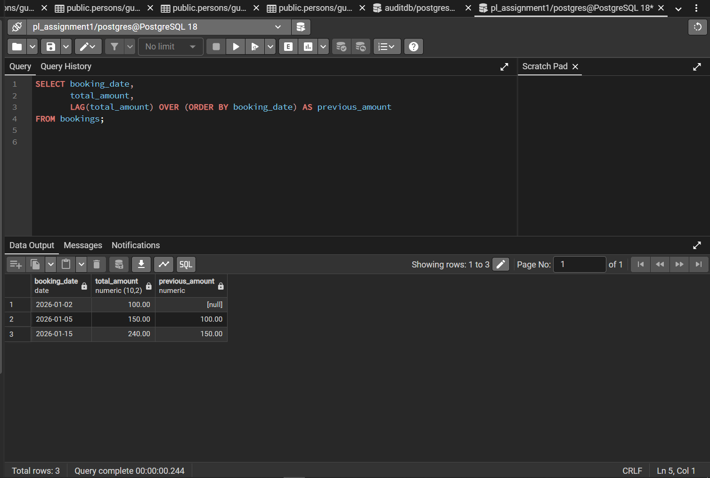
5.4 Distribution Functions (NTILE)
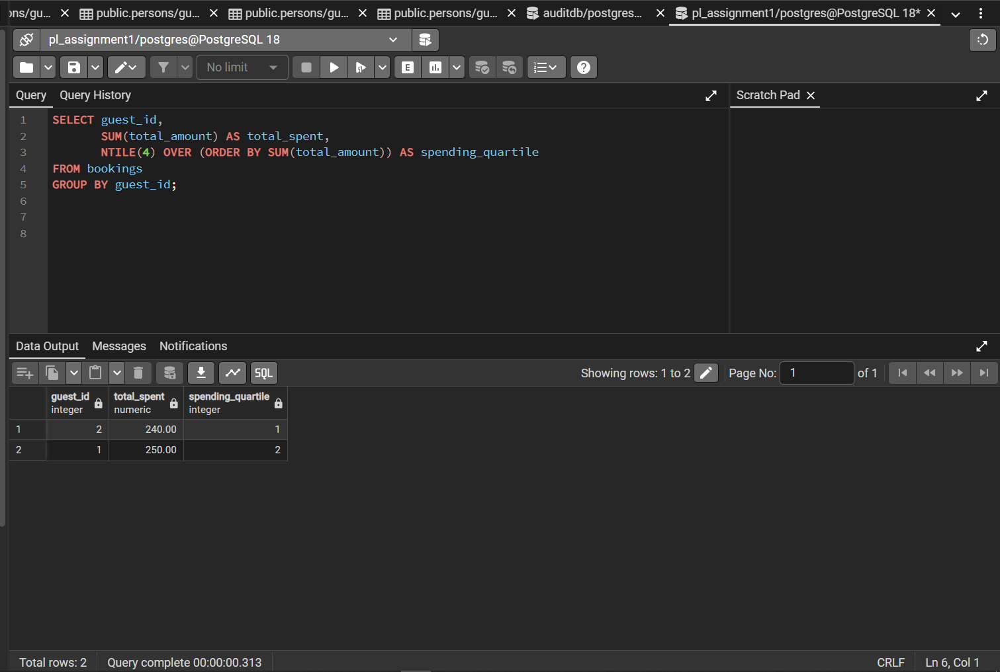
STEP 6: RESULTS ANALYSIS
Results Analysis
Descriptive The analysis shows that booking activity and revenue are not evenly distributed across rooms or time periods. Certain rooms consistently generate higher revenue, while others contribute less despite being available. Monthly revenue trends indicate fluctuations, with some months showing significantly higher booking volumes, suggesting seasonal demand patterns. Guest spending analysis also reveals that a small group of guests contributes a larger share of total revenue.
Diagnostic
These patterns are primarily driven by room pricing differences, room type preferences, and seasonal travel behavior. Higher-priced or premium rooms attract guests willing to spend more, leading to higher revenue concentration. Seasonal peaks likely correspond to holidays or travel seasons, increasing occupancy rates. Additionally, repeat guests tend to book more frequently or stay longer, which explains the higher revenue contribution from certain customer segments.
Prescriptive
Management should focus on optimizing pricing strategies by adjusting room rates during high-demand periods and promoting underutilized rooms during low seasons. Targeted marketing efforts can be directed toward high-value and repeat guests identified through customer segmentation. Finally, analyzing booking trends regularly using window functions can help management proactively plan staffing, promotions, and room availability to maximize occupancy and revenue.

