## Problem 1 – Exam 1 CHOCHEV HTML

Create a Web site (HTML5 + CSS3 + images) that looks and behaves like the screenshots below:

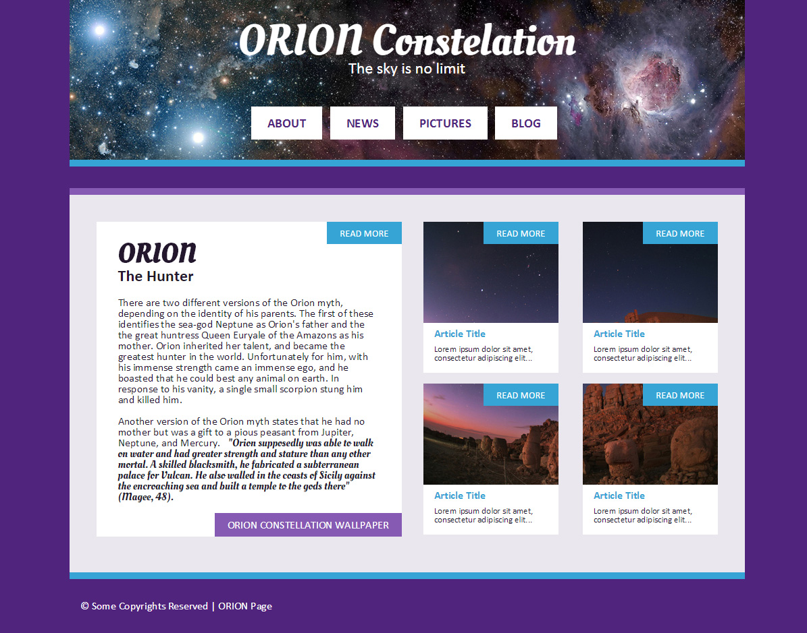

* The hand cursors in the screenshots show what happens when the mouse moves over certain elements.

### Input

You are given two screenshots + the texts + the images on the site.

### Output

The output should be valid HTML5 + CSS3 + images that implement the above Web site.

### Constraints

* Fonts:
  + Site content: Calibri, Arial, sans-serif; 12px.
  + Header title (68px), Main article title (48px) and quote: <http://fonts.googleapis.com/css?family=Oleo+Script>
  + Navigation font size: 18px;
  + Subtitles font size: 26px;
* Site content: fixed width 1000px.
* The site should open correctly in Chrome 35+.
* Responsive design is not required.
* Pixel-perfect implementation is not required.
* Take the colors from the pictures with color picker.