## Problem 1 – Blog Page

Create a Web site (HTML5 + CSS3 + images) that looks and behaves like the screenshots below:

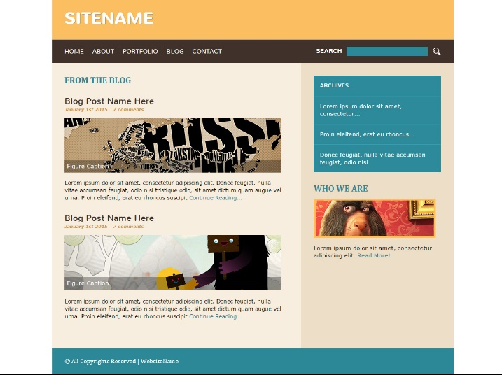

* The hand cursors in the screenshots show what happens when the mouse moves over certain elements.

### Input

You are given the above screenshots + the texts on the site + the images.

### Output

The output should be valid HTML5 + CSS3 + images that implement the above Web site.

### Constraints

* Fonts:
  + Site title: Nunito, bold 700x42px, (<http://fonts.googleapis.com/css?family=Nunito>).
  + Header navigation: Nunito, 100x16px.
  + Site content: Verdana, 13px.
  + Site footer: Cambria.
  + Title: Cambria, 22px.
  + Article Title: Nunito, 22px.
  + Article subtitle: Cambria, 10px.
* Site content: fixed width 1020px.
* The site should open correctly in Chrome 35.
* Responsive design is not required.
* Pixel-perfect implementation is not required.