Battery Waste Collection App
Product & Process Documentation — for Build Planning

1. Overview
This app lets people (households, businesses, EV owners) get their dead/waste batteries picked up, get paid for them, and have them safely recycled through certified partners — while automatically generating compliance records required under India's Battery Waste Management Rules, 2022 (EPR). The UX pattern follows on-demand pickup platforms like EpiCircle (cab-booking-style scrap collection), adapted for battery-specific safety and regulatory needs.

2. Users & Roles
Role | What they do in the app
Customer | Books a pickup, gets paid, receives disposal certificate, tracks impact
Collection Partner | Accepts jobs, follows safety checklist, collects/weighs/categorizes batteries, gets paid
Facility/Hub Staff | Receives batteries from partners, sorts by chemistry, manages storage & dispatch
Recycler/Refurbisher | Registered downstream partner who processes batteries and confirms recovery
Admin/Ops | Manages partners, pricing, facilities, and recycler network
Producer/OEM client (B2B) | Battery manufacturer/importer using the platform to meet their EPR obligations

3. App Modules & Features

3.1 Customer App
- Book a pickup — battery category selection + photo upload
- Indicative pricing based on category, weight, condition
- Live tracking of assigned partner (map + ETA)
- In-app chat/call with partner
- Digital wallet — cash-out, or redeem as rewards/coins
- Digital pickup & disposal certificate (downloadable, shareable)
- Personal impact dashboard — kg collected, CO2 avoided, materials recovered
- Order history and repeat-booking

3.2 Partner (Collection Agent) App
- Job feed — nearby pickup requests, accept/reject
- GPS navigation to pickup location
- Pre-pickup safety checklist (mandatory, per battery chemistry)
- Categorization + weighing + condition capture (with photo proof)
- Auto-calculated payout, added to partner wallet
- Bulk drop-off flow at hub with digital handover receipt
- Earnings history and incentive tracking

3.3 Admin / Compliance Dashboard (Web)
- Partner & job management (assignment, zones, ratings)
- Dynamic pricing engine by battery category/condition
- Facility inventory — stock by chemistry, dwell-time alerts
- Recycler/refurbisher directory — registration status, capacity, recovery data
- EPR reconciliation — collected vs. dispatched vs. certified
- Reporting exports for CPCB/SPCB annual returns
- Producer/OEM client portal — live progress against EPR targets

4. End-to-End Workflow
The diagram below shows the full pickup-to-compliance journey. Steps 1-4 are customer/partner-facing; steps 5-8 happen after the batteries leave the customer's hands.
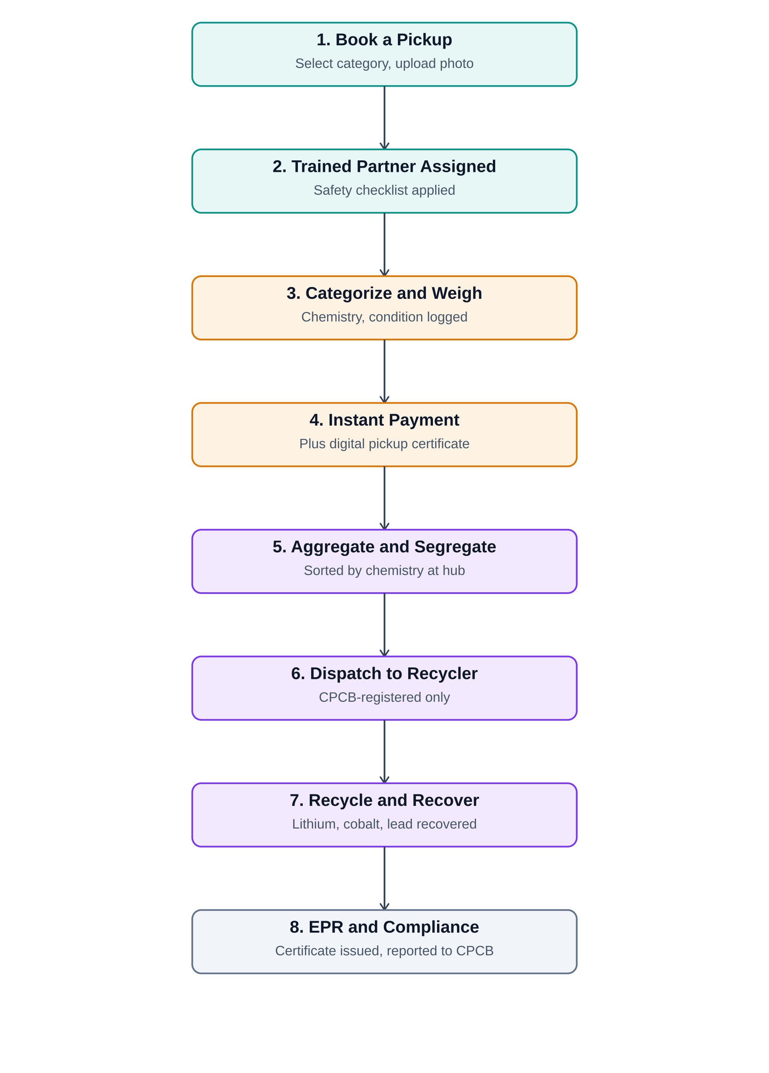

5. Workflow Steps (Detail)
- Book a pickup — customer selects battery category and uploads a photo; app returns an indicative value.
- Trained partner assigned — nearest available partner accepts and follows a mandatory safety checklist before pickup.
- Categorize and weigh — partner logs chemistry type, condition (healthy/swollen/leaking), and weight, with photo evidence.
- Instant payment — payout calculated from category + weight + condition; customer receives a digital certificate.
- Aggregate and segregate — batteries are grouped strictly by chemistry at a collection hub, stored under safety norms.
- Dispatch to recycler — only CPCB-registered recyclers/refurbishers receive shipments; a manifest is logged for traceability.
- Recycle and recover — recycler extracts lithium, cobalt, nickel, lead, etc., and confirms processing in-app.
- EPR and compliance — confirmation is converted into an EPR credit, reconciled against producer obligations, and rolled into CPCB/SPCB filings.

6. Core Data Entities (for backend design)
Entity | Key attributes
User (Customer) | id, name, address, phone, wallet balance
Partner | id, name, zone, vehicle, safety-training status, rating, wallet balance
Pickup Request | id, customer_id, partner_id, status, category, photo, scheduled time
Battery Item | id, pickup_id, chemistry type, condition, weight, price, photo
Facility/Hub | id, location, current inventory by chemistry, capacity
Recycler | id, name, CPCB registration no., capacity, accepted chemistries
Dispatch Manifest | id, facility_id, recycler_id, item list, dispatch date, status
EPR Certificate | id, manifest_id, producer_id, quantity, issue date, CPCB reference

7. Suggested Tech Stack
- Customer & Partner apps: cross-platform mobile (Flutter or React Native)
- Backend: REST/GraphQL API, job-assignment & pricing engine, wallet/payments service
- Database: relational DB (PostgreSQL/MySQL) with an append-only audit log for traceability
- AI/ML: image-based battery type & condition detection at booking and pickup
- Admin dashboard: web app (React) with role-based access for ops, producers, and eventually regulators
- Integrations: CPCB EPR portal, payment gateway/UPI, SMS/WhatsApp notifications, maps/geolocation

8. Compliance Checklist (India)
- Register the platform/collection entity, partners, and recyclers under the Battery Waste Management Rules, 2022 via the CPCB portal
- Never route batteries to landfill or incineration — recycler/refurbisher only
- Maintain chemistry-wise segregation from pickup through dispatch
- Generate and reconcile EPR certificates for every batch processed
- File annual returns to CPCB/SPCB (due 30 June for the prior financial year)

9. Suggested Build Order (MVP → Scale)
- MVP: Customer booking + Partner pickup + manual pricing + basic payment — for one battery category (e.g. portable) in one city.
- Add categorization/condition capture with photo proof and automated pricing.
- Add Facility/Hub module for segregation and dispatch tracking.
- Integrate with 2-3 registered recyclers and build the EPR reconciliation flow.
- Launch the B2B producer/OEM portal for compliance reporting.
- Expand battery categories (automotive, industrial, EV) and cities.

