Back2Basics 23/7/2026
Battery Waste Collection App Documentation.
Process Documentation & Workflow
Side | Role
Customer App | Books a pickup, sells scrap, tracks earnings and environmental impact
Partner App ("Eco-warrior") | Accepts pickup jobs, weighs/evaluates scrap, collects, gets paid
Admin / Backend | Assigns jobs, sets pricing, manages facilities, generates compliance reports

1.1 Core Process
- Book a Pickup — customer schedules a pickup slot in-app.
- Eco-warrior assigned — nearest trained partner accepts via the Partner App, GPS-guided.
- On-site evaluation — partner weighs and grades the scrap using live/market-linked rates.
- Instant payment — paid by weight × rate, or redeemed as Green Coins, gold, silver, or coupons.
- Sorting & tagging — material is tagged, sorted, and analyzed at a processing hub.
- Recycling / downstream processing — material moves to licensed recyclers.
- Tracking & impact dashboard — customer sees CO₂ avoided, plastic diverted, trees saved, etc.

1.2 What Makes the Model Work
- On-demand, cab-booking-style UX that removes the friction of finding a scrap dealer
- Real-time, transparent pricing tied to material type and weight
- Gamified incentives (Green Coins, gold/silver redemption, referrals, impact tracking)
- Two dedicated apps (consumer + field force) connected by a common backend

2. Adapting the Model for Battery Waste Collection
Batteries are not generic dry scrap. The core booking → pickup → payment → processing loop is reusable, but battery waste in India is governed by the Battery Waste Management Rules, 2022 (BWMR 2022), which adds safety and regulatory requirements on top of the model.
Battery App (adaptation needed)
Classify by battery chemistry: portable, automotive (lead-acid), industrial, EV
Partner needs safety training (short-circuit risk, swelling/leaking, terminal taping)
Valuation also factors condition (swollen, leaking, dead-short)
Needs hazardous-goods-compliant transport, segregated by chemistry
Facility must segregate by chemistry, route only to registered recyclers
Recovery of lithium, cobalt, nickel, lead via registered recyclers; generates EPR credit
Add EPR/regulatory dashboard: kg by category, recycler destination, certificates
Producers/collectors/recyclers must register with CPCB; pickups map to EPR records

2.1 Regulatory Backbone (India-specific)
- Battery Waste Management Rules, 2022 cover all battery types regardless of chemistry, shape, or use.
- Built on Extended Producer Responsibility (EPR): producers/importers are responsible for collection and recycling/refurbishment; no landfilling or incineration.
- A central online CPCB portal handles registration and exchange of EPR certificates between producers and recyclers/refurbishers.
- Producers/recyclers must file annual returns to CPCB/State Pollution Control Boards (by 30 June of the following financial year).
- Non-compliance triggers environmental compensation — a strong reason producers/OEMs would pay for a compliant collection platform.
Implication: this can be built as more than a consumer app — it can be sold as a compliance-as-a-service platform to producers/OEMs/importers who need to hit EPR collection targets. This is a second, B2B revenue stream.

3. Proposed App Ecosystem

A. Customer App (household / retailer / EV owner / business)
- Book a battery pickup (photo + category: portable / automotive / industrial / EV)
- Indicative quote — weight- or unit-based, plus condition flags (leaking/swollen/dead)
- Real-time tracking of assigned partner
- Digital invoice + disposal certificate for business/RWA compliance
- Wallet — cash payout or rewards (green coins, gold/silver, coupons)
- Personal impact dashboard (kg recycled, materials recovered, CO₂ avoided)

B. Partner App ("Battery Warrior")
- Accept/reject nearby jobs, GPS-guided navigation
- Safety checklist per pickup (terminal insulation, no puncturing, segregate by chemistry, fire-safe crate)
- On-site categorization + weighing, photo upload for condition proof
- Auto-priced payout by category/weight/condition, paid to partner wallet
- Bulk drop-off flow at aggregation/segregation center with digital chain-of-custody receipt

C. Admin / Compliance Dashboard
- Job assignment, partner network management, category-wise pricing
- Facility inventory by chemistry, dwell-time / fire-risk monitoring
- Recycler/refurbisher management — registration, capacity, recovery rates
- EPR reconciliation: collected → sent to recyclers → certificates generated, mapped to producer obligations
- Regulatory reporting exports for CPCB/SPCB annual returns
- Producer-facing portal showing live progress against EPR targets
4. Workflow Diagram
End-to-end battery waste collection process, from booking through recycling and compliance reporting:
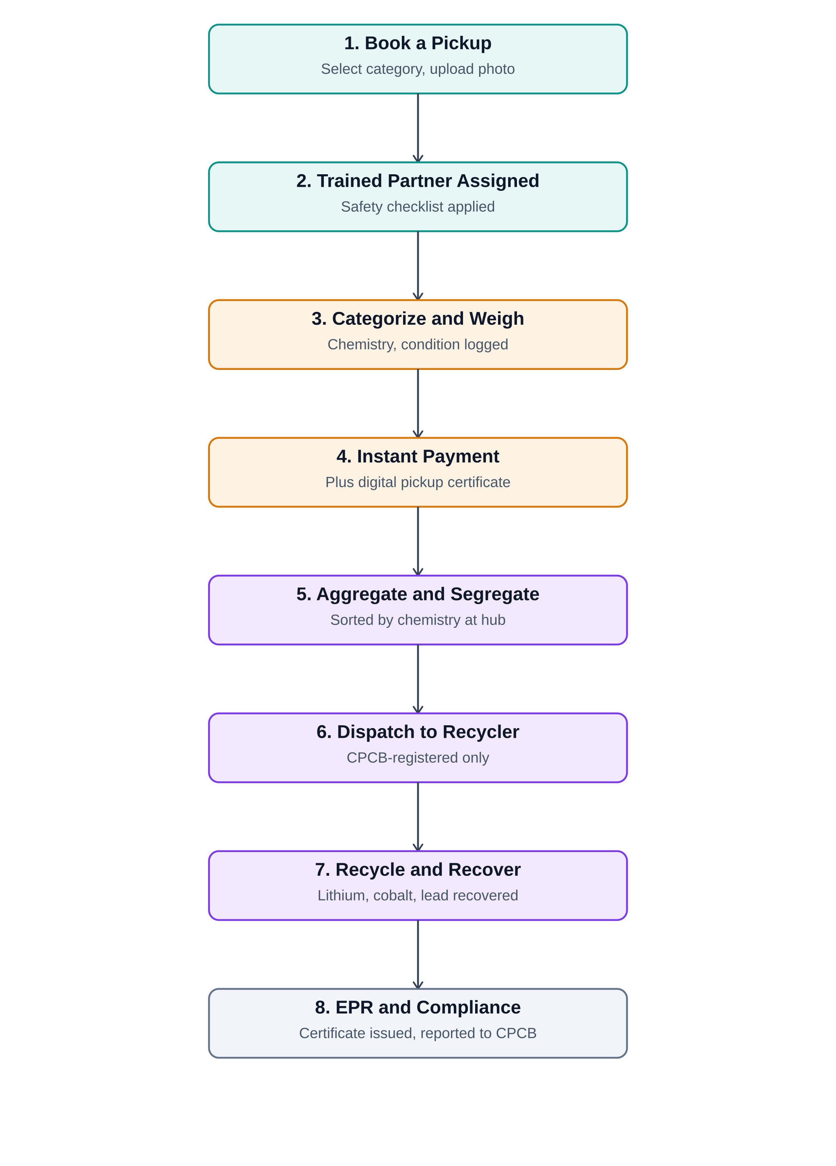

5. End-to-End Process Flow (Narrative)
- Customer books a pickup — selects battery type/category, uploads a photo, gets an indicative value.
- Partner assigned & trained handling applied — nearest trained agent follows a safety checklist (insulate terminals, fire-safe crate, no mixing chemistries).
- On-site categorization, weighing & condition check — partner tags chemistry, condition, and photographs it for the audit trail.
- Instant payment / reward — payout from category + weight + condition; customer gets a digital pickup certificate.
- Aggregation & segregation at hub — sorted strictly by chemistry, stored per safety norms, pending onward dispatch.
- Dispatch to registered recycler/refurbisher — only CPCB-registered recyclers receive material; manifest logged for traceability.
- Recycling / material recovery — recovery of lithium, cobalt, nickel, lead; recycler issues confirmation.
- EPR certificate generation & compliance reporting — confirmation converted to EPR credit, reconciled against producer obligations, feeds annual CPCB/SPCB filings.

6. Key Design Differences to Build In From Day One
- Category-first UX — first screen asks battery type, with photo-based AI-assist for non-technical users
- Condition flagging — swollen/leaking batteries need a careful handling path, not customer self-packing
- Chain-of-custody / traceability by default — timestamp, GPS, photos, weight, category from collection to recycler confirmation
- Two customer segments, two flows — household (gamified rewards) vs. bulk generators (contracted pickups, invoicing, EPR reporting)
- Facility safety module — track dwell time and storage conditions due to thermal-runaway risk
- Compliance dashboard as a first-class module — the key differentiator that justifies producers paying for the platform

7. Suggested Next Steps
- Decide the go-to-market wedge: household consumer play vs. B2B/EPR-compliance play with OEMs and bulk generators.
- Map out battery categories to support first — start with portable + automotive lead-acid before EV battery logistics.
- Identify 2–3 CPCB-registered recyclers/refurbishers to partner with before launch.
- Prototype the booking flow (category + photo capture) and the partner safety-checklist flow first.

