Perfect — below are all three deliverables, written so you can print, laminate, or drop straight into a PDF / Notion page. I’ll keep wording field-tight, color-coded, and new-hire friendly.

🟦 1-PAGE COLOR-CODED FIELD CHEAT SHEET
Flow Pump • Deaeration Pump • Air Issues (2008T / Bluestar)

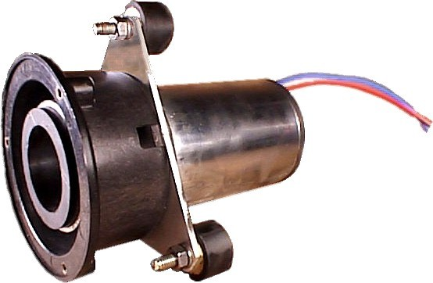

🔵 FLOW PUMP (Liquid Delivery)
Primary Role: Moves water through the system at controlled flow rates
Common Causes of Drift
- 🟦 Tubing fatigue / flattening
- 🟦 Roller wear or slipping
- 🟦 Chemical residue on rollers
- 🟦 Mechanical drag or bearing stiffness
- 🟦 Motor / encoder aging (less common)
Field Symptoms
- Low Flow alarms
- Failed flow calibration
- Conductivity instability without visible air
- Calibration improves after tubing change
Quick Checks
- Inspect tubing compression
- Watch for unstable flow during calibration
- Listen for abnormal pump noise

🟢 DEAERATION PUMP (Air Removal)
Primary Role: Removes dissolved & free air to maintain solid water column
Common Causes of Drift
- 🟢 Carbon brush wear (VERY common)
- 🟢 Air leaks (fittings, tubing, O-rings)
- 🟢 Weak vacuum pull
- 🟢 Moisture/chemical vapor exposure
- 🟢 Low or unstable voltage supply
Field Symptoms
- Hydro chamber won’t stay full
- Intermittent Low Flow alarms
- Conductivity drifting after rinse or idle
- Flow calibration repeatedly fails despite good tubing
Quick Checks
- Listen for weak or inconsistent motor pitch
- Watch hydro chamber refill behavior
- Check connectors and PDB voltage

🟡 AIR / AIRLOCK ISSUES (Often Misdiagnosed)
Primary Role: NOT a component — a condition
Common Causes
- 🟡 Incomplete priming
- 🟡 Empty or partially filled hydro chamber
- 🟡 Recent filter/pump service
- 🟡 Loose fittings allowing micro-air leaks
Field Symptoms
- Flow calibration fails → passes after rinse
- Conductivity swings randomly
- “No chemical intake” or flow inlet errors
- Machine improves after extended rinse
Quick Fix
- Extended rinse (5–10 min)
- Manually fill hydro chamber if empty
- Reseat fittings

🚨 FIELD RULE (MEMORIZE)
Air problems mimic flow pump failure.
Deaeration problems CREATE air problems.

🟨 DECISION TREE
Flow vs Deaeration vs Air
START
│
├── Is hydro chamber FULL and staying full?
│ │
│ ├── NO → Suspect DEAERATION or AIR
│ │ ├── Run extended rinse (5–10 min)
│ │ ├── Manually fill hydro chamber
│ │ └── If problem returns → Deaeration pump weak
│ │
│ └── YES
│
├── Does flow calibration FAIL consistently?
│ │
│ ├── YES
│ │ ├── Inspect tubing & rollers
│ │ ├── Replace tubing if worn
│ │ └── If still failing → Flow pump motor
│ │
│ └── NO
│
├── Are alarms INTERMITTENT?
│ │
│ ├── YES → Air or Deaeration
│ │ └── Listen for weak deaeration pump
│ │
│ └── NO → Mechanical flow issue
│
END

🟪 NEW-HIRE TRAINING INSERT
2008T / Bluestar – Flow & Deaeration Basics
🧠 How New Techs Should Think About It
- Flow pump moves water
- Deaeration pump removes air
- Air breaks everything downstream

🧪 Common Rookie Mistakes
❌ Replacing flow pump first
❌ Ignoring hydro chamber level
❌ Calibrating before removing air
❌ Assuming “passes once” means fixed

✅ Proper Troubleshooting Order
1️⃣ Clear air (rinse, prime, hydro chamber)
2️⃣ Observe deaeration pump behavior
3️⃣ Inspect flow tubing & rollers
4️⃣ Calibrate LAST — not first

🛠️ Field Wisdom (Experience Shortcut)
- If it fixes itself after rinse → AIR
- If it keeps coming back → DEAERATION
- If tubing is old or flat → FLOW

🧾 When to Replace
- Flow Pump: tubing/rollers fail calibration repeatedly
- Deaeration Pump: weak vacuum, brush wear, repeated air issues

✅ NEXT STEPS (Optional – I Can Build These Fast)
- 📄 Printable PDF (letter, color-coded, laminated-ready)
- 📱 Notion / mobile version
- 🧠 Quiz sheet for new hires
- 🧩 Add to your 2008T Field Shortcut Playbook
Just tell me:
PDF or Notion first?
Below is a field-relevant breakdown of why flow pumps and deaeration pumps drift or fail calibration on dialysis machines (especially common on Fresenius platforms). I’ll keep it practical and tied to what you actually see in clinics.
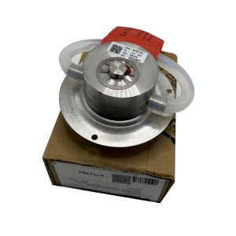
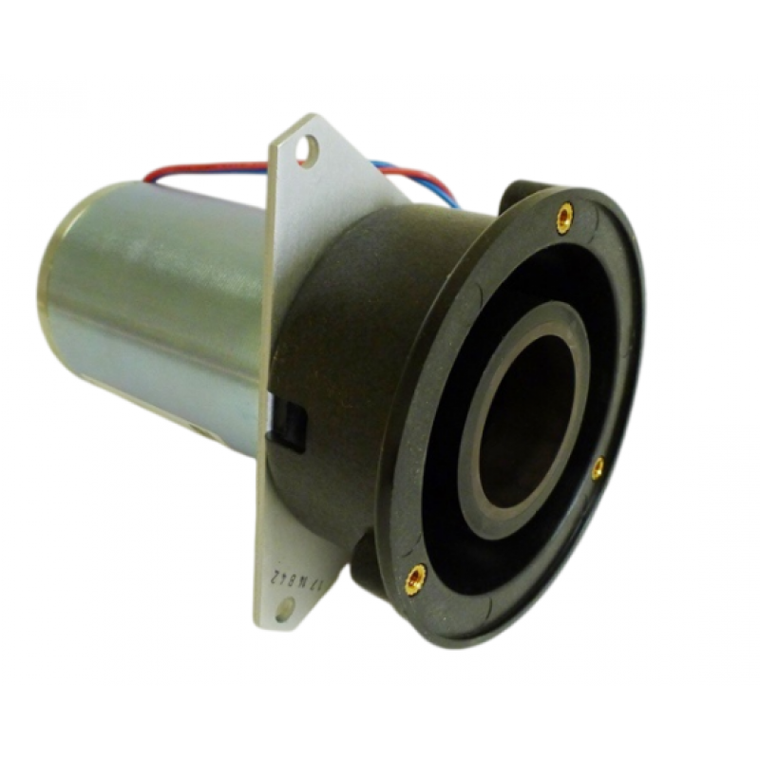
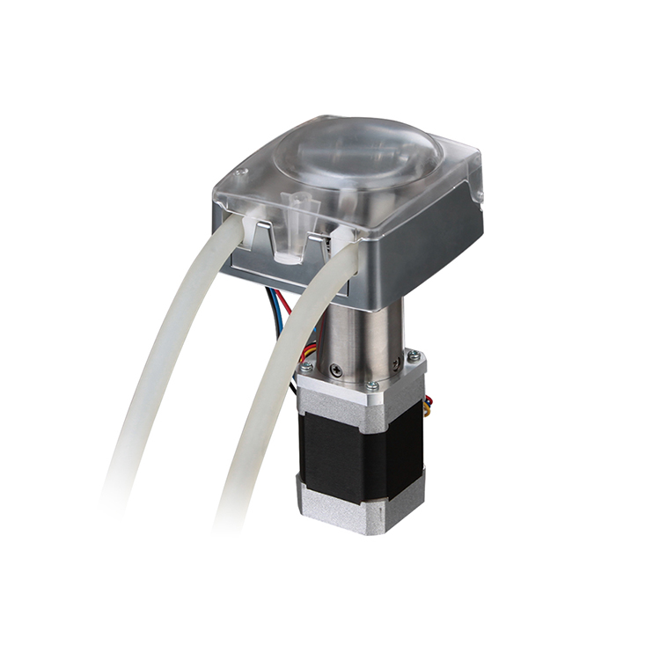
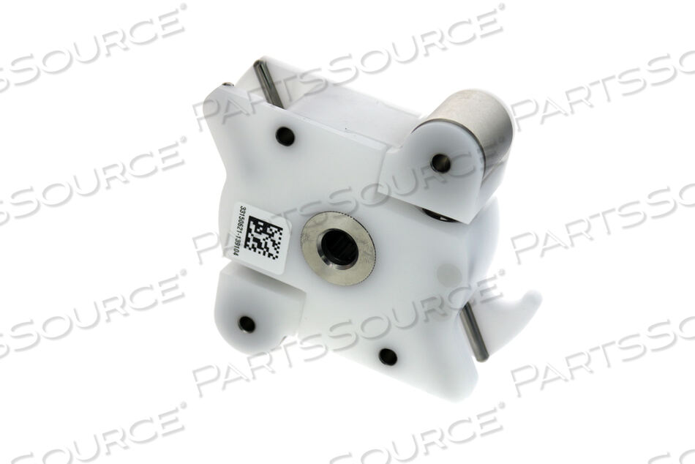

🔧 Common Causes of Flow Pump Becoming Uncalibrated
1️⃣ Tubing Wear / Fatigue (Most Common)
- Peristaltic tubing flattens over time
- Reduces actual delivered flow even if RPMs are correct
- Leads to low flow alarms, failed volume calibration, or conductivity instability
Field clue: Calibration “passes” one day, fails the next after normal use.

2️⃣ Roller Wear or Contamination
- Rollers develop flat spots or slip
- Chemical residue (acid/bicarb) reduces friction
- Flow becomes inconsistent per rotation
Field clue: Flow fluctuates during calibration instead of stabilizing.

3️⃣ Air in the Line / Incomplete Prime
- Air compresses → pump moves air, not fluid
- Calibration volume is falsely low
- Often happens after filter changes or pump servicing
Field clue: Calibration improves after extended rinse or manual priming.

4️⃣ Mechanical Drag or Binding
- Stiff bearings
- Misaligned pump head
- Increased resistance changes effective RPM vs flow
Field clue: Pump sounds louder or struggles during operation.

5️⃣ Electrical Drift (Encoder / Motor Control)
- Aging motor
- Encoder miscounting revolutions
- Board drift (less common but real)
Field clue: Tubing replaced but calibration still fails → suspect motor.

💨 Common Causes of Deaeration Pump Becoming Uncalibrated
1️⃣ Carbon Brush Wear (Very Common)
- Deaeration pumps are brushed DC motors
- Brushes wear → RPM drops
- Pump spins but doesn’t evacuate air efficiently
Field clue: Passes self-test but causes intermittent low flow or air alarms.

2️⃣ Air Leaks in Deaeration Path
- Loose fittings
- Cracked tubing
- Worn O-rings
Air leak = pump can’t pull proper vacuum.
Field clue: Hydro chamber won’t stay full or refills slowly.

3️⃣ Internal Pump Contamination
- Moisture or condensate inside pump
- Chemical vapor damage over time
Field clue: Pump runs but feels weak; calibration barely misses spec.

4️⃣ Electrical Supply Issues
- Low voltage from PDB
- Connector corrosion
- Intermittent power drop
Field clue: Deaeration pump performance varies between machines or outlets.

5️⃣ Software Compensation Limits
- Machine increases RPM to compensate for weak pump
- Eventually hits max limit → calibration failure
Field clue: Pump works “okay” until calibration is attempted.

⚠️ Why Flow & Deaeration Issues Often Appear Together
These systems are interdependent:
- Deaeration pump removes air → ensures solid water column
- Flow pump assumes liquid only, not compressible air
- Air in system = false low flow, bad conductivity, failed calibration
Real-world result:
You replace or calibrate the flow pump, but the problem keeps coming back → root cause is deaeration.

🧠 Field Shortcut (Experience-Based Logic)
If you see:
- ✔ Flow calibration drifting
- ✔ Conductivity instability
- ✔ Hydro chamber not staying full
- ✔ Intermittent low flow alarms
👉 Suspect deaeration pump FIRST, not just the flow pump.

🧪 Practical Field Checks (Before Replacing Anything)
Quick Check | What It Tells You
Extended rinse (5–10 min) | Clears air / confirms air-related issue
Manually fill hydro chamber | Rules out air lock
Listen for pump pitch change | Indicates motor or brush wear
Inspect tubing compression | Confirms flow pump integrity
Check PDB voltage | Rules out electrical cause

🧩 Want This Turned Into…
- A 1-page color-coded field cheat sheet
- A decision tree (flow vs deaeration vs air)
- A new-hire training insert for 2008T/Bluestar
- Or a Notion/mobile checklist you can use on rounds
Just tell me which format you want and I’ll build it for you.

