**Google Data Analytics Certificate — Case Study Report Template**

Case Study Title:

Bellabeat Case Study — How Can a Wellness Company Play It Smart?

1. **🧠 Business Task**

Bellabeat, a wellness-focused company, wants to better understand how users interact with smart fitness devices to improve their product and marketing strategy. My goal is to analyze Fitbit data and identify trends that can inform actionable business recommendations.

**2. 📂 Data Sources**

I used public Fitbit data from Kaggle, consisting of anonymized activity, sleep, and weight data for 30 users collected over 31 days in 2016. The key tables used include:

* dailyActivity_merged.csv: tracks steps, calories, intensity, and distance per user per day
* sleepDay_merged.csv: logs total minutes asleep and time in bed

**3. 🧹 Data Cleaning & Transformation**

What cleaning or prep steps did you do?

I removed duplicates, standardized column names, formatted dates, and ensured each table used the same date format. I joined dailyActivity with sleepDay to examine relationships between sleep and physical activity.

**4. 📊 Analysis Summary**

What patterns and trends did you find?

* Most users averaged fewer than 8,000 steps per day, suggesting a generally low daily activity level.
* Users who slept less than 7 hours per night logged more daily steps than those who slept 7+ hours. This unexpected trend may be influenced by user lifestyle differences or inconsistent sleep tracking.
* Caloric expenditure was lower on weekends compared to weekdays, indicating decreased physical activity during the weekend.
* Sedentary minutes made up the largest portion of the day, averaging over 16.5 hours (991 minutes) per user.
* Very active minutes averaged just 21 minutes per day, while lightly active minutes averaged around 3.2 hours.
* A small percentage of users consistently tracked their weight, limiting the ability to draw strong conclusions in that area.

**5. 📈 Visualizations & Key Findings**

* Bar chart: Average steps per weekday
* Pie chart: Proportion of time spent sedentary vs. active

**6. 📣 Recommendations**

Based on your insights, what should Bellabeat do?

* Emphasize the benefits of consistent sleep in Bellabeat’s marketing and in-app messaging to encourage healthier routines, even if increased sleep doesn’t always correlate directly with more steps.
* Design app features that reward daily tracking of both sleep and steps, helping users stay engaged and improving data consistency.
* Educate users on how low activity levels affect health, using personalized insights (e.g., “You’ve been sedentary for X hours today”) to encourage movement throughout the day.
* Promote stronger weekday routines and weekend engagement strategies, such as activity reminders or weekend challenges, to help users maintain momentum across the full week.

**1. Average Steps per Day**

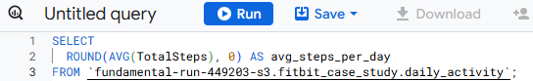

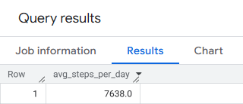

(sec. 4 analysis summary)

The average number of steps taken per day by users in the dataset was approximately 7,638 steps. This falls below the widely recommended 10,000 steps/day goal, suggesting that many users of smart fitness devices may still be relatively inactive despite using a tracker. This presents an opportunity for Bellabeat to promote increased daily movement through personalized app reminders, challenges, or goal-setting features.

**2. Average Calories Burned by Weekday**

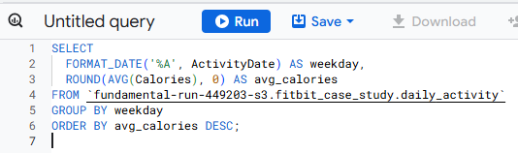

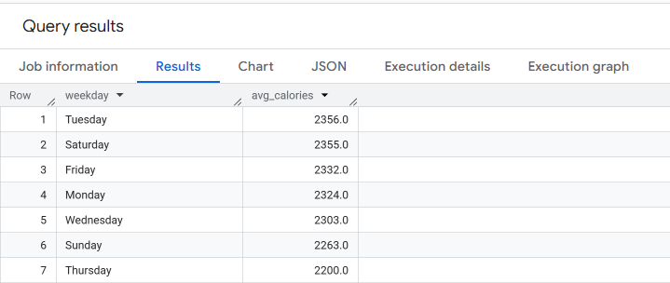

This data reveals that users burn the most calories on Tuesdays and Saturdays, with average daily calories burned reaching approximately 2,356 kcal. The lowest activity levels occur on Thursdays (2,200 kcal).

This suggests that user engagement in physical activity varies by day of the week, with noticeable peaks early in the workweek and on weekends. Bellabeat can use this trend to:

Schedule motivational push notifications or challenged on lower activity days like Thursdays

Promote workweek and weekend routines that build on existing habits

Develop social or community features to boost engagement midweek

**3.Sleep Duration vs Steps (JOIN)**

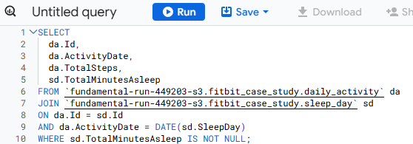

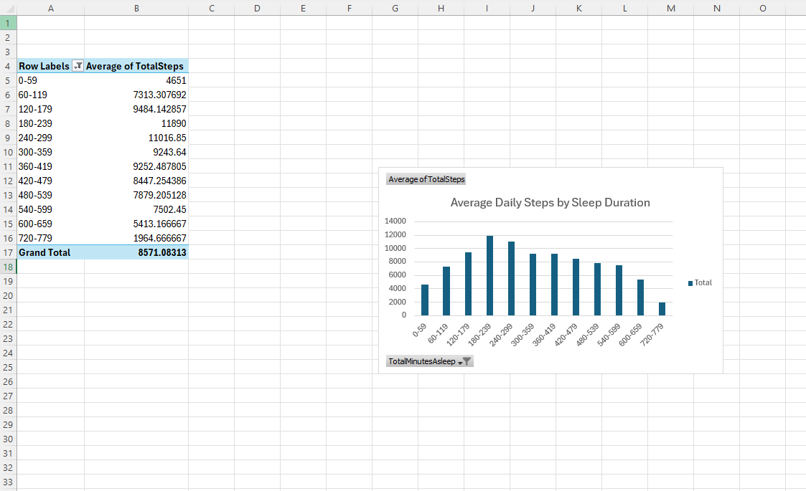

This chart show that physical activity, measured by steps, increases with more sleep up to about 240-300 minutes (4-5 hours), peaking around 120-180 minutes (which may be due to small sample size). There’s a general decline in activity after 480+ minutes (8+ hours) of sleep, suggesting that 7-8 hours may be the optimal widow for balancing rest and movement.

**Compare 7+ hrs sleep vs <7 hrs**

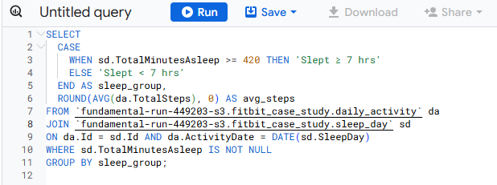

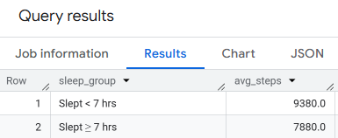

**4. Users with 7+ Hours Sleep – Do They Walk More?**

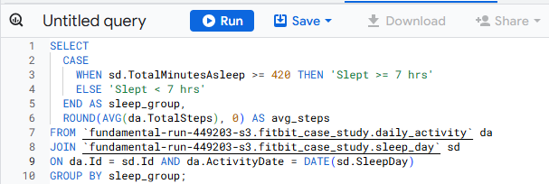

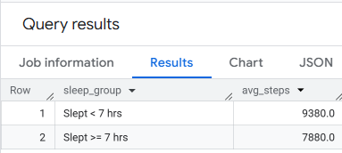

Surprisingly, the data showed that users who sleep less than 7 hours walked ore steps per day(9,380 steps) comparted to those who slept 7+ hours (7,880 steps). While this is contrary to expectations, it may be influenced by small sample size, inconsistent sleep tracking or differences in lifestyle (more active users sleeping less). Bellabeat can use this as a cue to encourage consistent sleep tracking and explore user routines further. Due to real-world variation in sleep and activity tracking, some findings may not follow expected patterns. This highlights the importance of encouraging consistent data logging in Bellabeat’s user base.

**Activity Type Breakdown**

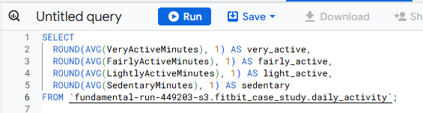

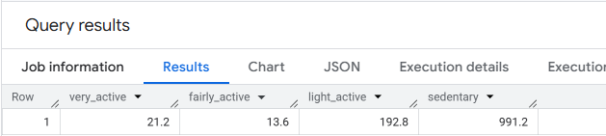

* Activity breakdown data reveals that Bellabeat users spend approximately 16.5 hours per day in sedentary activity, with less than 30 minutes in high intensity movement.
* This suggests a key opportunity to encourage more frequent movement through:
* Gentle push notifications for stretch/move breaks
* Activity streak rewards (ex. “3 days of 30 minutes = 1 badge”)
* Reminders triggered after long sedentary periods

