Health App

Deployment Specification

December 3, 2017

Gayatri Patel

Melissa Heredia

Gopika Menon

Thanjila Uddin

# Table of Contents

**Table of Contents** **2**

**Offline Version** **3**

Setting Up MyHealthKeeper for Deployment 3

Prerequisite 3

Steps 3

**Online Version** **4**

Setting Up MyHealthKeeper for Deployment 4

Prerequisite 4

Steps 4

Accessing AWS Server 5

Steps 5

View PHP files 5

# 

# 

# Offline Version

## Setting Up MyHealthKeeper for Deployment

### Prerequisite

* macOS Sierra version 10.12.6 or higher
* Valid Apple ID and Password

### Steps

1. Navigate to App Store and Install XCode Version 8 or higher, if not already installed:
   1. Search for and navigate to ‘XCode’.
   2. Select ‘Get’ then ‘Install’ button to download the application.
   3. Enter valid Apple ID Password when prompted.
   4. Select ‘Open’ to open XCode.
2. Install GitHub Desktop, if not already installed:
   1. Please refer to <https://desktop.github.com/> for installation instructions.
3. Install SQLite version 3.21.0
   1. If you have any trouble with this installation please refer to <https://www.sqlite.org/>
4. In GitHub Desktop, select the project repository under <https://github.com/gmn17/myHealthApp>
   1. Clone MyHealthKeeper in GitHub Desktop from the master branch
5. Open the project in XCode.
6. Change all the path variables located in the files listed below to a path on your local computer where you would like to save the database file.

* DBManager.swift
* DBFeatures.swift
* DocumentDBManager.swift
* DBMadicalInfo.swift

Example: let path = "/Users/Username/Desktop/FOLDER_NAME"

# Online Version

## Setting Up MyHealthKeeper for Deployment

### Prerequisite

* macOS Sierra Version 10.12.6 or higher
* Valid Apple ID and Password

### Steps

1. Install XCode version 8 or higher, if not already installed:
   1. Search for and navigate to ‘XCode’
   2. Select ‘Get’ then ‘Install’ button to download the application
   3. Enter valid Apple ID Password when prompted
   4. Select ‘Open’ to open XCode
2. Install GitHub Desktop, if not already installed:
   1. Please refer to <https://desktop.github.com/> for installation instructions
3. Install SQLite version 3.21.0
   1. If you have any trouble with this installation please refer to <https://www.sqlite.org/>
4. In GitHub Desktop, select the project repository under <https://github.com/gmn17/myHealthApp>
   1. Clone MyHealthKeeper in GitHub Desktop from the OnlineWithOfflineFeatures branch
5. Open the project in XCode.
6. Change all the path variables located in the files listed below to a path on your local computer where you would like to save the database file.

* DBManager.swift
* DBFeatures.swift
* DocumentDBManager.swift
* DBMedicalInfo.swift

Example: let path = "/Users/Username/Desktop/FOLDER_NAME"

## Accessing AWS Server

### Steps

1. To go to our current server, enter the following path in your browser:

[**http://ec2-18-220-5-137.us-east-2.compute.amazonaws.com/phpMyAdmin**](http://ec2-18-220-5-137.us-east-2.compute.amazonaws.com/phpMyAdmin)

1. In the fields presented, type in ‘root’ for username and ‘myhealth’ for password.

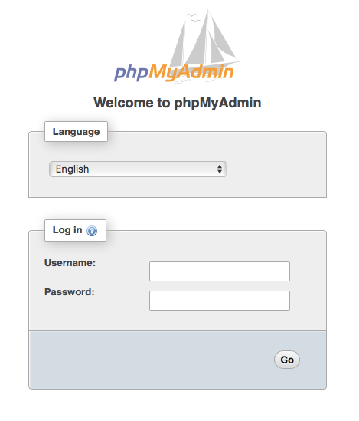

3. The current database schema is the myHealthApp database.

### View PHP files

1. Log in to the EC2 instance through the terminal by typing in the following command:

ssh -i location_of_myhealth.pem [ec2-user@ec2-18-220-5-137.us-east-2.compute.amazonaws.com](mailto:ec2-user@ec2-18-220-5-137.us-east-2.compute.amazonaws.com)

2. Access the PHP files through the terminal by typing in the following commands:

cd /var/www/html

cd myHealthAppOnlineVersion ← Folder which contains the files

ls

Two folders will be available:

* includes
* api

3. To view the PHP files on the server, type in the following commands in the terminal:

cd folder (folder can be includes or api)

ls

Three files will be available in includes:

* Config.php
* DBOperation.php
* DbConnect.php

Eighteen files will be available in api:

* Allergy.php
* Doctor.php
* Document.php
* Illness.php
* Image.php
* InsuranceInformation.php
* Login.php
* MedicalInformation.php
* Medication.php
* MonthlyReminder.php
* PersonalInfo.php
* Registration.php
* Reminder.php
* ResetPassword.php
* Security.php
* Surgery.php
* Timestamp.php
* Vaccine.php

These files can be viewed individually through the nano text editor. Enter the following command in the terminal to view a file:

nano file_name

4. To access and view the files locally:

1. In GitHub Desktop, select the project repository under https://github.com/mtwins/myHealthAppOnlineVersion
2. Clone the project in GitHub Desktop from the master branch
3. Open the PHP files via a PHP editor like Sublime. <https://www.sublimetext.com/>