Tufte Chapter 4 – Data Ink

In his own words Tufte’s five principles of data graphics:
- Above all else, show the data
- Maximize the data-ink ratio
- Erase non-data ink
- Erase redundant data
- Revise and edit

What did I find new or interesting?
Tufte stated that redundancy may have use, if it is “giving a context and order to complexity, facilitating comparisons over various parts of the data, [or] perhaps creating an aesthetic balance.”

What did I find old, passe or dull?
Tufte mentions printing graphic images. In this modern age, I would argue that a lot of data is presented electronically, never to be actually printed out.

Non-Example:
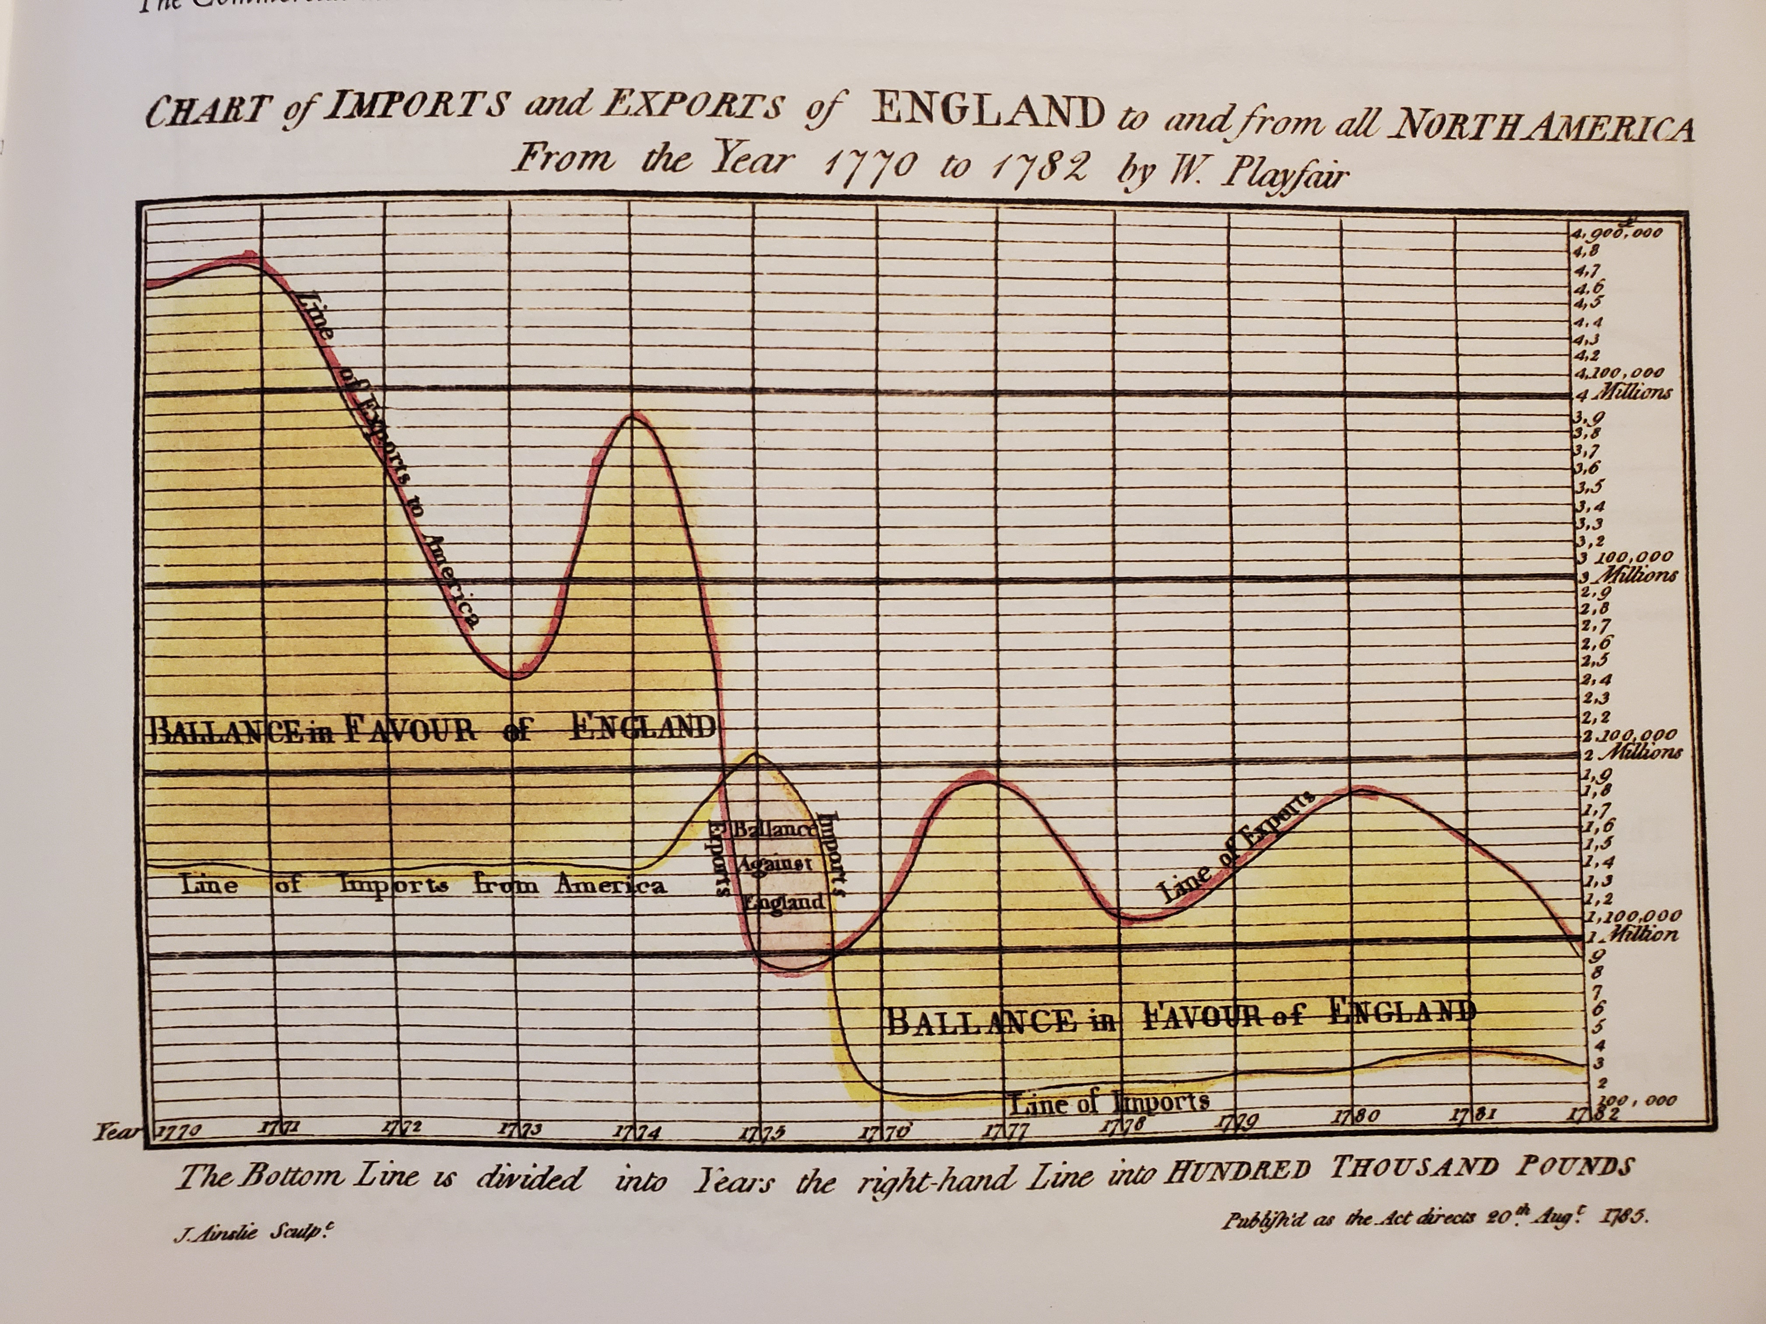

- Very busy grid
- Long title
- Label for each point on both axes

Anchor (Example):
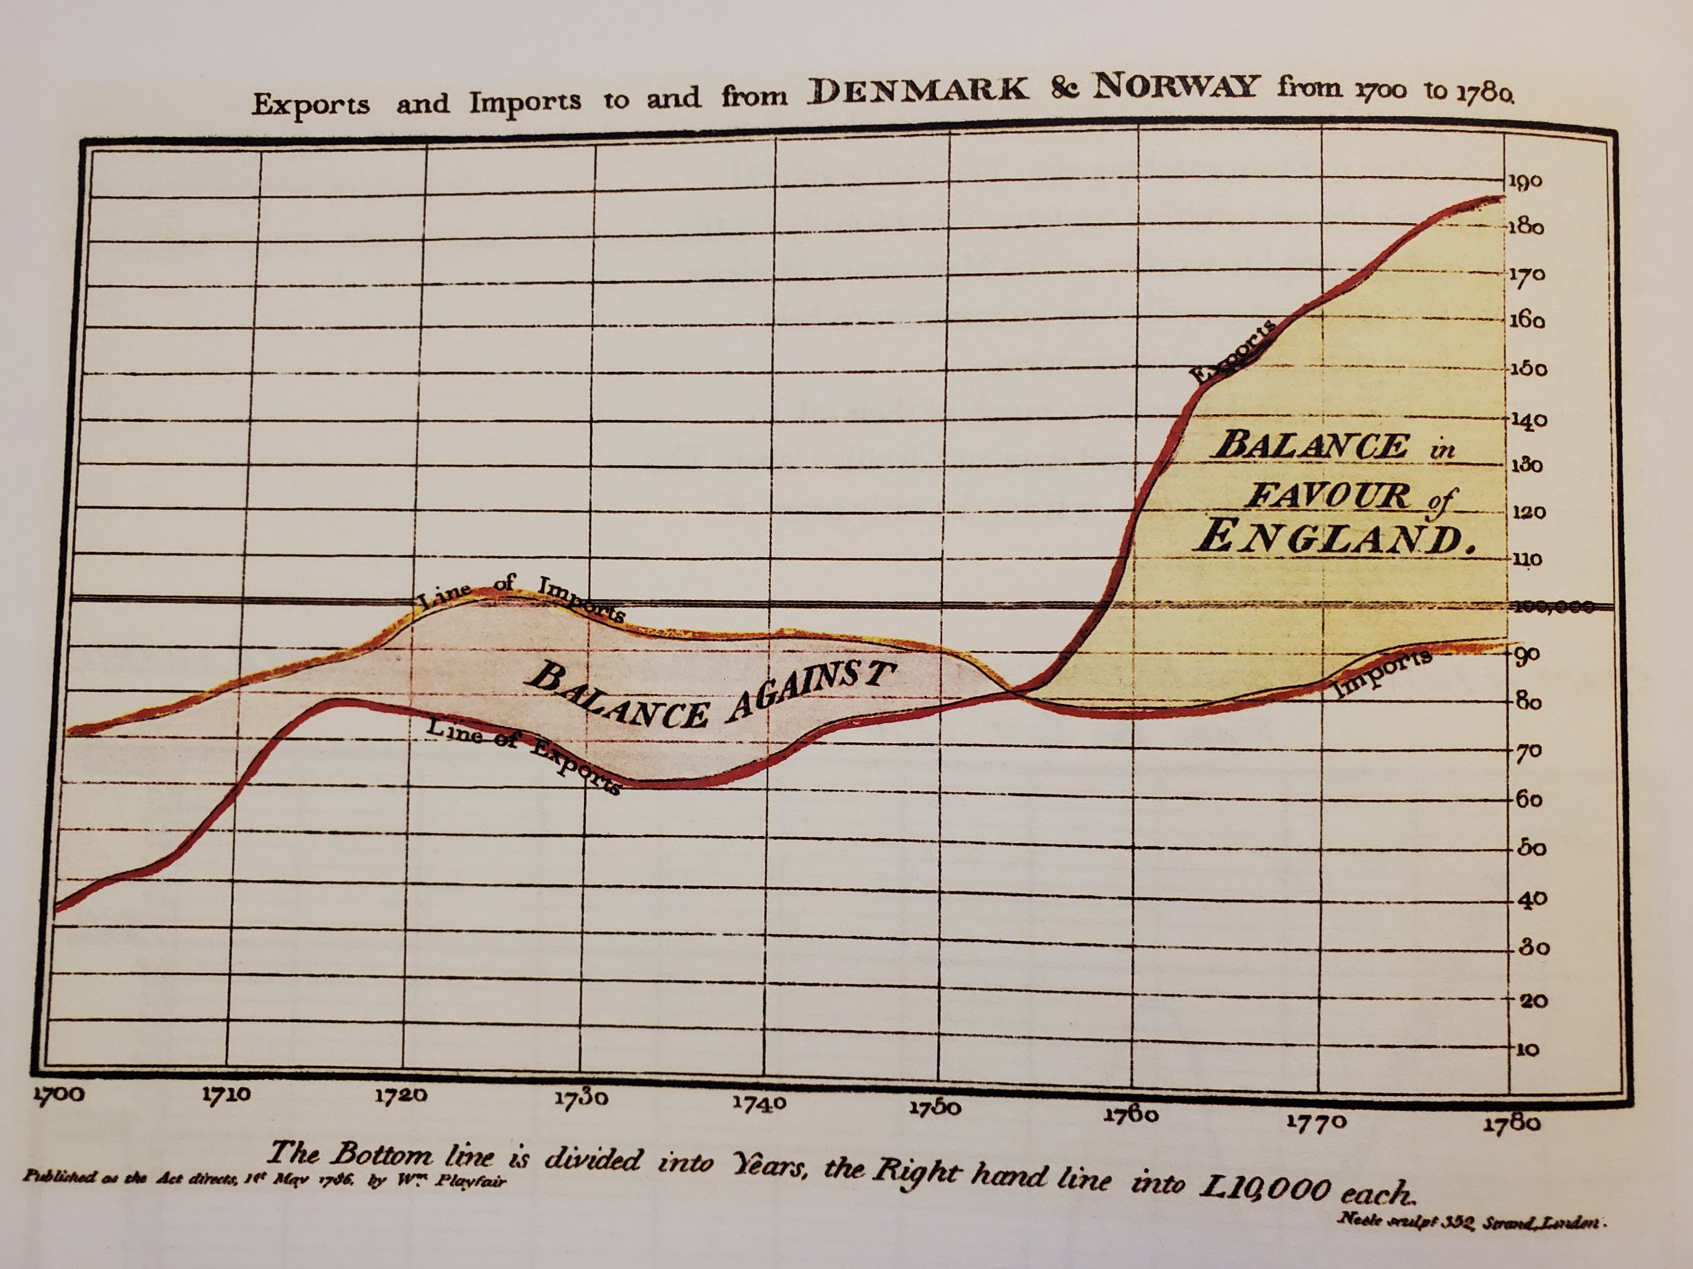

- Less background ink
- Shorter title
- Axes more appropriately segmented

- Above all else, show the data
  - Visuals should not distract from the data at hand
- Maximize the data-ink ratio
  - data-ink is the “non erasable core of a graphic, the non-redundant ink arranged in response to variation in the numbers represented”
  - data-ink ratio = data-ink / total ink used to print the graphics
  - highest possible ratio is 1.0
- Erase non-data ink
  - Non-data ink is ink that does not depict statistical information
  - Some non-data ink is necessary, such as axis titles, labels, etc. However, it should be reduced within reason
- Erase redundant data
  - Redundant data-ink is ink that depicts the same data more than once
  - Bar graph example

  - Some redundant data may be necessary, if it has a purpose. Outside of that, redundant data should be removed
    - Redundant data can give context, provide clarity to complex data or create an “aesthetic balance”
    - For example, cyclical data may be repeated so that the viewer has a better understanding of the cycle
- Revise and edit
  - Just like any other work, graphs should be reviewed and revised until the best product results

