Kayla Bracall
Homework 2
September 24, 2020

In this assignment, I decided to look at miles per gallon (mpg) by both car type and by type of transmission. First I looked at mpg by transmission type. My hypothesis is that manual transmission cars would have better mpg than automatic transmission cars, especially in city driving. I assumed this would be the case as drivers of a car with a manual transmission would have more control over what gear the car is in and during city driving especially, can make decisions that positively impact mpg.

However, when I looked at mpg by in both highway and city settings, I did not see much of a difference between automatic and manual transmissions. While the boxplot representing cars with a manual 5 speed transmission do have outliers with very high mpg, overall the cars with manual transmissions seem to compete on par with cars with 3 speed automatic and constantly variable automatic transmissions.

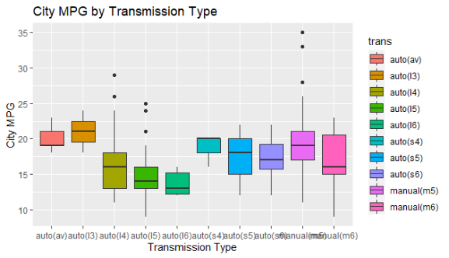

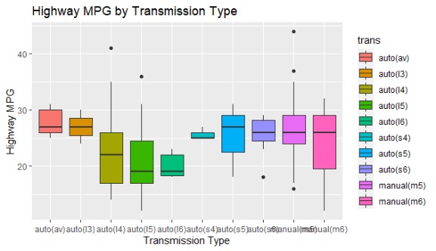

I then looked at mpg by car type, inferring that sports utility vehicles (SUVs), notorious for their poor mpg, would fare the worst in this comparison. Indeed, SUVs fared poorly, but mpg for pick up trucks was on par with SUVs, and arguably worse in city driving. Compact cars and subcompact cars fared the best in both city and highway mpg.

