1. A triangular number series contains the number of objects that form an equilateral triangle of increasing size. The formula for the series is $T_{n}=\frac{n^{2}+n}{2}$. You can use the following image to visualize the pattern for $T_{1}$, $T_{2}$, $T_{3}$, and $T_{4}$:

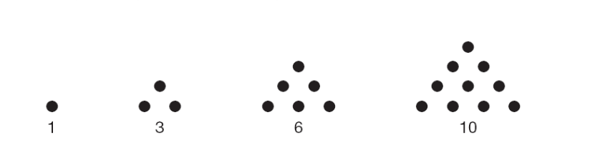

Please do the following:

* 1. Use a loop to generate a vector with the first 20 elements in this series.
  2. Use another loop to create another vector with only the even elements from the vector from a.
  3. Generate the answers to a and b without using a loop.

HINT: Any even number will return 0 when mod 2 is applied!

1. Use a repeat loops to do the following:
   1. Create a vector of length 20 where the first value is 1 and each value after that is three times the preceding value minus 1. That is, $V_{1}=1$ and $V_{n}=3V_{n-1}-1$ for every $V_{n}$ after $V_{1}$
   2. Loop through the vector to change all odd elements to even by adding 1. Do not change the elements that are already even.
   3. Using the original vector you created in a (you must recreate it since you changed it in b), recreate the answer from b without using any loops.
   4. Which method do you think is better and why?
2. Using the superbowl.csv data, create a function called winCount() that receives an NFL team as a character string and returns the number of wins that team has had. If the team provided is not on the list of winners, the function should return “Sorry, that team has not won yet.”