CS 557 Homework #3

Chapter 5 Problems

4)

Case 8)

Chapter 6 Problems

1)

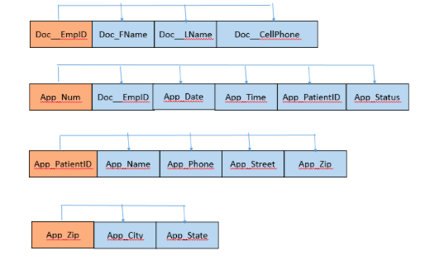

2)

5)