**Installing and Running Thermoengine on Windows x64**

*\*\*\* These instructions are an expanded version of instructins provided at:* [*https://gitlab.com/ENKI-portal/ThermoEngine/-/tree/master/#running-a-container-image-locally*](https://gitlab.com/ENKI-portal/ThermoEngine/-/tree/master/#running-a-container-image-locally)

**Installation**

1. Install Docker on your computer/system
   1. Go the the [Docker website](https://www.docker.com/products/docker-desktop) and download the individual distribution of Docker Desktop for Windows (this is free as of 02/02/2022)
   2. Run the Docker Desktop installation program which will install Docker on your system
      1. During installation, the installation window may prompt you for configuration settings, be sure that “Install required Windows components for WSL 2” is checked
   3. After Docker is finished installing, run the program to check that it installed properly. You may get a pop-up upon starting the program saying that WSL 2 is not installed, if this occurs follow the link to the WSL website and install the program following the provided instructions.

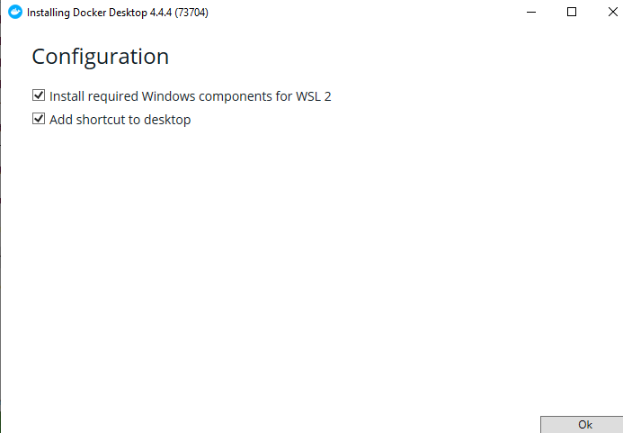

* + 1. Instructions from Docker: <https://docs.docker.com/desktop/windows/wsl/>
    2. Download and instructions installing WSL 2 (follow step 4): <https://docs.microsoft.com/en-us/windows/wsl/install-manual#step-4---download-the-linux-kernel-update-package>

1. Install Git on your system
   1. Go to the [Git website](https://git-scm.com/downloads) and download the x64 bit distribution for Windows
   2. Run the Git installation program, you may choose whatever set-up instructions you want, however, the default set-up configuration is confirmed to work for installing Thermoengine
2. Clone the ThermoEngine repository to a convenient location on your system
   1. Open a terminal window (command window) by either clicking the windows icon and typing command to locate the command prompt or by pressing Windows+R type “cmd” in the run box, and then click “ok”
   2. Choose a directory to install ThermoEngine, you will need to navigate to this directory whenever you run ThermoEngine
      1. Open the file explorer and navigate to the directory where you want to install ThermoEngine
      2. Copy the file path
      3. In the command prompt window type “cd {your directory}” replacing {your directory} with the file path to your chosen directory
   3. Paste “git clone <https://gitlab.com/ENKI-portal/ThermoEngine.git>” into your command prompt to clone the ThermoEngine repository to your chosen directory
3. Run the Docker Image for the first time
   1. In the command prompt, paste “cd ThermoEngine”
      1. This will change the directory to the root of the ThermoEngine repository
   2. Run the shell script “./run_docker_locally.sh”
      1. If you get the error “'.' is not recognized as an internal or external command, operable program or batch file” try running “run_docker_locally.sh”
      2. Allow the script to run, this will likely take several minutes. During this time a Git window will pop-up showing installation progress, the installation is complete when this window disappears
   3. Check to make sure the repository is up to date by running “git pull” in the command prompt

**Running ThermoEngine**

1. Open Docker Desktop
2. Click the “Images” tab
3. Find the image “registry.gitlab.com/enki-portal/thermoengine” and hover over the entry line revealing a “run” button
4. Click “run” which should then take you to the “Containers/Apps” tab
5. Find the running container and click the CLI symbol “>-“ 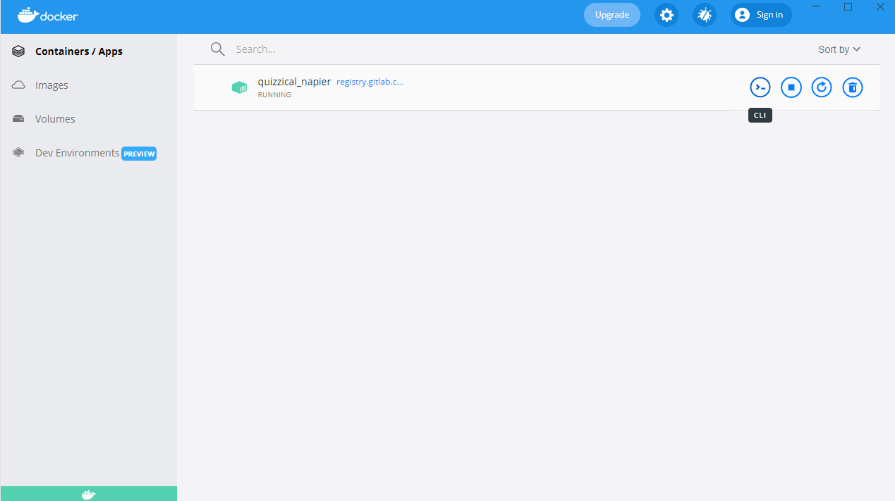
6. This will open a log window in Docker with three links at the bottom of the log, copy and paste each log into a browser until you find a working link (I have found that the bottom link which uses your internal IP works consistently)
   1. If you get a load error, check your firewall settings and ensure that Docker and your browser have inbound and outbound permissions on private and public networks
   2. If you still get a load error, try exiting the container and then starting a new container by restarting at step 2, however open the “Optional Settings” drop-down after you click “run”. In the “Local Host” field, enter “8888” and then click “run”. Re-try the links at the bottom.

***Note: You can re-run your container at a later date by starting Docker, going to the “Containers/Apps” tab and clicking the “Run” symbol which will restart your container; then proceed from Step 5