# Literature data

Compositional, intrinsic thermodynamic (P, T, fO2 if buffered or known), and experimental (run apparatus, capsule material, run time) data were digitized from 52 experimental studies conducted at relatively low fO2 (<IW) that produced silicate melt and a co-existing Si-bearing metal phase. The full unfiltered database consisted of 765 samples. These data were then filtered to remove samples of low quality or compositional outliers, resulting in a final database of 434 samples. Samples were removed from the database if: FeOmelt was <0.1 wt%, SiO2melt was < 1 wt%, Simetal was <0.1 wt% or >25 wt%, Fe was not the dominant component of the metal phase, insufficient chemistry was reported to calculate activity coefficients, or if experiments showed apparent disequilibrium problems or had inconsistencies in data reporting.

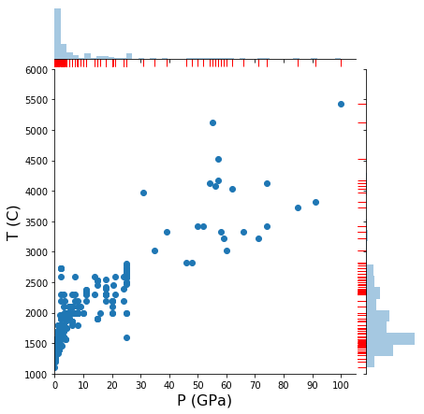

The final database consists of experiments carried out in 1-atmosphere gas mixing furnaces, non-end-loaded piston cylinders, end-loaded piston cylinders, multi anvils, or diamond anvil cells. Experiments ranged from 1100–5426 °C and 0–100 GPa at fO2 from IW-8 to IW. Figure X illustrates the distribution of the database in P-T space. Run durations ranged from <1 minute to just over 24 hours. Experiments were housed in graphite, Al2O3, MgO, or Pt capsules. All experiments produced a silicate melt and metal alloy phase, and many experiments also contained phenocrysts (typically olivine ± pyroxene ± sulfides).

# Data processing

## Activities, activity coefficients, and oxygen fugacity

For all experiments, the fO2 was calculated using Fe-FeO equilibrium:

$${\text{FeO}}_{\text{silicate melt}}\text{=} {\text{Fe}}_{\text{metal}}\text{+} \frac{\text{1}}{\text{2}}{\text{O}}_{\text{2}}$$

where the fO2 of the experiment can be expressed relative to the iron-wüstite (IW) buffer as:

$$\text{2}\text{log}\left(\frac{{\text{α}}_{\text{FeO}}}{{\text{α}}_{\text{Fe}}}\right)\text{=2}\text{log}\left(\frac{{{\text{X}}_{\text{FeO}}\text{ * γ}}_{\text{FeO}}}{{\text{X}}_{\text{Fe}}\text{ *} {\text{γ}}_{\text{Fe}}}\right)\text{= ΔIW}$$

where α is the activity, X is the mole fraction, and γ is the activity coefficient of the subscripted component. Experimental *f*O2s were calculated using a non-ideal solution model for both metallic and silicate liquid. For each experiment, the activity coefficient for FeO in the silicate, γFeO,was calculated with a parameterization based on Holzheid et al. (1997), where γFeO is taken as a fixed value in the range 1.7–3 dependent only upon MgO content of the silicate melt: where MgO ≤20 wt%, γFeO is set equal to 1.7; where MgO is >20 wt%, γFeO is calculated as

$$γ_{\text{FeO}}=1.7+0.1({\text{MgO}}_{\text{silicate, }\text{wt}\text{\%}}-20)$$

with a maximum allowable γFeO value of 3.0. The activity of SiO2 in the silicate melt was calculated using MELTS in the ENKI python framework (v. 1.1.0; citation). The activity coefficients for Fe and Si in Fe-rich metal, γFe andγSi,were calculated using the ε-approach (Wagner, 1952; Ma, 2001), which considers non-ideal interactions between components within the metal alloy. Here we consider interactions between Fe, Si, S, C, O, Ni, Cu, Mn, Cr, Ga, Nb, and Ta. Our code to calculate activity coefficients for all species was benchmarked against activity coefficients reported by Corgne et al. (2008) and calculated with the Norris Scientific Metal Activity Calculator (Wade and Wood, 2005; MetalAct Website) using compositional data of Corgne et al. (2008) as inputs. The full python code library, benchmarking tests, and a Jupyter notebook demonstrating the calculations described above on our dataset are all given in the Supplementary Material, the GitHub repository (link), and archived at zenodo (link/DOI).

359 of the 434 samples in the database reported experimental fO2 values variably based on ideal or non-ideal equilibria, assumed equilibration with a buffer or capsule material, or an assumed intrinsic fO2 of the experimental apparatus. For consistency, we recalculated all reported values based on non-ideal Fe-FeO equilibria as described above and use only calculated values in subsequent modeling. Reported versus calculated fO2 for all these experiments is shown in Figure X. The majority of calculated fO2s are within one log unit of reported values.