# CHAPTER ONE

## 1.0 INTRODUCTION

## 1.1 BACKGROUND INFORMATION

According to Wikipedia a hospital is an institution for health care that provides patient treatment by specialized staff and equipment. Usually, hospitals are funded by the public sector, by health organizations (for profit or nonprofit), health insurance companies or charities, including funds by direct charitable donations. Historically, however, hospitals were often founded and funded by religious orders or charitable individuals and leaders. Modern-day hospitals are largely staffed by professional physicians, surgeons, and nurses.

## 1.2 BRIEF DESCRIPTION OF HOSPITAL ACTIVITIES

A Hospital is a place where patients visit to for medical checkup or diagnosis and treatment. Hospitals provide facilities like:-

1. Consultation and diagnoses of diseases by doctors.
2. Provision of treatment facilities.
3. Facility for admitting Patients (providing beds, nursing, medicines etc.)
4. Immunization of patients/children.

Various operational works are done in a hospital; all these works are done manually using papers as follows:

1. Recording information about the patients that visit a hospital for treatment.
2. Generating bills.
3. Recording information related to diagnosis given to patients.
4. Keeping record of the Immunization provided to children/patients.
5. Keeping information about various diseases and medicines available to cure them.

These are the various jobs that are done in a hospital by the operational staff and doctors; information about patients is recorded manually by just writing the patients name, age and gender. Whenever the patient visits, his information is stored again;

1. Bills are generated by recording price for each service provided to patient on a separate sheet and at last they all are summed up.
2. Diagnosis information to patients is generally recorded on the document, which contains patient information. It is destroyed after some time to decrease the paper load in the office.
3. Immunization records of children are maintained in pre-formatted sheets, which are kept in a file.
4. Information about various diseases is not kept as any document. Doctors themselves do this job by remembering various medicines.
5. All this work is done manually by the receptionist and other operational staff and lots of papers are needed to be handled and taken care of. Doctors have to remember various medicines available for diagnosis and sometimes miss better alternatives as they can’t remember them at that time.

## 1.3 PROBLEM STATEMENT

**Lack of immediate retrieval**: -The information is very difficult to retrieve and to find particular information e.g. - To find out about the patient’s history, the user has to go through various registers. This results in inconvenience and waste of time.

**Lack of immediate information storage**: - The information generated by various transactions takes time and efforts to store them.

**Error prone manual calculation**: - Manual calculations are error prone and takes a lot of time, this may result in incorrect information. For example, calculation of patient’s bill based on various treatments.

**Preparation of accurate and prompt reports**: - This becomes a difficult task as business intelligence is difficult, this is due to lack of information collation (ability to put information together and analyze them).

## 1.4 NEED FOR AUTOMATED SYSTEM.

The need for an Automated Hospital Management System can be summarized as follows:-

**Planned approach towards work**: - The activities in the organization will be well planned and organized. The data will be stored properly in data stores, which will help in retrieval of information and in enforcing security.

**Accuracy**: - The level of accuracy in the proposed automated system will be higher. All operations would be done correctly and accurately. In practice, errors are not completely eliminated, they are reduced.

**Reliability**: - The reliability of the proposed system will be high as information is stored properly and securely.

**No Redundancy**: - In the proposed system utmost care would be taken to ensure that no information is repeated anywhere, in storage. This would assure economic use of storage space and consistency in the data stored.

**Immediate retrieval of information**: - The main objective of the proposed system is to provide for a quick and efficient retrieval of information. Any type of information would be available whenever users require them.

**Immediate storage of information**: - In manual system, lots of problems are encountered in trying to store large amount of information.

**Easy to Operate**: - The system should be easy to operate and should be such that it can be developed within a short period of time and fit the limited budget of the user.

## 1.5 PROJECT OBJECTIVES

The main aim of this project is to design an automated system for controlling the flow of patient’s data in the hospital by solving most of the problems encountered in the hospital using the old and manual system of medical administration. In the manual system, almost all the patient folders in the records have to be accessed by the staff for every folder request. The integrity and security of the data in database system are considered here from the point of view of freedom from risk. The risks are those events that threaten the data; threaten to destroy or corrupt it to prevent its use, threaten to access it illicitly or to steal it. The objectives of the project include:

## 1.6 SPECIFIC OBJECTIVE

1. Requirement analysis of the system
2. Design and development
3. Testing
4. Implementation of the system

## 1.7 THE PROJECT SCOPE

Is the part of project planning that involves determining and documenting a list of specific project goals, [deliverables](http://whatis.techtarget.com/definition/deliverable), tasks, costs and deadlines.

The documentation of a project's scope explains the boundaries of the project.

The hospital management system is capable of supporting any number of staff of the hospital and each module of the package runs independently without affecting other modules. This means that all departments of the hospital working independently and it cover complete cycle from seven modules which are:-

### 1.7.1 PATIENT

This module deals with registering of new patients, for either OPD (Out-patient department) or IPD (In-patient department) and issuing unique identification numbers to the patients. These numbers are unique throughout the system. A patient is first registered at the OPD front office. If eventually the patient is admitted, the same number issued. The IPD/ OPD identification number is used for tracking the medical records of the patient for any OPD visitor IPD admission. All medical records of this patient are identified by this number. The number helps in a flexible searching finding the patient records. This number is assigned to the patient together with a patient card. The number will be used to track the patient record and medical history throughout the lifecycle of the patent medical section.

### 1.7.2 NURSE

A nurse’s work bench is a work platform provided for use by intermediate nurses (auxiliary nurses) to assist in taking patients preliminary examination, accessing current health condition, managing appointment queue and waiting list .Preliminary examination involves taking temperature reading, blood pressure, height and weight of the patient. The features are:-

1. Waiting list
2. Referrals
3. Pre–examination
4. Bill payment

### 1.7.3 DOCTOR

This is a special diagnostic plat-form for doctors. Through the doctor’s workbench, doctors can perform various tasks such as:

1. Viewing and editing patient’s registration data
2. Requesting and viewing laboratory test and result
3. Performing diagnosis
4. Managing beds / wards.
5. Issuing admission and discharge orders
6. Scheduling appointments.

### 1.7.4 LABOLATORY/ RADIOLOGY

This is used to perform data entry of lab test performed on a patient. Tests are grouped under various sections and sample types. Results are based on the type of sample. These results are entered for either one, or multiple tests. These test results are available to concerned doctors. The results of the test are confidential land secured. Most tests are done after the billing is done although this rule is violated in an emergency case. For the X – RAY system, the system stores all the result details of various test results.

### 1.7.5 PHARMACY

This module maintains the data related to the servicing of the in-patient and out-patient of the pharmacy department. It is more of drug order dispensary administration, billing and reporting system.

### 1.7.6 ADMIN

This is the main administration plat form used by the Chief Medical Director (CMD), hospital admin, hospital secretary, account and any other authorized personnel in the hospital to monitor overall activities of all the modules.

### 1.7.7 ACCOUNTANT

This module is for monitoring payments and billing. The entire billing system for the patient will automatically be created. It includes all kinds of expenses made by the patient. When the patient is discharged, the entire bill will be generated automatically. The bill will contain all the expenses, which should be charged to the patient for the period for which he / she were admitted in the hospital.

But also it cover or based in web-based client and multi-platform system. It requires no modular installation and sits in any computer architecture.

## 1.8 REASON OF SELECTING PROJECT SCOPE

1. To reach specific project goals, and [deliverables](http://whatis.techtarget.com/definition/deliverable),
2. Easy managing tasks,
3. To overcome large costs
4. To complete in a required time (deadlines of a project)

# CHAPTER TWO

# LITERATURE REVIEW

## 2.1 CLASSIFICATION OF HOSPITAL.

The ministry of health and social welfare distinguish hospital by their ownership, scope of services, and whether they are teaching hospitals with academic affiliations. Hospitals may be operated as proprietary (for-profit) businesses, owned either by corporations or individuals such as the physicians or they may be voluntary-owned by non-profit corporations, religious organizations, or operated by federal, state, or city governments. Voluntary and non-profit hospitals are usually governed by a board of trustees, selected from among community business and civic leaders, who serve without pay to oversee hospital operations.

**MEANING OF HOSPITAL**

is a [health care](https://en.wikipedia.org/wiki/Health_care) institution providing [patient](https://en.wikipedia.org/wiki/Patient) treatment with specialized staff and equipment.

Hospitals are usually [funded by the public sector](https://en.wikipedia.org/wiki/Publicly_funded_healthcare), by health organizations ([for profit](https://en.wikipedia.org/wiki/For-profit_hospital) or [nonprofit](https://en.wikipedia.org/wiki/Non-profit_organisation)), by [health insurance](https://en.wikipedia.org/wiki/Health_insurance) companies, or by [charities](https://en.wikipedia.org/wiki/Charitable_organisation), including direct charitable donations. Historically, hospitals were often founded and funded by [religious orders](https://en.wikipedia.org/wiki/Religious_orders) or charitable individuals and leaders.

Today, hospitals are largely staffed by professional [physicians](https://en.wikipedia.org/wiki/Physician), [surgeons](https://en.wikipedia.org/wiki/Surgeon), and [nurses](https://en.wikipedia.org/wiki/Nurse), whereas in the past, this work was usually performed by the founding religious orders or by [volunteers](https://en.wikipedia.org/wiki/Volunteering).

**ADVANTAGES OF HOSPITAL**

1. Improve patient safety and satisfaction through the immediate availability of specialists in the management of high-risk obstetric encounters and emergencies.
2. Prevent the loss of physicians and delivery volume (knowing that a loss of obstetric volume will most likely be associated with a loss in elective surgery volume).
3. Retain transports (which increase patient satisfaction and revenue).
4. Increase market share by reaching out to physicians who are splitting deliveries with their competition or who are exclusive with their competition.
5. Increase market share by reaching out to family practitioners, mid-level providers and clinics.
6. Grow their high-risk service and become known as the leader in obstetrics for their market.
7. Foster the relationship with obstetric patients so that they choose the hospital for their other healthcare needs (and those of their families).

**DISADVANTAGES OF HOSPITAL**

1. Its too expensive. People who are low in income will have greater burden of medical fees than those with high income. For example Private hospital
2. No proper treatment. For example Public hospital
3. No hygiene. For example Public hospital
4. Doctors are not available on time. For example Public hospital
5. Hospitals are always messed up. For example Public hospital
6. No vacancies for emergency cases. For example Public hospital
7. No proper cure and worried about allergies and side effects. For example Public hospital

**CHARACTERISTIC OF HOSPITAL**

1. **Be open to technology and workflow changes**

Hospitals will rely heavily on data mining and analytics to guide care. The healthcare community is pushing to make big data actionable, including through the use of predictive medicine. "You need to be able to handle the patient in a seamless way. If you're going to do that, you have to have clinical information systems that are very effective," said Michael Blaszyk, CFO of Dignity Health, Becker's reported. In Atlanta, doctors at Emory University Hospital are using health IT to combine data collected by multiple machines used in critical care into a single report that provides a comprehensive picture of the patient's condition, Fierce Health IT previously reported.

1. **Make prices transparent**

With patients shouldering more of cost burden of care, it is essential for hospitals to make their pricing available for customers, said Toby Cosgrove, M.D., president and CEO of the Cleveland Clinic, according to the article.

1. **Provide risk-based contracts**

Hospitals must provide efficient, coordinated care that focus on the patient in order to take on risk. "If you're going to take risk, you have to have a seamless integrated system that is all around the patient," Blaszyk said.

1. **Offer team-based care**

With a growing demand for comprehensive healthcare and a physician population that isn't growing as fast as America needs, Henderson said hospitals must give non-physician caregivers the ability to work at the top of their license. Hospitals that embrace teamwork also could help prevent medical errors, encourage reciprocal communication and reduces errors, Fierce Healthcare previously reported.

### 2.1.1 CONSULTANT HOSPITAL

Has a special departments, medical specialist, university and clinics;

1. Dar-es-Salaam(Muhimbuli)
2. Mwanza(Bugando)
3. Moshi(KCMC)

### 2.1.2 REGIONAL HOSPITAL

One Hospital for every region/1 Million population, medical specialists, experienced general doctors, Medical Assistants, schools for Medical Assistants, small departments of specialization, hospitals for referring patients to referral hospitals.

### 2.1.3 DISTRICT HOSPITAL

one bed per 1000 inhabitants, 2-4 doctors, Medical Assistant, there is no special departments,  
1 District: Population from 100,000-200,000.

### 2.1.4 HEALTH CENTRE

One Health center, per 50,000 in habitants. One doctor, Senior Medical Assistant who has finished his additional studies as leader, Medical Assistant, co-workers for preventive health work, release and delivery stations, midwives, nurses, laboratory assistant, supervision of the dispensaries, vaccination, mother-child-clinics, possibilities for in-patient treatment, about 20 beds.

### 2.1.5 DISPENSARY

One Dispensary per 10,000 inhabitants. Medical assistant, curative and preventive work, nurses, release and delivery services, vaccination, mother-child-services. Private dispensaries can be registered and recognized by state if they have a doctor or an assistant medical officer.

## 2.2 MANUAL WORKFLOW OF THE HOSPITAL

In a hospital where patients are taken care of, when a patient visits the hospital, the patient is an inpatient if he/she is admitted while is an outpatient when he/she is not admitted. Or a patient is rushed in case of emergency. Some patients go to a hospital just for diagnosis, treatment, or therapy and then leave as outpatients without staying overnight; while others are admitted and stay overnight or for several days or weeks or months as inpatients. Hospitals usually are distinguished from other types of medical facilities by their ability to admit and care for inpatients whilst the others often are described as clinics. When a patient enters the hospital the following sequence of operation is carried out. First and foremost, the patient is registered in the card/registration room, and then the patient goes to the nurses workbench for examination (vital signs), the nurses then carries the patient folder to the doctors workbench for diagnosis. After the diagnosis, the patient is then sent to the laboratory for test or the patient is sent to the pharmacy for collection of drugs; the pharmacy section checks the patients prescribed drugs and cost them before the folder is sent to the bill office for billing. After diagnosis the patient can also be referred to another clinic or to see a consultant in the same hospital. For example he/she may be referred for radiology services (CT scan, MRI, and ultrasound) or to special services like dental care. There may also be possibilities for surgical services. The inpatient may recover fully and be discharged or die and will be given a death report. The purpose of the hospital management system is to automate the system for storage and easy retrieval of data, flow of information and management of hospital.

**SYSTEM**

Is a set of [interacting](https://en.wikipedia.org/wiki/Interaction) or interdependent component parts forming a complex/intricate whole. Every system is delineated by its spatial and temporal boundaries, surrounded and influenced by its environment, described by its structure and purpose and expressed in its functioning.

**TYPES OF SYSTEM**

**Abstract and physical systems**

An abstract or conceptual system is an orderly arrangement of interdependent ideas or constructs, which may or may not have any counterpart in the real world.

On the other hand, physical systems are generally concrete operational systems made up of people, materials, machines, energy and other physical things; Physical systems are more than conceptual constructs.

**Deterministic and Probabilistic Systems**

A deterministic system is one in which the occurrence of all events is known with certainty. A probabilistic system is one in which the occurrence of events cannot be perfectly predicted. Though the behavior of such a system can be described in terms of probability, a certain degree of error is always attached to the prediction of the behavior of the system.

**Open and Closed Systems**

An open system is one that interacts with its environment and thus exchanges [information](http://ecomputernotes.com/fundamental/information-technology/what-do-you-mean-by-data-and-information), material, or energy with the environment, including random and undefined inputs. Open systems are adaptive in nature, as they tend to react with the environment in such a way, so as to favor their continued existence. Such systems are ‘self ,are organizing’, in the sense that they change their organization in response to changing conditions.

A closed system is one, which does not interact with its environment. Such systems in business world are rare, but relatively closed systems are common. Thus, the systems that are relatively isolated from the environment but not completely closed, are termed closed system.

**User Machine Systems**

Most of the physical systems are user-machine (or human –machines) systems It is difficult to think of a system composed only of people who do not utilize equipment of some kind to achieve their goals. In user-machine systems, both, i.e. human as well as machine perform some activities in the accomplishment of a goal (e.g. decision-making). The machine elements (may be [computer](http://ecomputernotes.com/fundamental/introduction-to-computer/what-is-computer) hardware and software) are relatively closed and deterministic, whereas the human elements of the system are open and probabilistic.

**COMPONENTS OF A SYSTEM**

**Input elements**

The information entered into a system. For instance raw data input to the computer system.

**Process**

Any specific treatment defined in the system to be performed on the data entered into the system, for instance, computation, analysis, application of any model**.**

**Output elements**

The results given by the system after the process has been performed on the data being input to the system.

**Control mechanism**

Every system is expected to generate some sort of standardized output. Hence actual output needs to be compared with what it is supposed to generate. This comparison of actual with expected output is done with the help of control mechanism.

**Feedback system**

Once the control mechanism has been devised, it needs to a reporting mechanism, which should respond with a corrective action, if required.

**Objectives**

We just mentioned that a control mechanism should compare actual output with expected/Ideal output.

But before this is being done, there needs to be a list of specific objectives which define expected output.

**Environment**

The environment is the “supra-system” within which an organization operates. It is the source of external elements that impinge on the system. In fact, it often determines how a system must function.

**Boundaries and Interfaces**

A system should be defined by its boundaries- the limits that identify its components,

Processes, and interrelationships when it interfaces with another system.

**CHARACTERISTICS OF A SYSTEM**

**Organization**

It implies structure and order. It is the arrangement of components that helps to achieve objectives.

**Interaction**

It refers to the manner in which each component functions with other components of the system.

**Interdependence**

It means that parts of the organization or computer system depend on one another. They are coordinated and linked together according to a plan. One subsystem depends on the output of another subsystem for proper functioning.

**Integration**

It refers to the holism of systems. It is concerned with how a system is tied together.

**Central Objective**

A system should have a central objective. Objectives may be real or stated. Although a stated objective may be the real objective, it is not uncommon for an organization to state one objective and operate to achieve another. The important point is that users must know the central objective of a computer application early in the analysis for a successful design and conversion.

**ADVANTAGES OF A SYSTEM**

1. It reduces the cost and administrative workload associated with the issuance and custody of beneficial certificates
2. It executes administrative procedures promptly—for example, it used to take a number of days to have the beneficial certificates issued after the purchase, but under this System, the rights are recorded in the transfer account book on the day of the purchase
3. It eliminates the risk of loss, theft, forgery,

## 2.3 AUTOMETED HOSPITAL MANAGEMENT SYSTEM

Automated Hospital Management System is a computerized medical information system that collects stores and displays patient information. It deals with drug, equipment, human resources and other relevant information. They are a means to create legible and organized patient data and to access clinical information about individual patients. Automated hospital management systems are intended to complement existing (often paper based) medical records which are already familiar to practitioners. Patient records have been stored in paper form for centuries and, over this period of time; they have consumed increasing space and notably delayed access to efficient medical care. In contrast, automated hospital management system store individual patient clinical information electronically and enable instant availability of this information to all providers in the healthcare chain and so assist in providing coherent and consistent care.

Our team conducted a survey to classify evaluation studies of information systems in health care. The primary objective was to get an insight into the various systems applied. In all 8 studies survey conducted for all hospitals with manual system and automated systems where included in the review.

The hospitals are:

1. Muhimbili National Hospital.
2. AAR Hospital
3. Hindu Mandal hospital
4. London Health Care
5. Aga Khan Hospital
6. Mount meru Hospital
7. Amana Hospital
8. Mwananyamala Hospital

The purpose of this survey was to analyze evaluation studies of inpatient and outpatient patient care information systems requiring data entry and data retrieval by health care professionals as witnessed at different healthcare institution, to determine the attributes that were used to assess the success of these systems and to categorize these attributes.

**MANAGEMENT SYSTEM**

Is the management of the information technology systems in an [enterprise](http://searchwinit.techtarget.com/definition/enterprise). This includes gathering requirements, purchasing equipment and software, distributing it to where it is to be used, configuring it, maintaining it with enhancement and service updates, setting up problem-handling processes, and determining whether objectives are being met. Systems management is usually under the overall responsibility of an enterprise's Chief Information Officer ([CIO](http://searchcio.techtarget.com/definition/CIO)). The department that performs systems management is sometimes known as management information systems ([MIS](http://searchdatacenter.techtarget.com/definition/MIS)) or simply information systems ([IS](http://whatis.techtarget.com/definition/IS-information-system-or-information-services)).

**TRENDS AND ISSUES IN MANAGEMENT SYSTEM**

1. The [total cost of ownership](http://searchdatacenter.techtarget.com/definition/TCO), which emphasizes that updating and servicing equipment is likely to be a major cost
2. The right balance of resources and control between centrally-managed and network-distributed systems
3. The [outsourcing](http://searchcio.techtarget.com/definition/outsourcing) of all or part of information systems and systems management
4. Tactical versus strategic purchasing decisions
5. The choices between proprietary, compatible, and [Open Source](http://searchenterpriselinux.techtarget.com/definition/open-source) software
6. Exploitation of the Internet and Web interfaces
7. Graphical user interfaces for controlling the information system
8. Security management, including security for mobile device users

### 2.3.1 POWERWEB HOSPITAL MANAGEMENT SYSTEM

Power web’s Hospital Management Software is one of the holistic leading edge technology software, a 360 tool in a hospital organization, which enables a paperless environment. It work in various health institution

POWERWEB is used by various hospital including Hindu Mandal where we conducted our survey, it have the following features.

**Features:**

1. Comprehensive & Integrated Hospital Management System designed and developed in a state-of-art web based technology
2. Fully geared up to meet the demands of running a multi-specialist Hospital or a Clinic

Conceived by a blend of seasoned professionals with rich and relevant experience in IT industry

1. Computerized Billing of each department
2. Computerized appointment for all consultants
3. Daily Cash Collection Report
4. Patient's Electronic Medical Record (EMR)
5. Insurance Provider / Company Record
6. Modular Approach
7. Theft Control
8. Comprehensive Doctor's Module
9. Inclusive Pharmacy Module

### 2.3.2 CARE2X

CARE2x is designed to overcome integration problems in a network of multiple incompatible programs. It can integrate almost any type of service, system, department, clinic, process, data, communication, etc. in a hospital. Its design can also handle non-medical services or functions such as security and maintenance. It is modular and highly scalable. This system is used in Tanzania at Mount Meru hospital in Arusha

CARE2x uses a standard SQL database format for storing and retrieving data. The use of a single data format solves the problem of data redundancy. It can be configured to support multiple database configurations to enhance data security and integrity.

**Features**

1. Patient admission system with search and archive functions.
2. A documentation system for both inpatient and outpatient departments, patients' medical history, etc.
3. Duty planner for physicians and surgeons among others.
4. Nursing wards administration, patient data monitoring, nurse planner, appointment scheduler, patient search, documentation, patient data folders, etc.
5. Operating Room. Documenting surgical operations (surgery, anesthesia, nursing, material, medicines, etc.),
6. Entering and displaying laboratory examination results for patients. Currently, the medical laboratory is functional.

### 2.3.3 Hims

HIMS (Hospital Information Management System) This have several management systems each for different operations doctors, accountants, human restores, procurements, lab and reception have separate systems which are not integrated together. The system is mainly and only used at Agha Khan Hospital. The doctors have to log in to several systems to carry out required task. The system are;

1. **POE-Physician order entry**- This system operate between the physician and the pharmacy. POE have a database for all the medicines where prescription of doses to patient is carried out. A doctor prescribe a dose and a patient can collect the doses from the pharmacy window without carrying prescription paper
2. **CLINICIAN WORKBENCH**- This operate between the physician and the ward where the overall routine checkup rounds data of a patient are filled in.
3. **PCS LAB**- the give out lab result from the lab technician to the doctor

They also have separate system for accounts, billing, and procurement. This system are not integrated together and the use different database

### 2.3.4 INAYA

Like many other hospitals management system this system have automated some but not all operations carried out, INAYA is used by London hospital to automate its daily operations It have the following features;

1. **Docto**r- where a doctor can see patient information, vitals, lab result, list of medicine, past record.
2. **Lab**- this is where the lab result are filled in and the list of lab check up to be done on a patient is viewed
3. **Nurse**- all the vitals are been recorded here
4. **Reception**- payment information, insurance information and patient record are kept
5. **DOA**- Ward**,** Admission, Vitals, Bed Charges, Billing

### 2.3.5 MNH JEEVA

Likely enough muhimbili have a full automated system MNH JEEVA which serve as an electronic database with all hospital operation, it have the following features;

1. **Admin:** Staffs, Doctors, Departments, Wards
2. **Reception:** Patients, Appointments, Past Appointments, Reports
3. **Nursing:** Patients' Vitals.
4. **Doctors:** Patients' Waiting List, Examination with over 250 Fields, Past Diagnosis, Patients' Past Report.
5. **Laboratory:** Patients' Waiting List, Report Generation, Auto Uploading to Doctors' Module, Patients' Past Reports.
6. **Ward:** Admission, Vitals, Bed Charges, Billing.
7. **Pharmacy:** Products, Suppliers ,Customer Order, Supplier Payments, Daily Summary, Expiry Items Report
8. **Accounts:** Insurance Companies, Patients' Details, Doctors' Details, Insurance Companies Details,

# CHAPTER THREE

# APPROACH DEVELOPMENTS

## 3.0 OVERVIEW

The system analysis and specification encompasses those tasks that determine the needs or conditions to be met for a new product, taking into account the possible conflicting requirements of the various stakeholders such as beneficiaries or users. A methodology is a complete description of the behavior and procedures of the system to be developed. It includes a set of used cases that describe all the interactions that the users will have with the software. it also analyses the type of technology to be used.

## 3.1 METHODOLOGIES

A [system](http://www.businessdictionary.com/definition/system.html) of broad [principles](http://www.businessdictionary.com/definition/principles.html) or [rules](http://www.businessdictionary.com/definition/rule.html) from which specific [methods](http://www.businessdictionary.com/definition/method.html) or [procedures](http://www.businessdictionary.com/definition/procedure.html) may be derived to interpret or solve different [problems](http://www.businessdictionary.com/definition/problem.html) within the [scope](http://www.businessdictionary.com/definition/scope.html) of a particular [discipline](http://www.businessdictionary.com/definition/discipline.html). Unlike an [algorithm](http://www.businessdictionary.com/definition/algorithm.html), a methodology is not a [formula](http://www.businessdictionary.com/definition/formula.html) but a set of [practices](http://www.businessdictionary.com/definition/practice.html).

Software engineering is carry out of using preferred procedure techniques to progress the quality of a software development effort. A methodology is defined as a collection of procedures, techniques, tools, and documentation aids which will help developers in their efforts (both product and process related activities) to implement a new system. For successful implementation, a well-organized and systematic approach is crucial. Therefore, several methodologies were developed to encourage the systematic approach to planning, analysis, design, testing and implementation. Methodologies offer various tools and techniques to assist in analysis, design and testing in terms of detailed design of software, data flowcharts and database design. Why use the methodologies

1. To complete a project within time and budget with the expected scope and quality we need methodologies which provide for a framework.
2. Most methodologies have a general planning, developing and managing stages in common. They suggest the development team the ways of thinking, learning and arriving at a regular feasible solution.

To select an ideal methodology was based on project requirements and goals.

1. Functional Decomposition: The methodology should have stages according to the interrelated activities which can be grouped into different functional areas.
2. Requirement Changes: If required, methodology provides scope to change the requirement.
3. Manage Risks: Determined the risk is an important activity to develop a project.
4. Iterative approach: Iteration allows refinement of requirement as well as design.
5. Documentation: Methodology provides support for large documentation.
6. Analysis and Design Support: A well-defined structure of the methodology helps for analysis and designing to development process..
7. Implementation: The system should be implemented as per plan.
8. Testing Support: More testing, more reliable the product is.
9. Object Oriented Approach: Object oriented concepts will be used in developing the project as it supports component reusability.

### 3.1.1 WATER FALL MODEL

The Waterfall Model was first Process Model to be introduced. It is also referred to as a linear-sequential life cycle model.  It is very simple to understand and use.  In a waterfall model, each phase must be completed fully before the next phase can begin. This type of model is basically used for the project which is small and there are no uncertain requirements. At the end of each phase, a review takes place to determine if the project is on the right path and whether or not to continue or discard the project. In this model the testing starts only after the development is complete. In waterfall model phases do not overlap.

Figure : Waterfall-model

**[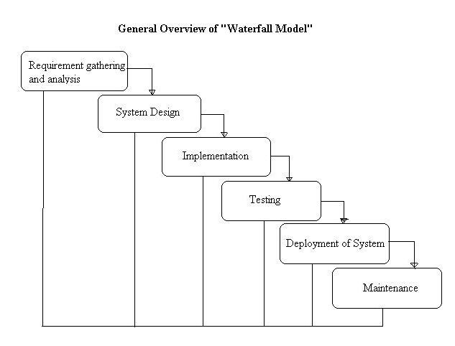](http://istqbexamcertification.com/wp-content/uploads/2012/01/Waterfall-model.jpg)**

**PHASES OF WATERFALL MODEL**

1. **Requirement Gathering and analysis**

All possible requirements of the system to be developed are captured in this phase and documented in a requirement specification documents.

1. **System Design**

The requirement specifications from first phase are studied in this phase and system design is prepared. System Design helps in specifying hardware and system requirements and also helps in defining overall system architecture.

1. **Implementation**

With inputs from system design, the system is first developed in small programs called units, which are integrated in the next phase. Each unit is developed and tested for its functionality which is referred to as Unit Testing.

1. **Integration and Testing**

All the units developed in the implementation phase are integrated into a system after testing of each unit. Post integration the entire system is tested for any faults and failure.

1. **Deployment of system**

Once the functional and non-functional testing is done, the product is deployed in the customer environment or released into the market.

1. **Maintenance**

There are some issues which come up in the client environment. To fix those issues patches are released. Also to enhance the product some better versions are released. Maintenance is done to deliver these changes in the customer environment.

**Advantages of waterfall model:**

1. This model is simple and easy to understand and use.
2. It is easy to manage due to the rigidity of the model – each phase has specific deliverables and a review process.
3. In this model phases are processed and completed one at a time. Phases do not overlap.
4. Waterfall model works well for smaller projects where requirements are very well understood.

**Disadvantages of waterfall model:**

1. Once an application is in the [testing](http://istqbexamcertification.com/what-is-a-software-testing/) stage, it is very difficult to go back and change something that was not well-thought out in the concept stage.
2. No working software is produced until late during the life cycle.
3. High amounts of risk and uncertainty.
4. Not a good model for complex and object-oriented projects.
5. Poor model for long and ongoing projects.
6. Not suitable for the projects where requirements are at a moderate to high risk of changing.

**When to use the waterfall model:**

1. This model is used only when the requirements are very well known, clear and fixed.
2. Product definition is stable.
3. Technology is understood.
4. There are no ambiguous requirements
5. Ample resources with required expertise are available freely
6. The project is short.

Very less customer enter action is involved during the development of the product. Once the product is ready then only it can be deemed to the end users. Once the product is developed and if any failure occurs then the cost of fixing such issues are very high, because we need to update everywhere from document till the logic.

### 3.1.2 INCREMENTAL MODEL

In incremental model the whole requirement is divided into various builds. Multiple development cycles take place here, making the life cycle a [“multi-waterfall” cycle](http://istqbexamcertification.com/what-is-waterfall-model-advantages-disadvantages-and-when-to-use-it/).  Cycles are divided up into smaller, more easily managed modules.  Each module passes through the requirements, design, implementation and [testing](http://istqbexamcertification.com/what-is-a-software-testing/) phases. A working version of software is produced during the first module, so you have working software early on during the [software life cycle](http://istqbexamcertification.com/what-are-the-software-development-life-cycle-phases/). Each subsequent release of the module adds function to the previous release. The process continues till the complete system is achieved.

Figure 2; Diagram of Incremental model

[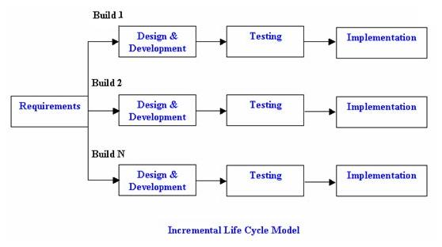](http://istqbexamcertification.com/wp-content/uploads/2012/01/Incremental_model.jpg)

**PHASES OF INCREMENTAL MODEL**

**Requirement**

In this phase of incremental model the basic requirements are

**Advantages of Incremental model:**

1. Generates working software quickly and early during the software life cycle.
2. This model is more flexible – less costly to change scope and requirements.
3. It is easier to test and debug during a smaller iteration.
4. In this model customer can respond to each built.
5. Lowers initial delivery cost.
6. Easier to manage risk because risky pieces are identified and handled during it’d iteration.

**Disadvantages of Incremental model:**

1. Needs good planning and design.
2. Needs a clear and complete definition of the whole system before it can be broken down and built incrementally.
3. Total cost is higher than [waterfall](http://istqbexamcertification.com/what-is-waterfall-model-advantages-disadvantages-and-when-to-use-it/).

**When to use the Incremental model:**

**Situation where most appropriate**

1. This model can be used when the requirements of the complete system are clearly defined and understood.
2. Major requirements must be defined; however, some details can evolve with time.
3. There is a need to get a product to the market early.
4. A new technology is being used
5. Resources with needed skill set are not available
6. There are some high risk features and goals.
7. Project is for development of a mainframe-based or transaction-oriented batch system.
8. Project is large, expensive, and complicated.
9. Project has clear objectives and solution.
10. Pressure does not exist for immediate implementation.
11. Project requirements can be stated unambiguously and comprehensively.
12. Project requirements are stable or unchanging during the system development life cycle.
13. User community is fully knowledgeable in the business and application.
14. Team members may be inexperienced.
15. Team composition is unstable and expected to fluctuate.
16. Project manager may not be fully experienced.
17. Resources need to be conserved.
18. Strict requirement exists for formal approvals at designated milestones.

**Situations where it’s least appropriate:**

1. Large projects where the requirements are not well understood or are changing for any reasons such as external changes, changing expectations, budget changes or rapidly

### 3.1.3PROTOTYPING MODEL

The basic idea here is that instead of freezing the requirements before a design or coding can proceed, a throwaway prototype is built to understand the requirements. This prototype is developed based on the currently known requirements. By using this prototype, the client can get an “actual feel” of the system, since the interactions with prototype can enable the client to better understand the requirements of the desired system.  Prototyping is an attractive idea for complicated and large systems for which there is no manual process or existing system to help determining the requirements. The prototype are usually not complete systems and many of the details are not built in the prototype. The goal is to provide a system with overall functionality.

**PHASES OF PROTOTYPING**

1. **Requirements gathering and analysis**

A prototyping model begins with requirements analysis and the requirements of the system are defined in detail. The user is interviewed in order to know the requirements of the system.

1. **Quick design**

When requirements are known, a preliminary design or quick design for the system is created. It is not a detailed design and includes only the important aspects of the system, which gives an idea of the system to the user. A quick design helps in developing the prototype.

1. **Build prototype**

Information gathered from quick design is modified to form the first prototype, which represents the working model of the required system.

1. **User evaluation**

Next, the proposed system is presented to the user for thorough evaluation of the prototype to recognize its strengths and weaknesses such as what is to be added or removed. Comments and suggestions are collected from the users and provided to the developer.

1. **Refining prototype**

Once the user evaluates the prototype and if he is not satisfied, the current prototype is refined according to the requirements. That is, a new prototype is developed with the additional information provided by the user. The new prototype is evaluated just like the previous prototype. This process continues until all the requirements specified by the user are met. Once the user is satisfied with the developed prototype, a final system is developed on the basis of the final prototype.

1. **Engineer product**

Once the requirements are completely met, the user accepts the final prototype. The final system is evaluated thoroughly followed by the routine maintenance on regular basis for preventing large-scale failures and minimizing downtime.

Figure 3:Diagram of Prototype model

[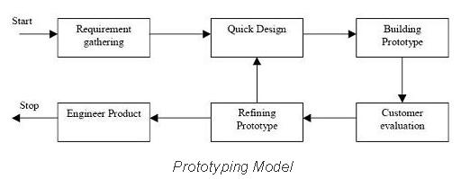](http://istqbexamcertification.com/wp-content/uploads/2012/01/Prototype-model.jpg)

**Advantages of Prototype model:**

1. Users are actively involved in the development
2. Since in this methodology a working model of the system is provided, the users get a better understanding of the system being developed.
3. Errors can be detected much earlier.
4. Quicker user feedback is available leading to better solutions.
5. Missing functionality can be identified easily
6. Confusing or difficult functions can be identified  
   Requirements validation, Quick implementation of, incomplete, but  
   functional, application.

**Disadvantages of Prototype model:**

1. Leads to implementing and then repairing way of building systems.
2. Practically, this methodology may increase the complexity of the system as scope of the system may expand beyond original plans.
3. Incomplete application may cause application not to be used as the  
   full system was designed  
   Incomplete or inadequate problem analysis.

**When to use Prototype model:**

1. Prototype model should be used when the desired system needs to have a lot of interaction with the end users.
2. Typically, online systems, web interfaces have a very high amount of interaction with end users, are best suited for Prototype model. It might take a while for a system to be built that allows ease of use and needs minimal training for the end user.
3. Prototyping ensures that the end users constantly work with the system and provide a feedback which is incorporated in the prototype to result in a useable system. They are excellent for designing good human computer interface systems.

### 3.1.4 SPIRAL MODEL

The spiral model is similar to the [incremental model](http://istqbexamcertification.com/what-is-incremental-model-advantages-disadvantages-and-when-to-use-it/), with more emphasis placed on risk analysis. The spiral model has four phases: Planning, Risk Analysis, Engineering and Evaluation. A software project repeatedly passes through these phases in iterations (called Spirals in this model). The baseline spiral, starting in the planning phase, requirements are gathered and risk is assessed. Each subsequent spirals builds on the baseline spiral.

Figure no: 4

[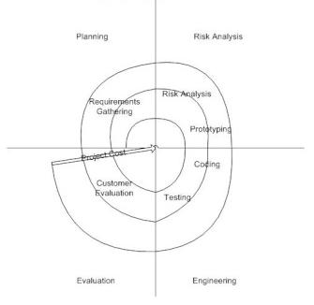](http://istqbexamcertification.com/wp-content/uploads/2012/01/Spiral-model.jpg)

**PHASES OF SPIRAL MODEL**

1. **Planning Phase**

Requirement are gathered during planning phase. Requirements like ‘BRS’ that is ‘Business Requirement Specifications’ and ‘SRS’ that is ‘System Requirement specifications’.

1. **Risk Analysis**

In the risk analysis phase, a process is undertaken to identify risk and alternate solutions.  A prototype is produced at the end of the risk analysis phase. If any risk is found during the risk analysis then alternate solutions are suggested and implemented.

1. **Engineering Phase**

In this phase software is developed, along with [testing](http://istqbexamcertification.com/what-is-a-software-testing/) at the end of the phase. Hence in this phase the development and testing is done.

1. E**valuation phase**

This phase allows the customer to evaluate the output of the project to date before the project continues to the next spiral.

**Advantages of Spiral model:**

1. High amount of risk analysis hence, avoidance of Risk is enhanced.
2. Good for large and mission-critical projects.
3. Strong approval and documentation control.
4. Additional Functionality can be added at a later date.
5. Software is produced early in the [software life cycle](http://istqbexamcertification.com/what-are-the-software-development-life-cycle-phases/).

**Disadvantages of Spiral model:**

1. Can be a costly model to use.
2. Risk analysis requires highly specific expertise.
3. Project’s success is highly dependent on the risk analysis phase.
4. Doesn’t work well for smaller projects.

**When to use Spiral model:**

1. When costs and risk evaluation is important
2. For medium to high-risk projects
3. Long-term project commitment unwise because of potential changes to economic priorities
4. Users are unsure of their needs
5. Requirements are complex
6. New product line
7. Significant changes are expected (research and exploration)

### 3.1.5 AGILE

Agile model believes that every project needs to be handled differently and the existing methods need to be tailored to best suit the project requirements. In agile the tasks are divided to time boxes (small time frames) to deliver specific features for a release. Iterative approach is taken and working software build is delivered after each iteration. Each build is incremental in terms of features; the final build holds all the features required by the customer.

1. **Individuals and interactions** - in agile development, self-organization and motivation are important, as are interactions like co-location and pair programming.
2. **Working software** - Demo working software is considered the best means of communication with the customer to understand their requirement, instead of just depending on documentation.
3. **Customer collaboration** - As the requirements cannot be gathered completely in the beginning of the project due to various factors, continuous customer interaction is very important to get proper product requirements.
4. **Responding to change** - agile development is focused on quick responses to change and continuous development.

**Advantages**

1. Is a very realistic approach to software development
2. Promotes teamwork and cross training.
3. Functionality can be developed rapidly and demonstrated.
4. Resource requirements are minimum.
5. Suitable for fixed or changing requirements
6. Minimal rules, documentation easily employed.
7. Enables concurrent development and delivery within an overall planned context.
8. Gives flexibility to developers.

**Disadvantages**

1. Not suitable for handling complex dependencies.
2. More risk of sustainability, maintainability and extensibility.
3. Strict delivery management dictates the scope, functionality to be delivered, and adjustments to meet the deadlines.
4. Depends heavily on customer interaction, so if customer is not clear, team can be driven in the wrong direction.
5. There is very high individual dependency, since there is minimum documentation generated.

Figure no: 5

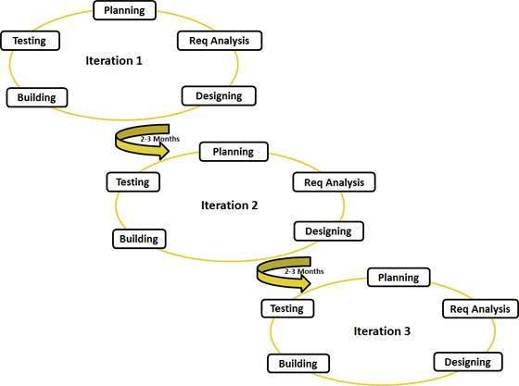

### 3.1.6 ADOPTED METHODOLOGY

After thorough research and analysis we opted to choose incremental methodology. Incremental methodology is based on the combination of linear and iterative system development methodology with the primary objective of each being to reduce inherent project risk by breaking the project into smaller segment and providing more easy of change during the development process reasons for adopted methodology;

1. This model can be used when the requirements of the complete system are clearly defined and understood.
2. Major requirements are defined; however, some details can evolve with time.
3. It help to get a product to the market early.
4. A new technology is being used
5. When resources with needed skill set are not available
6. Having some high risk features and goals.
7. Project is for development of a mainframe-based or transaction-oriented batch system.

Project is large, expensive, and complicated

## 3.2 ADOPTED TECHNOLOGY

In hospital automation system there are two sides in which technology used in order to support operation of their specification.

3.2.1BACK END

Is the application or program serves indirectly in support of the front-end services, usually by being closer to the required resource or having the capability to communicate with the required resource. The back-end application may interact directly with the front-end or, perhaps more typically, is a program called from an intermediate program that mediates front-end and back-end activities.

**Structure Query Language(SQL)**

A query language for RDBMS based on Non –procedure approach to retrieve record from RDBMS.SQL was proposed by IBM and got its standardization by ANSI and adopted by different corporation with bit modification.

SQL can be divided the following categories as given below:

1. DML – Data Manipulation Language.
2. DCL - Data Control language.
3. DDL – Data Definition language
4. DML :- Primarily used to retrieve the records from RDBMS
5. DDL:- Primary used to create tables/indexes etc.
6. DCL:- Primarily used for administrative /option operation like creating if user/assignment of password updating of record/deletion of user/creation of roles/assignment of access right.

In a summarized way it could be concluded that SQL becomes the query engine that resides over the database engine having been designed on the client-server Approach and provided retrieval of data as well as operation on RDBMS. By the Application package and web pages.

### 3.2.2 FRONT END

Is one that application users interact with direct. The technology which can be used in front end is:

**Hypertext Preprocessor (PHP)**

Is a [server-side scripting](https://en.wikipedia.org/wiki/Server-side_scripting) language designed for [web development](https://en.wikipedia.org/wiki/Web_development) but also used as a [general-purpose programming language](https://en.wikipedia.org/wiki/General-purpose_programming_language). PHP code may be embedded into [HTML](https://en.wikipedia.org/wiki/HTML) code, or it can be used in combination with various [web template systems](https://en.wikipedia.org/wiki/Web_template_system), web content management system and [web frameworks](https://en.wikipedia.org/wiki/Web_framework). PHP code is usually processed by a PHP [interpreter](https://en.wikipedia.org/wiki/Interpreter_%28computing%29) implemented as a [module](https://en.wikipedia.org/wiki/Plugin_%28computing%29) in the web server or as a [Common Gateway Interface](https://en.wikipedia.org/wiki/Common_Gateway_Interface) (CGI) executable. The web server combines the results of the interpreted and executed PHP code, which may be any type of data, including images, with the generated web page. PHP code may also be executed with a [command-line interface](https://en.wikipedia.org/wiki/Command-line_interface) (CLI) and can be used to implement [stand alone](https://en.wikipedia.org/wiki/Computer_software) [graphical applications](https://en.wikipedia.org/wiki/Graphical_user_interface).

### 3.2.3 ADOPTED TOOLS

In system development there are different tools which are used to support the whole process of automation.

**Unified Modeling Language (UML)**

The UML is an international industry standard graphical notation for describing software analysis and designs. When a standardized notation is used, there is little room for misinterpretation and ambiguity. Therefore, standardization provides for efficient communication (a.k.a. “a picture is worth a thousand words”) and leads to fewer errors caused by misunderstanding. The different diagram can be drawing by using this tool such as use case diagram, Flow chart diagram, Sequence diagram, Class diagram, Entity relationship diagram(ERD),State diagram, Activity diagram and Object diagram.

# CHAPTER 4

# REQUIREMENT ANALYSIS

## 4.0 OVERVIEW

Requirements analysis is critical to the success of a development project. Requirements must be documented, actionable, measurable, testable, related to identified business needs or opportunities, and defined to a level of detail sufficient for system design. Requirements can be architectural, structural, behavioral, functional, and non-functional.

An analysis and full description of the existing system should lead to a full specification of the users’ requirement. This requirement specification can be examined and approved before the system design is embarked upon. In recent times, greater emphasis has been placed upon this stage because of former experience of designers who failed to meet requirements. The earlier in a system life cycle that a mistake is discovered, the less costly it is to correct. Hence, the need for requirement specification is very clear. We are going to start with the analysis of the existing manual system under the following heading: data collection, data storage, data communication and manipulation, data security and system cost.

## 4.1 REQUIREMENT SPECIFICATION

In the course of the requirement elicitation, it was observed that some hospitals already have the automated system.MNH, AAR LONDON, HIDU MANDAL etc has an automated system while MWANANYAMAL HOSPITAL does not have automated system. Of the hospitals that are not yet automated, TMJ HOSPITAL has the network and is computerized but it has not installed the software but it has an accounting system which manages the finances and transaction.

Each requirement in this section should be:

1. Correct
2. Traceable (both forward and backward to prior/future artifacts)
3. Unambiguous
4. Verifiable (i.e., testable)
5. Prioritized (with respect to importance and/or stability)
6. Complete
7. Consistent
8. Uniquely identifiable

Automated hospital Management system requirements presented in this section so that they may easily accessed and understood.

**4.2 SYSTEM STAKEHOLDER**

In automated hospital management system there are number of stakeholder involved for to complete different activities take place within the hospital.

1. Nurse
2. Doctor
3. Patient
4. Pharmacist
5. Accountant
6. Laboratory Technician

**4.3 PROPOSED SOLUTION OF THE SYSTEM**

Electronic system that will capture patient information, Doctor and nurse information, Reception and account, Blood bank, ward, and pharmacy. All these information will be Automated and the consultation will be conducted using the system instead of paper method and the patient sample for test will electronically transferred to laboratory from Doctor and the results back to doctor after examination. Also this data are maintained in a Database for reference.

### 4.2.1 EXTERNAL INTERFACE REQUIREMENTS.

Input from the user will be via keyboard input and mouse point and click. The user will navigate through the software by clicking on icons and links. The icons will give appropriate responses to the given input.

1. HARDWARE constraints
   1. 1.5GHz PROCESS
   2. 512 M.B. RAM
   3. 170 M.B. SPACE (APPROXIMATELY) REQUIRED
   4. 7”
2. SOFTWARE constraints
   1. OPERATING SYSTEM: MULT PLATFORM
   2. BACKEND                 :  MYSQL
   3. FRONTEND            : PHP5
   4. ANDROID APP: XML &JAVA

### 4.2.2 USER INTERFACES.

There are many factors that must be considered when designing the user interface of for automated hospital Management System. The user must be able to interact with the system in a way that the system will understand whatever the input given by the user. Therefore, the quality of the interface and software in general must pass the usability testing standard. Some usability factors, such as fit for use, ease of learning, task efficiency, ease to remember, subjective satisfaction and understandability but all be put into consideration when designing the user interface. Fit for use deals with the system’s task support that the user has in the real life. The other factors only deal with the ease of use or how user friendly the system is. (According to Soren Lusen, 2005).” Making user interaction as simple as possible when designing the user interface is very important and this must be considered during functional requirement phase of a software design. To create an operational, usable and user friendly interface, the technical functionality with visual element must put into consideration. “

### 4.2.3 HARDWARE INTERFACES

According to Wikipedia Hardware interface design (HID) is a cross-disciplinary design field that shapes the physical connection between people and technology. It employs a combination of filmmaking tools, software prototyping, and electronics broad boarding.

Through this parallel visualization and development, hardware interface designers are able to shape a cohesive vision alongside business and engineering that more deeply embeds design throughout every stage of the product. The development of hardware interfaces as a field continues to mature as more things connect to the internet.

### 4.2.4 SOFTWARE INTERFACES

Automated Hospital Management system design modules System requirements are intended to communicate the functions that the system should provide. A software requirements document is an agreed statement of the system requirements. The IEEE standard is a useful starting point for defining more detailed specific requirements standards

### 4.2.5 COMMUNICATIONS INTERFACES

The communication between the different parts of the system is important since they depend on each other. However, in what way the communication is achieved is not important for the system and is therefore handled by the underlying operating systems for both the mobile application and the web portal. The Modules involved in our system has interlink, the device that will support our system such as desktop, mobile phone and Pads will require the use of organizational domain.

## 4.3 UNIT REQUIREMENT DEFINITION

All inputs that are not of standard ASCII code / format, HLT codes or byte stream will be rejected and treated as invalid inputs. In response to invalid inputs, the system shall produce an error message or help message so that the input shall not cause the database application to crash or fail. For instance, if a user makes an invalid entry, the system will respond with an error massage relevant to the error generating input in this case, the system will not crash in operation.

## 4.4 FUNCTIONAL REQUIREMENT

A function specification explains what has to be done by identifying the necessary tasks, action or activities that must be accomplished in the design. Automated hospital management is a system, which is conceived, designed and developed to increase clinical outcomes, operational efficiency, improve financial outcome, and manage all hospital records on computers. Automated Hospital Management System (AHMS) addresses all major functional areas of a hospital. It keeps track of a patient record from registration to discharge. This software helps to maintain the data of each individual patient with a unique identification for a life time.

The development environment ensures that AHMS has the portable and connectivity features to run on virtually all-standard hardware and software platforms, with stringent data security and easy recovery in case of system failure. The software provides the benefits of streamlining operations, enhancing administration and control, improving response to patient care, cost control and profitability.Describe functionality or system services. Depend on the type of software, expected users and the type of system where the software is used. Functional user requirements may be high-level statements of what the system should do but functional system requirements should describe the system services in detail.

### 4.4.1 FUNCTIONAL SYSTEM REQUIREMENTS

1. The AHMS must allow input of patient data from the Reception and the Physician.
2. A web-based system can allow initial patient information to be gathered by a dumb terminal in office or from patient’s own computer upon Email appointment verification hyperlinked to input screen.
3. The AHMS must request username and password for access to data, only after authentication the system will allow access.
4. The AHMS must require high levels of error correction and input validation. Note. Message box prompts would require a second entry of key data fields including name, DOB, Social Security Number, medications and allergies. Doctor’s inputs will similarly prompt proper code sets for diagnosis.
5. The system panel must allow browsing by the physician/Doctor of historical medical information of his/her patients only.
6. The system must identify the patient by a unique numeric identifier derived from a function performed on the patient’s identity number or birth date.
7. The AHMS must retrieve, update, and store data from multiple input locations including but not limited to hospital workstations, physician workstations, inbound emergency vehicles, and the electronic monitoring equipment.
8. The AHMS must allow patient to view their own medical record online allowing changes only to address, Insurance # and phone number.
9. The AHMS must only allow deletions by the vendor and only after archiving data. This will be administrator privilege.
10. The system to be developed must display the correct patient name.
11. The system to be developed shall display the correct time of day in compliance with ISO 8601.
12. The system to be developed must operate twenty-four hours a day.
13. The AHMS must allow full and complete record search queries by physicians, Doctor; and nurse also allow access to limited blood bank, medication, and allergen information of patients and display results in order specified by operator.
14. The system must allow input of diagnostic imagery and FAT32 compression for storage and transmission of data-Scan and Other x ray pictures to be stored within patient’s records.
15. The system must enable output of real-time data and imagery from electronic diagnostic equipment through java applets which run in the web browser. Nurses at workstation or doctors at desktop can access this data.
16. The system must retrieve and sort medical record information and allow for screen and print output of said information. Note. Print output will include name, DOB, and requested diagnostic information only.
17. The software must encrypt the data encryption algorithms from the database for transmission from point to point.

### 4.4.2VALIDATING FUNCTIONAL REQUIREMENTS

A use case and class diagram is a technique for documenting the potential requirements of a new system or system change. Each use case provides one or more scenarios that convey how the system should interact with the end user or another system to achieve a specific goal. Class Diagram shows a set of classes, interfaces, and collaborations and their relationships. They are important for visualizing, specifying, and documenting structural models. Developing these also called scenarios or stories helps engage them in the process of acquisition and begins the introduction of change.

1. **Use Case-** Use case Diagram is a visual representation of actor and use case together with any additional definition and specification. It has use cases (requirement) & Actor (person or system) there may be some use cases that do not directly interact with actors. In many instance, a function requirement maps directly to a use case. In Use case diagram of hospital management system there are an actors patient, doctor, nurse, technologist, technician& employee. An employee are generalized as receptionist, administration, Cleaner & cooker. symbols used in use case diagram

Figure No: 6 Use Case Diagram



1. **Class diagram-** executable systems through forward and reverse engineering. In class diagram of hospital management there are many classes like Hospital, Patient, Doctor, Receptionist, Nurse etc. the relationship among classes are association, generalization, composition, aggregation. Symbol used Class Diagram shows a set of classes, interfaces, and collaborations and their relationships. They are important for visualizing, specifying, and documenting structural models and also for constructing

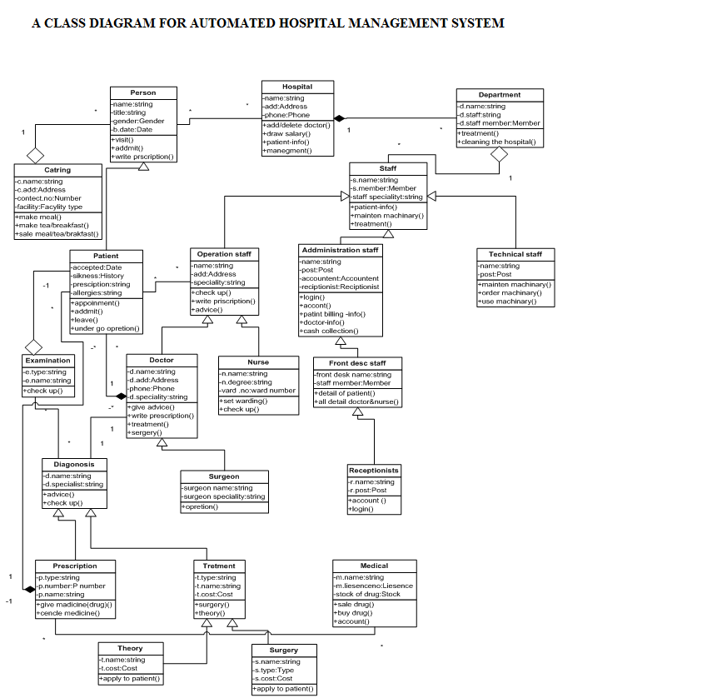

Figure No: 7

## 4.5 AHMS MODULES

### 4.5.1 PATIENT

This module deals with registering of new patients, for either OPD (Out-patient department) or IPD(In-patient department) and issuing unique identification numbers to the patients. These numbers are unique throughout the system. A patient is first registered at the OPD front office. If eventually the patient is admitted, the same number issued. The IPD/ OPD identification number is used for tracking the medical records of the patient for any OPD visitor IPD admission. All medical records of this patient are identified by this number. The number helps in a flexible searching finding the patient records. This number is assigned to the patient together with a patient card. The number will be used to track the patient record and medical history throughout the lifecycle of the patent medical section.

### 4.5.2 NURSE

A nurse’s work bench is a work platform provided for use by intermediate nurses (auxiliary nurses) to assist in taking patients preliminary examination, accessing current health condition, managing appointment queue and waiting list .Preliminary examination involves taking temperature reading, blood pressure, height and weight of the patient. The features are:-

* Waiting list
* Referrals
* Pre–examination
* Bill payment

### 4.5.3 DOCTOR

This is a special diagnostic plat-form for doctors. Through the doctor’s workbench, doctors can perform various tasks such as:

1. Viewing and editing patient’s registration data
2. Requesting and viewing laboratory test and result
3. Performing diagnosis
4. Managing beds / wards.
5. Issuing admission and discharge orders
6. Scheduling appointments.

### 4.5.4 LABOLATORY/ RADIOLOGY

This is used to perform data entry of lab test performed on a patient. Tests are grouped under various sections and sample types. Results are based on the type of sample. These results are entered for either one, or multiple tests. These test results are available to concerned doctors. The results of the test are confidential land secured. Most tests are done after the billing is done although this rule is violated in an emergency case. For the X – RAY system, the system stores all the result details of various test results.

### 4.5.5 PHARMACY

This module maintains the data related to the servicing of the in-patient and out-patient of the pharmacy department. It is more of drug order dispensary administration, billing and reporting system.

### 4.5.6 ADMIN

This is the main administration plat form used by the Chief Medical Director (CMD), hospital admin, hospital secretary, account and any other authorized personnel in the hospital to monitor overall activities of all the modules.

### 4.5.7 ACCOUNTANT

This module is for monitoring payments and billing. The entire billing system for the patient will automatically be created. It includes all kinds of expenses made by the patient. When the patient is discharged, the entire bill will be generated automatically. The bill will contain all the expenses, which should be charged to the patient for the period for which he / she were admitted in the hospital.

## 4.6 NON-FUNCTIONAL REQUIREMENTS

Non-functional requirements are attributes that either the system or the environment must have. Some of these are requirements that many stakeholders gravitate to, and some are requirements few if any end users recognize are needed. The following lists non-functional requirements and their descriptions (adapted from McEwen, Scott, Meta system Technologies, IBM Developer Works,and Requirements: An Introduction, 2004).

1. **Performance**

* **Response Time:-**The system shall give responses in 1 second after checking the patient’s information.
* **Capacity:-**The System must support more than 100 people at a time.
* **User- interface :-**The user-interface screen shall respond quickly
* **Conformity :**

1. **Security**

* **Logon ID:-**Any user who uses the system shall have a Logon ID and Password.
* **Modification:- Any** modification (inert, delete, update) for the Database shall be synchronized and only by the administrator in the ward.
* **Administrators**' **Rights: -**Administrators shall be able to view and modify all information in AHMS.

1. **Reliability;-**How general the form generation language is Simplicity vs. functionality of the form language= Speeds up form development but does not limit functional.
2. **Availability;**-The system shall be available all the time.
3. **Safety;-**Humans are error-prone, but the negative effects of common errors should be limited. E.g., users should realize that a given command will delete data, and be asked to confirm their intent or have the option to undo.
4. **Software Quality;**-Good quality of the framework= produces robust, bug free software which contains all necessary requirements Customer satisfaction.
5. **Reusability;**-Is part of the code going to be used elsewhere= produces simple and independent code modules that can be reused
6. **Maintainability**

* **Back Up**;-The system shall provide the capability to back-up the Data.
* **Errors**;-The system shall keep a log of all the errors.

**4.7 DATABASE REQUIREMENTS**

A database is a collection of information and is systematically stored in tables in the form of rows and columns. The table in the database has unique name that identifies its contents. The database in turn is further described in detail giving all the fields used with the data types, constraints available, primary key and foreign key. Database design is used to manage large bodies of information. In this database we describe all the 4 tables available in the software, which are used to store all the records.

Fields in database table have a data type. Some of the data types used in database table are explained below.

1. Integer:-One optional sign character (+ or -) followed by at least one digit (0-9). Leading and trailing blanks are ignored. No other character is allowed.
2. Varchar: It is used to store alpha numeric characters. In this data type we can set the maximum number of characters up to 8000 ranges by default SQL server will set the size to 50 characters large
3. Date/Time :Date/Time data type is used for representing data or time

|  |  |  |
| --- | --- | --- |
| **Fields** | **Data Type** | **Relationships** |
| Pid | Varchar(5) | Primary Key |
| Name | Varchar(20) | Not Null |
| Age | Int | Not Null |
| Weight | Int | Not Null |
| Gender | Varchar(10) | Not null |
| Address | Varchar(50) | Not Null |
| Phoneno | Int | Not Null |
| Disease | Varchar(20) | Not Null |
| Doctored | Varchar(5) | Not Null |

1. Table ; Doctor Table

|  |  |  |
| --- | --- | --- |
| **Fields** | **Data Type** | **Relationships** |
| Doctored | Varchar(5) | Primary Key |
| Doctorname | Varchar(15) | Not Null |
| Dept | Varchar(15) | Not Null |

1. Table ; Lab Table

|  |  |  |
| --- | --- | --- |
| **Fields** | **Data Type** | **Relationships** |
| Labno | Varchar(5) | Primary Key |
| Pid | Varchar(5) | Not Null |
| Weight | Int | Not Null |
| Doctored | Varchar(5) | Foreign Key |
| Date | Date/Time | Not Null |
| Category | Varchar(15) | Not Null |
| patient_type | Varchar(15) | Not Null |
| Amount | Int | Not Null |

1. Table ; Inpatient Table

|  |  |  |
| --- | --- | --- |
| **Fields** | **Data Type** | **Relationships** |
| Pid | Varchar(5) | Primary Key |
| room_no | Varchar(50) | Not Null |
| date_of_adm | Date/Time | Not Null |
| date_of_dis | Date/Time | Not Null |
| Advance | Int | Not Null |
| Labno | Varchar(5) | Foreign Key |

1. Table ; Outpatient Table

|  |  |  |
| --- | --- | --- |
| **Fields** | **Data Type** | **Relationships** |
| Pid | Varchar(5) | Primary Key |
| Date | Date/Time | Not Null |
| Labno | Varchar(5) | Foreign Key |

1. Table ; Ward Table

|  |  |  |
| --- | --- | --- |
| **Fields** | **Data Type** | **Relationships** |
| room_no | Varchar(50) | Primary Key |
| room_type | Varchar(10) | Not Null |
| Status | Varchar(10) | Not Null |

1. Table ; Bill Table

|  |  |  |
| --- | --- | --- |
| **Fields** | **Data Type** | **Relationships** |
| bill_no | Varchar(50) | Primary Key |
| Pid | Varchar(5) | Foreign Key |
| patient_type | Varchar(10) | Allow Null |
| doctor_charge | Int | Not Null |
| medicine_charge | Int | Not Null |
| room_charge | Int | Not Null |
| oprtn_charge | Int | Allow Null |
| no_of_days | Int | Allow Null |
| nursing_charge | Int | Allow Null |
| Advance | Int | Allow Null |
| health_card | Varchar(50) | Allow Null |
| lab_charge | Int | Allow Null |
| Bill | Int | Not Null |

1. From the table above the primary key in patient registration module is the patient identity number and this module is related to all the other modules like admission, laboratory, death, referral etc, in the sense that the same patient with patient identity can be admitted, referred, sent to laboratory or examined by the nurse but the primary key in the patient registration of this patient now becomes a foreign key in other modules because the primary key of each module is that key with which the patient is primarily identified there. For example, in Admission table, the admission number is the primary key while the patient identity number is the foreign key, in laboratory; the laboratory identity is the primary key while the patient identity number is the foreign key and so on.

### E-R DIAGRAM

Entity relationship diagram is used in modern database software engineering to illustrate logical structure of database. It is a relational schema database modeling method used to model a system and approach. This approach commonly used in database design. The diagram created using this method is called E-R diagram.

The E-R diagram depicts the various relationships among entities considering each object as entity. Entity is represented as diamond shape and relationship is represented as rectangle. It depicts the relationship between data objects. The E-R diagram is the relation that is used to conduct the data modeling activity.

1. Entity:-Entity is the thing which we want to store information. It is an elementary basic building block of storing information about business process. An entity represents an objects defined within the information system about which you want to store information.

Figure 9; Entity

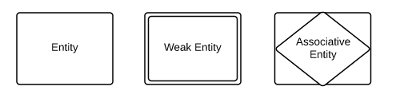

1. Relationship:-A relationship is named connection or association between entities used to relate two or more entities with some common attributes of meaningful interaction between the object.

Figure 10; Relationship

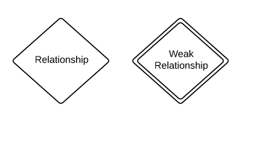

1. Attributes:-Attributes are the properties of the entities and relationship. Descriptor of the entity. Attributes are elementary pieces of information attached to an entity.

Figure 11; Attribute

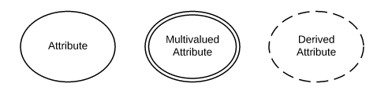

**ENTITY RELATIONSHIP DIAGRAM FOR AUTOMATED HISPITAL MANAGEMENT SYSTEM**

patient

Consults

doctor

Checks

Lab Report

Decides

Inpatient

Outpatient

issued_to

Admitted toto

Bill

room

Figure No:12

# CHAPTER FIVE

# SOFTWARE DESIGN

## 5.1 OVERVIEW

A software design is a model of a real world system that has many participating entities and relationships. This design is used in different ways. It acts as a basis for tailed implementation; it serves as a communication medium between the designers of subsystems; it provides information to system maintainers about original intentions of the system designer. Database design is the process of creating structure from user requirement. It is a complex and demanding process that requires both creativity and experience.

In this work, an object – oriented design was chosen. This is because of its widespread popularity and they are concerned with record processing where the processing of one record is not dependent on any previous processing. An object oriented design relies on decomposing the system into a set of interacting objects with a centralized system state shared by these objects.

Database design is the process of producing a detailed data model of a database. This logical data model contains all the needed logical and physical design choices and physical storage parameters needed to generate a design in a data definition language which can be used to create a database. A fully attributed data model contains detailed attributes for each entity.

Database design has some parallels to more classic code or software design processes. It goes through two stages namely: the logical design and physical design. The logical model is concerned with transforming the database specification and normalized database schemas respectively. The physical design process is concerned with how the database system will be implemented. It specifies the physical configuration of the database on the storage media. It includes the detailed specification of data element, data types, indexing options and other parameters residing in the database management system. It is the detailed design of a system that include modules, database’s hardware and software specification of the system.

## 5.2 DATABASE DESIGN

A database is a collection of information and is systematically stored in tables in the form of rows and columns. The table in the database has unique name that identifies its contents. The database in turn is further described in detail giving all the fields used with the data types, constraints available, primary key and foreign key. Database design is used to manage large bodies of information. In this database we describe all the 4 tables available in the software, which are used to store all the records.

Fields in database table have a data type. Some of the data types used in database table are explained below.

1. Integer:-One optional sign character (+ or -) followed by at least one digit (0-9). Leading and trailing blanks are ignored. No other character is allowed.
2. Varchar: It is used to store alpha numeric characters. In this data type we can set the maximum number of characters up to 8000 ranges by default SQL server will set the size to 50 characters large
3. Date/Time :Date/Time data type is used for representing data or time

Table 1; Patient Table

|  |  |  |
| --- | --- | --- |
| **Fields** | **Data Type** | **Relationships** |
| Pid | Varchar(5) | Primary Key |
| Name | Varchar(20) | Not Null |
| Age | Int | Not Null |
| Weight | Int | Not Null |
| Gender | Varchar(10) | Not null |
| Address | Varchar(50) | Not Null |
| Phoneno | Int | Not Null |
| Disease | Varchar(20) | Not Null |
| Doctored | Varchar(5) | Not Null |

Table 2; Doctor Table

|  |  |  |
| --- | --- | --- |
| **Fields** | **Data Type** | **Relationships** |
| Doctored | Varchar(5) | Primary Key |
| Doctorname | Varchar(15) | Not Null |
| Dept | Varchar(15) | Not Null |

Table 3; Lab Table

|  |  |  |
| --- | --- | --- |
| **Fields** | **Data Type** | **Relationships** |
| Labno | Varchar(5) | Primary Key |
| Pid | Varchar(5) | Not Null |
| Weight | Int | Not Null |
| Doctored | Varchar(5) | Foreign Key |
| Date | Date/Time | Not Null |
| Category | Varchar(15) | Not Null |
| patient_type | Varchar(15) | Not Null |
| Amount | Int | Not Null |

Table 4; Inpatient Table

|  |  |  |
| --- | --- | --- |
| **Fields** | **Data Type** | **Relationships** |
| Pid | Varchar(5) | Primary Key |
| room_no | Varchar(50) | Not Null |
| date_of_adm | Date/Time | Not Null |
| date_of_dis | Date/Time | Not Null |
| Advance | Int | Not Null |
| Labno | Varchar(5) | Foreign Key |

Table 5; Outpatient Table

|  |  |  |
| --- | --- | --- |
| **Fields** | **Data Type** | **Relationships** |
| Pid | Varchar(5) | Primary Key |
| Date | Date/Time | Not Null |
| Labno | Varchar(5) | Foreign Key |

Table 6; Ward Table

|  |  |  |
| --- | --- | --- |
| **Fields** | **Data Type** | **Relationships** |
| room_no | Varchar(50) | Primary Key |
| room_type | Varchar(10) | Not Null |
| Status | Varchar(10) | Not Null |

Table 7; Bill Table

|  |  |  |
| --- | --- | --- |
| **Fields** | **Data Type** | **Relationships** |
| bill_no | Varchar(50) | Primary Key |
| Pid | Varchar(5) | Foreign Key |
| patient_type | Varchar(10) | Allow Null |
| doctor_charge | Int | Not Null |
| medicine_charge | Int | Not Null |
| room_charge | Int | Not Null |
| oprtn_charge | Int | Allow Null |
| no_of_days | Int | Allow Null |
| nursing_charge | Int | Allow Null |
| Advance | Int | Allow Null |
| health_card | Varchar(50) | Allow Null |
| lab_charge | Int | Allow Null |
| Bill | Int | Not Null |

From the table above the primary key in patient registration module is the patient identity number and this module is related to all the other modules like admission, laboratory, death, referral etc, in the sense that the same patient with patient identity can be admitted, referred, sent to laboratory or examined by the nurse but the primary key in the patient registration of this patient now becomes a foreign key in other modules because the primary key of each module is that key with which the patient is primarily identified there. For example, in Admission table, the admission number is the primary key while the patient identity number is the foreign key, in laboratory; the laboratory identity is the primary key while the patient identity number is the foreign key and so on.

## 5.3 PROGRAM DESIGN

 The purpose of design phase is to plan a solution for problem specified by the requirements. System design aims to identify the modules that should be in the system, the specification of those modules and how they interact with each other to produce the result. The goal of the design process is to produce a model or representation of a system can be used later to build that system. Design of Hospital management system is based on UML diagram.Unified Modeling Language (UML) is a general-purpose, developmental, modeling language in the field of software engineering that is intended to provide a standard way to visualize the design of a system.

The different diagram can be drawing by using UML includes:-

1. Class Diagram
2. Object Diagram
3. Activity Diagram
4. State Diagram
5. Sequence Diagram
6. Data Flow Diagram

### 5.3.1 DATA FLOW DIAGRAM

Data Flow Diagram (DFD) is a graphical representation of the "flow" of data through an [information system](https://en.wikipedia.org/wiki/Information_system), modeling its process aspects. A DFD is often used as a preliminary step to create an overview of the system, which can later be elaborated. DFDs can also be used for the [visualization](https://en.wikipedia.org/wiki/Data_visualization) of [data processing](https://en.wikipedia.org/wiki/Data_processing) (structured design).

A DFD shows what kind of information will be input to and output from the system, where the data will come from and go to, and where the data will be stored. It does not show information about the timing of process or information about whether processes will operate in sequence or in parallel

Table 12; Data Flow Diagram

|  |  |  |
| --- | --- | --- |
| http://cpanel.stpaulsscience.org/gceict/specifications/ocr/unit3/sdlc/dfd/entity.jpg | An entity. A source of data or a destination for data. |  |
|  | A process or task that is performed by the system. |  |
|  | A data store, a place where data is held between processes. |  |
| http://cpanel.stpaulsscience.org/gceict/specifications/ocr/unit3/sdlc/dfd/flow.jpg | A data flow. |  |

Figure 13; Data Flow Model

***HOME***

*Check*

*User*

*Name*

*&*

*Password*

*Auth.*

*Failed*

***A***

Figure 14; Level 0 DFD

*Inpatient*

*Details*

*In*

*Patient*

*Outpatient*

*Details*

***A***

*ADMISSION*

*Out*

*Patient*

*Staff*

*Details*

***B***

*STAFF*

*Inpatient*

*Bill*

*In*

*Bill*

*BILLING*

*In*

*Patient*

*Billing*

*Bi*

*ll*

*Out*

*Patient*

Figure 15; Level 0 DFD

*Staff*

***PAYROLL***

*Payroll*

*Details*

*Payroll*

***PERSONAL***

***DETAILS***

*Staff*

*Details*

*Staff*

***ATTENDANCE***

*Attendance*

*Details*

***B***

***ON DUTY***

*On Duty*

*Details*

*Staff*

***OD***

*Atten*

***OD***

*Shift*

*SHIFT*

*Shift*

*Details*

### 5.3.2ACTIVITY DIAGRAM

An activity diagram shows the sequence of steps that make up a complex process, such as an algorithm or work flow it focus on operation.



Initial state is a notation of starting of activity.



An action state is noted the working flow. Example Get appointment is a active state.



In decision if one condition is satisfied, it’s arrow indicate The next activity to perform. Example. Pay fees of doctor is a guard condition.



Fork pseudo state enable to take a single event transmission & split it into several control parts.



Join pseudo manages multiple transmission part into one Transmission.



Final state is a notation

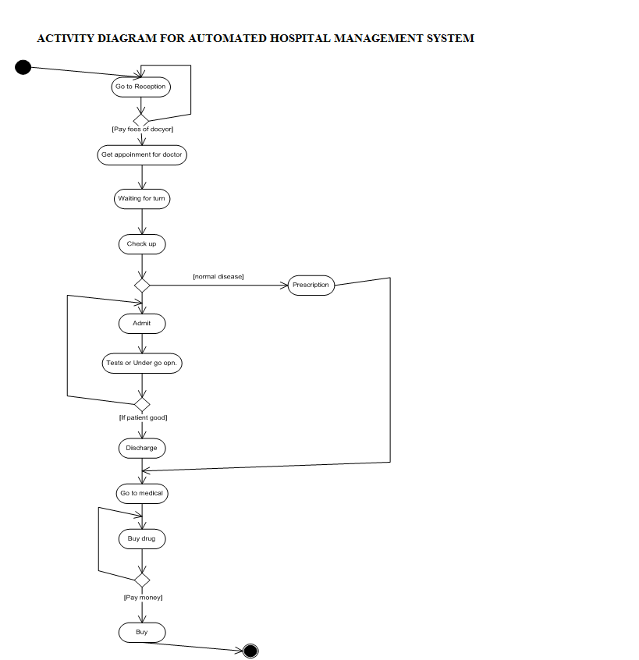

### 5.3.3STATE DIAGRAM

A state diagram is a graph whose nodes are states and whose direct arcs are transition between states. A state diagram specifies the state sequence caused by event sequence.



Fork pseudo state enable to take a single event transmission& split it into several control parts.



Join pseudo manages multiple transmission part into one Transmission.



A state is an abstraction of the values and links of an Objects, sets of values and links are grouped to gather into a state according to the group behavior of object. Example Prescribing is a state.



Drawn as a line from the origin state to the target state. An arrow head points to the target state.

Note: Final and Initial state are as same as in Activity diagram.

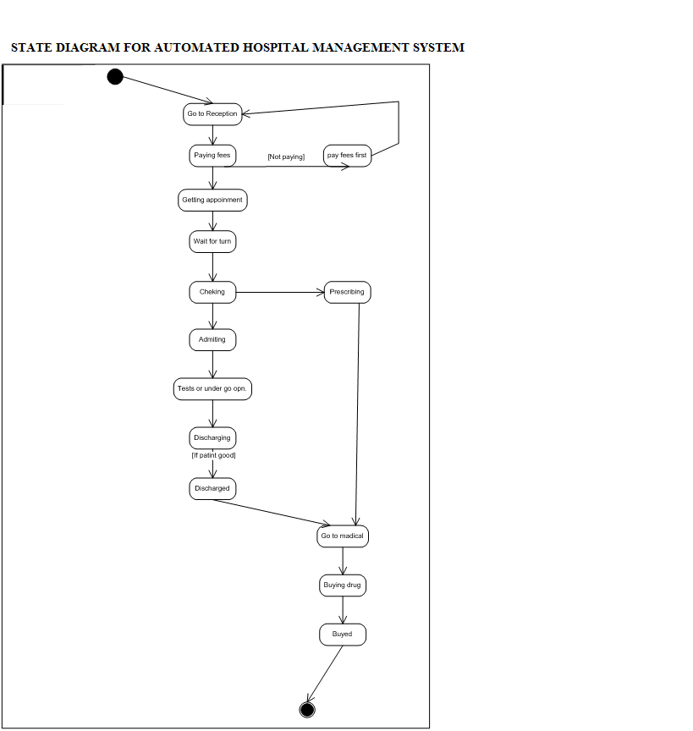

### 5.3.4SEQUENCEDIAGRAM

A sequence diagram shows the participants in an interaction and the sequence of messages among them. It is not attempt to be general.

In Sequence diagram each actor, object or system is represent by vertical line called object life line.



An Activation describe that the system is in process bymeans system in use.





Messages extend from the lifeline of one object to the life line of another except in the case of a message from an object to itself, in which case the message begins and ends on the same lifeline.

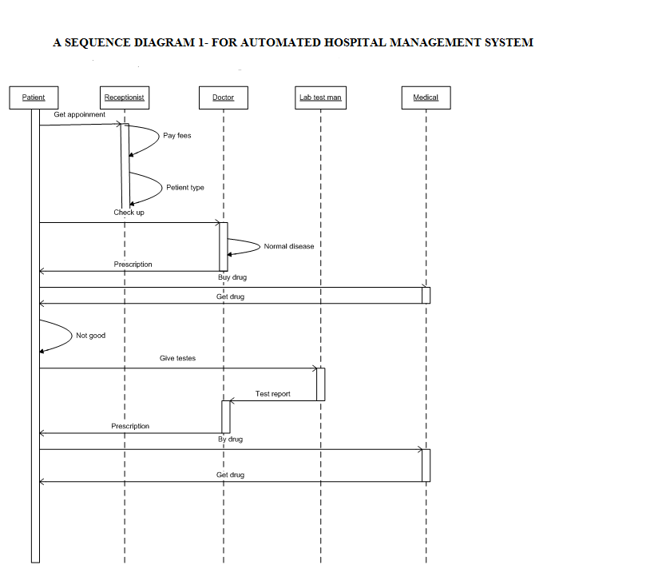

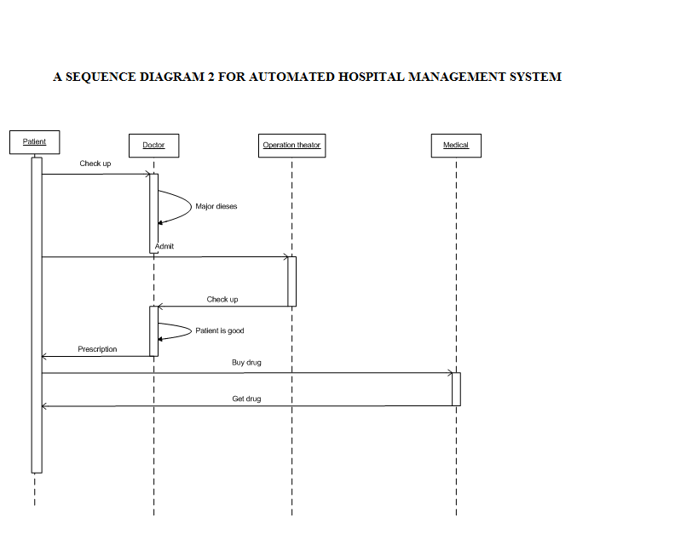

# CHAPTER SIX

# IMPLIMENTATIONANDTESTING

## 6.1 OVERVIEW

Implementation is the realization of a technical specification or algorithm as a program or software component. It involves the accurate transform at or of the software design into some executable program code using any programming language of choice. A design may be implemented in various ways depending on the priorities of the software developer. In this work, several factors were taken into consideration during implementation.

## 6.1 CHOICE OF PROGRAMMING LANGUAGE

PHP on PC based system and Java on android system was chosen as the programming language which serves as the client to enable me to create the input and output forms while the MySQL database was used as the database server.

For most software applications there exists a wide variety of languages in which the application may be implemented. Apart from use of PHP there is the use of other scripting language like JavaScript and CSS to support HTML generation by PHP, also without forgetting Java based android app interface was generated by XML

### 6.1.1THE FACTORS THAT INFLUENCED THE CHOICE OF THE PHP

1. Speed: Being a compiled language, it is very fast and speed is important in database application.
2. Environment: It can run in windows.
3. Efficient: The final code tends to be compact and run quickly.
4. Portability: If compiled, it can be executed in different machines with alteration of source code.
5. Maintainability: To ensure maintainability, this program is broken into modules and each module assigned a specific function. This will make maintenance of the system easier.
6. Security: it has proper backups, quality control mechanism for all modules and unauthorized access to sensitive data is prohibited.
7. PHP supports full object oriented programming giving us more control over the graphic user interface
8. PHP supports all the new AJAX and CSS. It makes the graphic user interface friendly.

### 6.1.2 WHY MYSQL DATABASE WAS CHOSEN:

1. MYSQL maintains a high level of security.
2. MYSQL database ensures maximum data throughput (i.e. accepting of data with
3. MYSQL database has a very high data storage capacity limit, severalNano byte and terabytes .
4. MYSQL is multiplatform working on all platforms, linux, Os X and mobile platform
5. MYSQL together withbuilt-in front end (client) and back end (DB sever) such as MYSQL workbench or PHPmyadmin has several data management and administrative services.
6. MYSQL has data backup and recovery management services.
7. MYSQL is open sources application
8. MYSQL can be installed as a cluster servers- this makes it possible for two or more MYSQL database servers to be united as a common server in a cluster server

### 6.1.3 WHY USE ANDROID APP

## 6.2 USER INTERFACE:

User interface is the system by which users interact with a machine. The user interface includes hardware and software components. User interfaces exist for various systems and provide a means of:

* Input, allowing the users to manipulate a system.
* Output, allowing the system to indicate the effects of the user’s manipulation.

The main aim of human-machine interaction is to produce a user interface which makes it easy, efficient enjoyable for humans to operate a machine in a way which produces the desired result.

1. **GRAPHIC USER INTERFACE**: This type accepts input via devices such as computer keyboard and mouse and provides articulated graphical output on the computer monitor.
2. **WEB-BASE USER INTERFACES**: Accepts input and provide output by generating web pages which are transmitted via the internet and viewed by the user using a web browser program.
3. **TOUCH USER INTERFACE**: These are graphical user interfaces using a touch screen display as a combined input and output device.
4. **NATURAL LANGUAGE INTERFACE**: Natural language interface is used for search engines and on Webpages. The user types in a question and waits for a response.

In this design, ease of use was paramount; robust input procedures, error checking procedures, system e.t.c were included in implementation to ensure easy and efficient use of the software. This of course was achieved at the cost of bulkier code and resulting in increase of occupied memory space. The trade-off, however is justified as most target users may have little or no computer training and, thus require a very simple and straight forward user interfaces.

## 6.3 SECURITY

Quality control on the implementation was enhanced by the use of structural techniques as well as subjective testing for all stages and modules of the software system. Unauthorized access to data was handled by the inclusion of password protection for all sensitive modules of the system; thereby reducing the probability of inadvertent or malicious access to the sensitive area of the system. However, for the hospital management system, there are two major categories of security deployed thus;

1. **CLIENT SOFTWARE SECURITY**: This level of security ensures that only authorized persons such as doctors, nurses, consultants etc can have access to the system. The system therefore presents a login box requesting for the users user name and password. The username and password information are both stored in the database. Hence, during login, the entered information must be validated in comparison with the account information in the database. The above means that only authorized users can have access to the software
2. **DATABASE SERVER SECURITY:** The database is MYSQL and thus maintains an architectural security enabled profile. As a result, at run-time a connection must be established from the client software to the database server. This is a one-way connection and authentication is required. Full access to the MYSQL database also requires that the connection in client (user) must have the following information’s
3. Correct username and password
4. MYSQL server link or URL USUALLY LOCALHOST FOR Private web server 3 Correct port number of the server

Incorrect supply or error in the above information will lead to access denial to the MYSQL database. This also enhances the security detail of the system.

## 6.4 SOFTWARE TESTING/VERFIFICATION

In this stage, the software design is realized as a set of programs or program units. Each unit is tested to verify that it meets its specific action. This exercise proves the correction of the software application. Three different approaches can be used to demonstrate that the codes are correct:

Test based purely on structure, test based purely on function and a formal proof of correctness. Each approach leads to the conclusion that complete testing on the sense of a proof is not theoretically possible. Again to completely ascertain the software throughput, various testing method. Each method is categorically deployed to check for reliability, strength, weakness, and efficiency of the software. Among the testing methods used includes;

### 6.4.1DEBUGGING:

This test was carried out before the final compilation of the project for final publishing. This testing was used to check for code and syntax errors.

### 6.4.2OPERATIONAL FLOW TESTING

This test was mainly used ensure that the program at runtime follows the proper flow system. Here common issues like false links and broken hyperlinks were checked.

### 6.4.3 DATA INTEGRITY AND FORMAT TESTING

This testing was used to check for data validation. The make sure the system accepts only the set data format and to report error when wrong data is keyed in.

### 6.4.4 LOAD TESTING

This is an efficiency test. The system is subjected to high operating condition and the behavior of the software monitored. Several assumptions were also made; this includes the average number of users accessing the data at a time and the number of concurrent connections to the MYSQL database server.

Finally, the above test methods generally provides the analytical result on the performance and integrity of the software

## 6.5 PROJECT COST

Cost in a project of this nature can be classified either as recurring or nonrecurring cost. Recurring costs are costs associated with on-going use of the system once it comes on screen and include consumables, the cost of operating the system as well as the cost for dedicated labour (staff time)

Non-Recurring costs are costs incurred in system development or facilitation of system environment for instance providing hardware for the users. Part of it is development cost, which includes the cost of staff and all consumables used, computer and so on.

# chapter seven

# evaluation and conclusion