**The spread of Dutch Elm Disease in elm populations with resistance**

Kaylee Rosenberger

Calculating Biological Quantities, Fall 2022

13 November 2022

**Introduction:**

Plant pathogens and their host species have been co-evolving for hundreds of millions of years (Han, 2018). It is a perpetual arms race, with pathogens continually overcoming host defenses. Pathogens pose a threat to biodiversity, ecosystem stability, and society and have contributed to species extinctions (Potter et al., 2019). The number of diseases species face is increasing due to global connectedness, climate change, and other anthropogenic factors (Sniezko and Koch, 2017). Although plants lack the adaptive immune system of vertebrate species, plants species have developed several innate immune responses to pathogens (Han, 2018). Genetically based disease resistance provides species with an intrinsic mechanism to respond and adapt to pathogens. This has been seen in several plant species which have co-evolved with their pathogens for long periods of time. Several species of elm trees provide an example into this mechanism.

Elm trees in Europe and North America are threatened by Dutch Elm Disease (DED), which results in wilt, dieback, and death in elms (Brunet and Gurles, 2016). Elm tree cultivars were commonly planted across North America and Europe for their shade, aesthetics, and hardiness to diverse climatic conditions. Many species of elms are particularly susceptible to the disease since they were planted as cultivated varieties, resulting in low genetic diversity in many areas, which may correspond to a lack of ability to adapt (Martin et al., 2018). Depending on the age and susceptibility, the tree can die in as little as 2 months to a few years following DED infection (Grabowski, 2019). DED is caused by a group of fungal pathogens, *Ophiostoma ulmi,* and is vectored by bark beetles, which feed on the bark of elms (Brasier, 2001)*.* DED can also spread from tree to tree through root graphs (Grabowski, 2019). Taxa of *Ophiostoma* are rapidly evolving due to hybridization, contributing to more severe outbreaks of DED, threatening millions of elm trees (Brasier, 2001).

While some species of elm are extremely susceptible to the disease, particularly those native to Europe and North America, other species, mostly those found in Asia, are resistant and can overcome infection of DED (Gibbs, 1978). Resistance phenotypes range from susceptible to infection and death, to tolerant (survives with infection), to resistant (avoids infection). Since DED resistance is genetically based and in general, trees have the ability to hybridize with other species, resistance can spread between populations and species through introgression and be passed on to offspring. Introducing resistant genotypes in a population of susceptible trees should allow the resistance genotype to spread over time, theoretically allowing the population to survive DED infection. However, little is known about the gene or genes governing resistance to DED. Additionally, due to the long generation times of trees (at least 15 years to reach reproductive age), resistance spread would be slow, so introducing individuals after the population has been infected would likely not be an effective strategy.

As previously mentioned, several Asian elm species have genetic resistance to DED. This might be expected if these species co-evolved with this pathogen for long periods of time due to selection; however, *Ophiostoma taxa* are not found in Asia, nor is there evidence of *Ophiostoma* having a historical range in Asia (Gibbs, 1978). If *Ophiostoma* did not historically exist in Asia, this poses the questions: *could disease resistance have evolved by chance, from another selection pressure, or from a trait that is linked to resistance?* Additionally, *does resistance persist in species that are not facing the direct threat of disease?*



Here, I aim to explore the dynamics of DED spread in populations of elms with varying levels of resistance models of selection and disease dynamics models. I aim to answer the questions:

1. What is the optimal initial proportion of resistance for the trait to become fixed in a population?
2. How many generations will it take for resistance to become fixed in the population?
3. What are the allele frequency dynamics for a population that is not undergoing direct selective pressure?

The optimal initial proportion of resistant individuals to introduce in a population would be useful for land managers and conservationists to plan to protect and supplement elm populations to survive DED outbreaks. We would want to introduce the smallest number of individuals in the population due to logistical constraints. The number of generations for resistance to become fixed is also important for planning purposes. Finally, I wish to know the allele frequency dynamics for a population that is not under selection to explore if resistance could evolve in a population without a DED outbreak (as in the case of Asian elm trees).

I hypothesize that it will take many generations for resistance to become fixed in a population, even with strong selective pressure, due to the long generation time of elm trees. However, resistance will become fixed quicker with a higher selective pressure. Additionally, the greater the initial proportion of resistant individuals, the faster resistance will become fixed. Lastly, I hypothesize that resistance will not become fixed in a population that is not under selection; instead, the alleles will exist in an equilibrium that is in between 0 and 1 (related to their initial values).

First, I will model resistance in the form of major gene resistance (resistance controlled by a single locus). Full resistance will be represented by a homozygous dominant genotype (AA), tolerance will be represented by a heterozygous genotype (Aa), and susceptibility will be represented by a homozygous recessive genotype (aa). Most elms are diploid, so I will use the diploid selection model to analyze the allele frequency dynamics of this population based on different initial proportions of alleles. Then, I will model the population dynamics of a population of elm trees with DED infections using a disease dynamics model that is similar to the standard SIR model. Again, over time, I hypothesize that resistance will become fixed when a population is experiencing DED infections.

**Methods:**

Diploid allele frequency dynamics of a population under selection are represented in Equation 1 in discrete time (Otto and Day, 2007):

Where *p* is the proportion of the dominant allele, A, *q* is the proportion of the recessive allele, a*,* and represent the relative fitness of each genotype. The equation for *q* can be calculated using the formula: 1=p+q. *W* represents the mean fitness of the population, shown in Equation 2:

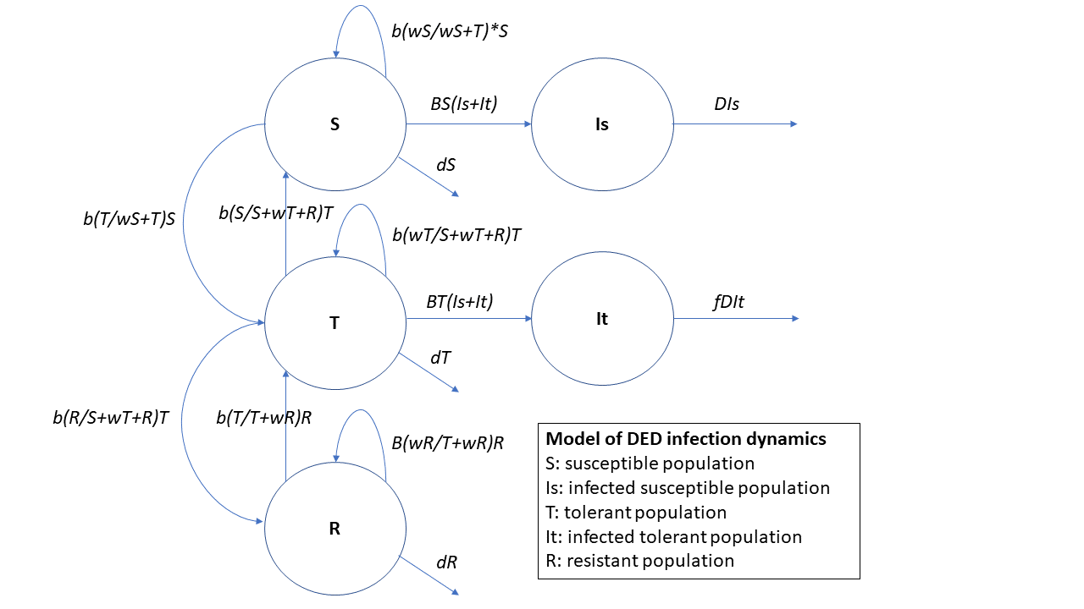I explored the allele frequency dynamics of the population for different initial proportions of the resistance allele, *A*, in the population at increments of 0.01 ranging from 0 to 0.5. Then I test a variety of scenarios of fitness for each genotype: represents a scenario we would expect in the case of major gene resistance, with resistant individuals having the highest fitness; represents a case we might not expect in reality—when tolerant and susceptible individuals have the same fitness; and , where the fitness of each genotype is the same—that is, the population is not under selection (no DED infections). The scenarios of relative fitness strengths are shown in Table 1. I simulated all combinations of these scenarios in R for 50 generations and examined the allele frequencies over time.

Table 1: Simulation values chosen for the relative fitness values:

|  |  |  |
| --- | --- | --- |
|  |  |  |
| 0.1 | 0.1 | 0.1 |
| 0.1 | 0.05 | 0.05 |
| 0.1 | 0.05 | 0.025 |
| 0.1 | 0.05 | 0.01 |
| 0.2 | 0.05 | 0.01 |

The modified SIR model in Figure 1 represents the dynamics for a population undergoing DED infection. There are five categories of the population—susceptible to infection, infected susceptible, tolerant, infected tolerant, and resistant to infection. Susceptible and tolerant individuals have a chance to become infected, modeled as a per capita infection rate. Infected individuals die at a per capita death rate which is higher for infected susceptible individuals compared to infected tolerant individuals (scaled by *f*). In this model, infected individuals do not have the opportunity to recover. Resistant individuals completely avoid infections. Natural births and deaths are modeled as per capita rates for all categories except infected, which I’ve assumed to be expending all their energy towards survival and not reproduction. A proportion of births are selfed (births into the same category) and a proportion of births swap categories in a stepping-stone manner from susceptible to tolerant, tolerant to resistant, and vice versa. Here, selection arises from the susceptible and tolerant categories becoming infected and eventually dying. Eventually, this should result in the entire population to become resistant. No outside intervention is assumed (DED mitigation strategies like vaccination, pruning, fungicides, etc.). The dynamics of this flow diagram is shown in equation form in Equation 3.

*Figure 1: Dynamics of a population undergoing DED infection, modeling susceptible, tolerant, resistant, and infected populations. Infections occur in susceptible and tolerant populations at a rate B. The death rate due to DED is given by D1 for susceptible individuals and D2 for tolerant individuals with D1 > D2. Natural birth and death rates are given by b and d respectively. Offspring can change compartments from susceptible > tolerant > resistant in steps by a rate m.*

**Results:**

***What is the optimal initial proportion of resistance for the trait to become fixed in a population?***

It is possible for resistance to become fixed in a population with an initial allele frequency of just 1% in the population if there is selection. If the population is not under selection, the allele frequencies will not change over time. If there is a genotype that is favored through selection (i.e., resistant genotypes favored in a population with DED), that allele increases in frequency over time until it is fixed (frequency = 1). With strong selection favoring the resistant genotype, the allele can become fixed in 10-20 generations. The stronger selection, the faster the allele can become fixed.

Increasing the initial proportion of the resistant allele in the population makes a small difference in the amount of time it takes for the allele to reach fixation. However, the difference may not be enough to recommend a large introduction size. Even in a case with a starting value of 20% resistance allele in the population, it still takes roughly 10 generations to reach fixation.

**Discussion:**

These results indicate that genetically based resistance in the form of major gene resistance can become fixed in a population under selection from a disease in roughly 10-20 generations. The amount of time this will take depends on the generation time of the species of interest and on the relative fitness of each genotype.

It is important to note that major gene resistance may not adequately model the system of DED resistance in elms. Since resistance phenotypes range on a scale of susceptible to resistant with a variety of tolerant phenotypes, it’s more likely that resistance is a quantitative trait, resulting from the additive value of many genes. If DED resistance is a quantitative trait, then the amount of time for the trait to become fixed would increase. To build on this project, I would try modeling selection on a number of loci instead of just one to model quantitative resistance and compare the results to major gene resistance.

These results can be applied for other systems with genetically determined disease resistance. These results show an optimal number of resistant individuals to introduce in a population.

**References:**

Brasier, C. (2001). Rapid evolution of introduced plant pathogens via interspecific hybridization: Hybridization is leading to rapid evolution of Dutch elm disease and other fungal plant pathogens. *Bioscience,* 51(2).

Brunet, J. and Gurles, R. (2016). Elm genetic diversity and hybridization in the presence of Dutch Elm Disease. Proceedings of the American elm restoration workshop 2016.

Gibbs (1978) Ann. Rev. Phytopathol.

Grabowski, M. (2019). Dutch elm disease. *University of Minnesota extension.*

Han, G. (2018). Origin and evolution of the plant immune system. New Phytologist, 222(1).

Martin et al. (2018) New Forests

Otto, S. and Day, T. (2007). Deriving classic models in ecology and evolutionary biology. *A biologist’s guide to mathematical modeling in ecology and evolution.* Princeton University Press.

Potter et al. (2019) Forests

Sniezko and Koch (2017) Forest Invasions