Stability of Large Language Model Outputs Under Prompt Perturbation
- Result and Analysis
  - Results for RQ1
In this section, the results for RQ1 from 1000 LLM output generations will be presented.
Task type | Num of prompts | Mean with-in prompt similarity | Mean sampling noise drift | SD of mean sampling noise drift
Factual QA | 10 | 0.951691 | 0.048309 | 0.064513
Math reasoning | 10 | 0.913485 | 0.086515 | 0.044816
Code generation | 10 | 0.931653 | 0.068347 | 0.028244
Open-ended writing | 10 | 0.921510 | 0.078490 | 0.072555
Table ? : Sampling noise drift calculated for four task types.
In Table ?, the mean with-in prompt similarity of all four task types shows a relatively high value, with the task type Factual QA having the highest mean with-in prompt similarity of 0.95691 and the lowest mean with-in prompt similarity 0.913485 from Math reasoning. Mean with-in prompt similarity shows the stability of LLM output, with a higher value indicating a higher similarity when prompts are repeatedly provided to the LLM, which the repeat number is 5 in this experiment, and vice versa. The standard deviation of the mean sampling noise drift has been showed to have a relatively large value compared to the mean sampling noise drift. In order to determine the statistical significance between groups, Turkey is used as a mathematical analyzing tool towards determining the relation between sampling noise drift and task type. Calculation shows that p=0.455 > 0.05, meaning that the current data does not provide sufficient evidence that the sample noise baseline is task-dependent.
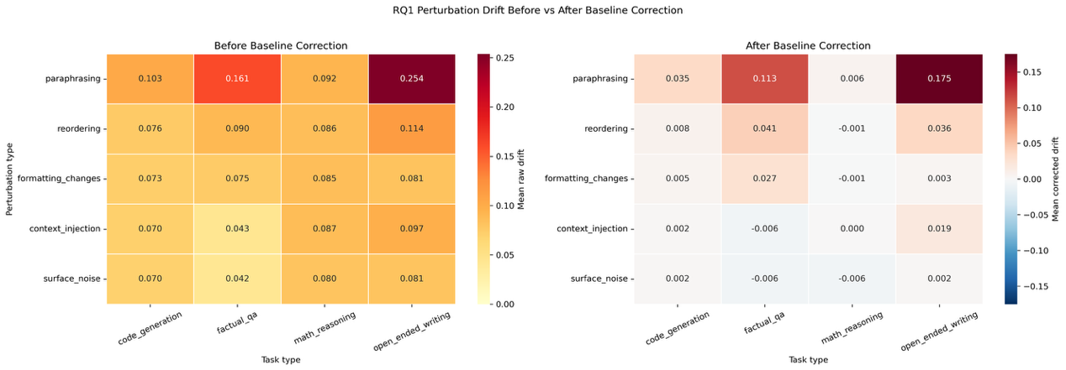
Figure ?: Heat map for RQ1 showing the perturbation drift of LLM outputs before and after baseline correction.
Figure? shows the perturbation drift before baseline correction. The overall perturbation drift shows a range of 0.212, ranging from 0.042 produced by factual QA under the perturbation of surface noise to 0.254 produced by open ended writing under the perturbation of paraphrasing. Specifically, the open-ended writing shows a greater perturbation drift compared to the other task types, corresponding with the researcher’s expectation that LLM will be more sensitive to perturbations when performing tasks without a definable sample answer.
Figure? shows the perturbation drift after baseline correction. The heat map contains both positive and negative values: when the value is negative, it indicates that the perturbation drift calculated previously is completely caused by the sampling noise drift rather than the perturbation; when the value is positive, the current perturbation drift value is caused by perturbations in the LLM prompt. Comparing across perturbation types, data shows that LLM has performed a relatively strong resistance against surface noise, with perturbation drift ranging from -0.006 to 0.002. On the other hand, paraphrasing has been shown to be the most portent perturbation, showing a relatively strong ability to impede the performance of LLM under open-ended writing tasks. Comparing across task types, it can be observed that math reasoning is relatively unsusceptible to all perturbations.
Answering RQ1,
6.2 Results from RQ2
Task type | Mean performance change | 95% CI | Mean drift | Mean PDR
code_generation | 0.088000 | [0.016140, 0.159860] | 0.010172 | 0.130000
factual_qa | 0.094951 | [0.017525, 0.172377] | 0.033779 | 0.108539
math_reasoning | 0.060000 | [-0.005213, 0.125213] | -0.000296 | 0.003333

Perturbation type | Mean drift | 95% CI drift | Mean performance change | 95% CI change
paraphrasing | 0.050990 | [0.022317, 0.079663] | 0.256647 | [0.110617, 0.402677]
reordering | 0.016125 | [0.000303, 0.031947] | 0.059228 | [-0.019452, 0.137908]
formatting_changes | 0.010170 | [-0.005386, 0.025726] | 0.051278 | [-0.027272, 0.129828]
surface_noise | -0.003515 | [-0.010338, 0.003308] | 0.019444 | [-0.010685, 0.049573]
context_injection | -0.001012 | [-0.008183, 0.006159] | 0.018321 | [-0.050714, 0.087356]

Task type | Perturbation | Mean drift | Mean perf. change | Pearson r
code_generation | context_injection | 0.002075 | 0.040000 | -0.206895
code_generation | formatting_changes | 0.004808 | 0.040000 | -0.572964
code_generation | paraphrasing | 0.034560 | 0.300000 | 0.650357
code_generation | reordering | 0.007690 | 0.020000 | 0.210501
code_generation | surface_noise | 0.001728 | 0.040000 | -0.212427
factual_qa | context_injection | -0.005502 | -0.025036 | 0.061895
factual_qa | formatting_changes | 0.026844 | 0.073834 | 0.010064
factual_qa | paraphrasing | 0.112586 | 0.329941 | 0.480695
factual_qa | reordering | 0.041203 | 0.097685 | 0.194632
factual_qa | surface_noise | -0.006236 | -0.001669 | -0.444451
math_reasoning | context_injection | 0.000390 | 0.040000 | -0.546474
math_reasoning | formatting_changes | -0.001141 | 0.040000 | -0.606590
math_reasoning | paraphrasing | 0.005822 | 0.140000 | -0.015417
math_reasoning | reordering | -0.000518 | 0.060000 | -0.491941
math_reasoning | surface_noise | -0.006036 | 0.020000 | 0.042583

Scope | n | Pearson r | Pearson p | Spearman rho | Spearman p
overall | 150 | 0.327704 | 0.000042 | 0.089610 | 0.275487
code_generation | 50 | 0.537373 | 0.000057 | 0.131946 | 0.361031
factual_qa | 50 | 0.481403 | 0.000401 | 0.434788 | 0.001604
math_reasoning | 50 | -0.330193 | 0.019187 | -0.215038 | 0.133694

