PIFSC Data Report Template
Phoebe Woodworth-Jefcoats
Revere Wood
Table of contents

Delete this page in Word
Along with the page before it that the template generates.
Before that, though, follow these instructions:
- At the top of the Table of Contents, select Insert > Break > “Section Break (continuous)”
- At the top of the first section after your Executive Summary, do the same thing: Insert > Break > “Section Break (continuous)”
- From your Table of Contents page, select Insert > Page Numbers. Select “Alignment” to be “Right”. Then, click on “Format” and select lower-case Roman numerals.
- On an odd-numbered page, click in the footer area and insert the following footer:
U.S. Department of Commerce | National Oceanic and Atmospheric Administration
- On an even-numbered page, insert the following footer:
National Marine Fisheries Service | Pacific Islands Fisheries Science Center
Then, follow the instructions on the following pages:
- Table of Contents
- List of Tables
- List of Figures

Pacific National Coral Reef Monitoring Program, 2024, —Reef Fishes of, Hawai‘i
Kaylyn S. McCoy¹, Andrew Shantz²
¹ Pacific Islands Fisheries Science Center
National Marine Fisheries Service
1845 Wasp Boulevard
Honolulu, HI 96818
² Cooperative Institute for Marine and Atmospheric Research
University of Hawaiʻi at Mānoa
1000 Pope Road
Honolulu, HI 96822

NOAA Data Report DR-##-#
[Month] [Year]

U.S. Department of Commerce
National Oceanic and Atmospheric Administration
National Marine Fisheries Service
Pacific Islands Fisheries Science Center

About this report
The Pacific Islands Fisheries Science Center (PIFSC) uses the PIFSC Data Report series to distribute scientific and technical information that has been scientifically reviewed and edited. Documents within this series reflect sound professional work and may be referenced in the formal scientific and technical literature. This report outlines a portion of the National Coral Reef Monitoring Program surveys conducted by the National Oceanic and Atmospheric Administration (NOAA) PIFSC Archipelagic Research Program (ARP) of the Ecosystem Sciences Division (ESD) in 2024 in Hawai‘i.
Mention throughout this document to trade names or commercial companies is for identification purposes only and does not imply endorsement by the National Marine Fisheries Service, NOAA.
Cover photo: Replace this green text with a brief description of the cover photo. Photo Credit: NOAA Fisheries. Photographer: Either note the cover photo photograper here or delete this entire line of code.
Edited by [First name][Last name]
Recommended citation
McCoy K.S., Shantz A. (2024). Pacific National Coral Reef Monitoring Program, 2024, —Reef Fishes of, Hawai‘i. Department of Commerce. NOAA PIFSC Data Report. DR-xx-xx. doi:10…
Copies of this report are available from
Pacific Islands Fisheries Science Center
National Marine Fisheries Service
National Oceanic and Atmospheric Administration
1845 Wasp Boulevard, Building #176
Honolulu, Hawaiʻi 96818
Or online at
https://repository.library.noaa.gov/

Table of Contents
Delete this text. To add the table of contents, add a line below the following paragraph, select Insert > Index and Tables… and select “Table of Contents”. Unselect “Use hyperlinks instead of page numbers.” Click “Okay”.
To auto-generate the table of contents, highlight the table of contents and click “Update Table” in the top-left corner. If you want Headings 3 visible in the ToC, or if you don’t want Headings 2 visible: go to References > Table of Contents > look at the bottom of the drop-down menu and click “Custom Table of Contents” > keep everything the same except increase or decrease “levels”; to show more headings: show three levels; to show less headings: show two levels > click “Yes” on the pop-up asking to replace TOC. Make sure the new TOC have the dotted lines.

List of Tables
Delete this text. To update the pre-inserted List of Tables (note: since there are no properly formatted figures present in the document, the list shows up as “No table of figures entries found”): highlight the table > go to References > Captions > click “Update Table” > click “update entire table”.
If you need to auto-generate a new List of Tables: go to the References tab > Captions > insert Table of Figures > check “Caption Label” is set to “Figures” in the pop-up menu > press “OK”. Do this process after figures have been inserted into document. If your captions are not auto-generating, ensure you have followed proper steps for inserting captions found on pages b and c.

List of Figures
Delete this text. To update the pre-inserted List of Figures (note: since there are no properly formatted figures present in the document, the list shows up as “No table of figures entries found”): highlight the table > go to References > Captions > click “Update Table” > click “update entire table”.
If you need to auto-generate a new List of Figures: go to the References tab > Captions > insert Table of Figures > check “Caption Label” is set to “Figures” in the pop-up menu > press “OK”. Do this process after figures have been inserted into document. If your captions are not auto-generating, ensure you have followed proper steps for inserting captions found on pages b and c.

Executive Summary
Write your Executive Summary here. What makes for a good Executive Summary? I’m honestly not sure, but I figure it’s the most important points of your report, on a single page, and written so that it sticks in the mind of someone who’s very busy and not necessarily interested in the document. Easier said than done.

Introduction

Background
The Archipelagic Research Program of the Ecosystem Sciences Division (ESD) at the Pacific Islands Fisheries Science Center (PIFSC) leads the U.S. Pacific National Coral Reef Monitoring Program (NCRMP; Figure 1), formerly known as the Pacific Reef Assessment and Monitoring Program (RAMP), providing scientific information that supports ecosystem approaches to the management and conservation of coral reefs. Since its inception in 2000, the Pacific RAMP surveyed each region on a biennial basis to establish baseline ecosystem assessments and conduct long-term monitoring that integrates biological observations with water quality and oceanographic data. In 2011, the NOAA Coral Reef Conservation Program (CRCP) established the NCRMP, and the Pacific RAMP was integrated into this broader objective to monitor the status and trends of all U.S. coral-reef ecosystems (including the Atlantic, Caribbean, and Puerto Rico; [NOAA CRCP, 2014]). Starting in 2012, the Pacific NCRMP transitioned to monitoring each region on a triennial cycle.
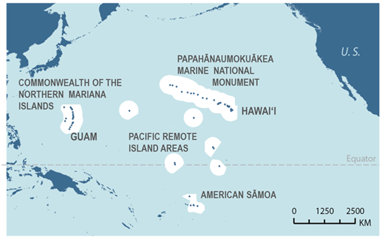
Figure 1: Coral-reef areas surveyed for the Pacific NCRMP. White areas represent the Exclusive Economic Zones (EEZs) for each U.S. Pacific region surveyed.ALT: A map of the Pacific Ocean highlighting islands surveyed for Pacific NCMRP
As an interdisciplinary monitoring program, the NCRMP has three main themes: biological, climate, and socioeconomic monitoring. The Pacific NCRMP executes the biological and climate components of hard-bottomed reef habitats in the 0–30 m depth range. Under the biological monitoring theme, the Pacific NCRMP collects the following reef-fish data for every observed species, including key fish taxa:
- abundance
- size structure
- diversity
- distribution
Partnership and cooperation with other federal and jurisdictional management groups is a core principle of the NCRMP. For example, the University of Guam’s Long-term Coral Reef Monitoring Program (GLTMP) conducts reef fish monitoring surveys around Guam using similar survey designs and methods. Data gathered by GLTMP is therefore readily merged with NCRMP data resulting in increased survey domain for local research efforts.
This report focuses on the data collected using the stationary point count (SPC) method to survey the fish assemblage (see Section: Methods). Note that the Pacific NCRMP also collects benthic data via benthic transects in the same locations as SPC surveys, which are not included in this report (for more information see NOAA Coral Program [2021]).

Monitoring scope of the NCRMP
CRCP’s NCRMP includes the following biological monitoring goals:
- develop and implement consistent and comparable methods and standard operating procedures which detail specific field, laboratory, and/or analytical procedures and best practices for all indicators (with periodic updates to reflect new technologies or logistical considerations)
- develop and maintain strong partnerships with federal, state/territory, and academic partners
- collect scientifically sound, geographically comprehensive data in U.S. coral reef areas
- deliver high‐quality data, data products, and tools to the coral reef conservation community
- provide context for interpreting results of localized monitoring
- provide periodic assessments of the status and trends of the nation’s coral reef ecosystems
- contribute to local capacity-building through its engagement of jurisdictional entities and private-public partnerships involved in NCRMP data collection
These goals are based on the key monitoring questions for the CRCP and NCRMP support for baseline observations and monitoring (NOAA Coral Reef Conservation Program 2009; NOAA CRCP 2014; NOAA Coral Program 2021).
The Pacific NCRMP involves monitoring over very large spatial scales: ~ 40 islands and atolls spread over thousands of kilometers. The target for fish monitoring is to provide periodic snapshot assessments of coral-reef assemblages at U.S.-affiliated islands in the Pacific, with the core reporting unit being at the island scale (or sub-island scale for large islands). As such, the survey design and effort are optimized to generate data at the spatial scale of islands and atolls. The NCRMP is therefore explicitly a “wide-but-thin” survey program, with the aim of generating large-scale, regional status and trend information of the nation’s shallow (0–30 m) coral-reef ecosystems, to provide a broad-scale context and perspective for management and conservation.

Report Structure
This report summarizes the reef-fish survey data collected in Hawai‘i during the Pacific NCRMP survey mission in 2024. The status of reef-fish assemblages is described at the island scale, and for larger islands, at the sector scale. By collecting data using the same methods over time, we are able to provide time series that begin in 2009, when the Program started to consistently use SPC fish surveys.
All data used in this report are available through the online data visualization tool (https://ncrmp.coralreef.noaa.gov/), or through NOAA’s InPort data system for 2009 – 2012 (https://www.fisheries.noaa.gov/inport/item/34515), and 2014 on (https://www.fisheries.noaa.gov/inport/item/34518). For all remaining data requests or inquiries, please contact Andrew.Shantz@noaa.gov.

Methods

Sampling domain and survey design
The target sampling domain is hard-bottom habitat in water shallower than 30 m (Table 1). All islands/atolls within regions are stratified by reef zone (backreef, forereef, lagoon, protected slope) and depth zone: shallow (> 0–6 m, mid (> 6–18 m), and deep (> 18–30 m). The areas surveyed in American Samoa are all characterized as forereef, except for the interior of Rose Atoll, which consists of a lagoon. Tutuila is further stratified into sectors per island, where sector boundaries reflect broad differences in oceanographic exposure, reef structure, and local human population density.
Table 1: Sampling terms and definitions
Term | Definition
Sampling domain | Hard-bottom habitat in water less than 30 m depth.
Reporting unit | A collection of sample sites, typically an island or atoll and in some cases, small island groups or sectors of larger islands.
Sectors | Management units and stretches of coastline with broadly similar habitat attributes and local human population density
Reef zone | Backreef, forereef, lagoon, or protected slope
Depth zone | Shallow > 0*–6 m, mid > 6–18 m, deep > 18–30 m
Strata | Combination of sectors, reef zone and depth zone - the pooling level for site estimates by reef area
Sample site data | The average values of estimated observed quantities from the SPC surveys conducted at each site. These are typically derived from a single pair of simultaneous surveys. Sites are tied to geographic coordinates.

*For practical reasons, sites in which the center point of the survey cylinder is shallower than 1.5 m are not surveyed.
The number of sites to be surveyed per stratum is based on a weighting factor calculated from the proportional area per stratum per reporting unit (e.g., island) and the variance of the target output metrics (e.g., consumer group biomass and total fish biomass; see Section: Fish groupings), in combination with the ship time allotted per island or atoll. The resulting target number of sites are then randomly distributed across each stratum (see below). Details on the sampling effort across survey cruises included in this report are provided in Appendix B: Samples per sector and strata in 2024.

Site selection
Prior to each survey mission, sample site locations (latitude and longitude) are randomly drawn from geographic information system (GIS) habitat and strata maps of the entire sampling domain (Figure 2).
Maps used in the site selection procedure were created using information from the NOAA National Centers for Coastal Ocean Science, reef zones (e.g., forereef) digitized from IKONOS satellite imagery or nautical charts, bathymetric data from the PIFSC-affiliated Pacific Islands Benthic Habitat Mapping Center at the University of Hawaiʻi at Mānoa, and prior knowledge gained from previous visits to survey locations.
Although the Pacific NCRMP aims to survey around the entirety of each island or atoll, the achieved monitoring effort is ultimately determined by field logistics and weather conditions encountered during field operations on each research cruise. If a site is not suitable (e.g., soft- as opposed to hard-bottomed habitat) or accessible (e.g., due to inclement sea conditions), the dive is aborted and an alternate (backup) site is picked from the randomized list. In some cases, the spatial coverage of sampling sites around the entire area of target sampling domain is incomplete. As such, any inferences about coral-reef fish assemblages and habitat made at the island scale are only representative of the areas sufficiently surveyed (Appendix B: Samples per sector and strata in 2023). For further details on the methods and maps used to select sites, see (Ayotte P, 2015; Williams ID, 2011).
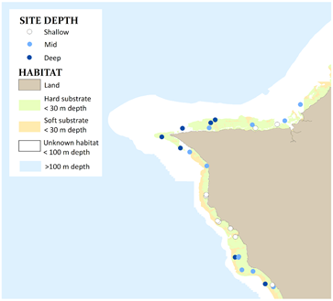
Figure 2: An example of the benthic habitat and depth strata information used in the site-selection process. Each circle identifies a site which falls on hard substrata (green) in the three depth strata (see map legend, shallow: < 6 m, mid: > 6–18 m, and deep: > 18–30 m). ALT: Map of an island with benthic substrate categories of land, hard substrate, soft substrate, and unknown habitat.

Sampling Methods
At each survey site, divers record the counts and sizes of observed fish assemblages. The SPC protocol closely follows that used by Ault and colleagues (2006) and involves a pair of divers conducting simultaneous counts in adjacent, visually estimated 15-mdiameter cylindrical plots extending from the substrate to the limits of vertical visibility (Figure 3). Prior to beginning each SPC, a 30-m line is laid across the substratum. Markings at 7.5 m, 15 m, and 22.5 m enable survey divers to locate the midpoint (7.5 m or 22.5 m) and two edges (0 m and 15 m; or 15 m and 30 m) of their survey plots. Each count consists of two components. The first is a 5-minute species enumeration period in which the diver records the taxa of all species observed within their cylinder. At the end of the 5-minute period, divers begin the tallying portion of the count, in which they systematically work through their species list and record the number and estimated size (total length, TL, to the nearest cm) of each individual fish. The tallying portion is conducted as a series of rapid visual sweeps of the plot, with one species-grouping counted per sweep. To the extent possible, divers remain at the center of their cylinders throughout the count. However, small, generally site-attached and semi-cryptic species, which tend to be under-represented in counts made by an observer remaining in the center of a 7.5-m radius cylinder, are left to the end of the tally period, at which time the observer swims through their plot area carefully searching for those species. In cases where a species is observed during the enumeration period but is not present in the cylinder during the tallying period, divers record their best estimates of size and number observed in the first encounter during the enumeration period and mark the data record as “non-instantaneous.” Beginning in 2012, divers also recorded observations of fishes that were first seen inside the cylinders at some point between 5 and 30 minutes into the survey. However, for consistency across time periods, those additional observations were not used in this report. Surveys are not conducted if horizontal visibility is less than 7.5 m, i.e., when observers cannot distinguish the edges of their cylinder (Ayotte P, 2015).
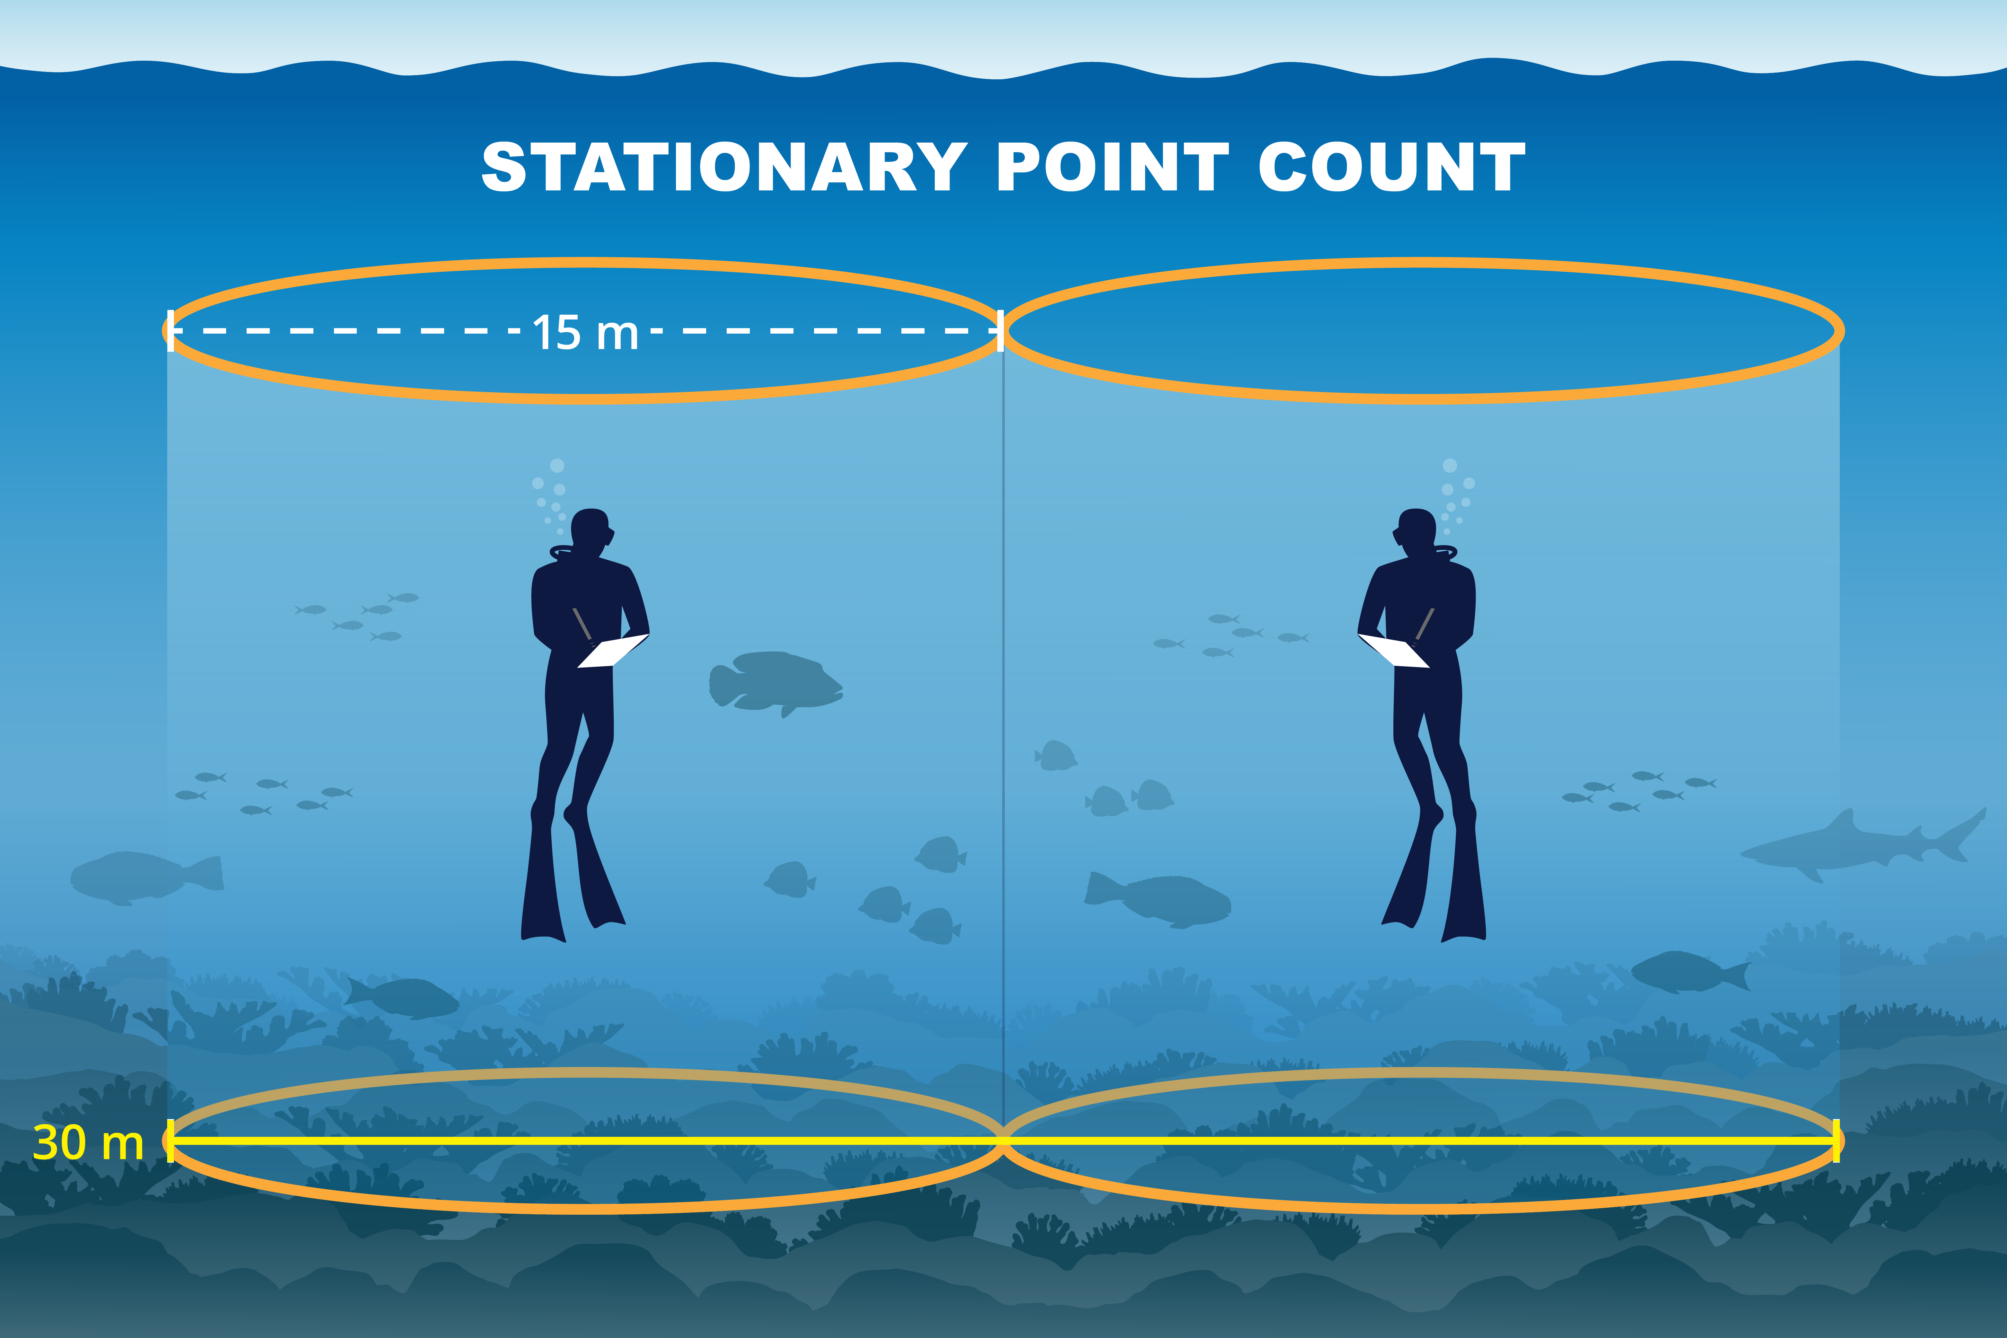
Figure 3: Side view of the stationary point count method. A pair of divers count and size the fishes within adjacent cylinders measuring 15 m in diameter. ALT: Two divers record fish data in a visually estimated cylinder with a 15-m diameter

Data entry and storage
Data are entered into a custom data entry application built with Oracle Application Express and stored in an Oracle mission-specific database. Upon completion of each monitoring cruise, all data are migrated to an existing master Oracle database that is stored on a server at the PIFSC.

Data quality control
Data quality control is implemented at three main stages:
- Prior to conducting fish surveys for the Pacific NCRMP, each observer must take the full training course. In between field data collections, observers practice survey methods and take fish identification tests (Figure 4: Pre-field).
- Checking for errors at the data entry stage (Figure 4: In the field) occurs on the cruise when observers check the data entered by their dive partner against their datasheet for typing and potential sizing errors. At the end of the cruise, a series of error checking scripts are run prior to migrating from the mission Oracle database to the master Oracle database (Figure 4: Post-field).
Examining diver estimation accuracy occurs during and after the monitoring cruise when diver estimates are compared between dive partner pairs (Figure 4: In the field). Observer comparisons from the regions surveyed in 2024 are in Appendix C: SPC Quality control: Observer cross-comparison.
Figure 4: The training, data collection, data processing, and reporting phases for the Pacific NCRMP SPC surveys. ALT: Training, data collection, and data review process infographic

Data handling

Calculating fish biomass per site
Using the count and size data collected per observer in each replicate survey, the body weight of each individual fish is calculated using length-to-weight (LW) conversion parameters and, where necessary, length-length (LL) parameters (for example, to convert TL to fork length [FL] for species with LW parameters based on FL). LW and LL conversion parameters were taken from FishBase (Froese R, 2010; Kulbicki M, 2005). Biomass per fish is calculated using the standard length-weight equation. Herein, the term “biomass” refers to the aggregate body weight of a group of fishes per unit area (g m^{–2}). Site is the base sample unit, and the estimated biomass of fishes per site is calculated by taking the mean value from the paired SPC surveys. # Fish groupings {.unnumbered}
In this report, species data are summarized at several different levels: consumer group, total fish biomass (“all fishes”), parrotfish biomass, and average total length. Consumer groups are: “primary consumers” (herbivores and detritivores); “secondary consumers” (omnivores and benthic invertivores); “planktivores;” and “piscivores,” with classifications based on diet information taken largely from FishBase (Froese R, 2010). Size classes for parrotfish are 10–30 and greater than 30 cm TL, as 30 cm is the legal minimum size for fishing on all islands.

Generating island-scale estimates from the stratified design
Summary statistics (e.g., mean and variance) of survey metrics (e.g., biomass) are calculated by first averaging values within each stratum before calculating the reporting unit values. A weighted-average method to calculate summary statistics is used because survey strata vary in size within each reporting unit.
Estimates of the mean and variance for each survey quantity considered are calculated based on the observed values at sampled sites within each stratum. Then, aggregate estimates of the quantities across all strata are calculated using the formulas below.
- pooled mean biomass (X) across S strata:
$$\begin{matrix}X=Σ_{1}^{S}\left(X_{i}*w_{i}\right)\end{matrix}$$
- pooled mean variance of mean biomass (VAR) across S strata:
$$\begin{matrix}VAR=Σ_{1}^{S}\left(VAR_{i}*w_{i}^{2}\right)\end{matrix}$$
- where
$$X_{i}$$
- is the estimate of mean biomass within stratum i,
$$VAR_{i}$$
- is the estimated variance of Xi, and wi is the stratum-weighting factor. Strata weighting factors were based on the size of strata, i.e., if a stratum is 50% of the total habitat area surveyed at an island, its weighting factor will be 0.5, and total of all weighting factors in an island sums to 1 (Smith SG, 2011).
In this report, only data from sites surveyed under the stratified sampling design are used (i.e., data collected from 2009 onwards; Appendix D: Random stratified sites surveyed at each island per year). In the rare cases where fewer than two sites were surveyed in a stratum during a reporting period, they were removed from the island-scale parameter estimates for that period.
Island-scale values for total fish biomass (i.e., all fishes, fishes by size class) and biomass per consumer group, parrotfish size class, and species of interest (mean and variance) are calculated by year (see Section: Island status and trends).
All data handling and analyses were performed using raw site data extracted from the NOAA PIFSC Oracle database, processed using a set of routine processing scripts written in R (R Development Core Team, 2011; Figure 4: Post-field), and visualized using the ggplot2 package (Wickham H, 2016). The site-level data used to generate all figures and summary statistics are available upon request.

Island status and trends
This section summarizes SPC data collected at each island between 2010 and 2024, when comparable methods were used. For each island within a region, maps illustrate the SPC site-level data, and a standard set of graphs shows summary information on the fish community at the island scale for each year there was sufficient sampling. On each fish biomass graph for the forereef habitat, a reference line indicates the region-wide mean estimate across all surveyed years (2010–2024), provided as a relevant regional comparison for island-level estimates. Fish biomass estimates are shown for each year of all fish combined, all fish in two size classes, parrotfish in two size classes, species of interest, and by consumer group. All fish, consumer group, and parrotfish biomass are core NCRMP indicators (NOAA CRCP 2014). Large parrotfishes are important grazers, so parrotfish biomass is separately reported for two size groups: large (> 30 cm TL) and small (10–30 cm TL) fishes. Mean fish size (cm TL) per island and year is also reported, as it can be a useful indicator of fishing pressure; fishes smaller than 10 cm TL are excluded to reduce noise from variable levels of recent fish recruitment. Species of interest were identified by local managers, and biomass for humphead wrasse, and all shark species are also shown.

1. ————————————————————

1.0.1 Images generated by document code
You can also include code within your data report to generate the figures, rather than importing them. The code below walks through an example of how to do this.
Some notes about the code:
- echo: false prevents the code from showing up in your document. If you want to include code, delete this line.
- message: false prevents messages that result from running your code from showing up in your document.
warning: false prevents warnings that result from running your code from showing up in your document. In this case, it’s a warning about the version of R that nmfspalette was built under. - label: fig-co2growth allows you to create a cross reference to the figure in your text. There’s an example of this below the code.
- calling par(bg = NA) before plotting creates a transparent background, which comports with the PIFSC template. If you are generating a figure that you’re going to save and then import, you can use bg = "transparent" in the command to save your figure instead.
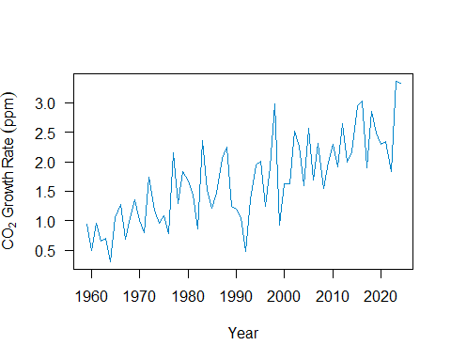
Figure 1.1: Annual increase in atmospheric CO₂
As we can see in Figure 1.1, the amount of carbon dioxide added to the atmosphere continues to increase over time.

1.0.2 Tables
These examples walks through how to create a table using code. Do not import a table as an image or the editors will send your Data Report back to you and ask you to replace it with an actual table.
A few things to note about tables in PIFSC Data Reports:
- Use consistent significant figures throughout a given table.
- All blank cells must be filled, even if it’s only with a hyphen (this helps screen readers work).
- All tables need captions. As with figures, you’ll need to add these in Word.
- There’s some formatting that you’ll need to do in Word for the time being (e.g., subscripts, font). In the meantime, solutions are welcome!

1.0.2.1 Creating a table from a csv
This example creates a table directly from a csv using the kable package. It allows you to rename column headers, align columns, harmonize the number of digits, format numbers, handle missing values, and more. You can see more at: https://bookdown.org/yihui/rmarkdown-cookbook/kable.html
Table 1.1: Annual increase in atmospheric CO₂ of the past 10 years
Year | Annual CO₂ Increase (ppm)
2014 | 2.17
2015 | 2.95
2016 | 3.03
2017 | 1.90
2018 | 2.85
2019 | 2.49
2020 | 2.30
2021 | 2.34
2022 | 1.83
2023 | 3.36
2024 | 3.33

As Table 1.1 demonstrates, you’ll need to do some of the formatting by hand in Word. Frustratingly, some of the coded instructions (e.g., alignment) don’t seem to be carrying through. Suggestions for fixing this are welcome!

1.0.2.2 Creating a table by hand
This example creates a table by hand, which can be tedious though is sometimes necessary.
In the code that creates ?@tbl-GWP the colons (:) in the line under the header denote column alignment. Although this seems not to be working… Something to fix.

1.0.2.3 Landscape orientation for wide tables
If you have a very wide table, you can use landscape orientation to display it more cleanly. Simply enclose your table in fences (:::) designating the page orientation. There’s an example below.

Check out how wide Table 1.2 is. Thanks to PIFSC’s OceanWatch for supplying the data!
Table 1.2: 2024 monthly ESA OC CCI chlorophyll data
Month | Lat (°N) | Lon (°E) | chlor_a (mg m-3) | OLCI_A_nobs_sum | OLCI_B_nobs_sum | chlor_a_log10_bias | chlor_a_log10_rmsd | total_nobs_sum
1 | 22.73 | 202.02 | 0.0931 | 59 | 77 | 0.000568 | 0.198 | 136
2 | 22.73 | 202.02 | 0.0817 | 90 | 57 | 0.001890 | 0.198 | 148
3 | 22.73 | 202.02 | 0.0816 | 31 | 96 | 0.003220 | 0.196 | 127
4 | 22.73 | 202.02 | 0.0722 | 27 | 47 | 0.006970 | 0.194 | 74
5 | 22.73 | 202.02 | 0.0708 | 50 | 68 | 0.008010 | 0.193 | 118
6 | 22.73 | 202.02 | 0.0643 | 41 | 109 | 0.010000 | 0.192 | 151
7 | 22.73 | 202.02 | 0.0705 | 85 | 66 | 0.009090 | 0.193 | 150
8 | 22.73 | 202.02 | 0.1270 | 108 | 65 | -0.009130 | 0.212 | 173
9 | 22.73 | 202.02 | 0.0826 | 38 | 61 | 0.005550 | 0.195 | 100
10 | 22.73 | 202.02 | 0.0717 | 50 | 71 | 0.011000 | 0.192 | 121
11 | 22.73 | 202.02 | 0.0873 | 31 | 54 | 0.004670 | 0.195 | 84
12 | 22.73 | 202.02 | 0.0771 | 59 | 96 | 0.008200 | 0.193 | 154

Literature Cited
Ault, J.S., Smith, S.G., Bohnsack, J.A., Luo, J., Harper, D.E., & McClellan, D.B. (2006). Building sustainable fisheries in Florida’s coral reef ecosystem: positive signs in the dry Tortugas. Bull Mar Sci. 78 (3): 633–654.
Ayotte, P., McCoy, K., Heenan, A., Williams, I., & Zamzow, J. (2015). Coral Reef Ecosystem Program standard operating procedures: data collection for Rapid Ecological Assessment fish surveys. Pacific Islands Fisheries Science Center Administrative Report H-15-07, 39 p.
Froese, R., & Pauly, D. (2010). “Fishbase”, World Wide Web electronic publication. http://www.fishbase.org/search.php
Kulbicki, M., Guillemot, N., & Amand, M. (2005). A general approach to length-weight relationships for New Caledonian lagoon fishes. Cybium, vol. 29, 3, 235–252.
NOAA Coral Reef Conservation Program. (2009). Goals & Objectives 2010–2015, NOAA Coral Reef Conservation Program. 40 p.
NOAA CRCP. (2014). National Coral Reef Monitoring Plan. NOAA Coral Reef Conservation Program. Silver Spring, MD. 40 p. ftp://ftp.library.noaa.gov/noaa_documents.lib/CoRIS/CRCP/noaa_crcp_national_coral_reef_monitoring_plan_2014.pdf.
NOAA Coral Program. (2021). National Coral Reef Monitoring Plan. Silver Spring, MD, NOAA Coral Reef Conservation Program. 40 p. https://repository.library.noaa.gov/view/noaa/32748
R Development Core Team. (2011). R: A Languange and Environment for Statistical Computing, Vienna, Austria.
Smith, S.G., Ault, J.S., Bohnsack, J.A., Harper, D.E., Luo, J., McClellan, D.B. (2011). Multispecies survey design for assessing reef-fish stocks, spatially explicit management performance, and ecosystem condition. Fish Res.109(1):25–41.
Wickham, H. (2016). ggplot2: Elegant Graphics for Data Analysis. Springer-Verlag New York.
Williams, I.D., Richards, B.L., Sandin, S.A., Baum, J.K., Schroeder, R.E., Nadon, M.O., Zgliczynski, B., Craig, P., McIlwain. J.L., & Brainard, R.E. (2011). Differences in reef fish assemblages between populated and remote reefs spanning multiple archipelagos across the central and western Pacific. J Mar Biol. Article ID 826234, 14 p. DOI: 10.1155/2011/826234.

Appendix
If you have an appendix, it would go here.
If you don’t have an appendix, you’ll need to edit _quarto.yml to delete the line referencing this file (currently line 18). You can leave this file as-is or delete it. Up to you.

