What is Parliament Saying About Education? Education Discourse in the Canadian House of Commons, 1901-2019
Introduction
Education is a provincial responsibility in Canada, yet it remains a visible and recurring subject in House of Commons debate. This creates a straightforward, but politically important puzzle. Under Section 93 of the Constitution Act, 1867, provinces hold primary legislative authority over education. Even so, Members of Parliament (MPs) continue to raise education in federal debate across a wide range of contexts. It is unlikely that these references are random. Parliamentary speeches are one of the main ways legislators signal their priorities, frame public problems, and attach issues to partisan and policy narratives. The recurring presence of education in House of Commons speech raises the question: what, exactly, are MPs doing when they talk about education in a chamber that does not directly govern schooling?
Existing scholarship illustrates the institutional distribution of education authority in Canada and identifies several fields through which education enters federal politics. What it does not fully explain is how MPs address education rhetorically in House of Commons debate. Research on legislative speech shows that parliamentary interventions are politically meaningful. Debate can transmit information to other legislators (Austen-Smith 1990), while floor speeches can serve as a venue for position-taking (Proksch and Slapin 2010), partisan signaling, and representation shaped by party strategy and institutional rules (Proksch and Slapin 2012, 2014).
Canadian education policy scholarship also reveals that education appears in federal politics through several distinct policy fields. Research on postsecondary affordability centers on tuition, student aid, and access (Council of Ministers of Education 2007); scholarship on universities emphasizes Ottawa’s growing role in research and innovation funding despite provincial jurisdiction over higher education (Bégin-Caouette et al. 2021); studies of skills and training treat education as an integral part of labour-market policy (Jansen et al. 2019); and work on early learning and childcare shows how this policy arena has developed unevenly, but more recently through Canadian federalism. These literatures suggest that federal education speech should be understood as a meaningful form of political communication in a policy area that is institutionally fragmented and substantively diverse (Friendly 2000). They do not, however, fully explain how those different meanings of education are assembled, emphasized, and shifted within federal parliamentary speech.
The project addresses that gap, by examining how MPs give speeches about education in House of Commons debate, and what these speeches reveal about federal political priorities, narratives, and conflicts. To account for the multi-faceted nature of education policy, I treat federal references to education as a strategic rhetorical practice whose purposes should be visible in recurring patterns of language, subtopic emphasis, and changes over time. The report proceeds as follows. I first describe the data, corpus construction, and classification workflow used to identify education-related speech and code seven education subtopics. I then present results on the prevalence of education speech over time, the changing composition of education discourse, and the overall distribution of topic labels within the corpus. I conclude by discussing the project’s contributions, limitations, and next steps.
Data and Methods
This study uses Canadian parliamentary speech data from the Linked Parliamentary Data (LIPAD) corpus and the digitized House of Commons debates compiled by Beelen et al. (2017). To carry out the analysis, I constructed a large speech-level working sample from the raw Hansard files covering speeches from 1901 to 2019.
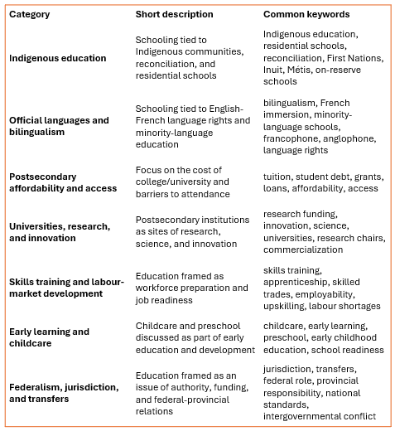
The unit of observation is the individual parliamentary speech turn delivered by a Member of Parliament (MP). Each observation consists of one speech linked to its associated metadata, including date, speaker, party affiliation, and unique identifiers. Treating the individual speech as the unit of analysis is appropriate for this project, because it was built to explore the frequency and substantive content of education-related claims at the level at which parliamentary rhetoric is articulated.

The analysis relied on both raw and constructed variables. At the raw level, the data include the speech text and available metadata. From these data, I first constructed a binary indicator of whether a speech was education related. I then generated a second set of topic-specific variables intended to capture whether an education-related speech contained one of the subtopics. The initial codebook, summarized in Table 1, included seven categories: Indigenous education, minority language education, postsecondary affordability and access, universities and research, skills and training, early learning and childcare, and federalism/jurisdiction. All seven categories are retained in the analysis, but greater interpretive weight is placed on those that demonstrated the strongest conceptual distinctiveness and empirical reliability during validation. The strongest-performing categories were early learning and childcare, skills training and labour-market development, and postsecondary affordability and access, while the remaining categories exhibited weaker agreement and greater overlap with adjacent subtopics.
Data preparation occurred in several stages. First, I used a reproducible import loop to compile speeches stored across multiple daily Hansard source files into a single master dataset. In this step, I sampled up to 100 speeches per file, which produced a working corpus of 1,312,018 observations and 22 variables. This procedure was intended to approximate temporal coverage across the corpus while keeping the dataset manageable. Second, I applied a dictionary-based retrieval procedure to identify potentially education-related speeches from the sampled Hansard corpus. The dictionary was implemented using regular expressions and included education-related terms. This step was intentionally inclusive because the goal was to construct a reduced corpus within which subtopics could be distinguished more carefully. Applying this filter reduced the sampled corpus to 60,833 education-related speeches. Third, I cleaned the resulting education corpus by standardizing text formatting and removing errors carried over by the source files. This included replacing line breaks, stripping selected punctuation, and generating a clean version of the speech text for later coding and classification.
After constructing the education corpus, I drew a sample of 200 education-related speeches for hand coding. These speeches were coded using a topic codebook designed to identify the presence or absence of each of the 7 education subtopics. Hand-coding allowed for a check on whether the initial dictionary filter was capturing the kinds of speeches the project was meant to study. It also created a label dataset that could be used to train and evaluate a supervised classification approach.
Analysis
The analysis for this project proceeded in four stages: corpus construction, codebook validation, expansion of topic-specific training data, and supervised classification of the education corpus. To construct a reduced corpus of education related-speeches from the larger sampled Hansard dataset, first I applied a regular-expression dictionary containing general education-related language. This initial step was intentionally inclusive, so that the corpus from which I identified the topics from was broad enough to ensure proper identification. I then cleaned and standardized the corpus to prepare it for coding and classification.
The second stage of the analysis focused on validating the topic codebook. The seven categories used in this project were derived through an iterative process that combined existing scholarship on education politics and policy with close reading of the parliamentary speeches. Literature-informed themes provided the initial coding structure, but the coding frame was refined as I read speeches, identified recurring patterns in how education was discussed, and clarified overlapping or ambiguous category boundaries. Using a hand-coded sample of 200 education-related speeches, I then evaluated whether the seven pre-defined education subtopics could be identified consistently in the text: Indigenous education, official languages and minority-language education, postsecondary affordability and access, universities and research, skills training and labour-market development, early learning and childcare, and federalism/jurisdiction. These categories were operationalized into a project-specific coding frame for use in both the hand-coding and validation stages.
To assess the viability of these categories, I implemented a zero-shot, prompt-based LLM classification workflow for all seven topics. Each topic was treated as a separate binary classification task, with the model asked to determine whether an individual speech contained the topic of interest. Speeches were then passed to the model one at a time, and the output was a binary label (0 = absent, 1 = present). This produced an initial validation benchmark against which the hand-coded sample could be compared, allowing me to assess whether the topics in the coding frame were sufficiently clear and distinct to support larger-scale automated analysis.
Model performance in the zero-shot was evaluated using several complementary metrics. I used confusion matrices to examine the balance of false positives and false negatives, F1 scores to assess classification quality under class imbalance, and Cohen’s kappa and Krippendorff’s alpha to evaluate agreement between machine-generated and human-coded labels. Across the seven topics, agreement varied significantly. Cohen’s kappa ranged from approximately 0.28 to 0.66, while Krippendorff’s alpha ranged from approximately 0.28 to 0.67. The strongest results were from the early learning/childcare topic (kappa = 0.66, alpha = 0.66), skills training and labour-market development (kappa = 0.61, alpha = 0.61), and postsecondary affordability and access (kappa = 0.59, alpha = 0.59). By contrast, Indigenous education and federalism/jurisdiction produced the weakest agreement, with coefficients below 0.30, while minority languages and university research fell in a weaker middle range around 0.38. This pattern suggests that affordability, skills, and early learning were more clearly bounded and consistently identifiable in the education sample. These validation results informed the later interpretation of the findings and justified placing greater analytical weight on the more robust categories.
The third stage involved expanding the training data for each topic. To do this, I created topic-specific regex dictionaries designed to retrieve likely positive examples for each of the seven education subtopics from within the education corpus. These speeches were then manually checked and combined with the original hand-coded validation sample to create topic-specific training files. Duplicate cases were resolved by retaining the original hand-coded version where overlap occurred, and the resulting training files were standardized into binary labels to prepare for supervised classification. This step was important, because the initial 200-speech validation sample was sufficient for benchmarking the codebook, but too small on its own to support more robust downstream classification across the rest of the corpus.
The fourth stage involved supervised classification. Using the expanded labeled datasets, I estimated topic-specific binary classifiers that treated the cleaned speech as input and the topic label as the outcome. The purpose of this stage was to classify the larger education corpus and estimate how often each of the seven education subtopics appeared in parliamentary debate, which made it possible to move from the narrower question of whether a topic could be coded reliably to the descriptive question of how education was being discussed across time and political context. Although the validation results indicated that some categories were more robust than others, the supervised workflow was carried out separately for all seven topics.
To illustrate how the coding frame mapped onto the text, Figure 1 presents exemplar quotations for the strongest-performing categories. These excerpts serve as a qualitative check on the classification strategy by showing what affordability, skills training, and early learning/childcare looked like in actual parliamentary speech. The affordability excerpt illustrates how the affordability topic pulls speeches centered on tuition, debt, student debt, and financial barriers to access. The skills excerpt frames education in terms of employability, workforce preparation, and labour-market adjustment. The childcare excerpt emphasizes childcare systems, early childhood development, and organized early learning provision.
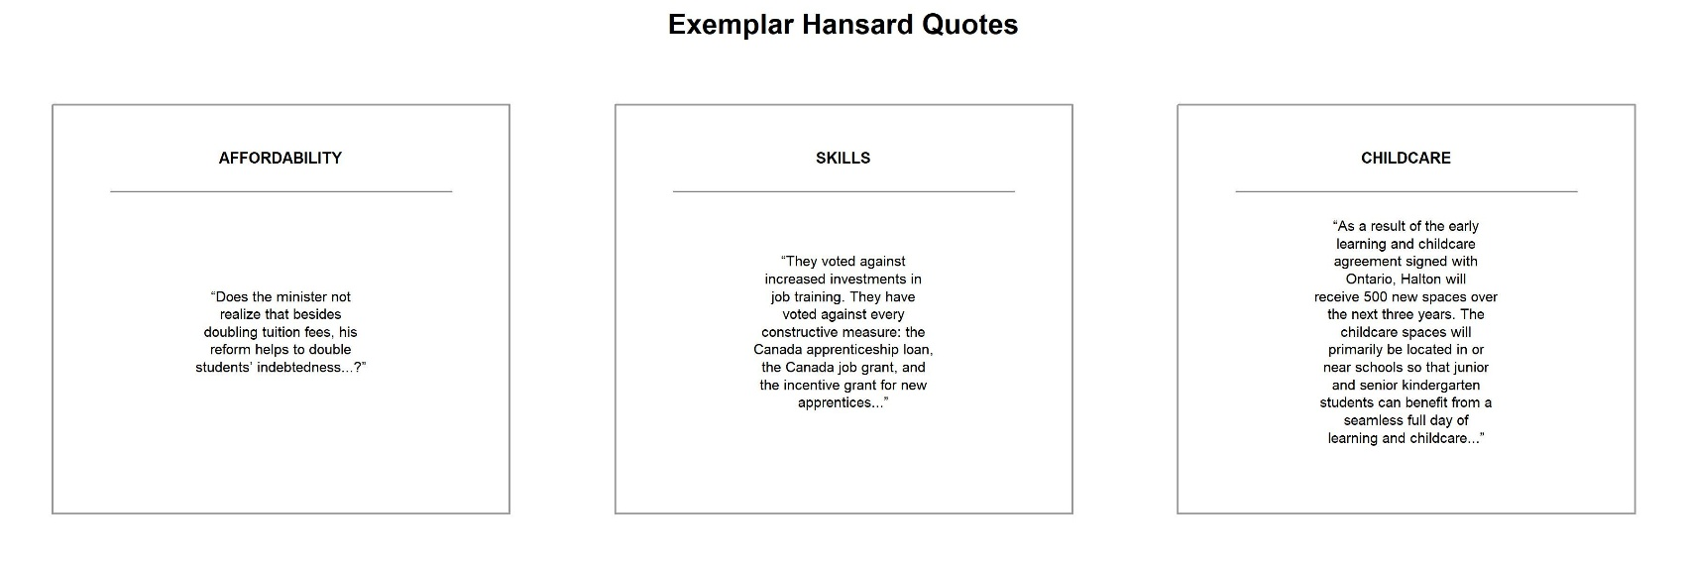
Figure 1: Exemplar Hansard Quotations for Key Education Subtopics
The analytical strategy outlined above supports the project’s goals in two ways. First, it provides a transparent and repeatable method for distinguishing among education subtopics in parliamentary speech. Second, it allows for descriptive comparison across parties, time periods, and rhetorical contexts. At the same time, the validation stage makes it clear that not all categories are equally strong measures. For that reason, the final interpretation places greater analytical weight on the strongest-performing topics while still discussing the full seven-topic structure as part of a full mapping of education discourse.
Results
I present the results in three steps. I first show how often education appears in the sampled Hansard corpus over time. I then examine how the composition of education-related speech changes across the seven subtopic categories. Finally, I summarize the overall distribution of topic labels within the education corpus.
Education-Related Speech Over Time
Before breaking education speech into sub-categories, I first examined how often education appeared in the sampled Hansard corpus over time. Figure 2 plots the annual proportion of sampled speeches classified as education related. Although education-related speech remains a relatively small share of parliamentary debate overall, never exceeding about 2.25 percent of sampled speeches, its prevalence rises across the century and becomes much more prominent in the late twentieth century. In the earlier decades of the period, education generally accounts for under one percent of sampled speeches, with some short-lived spikes. After mid-century, however, education becomes more consistently visible, and its share rises further from the 1980s onward, peaking in the early 1990s and remaining elevated through much of the later period.

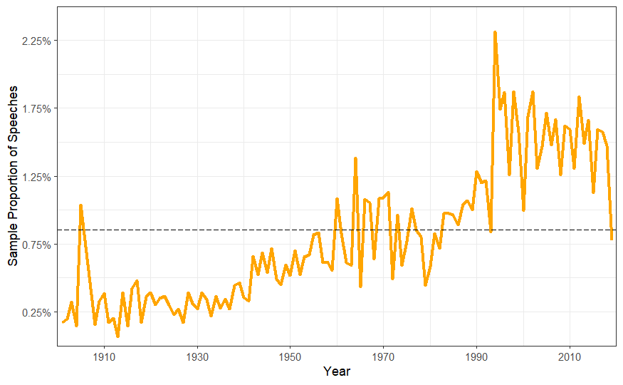
Figure 2: Annual Proportion of Education-Related Speeches in the Sampled Hansard Corpus, 1901-2019

This pattern suggests that education is not a static or incidental topic in House of Commons debate. Rather, its salience changes historically and appears to respond to shifting political and policy contexts. Even before topic classification, the results indicated that MPs refer to education more frequently in some periods than others.
The Composition of Education Discourse Changes Across Time
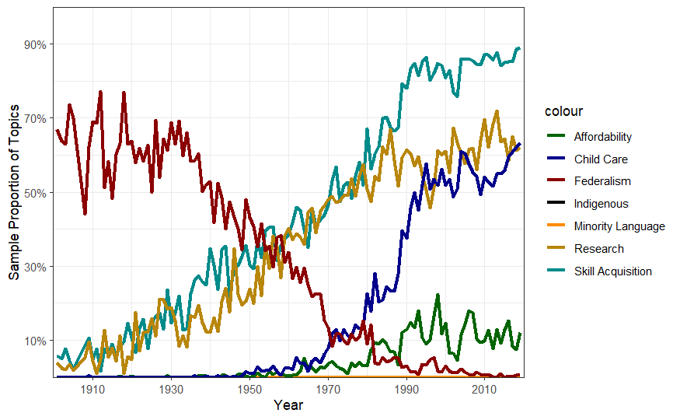
I next examined how the content of education-related speech varies over time. Figure 3 shows the estimated yearly proportion of education speeches classified into each of the seven subtopics. Because speeches could receive more than one topic label, these topic proportions do not sum to 100 percent. Figure 3 indicates that the composition of education discourse changes substantially across the century, suggesting that federal education references may be politically and temporally contingent.
Figure 3: Changing Composition of Subtopic Speech in the Sampled Hansard Corpus, 1901-2019
The most interesting pattern is the decline of the federalism/jurisdiction subtopic. In the early decades of the twentieth century, federalism is by far the most prominent subtopic. Over time, however, its prevalence falls, with a particularly sharp decline after the mid-twentieth century. By the 1990s and 2000s, jurisdictional discussion is nearly absent from the education corpus.
By contrast, skills and training and labour-market development rise steadily across the period and become the most prominent education subtopic in later decades. This suggests that MPs increasingly frame education in terms of workforce preparation, employability, and economic competitiveness. A similar upward trend appears for universities, research, and innovation, which becomes increasingly tied to human capital, research capacity, and economic development.
Early learning and childcare also show a strong upward trajectory, especially from the 1970s onward. While largely absent in earlier decades, this category becomes much more visible in the late twentieth century and remains a substantial part of education discourse. This pattern is consistent with the growing political importance of childcare and early childhood development in debates over family policy and social investment.
Postsecondary affordability and access were relatively limited early in the period but became more visible from the 1980s onward. Although affordability does not reach the same prevalence as skills or childcare, it emerges as a recurring subtopic in later decades, consistent with growing attention to tuition, student debt, and barriers to postsecondary education.
By contrast, Indigenous education and official languages and minority-language education remain comparatively low across the period. While these subtopics are substantively important, they account for a smaller proportion of education-related speech in the sampled corpus than skills, research, childcare, or affordability.
Taken together, Figure 3 shows that federal education discourse is not organized around a single, stable concern. Instead, different types of discourse rise and fall across time, reflecting shifts in political priorities and policy debates.

Skills, University Research, and Early Learning Account for the Largest Share of Education Discourse Overall
Figure 4 summarizes the overall distribution of topic labels within the education corpus. Because speeches may contain multiple topics, the proportions reflect the share of education speeches classified into each category, rather than mutually exclusive topic assignments. Figure 4 shows that skills acquisition, research, and early learning account for the largest share of topic labels overall, while federalism occupies a middle position and affordability remains present but less dominant.
This overall distribution reinforces the temporal patterns shown in Figure 3. Federal education discourse is more likely to be attached to labour-market development, postsecondary research and innovation, and early childhood policy than to rights-based or jurisdictional questions. At the same time, the persistence of affordability and federalism suggests that redistribution and authority remain part of the general rhetorical field, even if they are not the dominant frames across the full period.
Taken together, these results indicate that education becomes more visible in federal debate over time and that the composition of education-related speech shifts substantially across the century. Early debate was organized more around jurisdictional questions, whereas later debate increasingly emphasized skills, research, early learning, and, to a lesser extent, affordability. Collectively, the results found in this project illustrate that education appears to serve different rhetorical and political functions across different historical periods.
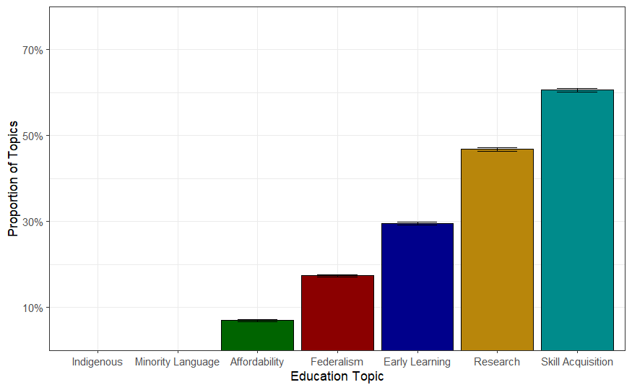
Figure 4: Average Subtopic Proportion Within Education-Related Hansard Speech Sample
Discussion
This project set out to examine how MPs talk about education in the federal legislature. Three findings stand out. First, education-related speech becomes more prominent over time in the sampled Hansard corpus, especially in the late twentieth century. Second, the composition of that discourse changes substantially across the century. Education discourse was more strongly organized around questions of federalism and jurisdiction, while later debate increasingly emphasized skills training, research and innovation, early learning and childcare, and to a lesser extent, postsecondary affordability. Third, federal education discourse is not stable. Instead, it appears to operate as a flexible political language through which MPs discuss labour-market development, family policy, redistribution, and institutional authority.
These findings make two main contributions. Substantively, they show that education is not marginal to federal parliamentary speech just because formal authority over schooling is limited. MPs may use education to frame important, and likely politicized national concerns, and the meaning attached to education shifts over time with political context. This helps explain why education remains visible in House of Commons debate even in a policy area that is constitutionally attributed to the provinces. Methodologically, this project has allowed for the development of a reproducible workflow that can used for identifying, classifying, and comparing parliamentary speeches about education. At the same time, the validation results make clear that not all categories are equally strong measures, which is itself an important finding. Some education subtopics were more conceptually distinct and empirically workable than others.
The project also points to several next steps. The first is to improve the models and retrain them using a revised codebook. Future iterations should expand the coding frame to capture topics that emerged in the speeches but were not fully incorporated into the current version of the project, including immigration and education, religion in schools, and more general forms of education discourse that do not neatly fit into existing categories. This is important because some of the weaker performing categories likely reflect model limitations as well as a need for improvement in the codebook. A revised coding frame would also allow the project to better capture those additional rhetorical uses of education and improve the fit between the categories and the corpus.
A second next step is comparative expansion. The same workflow could be applied to provincial parliamentary speeches to compare how education is discussed across levels of government. That comparison would be especially useful because it could help identify whether federal and provincial parties divide the labour discussing education in different ways. For example, it may be that provincial legislatures carry more of the direct debate about schooling governance and delivery, while federal debate is more likely to attach education to labour markets, family policy, rights claims, or spending power. Extending the project in this direction would make it possible to assess more directly how constitutional structure shapes not just who governs education, but who talks about it, and in what ways.
A third next step is to incorporate greater institutional control into the analysis of party differences. One especially important refinement would be to identify and control for speeches delivered during Question Period. These speeches are often more strategic, confrontational, and procedurally different from other forms of parliamentary speech, and they may distort party-level topic proportions if some parties appear more heavily in that context than others. Filtering Question Period speeches out of the analysis would provide a cleaner comparison of how parties discuss education. This would strengthen claims about partisan differences by reducing the possibility that those differences are driven by challenges to governmental policy made by opposition parties.
In all, this project has illustrated that federal education discourse is historically variable, substantively diverse, and politically meaningful. Even in a system where authority over schooling lies with provincial governments, education remains a recurring object of federal rhetorical and political attention. Incorporating the next steps outlined above, could move the project closer to fully accounting for how education is politically narrated across Canada’s multilevel parliamentary system.

References
Austen-Smith, D. (1990). Information Transmission in Debate. American Journal of Political Science, 34(1), [i]-288.
Begin-Caouette, O., Jones, G., Stephenson, G., & Metcalfe, A. (2021). Canada: The Role of the University Sector in National Research and Development. In Universities in the Knowledge Society: The Nexu of National Systems of Innovation and Higher Education. Springer International Publishing. https://cirst.uqam.ca/publications/description-dune-publication/
Benoit, K., Laver, M., & Mikhaylov, S. (2009). Treating Words as Data with Error: Uncertainty in Text Statements of Policy Positions. American Journal of Political Science, 53(2), 495–513. https://doi.org/10.1111/j.1540-5907.2009.00383.x
Friendly, M. (2000). Child Care and Canadian Federalism in the 1990s: Canary in a Coal Mine. Occasional Paper No. 11. Childcare Resource and Research Unit, Centre for Urban and Community Studies, University of Toronto, 455 Spadina Avenue, Room 305, Toronto, Ontario, M5S 2G8, Canada; Tel: 416-978-6895; Fax: 416-971-2139; e-mail: crru@chass. https://eric.ed.gov/?id=ED445821
Jansen, A. J., White, L. A., Dhuey, E., Foster, D., & Perlman, M. (2019). Training and Skills Development Policy Options for the Changing World of Work. Canadian Public Policy / Analyse de Politiques, 45(4), 460–482.
Proksch, S.-O., & Slapin, J. B. (2010). Position Taking in European Parliament Speeches. British Journal of Political Science, 40(3), 587–611. https://doi.org/10.1017/S0007123409990299
Proksch, S.-O., & Slapin, J. B. (2012). Institutional Foundations of Legislative Speech. American Journal of Political Science, 56(3), 520–537.
Proksch, S.-O., & Slapin, J. B. (2014). The Politics of Parliamentary Debate: Parties, Rebels and Representation. Cambridge University Press. https://doi.org/10.1017/CBO9781139680752
Tandem Social Research Consulting. (2007). Literature Review of Postsecondary Education Affordability in Canada. Council of Ministers of Education.

