

TASK
Exploratory Data Analysis on the Automobile Data Set



Introduction
The Automobile data set used in this report is a collection of data related to different types of automobiles, including make and price. By exploring this data, we can identify what to look out for when buying a car. This includes the effects of body style, engine size and make on the price of the automobile.

DATA CLEANING
In order to prepare the data for its use in visualizations, I dropped a few columns that were unnecessary for this analysis. This includes symbolling, number of doors, height, length, width, engine location, fuel type and fuel system. The drop function from the pandas library was used. Duplicates were also dropped using the drop_duplicates function. The absence or presence of missing values was detected using the isnull and sum functions. Certain columns, such as “bore” and “stroke”, had to be converted from object values to numeric values in order to use them in future visualizations. After using the groupby and mean functions on “body-style” and “price”, a bar graph could be plotted. The “engine-type” column was also used in a word cloud from the wordcloud library. “engine-size” and “price” were used in a line graph. The nlargest and nsmallest functions were used to identify the most expensive and least expensive automobiles, which were then plotted on a pie chart.

MISSING DATA
The automobile data set has no missing values as identified by the isnull function. However, the “normalized-losses” column included a few rows with “?” as an entry. I made the decision to remove this column, as I would not need it for my analysis. However, I have assumed that this data was not missing at random.

DATA STORIES AND VISUALIZATIONS
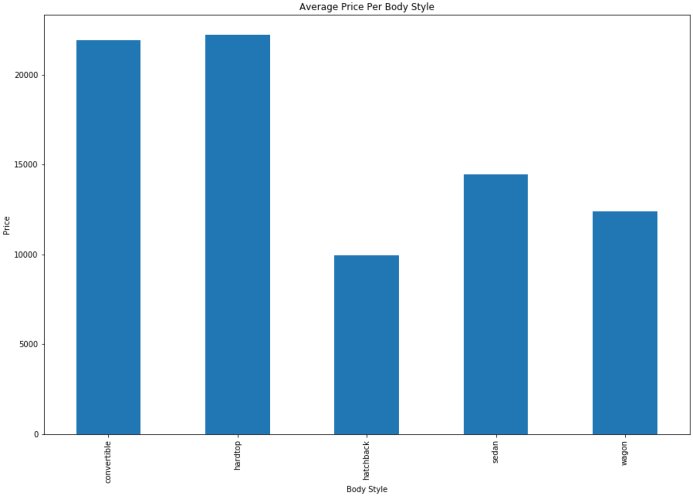
Figure 1: Average Price Per Body Style
The average price, as seen in the bar graph above, changes significantly according to the body style. A hardtop is the most expensive automobile, with convertible coming a close second. They are both well over 20000. A hatchback appears to be the cheapest automobile at approximately half the average price of the first two. Sedans and wagons, while more expensive than a hatchback, are also far cheaper than the first two body styles. For someone who has little to spend on a vehicle, a hatchback would be the body style to look at. Well-off individuals are able to consider any of the body styles above. From the visualization it is clear that body style plays a big role in the price of an automobile.

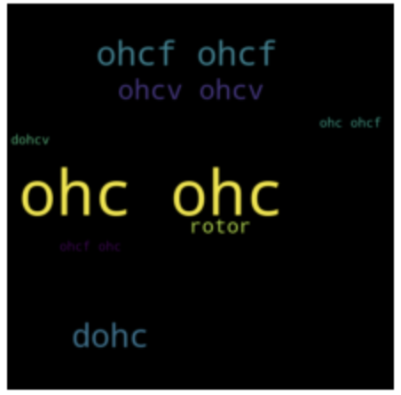
Figure 2: Most Popular Automobile Engine Types
The OHC engine type is the most prominent word in the world cloud, followed by OHCF and DOHC. This means that these automobile engine types are the most used, or most popular.

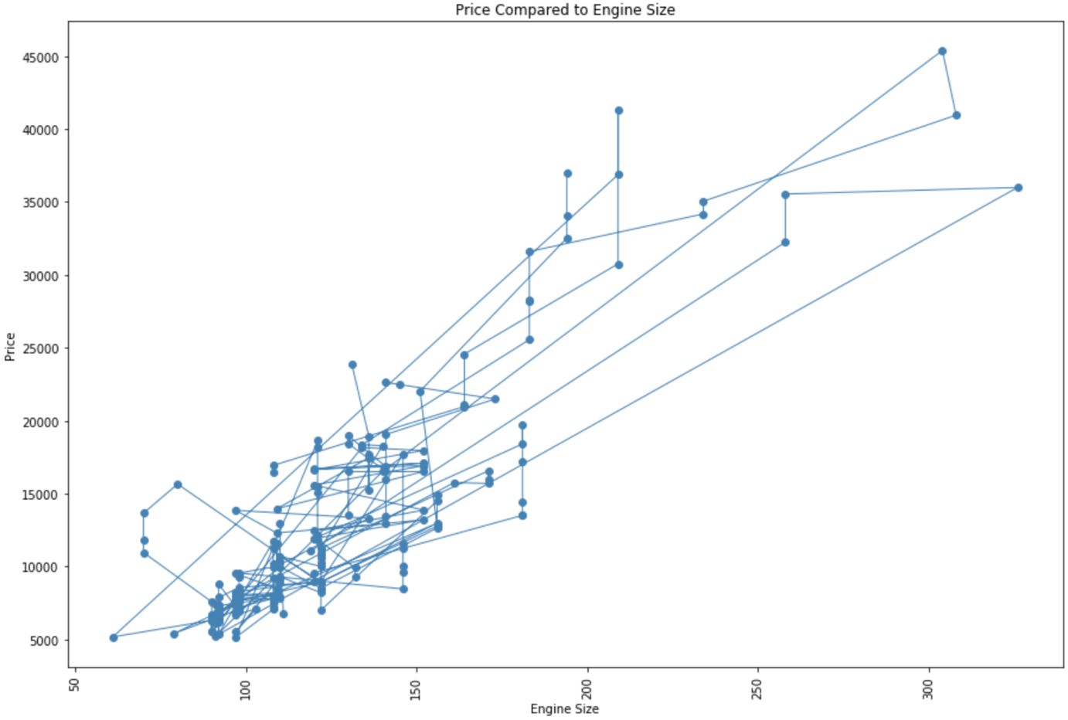
Figure 3: Automobile Price Compared to Engine Size
The line graph demonstrates the effect that engine size has on the price of an automobile. While the data appears to be all over the place, there is a trend as the data appears to be shaped from bottom-left to top-right. This means that engine size does play a role in the price of an automobile, with the two values being just about proportionate. Someone with little to spend on a vehicle would look at smaller engine sizes.

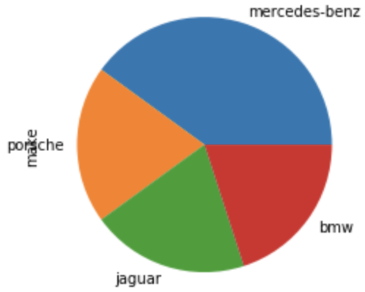
Figure 4: Makes of the Top 10 Most Expensive Automobiles
The pie chart above demonstrates the makes of the top 10 most expensive automobiles in the data set. It is clear that Mercedes-Benz appears the most in the top 10 most expensive automobiles, followed by Porsche, Jaguar and BMW. These makes would be desirable to a well-off individual, but perhaps avoided by those with a tight budget.

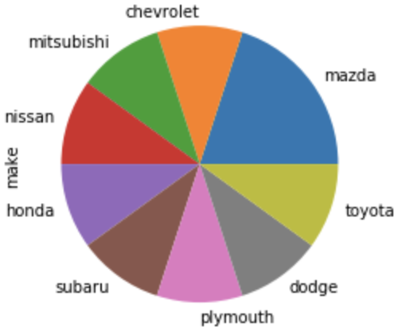
Figure 5: Makes of the Top 10 Cheapest Automobiles
The second pie chart demonstrates the makes of the top 10 cheapest automobiles in the data set. Mazda appears the most in the top 10 cheapest automobiles, followed by Nissan, Honda, Toyota, Chevrolet, Mitsubishi, Dodge, Plymouth and Subaru. Not only will these cars be more desirable to those with tighter budgets, but these cars can also be considered when supplying developing countries. An interesting observation from the two pie charts above is the difference in variety between the most expensive and cheapest automobiles. There is more variety in cheaper automobiles than very expensive ones.

In conclusion, there are many factors that affect the price of an automobile. These include, but are not limited to, body style, engine size and make. The cheapest automobile would be a hatchback, have as small an engine as possible, and perhaps be one of the nine makes demonstrated in Figure 5. The most expensive automobile would be a hardtop or convertible, have a bigger engine, and be one of the four makes demonstrated in Figure 4. This should be considered when shopping for a car within your budget.

THIS REPORT WAS WRITTEN BY: Kaylyn Van As

