

TASK
Exploratory Data Analysis on the Novel Coronavirus 2019 Data Set



Introduction
Coronaviruses are a family of viruses, with COVID-19 being the latest coronavirus discovered after an outbreak in many countries around the world. (World Health Organization, 2020) The Novel Coronavirus 2019 data set used in this report is a record of confirmed Novel Coronavirus 2019 (COVID-19) cases in the world accumulated from 22 January 2020 to 20 February 2020. By exploring this data, we can identify where the outbreak started, where it has spread to, which locations are affected the most, and the rate at which total confirmed cases are increasing.

DATA CLEANING
In order to prepare the data for its use in visualizations, I added a column titled “geometry” in order to create coordinates for use of the GeoPandas library using the latitude and longitude data in the columns “Lat” and “Long” respectively. The locations of confirmed cases of COVID-19 were then plotted on a world map. “Lat” and “Long” were both removed afterwards by implementing pandas library’s drop function, as they were of no further use. The groupby function of pandas was used to group the data by “Country/Region” in order to get the total number of confirmed cases of COVID-19 on 2/20/20 per country/region. This data was plotted onto a simple horizontal bar graph in order to visually compare the total number of confirmed cases per country/region. A new data frame was then created using the first 31 rows of the data set, cases in Mainland China which was identified as an area of concern. This was plotted on a pie chart in order to compare the total number of confirmed cases on 2/20/20 in each “Province/Region” in Mainland China. Another data frame was created from the 31st row to the last row, cases in the rest of the world excluding Mainland China. A word cloud was created using “Country/Region” to see which countries have the highest distribution of confirmed cases of COVID-19. The sum of confirmed cases in Mainland China each day was calculated, as well as the sum of confirmed cases in the rest of the world, and both were plotted onto a line graph in order to compare the rate of confirmed cases of COVID-19 in Mainland China and the rest of the world.

MISSING DATA
Missing values were detected using pandas library’s isnull function. The “Province/State” column was the only column with missing values, specifically 23 missing values. I made the decision to fill these values with the string, “Unknown”, as the “Country/Region” column could still be used to find locations. Additionally, I noticed that there were no missing values for “Province/State” where the “Country/Region” is “Mainland China”, which plays an extremely important and useful role in this analysis.

DATA STORIES AND VISUALIZATIONS

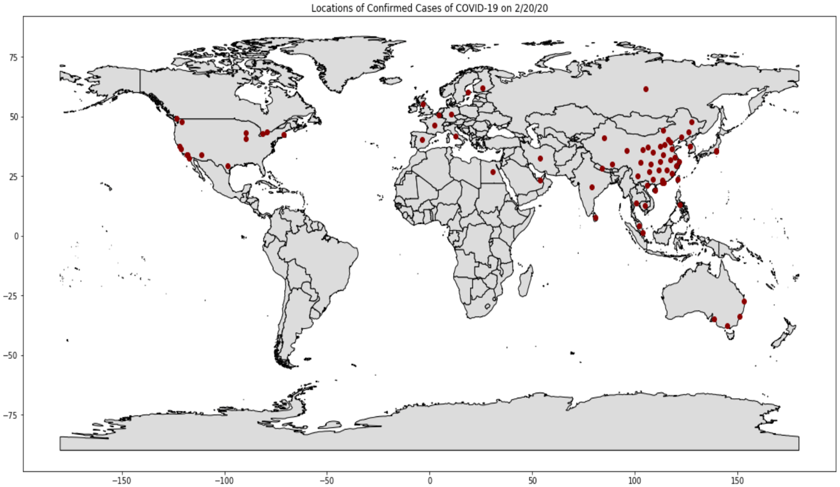
Figure 1: Locations of Confirmed Cases of COVID-19 on 2/20/20
By 20 February 2020, confirmed cases of COVID-19 were present in many countries around the world. From the visualization above, which includes the exact locations of confirmed cases of COVID-19 plotted as a dark red dot, it is clear that there were a higher number of locations in Asia than any other continent, with Europe and North America following. While every location and case is important, attention needs to be given to these continents in order to find out more about the origin of COVID-19 outbreak.
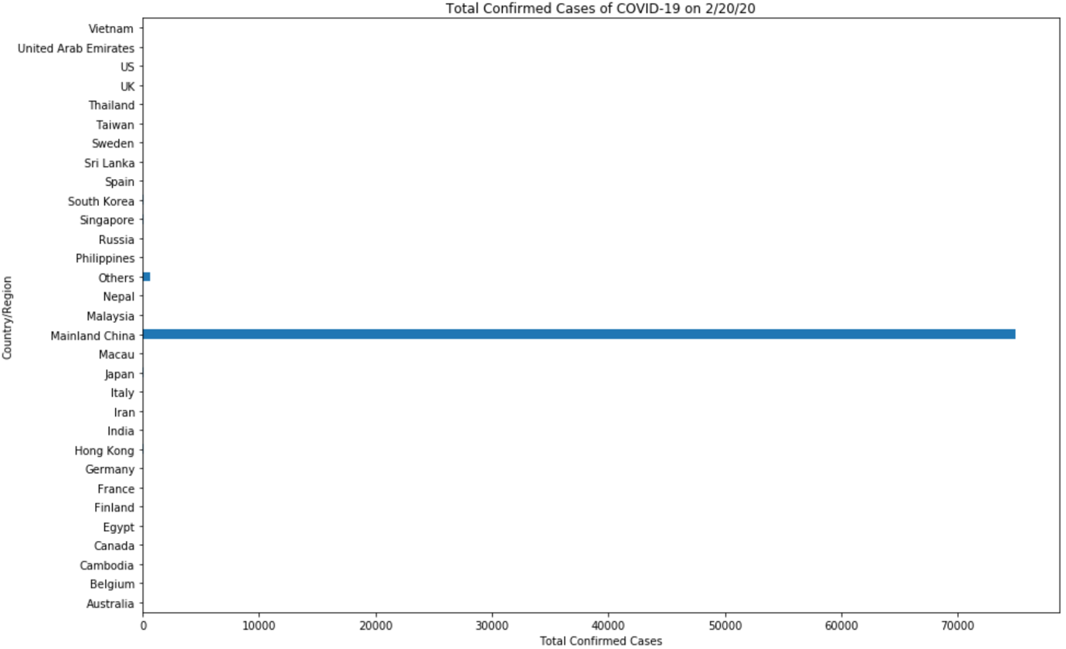
Figure 2: Total Confirmed Cases of COVID-19 on 2/20/20
The bar graph above shows us that the number of confirmed cases of COVID-19 in Mainland China on 20 February 2020 is significantly higher than any other country or region. The second highest bar, “Others”, refers to the Diamond Princess cruise ship, where an infected guest from Hong Kong tested positive for COVID-19 on 1 February 2020, six days after leaving the ship. On 4 February 2020, a statement was released confirming cases of COVID-19 on Diamond Princess. (Princess Cruises, 2020) From this visualization, it can be assumed that the COVID-19 outbreak began in Mainland China and that this is the area that is of most concern. Mainland China can now be analysed in more detail.
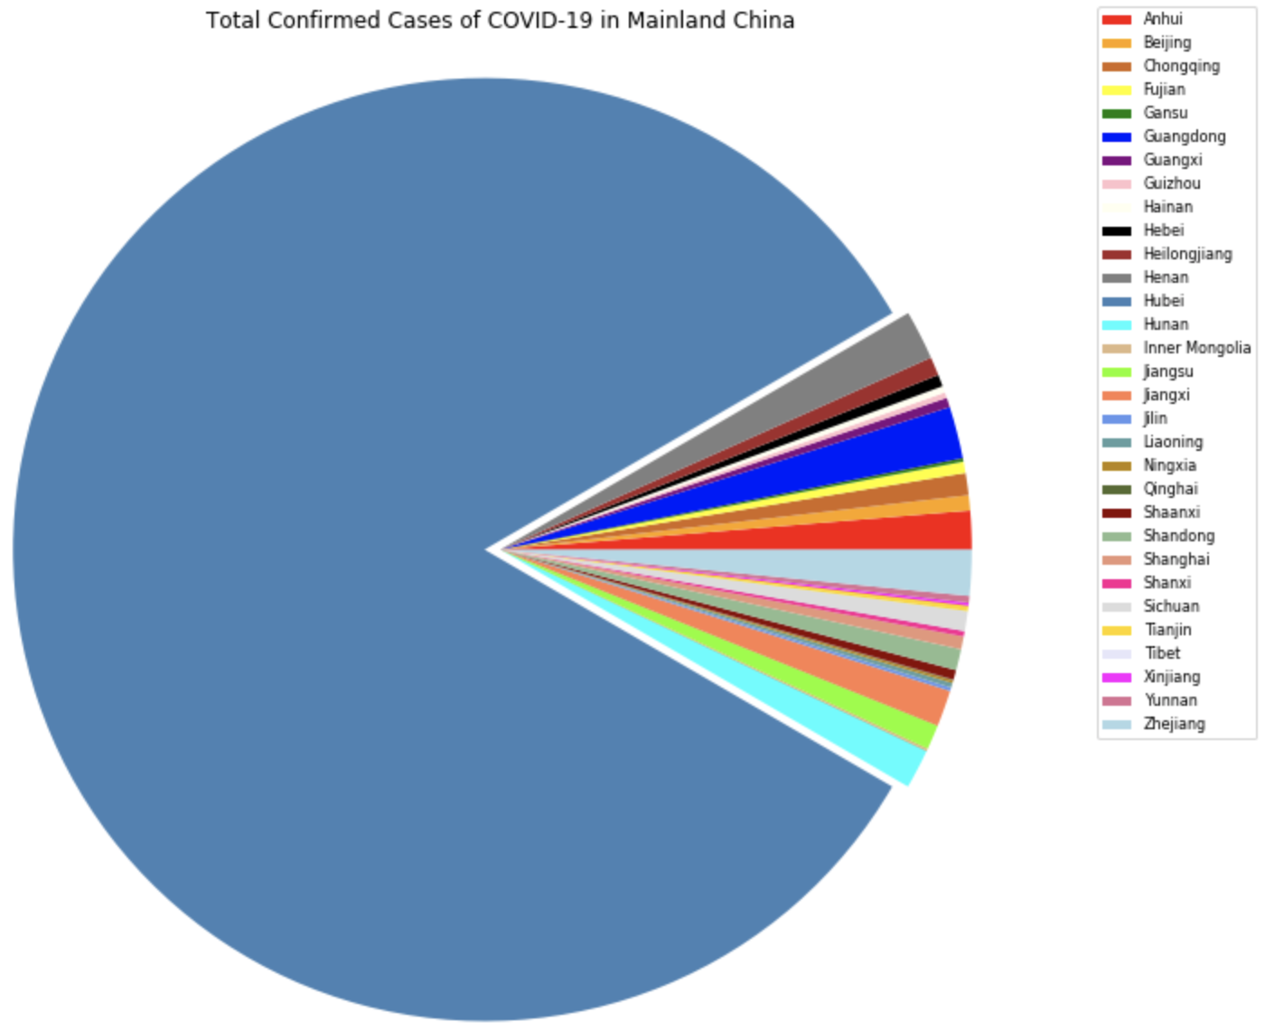
Figure 3: Total Confirmed Cases of COVID-19 in Mainland China
The pie chart demonstrates the total confirmed cases of COVID-19 in Mainland China’s 30 provinces.
It is clear that the number of cases is significantly higher in Hubei than any other province in Mainland China. With this information, it can be assumed that the COVID-19 outbreak must have originated in the Hubei province and spread to its neighbouring provinces, Hunan, Henan, Anhui, Jianxi and further. Authorities can use this information when sending medical supplies and other forms of relief.
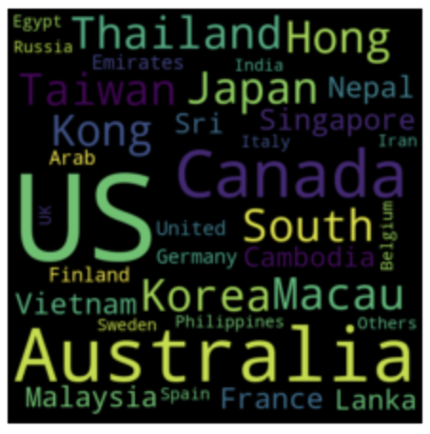
Figure 4: Distribution of Confirmed Cases of COVID-19 in the Rest of the World
The word cloud above demonstrates which countries or regions, excluding Mainland China, have the highest distribution confirmed cases of COVID-19. The US, Australia and Canada are three countries that stand out in this visualization, followed by South Korea, Thailand, Macau and Japan. However, this does not mean that these countries have the highest number of confirmed cases. It simply means that the cases are present in more provinces or states. This can be a cause for concern as the virus is not confined to a small area of these countries, possibly making it more difficult to contain.

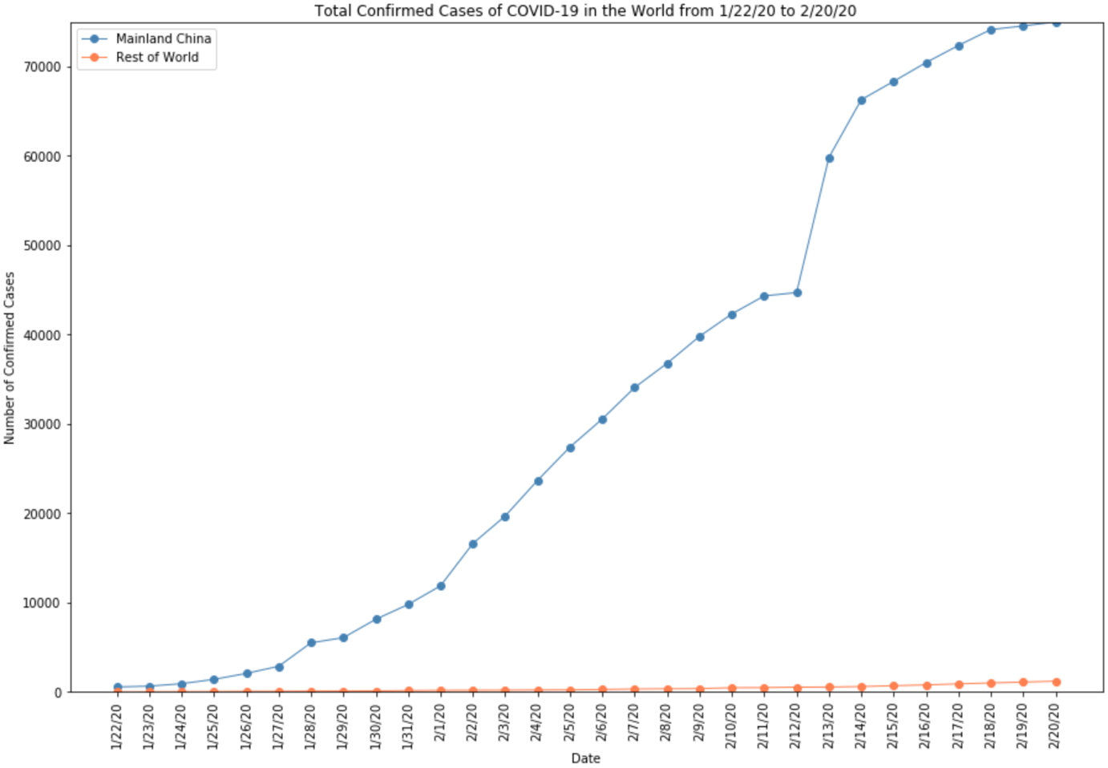
Figure 5: Total Confirmed Cases of COVID-19 in the World from 1/22/20 to 2/20/20
Confirmed cases of COVID-19 have increased from 22 January 2020 to 20 February 2020, especially towards the end of February for the rest of the world. A big leap in confirmed cases in Mainland China is visible from 12 February 2020. This visualization makes it clear that COVID-19 is currently a far greater risk in Mainland China than the rest of the world. However, from the rate that it is increasing COVID-19 can become a risk to the rest of the world if it is not controlled, especially in developing countries that are not prepared.

In conclusion, the visualizations show us that the COVID-19 outbreak originated in the Hubei province in Mainland China. It has since spread to other parts of China, as well as other countries in the world. However, the number of confirmed cases in Mainland China is increasing at a far more rapid rate than the rest of the world and is a cause for concern.

THIS REPORT WAS WRITTEN BY: Kaylyn Van As

