## Digital Playground for the online public

## Vis-IT York project

## Eirini Kaymenaki, S1793318

## Word Count: 1221

## Introduction

In this project, I have used digital technologies to visually represent publicly-available datasets related to the city of York in North Yorkshire, England. York is a relatively small city with a population of about 200K, but with a very strong historical background. It is a popular tourist destination, mainly for its history during the medieval period. However, over the last few years, York has been growing increasingly and attracts students and professionals who are seeking personal, academic and professional development.

I have split the process of developing this project into four stages

1. building the idea and the concept;
2. designing wireframes and mock ups;
3. conducting research and gathering data;
4. building the page and add interactivity.

In this project the exploratory method has been used to visualise the collected data. This method is typically used to reveal patterns, trends and issues in a set of data (Andrienko & Andrienko, 2001). As illustrated in figure 1, this was an iterative process. In each iteration, a new dataset was collected, appropriate techniques for visualising it were selected and applied, interactivity was added, and the result was assessed for effectiveness.

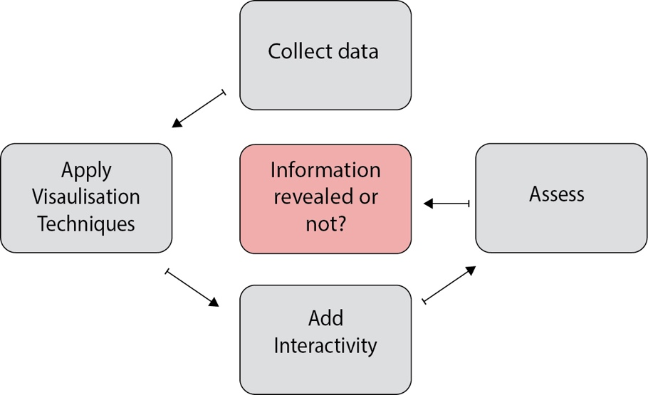

Figure 1: Exploratory method overview

## Visual Analysis and Design

Visualisation can help to alleviate the problem of information overload by taking advantage of the powerful human perceptual system that is extremely efficient in processing visual input to make sense of data, explore complex information spaces, or spot patterns and relationships. It is an interdisciplinary field that is commonly defined as the “use of computer-supported, interactive, visual representations of data to amplify cognition” (Card, Mackinlay, & Shneiderman, 1999).

Based on Tufte’s (Tufte, 1983) graphical excellence principles, all the data visualisation displays should show the data, induce the viewer to think about the substance rather than about methodology, graphic design, or the technology of graphic production, be accurate and avoid distorting what the data has to say. Also, they should encourage the eye to compare different pieces of data, reveal the data at several levels of details - from a broad overview to the fine structure - and serve a reasonably clear purpose such as description, exploration, tabulation or decoration. The following data visualisation techniques have been used in the project:

* **Spatial visualisation** includes techniques that visualise topological, or geographic properties (interactive maps).
* **Graph/chart-based** techniques visualize large data sets to convey their meaning and highlights clearly and efficiently. (Ahlberg & Wistrand, 1995)
* With **dynamic techniques**, the user dynamically interacts with the visualisation of the data for a more effective exploration of the data. Dynamic techniques include dynamic projections, dynamic linking and brushing, dynamic environment, dynamic zooming, dynamic detail on demand, and dynamic data-to-visualisation mapping. (Keim & Kriegel, 1995).

The first mock up I created for this project is not far from the final prototype. As illustrated in figure 2, the first mock up consisted of a header that holds menu bars and logos, a body for a map containing places of interest, charts and text, and a footer for further information and copyright. While building this mock up I realised that the volume of data would be overwhelming and the pointers on the map thousands which would make the map hard to be read and not user friendly. Therefore, I took the decision to reduce the number of categories of points of interest to display on the map and switch to a modern and engaging layout with less content as illustrated on the screenshot (figure 3). The second mock up, like the first one, consists of a header with a title and logo, a body with the main text and a footer with copyrights. I have chosen a parallax style with motion in the background while scrolling to make the user experience more interesting.

For the map, I collected data from the official [York Council database](https://www.yorkopendata.org/), and after collecting all the categories with geo properties (longitude and latitude), I excluded those that visitors would be less interested in (ex. traffic lights). Then, I put all the data in a structured XML file and checked all properties and especially geo properties to be accurate and provide correct information. Regarding charts, I have used single and double bar charts to visually provide statistics about the city of York.

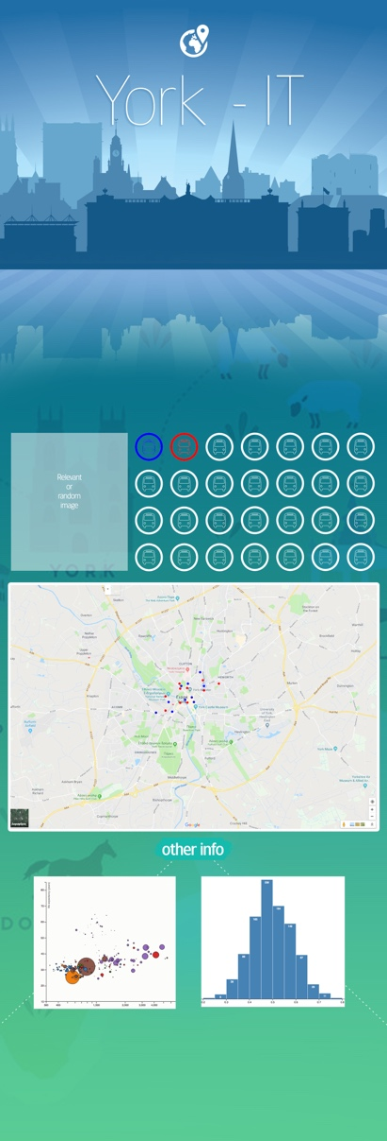 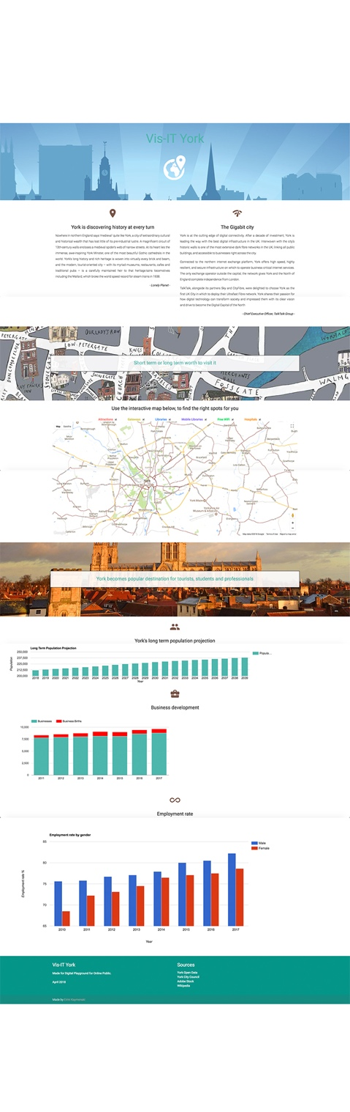

Figure 2: First mock up Figure 3: Final product

## Development

The tools that have been used in this project are divided in two categories. The design tools and the development tools. On the design side, Adobe software such as Illustrator, Photoshop, XD, has been used to create graphics, mock-ups and prototypes. Also, a parallax website template has been used, to make the page more visually interesting.

On the development side, HTML, CSS and Javascript have been used. Javascript is a cross-platform, object-based scripting language for client and server applications. Javascript lets web pages respond to events and is essential for creating interactive web sites. In addition, Google Charts, Google Maps, Google Javascript API V3 and libraries such as D3.js and jQuery are helpful tools that allow the artist to create advanced interactive digital content. In terms of creativity, all the icons, logos and assets that have been used for the interface, are original graphics that were created for this project with the exception of the large York images which were obtained from the Adobe Stock image service.

## Reflection

The main objective that I was expecting to meet in this project, was to build a functional, responsive and engaging application that would provide accurate information to its prospective users. This project challenged my technical skills. Before I started the project, I wasn’t very familiar with data visualisation techniques. Challenges that I faced while designing and developing the map included choosing an appropriate visualisation approach for the points of interest, dealing with the heterogeneity and volume of the available dataset. On the technical side of this project, because the map uses Javascript and reads the markers from a server-side XML file, I had to use a local webserver (MAMP) to run and debug my web page. The web page is accessible in full function through my [GitHub webpage](https://kaymenaki.github.io/Visit-York/parallax-template/).

## Future Work

Having gained a deeper knowledge and skills on both coding for data visualisation and designing for user interfaces for web, there are several aspects that I want to improve in future development iterations of this project. I would like to add more datasets to the web page, using various visualisation techniques and information to be revealed through more ‘call to action’ areas for the user. Also, I am considering the potential of exploring adaptive user interfaces in terms of layout, language and content based on user’s background and preferences.

**References**

2.     E. R. Tufte. The Visual Display of Quantitative Information. Graphics Press. Cheshire, CT, 1983

3.     D. A. Keim. Pixel-oriented database visualizations. SIGMOD Record, 25(4):35- :39. 1995

4.     C. Ahlberg and E. Vistrand. IVEE: An information visualization and exploration environment. In Proceedings International Symposium on Information Visualisation, Atlanta, GA, 1995

5.    Card, S., Mackinlay, J., and Shneiderman, B. (1999). Readings in Information Visualization: Using Vision to Think. Morgan Kaufmann Publishers, San Francisco, CA, USA, page 6

14.  Shneiderman, B. and Plaisant, C. (2004). Designing the User Interface: Strategies for Effective Human-Computer Interaction (4th Edition). Pearson Addison Wesley.

16.  Andrienko, G., Andrienko, N. (2001). Interactive maps for visual data exploration pages 355-374