FraudShield BI: Quantifying the Impact of False Positives in Credit Card Fraud Detection
Final Research Paper
Atta Febri-Yeboah
Colorado State University Global
MIS581 - Capstone - Business Intelligence and Data Analytics
Dr. Jamia Mills
June 28, 2026

Abstract
Credit card fraud detection requires organizations to identify suspicious transactions without creating excessive disruption for legitimate customers. This quantitative study evaluated the impact of false positives in a simulated credit card transaction dataset containing 1,296,675 training records and 555,719 testing records. The analysis compared class-weighted logistic regression with histogram-based gradient boosting and examined transaction amount, category, time, customer age, city population, customer-to-merchant distance, and gender. Because fraud represented less than 1% of the data, model performance was evaluated using precision, recall, F1-score, ROC-AUC, precision-recall AUC, confusion matrices, threshold analysis, and estimated business cost rather than accuracy alone. Gradient boosting substantially outperformed logistic regression at the 0.50 threshold, producing 163 false positives, 91.14% precision, 78.18% recall, and an F1-score of 84.17%. Threshold analysis showed that fraud capture, false-positive volume, review workload, and estimated total cost changed meaningfully as the cutoff changed. False-positive outcomes were also significantly associated with transaction amount, category, and hour. All three null hypotheses were rejected. A four-page Power BI dashboard was developed to present model performance, threshold tradeoffs, cost scenarios, and false-positive patterns in a business-readable format. The findings demonstrate that model and threshold selection should be treated as business decisions because they affect fraud losses, customer friction, manual-review workload, and operating cost.

Introduction
Credit card fraud detection has become an increasingly important issue in financial services because of the growth of digital payments, e-commerce, online banking, and mobile transactions. In my view, the challenge is not only whether an organization can stop fraud, but whether it can do so without creating unnecessary friction for legitimate customers. Financial institutions and payment providers must protect customers from fraud while also allowing valid transactions to move through with minimal disruption. This creates a practical business problem because fraud controls must balance two goals that can sometimes work against each other: detecting suspicious activity quickly and avoiding unnecessary disruption to legitimate customer activity. Fraud detection is therefore not only a technical issue; it is also a business decision-making issue that affects operations, customer experience, revenue, and trust.
This Capstone Project, FraudShield BI: Quantifying the Impact of False Positives, focuses on the business impact created when legitimate transactions are incorrectly classified as suspicious or fraudulent. A false positive occurs when a valid transaction is flagged as fraud even though the customer is acting legitimately. I chose this focus because false positives are easy to overlook when the discussion is centered only on stopping fraud. However, from a customer and operations perspective, a false positive may lead to a declined purchase, additional authentication, manual review, customer service contact, lost revenue, and lower customer confidence. Although these errors may appear to be acceptable tradeoffs in a fraud prevention system, they can create hidden costs for the organization and unnecessary frustration for customers.
The problem addressed in this study is that many fraud detection efforts focus heavily on stopping fraud but do not always measure the full cost of false positives. Overall accuracy can also be misleading because fraud datasets are usually highly imbalanced. Most transactions are legitimate, while fraudulent transactions represent a small minority. As a result, a model can appear accurate while still missing fraud or generating too many false-positive alerts. My goal is to evaluate fraud detection from both a model performance perspective and a business impact perspective, so the final project is useful to both technical analysts and business leaders.

Objectives
This study focused on creating a business intelligence framework to help identify credit card fraud and quantify the costs associated with false positives. The project went beyond evaluating whether a model could identify fraud and also examined the amount of customer friction and manual-review workload created when legitimate activity was incorrectly flagged. This mattered because a fraud model could appear successful statistically while still creating avoidable work for fraud teams and unnecessary stress for customers.
The specific objectives were to examine transaction patterns in a credit card fraud dataset, evaluate selected fraud classification models, measure false-positive outcomes, analyze how classification thresholds affected fraud detection and customer friction, estimate the False Positive Tax, and prepare dashboard-ready outputs that presented the results in business-readable terms. These objectives supported the larger purpose of the project by connecting technical model outputs to operational and customer-experience outcomes. The completed Power BI dashboard was designed to be understandable to a fraud manager or business stakeholder, not only to a data analyst.

Overview of Study
This study analyzed the Credit Card Transactions Fraud Detection Dataset provided on Kaggle. The dataset contains simulated credit card transactions generated through the Sparkov data-generation tool and includes both legitimate and fraudulent transactions made between January 1, 2019, and December 31, 2020. It contains two files: fraudTrain.csv, with 1,296,675 simulated transaction records, and fraudTest.csv, with 555,719 records. The primary response variable is is_fraud, where 0 indicates a legitimate transaction and 1 indicates a fraudulent transaction. The dataset was suitable for this study because it contains transaction-level variables that are meaningful to a typical business audience, including transaction amount, transaction category, merchant information, customer and merchant location, city population, customer occupation, gender, date of birth, transaction date and time, and the fraud label. Some fraud datasets contain mostly anonymized fields that are difficult to interpret, but this dataset supported both predictive modeling and dashboard development because the variables were more business-readable. That was important for FraudShield BI because the final output needed to explain what the model was doing in operational terms, not simply produce a technical score.
The project began with data preparation in Python. Data were checked for missing values, duplicate records, inconsistent field types, and variables requiring transformation. Exploratory data analysis then provided insight into transaction distributions, fraud rates, class imbalance, category-level patterns, and differences in transaction amounts between legitimate and fraudulent activity. After the exploratory analysis, class-weighted logistic regression and histogram-based gradient boosting models were trained and evaluated. Their outputs were used to identify false positives and examine how classification thresholds affected fraud detection, false-positive volume, manual-review workload, and estimated business cost. The final step used Power BI to translate the model results into interactive measures and visuals that business stakeholders could understand.

Research Questions and Hypotheses
The following research questions guide this Capstone Project:
RQ1: How does changing the fraud classification threshold affect the false-positive rate, fraud detection rate, and estimated False Positive Tax?
RQ2: Which transaction characteristics and model outputs are most strongly associated with false-positive fraud decisions?
RQ3: How can business intelligence dashboards and scenario analysis help decision-makers compare fraud prevention outcomes against customer friction and operational costs?
The hypotheses below are designed to test measurable relationships between fraud thresholds, transaction characteristics, model outputs, and estimated business costs. The null hypotheses state that no significant relationship or difference exists, while the alternative hypotheses state that meaningful relationships or differences exist.
Research Question | Null Hypothesis | Alternative Hypothesis | Analytical Method
RQ1 | H01: Changes in the fraud classification threshold do not significantly change the false-positive rate, fraud detection rate, or estimated False Positive Tax. | Ha1: Changes in the fraud classification threshold significantly change the false-positive rate, fraud detection rate, and estimated False Positive Tax. | Confusion-matrix comparison, threshold analysis, precision-recall analysis, manual-review volume comparison, and cost-scenario analysis.
RQ2 | H02: Transaction characteristics and model risk scores are not significantly associated with whether a legitimate transaction becomes a false positive. | Ha2: Transaction characteristics and model risk scores are significantly associated with whether a legitimate transaction becomes a false positive. | Class-weighted logistic regression, segmented false-positive analysis, chi-square tests for categorical variables, and Mann-Whitney U tests for transaction amount.
RQ3 | H03: Cost-based scenario analysis does not produce meaningful differences in estimated fraud loss, false-positive cost, manual review volume, or total expected business cost across thresholds. | Ha3: Cost-based scenario analysis produces meaningful differences in estimated fraud loss, false-positive cost, manual review volume, and total expected business cost across thresholds. | Cost-matrix modeling, sensitivity analysis across low, moderate, and high cost scenarios, and comparison of model and threshold outcomes.

Literature Review
The literature reviewed for this project demonstrates that credit card fraud detection is a complicated problem involving model performance, class imbalance, cost tradeoffs, and operational decision-making. Traditional machine learning and deep learning methods can improve fraud detection; however, class imbalance must be addressed for those models to perform effectively (Albalawi & Dardouri, 2025). Methods used to reduce the impact of class imbalance include SMOTE, hyperparameter tuning, and focal loss. This means that model performance depends not only on which model is selected, but also on how the data are prepared and evaluated. Accordingly, FraudShield BI examined the errors that matter to the business rather than relying only on aggregate accuracy.
A major theme in the literature is that traditional performance metrics can be misleading in imbalanced classification problems. According to Imani and others (2026), ROC-AUC could exaggerate how well a model works in situations where there are many more occurrences of one target than the other target (e.g. there are 10,000 instances of one target and one instance of the opposite target). Consequently, Imani et al. suggested the additional use of validation methods for models to include other measures, including Matthews correlation coefficient, F2-score, precision-recall AUC, and cost-sensitive measures. The principles used to validate a fraud detection model within this project are also supported by the existence of different business costs associated with false positive and false negative results. For example, there can be significant business costs associated with a false negative (i.e., potential loss of revenue due to fraud), but there can also be significant business costs associated with a false positive (i.e., excessive workload from manually reviewing transactions, loss of sales, customer dissatisfaction, etc.).
Additionally, the literature provides support for evaluating fraud detection models from economic and operational perspectives. A model’s predictive ability should be considered together with economic outcomes such as expected loss, savings, and the business cost of classification errors. This is important because two models may have similar statistical performance while producing very different operational and financial outcomes. Vanini et al. (2023) explored the connection between payment fraud detection and risk management and emphasized the need for organizations to detect fraud without generating excessive false alerts.
These studies support the central idea of FraudShield BI: a fraud model should be evaluated based on both fraud prevention and false-positive impact. Technical metrics are useful, but business leaders also need to understand the operational consequences of those metrics. For example, a model that catches more fraud may still be difficult to justify if it creates an excessive number of false positives and increases manual review volume. This is why the dashboard component is important. It translates model outputs into measures such as false-positive count, estimated review volume, estimated false-positive cost, and threshold tradeoffs. In that sense, the project connects predictive analytics with business intelligence and practical fraud strategy.

Research Design
This study used a quantitative research design that relied on numerical transaction data, statistical testing, machine learning model outputs, and dashboard metrics. The design was appropriate because the project focused on measuring fraud-classification outcomes, false positives, and estimated business costs.
The research used secondary simulated data rather than collecting primary data. This approach allowed the study to evaluate fraud classification, incorrect classifications, and estimated financial impact without using employer-owned records, real customer information, internal fraud rules, or confidential business processes.
The research followed a structured sequence similar to a Waterfall approach. The problem, objectives, research questions, and hypotheses were defined first. The dataset was then prepared and explored, followed by model development and evaluation, false-positive and threshold analysis, cost-scenario analysis, and development of the Power BI dashboard. This structure fit the eight-week Capstone timeline while still allowing small refinements when the analysis revealed issues that required replanning.
The primary outcome was the false-positive indicator, which identified legitimate transactions that the model incorrectly classified as fraudulent. Model outputs were expressed as predicted fraud probabilities or risk scores and were evaluated at multiple thresholds. Independent variables included transaction amount, transaction hour, customer age, city population, customer-to-merchant distance, transaction category, and gender. Business-impact measures included estimated false-positive cost, estimated fraud loss, manual-review volume, and total expected cost.

Methodology
This project used a quantitative methodology with structured transaction-level data, statistical analysis, predictive modeling, and business intelligence reporting. Because the data were simulated and secondary, they were appropriate for an academic fraud project and avoided the privacy concerns associated with real customer records. The project demonstrated how fraud-model results could support business decision-making without relying on confidential organizational information.
The technical analysis was completed in Python. Pandas and NumPy supported data cleaning, validation, feature preparation, and exploratory analysis. Scikit-learn was used to build and evaluate class-weighted logistic regression and histogram-based gradient boosting models. Logistic regression served as an interpretable baseline, while gradient boosting helped identify nonlinear patterns and interactions among the features. The data were supplied in separate training and testing files so that model performance could be evaluated on transactions the models had not already seen. Power BI was then used to organize the validated outputs into an interactive decision-support dashboard.
The methodology also included threshold and scenario analysis. Instead of relying only on the default 0.50 classification threshold, the project tested multiple thresholds to observe how false positives, false negatives, fraud capture, manual-review volume, and estimated business cost changed. Lowering the threshold made the model more aggressive, which generally caught more fraud but also created more false positives. Raising the threshold reduced false positives but allowed more fraud to pass through. The purpose of this analysis was to quantify the tradeoff between fraud prevention, customer friction, and operating cost.

Methods
The first step was data preparation. The Kaggle fraudTrain.csv and fraudTest.csv files were imported into Python and reviewed for variable types, record counts, missing values, duplicate records, and inconsistent formats. Date and time fields were transformed to create transaction-hour variables, and date of birth was used to calculate customer age. Customer and merchant latitude and longitude were used to calculate customer-to-merchant distance. Direct identifiers and high-cardinality fields that could encourage memorization, including credit card number, transaction number, customer names, street address, and merchant name, were excluded from the models.
The second step was exploratory data analysis. Descriptive statistics were calculated for transaction amount, fraud count, fraud rate, and other selected variables. Visualizations compared legitimate and fraudulent transactions by amount, category, and hour. The analysis also examined the level of class imbalance because fraudulent transactions represented only a small portion of the dataset.
The third step was model development and evaluation. Class-weighted logistic regression and histogram-based gradient boosting were trained on the training file and evaluated on the separate test file. The models were compared using accuracy, precision, recall, F1-score, ROC-AUC, precision-recall AUC, and confusion-matrix results. Accuracy was reported but was not treated as the primary measure because it can be misleading when one class is much larger than the other. Precision showed how many transactions flagged as fraud were actually fraudulent, while recall showed how many actual fraud cases were detected.
The fourth step was false-positive and threshold analysis. False positives were isolated after the models generated their predictions by identifying legitimate transactions that had been classified as fraudulent. The analysis calculated the false-positive count, false-positive rate, estimated manual-review volume, and estimated False Positive Tax. Multiple thresholds were compared to illustrate the tradeoff between preventing fraud and creating customer friction.
The fifth and final step was to develop the Power BI dashboard from the validated Python outputs. The dashboard presented model performance and business-impact measures in a form that decision-makers could understand. The completed visuals included precision, recall, F1-score, false-positive count, manual-review volume, threshold comparisons, cost scenarios, false-positive rates by category, and fraud rates by hour. The dashboard was designed to tell the story behind the numbers by showing how model decisions affected fraud prevention, customer friction, and operational workload.

Power BI Dashboard Development
The Power BI dashboard was developed after the Python analysis had been completed and the exported results had been validated. The report contains four pages: Executive Overview, Threshold Decision Lab, Cost & Recommendation, and False-Positive Deep Dive. The Executive Overview compares the two models at the 0.50 threshold. The Threshold Decision Lab allows a user to select a model and threshold and observe changes in precision, recall, F1-score, false positives, and manual-review volume. The Cost & Recommendation page compares low, moderate, and high cost assumptions and displays the recommended model and threshold. The False-Positive Deep Dive shows the transaction categories with the highest false-positive rates and the hours with the highest fraud rates.
Page navigation and reset controls were added so that the report could be used during a live presentation without requiring the user to rebuild filters. The dashboard values were compared with the Python export files before the final report was completed. This review identified and corrected an aggregation issue on the cost page, where results from two models had initially been combined. After the model filter was applied, the Power BI results matched the Python outputs. This validation step was important because a dashboard can look convincing even when a field is summarized incorrectly.

Limitations
This project has several limitations. The first limitation is that the dataset is simulated. Although simulated data is useful for academic research and avoids the use of sensitive customer information, it may not fully capture the complexity of real-world fraud patterns or customer behavior. Real fraud behavior can change quickly, and real customers may respond differently to declined transactions, verification requests, or manual reviews than a simulated dataset can show.
A second limitation was that the dataset did not include direct customer-experience measures. It did not contain customer complaints, call-center contacts, customer-satisfaction scores, abandoned purchases, lost revenue, or customer attrition. Because those measures were not available, the project used proxy measures such as false-positive count, manual-review volume, and estimated customer friction. These measures were useful for business analysis, but they could not fully represent how a real customer might feel or behave after being incorrectly flagged.
A third limitation was that the project used estimated cost assumptions rather than actual internal company cost data. In a real financial institution, the cost of a false positive could include labor, call-center handling time, lost interchange revenue, lost sales, complaints, and possible customer attrition. Because employer-owned or confidential data were not used, the cost estimates were clearly labeled as scenario assumptions rather than exact institutional costs.
A fourth limitation was the eight-week academic timeframe. The project could not test every possible model, tune every hyperparameter, or build a fully production-ready dashboard. The analysis therefore focused on a practical and explainable comparison that directly supported the research questions, while the dashboard concept prioritized decision-making value over visual complexity.
Another limitation involved how the classification thresholds and cost recommendations were evaluated. For this project, I used the test dataset that came with the Kaggle data. This approach was practical for the Capstone, but using the same data to select and evaluate a threshold can make performance and cost estimates appear slightly better than they may be in practice. In a production setting, I would use a separate validation sample to select the threshold and then confirm the final results on an untouched holdout dataset.
The false-positive cost scenarios were also based on a fixed estimated cost for each alert. This made the scenarios easier to compare, but it did not capture every possible business impact. For example, incorrectly declining a high-value legitimate transaction may create more lost-sale risk and customer frustration than reviewing a smaller purchase. Future analysis could include the value of the transaction, customer-contact expenses, and the possible long-term cost of customer dissatisfaction or attrition.
The false-positive segmentation analysis used logistic regression at the 0.70 threshold because it produced enough false positives to support meaningful comparisons across transaction categories, amounts, and times of day. These patterns should not automatically be assumed to apply in exactly the same way to gradient boosting. Future research should repeat the analysis using gradient boosting at its selected operating threshold. Although that model produced fewer false positives, the 1,173 alerts generated at the 0.10 threshold would still provide enough observations for a focused segment analysis.
Finally, gender was included as a feature in this simulated academic analysis. Before using a similar model in a real business setting, an organization should evaluate whether sensitive attributes such as gender should be removed and should compare false-positive and false-negative rates across customer groups. This would help identify possible fairness concerns and determine whether the attribute provides enough predictive value to justify its use.

Ethical Considerations
Fraud analytics involves financial transaction information that may reveal customer behavior, identifying information, and factors used to make risk decisions. Even though this project used simulated data, the same ethical concerns that apply to real financial data remained relevant. For that reason, the simulated data were treated with the level of care that would be expected if the analysis involved real customers.
Privacy was the first ethical consideration. Real transaction data can reveal where customers shop, how much they spend, where they live, and other personal behavior. If real data were used, personally identifiable information would need to be removed or protected, and the data would need to be stored securely. This study did not use employer data, internal fraud procedures, real customer records, or confidential business information. Using simulated data reduced privacy risk while still allowing meaningful analysis.
Fairness was another ethical concern. Fraud detection systems can harm legitimate customers when some transaction types or customer groups are flagged more often than others. A model that is too aggressive can create unequal customer friction based on transaction patterns, location, merchant category, or other variables. This study did not assume that the most aggressive model was automatically the best option. Instead, the analysis focused on balancing fraud prevention with the harm caused by false positives.
Transparency and responsible automation were also important. Fraud models should support decision-making, but they should not replace responsible human oversight. A dashboard can help business users understand what a model is doing, but it should not be treated as a fully automated decision system. FraudShield BI was therefore presented as a decision-support framework rather than a final production fraud system.
Together, the research design, methodology, limitations, and ethical safeguards established the foundation for interpreting the results responsibly. The following findings present the class distribution, exploratory patterns, model comparison, threshold tradeoffs, false-positive segments, cost scenarios, and decisions for each null hypothesis.

Findings
Data Preparation and Class Distribution
Fraud represented a very small portion of the training data. Of the 1,296,675 training transactions, 1,289,169 were legitimate and 7,506 were fraudulent. The fraud rate was 0.5789%. This imbalance confirmed that overall accuracy could not be used alone to judge model performance. A model that classified every transaction as legitimate would appear highly accurate while failing to identify any fraud. Therefore, the analysis emphasized precision, recall, F1-score, ROC-AUC, precision-recall AUC, confusion-matrix outcomes, and estimated business costs.
Figure 1
Distribution of Legitimate and Fraudulent Transactions
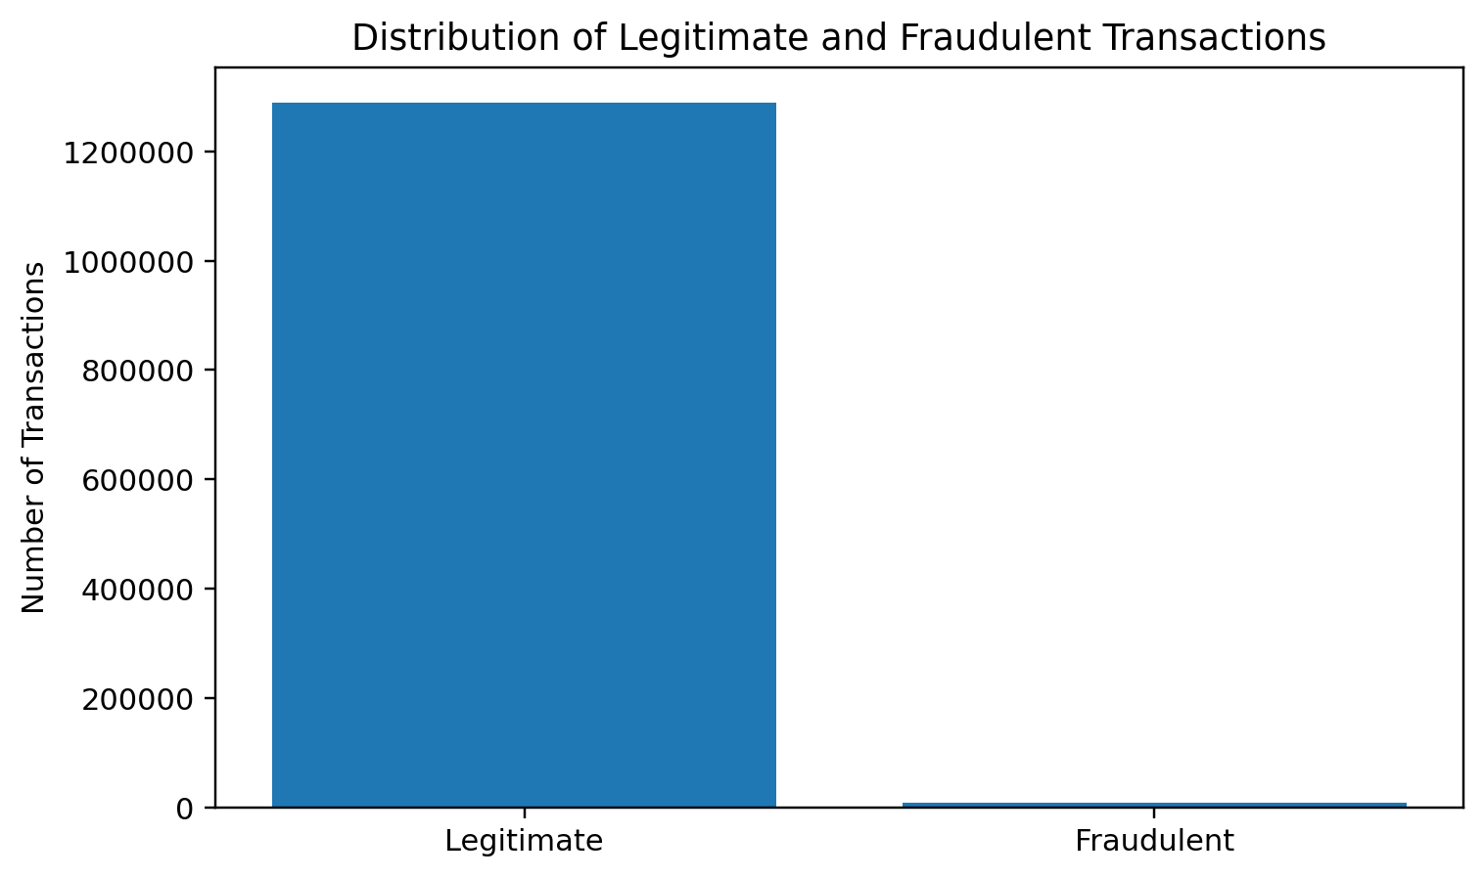
Exploratory Data Analysis
Transaction amount differed substantially between legitimate and fraudulent activity. Legitimate transactions had a mean amount of $67.67 and a median amount of $47.28. Fraudulent transactions had a mean amount of $531.32 and a median amount of $396.51. A Mann-Whitney U test showed that the distributions were significantly different, p < .001. This result indicated that transaction amount was related to fraud status in the simulated dataset, although the finding should be interpreted as an association rather than proof that high amounts cause fraud.
Fraud rates also varied by transaction category. The highest rates occurred in online shopping (1.7561%), miscellaneous online transactions (1.4458%), grocery point-of-sale transactions (1.4098%), shopping point-of-sale transactions (0.7225%), and gas or transportation transactions (0.4694%). A chi-square test found a significant association between transaction category and fraud classification, χ²(13) = 6,486.00, p < .001.
Time of day was also associated with fraud. The highest fraud rates occurred at 10:00 p.m. (2.8829%) and 11:00 p.m. (2.8738%). Fraud rates between midnight and 3:00 a.m. ranged from approximately 1.42% to 1.53%, while most daytime hours were near 0.09% to 0.14%. The association between transaction hour and fraud classification was statistically significant, χ²(23) = 18,243.56, p < .001. Figure 2 shows the sharp late-night increase.
Figure 2
Fraud Rate by Transaction Hour
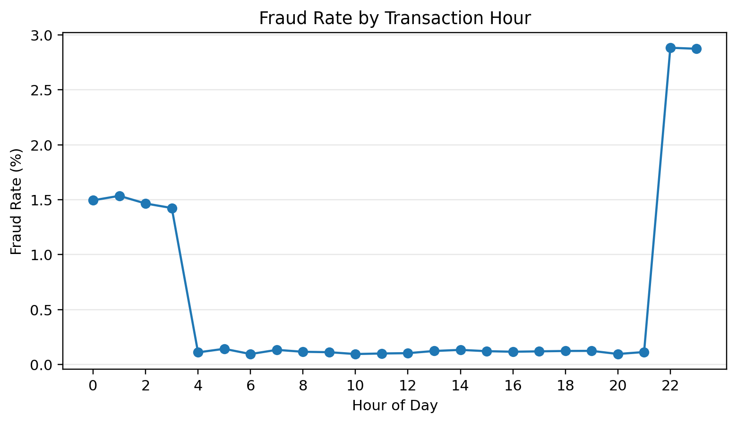
Model Development and Performance
Two classification models were trained on the 1,296,675-record training file and evaluated on the separate 555,719-record test file. The predictors were transaction amount, transaction hour, customer age, city population, customer-to-merchant distance, transaction category, and gender. Credit card number, transaction number, names, street address, and merchant name were excluded to reduce the risk of identification or memorization. The logistic regression model used balanced class weights so that the rare fraud observations had greater influence during training.
At the default 0.50 threshold, logistic regression produced 486,370 true negatives, 67,204 false positives, 556 false negatives, and 1,589 true positives. Accuracy was 87.81%, precision was 2.31%, recall was 74.08%, F1-score was 4.48%, ROC-AUC was 90.77%, and precision-recall AUC was 12.06%. Although the ROC-AUC suggested good general discrimination, the very low precision showed that most alerts were false positives. The model would have created 68,793 reviews at the 0.50 threshold, but only 1,589 of those alerts represented actual fraud.
Histogram-based gradient boosting performed substantially better. At the 0.50 threshold, it produced 553,411 true negatives, 163 false positives, 468 false negatives, and 1,677 true positives. Accuracy was 99.89%, precision was 91.14%, recall was 78.18%, F1-score was 84.17%, ROC-AUC was 99.72%, and precision-recall AUC was 89.09%. Compared with logistic regression, gradient boosting detected 88 additional fraudulent transactions while reducing false positives by 67,041. Figure 3 shows that the largest improvements occurred in precision, F1-score, and precision-recall AUC.
Figure 3
Model Performance Comparison at the 0.50 Threshold
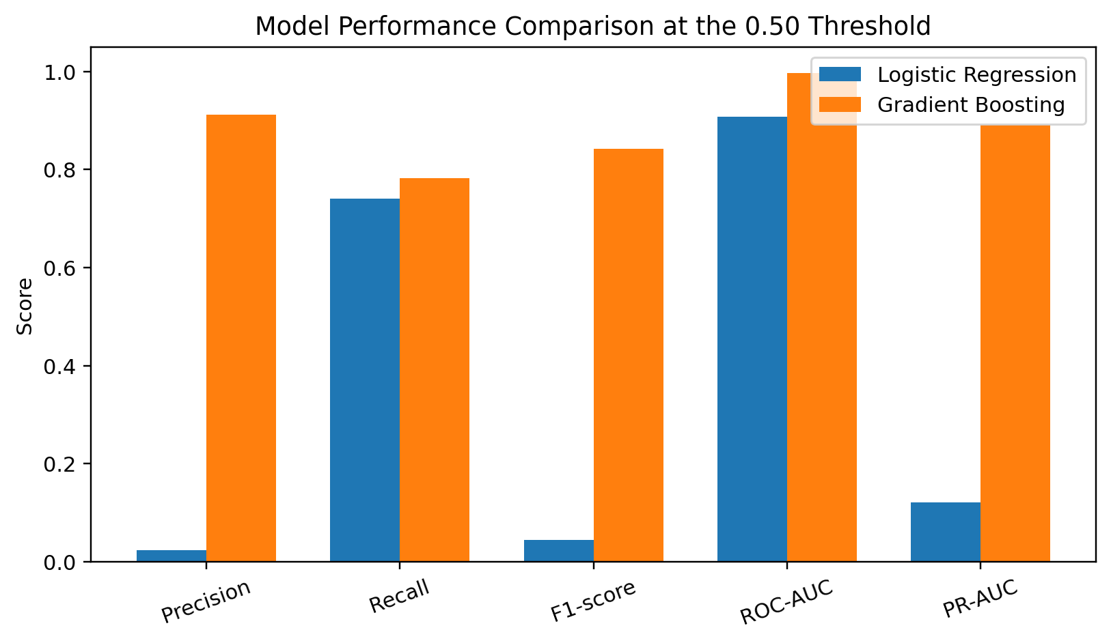
Table 1
Model Performance at the 0.50 Threshold
Model | False Positives | False Negatives | Precision | Recall | F1 | PR-AUC
Logistic regression | 67,204 | 556 | 2.31% | 74.08% | 4.48% | 12.06%
Gradient boosting | 163 | 468 | 91.14% | 78.18% | 84.17% | 89.09%
Threshold Analysis
Threshold analysis demonstrated that model performance depended on the cutoff used to convert a risk score into a fraud classification. For logistic regression, raising the threshold from 0.50 to 0.70 reduced false positives from 67,204 to 10,062 and reduced manual-review volume from 68,793 to 11,608. True positives declined only from 1,589 to 1,546, while false negatives increased from 556 to 599. Therefore, more than 57,000 unnecessary alerts were removed at the cost of detecting 43 fewer fraudulent transactions.
Gradient boosting separated fraudulent and legitimate transactions more effectively. At a threshold of 0.10, it detected 1,887 fraudulent transactions, missed 258, and produced 1,173 false positives. Its highest F1-score occurred near 0.40, while the 0.50 threshold retained 78.18% recall with only 163 false positives. These results show that thresholds must be validated separately for each model.
False-Positive Analysis
The logistic regression model at the selected 0.70 threshold was used to examine which legitimate transactions were most likely to be incorrectly flagged. The test data contained 10,062 false positives, representing 1.8176% of legitimate transactions. Correctly approved legitimate transactions had a mean amount of $57.00 and a median of $45.91. False-positive transactions had a mean amount of $640.94 and a median of $460.51. A Mann-Whitney U test found a significant difference between the two amount distributions, p < .001.
Transaction category was significantly associated with false-positive status, χ²(13) = 21,727.11, p < .001. Travel transactions had the highest false-positive rate at 13.02%, followed by miscellaneous point-of-sale transactions at 7.22%. Shopping point-of-sale, grocery point-of-sale, miscellaneous online, and online-shopping categories had false-positive rates of approximately 2% to 2.33%. The travel result is operationally important because customers may be especially dependent on card access while away from home.
Transaction hour was also associated with false-positive status, χ²(23) = 791.85, p < .001. The highest hourly false-positive rates occurred at 11:00 a.m. (2.83%), 10:00 a.m. (2.57%), 11:00 p.m. (2.46%), and 10:00 p.m. (2.30%). These patterns did not perfectly match the actual fraud pattern, which was concentrated late at night. This difference suggests that a model may identify genuine fraud patterns while still creating customer friction in other segments.
Figure 4
Highest False-Positive Rates by Transaction Category
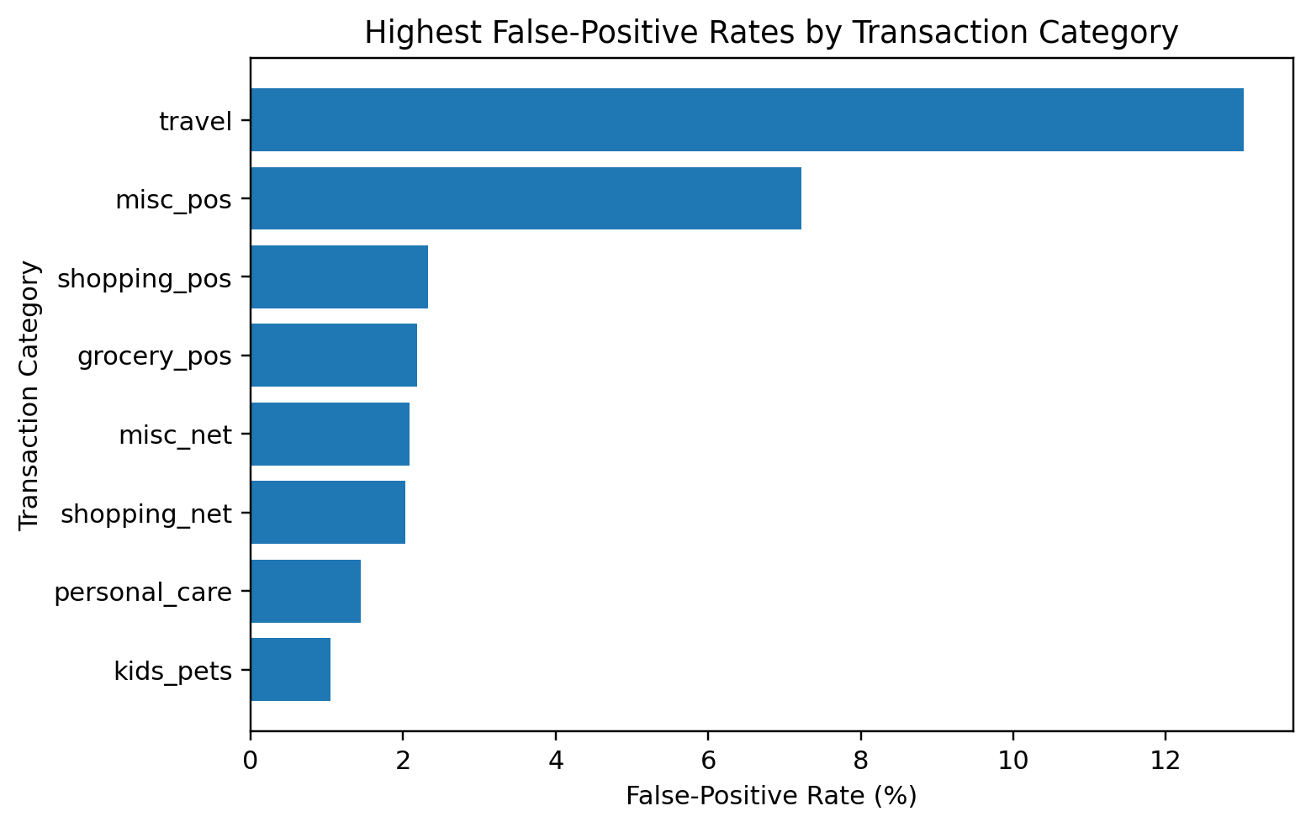
Cost and Scenario Analysis
The cost analysis assigned assumed false-positive costs of $5, $15, and $30 under low, moderate, and high scenarios. False-negative cost was based on the dollar value of missed fraudulent transactions multiplied by 1.0, 1.5, or 2.0 to represent additional investigation, chargeback, and reimbursement costs. These values were scenario assumptions rather than actual institutional expenses.
For logistic regression, the lowest-cost threshold was 0.70 in the low- and moderate-cost scenarios and 0.80 in the high-cost scenario. The estimated minimum costs were $82,365.03, $199,012.55, and $360,435.34. For gradient boosting, a threshold of 0.10 produced the lowest estimated cost in all three scenarios: $56,396.52, $93,392.28, and $136,253.04. The lower threshold was favored because gradient boosting caught substantially more fraud without creating the extreme false-positive volume observed for logistic regression.
Gradient boosting had the lower estimated total cost in every scenario. However, the threshold that minimized estimated cost was not necessarily the threshold with the best F1-score or the fewest reviews. The cost-minimizing result therefore should be considered alongside operational workload and customer impact.
Figure 5
Lowest Estimated Total Cost by Model and Scenario
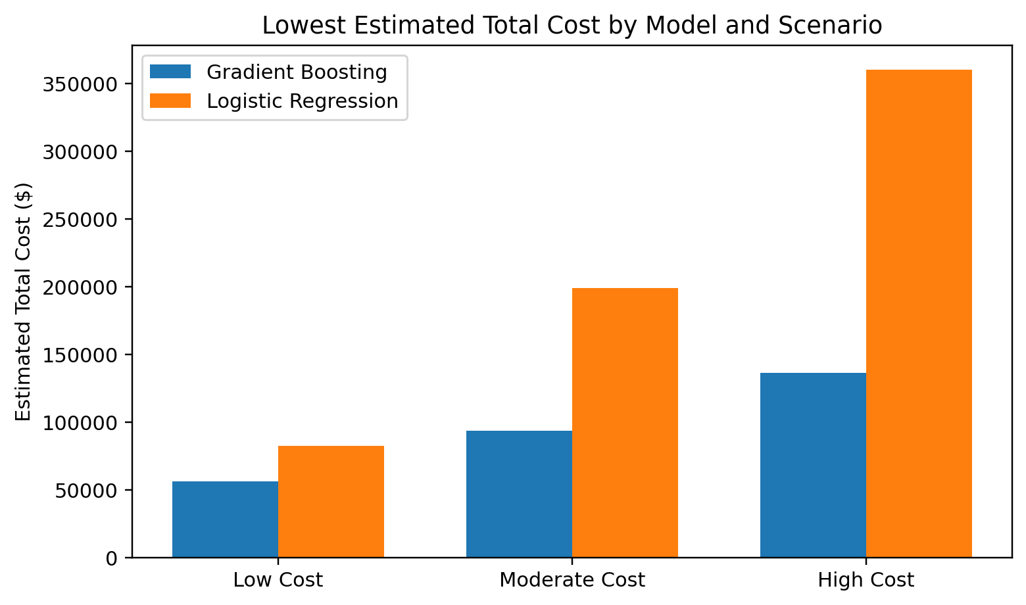
Power BI Dashboard Results
The completed dashboard converted the technical results into an interactive business decision tool. The Executive Overview showed the substantial performance difference between gradient boosting and logistic regression. The Threshold Decision Lab demonstrated that the preferred cutoff depended on whether the priority was precision, recall, F1-score, review volume, or cost. Under the moderate-cost scenario, the validated recommendation was gradient boosting at a threshold of 0.10, with an estimated total cost of $93,392.28, 1,173 false positives, 258 false negatives, and $50,531.52 in missed fraud. The dashboard also highlighted travel as the category with the highest false-positive rate and showed that actual fraud rates increased sharply during late-night hours.
Figure 6
FraudShield BI Executive Overview
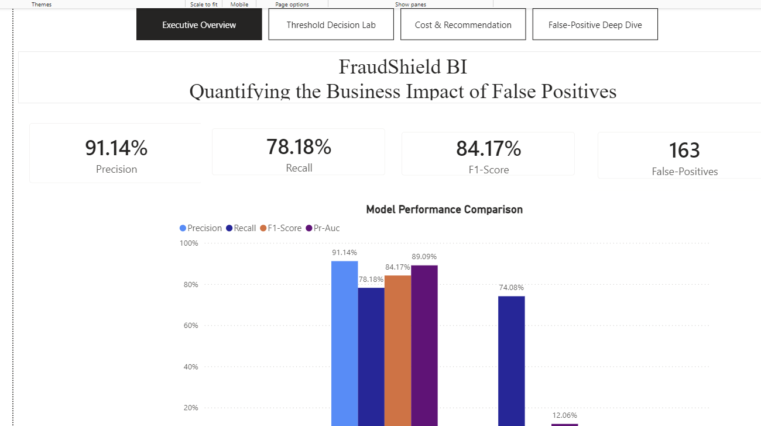
Hypothesis Decisions
H01 stated that changes in the fraud classification threshold would not significantly change the false-positive rate, fraud detection rate, or estimated False Positive Tax. The threshold analysis produced large changes in false positives, false negatives, recall, manual-review volume, and estimated total cost. Therefore, H01 was rejected. This finding indicates that threshold selection is a meaningful business decision rather than a minor technical setting.
H02 stated that transaction characteristics and model risk scores would not be significantly associated with whether a legitimate transaction became a false positive. Transaction amount differed significantly between false positives and correctly approved transactions, p < .001. Transaction category and transaction hour were also significantly associated with false-positive status. Therefore, H02 was rejected. These results indicate that false-positive burden is concentrated in identifiable transaction segments, although the analysis does not establish causation.
H03 stated that cost-based scenario analysis would not produce meaningful differences in estimated fraud loss, false-positive cost, manual-review volume, or total expected business cost across thresholds. The lowest-cost threshold changed by model and cost scenario, and gradient boosting produced a lower estimated total cost than logistic regression in every scenario. Therefore, H03 was rejected. The result demonstrates that a model or threshold that appears strongest according to one statistical metric may not produce the best estimated business outcome.
Table 2
Summary of Null-Hypothesis Decisions
Null Hypothesis | Primary Evidence | Decision
H01: Threshold changes do not affect outcomes. | Large changes in false positives, fraud capture, review volume, and cost. | Reject H01
H02: Transaction characteristics are not associated with false positives. | Amount p < .001; category χ²(13) = 21,727.11; hour χ²(23) = 791.85. | Reject H02
H03: Cost scenarios do not produce meaningful differences. | Lowest-cost thresholds and estimated costs varied by model and scenario. | Reject H03

Conclusion
This study examined credit card fraud detection from both a technical and a business perspective. The results confirmed that severe class imbalance can make surface-level accuracy misleading and that false positives must be evaluated alongside fraud detection. Logistic regression provided an interpretable baseline, but its low precision created an unacceptable number of false alerts at the default threshold. Raising its threshold reduced the false-positive burden substantially, demonstrating the importance of threshold management.
Gradient boosting was clearly the stronger model for this simulated dataset. At the 0.50 threshold, it achieved 91.14% precision and 78.18% recall while producing only 163 false positives. It also generated a lower estimated total cost than logistic regression under every cost scenario. The analysis showed that model choice and threshold choice are closely connected: logistic regression required a higher threshold to control false positives, while gradient boosting could use a lower threshold to capture more fraud without overwhelming the review process. The Power BI dashboard made these tradeoffs visible and allowed the results to be reviewed from both a technical and an operational perspective.

Recommendations
First, organizations should evaluate multiple models before selecting a fraud detection approach. For this dataset, gradient boosting substantially outperformed class-weighted logistic regression in precision, F1-score, precision-recall AUC, false-positive volume, and estimated total cost. Logistic regression may still be useful as an interpretable benchmark, but it should not be selected solely because it is simpler to explain.
Second, fraud thresholds should be selected through scenario analysis rather than automatically accepting a default cutoff of 0.50. Decision-makers should compare fraud capture, false-positive volume, false-negative losses, manual-review workload, and customer friction. The analysis should be repeated when organizational costs or risk tolerance change because the preferred threshold may also change.
Third, false-positive monitoring should be segmented by transaction amount, category, time, geography, and other relevant customer-behavior measures. The unusually high false-positive rate for legitimate travel transactions suggests that a production system should use travel context, customer notification, or step-up authentication instead of immediately declining all high-risk travel purchases. Borderline transactions may be routed to manual review or customer confirmation rather than being automatically rejected.
Finally, the model should be validated on real institutional data, later time periods, and previously unseen customers before operational use. Performance should be monitored for concept drift and fairness. FraudShield BI should support managerial judgment rather than replace responsible human oversight.

References
Albalawi, T., & Dardouri, S. (2025). Enhancing credit card fraud detection using traditional and deep learning models with class imbalance mitigation. Frontiers in Artificial Intelligence, 8, Article 1643292.
Federal Trade Commission. (2024). Consumer Sentinel Network data book 2023. https://www.ftc.gov/reports/consumer-sentinel-network-data-book-2023
Imani, M., Joudaki, M., Bagheri, A., & Arabnia, H. R. (2026). Why ROC-AUC is misleading for highly imbalanced data: In-depth evaluation of MCC, F2-score, H-measure, and AUC-based metrics across diverse classifiers. Technologies, 14(1), Article 54. https://doi.org/10.3390/technologies14010054
Kaggle. (n.d.). Credit card transactions fraud detection dataset. https://www.kaggle.com/datasets/kartik2112/fraud-detection
Khalid, A. R., Owoh, N., Uthmani, O., Ashawa, M., Osamor, J., & Adejoh, J. (2024). Enhancing credit card fraud detection: An ensemble machine learning approach. Big Data and Cognitive Computing, 8(1), Article 6. https://doi.org/10.3390/bdcc8010006
Microsoft. (n.d.). Power BI documentation. https://learn.microsoft.com/en-us/power-bi/
National Institute of Standards and Technology. (2025). Digital identity guidelines (NIST Special Publication 800-63-4). U.S. Department of Commerce. https://doi.org/10.6028/NIST.SP.800-63-4
Polonsky, M. J., & Waller, D. S. (2019). Designing and managing a research project: A business student's guide (4th ed.). SAGE Publications.
Scikit-learn developers. (n.d.). Scikit-learn: Machine learning in Python. https://scikit-learn.org/stable/
Vanini, P., Rossi, S., Zvizdic, E., & Domenig, T. (2023). Online payment fraud: From anomaly detection to risk management. Financial Innovation, 9, Article 66, 1–25. https://doi.org/10.1186/s40854-023-00470-w

