Kaymon McCain

Assignment 8.2

4/25/2021

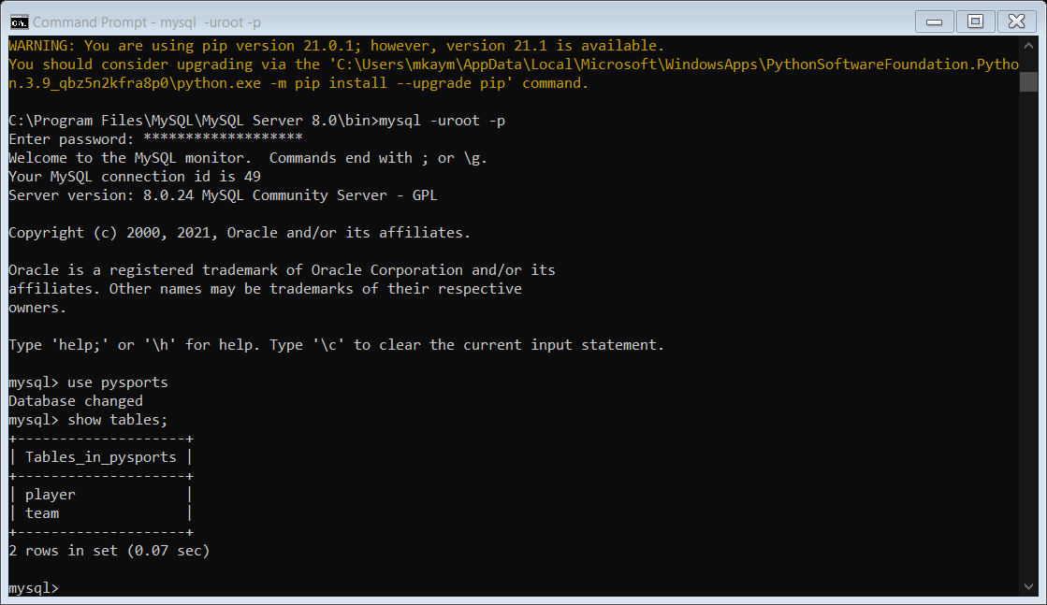

https://github.com/kaymonCodeM/csd-310.git