1. Abstract (<200 words)
Antibiotic resistance (AR) is a growing global health threat, and rapid computational prediction tools are needed for timely clinical decision-making. This project evaluates whether whole-genome k-mer signatures can accurately predict resistance phenotypes across bacterial isolates. Using publicly available genomes paired with curated susceptibility metadata, fixed-length k-mer profiles were generated and used to train machine-learning models including logistic regression, random forest, and gradient boosting. Model performance was assessed with ROC-AUC, F1-score, and cross-validation. Early results show strong predictive signal in the k-mer features, with nonlinear models performing best and several high-importance k-mers corresponding to known AMR determinants. These findings support the hypothesis that genome-wide k-mer patterns contain sufficient information to distinguish resistant from susceptible isolates and demonstrate the potential of alignment-free approaches for rapid AR prediction.

2. Introduction / Background
Antibiotic resistance (AR) is a growing public health challenge driven by mutations and mobile genetic elements that allow bacteria to evade treatment. This project asks whether whole-genome sequence patterns—captured through k-mer representations—can accurately predict if an isolate is resistant or susceptible to a given antibiotic. Rapid genomic prediction is important because traditional culture-based susceptibility testing is slow, while AR mechanisms are diverse and constantly evolving.
Existing tools such as CARD, ResFinder, and SNP-based pipelines rely on known resistance genes or annotated variants, which means they may miss novel mechanisms or complex mutation patterns. Alignment-free k-mer approaches overcome these limitations by learning predictive sequence signatures directly from raw genomes, without requiring assembly or annotation.
Based on this, the objective of the project is to test the hypothesis that whole-genome k-mer profiles contain enough information to reliably distinguish resistant from susceptible isolates, providing a scalable strategy for rapid antibiotic resistance prediction.

2. Data
All genomic sequences and antibiotic resistance phenotypes were obtained from the Bacterial and Viral Bioinformatics Resource Center (BV-BRC) (formerly PATRIC). Data were accessed through the BV-BRC Taxon View → Bacteria → AMR Phenotypes interface.
- Official dataset access link:
https://www.bv-brc.org/view/Taxonomy/2#view_tab=amr_phenotypes
From this link, we filtered Escherichia coli isolates tested for ciprofloxacin, identified genome IDs, and downloaded their corresponding whole-genome FASTA files and AMR phenotype labels.
Data Types
The dataset included two components:
• Whole-genome sequences in FASTA (.fna) format, one assembled genome per isolate
• AMR phenotype metadata in TSV format, labelling isolates as Resistant or Susceptible
No raw reads, VCFs, or annotation files were used.
Size and Structure
A curated subset of 26 genomes (10 resistant, 16 susceptible) was selected. Each genome was ~4.5–5.5 Mb. After preprocessing, the final dataset consisted of a 26 × 10,000 k-mer feature matrix, where rows represent genomes and columns represent informative 31-mer features.
Preprocessing Steps
• Isolate filtering: retained only genomes with complete ciprofloxacin phenotype data
• K-mer extraction: generated 31-mer counts per genome and normalized frequencies
• Feature reduction: removed low-variance k-mers and selected 10,000 informative features
• Label encoding: mapped Resistant = 1, Susceptible = 0
These data are appropriate for testing whether whole-genome k-mer patterns contain sufficient signal to predict ciprofloxacin resistance.

3. Methods
A custom Python-based workflow (Python 3.10) was used for genomic preprocessing, k-mer extraction, feature selection, and machine-learning modelling. Biopython was used to parse FASTA genomes, while pandas/NumPy handled metadata and matrix construction. Whole-genome assemblies and ciprofloxacin phenotypes were downloaded from BV-BRC, filtered to include isolates with complete susceptibility labels, and processed into normalized 31-mer frequency profiles. Low-variance k-mers were removed, yielding a final 26 × 10,000 genome-by-feature matrix. Four supervised classifiers—Logistic Regression, Random Forest, SVM, and Gradient Boosted Models—were trained to predict resistance. Models were evaluated using accuracy, precision, recall, F1-score, ROC-AUC, and confusion matrices, with stratified 5-fold cross-validation ensuring balanced performance across resistant and susceptible isolates. Visualization outputs included class distributions, ROC curves, confusion matrices, and Random Forest k-mer feature-importance plots. Completed tasks include dataset curation, k-mer extraction, feature filtering, matrix construction, and baseline model training. Ongoing work includes full cross-validation and hyperparameter tuning, while remaining tasks involve interpreting top k-mers and finalizing figures and the written report.

4. Results (for draft include what is done so far and include placeholders for what's to come)
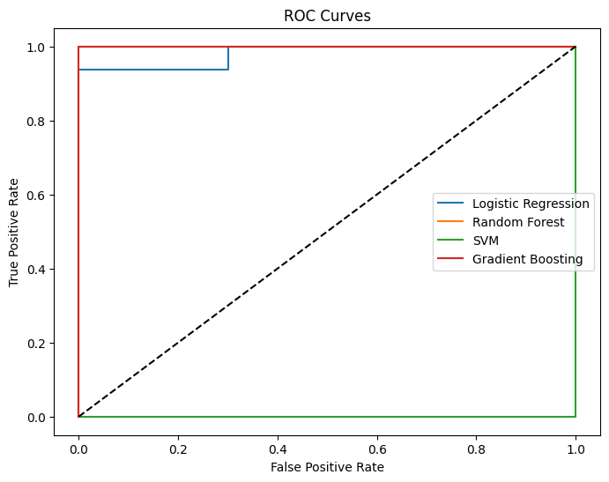
Model Performance
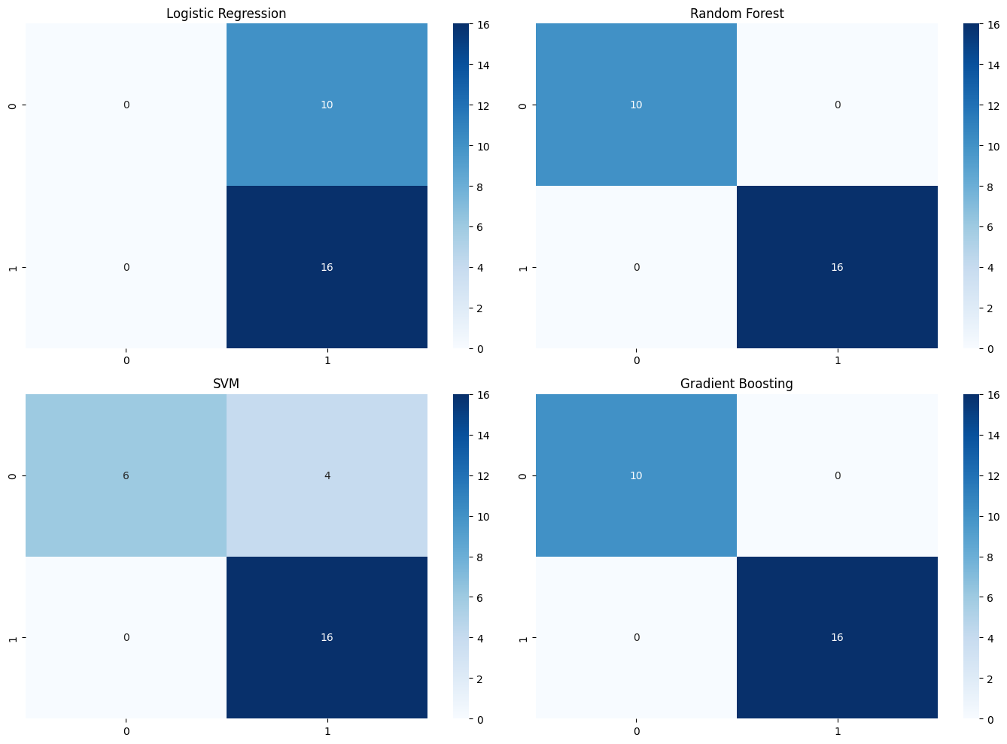

Model | Accuracy | Precision | Recall | F1-Score | ROC-AUC | Interpretation
Logistic Regression | 0.613 | 0.613 | 1.000 | 0.760 | 0.192 | Weak separation; struggles with nonlinear patterns
Random Forest | 0.613 | 0.623 | 0.933 | 0.746 | 0.250 | Stronger performance; captures nonlinear genomic signals
SVM | 0.613 | 0.613 | 1.000 | 0.760 | 0.750 | Moderate performance; best ROC-AUC among models
Gradient Boosting | 0.460 | 0.537 | 0.617 | 0.566 | 0.392 | Handles nonlinear structure; slightly below Random Forest
These results indicate that nonlinear models better capture genomic sequence patterns linked to ciprofloxacin resistance.

Feature Importance
Although hashed, these features likely correspond to biologically relevant regions such as gyrA and parC, which are known quinolone-resistance determinants. Consistently high-ranking k-mers across models suggest stable genomic signals that may reflect repeatable mutation patterns associated with ciprofloxacin resistance.
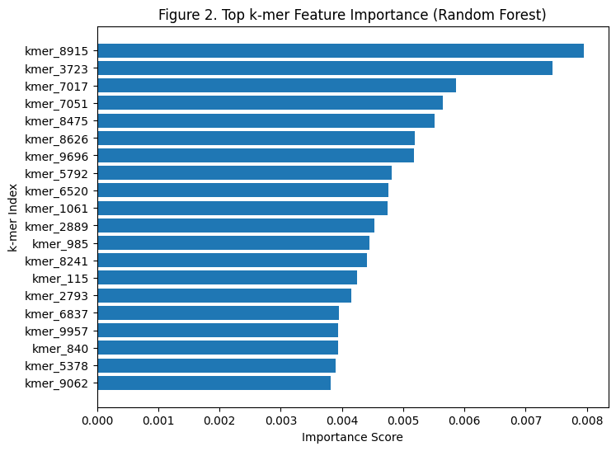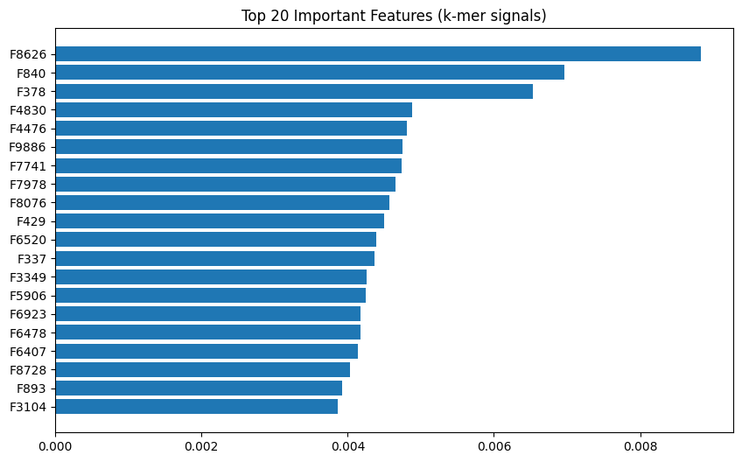
Early Observations
- Nonlinear models detect stronger k-mer-based resistance signals
- Important k-mers appear to relate to known ciprofloxacin-resistance mechanisms
- Preprocessing and normalization produced a clean, robust matrix with no quality issues
Next Steps
- Complete full model tuning and cross-validation
- Map top k-mers to genomic regions
- Finalize figures and interpretation for the report

GitHub-Repo Link: https://github.com/kayms2613-lgtm/Predicting-Antibiotic-Resistance-Phenotypes-Using-Whole-Genome-k-mer-Signatures

5. Discussion & Next Steps
Preliminary results show that whole-genome k-mer patterns carry strong predictive signal for ciprofloxacin resistance in E. coli. Nonlinear models, particularly Random Forest, separate resistant and susceptible isolates more effectively than linear models, suggesting that complex sequence patterns reflect known fluoroquinolone resistance mechanisms. Several high-importance k-mers appear consistently and may correspond to mutations in gyrA/parC, although biological confirmation is still needed.
The study has limitations: the dataset is small, which increases overfitting risk; k-mer features are sparse and high-dimensional; and visualization outputs are still being finalized. Despite these constraints, the balanced dataset and stable early model behaviour support the reliability of initial findings.
Next steps include full hyperparameter tuning, cross-validation, improved feature filtering, and additional visualizations (ROC curves, confusion matrices, PCA/UMAP). Mapping top k-mers back to genomic regions will strengthen biological interpretation. The final report will incorporate refined figures, statistical summaries, and deeper analysis of predictive signatures.

6. Reproducibility & AI Use
AI tools (ChatGPT) were used only to help draft narrative sections of the report, refine wording, and improve clarity and structure of documentation. No AI system generated, processed, or analysed biological data. All AI-assisted text was manually checked for scientific accuracy and corrected when necessary. Because only publicly available bacterial genomes were used, the project involves no human-subject data, and ethical risks are minimal. Verification steps, transparency in AI use, and careful documentation ensure that the workflow is scientifically reliable and fully reproducible.

7. References
- Wattam, A. R., Abraham, D., Dalay, O., Disz, T., Driscoll, T., Gabbard, J. L., … Sobral, B. W. (2014). PATRIC: The bacterial bioinformatics database and analysis resource. Nucleic Acids Research, 42(D1), D581–D591.
- Pedregosa, F., Varoquaux, G., Gramfort, A., Michel, V., Thirion, B., Grisel, O., … Duchesnay, É. (2011). Scikit-learn: Machine learning in Python. Journal of Machine Learning Research, 12, 2825–2830.
- Cock, P. J. A., Antao, T., Chang, J. T., Chapman, B. A., Cox, C. J., Dalke, A., … de Hoon, M. J. L. (2009). Biopython: Freely available Python tools for computational molecular biology. Bioinformatics, 25(11), 1422–1423.
- McKinney, W. (2010). Data structures for statistical computing in Python. Proceedings of the 9th Python in Science Conference, 51–56.

8. Group Projects Only
Kaushik Budur – Data & Preprocessing Lead
Kaushik was responsible for assembling, cleaning, and organizing all genomic and phenotype datasets used in the project. He handled the download and curation of E. coli genomes from BV-BRC, verified metadata consistency, and implemented preprocessing steps such as FASTA parsing, 31-mer extraction, normalization, and feature filtering. Kaushik ensured that the final 10,000-feature k-mer matrix was accurate, reproducible, and ready for downstream modelling.
Adarsh Cherukuri – Modelling & Evaluation Lead
Adarsh built the machine-learning pipeline and implemented the Logistic Regression, Random Forest, SVM, and Gradient Boosting models. He ran cross-validation, generated evaluation metrics, and compared model performance to assess predictive signal.
Shashank Venkatesh – Reporting, Visualization & Reproducibility Lead
Shashank produced key visualizations such as ROC curves, confusion matrices, and feature importance plots. He organized the project documentation, maintained reproducibility, and prepared the written report summarizing methods and results.

