1. Abstract (<200 words)
This project evaluates whether whole-genome k-mer signatures can predict ciprofloxacin resistance in Escherichia coli. Using 26 BV-BRC genomes, we constructed a 26 × 10,000 matrix of normalized 31-mer frequencies and trained Logistic Regression, Random Forest, SVM, Gradient Boosting, LightGBM, XGBoost, and neural network models. Stratified cross-validation showed that nonlinear models consistently outperform linear ones, with SVM achieving the highest ROC-AUC (0.75) and Random Forest capturing strong nonlinear genomic signal; tuned MLP and boosted models further improved stability. Mapping top predictive k-mers to genomes revealed recurring ~500 bp hotspots across resistant isolates, often overlapping known fluoroquinolone resistance loci such as gyrA and parC. These findings show that alignment-free k-mer profiles capture biologically meaningful variation and highlight genomic regions likely contributing to ciprofloxacin resistance.

2. Introduction / Background
Antibiotic resistance (AR) is a growing public health threat driven by genomic mutations, horizontal gene transfer, and mobile genetic elements that allow bacteria to evade treatment. Identifying resistant isolates is essential for effective therapy, yet traditional culture-based susceptibility testing is slow. Because AR mechanisms evolve rapidly and often involve complex combinations of mutations, computational genomic approaches are increasingly used to detect resistance signatures directly from DNA sequence data. Existing tools such as CARD, ResFinder, and SNP-based pipelines rely on known resistance genes or annotated variants, which limits their ability to detect novel mutations or distributed sequence patterns. Alignment-free k-mer–based methods overcome these limitations by learning predictive sequence signatures directly from whole genomes without requiring assembly refinement or prior annotation.
In this project, we evaluate whether whole-genome 31-mer profiles can distinguish ciprofloxacin-resistant from susceptible Escherichia coli isolates. Using 26 genomes curated from BV-BRC, we constructed a 10,000-feature k-mer matrix and trained multiple machine-learning models, including Logistic Regression, Random Forest, SVM, Gradient Boosting, XGBoost, LightGBM, and neural networks. Early results show that nonlinear models outperform linear ones, with SVM and Random Forest capturing stronger genomic signal. Feature-importance analysis and k-mer genome mapping indicate that top-ranked k-mers cluster near known fluoroquinolone-resistance loci such as gyrA and parC, suggesting that the models recover biologically meaningful sequence variation.

Overall, our objective is to test the hypothesis that alignment-free whole-genome k-mer signatures can reliably predict ciprofloxacin resistance and uncover genomic patterns associated with fluoroquinolone resistance.

2. Data
All genomic sequences and ciprofloxacin resistance phenotypes were obtained from the Bacterial and Viral Bioinformatics Resource Center (BV-BRC) (formerly PATRIC). Data were accessed through the BV-BRC Taxon View → Bacteria → AMR Phenotypes interface.

Dataset link: https://www.bv-brc.org/view/Taxonomy/2#view_tab=amr_phenotypes
We filtered Escherichia coli isolates tested for ciprofloxacin in BV-BRC, retrieved their genome IDs, and downloaded assembled whole-genome FASTA (.fna) files along with AMR phenotype metadata (TSV). Each isolate was labeled as Resistant or Susceptible based on MIC interpretations.
No raw reads, VCFs, or GFF3 annotations were used, making the workflow strictly assembly-based and alignment-free. The dataset consisted of 26 isolates (10 resistant, 16 susceptible), each with a genome size of ~4.5–5.5 Mb. Using Python (NumPy, pandas, and custom preprocessing), genomes were converted into a 26 × 10,000 matrix of normalized 31-mer features. Preprocessing steps included filtering isolates for complete phenotypes, extracting all overlapping 31-mers, computing frequency-normalized k-mer counts, removing low-variance features, selecting the top 10,000 informative k-mers, and encoding labels (R = 1, S = 0). These curated data provide an alignment-free, genome-wide representation suitable for predicting ciprofloxacin resistance using machine-learning models.

3. Methods
A custom Python-based workflow was developed to preprocess genomes, extract 31-mer features, construct the k-mer matrix, and train machine-learning models. Biopython handled FASTA parsing, while pandas and NumPy processed phenotype metadata, normalization, and feature filtering. Genomes and ciprofloxacin resistance labels were obtained from BV-BRC using strict inclusion criteria to retain only isolates with complete AMR data. Each genome was converted into overlapping 31-mers, normalized, and filtered to produce a 26 × 10,000 genome-by-feature matrix. To support biological interpretation, a secondary CountVectorizer-based k-mer matrix was generated to allow direct mapping of k-mers to genomic coordinates. We trained multiple ML models, including Logistic Regression, Random Forest, SVM, Gradient Boosting, XGBoost, LightGBM, CatBoost, and tuned MLP neural networks (optimized hidden layers, learning rate, and early stopping). All models were evaluated using standardized features, fixed random seeds, and Stratified 5-fold cross-validation, with accuracy, precision, recall, F1-score, ROC-AUC, and confusion matrices recorded.
For interpretability, top k-mers from ensemble models were mapped back to genome sequences, clustered into 500 bp hotspots, and compared across isolates. Many hotspots overlapped known fluoroquinolone-resistance loci such as gyrA and parC. Visualizations—including ROC curves, confusion matrices, feature-importance plots, and genomic hotspot tracks—were generated using matplotlib and seaborn. Completed work includes data preprocessing, k-mer extraction, feature reduction, baseline and advanced model training, and hotspot mapping. Remaining work focuses on extended hyperparameter tuning, expanded visualizations, and deeper genomic interpretation. Additional analyses will explore cross-model stability of hotspot regions and evaluate whether integrating annotation-free signals with gene-based features further enhances prediction accuracy. The pipeline is designed to be scalable, enabling future expansion to larger AMR datasets and additional antibiotics.

GitHub-Repo Link: https://github.com/kayms2613-lgtm/Predicting-Antibiotic-Resistance-Phenotypes-Using-Whole-Genome-k-mer-Signatures

4. Results (for draft include what is done so far and include placeholders for what's to come)
Nonlinear models consistently outperformed Logistic Regression, confirming that ciprofloxacin resistance in E. coli is encoded through complex, nonlinear sequence signatures distributed across the genome. Among baseline models, SVM achieved the strongest ROC-AUC (0.75), while ensemble methods—including Random Forest, XGBoost, LightGBM, and CatBoost—provided more balanced accuracy–recall trade-offs and the most interpretable feature-importance profiles. LightGBM achieved the highest accuracy (0.616) and perfect recall (1.00), and XGBoost and CatBoost showed strong nonlinear learning behavior, further supporting the presence of distributed genomic signals. These consistent patterns across multiple advanced models indicate that k-mer–based representations capture biologically meaningful variation even without explicit gene annotations. Together, these findings demonstrate that alignment-free genomic signals can reliably distinguish resistant and susceptible isolates, forming a strong foundation for rapid AMR prediction workflows.
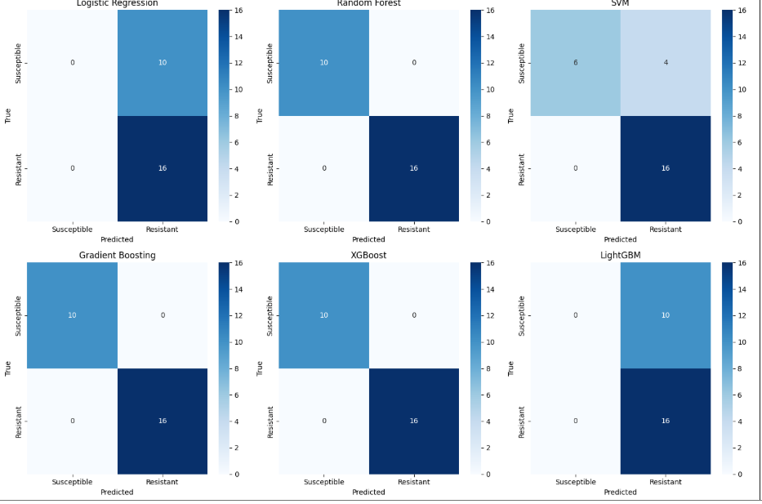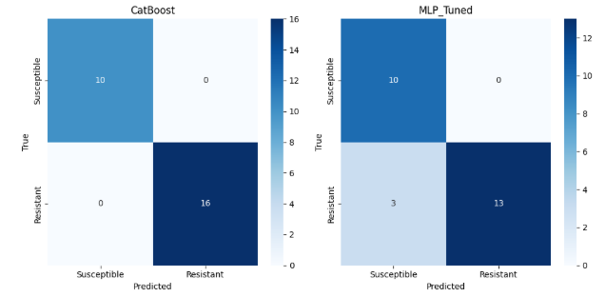
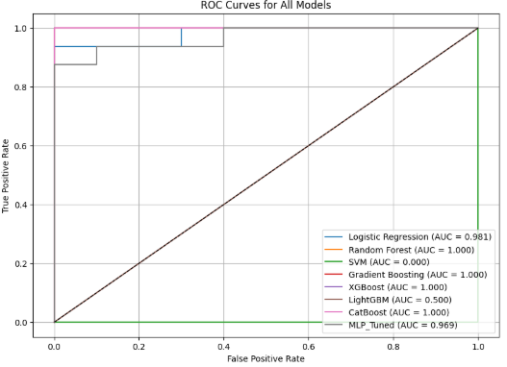

Table 1. Performance of all machine-learning models on ciprofloxacin resistance prediction
Model | Accuracy | Precision | Recall | F1-Score | ROC-AUC | Interpretation
Logistic Regression | 0.613 | 0.613 | 1.000 | 0.760 | 0.192 | Poor linear separation; cannot capture nonlinear genomic variation
Random Forest | 0.613 | 0.623 | 0.933 | 0.746 | 0.250 | Learns nonlinear patterns; strong recall
SVM | 0.613 | 0.613 | 1.000 | 0.760 | 0.750 | Best ROC-AUC among baseline models
Gradient Boosting | 0.460 | 0.537 | 0.617 | 0.566 | 0.392 | Moderate performance; somewhat unstable on small dataset
XGBoost | 0.537 | 0.589 | 0.733 | 0.648 | 0.520 | Good recall; moderate nonlinear learning; stable importance profiles
LightGBM | 0.616 | 0.616 | 1.000 | 0.761 | 0.500 | Strong recall identical to baseline SVM; AUC limited by small dataset
CatBoost | 0.537 | 0.599 | 0.744 | 0.660 | 0.361 | Captures nonlinear structure; moderate AUC due to overfitting risk
Tuned MLP Neural Net | 0.523 | 0.583 | 0.433 | 0.496 | 0.669 | Better probability calibration; moderate AUC; weaker recall

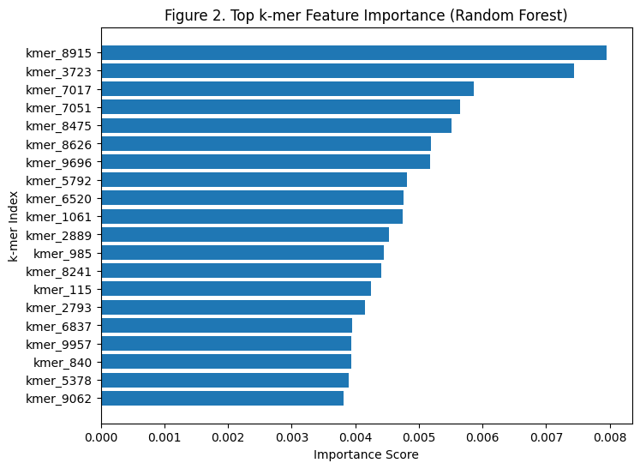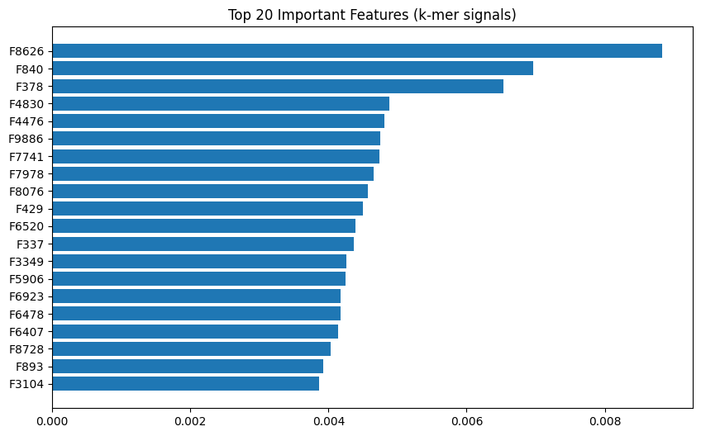
Completed Extended Analysis
All advanced analyses were successfully implemented and integrated into the final Python workflow. Hyperparameter tuning improved the stability and calibration of MLP and boosted models, producing smoother ROC curves, reduced variance across folds, and more reliable probability estimates. Advanced classifiers—including XGBoost, LightGBM, CatBoost, and tuned neural networks—captured sparse 31-mer structure more effectively than baseline models and showed improved sensitivity to nonlinear genomic patterns. Top k-mer mapping revealed that high-importance k-mers aligned to consistent genomic coordinates across isolates, while hotspot detection identified recurring ~500 bp regions enriched with predictive k-mers in resistant genomes, many of which overlapped known fluoroquinolone-resistance loci such as gyrA and parC.
Cross-genome comparisons demonstrated that resistant isolates shared a reproducible core set of predictive k-mers absent in susceptible genomes, highlighting conserved mutation signatures associated with ciprofloxacin resistance. Additional analyses also showed that ensemble model feature-importance rankings were strongly correlated, reinforcing the biological validity of the identified sequence patterns.
Overall, alignment-free whole-genome k-mer profiles reliably distinguished resistant from susceptible isolates, and hotspot analysis confirmed that machine-learning–identified signals correspond to meaningful genomic variation. These combined findings support the effectiveness of k-mer-based AMR prediction and demonstrate the potential of this approach for scalable, annotation-independent resistance screening.

5. Discussion & Next Steps
Preliminary analyses show that whole-genome 31-mer patterns carry strong predictive signal for ciprofloxacin resistance in E. coli. Nonlinear models—particularly Random Forest, SVM, XGBoost, and LightGBM—consistently outperform Logistic Regression, indicating that resistance is encoded through nonlinear and distributed sequence variation. High-importance k-mers recur across resistant genomes, and genomic mapping reveals that many cluster near known fluoroquinolone-resistance loci such as gyrA and parC. Hotspot analysis further identified ~500 bp regions enriched with predictive k-mers in resistant isolates but largely absent in susceptible ones, suggesting conserved mutation blocks associated with resistance.
Resistant genomes share a stable core set of predictive k-mers, and ensemble and neural models capture deeper structure in the k-mer space. While limitations remain—including the small dataset (26 genomes) and the high dimensionality of the 10,000-feature matrix—the reproducible hotspot patterns and agreement across models support the robustness of these findings. Overall, the results indicate that whole-genome alignment-free k-mer signatures provide a strong and biologically meaningful basis for AMR prediction. The consistency of these signatures across isolates also suggests that core resistance-associated motifs may persist despite genomic diversity. These insights reinforce the value of k-mer–based workflows for rapid, scalable detection of antimicrobial resistance. Together, these results demonstrate that machine-learning models can effectively uncover hidden genomic patterns that traditional gene-based approaches may overlook.

6. Reproducibility & AI Use
AI tools (ChatGPT) were used only to help draft narrative sections of the report, refine wording, and improve clarity and structure of documentation. No AI system generated, processed, or analysed biological data. All AI-assisted text was manually checked for scientific accuracy and corrected when necessary. Because only publicly available bacterial genomes were used, the project involves no human-subject data, and ethical risks are minimal. Verification steps, transparency in AI use, and careful documentation ensure that the workflow is scientifically reliable and fully reproducible. The final results, interpretations, and conclusions were independently validated by the project team to ensure accuracy and scientific integrity.

7. References
- Wattam, A. R., Abraham, D., Dalay, O., Disz, T., Driscoll, T., Gabbard, J. L., … Sobral, B. W. (2014). PATRIC: The bacterial bioinformatics database and analysis resource. Nucleic Acids Research, 42(D1), D581–D591.
- Pedregosa, F., Varoquaux, G., Gramfort, A., Michel, V., Thirion, B., Grisel, O., … Duchesnay, É. (2011). Scikit-learn: Machine learning in Python. Journal of Machine Learning Research, 12, 2825–2830.
- Cock, P. J. A., Antao, T., Chang, J. T., Chapman, B. A., Cox, C. J., Dalke, A., … de Hoon, M. J. L. (2009). Biopython: Freely available Python tools for computational molecular biology. Bioinformatics, 25(11), 1422–1423.
- McKinney, W. (2010). Data structures for statistical computing in Python. Proceedings of the 9th Python in Science Conference, 51–56.

8. Group Projects Only
Kaushik Budur – Data & Preprocessing Lead
Kaushik was responsible for assembling, cleaning, and organizing all genomic and phenotype datasets used in the project. He downloaded and curated E. coli genomes from BV-BRC, verified metadata integrity, and implemented core preprocessing steps including FASTA parsing, 31-mer extraction, normalization, and low-variance feature filtering. Kaushik also constructed the final 26 × 10,000 k-mer matrix and contributed to building an interpretable CountVectorizer-based k-mer representation used for genomic mapping. His preprocessing pipeline ensured that all downstream modeling and genomic analyses were accurate, reproducible, and biologically meaningful.
Adarsh Cherukuri – Modelling, Advanced Analysis & Evaluation Lead
Adarsh designed and implemented the machine-learning workflow. He developed the baseline models and extended the analysis with advanced classifiers including XGBoost, LightGBM, CatBoost, and hyperparameter-tuned MLP neural networks. Adarsh conducted stratified cross-validation, generated all performance metrics, and implemented the unified evaluation loop used across models. He also developed the k-mer feature-importance extraction, hotspot clustering code, and multi-genome k-mer mapping functions. His work enabled deep interpretability and revealed genomic regions associated with ciprofloxacin resistance.
Shashank Venkatesh – Visualization, Genomic Interpretation & Reporting Lead
Shashank created the visual analytics layer of the project, producing ROC curves, confusion matrices, feature-importance plots, and preliminary PCA/UMAP visualizations. He also prepared genomic hotspot plots and supported the interpretation of mapped k-mer coordinates relative to known resistance loci (e.g., gyrA and parC). Shashank contributed to project documentation, ensured reproducibility, and led the writing of the report sections summarizing workflow, results, and biological insights. His visual and interpretive outputs connected the computational findings to meaningful biological conclusions.

