1. Alare to Alare Contour (cm)
2. Back of Head to Glabella Contour (cm)
3. Bizygomatic Width Contour (cm)
4. Bizygomatic Width Linear (cm)
5. Cheillion to Cheillion Contour (cm)
6. Gonion to Submandibular Contour (cm)
7. Nasal Root Breadth (cm)
8. Pronasale to Alare Linear (cm)
9. Pronasale to Alare Contour (cm)
10. Pronasale to Subnasale Contour (cm)
11. Pronasale to Subnasale Linear (cm)
12. Sellion to Pronosale Contour (cm)
13. Sellion to Pronosale Linear (cm)
14. Sellion Dorsal Hump Contour (cm)
15. Sellion to Menton Linear (cm)
16. Subnasale to Menton Contour (cm)
17. Submandibular to Menton Contour (cm)
18. Submandibular to Menton Linear (cm)
19. Subnasale to Menton Linear (cm)
20. Top of Head to Obtasion Contour (cm)
21. Tragion to Earlobe Juncture Contour (cm)
22. Tragion to Gonion Contour (cm)
23. Tragion to Sellion Contour (cm)
24. Tragion to Submandibular Contour (cm)
25. Tragion to Subnasale Contour (cm)
26. Tragion to Tragion Contour (cm)
27. Tragion to Tragion Linear (cm)

APPENDIX A:

FACE MEASUREMENTS

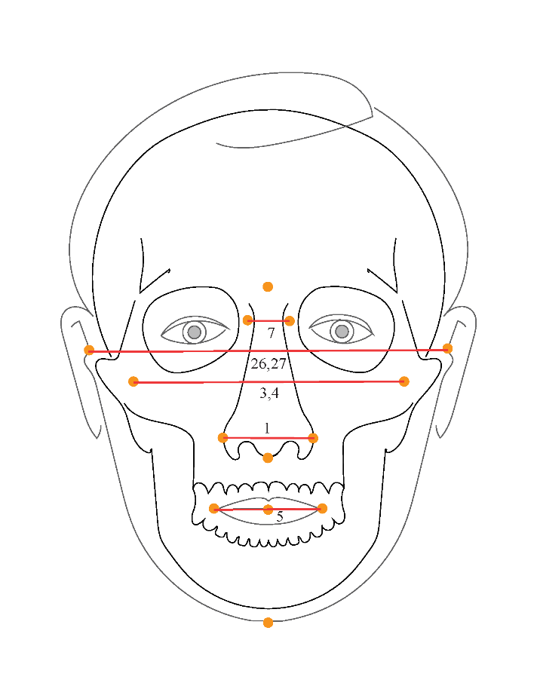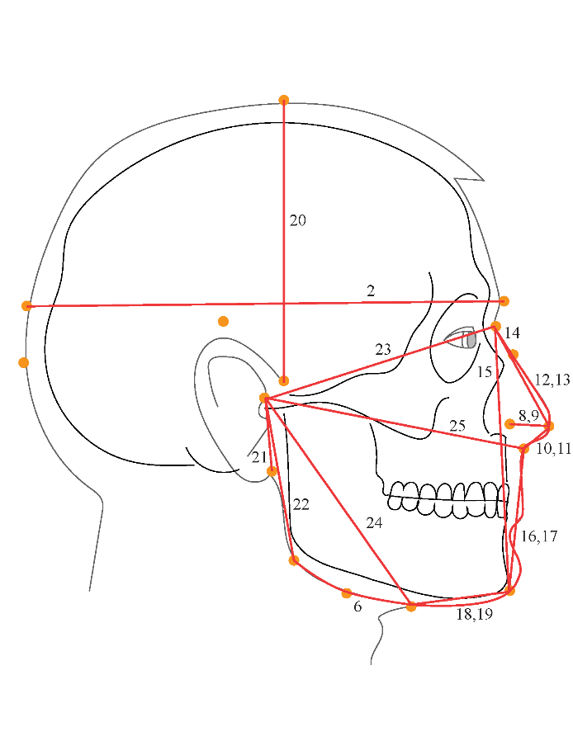

Figure A.1: Illustration of facial measurements gathered from sample population for this dissertation.

**Table A.1.**

*Measurement names (per Figure A.1 numbers), measurement type (linear, contour, or both), measurement location (front or right), and measurement name for data analysis.*

|  |  |  |  |  |
| --- | --- | --- | --- | --- |
| **Number(s) in Figure A** | **Measurement Name** | **Measurement Type** | **Measure- ment Location** | **Measurement Name Data Analysis** |
| 1 | Alare to Alare | Contour | Front | AA_C |
| 2 | Back of Head to Glabella | Contour | Right | BGl_C |
| 3, 4 | Bizygomatic Width | Both | Front | BiW_L & BiW_C |
| 5 | Cheilion to Cheilion | Contour | Front | ChCh_C |
| 6 | Gonion to Submandibular | Contour | Right | GoSub_C |
| 7 | Nasal Root Breadth | Linear | Front | NRB_L |
| 8, 9 | Pronasale to Alare | Both | Right | ProA_L & ProA_C |
| 10, 11 | Pronasale to Subnasale | Both | Front | ProS_L & ProS_C |
| 12, 13 | Sellion to Pronasale | Both | Front | SelP_L & SelP_C |
| 14 | Sellion to Dorsal Hump | Contour | Front | SelDH_C |
| 15 | Sellion to Menton | Linear | Front | SelM_L |
| 16, 17 | Subnasale to Menton | Both | Front | SnasM_L & SnasM_C |
| 18, 19 | Submandibular to Menton | Both | Front | SmanM_L & SmanM_C |
| 20 | Top of Head to Otobasion | Contour | Right | TrHO_C |
| 21 | Tragion to Earlobe Juncture | Contour | Right | TrEJ_C |
| 22 | Tragion to Gonion | Contour | Right | TrGo_C |
| 23 | Tragion to Sellion | Contour | Right | TrSel_C |
| 24 | Tragion to Submandibular | Contour | Right | TrSman_C |
| 25 | Tragion to Subnasale | Contour | Right | TrSnas_C |
| 26, 27 | Tragion to Tragion | Both | Front | TrTr_C & TrTr_L |