K-S testing

library(tidyverse)

## ── Attaching packages ─────────────────────────────────────── tidyverse 1.3.2 ──  
## ✔ ggplot2 3.3.6 ✔ purrr 0.3.4  
## ✔ tibble 3.1.8 ✔ dplyr 1.0.9  
## ✔ tidyr 1.2.0 ✔ stringr 1.4.0  
## ✔ readr 2.1.2 ✔ forcats 0.5.1  
## ── Conflicts ────────────────────────────────────────── tidyverse_conflicts() ──  
## ✖ dplyr::filter() masks stats::filter()  
## ✖ dplyr::lag() masks stats::lag()

library(flextable)

##   
## Attaching package: 'flextable'  
##   
## The following object is masked from 'package:purrr':  
##   
## compose

library(readxl)  
library(extrafont)

## Registering fonts with R

library(forcats)  
library(writexl)  
library(car)

## Loading required package: carData  
##   
## Attaching package: 'car'  
##   
## The following object is masked from 'package:dplyr':  
##   
## recode  
##   
## The following object is masked from 'package:purrr':  
##   
## some

#times new roman tables  
my_ft_theme <- function(ft, ...) {  
 # Remove vertical cell padding  
 ft <- padding(ft, padding.top = 0, padding.bottom = 0, part = "all")  
   
 # Change font to TNR 11  
 ft <- font(ft, fontname = "Times New Roman", part = "all")  
 ft <- fontsize(ft, part = "all", size = 12)  
 ft  
}

headscan_full1<-read_excel("C:\\Users\\19177\\OneDrive - Colostate\\Desktop\\Dissertation\\headscan_dissertation\\headscan_full1.xlsx")  
str(headscan_full1)

## tibble [2,016 × 33] (S3: tbl_df/tbl/data.frame)  
## $ ID : chr [1:2016] "400-20201012-002" "400-20201012-003" "400-20201012-004" "400-20201012-005" ...  
## $ AA_C : num [1:2016] 65 55 70 58 67 60 59 59 65 65 ...  
## $ BGl_C : num [1:2016] 315 289 293 313 288 306 320 NA 300 277 ...  
## $ BiW_C : num [1:2016] 130 127 143 140 137 130 141 138 143 150 ...  
## $ BiW_L : num [1:2016] 115 108 121 109 104 106 109 111 113 116 ...  
## $ ChCh_C : num [1:2016] 62 64 68 70 70 70 67 69 67 63 ...  
## $ GoSub_C : num [1:2016] 93 93 115 93 103 100 79 106 85 102 ...  
## $ NRB_L : num [1:2016] 17 18 19 21 19 14 17 18 16 17 ...  
## $ ProA_L : num [1:2016] 28 25 31 23 28 28 26 27 32 28 ...  
## $ ProA_C : num [1:2016] 31 27 33 27 31 29 27 29 34 31 ...  
## $ ProS_C : num [1:2016] 18 20 14 13 22 22 19 14 26 24 ...  
## $ ProS_L : num [1:2016] 17 18 14 13 20 20 18 12 24 22 ...  
## $ SelP_C : num [1:2016] 42 41 51 45 47 48 46 42 47 44 ...  
## $ SelP_L : num [1:2016] 42 41 51 44 47 48 46 41 46 44 ...  
## $ SelDH_C : num [1:2016] 15 9 9 11 13 15 9 9 12 14 ...  
## $ SelM_L : num [1:2016] 122 99 130 115 119 126 117 112 117 117 ...  
## $ SnasM_C : num [1:2016] 82 55 84 74 73 80 78 76 64 75 ...  
## $ SmanM_C : num [1:2016] 59 51 45 43 33 34 55 37 61 41 ...  
## $ SmanM_L : num [1:2016] 55 50 45 42 33 34 50 36 59 40 ...  
## $ SnasM_L : num [1:2016] 75 53 78 69 67 76 69 71 62 69 ...  
## $ TrHO_C : num [1:2016] 179 163 169 166 159 162 169 NA 167 166 ...  
## $ TrEJ_C : num [1:2016] 40 32 39 29 46 42 29 32 29 33 ...  
## $ TrGo_C : num [1:2016] 84 57 70 61 68 70 75 61 67 64 ...  
## $ TrSel_C : num [1:2016] 149 138 150 133 140 151 140 138 156 143 ...  
## $ TrSman_C : num [1:2016] 177 145 178 147 157 164 149 159 151 160 ...  
## $ TrSnas_C : num [1:2016] 163 142 167 145 152 157 148 149 157 NA ...  
## $ TrTr_C : num [1:2016] 296 276 292 273 279 300 283 275 307 286 ...  
## $ TrTr_L : num [1:2016] 155 141 156 149 146 146 147 151 157 144 ...  
## $ coder : chr [1:2016] "Kayna" "Kayna" "Kayna" "Kayna" ...  
## $ age : num [1:2016] 31 49 49 34 49 55 26 18 25 27 ...  
## $ gender : chr [1:2016] "Male" "Female" "Male" "Male" ...  
## $ race_eth : chr [1:2016] "Black" "white" "white" "white" ...  
## $ age_group: chr [1:2016] "18-36" "37-54" "37-54" "18-36" ...

nortest::lillie.test(headscan_full1$AA_C)

##   
## Lilliefors (Kolmogorov-Smirnov) normality test  
##   
## data: headscan_full1$AA_C  
## D = 0.063817, p-value < 2.2e-16

hist(headscan_full1$AA_C, breaks=30)

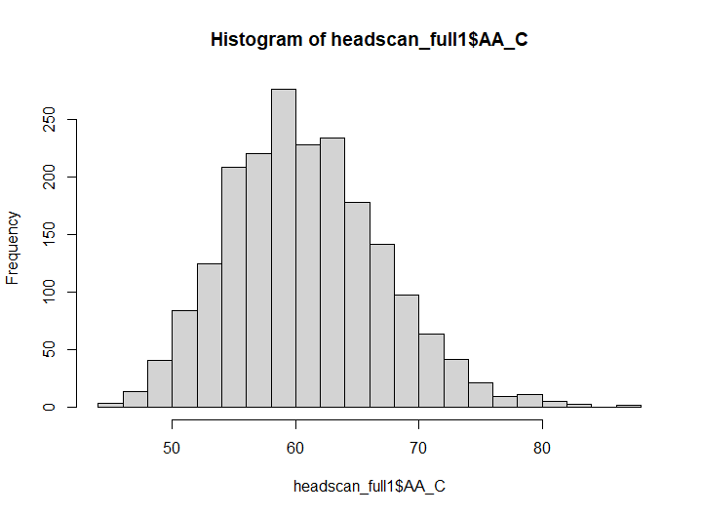

qqnorm(headscan_full1$AA_C)  
qqline(headscan_full1$AA_C)

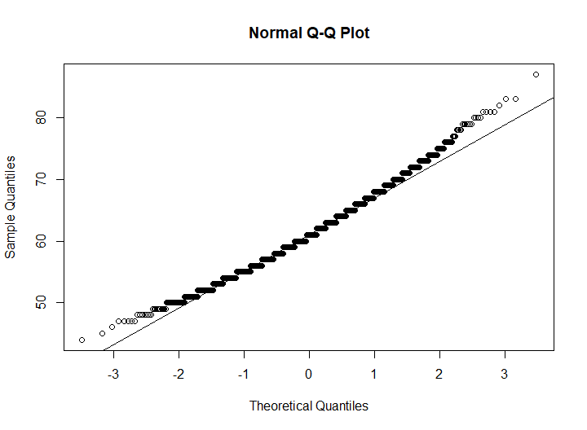

qqPlot(headscan_full1$AA_C, distribution = "norm")

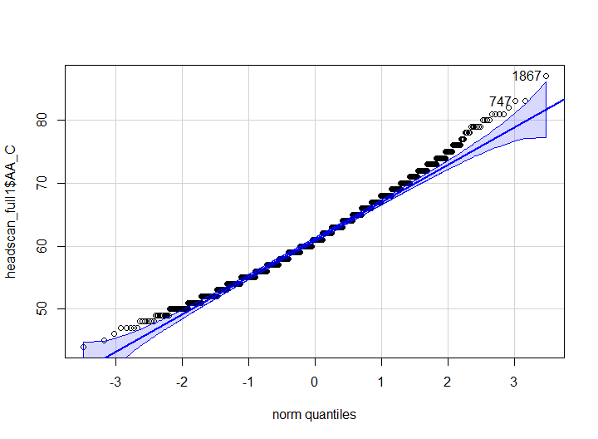

## [1] 1867 747