intra/inter-tables

2022-10-23

library(tidyverse)

## ── Attaching packages ─────────────────────────────────────── tidyverse 1.3.2 ──  
## ✔ ggplot2 3.3.6 ✔ purrr 0.3.4  
## ✔ tibble 3.1.8 ✔ dplyr 1.0.9  
## ✔ tidyr 1.2.0 ✔ stringr 1.4.0  
## ✔ readr 2.1.2 ✔ forcats 0.5.1  
## ── Conflicts ────────────────────────────────────────── tidyverse_conflicts() ──  
## ✖ dplyr::filter() masks stats::filter()  
## ✖ dplyr::lag() masks stats::lag()

library(readxl)  
library(flextable)

##   
## Attaching package: 'flextable'  
##   
## The following object is masked from 'package:purrr':  
##   
## compose

library(extrafont)

## Registering fonts with R

library(scales)

##   
## Attaching package: 'scales'  
##   
## The following object is masked from 'package:purrr':  
##   
## discard  
##   
## The following object is masked from 'package:readr':  
##   
## col_factor

library(forcats)

#times new roman tables  
my_ft_theme <- function(ft, ...) {  
 # Remove vertical cell padding  
 ft <- padding(ft, padding.top = 0, padding.bottom = 0, part = "all")  
   
 # Change font to TNR 11  
 ft <- font(ft, fontname = "Times New Roman", part = "all")  
 ft <- fontsize(ft, part = "all", size = 12)  
 ft  
}

intra_data_all <- read_excel("C:\\Users\\19177\\OneDrive - Colostate\\Desktop\\Dissertation\\headscan_dissertation\\PAPER_1\\intra_ICC_all.xlsx")

intra_data_all <- intra_data_all %>%   
 rename(rater="coder",  
 lower="Lower CI",  
 upper="Upper CI")

flextable(intra_data_all) %>%  
 my_ft_theme()%>%   
 bold(part = "header") %>%   
 set_caption(" ") %>%   
 fit_to_width(7.5) %>%   
 autofit()

**Table** :

| **measure** | **ICC** | **lower** | **upper** | **phase** | **RR** | **rater** |
| --- | --- | --- | --- | --- | --- | --- |
| AA_C | 0.9440 | 0.835 | 0.985 | phase 1 | intra | A |
| BGl_C | 0.6750 | -0.012 | 0.914 | phase 1 | intra | A |
| BiW_C | 0.7450 | 0.275 | 0.930 | phase 1 | intra | A |
| BiW_L | 0.8590 | 0.546 | 0.963 | phase 1 | intra | A |
| ChCh_C | 0.9680 | 0.907 | 0.992 | phase 1 | intra | A |
| GoSub_C | 0.4180 | -0.596 | 0.850 | phase 1 | intra | A |
| NRB_L | 0.8910 | 0.693 | 0.970 | phase 1 | intra | A |
| ProA_L | 0.8240 | 0.486 | 0.952 | phase 1 | intra | A |
| ProA_C | 0.7150 | 0.150 | 0.924 | phase 1 | intra | A |
| ProS_C | 0.9070 | 0.730 | 0.975 | phase 1 | intra | A |
| ProS_L | 0.9380 | 0.817 | 0.983 | phase 1 | intra | A |
| SelP_C | 0.8990 | 0.716 | 0.972 | phase 1 | intra | A |
| SelP_L | 0.9060 | 0.733 | 0.975 | phase 1 | intra | A |
| SelDH_C | 0.6980 | 0.155 | 0.916 | phase 1 | intra | A |
| SelM_L | 0.9580 | 0.872 | 0.989 | phase 1 | intra | A |
| SnasM_L | 0.9330 | 0.798 | 0.983 | phase 1 | intra | A |
| SmanM_C | 0.6610 | 0.041 | 0.914 | phase 1 | intra | A |
| SmanM_L | 0.6080 | -0.086 | 0.899 | phase 1 | intra | A |
| SnasM_C | 0.9470 | 0.838 | 0.987 | phase 1 | intra | A |
| TrHO_C | 0.9260 | 0.778 | 0.982 | phase 1 | intra | A |
| TrEJ_C | 0.9180 | 0.665 | 0.981 | phase 1 | intra | A |
| TrGo_C | 0.8690 | 0.547 | 0.972 | phase 1 | intra | A |
| TrSel_C | 0.9870 | 0.960 | 0.997 | phase 1 | intra | A |
| TrSman_C | 0.7110 | 0.100 | 0.936 | phase 1 | intra | A |
| TrSnas_C | 0.9950 | 0.983 | 0.999 | phase 1 | intra | A |
| TrTr_C | 0.9880 | 0.963 | 0.997 | phase 1 | intra | A |
| TrTr_L | 0.9780 | 0.935 | 0.995 | phase 1 | intra | A |
| AA_C | 0.8170 | 0.466 | 0.950 | phase 1 | intra | B |
| BGl_C | 0.7700 | 0.331 | 0.938 | phase 1 | intra | B |
| BiW_C | 0.2670 | -0.612 | 0.774 | phase 1 | intra | B |
| BiW_L | 0.6870 | 0.153 | 0.912 | phase 1 | intra | B |
| ChCh_C | 0.9160 | 0.758 | 0.977 | phase 1 | intra | B |
| GoSub_C | 0.8700 | 0.609 | 0.968 | phase 1 | intra | B |
| NRB_L | 0.8860 | 0.655 | 0.969 | phase 1 | intra | B |
| ProA_L | 0.8430 | 0.558 | 0.957 | phase 1 | intra | B |
| ProA_C | 0.7510 | 0.302 | 0.932 | phase 1 | intra | B |
| ProS_C | 0.5500 | -0.322 | 0.879 | phase 1 | intra | B |
| ProS_L | 0.6070 | -0.085 | 0.892 | phase 1 | intra | B |
| SelP_C | 0.9320 | 0.807 | 0.982 | phase 1 | intra | B |
| SelP_L | 0.9450 | 0.843 | 0.985 | phase 1 | intra | B |
| SelDH_C | 0.6920 | 0.134 | 0.914 | phase 1 | intra | B |
| SelM_L | 0.9340 | 0.803 | 0.984 | phase 1 | intra | B |
| SnasM_L | 0.9170 | 0.713 | 0.980 | phase 1 | intra | B |
| SmanM_C | 0.8580 | 0.579 | 0.965 | phase 1 | intra | B |
| SmanM_L | 0.8100 | 0.438 | 0.953 | phase 1 | intra | B |
| SnasM_C | 0.9210 | 0.755 | 0.981 | phase 1 | intra | B |
| TrHO_C | 0.7810 | 0.336 | 0.945 | phase 1 | intra | B |
| TrEJ_C | 0.8760 | 0.601 | 0.970 | phase 1 | intra | B |
| TrGo_C | 0.7620 | 0.259 | 0.947 | phase 1 | intra | B |
| TrSel_C | 0.9670 | 0.869 | 0.992 | phase 1 | intra | B |
| TrSman_C | 0.9650 | 0.888 | 0.992 | phase 1 | intra | B |
| TrSnas_C | 0.0408 | -1.913 | 0.762 | phase 1 | intra | B |
| TrTr_C | 0.9880 | 0.944 | 0.997 | phase 1 | intra | B |
| TrTr_L | 0.9510 | 0.829 | 0.988 | phase 1 | intra | B |
| AA_C | 0.4020 | -0.656 | 0.835 | phase 1 | intra | C |
| BGl_C | -0.2010 | -4.682 | 0.787 | phase 1 | intra | C |
| BiW_C | 0.7340 | 0.246 | 0.927 | phase 1 | intra | C |
| BiW_L | 0.8660 | 0.623 | 0.963 | phase 1 | intra | C |
| ChCh_C | 0.9220 | 0.779 | 0.979 | phase 1 | intra | C |
| GoSub_C | 0.6650 | -0.071 | 0.926 | phase 1 | intra | C |
| NRB_L | 0.8650 | 0.617 | 0.963 | phase 1 | intra | C |
| ProA_L | 0.7180 | 0.229 | 0.922 | phase 1 | intra | C |
| ProA_C | 0.6120 | -0.048 | 0.892 | phase 1 | intra | C |
| ProS_C | 0.7520 | 0.244 | 0.934 | phase 1 | intra | C |
| ProS_L | 0.8140 | 0.435 | 0.950 | phase 1 | intra | C |
| SelP_C | 0.8100 | 0.432 | 0.949 | phase 1 | intra | C |
| SelP_L | 0.8200 | 0.460 | 0.952 | phase 1 | intra | C |
| SelDH_C | 0.5420 | -0.463 | 0.880 | phase 1 | intra | C |
| SelM_L | 0.8790 | 0.576 | 0.977 | phase 1 | intra | C |
| SnasM_L | 0.8700 | 0.533 | 0.975 | phase 1 | intra | C |
| SmanM_C | 0.3690 | -2.046 | 0.890 | phase 1 | intra | C |
| SmanM_L | 0.4640 | -1.507 | 0.906 | phase 1 | intra | C |
| SnasM_C | 0.8890 | 0.591 | 0.979 | phase 1 | intra | C |
| TrHO_C | 0.9280 | 0.717 | 0.989 | phase 1 | intra | C |
| TrEJ_C | 0.9390 | 0.810 | 0.985 | phase 1 | intra | C |
| TrGo_C | 0.8220 | 0.403 | 0.961 | phase 1 | intra | C |
| TrSel_C | 0.9370 | 0.810 | 0.984 | phase 1 | intra | C |
| TrSman_C | 0.7650 | 0.162 | 0.956 | phase 1 | intra | C |
| TrSnas_C | 0.9660 | 0.885 | 0.992 | phase 1 | intra | C |
| TrTr_C | 0.9710 | 0.910 | 0.993 | phase 1 | intra | C |
| TrTr_L | 0.3900 | -0.402 | 0.828 | phase 1 | intra | C |
| AA_C | 0.8160 | 0.485 | 0.949 | phase 1 | intra | D |
| BGl_C | 0.8860 | 0.677 | 0.969 | phase 1 | intra | D |
| BiW_C | 0.0629 | -0.370 | 0.592 | phase 1 | intra | D |
| BiW_L | 0.5940 | -0.097 | 0.886 | phase 1 | intra | D |
| ChCh_C | 0.6870 | 0.105 | 0.921 | phase 1 | intra | D |
| GoSub_C | 0.9120 | 0.723 | 0.978 | phase 1 | intra | D |
| NRB_L | 0.8240 | 0.409 | 0.954 | phase 1 | intra | D |
| ProA_L | 0.8720 | 0.617 | 0.966 | phase 1 | intra | D |
| ProA_C | 0.8270 | 0.479 | 0.954 | phase 1 | intra | D |
| ProS_C | 0.8930 | 0.697 | 0.971 | phase 1 | intra | D |
| ProS_L | 0.8610 | 0.601 | 0.962 | phase 1 | intra | D |
| SelP_C | 0.8900 | 0.679 | 0.970 | phase 1 | intra | D |
| SelP_L | 0.8880 | 0.668 | 0.970 | phase 1 | intra | D |
| SelDH_C | -0.2770 | -1.040 | 0.727 | phase 1 | intra | D |
| SelM_L | 0.6970 | -0.031 | 0.941 | phase 1 | intra | D |
| SnasM_L | 0.5000 | -0.136 | 0.884 | phase 1 | intra | D |
| SmanM_C | 0.6410 | -0.092 | 0.927 | phase 1 | intra | D |
| SmanM_L | 0.6910 | -0.022 | 0.939 | phase 1 | intra | D |
| SnasM_C | 0.6260 | -0.090 | 0.923 | phase 1 | intra | D |
| TrHO_C | 0.8940 | 0.593 | 0.984 | phase 1 | intra | D |
| TrEJ_C | 0.7360 | 0.222 | 0.934 | phase 1 | intra | D |
| TrGo_C | 0.7690 | 0.248 | 0.949 | phase 1 | intra | D |
| TrSel_C | 0.9410 | 0.822 | 0.985 | phase 1 | intra | D |
| TrSman_C | 0.9110 | 0.701 | 0.981 | phase 1 | intra | D |
| TrSnas_C | 0.9580 | 0.869 | 0.990 | phase 1 | intra | D |
| TrTr_C | 0.9810 | 0.939 | 0.995 | phase 1 | intra | D |
| TrTr_L | 0.7440 | 0.260 | 0.935 | phase 1 | intra | D |
| AA_C | 0.9870 | 0.963 | 0.996 | phase 3 | intra | A |
| BGl_C | 0.9600 | 0.871 | 0.991 | phase 3 | intra | A |
| BiW_C | 0.9170 | 0.765 | 0.977 | phase 3 | intra | A |
| BiW_L | 0.9240 | 0.784 | 0.979 | phase 3 | intra | A |
| ChCh_C | 0.9840 | 0.949 | 0.997 | phase 3 | intra | A |
| GoSub_C | 0.9370 | 0.811 | 0.984 | phase 3 | intra | A |
| NRB_L | 0.8300 | 0.525 | 0.953 | phase 3 | intra | A |
| ProA_L | 0.9860 | 0.957 | 0.996 | phase 3 | intra | A |
| ProA_C | 0.9750 | 0.927 | 0.993 | phase 3 | intra | A |
| ProS_C | 0.9690 | 0.909 | 0.992 | phase 3 | intra | A |
| ProS_L | 0.9610 | 0.889 | 0.989 | phase 3 | intra | A |
| SelP_C | 0.9910 | 0.973 | 0.997 | phase 3 | intra | A |
| SelP_L | 0.9910 | 0.975 | 0.998 | phase 3 | intra | A |
| SelDH_C | 0.9260 | 0.787 | 0.980 | phase 3 | intra | A |
| SelM_L | 0.9950 | 0.979 | 0.999 | phase 3 | intra | A |
| SnasM_L | 0.9800 | 0.904 | 0.997 | phase 3 | intra | A |
| SmanM_C | 0.4570 | -1.100 | 0.900 | phase 3 | intra | A |
| SmanM_L | 0.5220 | -0.812 | 0.912 | phase 3 | intra | A |
| SnasM_C | 0.9540 | 0.807 | 0.992 | phase 3 | intra | A |
| TrHO_C | 0.9810 | 0.934 | 0.997 | phase 3 | intra | A |
| TrEJ_C | 0.9790 | 0.940 | 0.994 | phase 3 | intra | A |
| TrGo_C | 0.9710 | 0.913 | 0.993 | phase 3 | intra | A |
| TrSel_C | 0.9930 | 0.979 | 0.998 | phase 3 | intra | A |
| TrSman_C | 0.9930 | 0.978 | 0.998 | phase 3 | intra | A |
| TrSnas_C | 0.9710 | 0.917 | 0.992 | phase 3 | intra | A |
| TrTr_C | 0.9970 | 0.990 | 0.999 | phase 3 | intra | A |
| TrTr_L | 0.9980 | 0.995 | 1.000 | phase 3 | intra | A |
| AA_C | 0.9740 | 0.927 | 0.993 | phase 3 | intra | B |
| BGl_C | 0.9740 | 0.927 | 0.993 | phase 3 | intra | B |
| BiW_C | 0.9440 | 0.832 | 0.985 | phase 3 | intra | B |
| BiW_L | 0.9150 | 0.740 | 0.977 | phase 3 | intra | B |
| ChCh_C | 0.9680 | 0.909 | 0.991 | phase 3 | intra | B |
| GoSub_C | 0.9500 | 0.850 | 0.988 | phase 3 | intra | B |
| NRB_L | 0.7570 | 0.291 | 0.935 | phase 3 | intra | B |
| ProA_L | 0.9740 | 0.924 | 0.993 | phase 3 | intra | B |
| ProA_C | 0.9600 | 0.885 | 0.989 | phase 3 | intra | B |
| ProS_C | 0.9410 | 0.828 | 0.984 | phase 3 | intra | B |
| ProS_L | 0.9310 | 0.799 | 0.981 | phase 3 | intra | B |
| SelP_C | 0.9770 | 0.936 | 0.994 | phase 3 | intra | B |
| SelP_L | 0.9780 | 0.936 | 0.994 | phase 3 | intra | B |
| SelDH_C | 0.9200 | 0.719 | 0.979 | phase 3 | intra | B |
| SelM_L | 0.9690 | 0.899 | 0.993 | phase 3 | intra | B |
| SnasM_L | 0.9210 | 0.731 | 0.983 | phase 3 | intra | B |
| SmanM_C | 0.7400 | 0.093 | 0.944 | phase 3 | intra | B |
| SmanM_L | 0.6920 | -0.089 | 0.934 | phase 3 | intra | B |
| SnasM_C | 0.8490 | 0.474 | 0.967 | phase 3 | intra | B |
| TrHO_C | 0.9700 | 0.911 | 0.993 | phase 3 | intra | B |
| TrEJ_C | 0.9350 | 0.814 | 0.982 | phase 3 | intra | B |
| TrGo_C | 0.9690 | 0.895 | 0.993 | phase 3 | intra | B |
| TrSel_C | 0.9900 | 0.972 | 0.997 | phase 3 | intra | B |
| TrSman_C | 0.9970 | 0.989 | 0.999 | phase 3 | intra | B |
| TrSnas_C | 0.9880 | 0.964 | 0.997 | phase 3 | intra | B |
| TrTr_C | 0.9890 | 0.965 | 0.997 | phase 3 | intra | B |
| TrTr_L | 0.9920 | 0.976 | 0.998 | phase 3 | intra | B |
| AA_C | 0.9740 | 0.925 | 0.993 | phase 3 | intra | C |
| BGl_C | 0.8560 | 0.588 | 0.961 | phase 3 | intra | C |
| BiW_C | 0.8490 | 0.523 | 0.960 | phase 3 | intra | C |
| BiW_L | 0.6920 | 0.115 | 0.915 | phase 3 | intra | C |
| ChCh_C | 0.9240 | 0.783 | 0.979 | phase 3 | intra | C |
| GoSub_C | 0.9190 | 0.771 | 0.978 | phase 3 | intra | C |
| NRB_L | 0.3840 | -0.654 | 0.828 | phase 3 | intra | C |
| ProA_L | 0.9610 | 0.889 | 0.989 | phase 3 | intra | C |
| ProA_C | 0.9450 | 0.839 | 0.985 | phase 3 | intra | C |
| ProS_C | 0.6860 | 0.047 | 0.916 | phase 3 | intra | C |
| ProS_L | 0.9550 | 0.868 | 0.988 | phase 3 | intra | C |
| SelP_C | 0.9620 | 0.891 | 0.990 | phase 3 | intra | C |
| SelP_L | 0.9700 | 0.914 | 0.992 | phase 3 | intra | C |
| SelDH_C | 0.5030 | -0.278 | 0.859 | phase 3 | intra | C |
| SelM_L | 0.9770 | 0.924 | 0.995 | phase 3 | intra | C |
| SnasM_L | 0.9630 | 0.876 | 0.992 | phase 3 | intra | C |
| SmanM_C | 0.8850 | 0.632 | 0.975 | phase 3 | intra | C |
| SmanM_L | 0.8790 | 0.613 | 0.973 | phase 3 | intra | C |
| SnasM_C | 0.8990 | 0.669 | 0.978 | phase 3 | intra | C |
| TrHO_C | 0.8570 | 0.567 | 0.965 | phase 3 | intra | C |
| TrEJ_C | 0.9460 | 0.847 | 0.985 | phase 3 | intra | C |
| TrGo_C | 0.8710 | 0.624 | 0.965 | phase 3 | intra | C |
| TrSel_C | 0.9930 | 0.980 | 0.998 | phase 3 | intra | C |
| TrSman_C | 0.9650 | 0.900 | 0.991 | phase 3 | intra | C |
| TrSnas_C | 0.9830 | 0.950 | 0.995 | phase 3 | intra | C |
| TrTr_C | 0.9930 | 0.979 | 0.998 | phase 3 | intra | C |
| TrTr_L | 0.9950 | 0.986 | 0.999 | phase 3 | intra | C |
| AA_C | 0.9690 | 0.885 | 0.992 | phase 3 | intra | D |
| BGl_C | 0.9470 | 0.832 | 0.987 | phase 3 | intra | D |
| BiW_C | 0.9620 | 0.861 | 0.990 | phase 3 | intra | D |
| BiW_L | 0.9260 | 0.791 | 0.980 | phase 3 | intra | D |
| ChCh_C | 0.9490 | 0.855 | 0.986 | phase 3 | intra | D |
| GoSub_C | 0.9440 | 0.817 | 0.988 | phase 3 | intra | D |
| NRB_L | 0.9150 | 0.754 | 0.977 | phase 3 | intra | D |
| ProA_L | 0.9820 | 0.943 | 0.995 | phase 3 | intra | D |
| ProA_C | 0.9640 | 0.887 | 0.990 | phase 3 | intra | D |
| ProS_C | 0.9670 | 0.908 | 0.991 | phase 3 | intra | D |
| ProS_L | 0.9750 | 0.927 | 0.993 | phase 3 | intra | D |
| SelP_C | 0.9920 | 0.976 | 0.998 | phase 3 | intra | D |
| SelP_L | 0.9920 | 0.975 | 0.998 | phase 3 | intra | D |
| SelDH_C | 0.9430 | 0.836 | 0.985 | phase 3 | intra | D |
| SelM_L | 0.9970 | 0.990 | 0.999 | phase 3 | intra | D |
| SnasM_L | 0.9890 | 0.962 | 0.998 | phase 3 | intra | D |
| SmanM_C | 0.9700 | 0.891 | 0.994 | phase 3 | intra | D |
| SmanM_L | 0.9640 | 0.875 | 0.993 | phase 3 | intra | D |
| SnasM_C | 0.9860 | 0.951 | 0.997 | phase 3 | intra | D |
| TrHO_C | 0.9640 | 0.799 | 0.998 | phase 3 | intra | D |
| TrEJ_C | 0.8230 | 0.475 | 0.956 | phase 3 | intra | D |
| TrGo_C | 0.7770 | 0.220 | 0.952 | phase 3 | intra | D |
| TrSel_C | 0.7320 | 0.204 | 0.933 | phase 3 | intra | D |
| TrSman_C | 0.9070 | 0.700 | 0.980 | phase 3 | intra | D |
| TrSnas_C | 0.7400 | 0.235 | 0.935 | phase 3 | intra | D |
| TrTr_C | 0.9320 | 0.781 | 0.985 | phase 3 | intra | D |
| TrTr_L | 0.9950 | 0.985 | 0.999 | phase 3 | intra | D |

phase_one_intra <- intra_data_all %>%   
 filter(phase == "phase 1")  
  
flextable(phase_one_intra) %>%  
 my_ft_theme()%>%   
 bold(part = "header") %>%   
 set_caption("Phase 1 ICC statistics for IntraRR") %>%   
 fit_to_width(7.5) %>%   
 autofit()

**Table** : Phase 1 ICC statistics for IntraRR

| **measure** | **ICC** | **lower** | **upper** | **phase** | **RR** | **rater** |
| --- | --- | --- | --- | --- | --- | --- |
| AA_C | 0.9440 | 0.835 | 0.985 | phase 1 | intra | A |
| BGl_C | 0.6750 | -0.012 | 0.914 | phase 1 | intra | A |
| BiW_C | 0.7450 | 0.275 | 0.930 | phase 1 | intra | A |
| BiW_L | 0.8590 | 0.546 | 0.963 | phase 1 | intra | A |
| ChCh_C | 0.9680 | 0.907 | 0.992 | phase 1 | intra | A |
| GoSub_C | 0.4180 | -0.596 | 0.850 | phase 1 | intra | A |
| NRB_L | 0.8910 | 0.693 | 0.970 | phase 1 | intra | A |
| ProA_L | 0.8240 | 0.486 | 0.952 | phase 1 | intra | A |
| ProA_C | 0.7150 | 0.150 | 0.924 | phase 1 | intra | A |
| ProS_C | 0.9070 | 0.730 | 0.975 | phase 1 | intra | A |
| ProS_L | 0.9380 | 0.817 | 0.983 | phase 1 | intra | A |
| SelP_C | 0.8990 | 0.716 | 0.972 | phase 1 | intra | A |
| SelP_L | 0.9060 | 0.733 | 0.975 | phase 1 | intra | A |
| SelDH_C | 0.6980 | 0.155 | 0.916 | phase 1 | intra | A |
| SelM_L | 0.9580 | 0.872 | 0.989 | phase 1 | intra | A |
| SnasM_L | 0.9330 | 0.798 | 0.983 | phase 1 | intra | A |
| SmanM_C | 0.6610 | 0.041 | 0.914 | phase 1 | intra | A |
| SmanM_L | 0.6080 | -0.086 | 0.899 | phase 1 | intra | A |
| SnasM_C | 0.9470 | 0.838 | 0.987 | phase 1 | intra | A |
| TrHO_C | 0.9260 | 0.778 | 0.982 | phase 1 | intra | A |
| TrEJ_C | 0.9180 | 0.665 | 0.981 | phase 1 | intra | A |
| TrGo_C | 0.8690 | 0.547 | 0.972 | phase 1 | intra | A |
| TrSel_C | 0.9870 | 0.960 | 0.997 | phase 1 | intra | A |
| TrSman_C | 0.7110 | 0.100 | 0.936 | phase 1 | intra | A |
| TrSnas_C | 0.9950 | 0.983 | 0.999 | phase 1 | intra | A |
| TrTr_C | 0.9880 | 0.963 | 0.997 | phase 1 | intra | A |
| TrTr_L | 0.9780 | 0.935 | 0.995 | phase 1 | intra | A |
| AA_C | 0.8170 | 0.466 | 0.950 | phase 1 | intra | B |
| BGl_C | 0.7700 | 0.331 | 0.938 | phase 1 | intra | B |
| BiW_C | 0.2670 | -0.612 | 0.774 | phase 1 | intra | B |
| BiW_L | 0.6870 | 0.153 | 0.912 | phase 1 | intra | B |
| ChCh_C | 0.9160 | 0.758 | 0.977 | phase 1 | intra | B |
| GoSub_C | 0.8700 | 0.609 | 0.968 | phase 1 | intra | B |
| NRB_L | 0.8860 | 0.655 | 0.969 | phase 1 | intra | B |
| ProA_L | 0.8430 | 0.558 | 0.957 | phase 1 | intra | B |
| ProA_C | 0.7510 | 0.302 | 0.932 | phase 1 | intra | B |
| ProS_C | 0.5500 | -0.322 | 0.879 | phase 1 | intra | B |
| ProS_L | 0.6070 | -0.085 | 0.892 | phase 1 | intra | B |
| SelP_C | 0.9320 | 0.807 | 0.982 | phase 1 | intra | B |
| SelP_L | 0.9450 | 0.843 | 0.985 | phase 1 | intra | B |
| SelDH_C | 0.6920 | 0.134 | 0.914 | phase 1 | intra | B |
| SelM_L | 0.9340 | 0.803 | 0.984 | phase 1 | intra | B |
| SnasM_L | 0.9170 | 0.713 | 0.980 | phase 1 | intra | B |
| SmanM_C | 0.8580 | 0.579 | 0.965 | phase 1 | intra | B |
| SmanM_L | 0.8100 | 0.438 | 0.953 | phase 1 | intra | B |
| SnasM_C | 0.9210 | 0.755 | 0.981 | phase 1 | intra | B |
| TrHO_C | 0.7810 | 0.336 | 0.945 | phase 1 | intra | B |
| TrEJ_C | 0.8760 | 0.601 | 0.970 | phase 1 | intra | B |
| TrGo_C | 0.7620 | 0.259 | 0.947 | phase 1 | intra | B |
| TrSel_C | 0.9670 | 0.869 | 0.992 | phase 1 | intra | B |
| TrSman_C | 0.9650 | 0.888 | 0.992 | phase 1 | intra | B |
| TrSnas_C | 0.0408 | -1.913 | 0.762 | phase 1 | intra | B |
| TrTr_C | 0.9880 | 0.944 | 0.997 | phase 1 | intra | B |
| TrTr_L | 0.9510 | 0.829 | 0.988 | phase 1 | intra | B |
| AA_C | 0.4020 | -0.656 | 0.835 | phase 1 | intra | C |
| BGl_C | -0.2010 | -4.682 | 0.787 | phase 1 | intra | C |
| BiW_C | 0.7340 | 0.246 | 0.927 | phase 1 | intra | C |
| BiW_L | 0.8660 | 0.623 | 0.963 | phase 1 | intra | C |
| ChCh_C | 0.9220 | 0.779 | 0.979 | phase 1 | intra | C |
| GoSub_C | 0.6650 | -0.071 | 0.926 | phase 1 | intra | C |
| NRB_L | 0.8650 | 0.617 | 0.963 | phase 1 | intra | C |
| ProA_L | 0.7180 | 0.229 | 0.922 | phase 1 | intra | C |
| ProA_C | 0.6120 | -0.048 | 0.892 | phase 1 | intra | C |
| ProS_C | 0.7520 | 0.244 | 0.934 | phase 1 | intra | C |
| ProS_L | 0.8140 | 0.435 | 0.950 | phase 1 | intra | C |
| SelP_C | 0.8100 | 0.432 | 0.949 | phase 1 | intra | C |
| SelP_L | 0.8200 | 0.460 | 0.952 | phase 1 | intra | C |
| SelDH_C | 0.5420 | -0.463 | 0.880 | phase 1 | intra | C |
| SelM_L | 0.8790 | 0.576 | 0.977 | phase 1 | intra | C |
| SnasM_L | 0.8700 | 0.533 | 0.975 | phase 1 | intra | C |
| SmanM_C | 0.3690 | -2.046 | 0.890 | phase 1 | intra | C |
| SmanM_L | 0.4640 | -1.507 | 0.906 | phase 1 | intra | C |
| SnasM_C | 0.8890 | 0.591 | 0.979 | phase 1 | intra | C |
| TrHO_C | 0.9280 | 0.717 | 0.989 | phase 1 | intra | C |
| TrEJ_C | 0.9390 | 0.810 | 0.985 | phase 1 | intra | C |
| TrGo_C | 0.8220 | 0.403 | 0.961 | phase 1 | intra | C |
| TrSel_C | 0.9370 | 0.810 | 0.984 | phase 1 | intra | C |
| TrSman_C | 0.7650 | 0.162 | 0.956 | phase 1 | intra | C |
| TrSnas_C | 0.9660 | 0.885 | 0.992 | phase 1 | intra | C |
| TrTr_C | 0.9710 | 0.910 | 0.993 | phase 1 | intra | C |
| TrTr_L | 0.3900 | -0.402 | 0.828 | phase 1 | intra | C |
| AA_C | 0.8160 | 0.485 | 0.949 | phase 1 | intra | D |
| BGl_C | 0.8860 | 0.677 | 0.969 | phase 1 | intra | D |
| BiW_C | 0.0629 | -0.370 | 0.592 | phase 1 | intra | D |
| BiW_L | 0.5940 | -0.097 | 0.886 | phase 1 | intra | D |
| ChCh_C | 0.6870 | 0.105 | 0.921 | phase 1 | intra | D |
| GoSub_C | 0.9120 | 0.723 | 0.978 | phase 1 | intra | D |
| NRB_L | 0.8240 | 0.409 | 0.954 | phase 1 | intra | D |
| ProA_L | 0.8720 | 0.617 | 0.966 | phase 1 | intra | D |
| ProA_C | 0.8270 | 0.479 | 0.954 | phase 1 | intra | D |
| ProS_C | 0.8930 | 0.697 | 0.971 | phase 1 | intra | D |
| ProS_L | 0.8610 | 0.601 | 0.962 | phase 1 | intra | D |
| SelP_C | 0.8900 | 0.679 | 0.970 | phase 1 | intra | D |
| SelP_L | 0.8880 | 0.668 | 0.970 | phase 1 | intra | D |
| SelDH_C | -0.2770 | -1.040 | 0.727 | phase 1 | intra | D |
| SelM_L | 0.6970 | -0.031 | 0.941 | phase 1 | intra | D |
| SnasM_L | 0.5000 | -0.136 | 0.884 | phase 1 | intra | D |
| SmanM_C | 0.6410 | -0.092 | 0.927 | phase 1 | intra | D |
| SmanM_L | 0.6910 | -0.022 | 0.939 | phase 1 | intra | D |
| SnasM_C | 0.6260 | -0.090 | 0.923 | phase 1 | intra | D |
| TrHO_C | 0.8940 | 0.593 | 0.984 | phase 1 | intra | D |
| TrEJ_C | 0.7360 | 0.222 | 0.934 | phase 1 | intra | D |
| TrGo_C | 0.7690 | 0.248 | 0.949 | phase 1 | intra | D |
| TrSel_C | 0.9410 | 0.822 | 0.985 | phase 1 | intra | D |
| TrSman_C | 0.9110 | 0.701 | 0.981 | phase 1 | intra | D |
| TrSnas_C | 0.9580 | 0.869 | 0.990 | phase 1 | intra | D |
| TrTr_C | 0.9810 | 0.939 | 0.995 | phase 1 | intra | D |
| TrTr_L | 0.7440 | 0.260 | 0.935 | phase 1 | intra | D |

phase_one_intra %>%   
 ggplot(aes(x=fct_rev(measure), y=ICC, ymin=lower, ymax=upper))+  
 geom_pointrange()+  
 geom_hline(yintercept = c(0.5, 0.75, 0.9), linetype=2)+  
 coord_flip(ylim = c(0, 1))+  
 facet_grid(cols=vars(rater))+  
 theme_bw()+  
 theme(text=element_text(family= "Times New Roman"))+  
 theme(panel.spacing = unit(1, "lines"))+  
 labs(title="Phase 1 IntraRR, per individual rater",  
 subtitle="ICC reliability limits indicated by dashed lines",  
 x="3D Measurement Abbreviation",  
 y="ICC with 95% Confidence Interval")

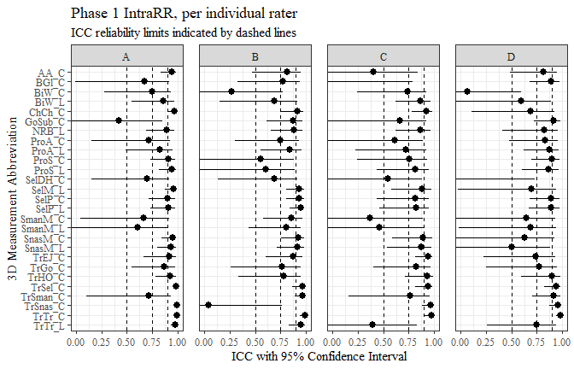

phase_three_intra <- intra_data_all %>%   
 filter(phase == "phase 3")  
  
flextable(phase_three_intra) %>%  
 my_ft_theme()%>%   
 bold(part = "header") %>%   
 set_caption("Phase 3 ICC statistics for IntraRR") %>%   
 fit_to_width(7.5) %>%   
 autofit()

**Table** : Phase 3 ICC statistics for IntraRR

| **measure** | **ICC** | **lower** | **upper** | **phase** | **RR** | **rater** |
| --- | --- | --- | --- | --- | --- | --- |
| AA_C | 0.987 | 0.963 | 0.996 | phase 3 | intra | A |
| BGl_C | 0.960 | 0.871 | 0.991 | phase 3 | intra | A |
| BiW_C | 0.917 | 0.765 | 0.977 | phase 3 | intra | A |
| BiW_L | 0.924 | 0.784 | 0.979 | phase 3 | intra | A |
| ChCh_C | 0.984 | 0.949 | 0.997 | phase 3 | intra | A |
| GoSub_C | 0.937 | 0.811 | 0.984 | phase 3 | intra | A |
| NRB_L | 0.830 | 0.525 | 0.953 | phase 3 | intra | A |
| ProA_L | 0.986 | 0.957 | 0.996 | phase 3 | intra | A |
| ProA_C | 0.975 | 0.927 | 0.993 | phase 3 | intra | A |
| ProS_C | 0.969 | 0.909 | 0.992 | phase 3 | intra | A |
| ProS_L | 0.961 | 0.889 | 0.989 | phase 3 | intra | A |
| SelP_C | 0.991 | 0.973 | 0.997 | phase 3 | intra | A |
| SelP_L | 0.991 | 0.975 | 0.998 | phase 3 | intra | A |
| SelDH_C | 0.926 | 0.787 | 0.980 | phase 3 | intra | A |
| SelM_L | 0.995 | 0.979 | 0.999 | phase 3 | intra | A |
| SnasM_L | 0.980 | 0.904 | 0.997 | phase 3 | intra | A |
| SmanM_C | 0.457 | -1.100 | 0.900 | phase 3 | intra | A |
| SmanM_L | 0.522 | -0.812 | 0.912 | phase 3 | intra | A |
| SnasM_C | 0.954 | 0.807 | 0.992 | phase 3 | intra | A |
| TrHO_C | 0.981 | 0.934 | 0.997 | phase 3 | intra | A |
| TrEJ_C | 0.979 | 0.940 | 0.994 | phase 3 | intra | A |
| TrGo_C | 0.971 | 0.913 | 0.993 | phase 3 | intra | A |
| TrSel_C | 0.993 | 0.979 | 0.998 | phase 3 | intra | A |
| TrSman_C | 0.993 | 0.978 | 0.998 | phase 3 | intra | A |
| TrSnas_C | 0.971 | 0.917 | 0.992 | phase 3 | intra | A |
| TrTr_C | 0.997 | 0.990 | 0.999 | phase 3 | intra | A |
| TrTr_L | 0.998 | 0.995 | 1.000 | phase 3 | intra | A |
| AA_C | 0.974 | 0.927 | 0.993 | phase 3 | intra | B |
| BGl_C | 0.974 | 0.927 | 0.993 | phase 3 | intra | B |
| BiW_C | 0.944 | 0.832 | 0.985 | phase 3 | intra | B |
| BiW_L | 0.915 | 0.740 | 0.977 | phase 3 | intra | B |
| ChCh_C | 0.968 | 0.909 | 0.991 | phase 3 | intra | B |
| GoSub_C | 0.950 | 0.850 | 0.988 | phase 3 | intra | B |
| NRB_L | 0.757 | 0.291 | 0.935 | phase 3 | intra | B |
| ProA_L | 0.974 | 0.924 | 0.993 | phase 3 | intra | B |
| ProA_C | 0.960 | 0.885 | 0.989 | phase 3 | intra | B |
| ProS_C | 0.941 | 0.828 | 0.984 | phase 3 | intra | B |
| ProS_L | 0.931 | 0.799 | 0.981 | phase 3 | intra | B |
| SelP_C | 0.977 | 0.936 | 0.994 | phase 3 | intra | B |
| SelP_L | 0.978 | 0.936 | 0.994 | phase 3 | intra | B |
| SelDH_C | 0.920 | 0.719 | 0.979 | phase 3 | intra | B |
| SelM_L | 0.969 | 0.899 | 0.993 | phase 3 | intra | B |
| SnasM_L | 0.921 | 0.731 | 0.983 | phase 3 | intra | B |
| SmanM_C | 0.740 | 0.093 | 0.944 | phase 3 | intra | B |
| SmanM_L | 0.692 | -0.089 | 0.934 | phase 3 | intra | B |
| SnasM_C | 0.849 | 0.474 | 0.967 | phase 3 | intra | B |
| TrHO_C | 0.970 | 0.911 | 0.993 | phase 3 | intra | B |
| TrEJ_C | 0.935 | 0.814 | 0.982 | phase 3 | intra | B |
| TrGo_C | 0.969 | 0.895 | 0.993 | phase 3 | intra | B |
| TrSel_C | 0.990 | 0.972 | 0.997 | phase 3 | intra | B |
| TrSman_C | 0.997 | 0.989 | 0.999 | phase 3 | intra | B |
| TrSnas_C | 0.988 | 0.964 | 0.997 | phase 3 | intra | B |
| TrTr_C | 0.989 | 0.965 | 0.997 | phase 3 | intra | B |
| TrTr_L | 0.992 | 0.976 | 0.998 | phase 3 | intra | B |
| AA_C | 0.974 | 0.925 | 0.993 | phase 3 | intra | C |
| BGl_C | 0.856 | 0.588 | 0.961 | phase 3 | intra | C |
| BiW_C | 0.849 | 0.523 | 0.960 | phase 3 | intra | C |
| BiW_L | 0.692 | 0.115 | 0.915 | phase 3 | intra | C |
| ChCh_C | 0.924 | 0.783 | 0.979 | phase 3 | intra | C |
| GoSub_C | 0.919 | 0.771 | 0.978 | phase 3 | intra | C |
| NRB_L | 0.384 | -0.654 | 0.828 | phase 3 | intra | C |
| ProA_L | 0.961 | 0.889 | 0.989 | phase 3 | intra | C |
| ProA_C | 0.945 | 0.839 | 0.985 | phase 3 | intra | C |
| ProS_C | 0.686 | 0.047 | 0.916 | phase 3 | intra | C |
| ProS_L | 0.955 | 0.868 | 0.988 | phase 3 | intra | C |
| SelP_C | 0.962 | 0.891 | 0.990 | phase 3 | intra | C |
| SelP_L | 0.970 | 0.914 | 0.992 | phase 3 | intra | C |
| SelDH_C | 0.503 | -0.278 | 0.859 | phase 3 | intra | C |
| SelM_L | 0.977 | 0.924 | 0.995 | phase 3 | intra | C |
| SnasM_L | 0.963 | 0.876 | 0.992 | phase 3 | intra | C |
| SmanM_C | 0.885 | 0.632 | 0.975 | phase 3 | intra | C |
| SmanM_L | 0.879 | 0.613 | 0.973 | phase 3 | intra | C |
| SnasM_C | 0.899 | 0.669 | 0.978 | phase 3 | intra | C |
| TrHO_C | 0.857 | 0.567 | 0.965 | phase 3 | intra | C |
| TrEJ_C | 0.946 | 0.847 | 0.985 | phase 3 | intra | C |
| TrGo_C | 0.871 | 0.624 | 0.965 | phase 3 | intra | C |
| TrSel_C | 0.993 | 0.980 | 0.998 | phase 3 | intra | C |
| TrSman_C | 0.965 | 0.900 | 0.991 | phase 3 | intra | C |
| TrSnas_C | 0.983 | 0.950 | 0.995 | phase 3 | intra | C |
| TrTr_C | 0.993 | 0.979 | 0.998 | phase 3 | intra | C |
| TrTr_L | 0.995 | 0.986 | 0.999 | phase 3 | intra | C |
| AA_C | 0.969 | 0.885 | 0.992 | phase 3 | intra | D |
| BGl_C | 0.947 | 0.832 | 0.987 | phase 3 | intra | D |
| BiW_C | 0.962 | 0.861 | 0.990 | phase 3 | intra | D |
| BiW_L | 0.926 | 0.791 | 0.980 | phase 3 | intra | D |
| ChCh_C | 0.949 | 0.855 | 0.986 | phase 3 | intra | D |
| GoSub_C | 0.944 | 0.817 | 0.988 | phase 3 | intra | D |
| NRB_L | 0.915 | 0.754 | 0.977 | phase 3 | intra | D |
| ProA_L | 0.982 | 0.943 | 0.995 | phase 3 | intra | D |
| ProA_C | 0.964 | 0.887 | 0.990 | phase 3 | intra | D |
| ProS_C | 0.967 | 0.908 | 0.991 | phase 3 | intra | D |
| ProS_L | 0.975 | 0.927 | 0.993 | phase 3 | intra | D |
| SelP_C | 0.992 | 0.976 | 0.998 | phase 3 | intra | D |
| SelP_L | 0.992 | 0.975 | 0.998 | phase 3 | intra | D |
| SelDH_C | 0.943 | 0.836 | 0.985 | phase 3 | intra | D |
| SelM_L | 0.997 | 0.990 | 0.999 | phase 3 | intra | D |
| SnasM_L | 0.989 | 0.962 | 0.998 | phase 3 | intra | D |
| SmanM_C | 0.970 | 0.891 | 0.994 | phase 3 | intra | D |
| SmanM_L | 0.964 | 0.875 | 0.993 | phase 3 | intra | D |
| SnasM_C | 0.986 | 0.951 | 0.997 | phase 3 | intra | D |
| TrHO_C | 0.964 | 0.799 | 0.998 | phase 3 | intra | D |
| TrEJ_C | 0.823 | 0.475 | 0.956 | phase 3 | intra | D |
| TrGo_C | 0.777 | 0.220 | 0.952 | phase 3 | intra | D |
| TrSel_C | 0.732 | 0.204 | 0.933 | phase 3 | intra | D |
| TrSman_C | 0.907 | 0.700 | 0.980 | phase 3 | intra | D |
| TrSnas_C | 0.740 | 0.235 | 0.935 | phase 3 | intra | D |
| TrTr_C | 0.932 | 0.781 | 0.985 | phase 3 | intra | D |
| TrTr_L | 0.995 | 0.985 | 0.999 | phase 3 | intra | D |

phase_three_intra %>%   
 ggplot(aes(x=fct_rev(measure), y=ICC, ymin=lower, ymax=upper))+  
 geom_pointrange()+  
 geom_hline(yintercept = c(0.5, 0.75, 0.9), linetype=2)+  
 coord_flip(ylim = c(0, 1))+  
 facet_grid(cols=vars(rater))+  
 theme_bw()+  
 theme(text=element_text(family= "Times New Roman"))+  
 theme(panel.spacing = unit(1, "lines"))+  
 labs(title="Phase 3 IntraRR, per individual rater",  
 subtitle="ICC reliability limits indicated by dashed lines",  
 x="3D Measurement Abbreviation",  
 y="ICC with 95% Confidence Interval")

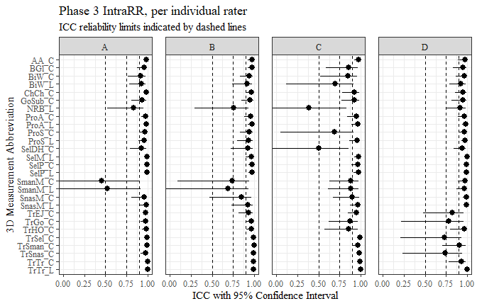

inter_data_all <- read_excel("C:\\Users\\19177\\OneDrive - Colostate\\Desktop\\Dissertation\\headscan_dissertation\\PAPER_1\\inter_ICC_all.xlsx")  
  
inter_data_all <- inter_data_all %>%   
 rename(lower="Lower CI",  
 upper="Upper CI")

flextable(inter_data_all) %>%  
 my_ft_theme()%>%   
 bold(part = "header") %>%   
 set_caption(" ") %>%   
 fit_to_width(7.5) %>%   
 autofit()

**Table** :

| **measure** | **ICC** | **lower** | **upper** | **phase** | **RR** |
| --- | --- | --- | --- | --- | --- |
| AA_C | 0.8740 | 0.673 | 0.964 | phase 1 | inter |
| BGl_C | 0.8270 | 0.476 | 0.966 | phase 1 | inter |
| BiW_C | -0.2010 | -0.718 | 0.575 | phase 1 | inter |
| BiW_L | 0.4130 | -0.158 | 0.803 | phase 1 | inter |
| ChCh_C | 0.8860 | 0.598 | 0.973 | phase 1 | inter |
| GoSub_C | 0.6020 | 0.005 | 0.902 | phase 1 | inter |
| NRB_L | 0.7570 | 0.253 | 0.935 | phase 1 | inter |
| ProA_L | 0.8250 | 0.543 | 0.951 | phase 1 | inter |
| ProA_C | 0.7500 | 0.370 | 0.928 | phase 1 | inter |
| ProS_C | 0.7150 | 0.279 | 0.919 | phase 1 | inter |
| ProS_L | 0.7750 | 0.435 | 0.936 | phase 1 | inter |
| SelP_C | 0.8600 | 0.641 | 0.961 | phase 1 | inter |
| SelP_L | 0.8650 | 0.654 | 0.962 | phase 1 | inter |
| SelDH_C | 0.2690 | -0.244 | 0.726 | phase 1 | inter |
| SelM_L | 0.8640 | 0.434 | 0.975 | phase 1 | inter |
| SnasM_L | 0.8410 | 0.390 | 0.970 | phase 1 | inter |
| SmanM_C | 0.1480 | -2.588 | 0.849 | phase 1 | inter |
| SmanM_L | 0.2850 | -1.895 | 0.872 | phase 1 | inter |
| SnasM_C | 0.8600 | 0.443 | 0.974 | phase 1 | inter |
| TrHO_C | 0.9060 | 0.644 | 0.989 | phase 1 | inter |
| TrEJ_C | 0.7530 | 0.338 | 0.936 | phase 1 | inter |
| TrGo_C | 0.7830 | 0.317 | 0.951 | phase 1 | inter |
| TrSel_C | 0.9540 | 0.931 | 0.989 | phase 1 | inter |
| TrSman_C | 0.5680 | -0.097 | 0.907 | phase 1 | inter |
| TrSnas_C | 0.9730 | 0.921 | 0.993 | phase 1 | inter |
| TrTr_C | 0.9760 | 0.900 | 0.994 | phase 1 | inter |
| TrTr_L | 0.6590 | 0.120 | 0.909 | phase 1 | inter |
| AA_C | 0.9380 | 0.826 | 0.983 | phase 2 | inter |
| BGl_C | 0.9230 | 0.607 | 0.995 | phase 2 | inter |
| BiW_C | 0.6410 | 0.069 | 0.898 | phase 2 | inter |
| BiW_L | 0.6290 | 0.069 | 0.895 | phase 2 | inter |
| ChCh_C | 0.8850 | 0.607 | 0.970 | phase 2 | inter |
| GoSub_C | 0.9210 | 0.755 | 0.980 | phase 2 | inter |
| NRB_L | 0.3650 | -0.051 | 0.759 | phase 2 | inter |
| ProA_L | 0.9170 | 0.741 | 0.978 | phase 2 | inter |
| ProA_C | 0.8790 | 0.573 | 0.969 | phase 2 | inter |
| ProS_C | 0.6740 | 0.152 | 0.915 | phase 2 | inter |
| ProS_L | 0.8110 | 0.491 | 0.951 | phase 2 | inter |
| SelP_C | 0.9590 | 0.851 | 0.990 | phase 2 | inter |
| SelP_L | 0.9600 | 0.861 | 0.990 | phase 2 | inter |
| SelDH_C | 0.8280 | 0.493 | 0.953 | phase 2 | inter |
| SelM_L | 0.6660 | 0.099 | 0.929 | phase 2 | inter |
| SnasM_L | 0.4930 | 0.007 | 0.869 | phase 2 | inter |
| SmanM_C | 0.6190 | 0.009 | 0.917 | phase 2 | inter |
| SmanM_L | 0.6560 | 0.063 | 0.927 | phase 2 | inter |
| SnasM_C | 0.4370 | 0.022 | 0.840 | phase 2 | inter |
| TrHO_C | 0.4000 | -11.069 | 0.988 | phase 2 | inter |
| TrEJ_C | 0.9080 | 0.652 | 0.980 | phase 2 | inter |
| TrGo_C | 0.8500 | 0.531 | 0.966 | phase 2 | inter |
| TrSel_C | 0.9360 | 0.802 | 0.986 | phase 2 | inter |
| TrSman_C | 0.9840 | 0.936 | 0.997 | phase 2 | inter |
| TrSnas_C | 0.9580 | 0.858 | 0.992 | phase 2 | inter |
| TrTr_C | 0.9820 | 0.938 | 0.996 | phase 2 | inter |
| TrTr_L | 0.9970 | 0.991 | 0.999 | phase 2 | inter |
| AA_C | 0.9520 | 0.838 | 0.987 | phase 3 | inter |
| BGl_C | 0.0432 | -0.002 | 0.224 | phase 3 | inter |
| BiW_C | 0.6890 | 0.116 | 0.915 | phase 3 | inter |
| BiW_L | 0.5380 | 0.016 | 0.856 | phase 3 | inter |
| ChCh_C | 0.9660 | 0.871 | 0.993 | phase 3 | inter |
| GoSub_C | 0.9230 | 0.779 | 0.983 | phase 3 | inter |
| NRB_L | 0.2450 | -0.130 | 0.678 | phase 3 | inter |
| ProA_L | 0.9500 | 0.833 | 0.987 | phase 3 | inter |
| ProA_C | 0.9310 | 0.778 | 0.982 | phase 3 | inter |
| ProS_C | 0.8500 | 0.616 | 0.958 | phase 3 | inter |
| ProS_L | 0.9380 | 0.825 | 0.983 | phase 3 | inter |
| SelP_C | 0.9670 | 0.892 | 0.991 | phase 3 | inter |
| SelP_L | 0.9680 | 0.892 | 0.992 | phase 3 | inter |
| SelDH_C | 0.8250 | 0.497 | 0.952 | phase 3 | inter |
| SelM_L | 0.8730 | 0.373 | 0.978 | phase 3 | inter |
| SnasM_L | 0.8090 | 0.239 | 0.970 | phase 3 | inter |
| SmanM_C | 0.3290 | -0.383 | 0.836 | phase 3 | inter |
| SmanM_L | 0.2990 | -0.443 | 0.830 | phase 3 | inter |
| SnasM_C | 0.5210 | 0.009 | 0.881 | phase 3 | inter |
| TrHO_C | 0.8710 | 0.452 | 0.991 | phase 3 | inter |
| TrEJ_C | 0.7760 | 0.346 | 0.943 | phase 3 | inter |
| TrGo_C | 0.8800 | 0.631 | 0.977 | phase 3 | inter |
| TrSel_C | 0.8660 | 0.641 | 0.966 | phase 3 | inter |
| TrSman_C | 0.9490 | 0.849 | 0.989 | phase 3 | inter |
| TrSnas_C | 0.9910 | 0.972 | 0.998 | phase 3 | inter |
| TrTr_C | 0.9580 | 0.861 | 0.991 | phase 3 | inter |
| TrTr_L | 0.9890 | 0.963 | 0.997 | phase 3 | inter |

phase_one_inter <- inter_data_all %>%   
 filter(phase == "phase 1")  
  
flextable(phase_one_inter) %>%  
 my_ft_theme()%>%   
 bold(part = "header") %>%   
 set_caption("Phase 1 ICC statistics for InterRR") %>%   
 fit_to_width(7.5) %>%   
 autofit()

**Table** : Phase 1 ICC statistics for InterRR

| **measure** | **ICC** | **lower** | **upper** | **phase** | **RR** |
| --- | --- | --- | --- | --- | --- |
| AA_C | 0.874 | 0.673 | 0.964 | phase 1 | inter |
| BGl_C | 0.827 | 0.476 | 0.966 | phase 1 | inter |
| BiW_C | -0.201 | -0.718 | 0.575 | phase 1 | inter |
| BiW_L | 0.413 | -0.158 | 0.803 | phase 1 | inter |
| ChCh_C | 0.886 | 0.598 | 0.973 | phase 1 | inter |
| GoSub_C | 0.602 | 0.005 | 0.902 | phase 1 | inter |
| NRB_L | 0.757 | 0.253 | 0.935 | phase 1 | inter |
| ProA_L | 0.825 | 0.543 | 0.951 | phase 1 | inter |
| ProA_C | 0.750 | 0.370 | 0.928 | phase 1 | inter |
| ProS_C | 0.715 | 0.279 | 0.919 | phase 1 | inter |
| ProS_L | 0.775 | 0.435 | 0.936 | phase 1 | inter |
| SelP_C | 0.860 | 0.641 | 0.961 | phase 1 | inter |
| SelP_L | 0.865 | 0.654 | 0.962 | phase 1 | inter |
| SelDH_C | 0.269 | -0.244 | 0.726 | phase 1 | inter |
| SelM_L | 0.864 | 0.434 | 0.975 | phase 1 | inter |
| SnasM_L | 0.841 | 0.390 | 0.970 | phase 1 | inter |
| SmanM_C | 0.148 | -2.588 | 0.849 | phase 1 | inter |
| SmanM_L | 0.285 | -1.895 | 0.872 | phase 1 | inter |
| SnasM_C | 0.860 | 0.443 | 0.974 | phase 1 | inter |
| TrHO_C | 0.906 | 0.644 | 0.989 | phase 1 | inter |
| TrEJ_C | 0.753 | 0.338 | 0.936 | phase 1 | inter |
| TrGo_C | 0.783 | 0.317 | 0.951 | phase 1 | inter |
| TrSel_C | 0.954 | 0.931 | 0.989 | phase 1 | inter |
| TrSman_C | 0.568 | -0.097 | 0.907 | phase 1 | inter |
| TrSnas_C | 0.973 | 0.921 | 0.993 | phase 1 | inter |
| TrTr_C | 0.976 | 0.900 | 0.994 | phase 1 | inter |
| TrTr_L | 0.659 | 0.120 | 0.909 | phase 1 | inter |

phase_one_inter %>%   
 ggplot(aes(x=fct_rev(measure), y=ICC, ymin=lower, ymax=upper))+  
 geom_pointrange()+  
 geom_hline(yintercept = c(0.5, 0.75, 0.9), linetype=2)+  
 coord_flip(ylim = c(0, 1))+  
 #facet_grid(cols=vars(rater))+  
 theme_bw()+  
 theme(text=element_text(family= "Times New Roman"))+  
 labs(title="Phase 1 InterRR, for all raters",  
 subtitle="ICC reliability limits indicated by dashed lines",  
 x="3D Measurement Abbreviation",  
 y="ICC with 95% Confidence Interval")

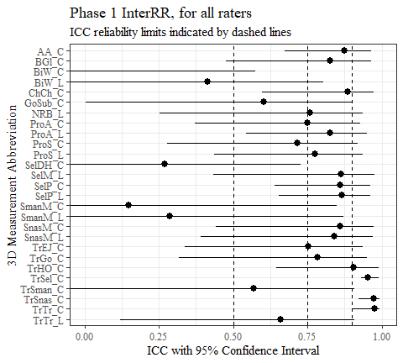

phase_two_inter <- inter_data_all %>%   
 filter(phase == "phase 2")  
  
flextable(phase_two_inter) %>%  
 my_ft_theme()%>%   
 bold(part = "header") %>%   
 set_caption("Phase 2 ICC statistics for InterRR") %>%   
 fit_to_width(7.5) %>%   
 autofit()

**Table** : Phase 2 ICC statistics for InterRR

| **measure** | **ICC** | **lower** | **upper** | **phase** | **RR** |
| --- | --- | --- | --- | --- | --- |
| AA_C | 0.938 | 0.826 | 0.983 | phase 2 | inter |
| BGl_C | 0.923 | 0.607 | 0.995 | phase 2 | inter |
| BiW_C | 0.641 | 0.069 | 0.898 | phase 2 | inter |
| BiW_L | 0.629 | 0.069 | 0.895 | phase 2 | inter |
| ChCh_C | 0.885 | 0.607 | 0.970 | phase 2 | inter |
| GoSub_C | 0.921 | 0.755 | 0.980 | phase 2 | inter |
| NRB_L | 0.365 | -0.051 | 0.759 | phase 2 | inter |
| ProA_L | 0.917 | 0.741 | 0.978 | phase 2 | inter |
| ProA_C | 0.879 | 0.573 | 0.969 | phase 2 | inter |
| ProS_C | 0.674 | 0.152 | 0.915 | phase 2 | inter |
| ProS_L | 0.811 | 0.491 | 0.951 | phase 2 | inter |
| SelP_C | 0.959 | 0.851 | 0.990 | phase 2 | inter |
| SelP_L | 0.960 | 0.861 | 0.990 | phase 2 | inter |
| SelDH_C | 0.828 | 0.493 | 0.953 | phase 2 | inter |
| SelM_L | 0.666 | 0.099 | 0.929 | phase 2 | inter |
| SnasM_L | 0.493 | 0.007 | 0.869 | phase 2 | inter |
| SmanM_C | 0.619 | 0.009 | 0.917 | phase 2 | inter |
| SmanM_L | 0.656 | 0.063 | 0.927 | phase 2 | inter |
| SnasM_C | 0.437 | 0.022 | 0.840 | phase 2 | inter |
| TrHO_C | 0.400 | -11.069 | 0.988 | phase 2 | inter |
| TrEJ_C | 0.908 | 0.652 | 0.980 | phase 2 | inter |
| TrGo_C | 0.850 | 0.531 | 0.966 | phase 2 | inter |
| TrSel_C | 0.936 | 0.802 | 0.986 | phase 2 | inter |
| TrSman_C | 0.984 | 0.936 | 0.997 | phase 2 | inter |
| TrSnas_C | 0.958 | 0.858 | 0.992 | phase 2 | inter |
| TrTr_C | 0.982 | 0.938 | 0.996 | phase 2 | inter |
| TrTr_L | 0.997 | 0.991 | 0.999 | phase 2 | inter |

phase_two_inter %>%   
 ggplot(aes(x=fct_rev(measure), y=ICC, ymin=lower, ymax=upper))+  
 geom_pointrange()+  
 geom_hline(yintercept = c(0.5, 0.75, 0.9), linetype=2)+  
 coord_flip(ylim = c(0, 1))+  
 #facet_grid(cols=vars(rater))+  
 theme_bw()+  
 theme(text=element_text(family= "Times New Roman"))+  
 labs(title="Phase 2 InterRR, for all raters",  
 subtitle="ICC reliability limits indicated by dashed lines",  
 x="3D Measurement Abbreviation",  
 y="ICC with 95% Confidence Interval")

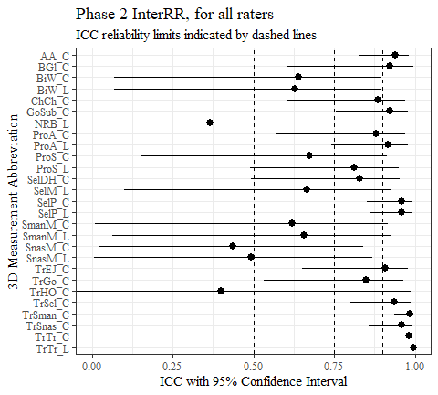

phase_three_inter <- inter_data_all %>%   
 filter(phase == "phase 3")  
  
flextable(phase_three_inter) %>%  
 my_ft_theme()%>%   
 bold(part = "header") %>%   
 set_caption("Phase 3 ICC statistics for InterRR") %>%   
 fit_to_width(7.5) %>%   
 autofit()

**Table** : Phase 3 ICC statistics for InterRR

| **measure** | **ICC** | **lower** | **upper** | **phase** | **RR** |
| --- | --- | --- | --- | --- | --- |
| AA_C | 0.9520 | 0.838 | 0.987 | phase 3 | inter |
| BGl_C | 0.0432 | -0.002 | 0.224 | phase 3 | inter |
| BiW_C | 0.6890 | 0.116 | 0.915 | phase 3 | inter |
| BiW_L | 0.5380 | 0.016 | 0.856 | phase 3 | inter |
| ChCh_C | 0.9660 | 0.871 | 0.993 | phase 3 | inter |
| GoSub_C | 0.9230 | 0.779 | 0.983 | phase 3 | inter |
| NRB_L | 0.2450 | -0.130 | 0.678 | phase 3 | inter |
| ProA_L | 0.9500 | 0.833 | 0.987 | phase 3 | inter |
| ProA_C | 0.9310 | 0.778 | 0.982 | phase 3 | inter |
| ProS_C | 0.8500 | 0.616 | 0.958 | phase 3 | inter |
| ProS_L | 0.9380 | 0.825 | 0.983 | phase 3 | inter |
| SelP_C | 0.9670 | 0.892 | 0.991 | phase 3 | inter |
| SelP_L | 0.9680 | 0.892 | 0.992 | phase 3 | inter |
| SelDH_C | 0.8250 | 0.497 | 0.952 | phase 3 | inter |
| SelM_L | 0.8730 | 0.373 | 0.978 | phase 3 | inter |
| SnasM_L | 0.8090 | 0.239 | 0.970 | phase 3 | inter |
| SmanM_C | 0.3290 | -0.383 | 0.836 | phase 3 | inter |
| SmanM_L | 0.2990 | -0.443 | 0.830 | phase 3 | inter |
| SnasM_C | 0.5210 | 0.009 | 0.881 | phase 3 | inter |
| TrHO_C | 0.8710 | 0.452 | 0.991 | phase 3 | inter |
| TrEJ_C | 0.7760 | 0.346 | 0.943 | phase 3 | inter |
| TrGo_C | 0.8800 | 0.631 | 0.977 | phase 3 | inter |
| TrSel_C | 0.8660 | 0.641 | 0.966 | phase 3 | inter |
| TrSman_C | 0.9490 | 0.849 | 0.989 | phase 3 | inter |
| TrSnas_C | 0.9910 | 0.972 | 0.998 | phase 3 | inter |
| TrTr_C | 0.9580 | 0.861 | 0.991 | phase 3 | inter |
| TrTr_L | 0.9890 | 0.963 | 0.997 | phase 3 | inter |

phase_three_inter %>%   
 ggplot(aes(x=fct_rev(measure), y=ICC, ymin=lower, ymax=upper))+  
 geom_pointrange()+  
 geom_hline(yintercept = c(0.5, 0.75, 0.9), linetype=2)+  
 coord_flip(ylim = c(0, 1))+  
 #facet_grid(cols=vars(rater))+  
 theme_bw()+  
 theme(text=element_text(family= "Times New Roman"))+  
 labs(title="Phase 3 InterRR, for all raters",  
 subtitle="ICC reliability limits indicated by dashed lines",  
 x="3D Measurement Abbreviation",  
 y="ICC with 95% Confidence Interval")

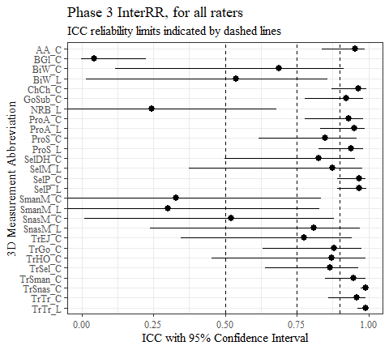

rater_a_data <- intra_data_all %>%   
 filter(rater == "A")  
  
flextable(rater_a_data) %>%  
 my_ft_theme()%>%   
 bold(part = "header") %>%   
 set_caption("Rater A ICC statistics for IntraRR, Phases 1 and 3") %>%   
 fit_to_width(7.5) %>%   
 autofit()

**Table** : Rater A ICC statistics for IntraRR, Phases 1 and 3

| **measure** | **ICC** | **lower** | **upper** | **phase** | **RR** | **rater** |
| --- | --- | --- | --- | --- | --- | --- |
| AA_C | 0.944 | 0.835 | 0.985 | phase 1 | intra | A |
| BGl_C | 0.675 | -0.012 | 0.914 | phase 1 | intra | A |
| BiW_C | 0.745 | 0.275 | 0.930 | phase 1 | intra | A |
| BiW_L | 0.859 | 0.546 | 0.963 | phase 1 | intra | A |
| ChCh_C | 0.968 | 0.907 | 0.992 | phase 1 | intra | A |
| GoSub_C | 0.418 | -0.596 | 0.850 | phase 1 | intra | A |
| NRB_L | 0.891 | 0.693 | 0.970 | phase 1 | intra | A |
| ProA_L | 0.824 | 0.486 | 0.952 | phase 1 | intra | A |
| ProA_C | 0.715 | 0.150 | 0.924 | phase 1 | intra | A |
| ProS_C | 0.907 | 0.730 | 0.975 | phase 1 | intra | A |
| ProS_L | 0.938 | 0.817 | 0.983 | phase 1 | intra | A |
| SelP_C | 0.899 | 0.716 | 0.972 | phase 1 | intra | A |
| SelP_L | 0.906 | 0.733 | 0.975 | phase 1 | intra | A |
| SelDH_C | 0.698 | 0.155 | 0.916 | phase 1 | intra | A |
| SelM_L | 0.958 | 0.872 | 0.989 | phase 1 | intra | A |
| SnasM_L | 0.933 | 0.798 | 0.983 | phase 1 | intra | A |
| SmanM_C | 0.661 | 0.041 | 0.914 | phase 1 | intra | A |
| SmanM_L | 0.608 | -0.086 | 0.899 | phase 1 | intra | A |
| SnasM_C | 0.947 | 0.838 | 0.987 | phase 1 | intra | A |
| TrHO_C | 0.926 | 0.778 | 0.982 | phase 1 | intra | A |
| TrEJ_C | 0.918 | 0.665 | 0.981 | phase 1 | intra | A |
| TrGo_C | 0.869 | 0.547 | 0.972 | phase 1 | intra | A |
| TrSel_C | 0.987 | 0.960 | 0.997 | phase 1 | intra | A |
| TrSman_C | 0.711 | 0.100 | 0.936 | phase 1 | intra | A |
| TrSnas_C | 0.995 | 0.983 | 0.999 | phase 1 | intra | A |
| TrTr_C | 0.988 | 0.963 | 0.997 | phase 1 | intra | A |
| TrTr_L | 0.978 | 0.935 | 0.995 | phase 1 | intra | A |
| AA_C | 0.987 | 0.963 | 0.996 | phase 3 | intra | A |
| BGl_C | 0.960 | 0.871 | 0.991 | phase 3 | intra | A |
| BiW_C | 0.917 | 0.765 | 0.977 | phase 3 | intra | A |
| BiW_L | 0.924 | 0.784 | 0.979 | phase 3 | intra | A |
| ChCh_C | 0.984 | 0.949 | 0.997 | phase 3 | intra | A |
| GoSub_C | 0.937 | 0.811 | 0.984 | phase 3 | intra | A |
| NRB_L | 0.830 | 0.525 | 0.953 | phase 3 | intra | A |
| ProA_L | 0.986 | 0.957 | 0.996 | phase 3 | intra | A |
| ProA_C | 0.975 | 0.927 | 0.993 | phase 3 | intra | A |
| ProS_C | 0.969 | 0.909 | 0.992 | phase 3 | intra | A |
| ProS_L | 0.961 | 0.889 | 0.989 | phase 3 | intra | A |
| SelP_C | 0.991 | 0.973 | 0.997 | phase 3 | intra | A |
| SelP_L | 0.991 | 0.975 | 0.998 | phase 3 | intra | A |
| SelDH_C | 0.926 | 0.787 | 0.980 | phase 3 | intra | A |
| SelM_L | 0.995 | 0.979 | 0.999 | phase 3 | intra | A |
| SnasM_L | 0.980 | 0.904 | 0.997 | phase 3 | intra | A |
| SmanM_C | 0.457 | -1.100 | 0.900 | phase 3 | intra | A |
| SmanM_L | 0.522 | -0.812 | 0.912 | phase 3 | intra | A |
| SnasM_C | 0.954 | 0.807 | 0.992 | phase 3 | intra | A |
| TrHO_C | 0.981 | 0.934 | 0.997 | phase 3 | intra | A |
| TrEJ_C | 0.979 | 0.940 | 0.994 | phase 3 | intra | A |
| TrGo_C | 0.971 | 0.913 | 0.993 | phase 3 | intra | A |
| TrSel_C | 0.993 | 0.979 | 0.998 | phase 3 | intra | A |
| TrSman_C | 0.993 | 0.978 | 0.998 | phase 3 | intra | A |
| TrSnas_C | 0.971 | 0.917 | 0.992 | phase 3 | intra | A |
| TrTr_C | 0.997 | 0.990 | 0.999 | phase 3 | intra | A |
| TrTr_L | 0.998 | 0.995 | 1.000 | phase 3 | intra | A |

rater_a_data$phase <- recode_factor(rater_a_data$phase,   
 'phase 1' = "Phase 1",  
 'phase 3' = "Phase 3")  
  
rater_a_data %>%   
 ggplot(aes(x=fct_reorder(measure, ICC), y=ICC, ymin=lower, ymax=upper))+  
 geom_pointrange()+  
 geom_hline(yintercept = c(0.5, 0.75, 0.9), linetype=2)+  
 coord_flip(ylim = c(0, 1))+  
 facet_grid(cols=vars(phase))+  
 theme_bw()+  
 theme(text=element_text(family= "Times New Roman"))+  
 labs(title="Rater A IntraRR, Phases 1 and 3",  
 subtitle="ICC reliability limits indicated by dashed lines",  
 x="3D Measurement Abbreviation",  
 y="ICC with 95% Confidence Interval")

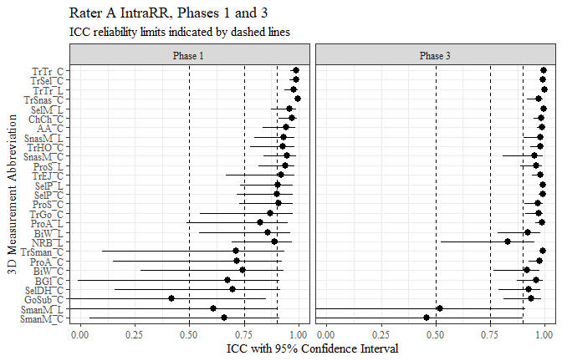

rater_a_data$intraRR <- as.factor(ifelse(rater_a_data$ICC < 0.5, 'Poor',  
 ifelse(rater_a_data$ICC < 0.75, 'Moderate',  
 ifelse(rater_a_data$ICC < 0.9, 'Good',  
 ifelse(rater_a_data$ICC < 1, 'Excellent')))))  
  
  
   
rater_a_data %>%   
 ggplot(aes(x=intraRR, label=stat(count)))+  
 geom_histogram(stat="count", color= "black", fill = "white")+  
 geom_text(stat="count",  
 position= position_dodge(0.9),  
 vjust = -0.5,   
 size = 3)+  
 facet_grid(cols=vars(phase))+  
 theme_bw()+  
 theme(text=element_text(family= "Times New Roman"))+  
 labs(title="Rater A IntraRR, Phases 1 and 3",  
 subtitle="Comparison of reliabilities",  
 x="IntraRR",  
 y="Count")

## Warning: Ignoring unknown parameters: binwidth, bins, pad

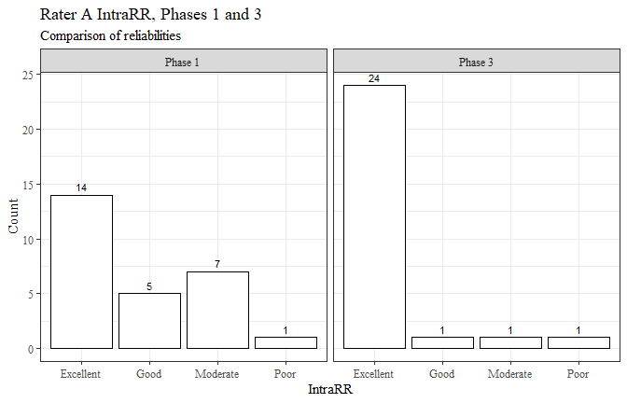

rater_b_data <- intra_data_all %>%   
 filter(rater == "B")  
  
flextable(rater_b_data) %>%  
 my_ft_theme()%>%   
 bold(part = "header") %>%   
 set_caption("Rater B ICC statistics for IntraRR, Phases 1 and 3") %>%   
 fit_to_width(7.5) %>%   
 autofit()

**Table** : Rater B ICC statistics for IntraRR, Phases 1 and 3

| **measure** | **ICC** | **lower** | **upper** | **phase** | **RR** | **rater** |
| --- | --- | --- | --- | --- | --- | --- |
| AA_C | 0.8170 | 0.466 | 0.950 | phase 1 | intra | B |
| BGl_C | 0.7700 | 0.331 | 0.938 | phase 1 | intra | B |
| BiW_C | 0.2670 | -0.612 | 0.774 | phase 1 | intra | B |
| BiW_L | 0.6870 | 0.153 | 0.912 | phase 1 | intra | B |
| ChCh_C | 0.9160 | 0.758 | 0.977 | phase 1 | intra | B |
| GoSub_C | 0.8700 | 0.609 | 0.968 | phase 1 | intra | B |
| NRB_L | 0.8860 | 0.655 | 0.969 | phase 1 | intra | B |
| ProA_L | 0.8430 | 0.558 | 0.957 | phase 1 | intra | B |
| ProA_C | 0.7510 | 0.302 | 0.932 | phase 1 | intra | B |
| ProS_C | 0.5500 | -0.322 | 0.879 | phase 1 | intra | B |
| ProS_L | 0.6070 | -0.085 | 0.892 | phase 1 | intra | B |
| SelP_C | 0.9320 | 0.807 | 0.982 | phase 1 | intra | B |
| SelP_L | 0.9450 | 0.843 | 0.985 | phase 1 | intra | B |
| SelDH_C | 0.6920 | 0.134 | 0.914 | phase 1 | intra | B |
| SelM_L | 0.9340 | 0.803 | 0.984 | phase 1 | intra | B |
| SnasM_L | 0.9170 | 0.713 | 0.980 | phase 1 | intra | B |
| SmanM_C | 0.8580 | 0.579 | 0.965 | phase 1 | intra | B |
| SmanM_L | 0.8100 | 0.438 | 0.953 | phase 1 | intra | B |
| SnasM_C | 0.9210 | 0.755 | 0.981 | phase 1 | intra | B |
| TrHO_C | 0.7810 | 0.336 | 0.945 | phase 1 | intra | B |
| TrEJ_C | 0.8760 | 0.601 | 0.970 | phase 1 | intra | B |
| TrGo_C | 0.7620 | 0.259 | 0.947 | phase 1 | intra | B |
| TrSel_C | 0.9670 | 0.869 | 0.992 | phase 1 | intra | B |
| TrSman_C | 0.9650 | 0.888 | 0.992 | phase 1 | intra | B |
| TrSnas_C | 0.0408 | -1.913 | 0.762 | phase 1 | intra | B |
| TrTr_C | 0.9880 | 0.944 | 0.997 | phase 1 | intra | B |
| TrTr_L | 0.9510 | 0.829 | 0.988 | phase 1 | intra | B |
| AA_C | 0.9740 | 0.927 | 0.993 | phase 3 | intra | B |
| BGl_C | 0.9740 | 0.927 | 0.993 | phase 3 | intra | B |
| BiW_C | 0.9440 | 0.832 | 0.985 | phase 3 | intra | B |
| BiW_L | 0.9150 | 0.740 | 0.977 | phase 3 | intra | B |
| ChCh_C | 0.9680 | 0.909 | 0.991 | phase 3 | intra | B |
| GoSub_C | 0.9500 | 0.850 | 0.988 | phase 3 | intra | B |
| NRB_L | 0.7570 | 0.291 | 0.935 | phase 3 | intra | B |
| ProA_L | 0.9740 | 0.924 | 0.993 | phase 3 | intra | B |
| ProA_C | 0.9600 | 0.885 | 0.989 | phase 3 | intra | B |
| ProS_C | 0.9410 | 0.828 | 0.984 | phase 3 | intra | B |
| ProS_L | 0.9310 | 0.799 | 0.981 | phase 3 | intra | B |
| SelP_C | 0.9770 | 0.936 | 0.994 | phase 3 | intra | B |
| SelP_L | 0.9780 | 0.936 | 0.994 | phase 3 | intra | B |
| SelDH_C | 0.9200 | 0.719 | 0.979 | phase 3 | intra | B |
| SelM_L | 0.9690 | 0.899 | 0.993 | phase 3 | intra | B |
| SnasM_L | 0.9210 | 0.731 | 0.983 | phase 3 | intra | B |
| SmanM_C | 0.7400 | 0.093 | 0.944 | phase 3 | intra | B |
| SmanM_L | 0.6920 | -0.089 | 0.934 | phase 3 | intra | B |
| SnasM_C | 0.8490 | 0.474 | 0.967 | phase 3 | intra | B |
| TrHO_C | 0.9700 | 0.911 | 0.993 | phase 3 | intra | B |
| TrEJ_C | 0.9350 | 0.814 | 0.982 | phase 3 | intra | B |
| TrGo_C | 0.9690 | 0.895 | 0.993 | phase 3 | intra | B |
| TrSel_C | 0.9900 | 0.972 | 0.997 | phase 3 | intra | B |
| TrSman_C | 0.9970 | 0.989 | 0.999 | phase 3 | intra | B |
| TrSnas_C | 0.9880 | 0.964 | 0.997 | phase 3 | intra | B |
| TrTr_C | 0.9890 | 0.965 | 0.997 | phase 3 | intra | B |
| TrTr_L | 0.9920 | 0.976 | 0.998 | phase 3 | intra | B |

rater_b_data$phase <- recode_factor(rater_b_data$phase,   
 'phase 1' = "Phase 1",  
 'phase 3' = "Phase 3")  
  
rater_b_data %>%   
 ggplot(aes(x=fct_reorder(measure, ICC), y=ICC, ymin=lower, ymax=upper))+  
 geom_pointrange()+  
 geom_hline(yintercept = c(0.5, 0.75, 0.9), linetype=2)+  
 coord_flip(ylim = c(0, 1))+  
 facet_grid(cols=vars(phase))+  
 theme_bw()+  
 theme(text=element_text(family= "Times New Roman"))+  
 labs(title="Rater B IntraRR, Phases 1 and 3",  
 subtitle="ICC reliability limits indicated by dashed lines",  
 x="3D Measurement Abbreviation",  
 y="ICC with 95% Confidence Interval")

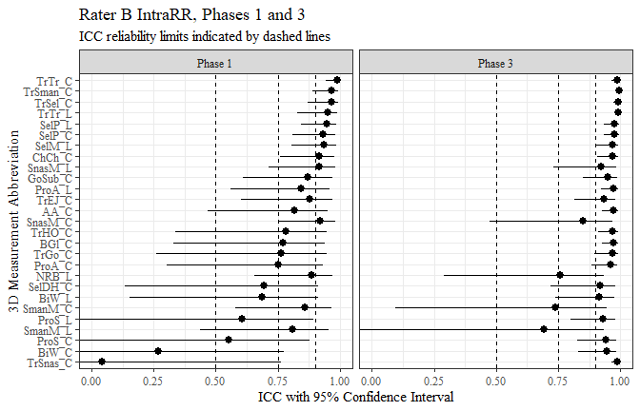

rater_b_data$intraRR <- as.factor(ifelse(rater_b_data$ICC < 0.5, 'Poor',  
 ifelse(rater_b_data$ICC < 0.75, 'Moderate',  
 ifelse(rater_b_data$ICC < 0.9, 'Good',  
 ifelse(rater_b_data$ICC < 1, 'Excellent')))))  
  
  
   
rater_b_data %>%   
 ggplot(aes(x=intraRR, label=stat(count)))+  
 geom_histogram(stat="count", color= "black", fill = "white")+  
 geom_text(stat="count",  
 position= position_dodge(0.9),  
 vjust = -0.5,   
 size = 3)+  
 facet_grid(cols=vars(phase))+  
 theme_bw()+  
 theme(text=element_text(family= "Times New Roman"))+  
 labs(title="Rater B IntraRR, Phases 1 and 3",  
 subtitle="Comparison of reliabilities",  
 x="IntraRR",  
 y="Count")

## Warning: Ignoring unknown parameters: binwidth, bins, pad

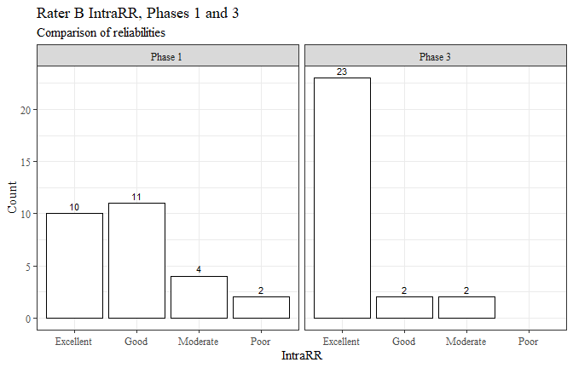

rater_c_data <- intra_data_all %>%   
 filter(rater == "C")  
  
flextable(rater_c_data) %>%  
 my_ft_theme()%>%   
 bold(part = "header") %>%   
 set_caption("Rater C ICC statistics for IntraRR, Phases 1 and 3") %>%   
 fit_to_width(7.5) %>%   
 autofit()

**Table** : Rater C ICC statistics for IntraRR, Phases 1 and 3

| **measure** | **ICC** | **lower** | **upper** | **phase** | **RR** | **rater** |
| --- | --- | --- | --- | --- | --- | --- |
| AA_C | 0.402 | -0.656 | 0.835 | phase 1 | intra | C |
| BGl_C | -0.201 | -4.682 | 0.787 | phase 1 | intra | C |
| BiW_C | 0.734 | 0.246 | 0.927 | phase 1 | intra | C |
| BiW_L | 0.866 | 0.623 | 0.963 | phase 1 | intra | C |
| ChCh_C | 0.922 | 0.779 | 0.979 | phase 1 | intra | C |
| GoSub_C | 0.665 | -0.071 | 0.926 | phase 1 | intra | C |
| NRB_L | 0.865 | 0.617 | 0.963 | phase 1 | intra | C |
| ProA_L | 0.718 | 0.229 | 0.922 | phase 1 | intra | C |
| ProA_C | 0.612 | -0.048 | 0.892 | phase 1 | intra | C |
| ProS_C | 0.752 | 0.244 | 0.934 | phase 1 | intra | C |
| ProS_L | 0.814 | 0.435 | 0.950 | phase 1 | intra | C |
| SelP_C | 0.810 | 0.432 | 0.949 | phase 1 | intra | C |
| SelP_L | 0.820 | 0.460 | 0.952 | phase 1 | intra | C |
| SelDH_C | 0.542 | -0.463 | 0.880 | phase 1 | intra | C |
| SelM_L | 0.879 | 0.576 | 0.977 | phase 1 | intra | C |
| SnasM_L | 0.870 | 0.533 | 0.975 | phase 1 | intra | C |
| SmanM_C | 0.369 | -2.046 | 0.890 | phase 1 | intra | C |
| SmanM_L | 0.464 | -1.507 | 0.906 | phase 1 | intra | C |
| SnasM_C | 0.889 | 0.591 | 0.979 | phase 1 | intra | C |
| TrHO_C | 0.928 | 0.717 | 0.989 | phase 1 | intra | C |
| TrEJ_C | 0.939 | 0.810 | 0.985 | phase 1 | intra | C |
| TrGo_C | 0.822 | 0.403 | 0.961 | phase 1 | intra | C |
| TrSel_C | 0.937 | 0.810 | 0.984 | phase 1 | intra | C |
| TrSman_C | 0.765 | 0.162 | 0.956 | phase 1 | intra | C |
| TrSnas_C | 0.966 | 0.885 | 0.992 | phase 1 | intra | C |
| TrTr_C | 0.971 | 0.910 | 0.993 | phase 1 | intra | C |
| TrTr_L | 0.390 | -0.402 | 0.828 | phase 1 | intra | C |
| AA_C | 0.974 | 0.925 | 0.993 | phase 3 | intra | C |
| BGl_C | 0.856 | 0.588 | 0.961 | phase 3 | intra | C |
| BiW_C | 0.849 | 0.523 | 0.960 | phase 3 | intra | C |
| BiW_L | 0.692 | 0.115 | 0.915 | phase 3 | intra | C |
| ChCh_C | 0.924 | 0.783 | 0.979 | phase 3 | intra | C |
| GoSub_C | 0.919 | 0.771 | 0.978 | phase 3 | intra | C |
| NRB_L | 0.384 | -0.654 | 0.828 | phase 3 | intra | C |
| ProA_L | 0.961 | 0.889 | 0.989 | phase 3 | intra | C |
| ProA_C | 0.945 | 0.839 | 0.985 | phase 3 | intra | C |
| ProS_C | 0.686 | 0.047 | 0.916 | phase 3 | intra | C |
| ProS_L | 0.955 | 0.868 | 0.988 | phase 3 | intra | C |
| SelP_C | 0.962 | 0.891 | 0.990 | phase 3 | intra | C |
| SelP_L | 0.970 | 0.914 | 0.992 | phase 3 | intra | C |
| SelDH_C | 0.503 | -0.278 | 0.859 | phase 3 | intra | C |
| SelM_L | 0.977 | 0.924 | 0.995 | phase 3 | intra | C |
| SnasM_L | 0.963 | 0.876 | 0.992 | phase 3 | intra | C |
| SmanM_C | 0.885 | 0.632 | 0.975 | phase 3 | intra | C |
| SmanM_L | 0.879 | 0.613 | 0.973 | phase 3 | intra | C |
| SnasM_C | 0.899 | 0.669 | 0.978 | phase 3 | intra | C |
| TrHO_C | 0.857 | 0.567 | 0.965 | phase 3 | intra | C |
| TrEJ_C | 0.946 | 0.847 | 0.985 | phase 3 | intra | C |
| TrGo_C | 0.871 | 0.624 | 0.965 | phase 3 | intra | C |
| TrSel_C | 0.993 | 0.980 | 0.998 | phase 3 | intra | C |
| TrSman_C | 0.965 | 0.900 | 0.991 | phase 3 | intra | C |
| TrSnas_C | 0.983 | 0.950 | 0.995 | phase 3 | intra | C |
| TrTr_C | 0.993 | 0.979 | 0.998 | phase 3 | intra | C |
| TrTr_L | 0.995 | 0.986 | 0.999 | phase 3 | intra | C |

rater_c_data$phase <- recode_factor(rater_c_data$phase,   
 'phase 1' = "Phase 1",  
 'phase 3' = "Phase 3")  
  
rater_c_data %>%   
 ggplot(aes(x=fct_reorder(measure, ICC), y=ICC, ymin=lower, ymax=upper))+  
 geom_pointrange()+  
 geom_hline(yintercept = c(0.5, 0.75, 0.9), linetype=2)+  
 coord_flip(ylim = c(0, 1))+  
 facet_grid(cols=vars(phase))+  
 theme_bw()+  
 theme(text=element_text(family= "Times New Roman"))+  
 labs(title="Rater C IntraRR, Phases 1 and 3",  
 subtitle="ICC reliability limits indicated by dashed lines",  
 x="3D Measurement Abbreviation",  
 y="ICC with 95% Confidence Interval")

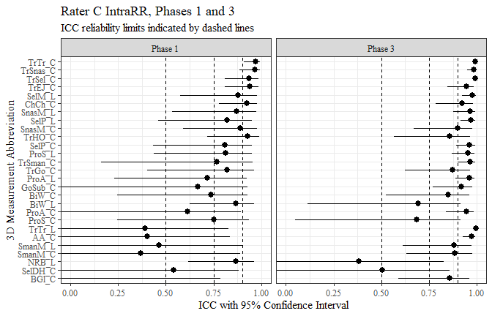

rater_c_data$intraRR <- as.factor(ifelse(rater_c_data$ICC < 0.5, 'Poor',  
 ifelse(rater_c_data$ICC < 0.75, 'Moderate',  
 ifelse(rater_c_data$ICC < 0.9, 'Good',  
 ifelse(rater_c_data$ICC < 1, 'Excellent')))))  
  
  
   
rater_c_data %>%   
 ggplot(aes(x=intraRR, label=stat(count)))+  
 geom_histogram(stat="count", color= "black", fill = "white")+  
 geom_text(stat="count",  
 position= position_dodge(0.9),  
 vjust = -0.5,   
 size = 3)+  
 facet_grid(cols=vars(phase))+  
 theme_bw()+  
 theme(text=element_text(family= "Times New Roman"))+  
 labs(title="Rater C IntraRR, Phases 1 and 3",  
 subtitle="Comparison of reliabilities",  
 x="IntraRR",  
 y="Count")

## Warning: Ignoring unknown parameters: binwidth, bins, pad

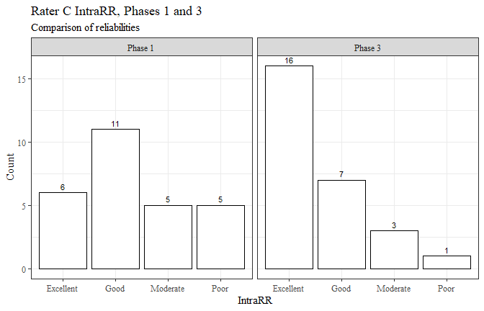

rater_d_data <- intra_data_all %>%   
 filter(rater == "D")  
  
flextable(rater_d_data) %>%  
 my_ft_theme()%>%   
 bold(part = "header") %>%   
 set_caption("Rater D ICC statistics for IntraRR, Phases 1 and 3") %>%   
 fit_to_width(7.5) %>%   
 autofit()

**Table** : Rater D ICC statistics for IntraRR, Phases 1 and 3

| **measure** | **ICC** | **lower** | **upper** | **phase** | **RR** | **rater** |
| --- | --- | --- | --- | --- | --- | --- |
| AA_C | 0.8160 | 0.485 | 0.949 | phase 1 | intra | D |
| BGl_C | 0.8860 | 0.677 | 0.969 | phase 1 | intra | D |
| BiW_C | 0.0629 | -0.370 | 0.592 | phase 1 | intra | D |
| BiW_L | 0.5940 | -0.097 | 0.886 | phase 1 | intra | D |
| ChCh_C | 0.6870 | 0.105 | 0.921 | phase 1 | intra | D |
| GoSub_C | 0.9120 | 0.723 | 0.978 | phase 1 | intra | D |
| NRB_L | 0.8240 | 0.409 | 0.954 | phase 1 | intra | D |
| ProA_L | 0.8720 | 0.617 | 0.966 | phase 1 | intra | D |
| ProA_C | 0.8270 | 0.479 | 0.954 | phase 1 | intra | D |
| ProS_C | 0.8930 | 0.697 | 0.971 | phase 1 | intra | D |
| ProS_L | 0.8610 | 0.601 | 0.962 | phase 1 | intra | D |
| SelP_C | 0.8900 | 0.679 | 0.970 | phase 1 | intra | D |
| SelP_L | 0.8880 | 0.668 | 0.970 | phase 1 | intra | D |
| SelDH_C | -0.2770 | -1.040 | 0.727 | phase 1 | intra | D |
| SelM_L | 0.6970 | -0.031 | 0.941 | phase 1 | intra | D |
| SnasM_L | 0.5000 | -0.136 | 0.884 | phase 1 | intra | D |
| SmanM_C | 0.6410 | -0.092 | 0.927 | phase 1 | intra | D |
| SmanM_L | 0.6910 | -0.022 | 0.939 | phase 1 | intra | D |
| SnasM_C | 0.6260 | -0.090 | 0.923 | phase 1 | intra | D |
| TrHO_C | 0.8940 | 0.593 | 0.984 | phase 1 | intra | D |
| TrEJ_C | 0.7360 | 0.222 | 0.934 | phase 1 | intra | D |
| TrGo_C | 0.7690 | 0.248 | 0.949 | phase 1 | intra | D |
| TrSel_C | 0.9410 | 0.822 | 0.985 | phase 1 | intra | D |
| TrSman_C | 0.9110 | 0.701 | 0.981 | phase 1 | intra | D |
| TrSnas_C | 0.9580 | 0.869 | 0.990 | phase 1 | intra | D |
| TrTr_C | 0.9810 | 0.939 | 0.995 | phase 1 | intra | D |
| TrTr_L | 0.7440 | 0.260 | 0.935 | phase 1 | intra | D |
| AA_C | 0.9690 | 0.885 | 0.992 | phase 3 | intra | D |
| BGl_C | 0.9470 | 0.832 | 0.987 | phase 3 | intra | D |
| BiW_C | 0.9620 | 0.861 | 0.990 | phase 3 | intra | D |
| BiW_L | 0.9260 | 0.791 | 0.980 | phase 3 | intra | D |
| ChCh_C | 0.9490 | 0.855 | 0.986 | phase 3 | intra | D |
| GoSub_C | 0.9440 | 0.817 | 0.988 | phase 3 | intra | D |
| NRB_L | 0.9150 | 0.754 | 0.977 | phase 3 | intra | D |
| ProA_L | 0.9820 | 0.943 | 0.995 | phase 3 | intra | D |
| ProA_C | 0.9640 | 0.887 | 0.990 | phase 3 | intra | D |
| ProS_C | 0.9670 | 0.908 | 0.991 | phase 3 | intra | D |
| ProS_L | 0.9750 | 0.927 | 0.993 | phase 3 | intra | D |
| SelP_C | 0.9920 | 0.976 | 0.998 | phase 3 | intra | D |
| SelP_L | 0.9920 | 0.975 | 0.998 | phase 3 | intra | D |
| SelDH_C | 0.9430 | 0.836 | 0.985 | phase 3 | intra | D |
| SelM_L | 0.9970 | 0.990 | 0.999 | phase 3 | intra | D |
| SnasM_L | 0.9890 | 0.962 | 0.998 | phase 3 | intra | D |
| SmanM_C | 0.9700 | 0.891 | 0.994 | phase 3 | intra | D |
| SmanM_L | 0.9640 | 0.875 | 0.993 | phase 3 | intra | D |
| SnasM_C | 0.9860 | 0.951 | 0.997 | phase 3 | intra | D |
| TrHO_C | 0.9640 | 0.799 | 0.998 | phase 3 | intra | D |
| TrEJ_C | 0.8230 | 0.475 | 0.956 | phase 3 | intra | D |
| TrGo_C | 0.7770 | 0.220 | 0.952 | phase 3 | intra | D |
| TrSel_C | 0.7320 | 0.204 | 0.933 | phase 3 | intra | D |
| TrSman_C | 0.9070 | 0.700 | 0.980 | phase 3 | intra | D |
| TrSnas_C | 0.7400 | 0.235 | 0.935 | phase 3 | intra | D |
| TrTr_C | 0.9320 | 0.781 | 0.985 | phase 3 | intra | D |
| TrTr_L | 0.9950 | 0.985 | 0.999 | phase 3 | intra | D |

rater_d_data$phase <- recode_factor(rater_d_data$phase,   
 'phase 1' = "Phase 1",  
 'phase 3' = "Phase 3")  
  
rater_d_data %>%   
 ggplot(aes(x=fct_reorder(measure, ICC), y=ICC, ymin=lower, ymax=upper))+  
 geom_pointrange()+  
 geom_hline(yintercept = c(0.5, 0.75, 0.9), linetype=2)+  
 coord_flip(ylim = c(0, 1))+  
 facet_grid(cols=vars(phase))+  
 theme_bw()+  
 theme(text=element_text(family= "Times New Roman"))+  
 labs(title="Rater D IntraRR, Phases 1 and 3",  
 subtitle="ICC reliability limits indicated by dashed lines",  
 x="3D Measurement Abbreviation",  
 y="ICC with 95% Confidence Interval")

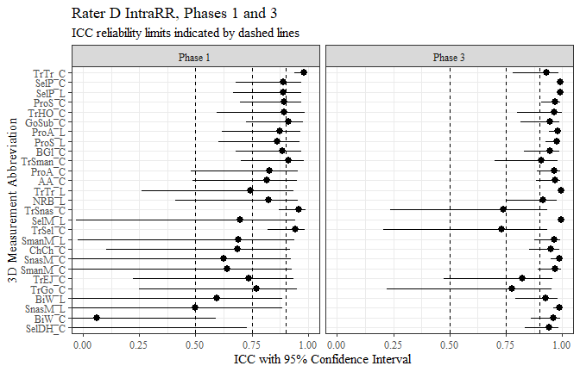

rater_d_data$intraRR <- as.factor(ifelse(rater_d_data$ICC < 0.5, 'Poor',  
 ifelse(rater_d_data$ICC < 0.75, 'Moderate',  
 ifelse(rater_d_data$ICC < 0.9, 'Good',  
 ifelse(rater_d_data$ICC < 1, 'Excellent')))))  
  
  
   
rater_d_data %>%   
 ggplot(aes(x=intraRR, label=stat(count)))+  
 geom_histogram(stat="count", color= "black", fill = "white")+  
 geom_text(stat="count",  
 position= position_dodge(0.9),  
 vjust = -0.5,   
 size = 3)+  
 facet_grid(cols=vars(phase))+  
 theme_bw()+  
 theme(text=element_text(family= "Times New Roman"))+  
 labs(title="Rater D IntraRR, Phases 1 and 3",  
 subtitle="Comparison of reliabilities",  
 x="IntraRR",  
 y="Count")

## Warning: Ignoring unknown parameters: binwidth, bins, pad

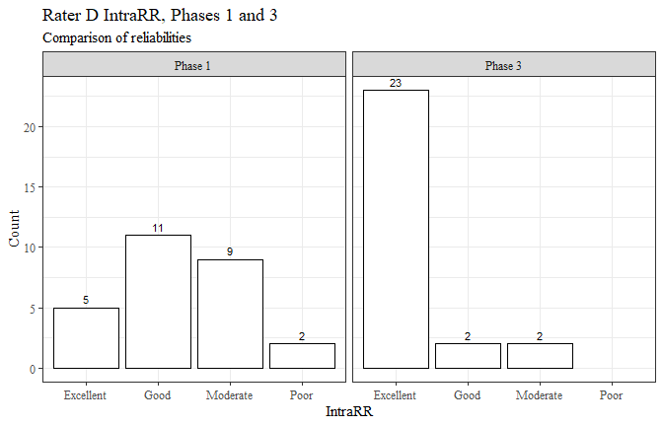

inter_data_all$phase <- recode_factor(inter_data_all$phase,   
 'phase 1' = "Phase 1",  
 'phase 2' = "Phase 2",  
 'phase 3' = "Phase 3")  
  
  
inter_data_all %>%   
 ggplot(aes(x=fct_reorder(measure, ICC), y=ICC, ymin=lower, ymax=upper))+  
 geom_pointrange()+  
 geom_hline(yintercept = c(0.5, 0.75, 0.9), linetype=2)+  
 coord_flip(ylim = c(0, 1))+  
 facet_grid(cols=vars(phase))+  
 theme_bw()+  
 theme(text=element_text(family= "Times New Roman"))+  
 theme(panel.spacing = unit(0.5, "lines"))+  
 labs(title="InterRR at Phases 1, 2, and 3",  
 subtitle="ICC reliability limits indicated by dashed lines",  
 x="3D Measurement Abbreviation",  
 y="ICC with 95% Confidence Interval")

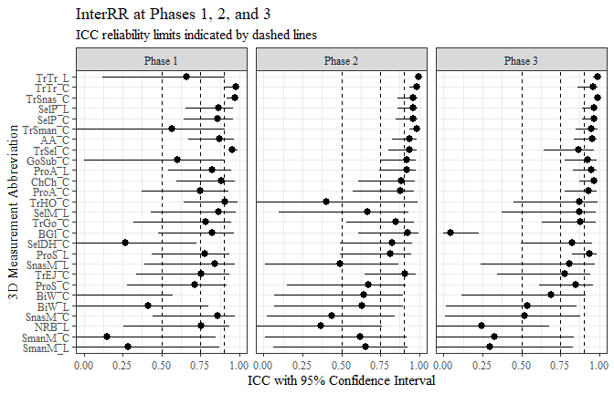

inter_data_all$interRR <- as.factor(ifelse(inter_data_all$ICC < 0.5, 'Poor',  
 ifelse(inter_data_all$ICC < 0.75, 'Moderate',  
 ifelse(inter_data_all$ICC < 0.9, 'Good',  
 ifelse(inter_data_all$ICC < 1, 'Excellent')))))  
  
  
   
inter_data_all %>%   
 ggplot(aes(x=interRR, label=stat(count)))+  
 geom_histogram(stat="count", color= "black", fill = "white")+  
 geom_text(stat="count",  
 position= position_dodge(0.9),  
 vjust = -0.5,   
 size = 3)+  
 facet_grid(cols=vars(phase))+  
 theme_bw()+  
 theme(text=element_text(family= "Times New Roman"))+  
 labs(title="InterRR at Phases 1, 2, and 3",  
 subtitle="Comparison of reliabilities",  
 x="InterRR",  
 y="Count")

## Warning: Ignoring unknown parameters: binwidth, bins, pad

