K-S testing

library(tidyverse)

## ── Attaching packages ─────────────────────────────────────── tidyverse 1.3.2 ──  
## ✔ ggplot2 3.3.6 ✔ purrr 0.3.4  
## ✔ tibble 3.1.8 ✔ dplyr 1.0.9  
## ✔ tidyr 1.2.0 ✔ stringr 1.4.0  
## ✔ readr 2.1.2 ✔ forcats 0.5.1  
## ── Conflicts ────────────────────────────────────────── tidyverse_conflicts() ──  
## ✖ dplyr::filter() masks stats::filter()  
## ✖ dplyr::lag() masks stats::lag()

library(flextable)

##   
## Attaching package: 'flextable'  
##   
## The following object is masked from 'package:purrr':  
##   
## compose

library(readxl)  
library(extrafont)

## Registering fonts with R

library(forcats)  
library(writexl)  
library(car)

## Loading required package: carData  
##   
## Attaching package: 'car'  
##   
## The following object is masked from 'package:dplyr':  
##   
## recode  
##   
## The following object is masked from 'package:purrr':  
##   
## some

library(moments)  
library(PerformanceAnalytics)

## Warning: package 'PerformanceAnalytics' was built under R version 4.2.2

## Loading required package: xts  
## Loading required package: zoo  
##   
## Attaching package: 'zoo'  
##   
## The following objects are masked from 'package:base':  
##   
## as.Date, as.Date.numeric  
##   
##   
## Attaching package: 'xts'  
##   
## The following objects are masked from 'package:dplyr':  
##   
## first, last  
##   
##   
## Attaching package: 'PerformanceAnalytics'  
##   
## The following objects are masked from 'package:moments':  
##   
## kurtosis, skewness  
##   
## The following object is masked from 'package:graphics':  
##   
## legend

#times new roman tables  
my_ft_theme <- function(ft, ...) {  
 # Remove vertical cell padding  
 ft <- padding(ft, padding.top = 0, padding.bottom = 0, part = "all")  
   
 # Change font to TNR 11  
 ft <- font(ft, fontname = "Times New Roman", part = "all")  
 ft <- fontsize(ft, part = "all", size = 12)  
 ft  
}

headscan_full1<-read_excel("C:\\Users\\19177\\OneDrive - Colostate\\Desktop\\Dissertation\\headscan_dissertation\\headscan_full1.xlsx")  
str(headscan_full1)

## tibble [2,016 × 33] (S3: tbl_df/tbl/data.frame)  
## $ ID : chr [1:2016] "400-20201012-002" "400-20201012-003" "400-20201012-004" "400-20201012-005" ...  
## $ AA_C : num [1:2016] 65 55 70 58 67 60 59 59 65 65 ...  
## $ BGl_C : num [1:2016] 315 289 293 313 288 306 320 NA 300 277 ...  
## $ BiW_C : num [1:2016] 130 127 143 140 137 130 141 138 143 150 ...  
## $ BiW_L : num [1:2016] 115 108 121 109 104 106 109 111 113 116 ...  
## $ ChCh_C : num [1:2016] 62 64 68 70 70 70 67 69 67 63 ...  
## $ GoSub_C : num [1:2016] 93 93 115 93 103 100 79 106 85 102 ...  
## $ NRB_L : num [1:2016] 17 18 19 21 19 14 17 18 16 17 ...  
## $ ProA_L : num [1:2016] 28 25 31 23 28 28 26 27 32 28 ...  
## $ ProA_C : num [1:2016] 31 27 33 27 31 29 27 29 34 31 ...  
## $ ProS_C : num [1:2016] 18 20 14 13 22 22 19 14 26 24 ...  
## $ ProS_L : num [1:2016] 17 18 14 13 20 20 18 12 24 22 ...  
## $ SelP_C : num [1:2016] 42 41 51 45 47 48 46 42 47 44 ...  
## $ SelP_L : num [1:2016] 42 41 51 44 47 48 46 41 46 44 ...  
## $ SelDH_C : num [1:2016] 15 9 9 11 13 15 9 9 12 14 ...  
## $ SelM_L : num [1:2016] 122 99 130 115 119 126 117 112 117 117 ...  
## $ SnasM_C : num [1:2016] 82 55 84 74 73 80 78 76 64 75 ...  
## $ SmanM_C : num [1:2016] 59 51 45 43 33 34 55 37 61 41 ...  
## $ SmanM_L : num [1:2016] 55 50 45 42 33 34 50 36 59 40 ...  
## $ SnasM_L : num [1:2016] 75 53 78 69 67 76 69 71 62 69 ...  
## $ TrHO_C : num [1:2016] 179 163 169 166 159 162 169 NA 167 166 ...  
## $ TrEJ_C : num [1:2016] 40 32 39 29 46 42 29 32 29 33 ...  
## $ TrGo_C : num [1:2016] 84 57 70 61 68 70 75 61 67 64 ...  
## $ TrSel_C : num [1:2016] 149 138 150 133 140 151 140 138 156 143 ...  
## $ TrSman_C : num [1:2016] 177 145 178 147 157 164 149 159 151 160 ...  
## $ TrSnas_C : num [1:2016] 163 142 167 145 152 157 148 149 157 NA ...  
## $ TrTr_C : num [1:2016] 296 276 292 273 279 300 283 275 307 286 ...  
## $ TrTr_L : num [1:2016] 155 141 156 149 146 146 147 151 157 144 ...  
## $ coder : chr [1:2016] "Kayna" "Kayna" "Kayna" "Kayna" ...  
## $ age : num [1:2016] 31 49 49 34 49 55 26 18 25 27 ...  
## $ gender : chr [1:2016] "Male" "Female" "Male" "Male" ...  
## $ race_eth : chr [1:2016] "Black" "White" "White" "White" ...  
## $ age_group: chr [1:2016] "18-36" "37-54" "37-54" "18-36" ...

Skewness is a measure of the asymmetry of a distribution. This value can be positive or negative.

A negative skew indicates that the tail is on the left side of the distribution, which extends towards more negative values. A positive skew indicates that the tail is on the right side of the distribution, which extends towards more positive values. A value of zero indicates that there is no skewness in the distribution at all, meaning the distribution is perfectly symmetrical. PerformanceAnalytics::PerformanceAnalytics::kurtosis is a measure of whether or not a distribution is heavy-tailed or light-tailed relative to a normal distribution.

The rule of thumb seems to be: If the skewness is between -0.5 and 0.5, the data are fairly symmetrical. If the skewness is between -1 and – 0.5 or between 0.5 and 1, the data are moderately skewed. If the skewness is less than -1 or greater than 1, the data are highly skewed.

The PerformanceAnalytics::kurtosis of a normal distribution is 3. If a given distribution has a PerformanceAnalytics::kurtosis less than 3, it is said to be playkurtic, which means it tends to produce fewer and less extreme outliers than the normal distribution. If a given distribution has a PerformanceAnalytics::kurtosis greater than 3, it is said to be leptokurtic, which means it tends to produce more outliers than the normal distribution.

qqPlot(headscan_full1$AA_C, distribution = "norm", col.lines = "grey")

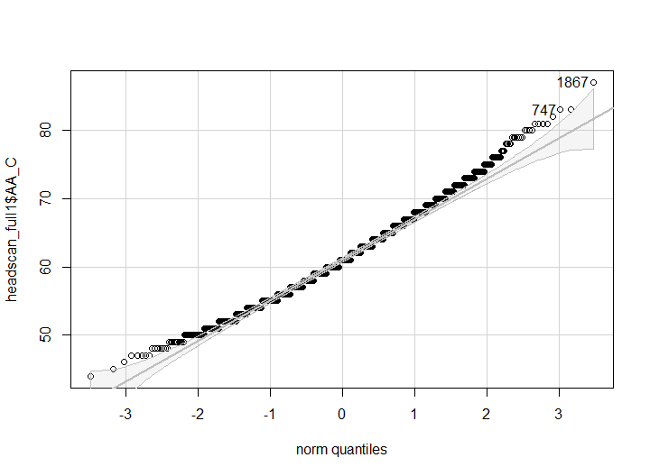

## [1] 1867 747

hist(headscan_full1$AA_C, breaks = 30)

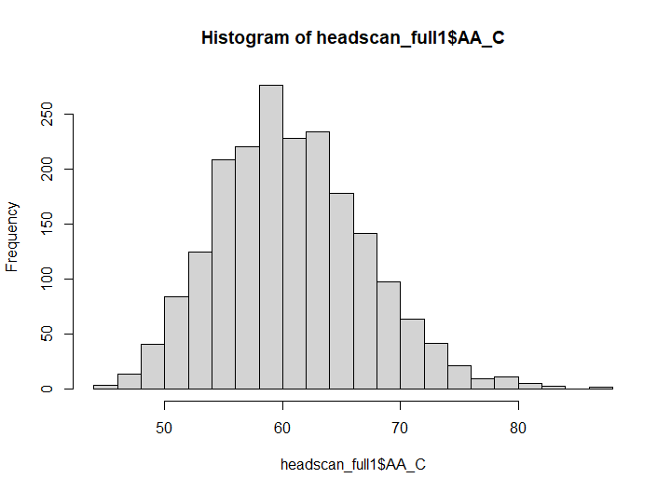

PerformanceAnalytics::kurtosis(headscan_full1$AA_C, na.rm = TRUE, method= "excess")

## [1] 0.1553001

skewness(headscan_full1$AA_C, na.rm = TRUE)

## [1] 0.4066898

qqPlot(headscan_full1$BGl_C, distribution = "norm", col.lines = "grey")

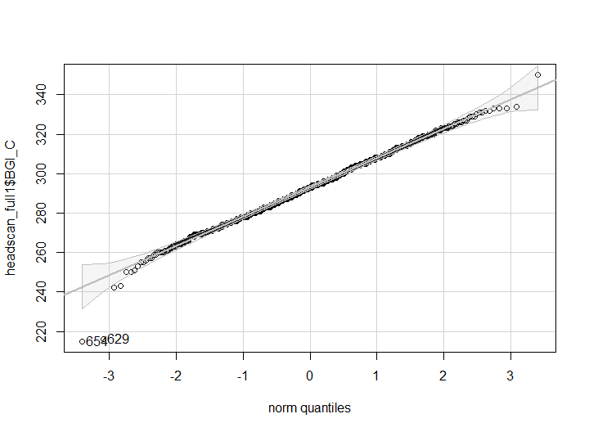

## [1] 654 629

hist(headscan_full1$BGl_C, breaks = 30)

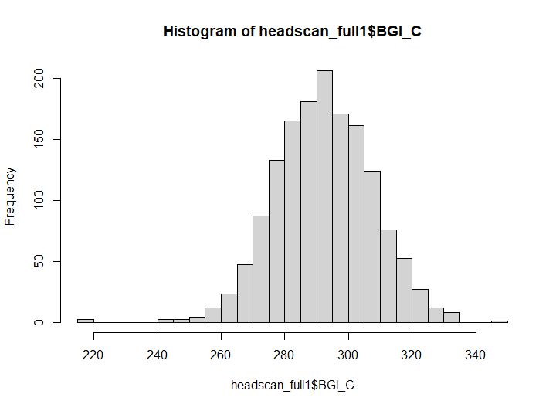

PerformanceAnalytics::kurtosis(headscan_full1$BGl_C, na.rm = TRUE, method= "excess")

## [1] 0.6673004

skewness(headscan_full1$BGl_C, na.rm = TRUE)

## [1] -0.1178039

qqPlot(headscan_full1$BiW_C, distribution = "norm", col.lines = "grey")

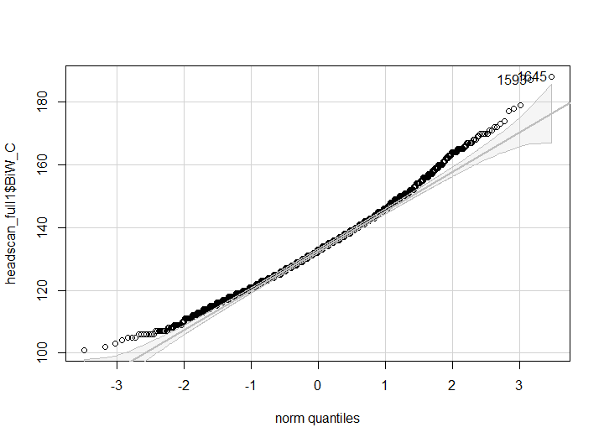

## [1] 1645 1593

hist(headscan_full1$BiW_C, breaks = 30)

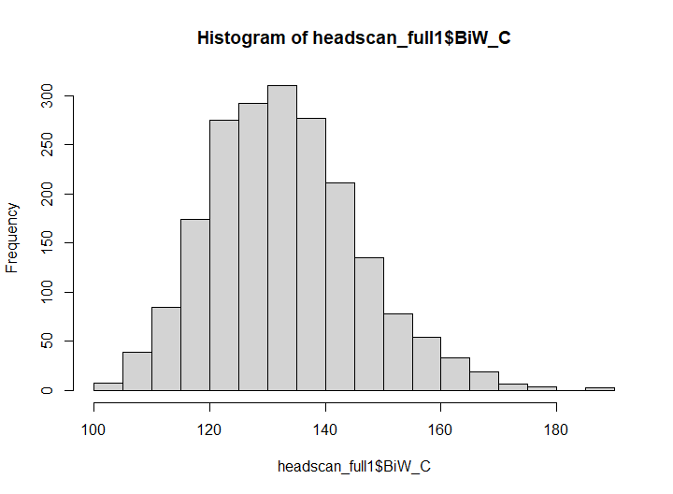

PerformanceAnalytics::kurtosis(headscan_full1$BiW_C, na.rm = TRUE, method= "excess")

## [1] 0.3304624

skewness(headscan_full1$BiW_C, na.rm = TRUE)

## [1] 0.4767801

qqPlot(headscan_full1$BiW_L, distribution = "norm", col.lines = "grey")

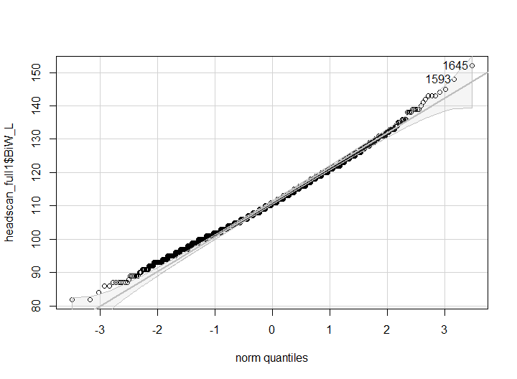

## [1] 1645 1593

hist(headscan_full1$BiW_L, breaks = 30)

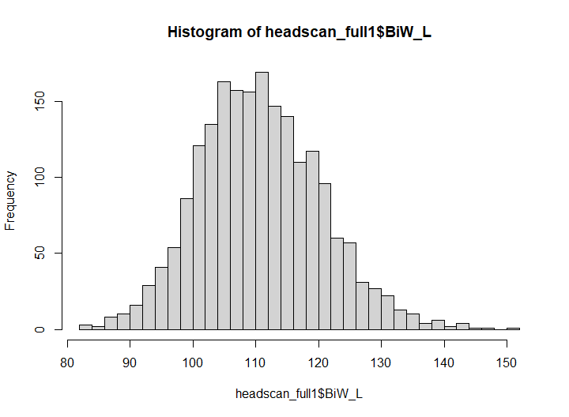

PerformanceAnalytics::kurtosis(headscan_full1$BiW_L, na.rm = TRUE, method= "excess")

## [1] 0.2679488

skewness(headscan_full1$BiW_L, na.rm = TRUE)

## [1] 0.295828

qqPlot(headscan_full1$ChCh_C, distribution = "norm", col.lines = "grey")

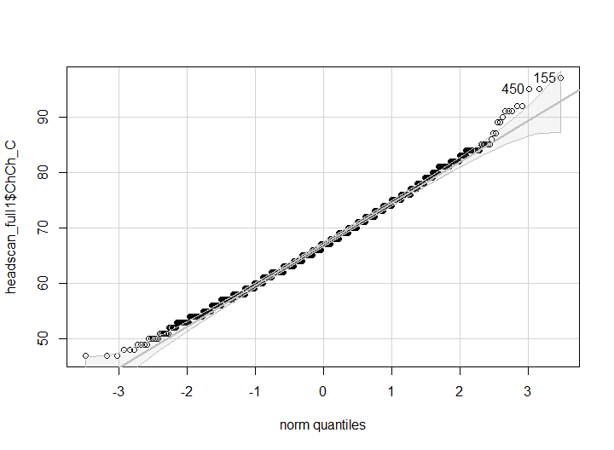

## [1] 155 450

hist(headscan_full1$ChCh_C, breaks = 30)

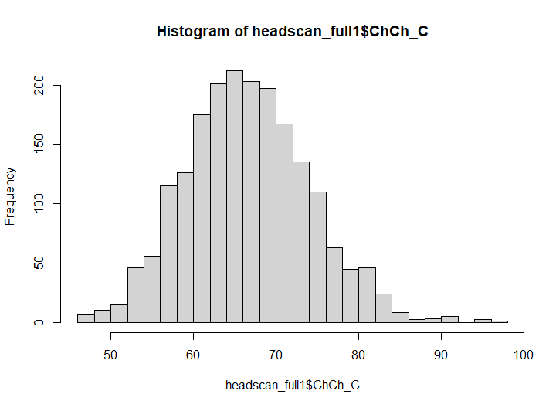

PerformanceAnalytics::kurtosis(headscan_full1$ChCh_C, na.rm = TRUE, method= "excess")

## [1] 0.1497826

skewness(headscan_full1$ChCh_C, na.rm = TRUE)

## [1] 0.2698316

qqPlot(headscan_full1$GoSub_C, distribution = "norm", col.lines = "grey")

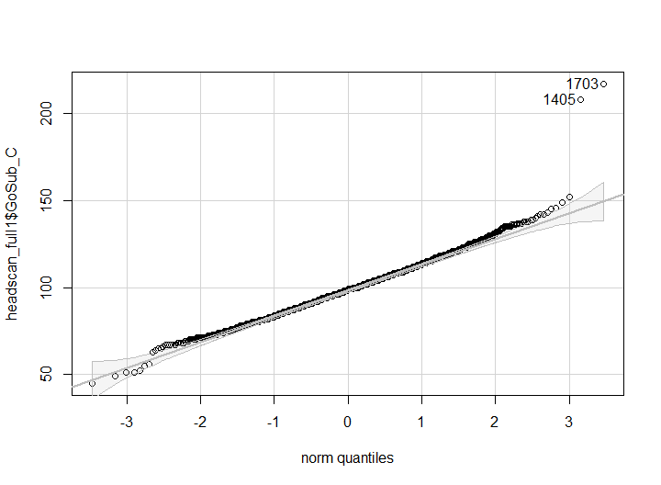

## [1] 1703 1405

hist(headscan_full1$GoSub_C, breaks = 30)

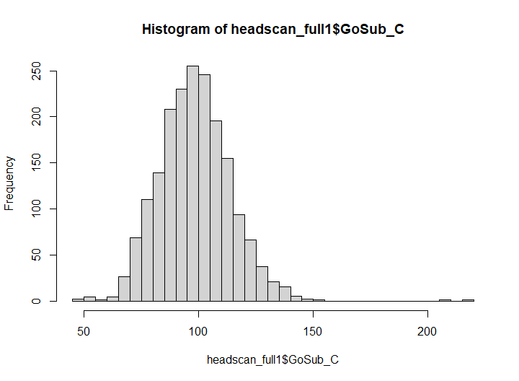

PerformanceAnalytics::kurtosis(headscan_full1$GoSub_C, na.rm = TRUE, method= "excess")

## [1] 2.909811

skewness(headscan_full1$GoSub_C, na.rm = TRUE)

## [1] 0.5522689

qqPlot(headscan_full1$NRB_L, distribution = "norm", col.lines = "grey")

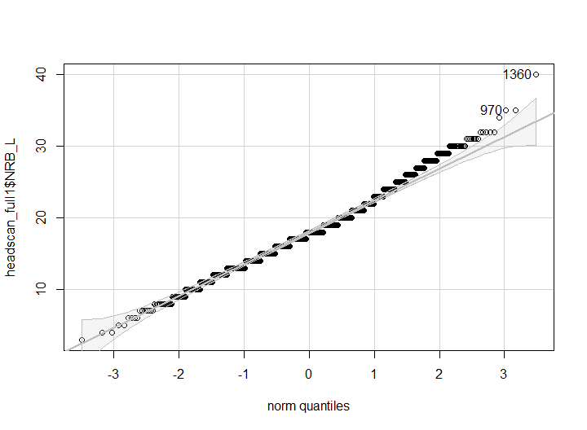

## [1] 1360 970

hist(headscan_full1$NRB_L, breaks = 30)

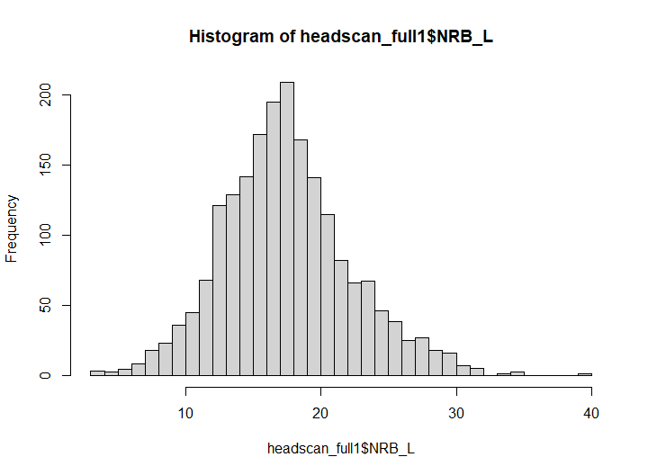

PerformanceAnalytics::kurtosis(headscan_full1$NRB_L, na.rm = TRUE, method= "excess")

## [1] 0.4866731

skewness(headscan_full1$NRB_L, na.rm = TRUE)

## [1] 0.382121

qqPlot(headscan_full1$ProA_L, distribution = "norm", col.lines = "grey")

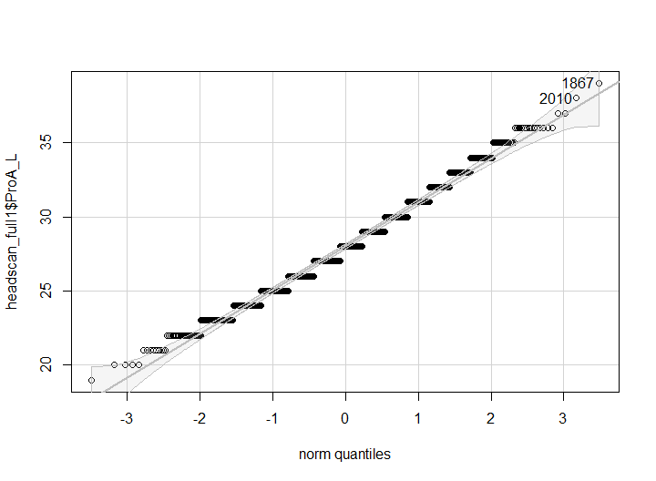

## [1] 1867 2010

hist(headscan_full1$ProA_L, breaks = 30)

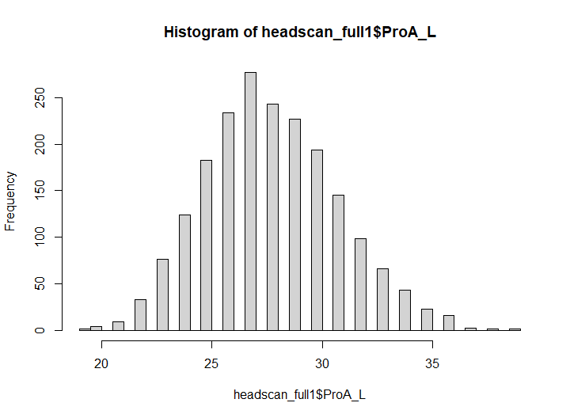

PerformanceAnalytics::kurtosis(headscan_full1$ProA_L, na.rm = TRUE, method= "excess")

## [1] -0.1123283

skewness(headscan_full1$ProA_L, na.rm = TRUE)

## [1] 0.2704969

qqPlot(headscan_full1$ProA_C, distribution = "norm", col.lines = "grey")

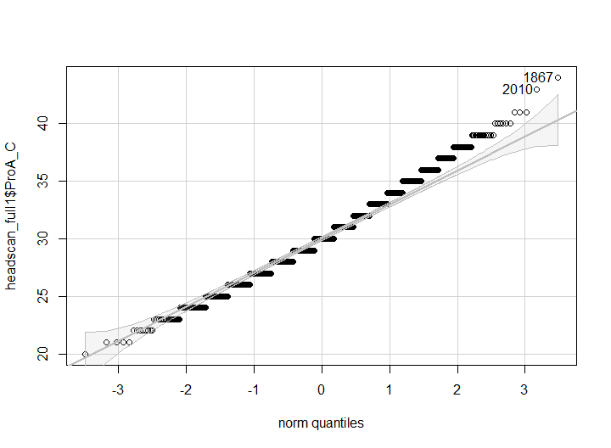

## [1] 1867 2010

hist(headscan_full1$ProA_C, breaks = 30)

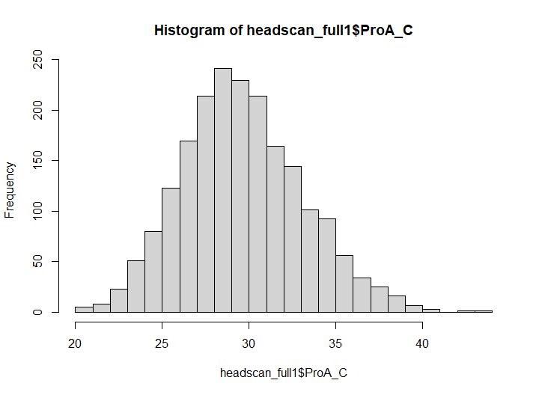

PerformanceAnalytics::kurtosis(headscan_full1$ProA_C, na.rm = TRUE, method= "excess")

## [1] 0.02933351

skewness(headscan_full1$ProA_C, na.rm = TRUE)

## [1] 0.3130431

qqPlot(headscan_full1$ProS_L, distribution = "norm", col.lines = "grey")

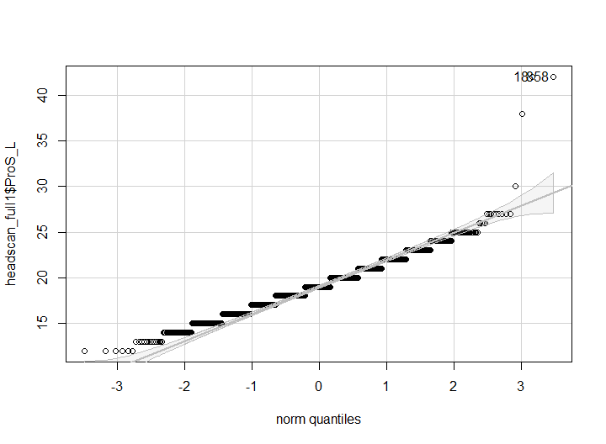

## [1] 18 858

hist(headscan_full1$ProS_L, breaks = 30)

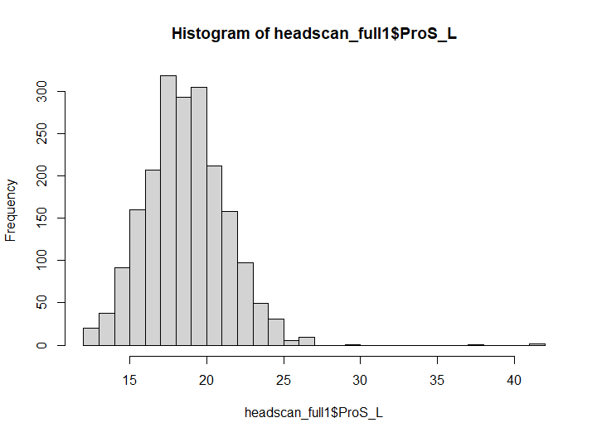

PerformanceAnalytics::kurtosis(headscan_full1$ProS_L, na.rm = TRUE, method= "excess")

## [1] 5.819533

skewness(headscan_full1$ProS_L, na.rm = TRUE)

## [1] 0.8978434

qqPlot(headscan_full1$ProS_C, distribution = "norm", col.lines = "grey")

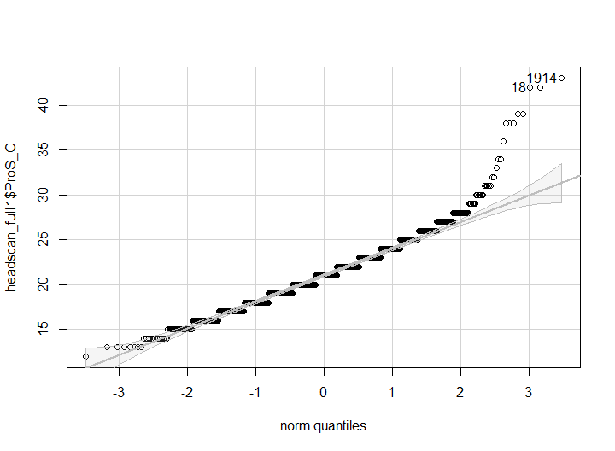

## [1] 1914 18

hist(headscan_full1$ProS_C, breaks = 30)

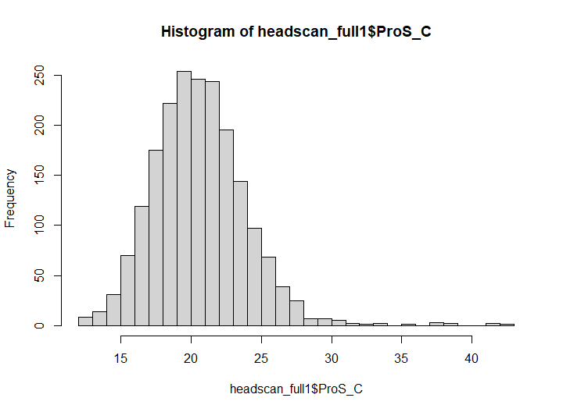

PerformanceAnalytics::kurtosis(headscan_full1$ProS_C, na.rm = TRUE, method= "excess")

## [1] 3.944653

skewness(headscan_full1$ProS_C, na.rm = TRUE)

## [1] 0.9825963

qqPlot(headscan_full1$SelP_L, distribution = "norm", col.lines = "grey")

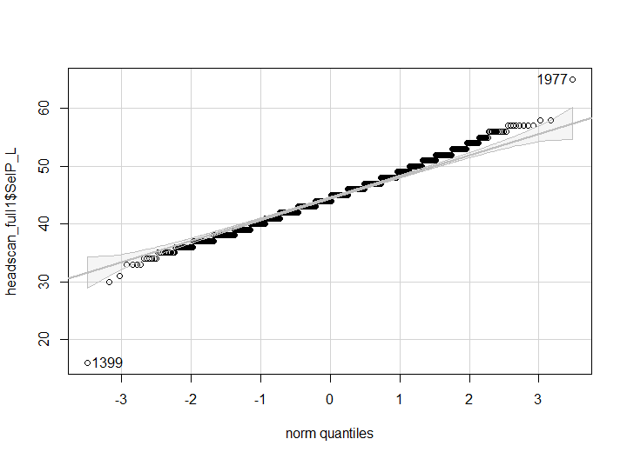

## [1] 1399 1977

hist(headscan_full1$SelP_L, breaks = 30)

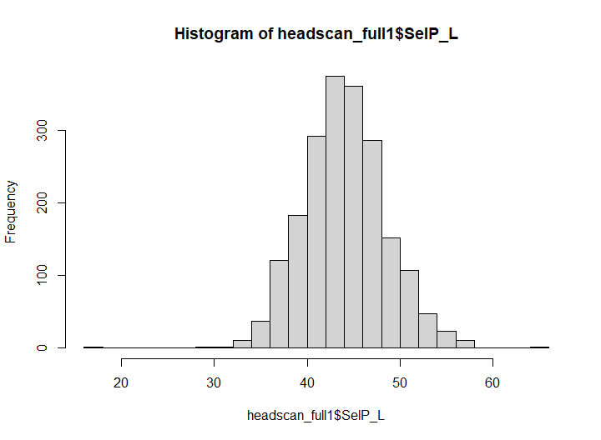

PerformanceAnalytics::kurtosis(headscan_full1$SelP_L, na.rm = TRUE, method= "excess")

## [1] 0.9375928

skewness(headscan_full1$SelP_L, na.rm = TRUE)

## [1] 0.08557127

qqPlot(headscan_full1$SelP_C, distribution = "norm", col.lines = "grey")

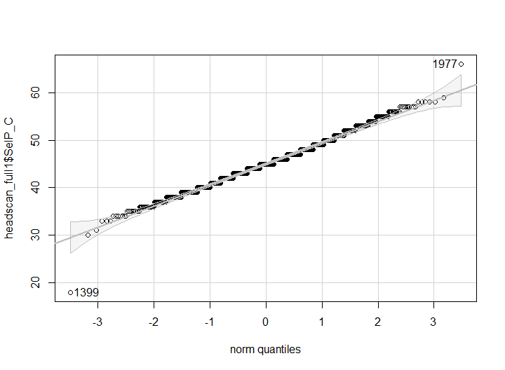

## [1] 1399 1977

hist(headscan_full1$SelP_C, breaks = 30)

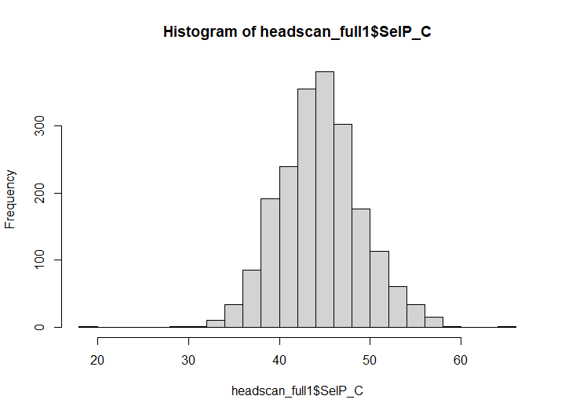

PerformanceAnalytics::kurtosis(headscan_full1$SelP_C, na.rm = TRUE, method= "excess")

## [1] 0.7579564

skewness(headscan_full1$SelP_C, na.rm = TRUE)

## [1] 0.1026326

qqPlot(headscan_full1$SelDH_C, distribution = "norm", col.lines = "grey")

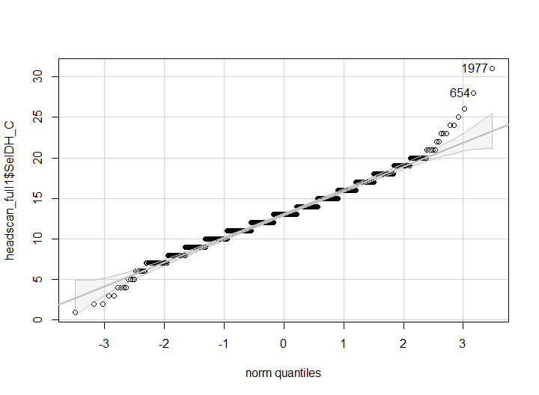

## [1] 1977 654

hist(headscan_full1$SelDH_C, breaks = 30)

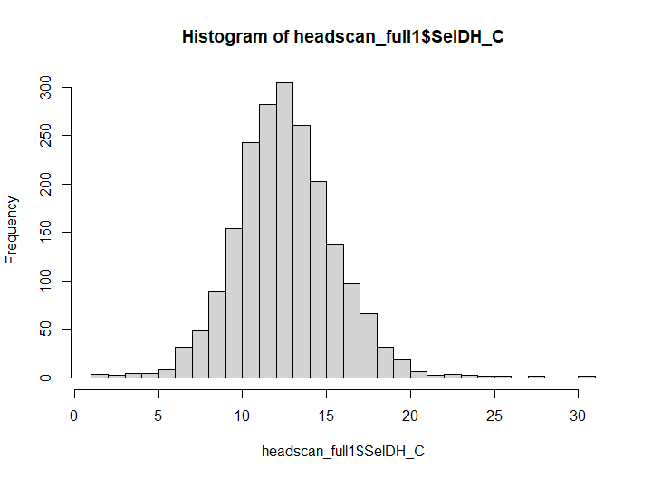

PerformanceAnalytics::kurtosis(headscan_full1$SelDH_C, na.rm = TRUE, method= "excess")

## [1] 1.661688

skewness(headscan_full1$SelDH_C, na.rm = TRUE)

## [1] 0.2922561

qqPlot(headscan_full1$SelM_L, distribution = "norm", col.lines = "grey")

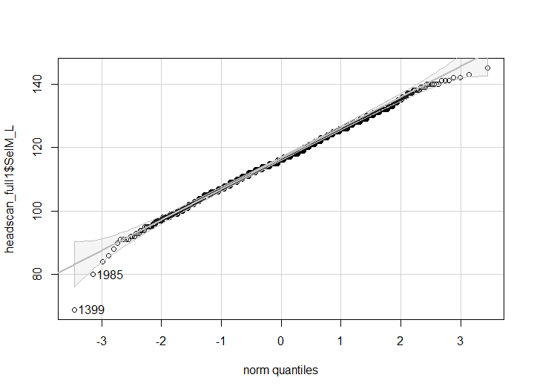

## [1] 1399 1985

hist(headscan_full1$SelM_L, breaks = 30)

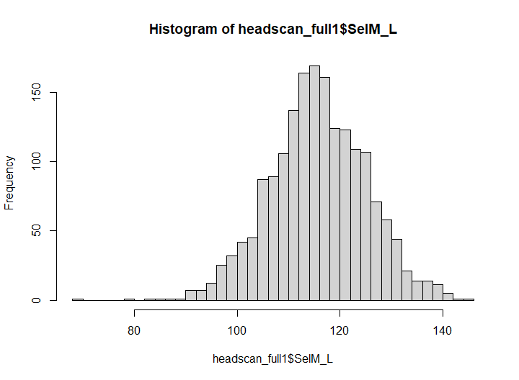

PerformanceAnalytics::kurtosis(headscan_full1$SelM_L, na.rm = TRUE, method= "excess")

## [1] 0.362218

skewness(headscan_full1$SelM_L, na.rm = TRUE)

## [1] -0.1100016

qqPlot(headscan_full1$SnasM_L, distribution = "norm", col.lines = "grey")

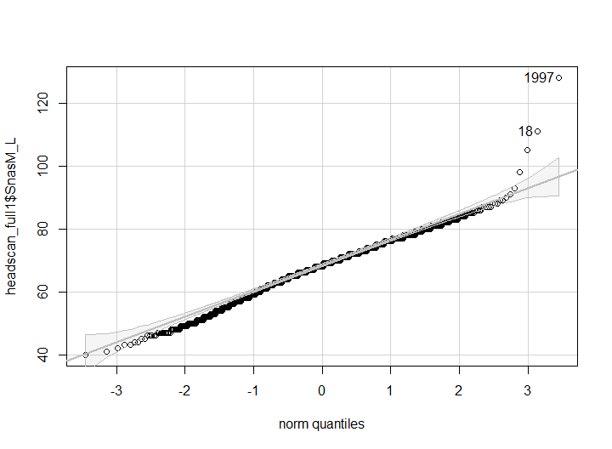

## [1] 1997 18

hist(headscan_full1$SnasM_L, breaks = 30)

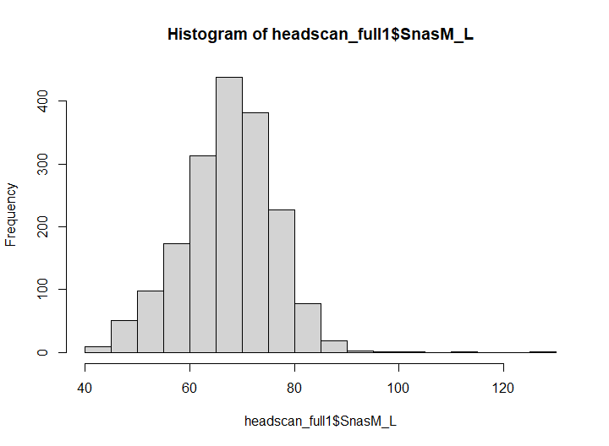

PerformanceAnalytics::kurtosis(headscan_full1$SnasM_L, na.rm = TRUE, method= "excess")

## [1] 1.594823

skewness(headscan_full1$SnasM_L, na.rm = TRUE)

## [1] 0.002947763

qqPlot(headscan_full1$SnasM_C, distribution = "norm", col.lines = "grey")

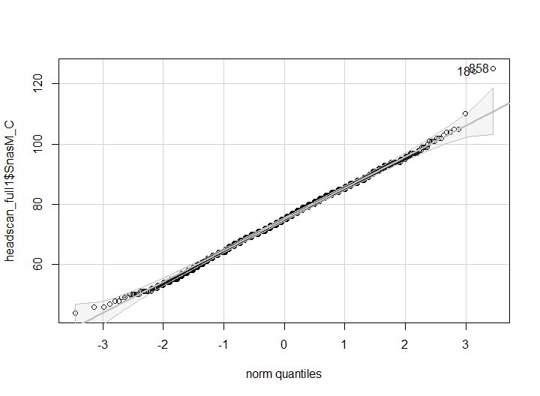

## [1] 858 18

hist(headscan_full1$SnasM_C, breaks = 30)

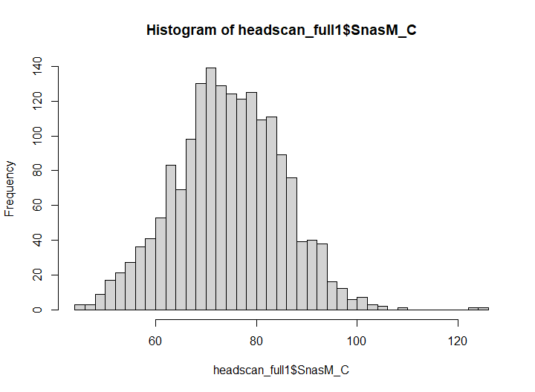

PerformanceAnalytics::kurtosis(headscan_full1$SnasM_C, na.rm = TRUE, method= "excess")

## [1] 0.2211252

skewness(headscan_full1$SnasM_C, na.rm = TRUE)

## [1] 0.05478824

qqPlot(headscan_full1$SmanM_L, distribution = "norm", col.lines = "grey")

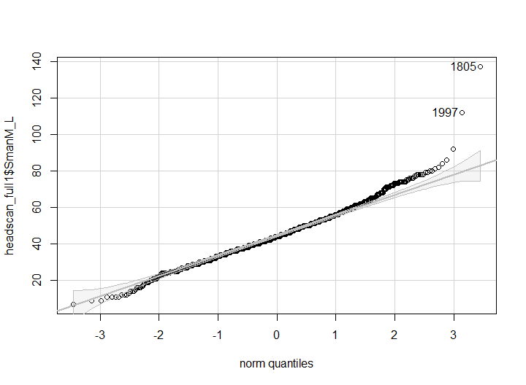

## [1] 1805 1997

hist(headscan_full1$SmanM_L, breaks = 30)

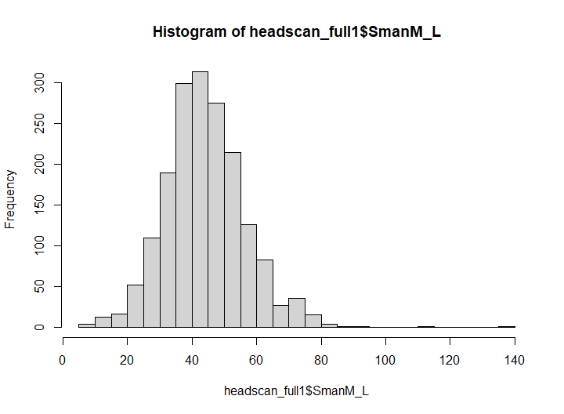

PerformanceAnalytics::kurtosis(headscan_full1$SmanM_L, na.rm = TRUE, method= "excess")

## [1] 2.398554

skewness(headscan_full1$SmanM_L, na.rm = TRUE)

## [1] 0.5733336

qqPlot(headscan_full1$SmanM_C, distribution = "norm", col.lines = "grey")

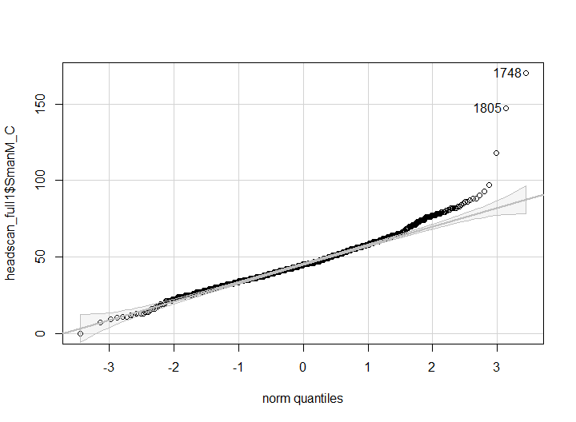

## [1] 1748 1805

hist(headscan_full1$SmanM_C, breaks = 30)

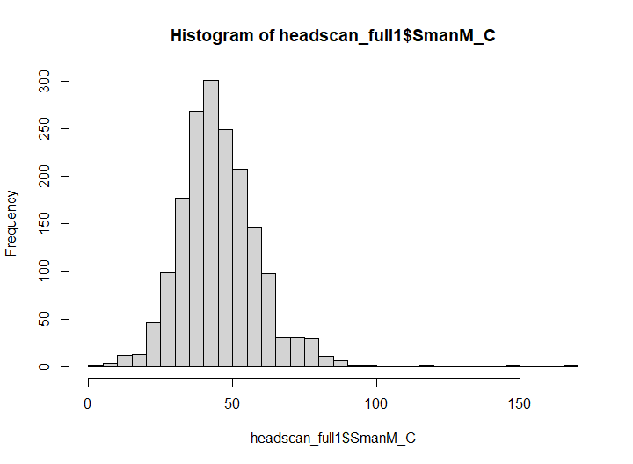

PerformanceAnalytics::kurtosis(headscan_full1$SmanM_C, na.rm = TRUE, method= "excess")

## [1] 6.145112

skewness(headscan_full1$SmanM_C, na.rm = TRUE)

## [1] 1.077109

qqPlot(headscan_full1$TrHO_C, distribution = "norm", col.lines = "grey")

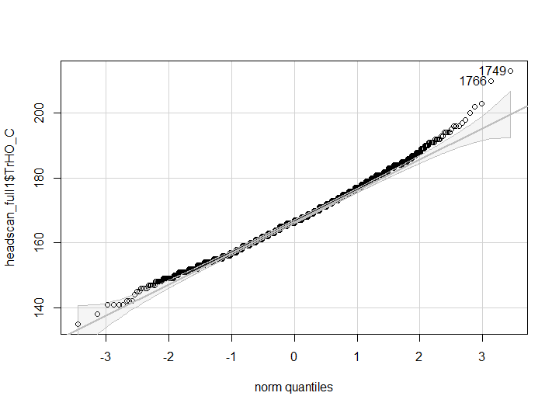

## [1] 1749 1766

hist(headscan_full1$TrHO_C, breaks = 30)

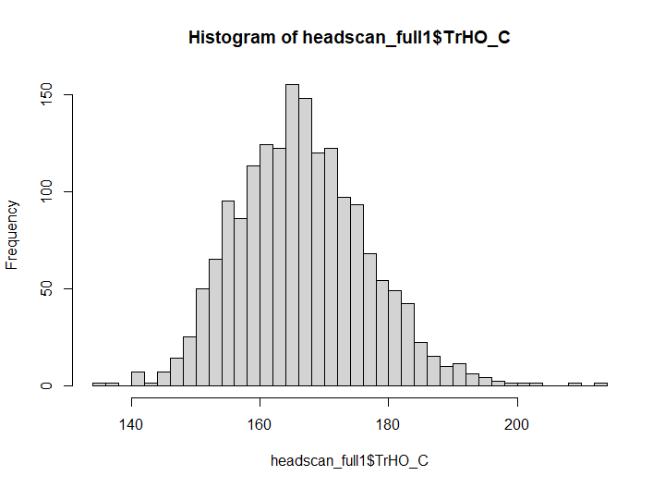

PerformanceAnalytics::kurtosis(headscan_full1$TrHO_C, na.rm = TRUE, method= "excess")

## [1] 0.3769569

skewness(headscan_full1$TrHO_C, na.rm = TRUE)

## [1] 0.3480794

qqPlot(headscan_full1$TrEJ_C, distribution = "norm", col.lines = "grey")

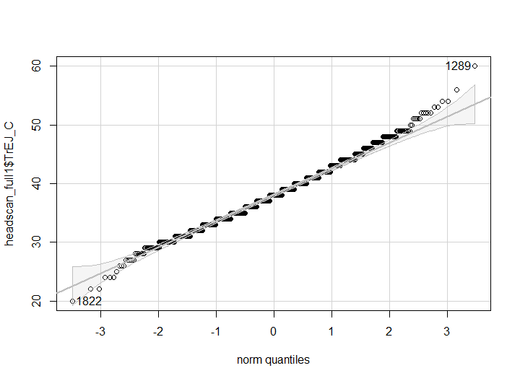

## [1] 1289 1822

hist(headscan_full1$TrEJ_C, breaks = 30)

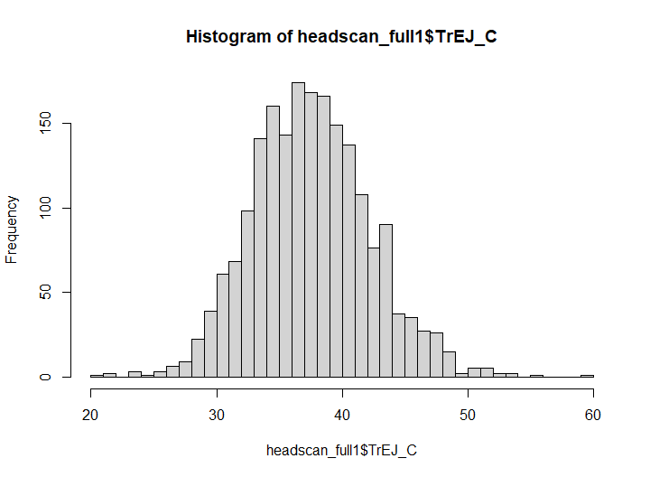

PerformanceAnalytics::kurtosis(headscan_full1$TrEJ_C, na.rm = TRUE, method= "excess")

## [1] 0.4414602

skewness(headscan_full1$TrEJ_C, na.rm = TRUE)

## [1] 0.2328707

qqPlot(headscan_full1$TrGo_C, distribution = "norm", col.lines = "grey")

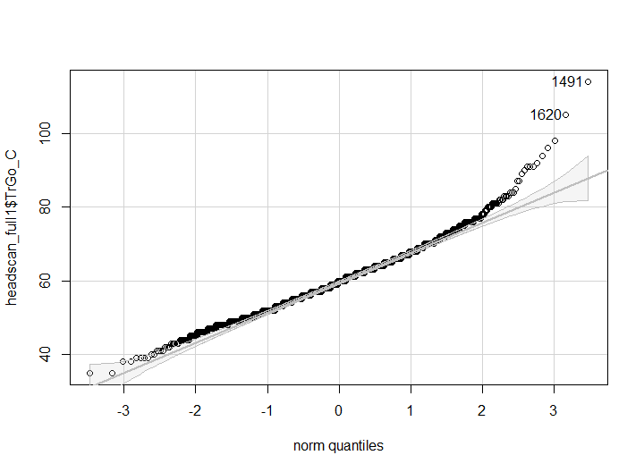

## [1] 1491 1620

hist(headscan_full1$TrGo_C, breaks = 30)

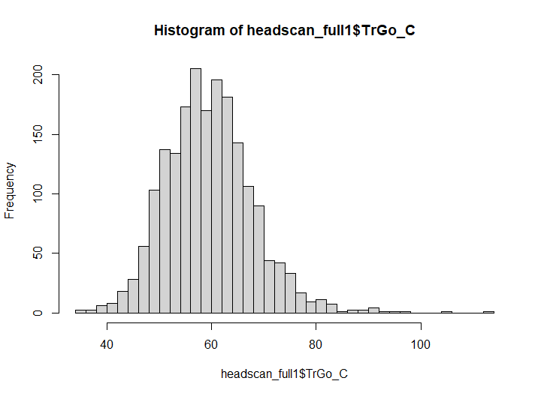

PerformanceAnalytics::kurtosis(headscan_full1$TrGo_C, na.rm = TRUE, method= "excess")

## [1] 1.934068

skewness(headscan_full1$TrGo_C, na.rm = TRUE)

## [1] 0.6469178

qqPlot(headscan_full1$TrSel_C, distribution = "norm", col.lines = "grey")

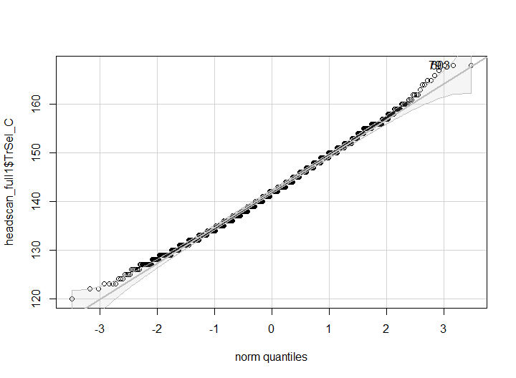

## [1] 79 603

hist(headscan_full1$TrSel_C, breaks = 30)

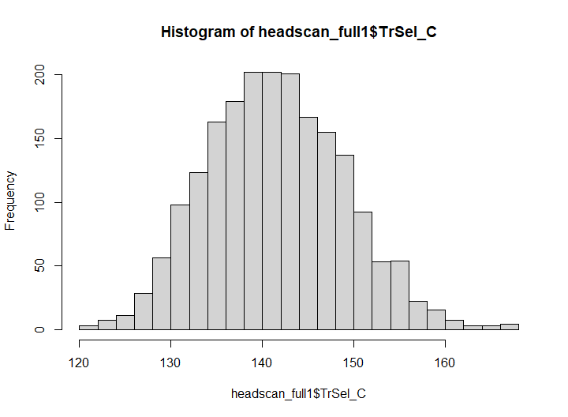

PerformanceAnalytics::kurtosis(headscan_full1$TrSel_C, na.rm = TRUE, method= "excess")

## [1] -0.07025007

skewness(headscan_full1$TrSel_C, na.rm = TRUE)

## [1] 0.2159916

qqPlot(headscan_full1$TrSman_C, distribution = "norm", col.lines = "grey")

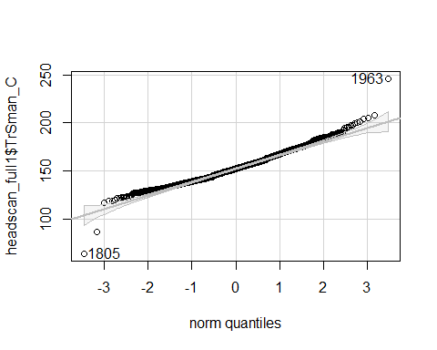

## [1] 1963 1805

hist(headscan_full1$TrSman_C, breaks = 30)

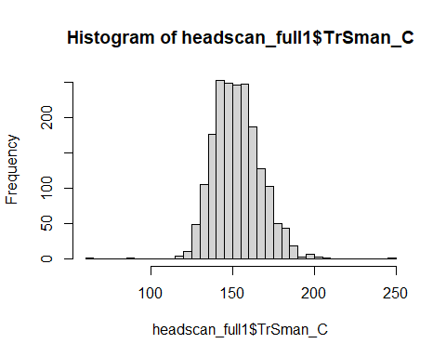

PerformanceAnalytics::kurtosis(headscan_full1$TrSman_C, na.rm = TRUE, method= "excess")

## [1] 1.716395

skewness(headscan_full1$TrSman_C, na.rm = TRUE)

## [1] 0.3721444

qqPlot(headscan_full1$TrSnas_C, distribution = "norm", col.lines = "grey")

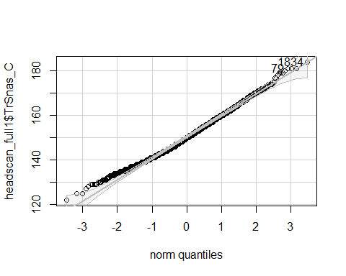

## [1] 1834 79

hist(headscan_full1$TrSnas_C, breaks = 30)

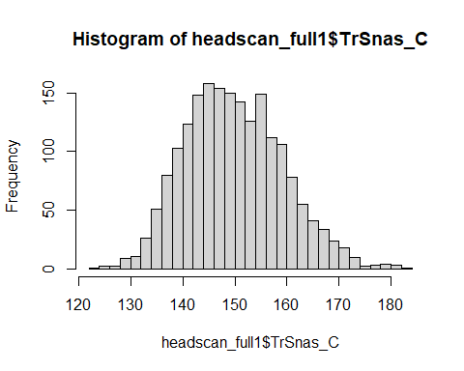

PerformanceAnalytics::kurtosis(headscan_full1$TrSnas_C, na.rm = TRUE, method= "excess")

## [1] -0.1116615

skewness(headscan_full1$TrSnas_C, na.rm = TRUE)

## [1] 0.3029935

qqPlot(headscan_full1$TrTr_C, distribution = "norm", col.lines = "grey")

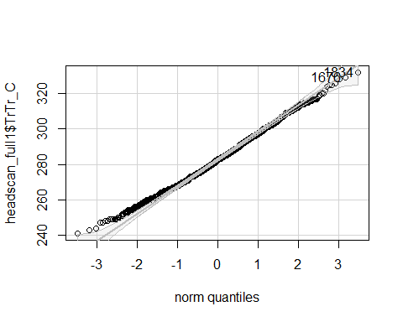

## [1] 1834 1676

hist(headscan_full1$TrTr_C, breaks = 30)

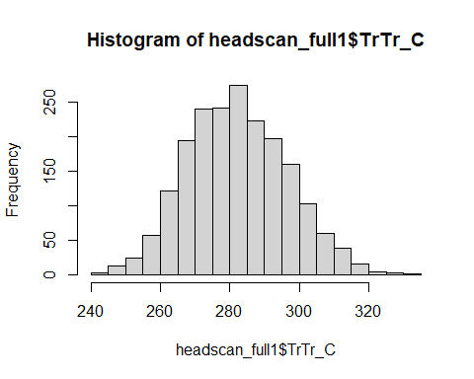

PerformanceAnalytics::kurtosis(headscan_full1$TrTr_C, na.rm = TRUE, method= "excess")

## [1] -0.2134962

skewness(headscan_full1$TrTr_C, na.rm = TRUE)

## [1] 0.1938274

qqPlot(headscan_full1$TrTr_L, distribution = "norm", col.lines = "grey")

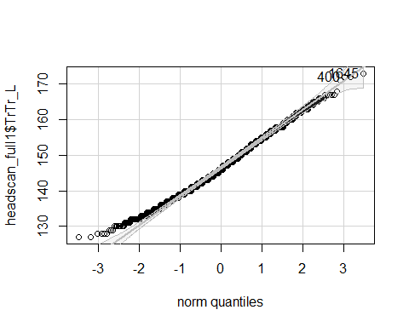

## [1] 1645 400

hist(headscan_full1$TrTr_L, breaks = 30)

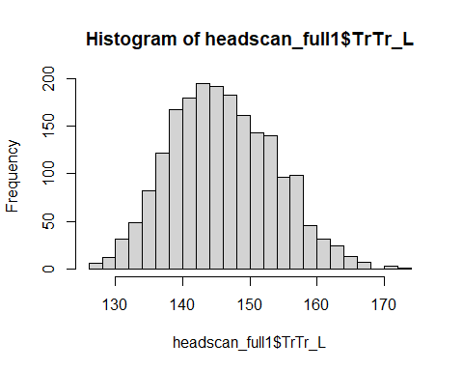

PerformanceAnalytics::kurtosis(headscan_full1$TrTr_L, na.rm = TRUE, method= "excess")

## [1] -0.2865562

skewness(headscan_full1$TrTr_L, na.rm = TRUE)

## [1] 0.2487262