PCA2

2022-08-16

library(tidyverse)

## ── Attaching packages ─────────────────────────────────────── tidyverse 1.3.2 ──  
## ✔ ggplot2 3.3.6 ✔ purrr 0.3.4  
## ✔ tibble 3.1.8 ✔ dplyr 1.0.9  
## ✔ tidyr 1.2.0 ✔ stringr 1.4.0  
## ✔ readr 2.1.2 ✔ forcats 0.5.1  
## ── Conflicts ────────────────────────────────────────── tidyverse_conflicts() ──  
## ✖ dplyr::filter() masks stats::filter()  
## ✖ dplyr::lag() masks stats::lag()

library(flextable)

##   
## Attaching package: 'flextable'  
##   
## The following object is masked from 'package:purrr':  
##   
## compose

library(readxl)  
library(extrafont)

## Registering fonts with R

library(fauxnaif) #na if in  
library(reshape2) #melt

##   
## Attaching package: 'reshape2'  
##   
## The following object is masked from 'package:tidyr':  
##   
## smiths

library(FactoMineR) #PCA  
library(kohonen)

## Warning: package 'kohonen' was built under R version 4.2.2

##   
## Attaching package: 'kohonen'  
##   
## The following object is masked from 'package:purrr':  
##   
## map

library(adegenet)

## Warning: package 'adegenet' was built under R version 4.2.2

## Loading required package: ade4

## Warning: package 'ade4' was built under R version 4.2.2

##   
## Attaching package: 'ade4'  
##   
## The following object is masked from 'package:FactoMineR':  
##   
## reconst  
##   
##   
## /// adegenet 2.1.8 is loaded ////////////  
##   
## > overview: '?adegenet'  
## > tutorials/doc/questions: 'adegenetWeb()'   
## > bug reports/feature requests: adegenetIssues()

PCAdata_full<-read_excel("C:\\Users\\19177\\OneDrive - Colostate\\Desktop\\Dissertation\\headscan_dissertation\\chosen_nona.xlsx")  
  
str(PCAdata_full)

## tibble [1,677 × 16] (S3: tbl_df/tbl/data.frame)  
## $ ID : chr [1:1677] "400-20201012-002" "400-20201012-003" "400-20201012-004" "400-20201012-005" ...  
## $ AA_C : num [1:1677] 65 55 70 58 67 60 59 59 65 65 ...  
## $ BiW_C : num [1:1677] 130 127 143 140 137 130 141 138 143 150 ...  
## $ BiW_L : num [1:1677] 115 108 121 109 104 106 109 111 113 116 ...  
## $ GoSub_C : num [1:1677] 93 93 115 93 103 100 79 106 85 102 ...  
## $ NRB_L : num [1:1677] 17 18 19 21 19 14 17 18 16 17 ...  
## $ ProS_L : num [1:1677] 17 18 14 13 20 20 18 12 24 22 ...  
## $ SelP_L : num [1:1677] 42 41 51 44 47 48 46 41 46 44 ...  
## $ SelM_L : num [1:1677] 122 99 130 115 119 126 117 112 117 117 ...  
## $ SnasM_C : num [1:1677] 82 55 84 74 73 80 78 76 64 75 ...  
## $ TrSman_C : num [1:1677] 177 145 178 147 157 164 149 159 151 160 ...  
## $ TrTr_C : num [1:1677] 296 276 292 273 279 300 283 275 307 286 ...  
## $ TrTr_L : num [1:1677] 155 141 156 149 146 146 147 151 157 144 ...  
## $ gender : chr [1:1677] "Male" "Female" "Male" "Male" ...  
## $ race_eth : chr [1:1677] "Black" "white" "white" "white" ...  
## $ age_group: chr [1:1677] "18-36" "37-54" "37-54" "18-36" ...

#https://tem11010.github.io/Plotting-PCAs/  
  
PCAdata_full1 <- PCAdata_full %>% filter (AA_C > 0, BiW_C > 0, BiW_L > 0, GoSub_C > 0,   
 NRB_L > 0, ProS_L > 0, SelP_L > 0, SelM_L > 0,   
 SnasM_C > 0, TrSman_C > 0, TrTr_C > 0, TrTr_L > 0)  
  
# log price  
  
# center and scale the data  
for (i in 1:length(colnames(PCAdata_full1))){  
   
 if (is.numeric(PCAdata_full1[, i])==TRUE)  
   
 PCAdata_full1[, i] <- as.numeric(scale(PCAdata_full1[, i]))  
   
 else  
   
 PCAdata_full1[, i] <- PCAdata_full1[, i]  
   
}

pca1 <- PCA(PCAdata_full1[ ,c("AA_C", "BiW_C", "BiW_L", "GoSub_C", "NRB_L", "ProS_L", "SelP_L",   
 "SelM_L", "SnasM_C", "TrSman_C", "TrTr_C", "TrTr_L")])

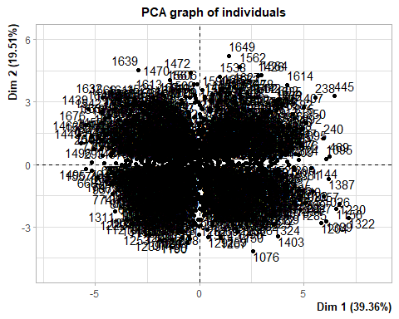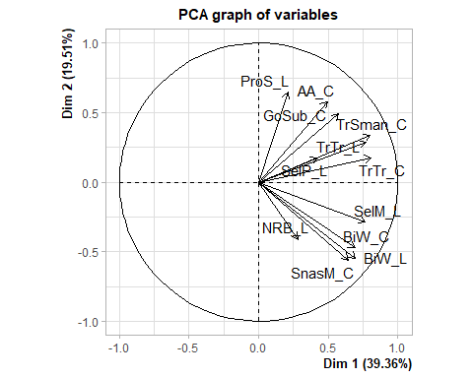

summary(pca1)

##   
## Call:  
## PCA(X = PCAdata_full1[, c("AA_C", "BiW_C", "BiW_L", "GoSub_C",   
## "NRB_L", "ProS_L", "SelP_L", "SelM_L", "SnasM_C", "TrSman_C",   
## "TrTr_C", "TrTr_L")])   
##   
##   
## Eigenvalues  
## Dim.1 Dim.2 Dim.3 Dim.4 Dim.5 Dim.6 Dim.7  
## Variance 4.723 2.341 1.325 0.953 0.736 0.624 0.446  
## % of var. 39.360 19.507 11.041 7.938 6.136 5.199 3.715  
## Cumulative % of var. 39.360 58.867 69.908 77.846 83.982 89.180 92.895  
## Dim.8 Dim.9 Dim.10 Dim.11 Dim.12  
## Variance 0.345 0.264 0.118 0.075 0.050  
## % of var. 2.877 2.197 0.986 0.629 0.416  
## Cumulative % of var. 95.772 97.968 98.954 99.584 100.000  
##   
## Individuals (the 10 first)  
## Dist Dim.1 ctr cos2 Dim.2 ctr cos2 Dim.3 ctr  
## 1 | 2.940 | 1.866 0.044 0.403 | 0.072 0.000 0.001 | -0.963 0.042  
## 2 | 3.161 | -2.489 0.078 0.620 | 0.258 0.002 0.007 | -1.121 0.057  
## 3 | 4.571 | 3.653 0.168 0.639 | -0.278 0.002 0.004 | -0.029 0.000  
## 4 | 2.741 | -0.492 0.003 0.032 | -1.613 0.066 0.346 | -0.616 0.017  
## 5 | 1.591 | 0.535 0.004 0.113 | 0.853 0.019 0.287 | 0.646 0.019  
## 6 | 2.400 | 1.238 0.019 0.266 | 0.670 0.011 0.078 | 0.565 0.014  
## 7 | 1.677 | -0.099 0.000 0.003 | -0.893 0.020 0.284 | 0.780 0.027  
## 8 | 3.163 | -0.043 0.000 0.000 | -1.113 0.032 0.124 | -1.789 0.144  
## 9 | 3.565 | 1.373 0.024 0.148 | 1.421 0.051 0.159 | 0.926 0.039  
## 10 | 2.142 | 1.210 0.018 0.319 | 0.333 0.003 0.024 | 0.358 0.006  
## cos2   
## 1 0.107 |  
## 2 0.126 |  
## 3 0.000 |  
## 4 0.051 |  
## 5 0.165 |  
## 6 0.055 |  
## 7 0.216 |  
## 8 0.320 |  
## 9 0.067 |  
## 10 0.028 |  
##   
## Variables (the 10 first)  
## Dim.1 ctr cos2 Dim.2 ctr cos2 Dim.3 ctr cos2   
## AA_C | 0.491 5.112 0.241 | 0.578 14.283 0.334 | 0.313 7.394 0.098 |  
## BiW_C | 0.692 10.152 0.480 | -0.473 9.564 0.224 | 0.172 2.228 0.030 |  
## BiW_L | 0.695 10.231 0.483 | -0.551 12.984 0.304 | -0.072 0.390 0.005 |  
## GoSub_C | 0.574 6.965 0.329 | 0.489 10.205 0.239 | -0.456 15.719 0.208 |  
## NRB_L | 0.283 1.693 0.080 | -0.411 7.221 0.169 | -0.239 4.319 0.057 |  
## ProS_L | 0.209 0.929 0.044 | 0.646 17.840 0.418 | 0.303 6.910 0.092 |  
## SelP_L | 0.422 3.773 0.178 | 0.173 1.284 0.030 | 0.732 40.450 0.536 |  
## SelM_L | 0.767 12.439 0.588 | -0.287 3.512 0.082 | 0.328 8.101 0.107 |  
## SnasM_C | 0.643 8.762 0.414 | -0.560 13.391 0.313 | 0.074 0.417 0.006 |  
## TrSman_C | 0.801 13.587 0.642 | 0.336 4.809 0.113 | -0.346 9.059 0.120 |

#loadingplot(pca1, show.names = TRUE)

PCAdata_full1$pc1 <- pca1$ind$coord[, 1] # indexing the first column  
  
PCAdata_full1$pc2 <- pca1$ind$coord[, 2] # indexing the second column

pca.vars <- pca1$var$coord %>% data.frame  
  
pca.vars$vars <- rownames(pca.vars)  
  
pca.vars.m <- melt(pca.vars, id.vars = "vars")

#circleFun <- function(center = c(0,0),diameter = 1, npoints = 100){  
 #r = diameter / 2  
 #tt <- seq(0,2*pi,length.out = npoints)  
 #xx <- center[1] + r * cos(tt)  
 #yy <- center[2] + r * sin(tt)  
 #return(data.frame(x = xx, y = yy))  
#}  
  
#circ <- circleFun(c(0,0),2,npoints = 500)

ggplot(data = PCAdata_full1, aes(x = pc1, y = pc2)) +  
 geom_point(color="darkgray")+  
 labs(y="PC2 (19.51%)",  
 x="PC1 (39.36%)",  
 title="PCA plot")+  
 theme_bw() + theme(text=element_text(family= "Times New Roman"))

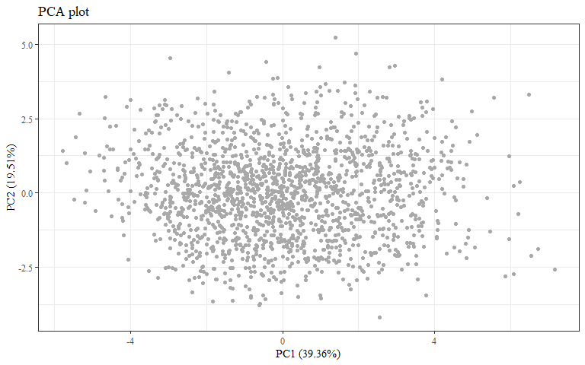

#checking to make sure this matches plot in PCA.Rmd  
ggplot(data = PCAdata_full1, aes(x = pc1, y = pc2, color = race_eth)) +  
 geom_hline(yintercept = 0, lty = 2) +  
 geom_vline(xintercept = 0, lty = 2) +  
 geom_point(alpha = 0.8) +  
 labs(y="PC2 (19.51%)",  
 x="PC1 (39.36%)",  
 title = "All Race/Ethnicities PCA plot",  
 color = "Race/Ethnicity")+  
 theme_bw() + theme(text=element_text(family= "Times New Roman"))

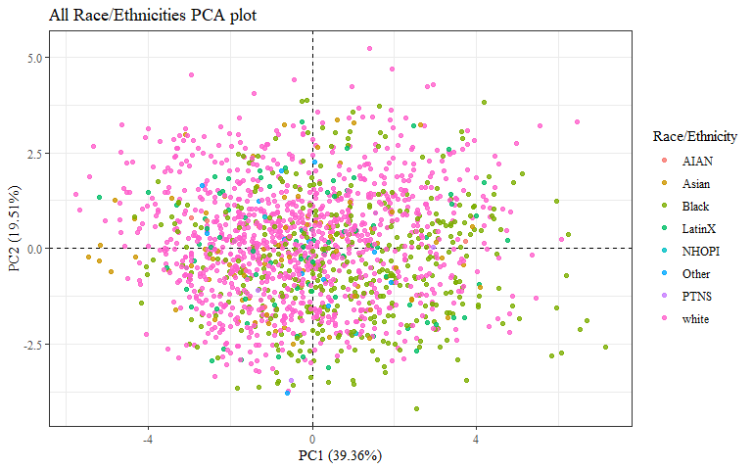

ggplot(data = PCAdata_full1, aes(x = pc1, y = pc2, color = race_eth)) +  
 geom_hline(yintercept = 0, lty = 2) +  
 geom_vline(xintercept = 0, lty = 2) +  
 geom_point(alpha = 0.8) +   
 stat_ellipse(geom="polygon", aes(fill = race_eth),   
 alpha = 0.2,   
 show.legend = FALSE,  
 level = 0.95) +  
 #theme_minimal() +  
 #theme(panel.grid = element_blank(), panel.border = element_rect(fill= "transparent"))+  
 labs(y="PC2 (19.51%)",  
 x="PC1 (39.36%)",  
 title = "All Race/Ethnicities PCA plot",  
 color = "Race/Ethnicity")+  
 theme_bw() + theme(text=element_text(family= "Times New Roman"))

## Too few points to calculate an ellipse

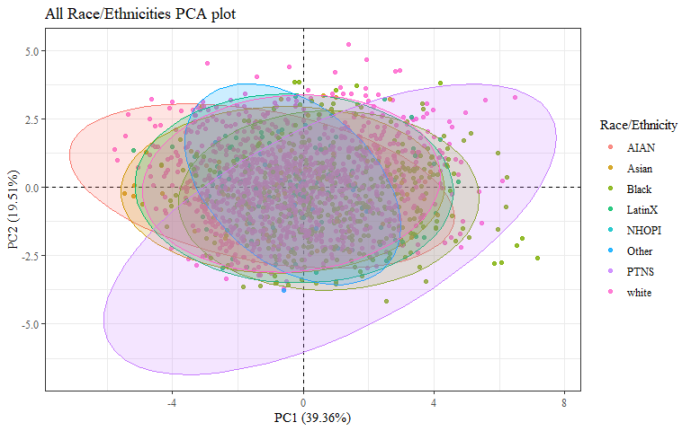 Need a plot with just Asian, Black, LatinX, and white

PCAdata_full2 <- PCAdata_full1  
  
PCAdata_full2$race_eth <- as.factor(PCAdata_full2$race_eth)  
PCAdata_full2$gender <- as.factor(PCAdata_full2$gender)  
PCAdata_full2$age_group <- as.factor(PCAdata_full2$age_group)

PCAdata_race_eth <- PCAdata_full2  
  
PCAdata_race_eth$race_eth <-   
 recode_factor(PCAdata_race_eth$race_eth, 'AIAN'= "Other",  
 'NHOPI' = "Other",  
 'PTNS' = "Other")  
  
PCAdata_race_eth_nas <- PCAdata_full1 %>%   
 mutate(race_eth = na_if_in(race_eth, c("AIAN", "Other", "NHOPI", "PTNS")))  
  
str(PCAdata_race_eth$race_eth)

## Factor w/ 5 levels "Other","Asian",..: 3 5 5 5 5 5 3 3 5 5 ...

str(PCAdata_race_eth_nas$race_eth)

## chr [1:1677] "Black" "white" "white" "white" "white" "white" "Black" ...

ggplot(data = PCAdata_race_eth, aes(x = pc1, y = pc2, color = race_eth)) +  
 geom_hline(yintercept = 0, lty = 2) +  
 geom_vline(xintercept = 0, lty = 2) +  
 geom_point(alpha = 0.8) +   
 stat_ellipse(geom="polygon", aes(fill = race_eth),   
 alpha = 0.2,   
 show.legend = FALSE,  
 level = 0.95) +  
 #theme_minimal() +  
 #theme(panel.grid = element_blank(), panel.border = element_rect(fill= "transparent"))+  
 labs(y="PC2 (19.51%)",  
 x="PC1 (39.36%)",  
 title="Four Most Common Race/Ethnicities PCA plot",  
 color = "Race/Ethnicity")+  
 theme_bw() + theme(text=element_text(family= "Times New Roman"))

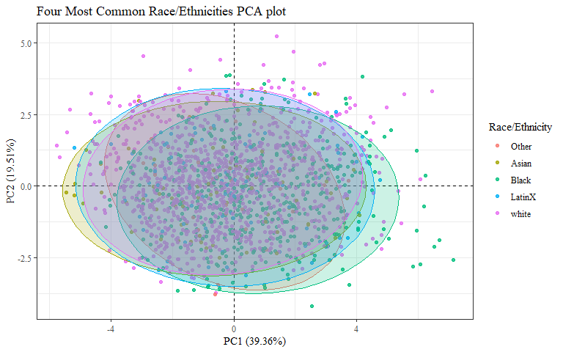

PCAdata_race_eth_nas %>%   
 drop_na(race_eth) %>%   
 ggplot(aes(x = pc1, y = pc2, color = race_eth)) +  
 geom_hline(yintercept = 0, lty = 2) +  
 geom_vline(xintercept = 0, lty = 2) +  
 geom_point(alpha = 0.8) +   
 stat_ellipse(geom="polygon", aes(fill = race_eth),   
 alpha = 0.2,   
 show.legend = FALSE,  
 level = 0.95) +  
 #theme_minimal() +  
 #theme(panel.grid = element_blank(), panel.border = element_rect(fill= "transparent"))+  
 labs(y="PC2 (19.51%)",  
 x="PC1 (39.36%)",  
 title="Race/Ethnicity PCA plot",  
 subtitle="Other Race/Ethnicities not shown",  
 color = "Race/Ethnicity")+  
 theme_bw() + theme(text=element_text(family= "Times New Roman"))

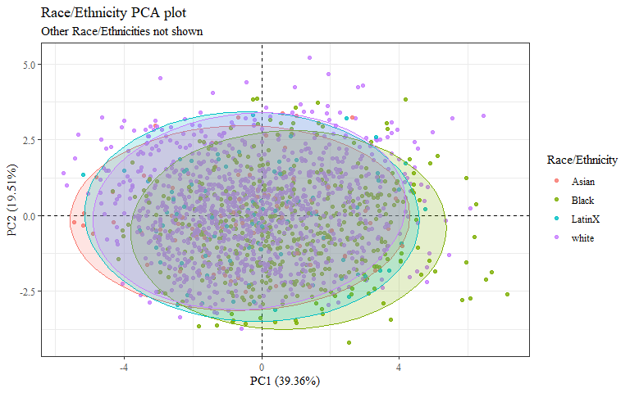

Just Asian and Black?

PCAdata_race_eth1 <- PCAdata_race_eth  
  
PCAdata_race_eth1$race_eth <-  
 recode_factor(PCAdata_race_eth1$race_eth, 'white'= "Other",  
 'LatinX' = "Other")  
  
PCAdata_race_eth_nas1 <- PCAdata_race_eth_nas %>%   
 mutate(race_eth = na_if_in(race_eth, c("white", "LatinX")))  
  
str(PCAdata_race_eth1$race_eth)

## Factor w/ 3 levels "Other","Asian",..: 3 1 1 1 1 1 3 3 1 1 ...

str(PCAdata_race_eth_nas1$race_eth)

## chr [1:1677] "Black" NA NA NA NA NA "Black" "Black" NA NA NA NA NA "Black" ...

ggplot(data = PCAdata_race_eth1, aes(x = pc1, y = pc2, color = race_eth)) +  
 geom_hline(yintercept = 0, lty = 2) +  
 geom_vline(xintercept = 0, lty = 2) +  
 geom_point(alpha = 0.8) +   
 stat_ellipse(geom="polygon", aes(fill = race_eth, na.rm=TRUE),   
 alpha = 0.2,   
 show.legend = FALSE,  
 level = 0.95) +  
 #theme_minimal() +  
 #theme(panel.grid = element_blank(), panel.border = element_rect(fill= "transparent"))+  
 labs(y="PC2 (19.51%)",  
 x="PC1 (39.36%)",  
 title="Black and Asian Race/Ethnicities PCA plot",  
 color = "Race/Ethnicity")+  
 theme_bw() + theme(text=element_text(family= "Times New Roman"))

## Warning: Ignoring unknown aesthetics: na.rm

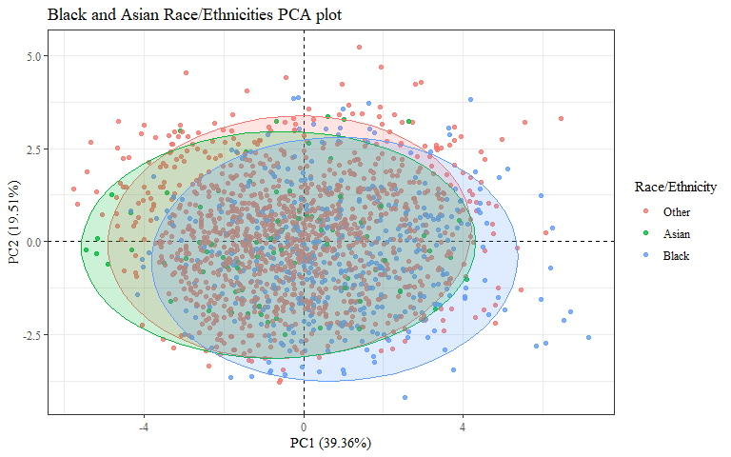

PCAdata_race_eth_nas1 %>%   
 drop_na(race_eth) %>%   
 ggplot(aes(x = pc1, y = pc2, color = race_eth)) +  
 geom_hline(yintercept = 0, lty = 2) +  
 geom_vline(xintercept = 0, lty = 2) +  
 geom_point(alpha = 0.8) +   
 stat_ellipse(geom="polygon", aes(fill = race_eth, na.rm=TRUE),   
 alpha = 0.2,   
 show.legend = FALSE,  
 level = 0.95) +  
 #theme_minimal() +  
 #theme(panel.grid = element_blank(), panel.border = element_rect(fill= "transparent"))+  
 labs(y="PC2 (19.51%)",  
 x="PC1 (39.36%)",  
 title="Black and Asian Race/Ethnicities PCA plot",  
 subtitle = "Other Race/Ethnicities not shown",  
 color = "Race/Ethnicity")+  
 theme_bw() + theme(text=element_text(family= "Times New Roman"))

## Warning: Ignoring unknown aesthetics: na.rm

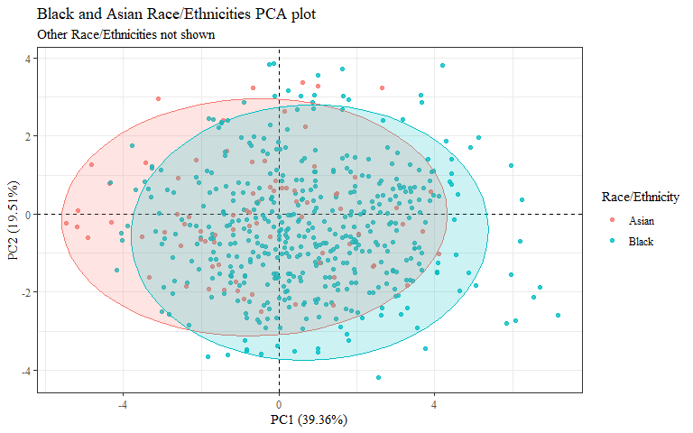

#checking to make sure this matches plot in PCA.Rmd  
ggplot(data = PCAdata_full1, aes(x = pc1, y = pc2, color = gender)) +  
 geom_hline(yintercept = 0, lty = 2) +  
 geom_vline(xintercept = 0, lty = 2) +  
 geom_point(alpha = 0.8) +  
 labs(y="PC2 (19.51%)",  
 x="PC1 (39.36%)",  
 title = "All Genders PCA plot",  
 color= "Gender")+  
 theme_bw() + theme(text=element_text(family= "Times New Roman"))

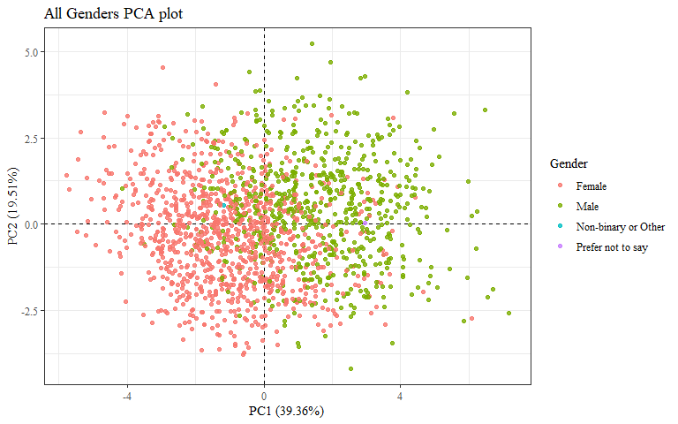

ggplot(data = PCAdata_full1, aes(x = pc1, y = pc2, color = gender)) +  
 geom_hline(yintercept = 0, lty = 2) +  
 geom_vline(xintercept = 0, lty = 2) +  
 geom_point(alpha = 0.8) +   
 stat_ellipse(geom="polygon", aes(fill = gender),   
 alpha = 0.2,   
 show.legend = FALSE,  
 level = 0.95) +  
 #theme_minimal() +  
 #theme(panel.grid = element_blank(), panel.border = element_rect(fill= "transparent"))+  
 labs(y="PC2 (19.51%)",  
 x="PC1 (39.36%)",  
 title="All Genders PCA plot",  
 color= "Gender")+  
 theme_bw() + theme(text=element_text(family= "Times New Roman"))

## Too few points to calculate an ellipse  
## Too few points to calculate an ellipse

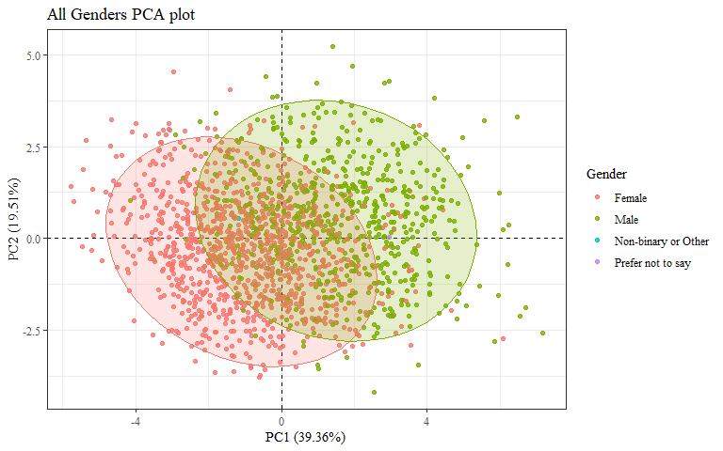 Need plot with just Male and Female

PCAdata_gender <- PCAdata_full2  
  
PCAdata_gender$gender <-   
 recode_factor(PCAdata_gender$gender, 'Non-binary or Other'= "Other",  
 'Prefer not to say' = "Other")  
  
PCAdata_gender$gender[is.na(PCAdata_gender$gender)]="Other"  
  
PCAdata_gender_nas <- PCAdata_full1 %>%   
 mutate(gender = na_if_in(gender, c("Non-binary or Other", "Prefer not to say", "Other")))  
  
str(PCAdata_gender$gender)

## Factor w/ 3 levels "Other","Female",..: 3 2 3 3 3 3 3 3 3 3 ...

str(PCAdata_gender_nas$gender)

## chr [1:1677] "Male" "Female" "Male" "Male" "Male" "Male" "Male" "Male" ...

ggplot(data = PCAdata_gender, aes(x = pc1, y = pc2, color = gender)) +  
 geom_hline(yintercept = 0, lty = 2) +  
 geom_vline(xintercept = 0, lty = 2) +  
 geom_point(alpha = 0.8) +   
 stat_ellipse(geom="polygon", aes(fill = gender),   
 alpha = 0.2,   
 show.legend = FALSE,  
 level = 0.95) +  
 #theme_minimal() +  
 #theme(panel.grid = element_blank(), panel.border = element_rect(fill= "transparent"))+  
 labs(y="PC2 (19.51%)",  
 x="PC1 (39.36%)",  
 title="Two Most Common Genders PCA plot",  
 color = "Gender")+  
 theme_bw() + theme(text=element_text(family= "Times New Roman"))

## Too few points to calculate an ellipse

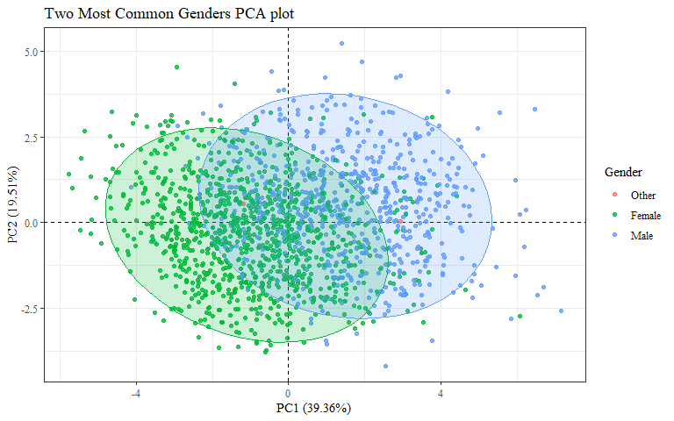

PCAdata_gender1 <- PCAdata_gender  
  
PCAdata_gender1$gender <-  
 recode_factor(PCAdata_gender1$gender, 'Female'= "Female/Other",  
 'Other' = "Female/Other")  
  
  
ggplot(data = PCAdata_gender1, aes(x = pc1, y = pc2, color = gender)) +  
 geom_hline(yintercept = 0, lty = 2) +  
 geom_vline(xintercept = 0, lty = 2) +  
 geom_point(alpha = 0.8) +   
 stat_ellipse(geom="polygon", aes(fill = gender),   
 alpha = 0.2,   
 show.legend = FALSE,  
 level = 0.95) +  
 #theme_minimal() +  
 #theme(panel.grid = element_blank(), panel.border = element_rect(fill= "transparent"))+  
 labs(y="PC2 (19.51%)",  
 x="PC1 (39.36%)",  
 title="Gender PCA Plot",  
 color = "Gender")+  
 theme_bw() + theme(text=element_text(family= "Times New Roman"))

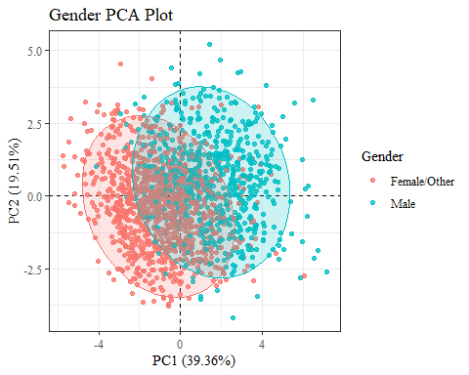

PCAdata_gender_nas %>%   
 drop_na(gender) %>%   
 ggplot(aes(x = pc1, y = pc2, color = gender)) +  
 geom_hline(yintercept = 0, lty = 2) +  
 geom_vline(xintercept = 0, lty = 2) +  
 geom_point(alpha = 0.8) +   
 stat_ellipse(geom="polygon", aes(fill = gender),   
 alpha = 0.2,   
 show.legend = FALSE,  
 level = 0.95) +  
 #theme_minimal() +  
 #theme(panel.grid = element_blank(), panel.border = element_rect(fill= "transparent"))+  
 labs(y="PC2 (19.51%)",  
 x="PC1 (39.36%)",  
 title="Four Most Common Genders PCA plot",  
 subtitle="Other Genders not shown",  
 color = "Gender")+  
 theme_bw() + theme(text=element_text(family= "Times New Roman"))

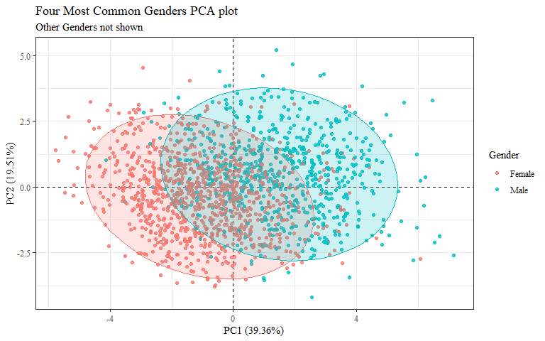

#checking to make sure this matches plot in PCA.Rmd  
ggplot(data = PCAdata_full1, aes(x = pc1, y = pc2, color = age_group)) +  
 geom_hline(yintercept = 0, lty = 2) +  
 geom_vline(xintercept = 0, lty = 2) +  
 geom_point(alpha = 0.8) +  
 labs(y="PC2 (19.51%)",  
 x="PC1 (39.36%)",  
 title = "Age Group PCA plot",  
 color= "Age Group")+  
 theme_bw() + theme(text=element_text(family= "Times New Roman"))

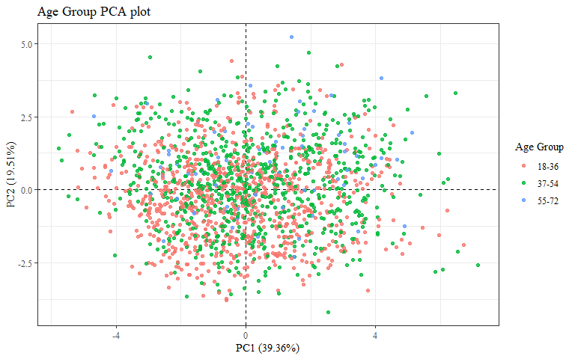

ggplot(data = PCAdata_full1, aes(x = pc1, y = pc2, color = age_group)) +  
 geom_hline(yintercept = 0, lty = 2) +  
 geom_vline(xintercept = 0, lty = 2) +  
 geom_point(alpha = 0.8) +   
 stat_ellipse(geom="polygon", aes(fill = age_group),   
 alpha = 0.2,   
 show.legend = FALSE,  
 level = 0.95) +  
 #theme_minimal() +  
 #theme(panel.grid = element_blank(), panel.border = element_rect(fill= "transparent"))+  
 labs(y="PC2 (19.51%)",  
 x="PC1 (39.36%)",  
 title = "All Age Groups PCA plot",  
 color= "Age Group")+  
 theme_bw() + theme(text=element_text(family= "Times New Roman"))

